<html>

<comment>webpage includes the concept of html</comment>

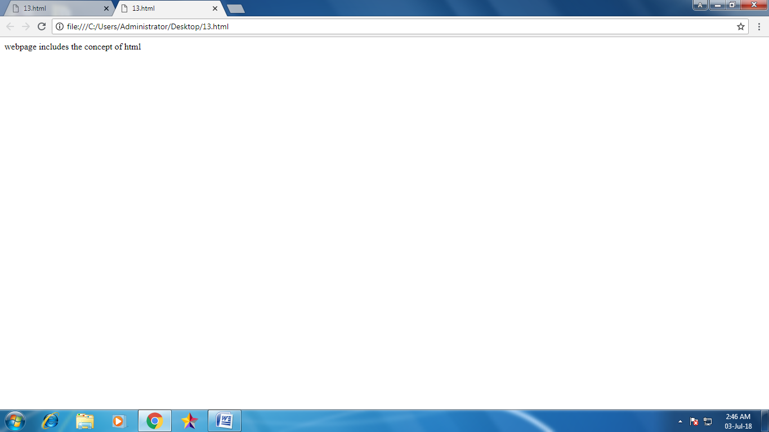</html>