EXn no:4

Program:

<html>

<h1>web technology</h1>

<P>paragraph tag</p>

</html>

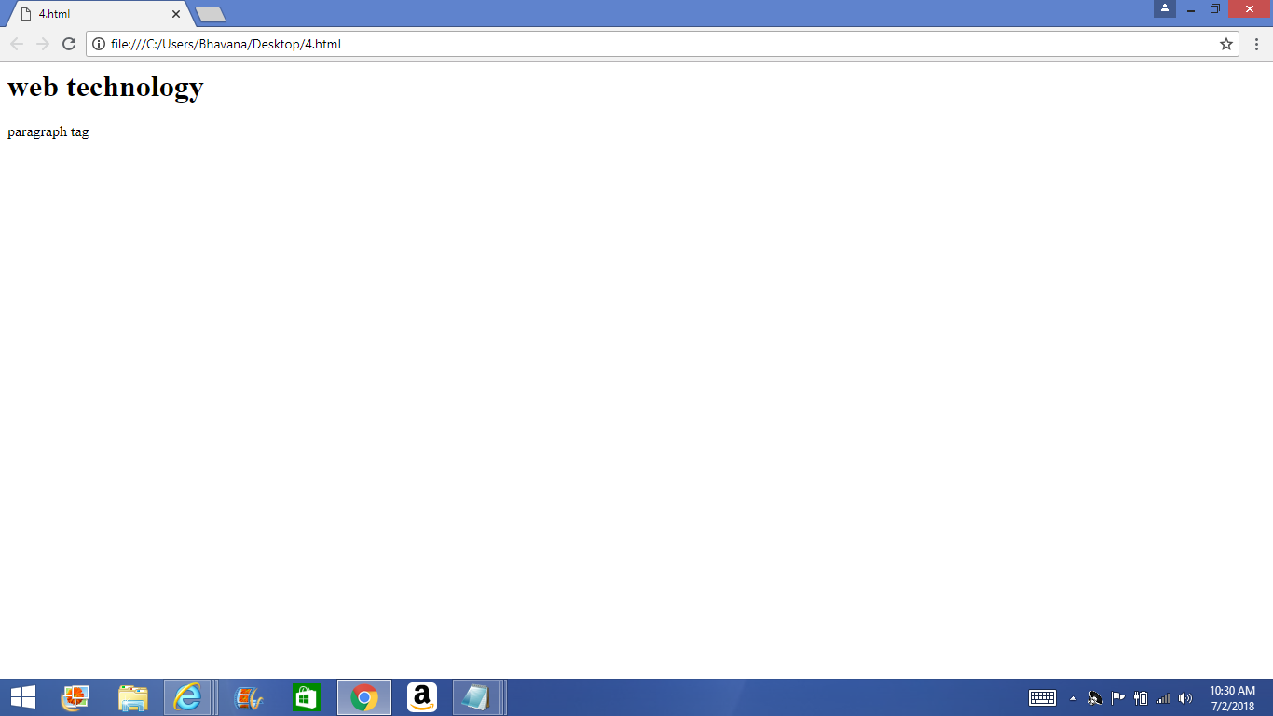Output: