Ex no:6

Program:

<html>

<b>samsung</b><br>

<strong>karbonn</strong><br>

<i>nokia</i><br>

redmi<sup>mi</sup><br>

<del>LG</del><br>

<code>A webpage is not available</code><br>

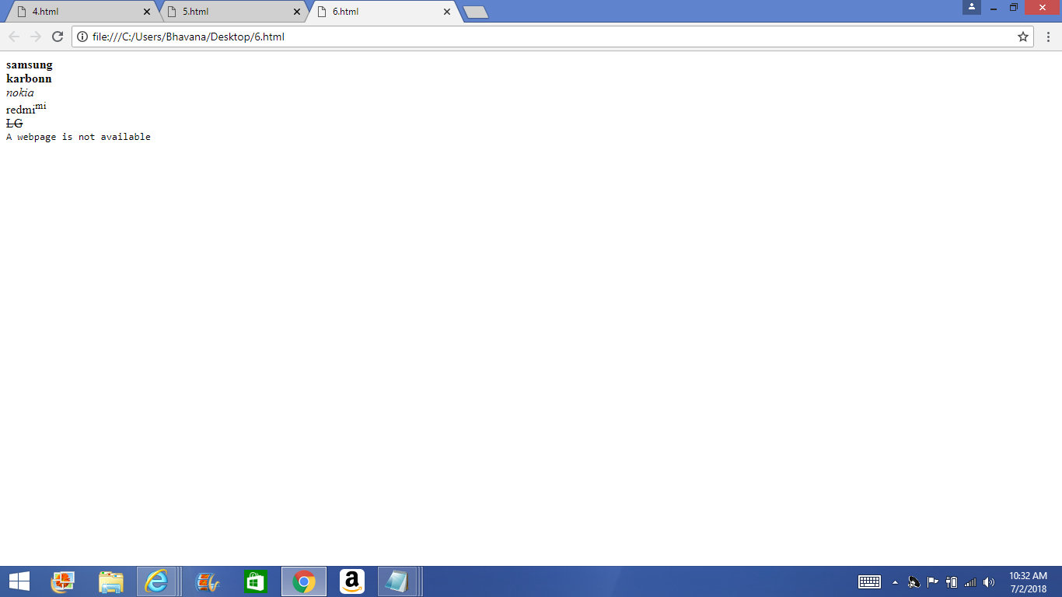</html>

Output: