Ex no:7

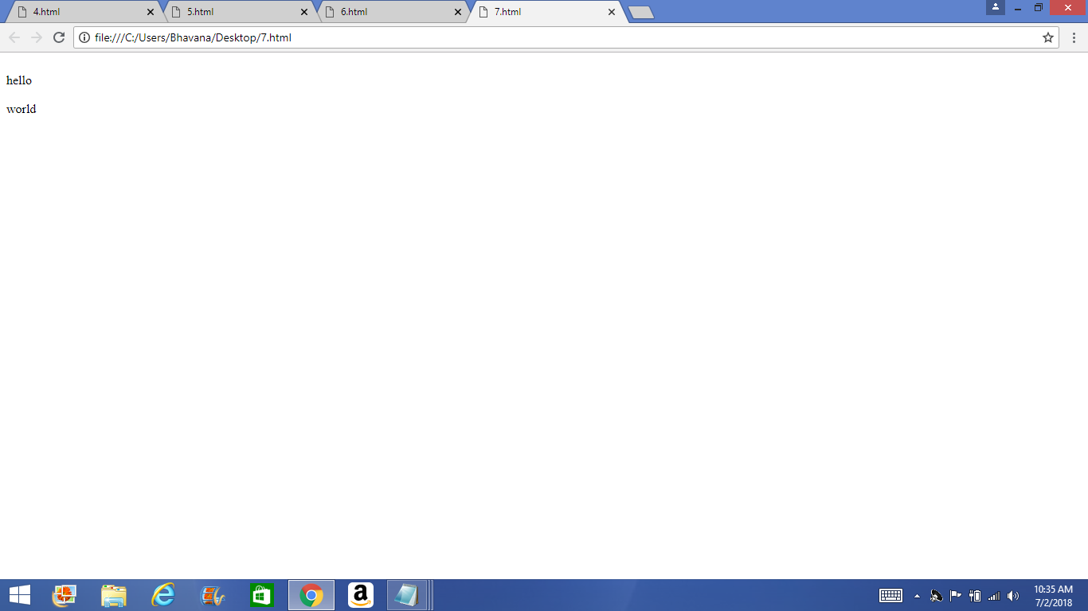Program:

<html>

<br>hello</br>

<br>world</br>

</html>

Output: