Ex no:8

Program:

<html>

<h1>web technology</h1>

<pre>html is used for web page</pre>

</html>

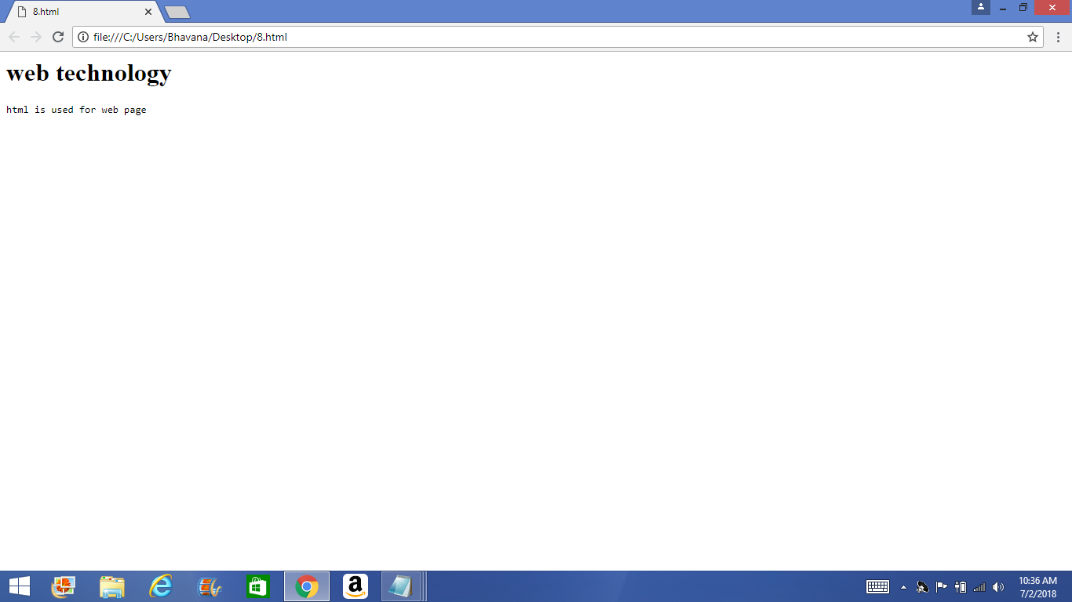Output: