Student Id
Bida25-492
NEELO SEPHIRI
Student name
Bida25-492@thuto.bac.ac.bw
Student email
2026
Cohort
SCIS WMD_2026 A01
Assignment title

Date of submission
Business Intelligence and Data Analytics
Programme of Study
YEAR 1
Year of study

Intellectual property statement
By checking the box below, I certify that this assignment is my own and is free from plagiarism. I understand that the assignment may be checked for plagiarism by electronic or other means and may be transferred and stored in a database for the purposes of data-matching to help detect plagiarism. The assignment has not previously been submitted for assessment in any other unit or to any other institution. I have read and understood the Botswana Accountancy College plagiarism guidelines policy.

Agree Signature N.Sephiri
Date 08/04/2026

PAGE TEMPLATE DESIGN
The website will have a clean and simple layout across all pages.
Layout structure
Header: Logo
Navigation Bar: Home | About | Products | Contact
Main content Area: Images, text and product displays
Footer: Contact information and social links
Wireframe
Each page will follow a consistent structure with a header at the top, navigation bar below it, content in the center and a footer at the bottom. The design will focus on simplicity and readability.
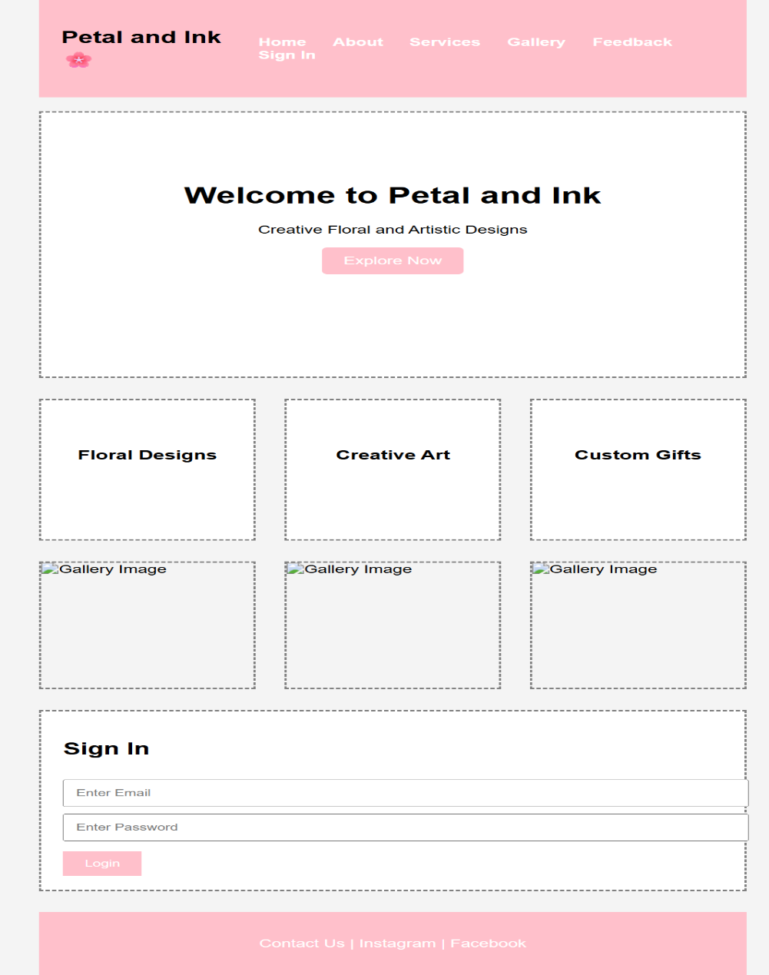

TECHNICAL BRIEF
Technologies to be sued
- HTML
- CSS
- Bootstrap
- JavaScript
Tools
- Visual Studio Code
- GitHub
Graphics Tools
- Canva

