PROMPTING

**Prompting** refers to the process of providing a clear and specific instruction or input, known as a *prompt*, to an artificial intelligence (AI) model to guide its response or output.  
  
Prompting is the act of formulating and presenting questions, commands, or statements to an AI system so that it performs a desired task or generates relevant information.  
  
**Example:**  
• **Prompt:** “Write a short paragraph on the importance of teamwork.”  
**Response:** The AI generates a paragraph explaining why teamwork is essential.  
  
In AI and natural language processing, the quality and clarity of a prompt significantly influence the accuracy, relevance, and usefulness of the model’s response.

Depending on how the prompt is phrased, the AI can generate a variety of outputs, from a single word to a detailed paragraph. It acts as the starting point for the AI’s generation process, directing it to create content that matches your intent. Prompts can range from simple “Translate this sentence to French” to complex, multi part instructions or scenarios.

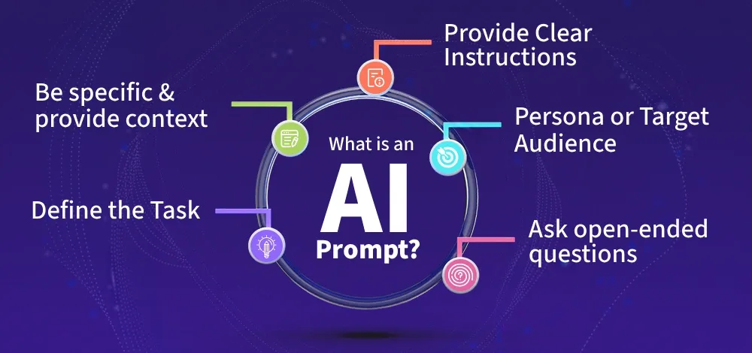

**Importance of AI Prompt**

* **Directs Output:** The prompt determines what the AI generates, how relevant it is and whether it meets your needs.
* **Improves Accuracy:** Clear, specific prompts reduce misunderstandings and produce more precise, useful responses.
* **Saves Time:** Well-crafted prompts minimize trial and error, speeding up workflows and improving productivity.
* **Enables Complex Tasks:** Good prompts allow you to use AI for sophisticated tasks like summarization, data extraction or creative writing.
* **Enhances User Experience:** Effective prompts make AI interactions smoother, more intuitive and more valuable.

**How to Create a Good AI prompts**

**1. Define the Task :**

Clearly state what you want the AI to do.

***Example****: “Write a summary of the following article.”*

**2. Be Specific :**

Provide necessary details and context to guide the AI.

***Example****: “Summarize the following article in three bullet points, focusing on environmental impacts.”*

**3. Use Clear Instructions**

Avoid ambiguity; state requirements directly.

***Example****: “List three pros and three cons of remote work for software engineers.”*

**4. Consider Audience**

Indicate the target reader or use case if relevant.

***Example****: “Explain blockchain technology to high school students.”*

**5. Prefer Open-Ended Questions**

Encourage richer, more informative responses.

***Example****: “What are some innovative ways small businesses can use AI in marketing?”*

**Applications of AI Prompts**

AI prompts have a wide range of applications across various fields. Here are some key areas where AI prompts can be applied:

1. **Content Creation**: Generate creative text formats and write marketing copy based on specific prompts.
2. **Software Development**: Write basic code based on functionality requirements and debug by identifying potential issues in the provided code.
3. **Image Generation**: Create unique images and assist in design by generating options for products or logos based on given aesthetic or functional details.
4. **Data Analysis and Research**: Process large text datasets to provide summaries and classify data effectively based on prompts.

**Challenges and ethical concerns with AI Prompt**

* **Harmful or Biased Outputs:** Poorly designed prompts can lead to offensive or skewed results.
* **Data Privacy:** Prompts may contain sensitive or personal information.
* **Unintended Outputs:** Ambiguous prompts can cause irrelevant or misleading answers.
* **AI Hallucinations:** The model may generate plausible but incorrect information.
* **Model Limitations:** Different models may interpret the same prompt differently so always fact-check outputs.

**Types of Prompting**

**Zero Shot Prompting**

Zero-shot prompting involves instructing a language model without providing specific examples, relying on the model’s inherent understanding of the context. The language model, having pre-existing knowledge, generates a response based on its contextual understanding.

**Prompt:**

*Perform sentiment analysis on the given text and categorize it as neutral, negative, or positive.*

**Text Input:**

*The Recent trip was great*

**Output:**

*Sentiment: Positive*

In this case, the language model is tasked with sentiment analysis without being given specific instances for training. The model leverages its existing knowledge to interpret and categorize the sentiment of the provided text. This approach is known as zero-shot prompting, as it relies on the model’s innate contextual comprehension rather than explicit examples.

**Chain-of-Thought Prompting**

Before delving directly into few-shot prompting, let me introduce you to a chain of thoughts. This will help you understand why providing examples within the prompt is necessary, especially in complex scenarios.

**Standard Prompt:**

***Question 1:****Sam has 3 notebooks. He purchases 4 more packs of notebooks, with 5 notebooks in each pack. How many notebooks does Sam have now?*

***Answer:****23 notebooks*

***Question 2****: The basket has 30 apples. If 20 apples are used for lunch and an additional 6 are bought from the market, how many apples are there in the basket?*

**The Model Output will be 11 which is wrong**

**Chain-of-Thought Prompt:**

***Question 1:****Sam has 3 notebooks. He purchases 4 more packs of notebooks, with 5 notebooks in each pack. How many notebooks does Sam have now?*

***Answer:****Sam initial notebooks: 3 notebooks  
Notebooks from the new packs: 4 packs * 5 notebooks/pack = 20 notebooks*

*Now, add these two quantities:*

*3 notebooks (initial) + 20 notebooks (new packs) =****23 notebooks***

***Question 2****: The basket has 30 apples. If 20 apples are used for lunch and an additional 6 are bought from the market, how many apples are there in the basket?*

The Model Output will be:

*Initial number of apples in the basket: 30 apples  
Apples used for lunch: -20 apples  
Apples brought from the market: +6 apples*

*Now, add these quantities:*

*30 apples (initial) — 20 apples (used for lunch) + 6 apples (brought from the market) =****16 apples***

**Chain-of-thought (CoT) prompting** means guiding a language model through a series of connected logical steps or thoughts. It allows the model to think step by step, considering different aspects of a problem.

When we say **complex reasoning capabilities**, we mean the ability of the model to think through intricate or complicated scenarios.

Now, **few-shot prompting** involves providing a few examples or instances within the prompt to help the model understand the task better.

So, *combining chain-of-thought* with *few-shot prompting* means you guide the model through logical steps, allowing it to reason through complexities, and you also provide a few examples to enhance its understanding. This combination helps the model tackle more intricate tasks that require thoughtful reasoning before generating a response.

**One-Shot and Few Shot Prompting:**

Even though large-language models can understand and generate text without examples (zero-shot capabilities), they struggle with more challenging tasks in this setting. To address this, we use a technique called *few-shot prompting*. This involves providing the model with a few examples or demonstrations in the prompt, essentially giving it a bit of training to improve its performance. These examples act as training guides, helping the model learn and generate better responses in similar situations.

**Prompt:**

*A****blizzlenut****is a rare fruit found in the mystical forest.*

*An example of a sentence that uses the word blizzlenut is: During our magical journey, we discovered a grove filled with enchanting****blizzlenuts****.*

*To perform a****gleamfrolic****means to twirl around with joy.*

**Output:**

*An example of a sentence that uses the word gleamfrolic is: After receiving good news, she couldn’t help but****gleamfrolic****in the garden.*

We notice that the model can grasp a task with just a single example (one-shot). However, when dealing with more challenging tasks, we can explore improved performance by experimenting with an increased number of examples, such as 3-shot, 5-shot, 10-shot, and so on.

Let’s try for Few-Shot Prompt for Text Sentiments:

*This is fantastic! — — ->****Negative***

*This is terrible! — — ->****Positive***

*Wow, that book was amazing! — — ->****Negative***

*What a dreadful performance! — — ->****Positive***

I have randomly assigned sentiments to the above texts.

**Output:**

*This dessert is delicious! — — ->****Negative***

**Prompt Tuning**

Prompt tuning is a technique that involves modifying the input to a pre-trained language model rather than altering the model's parameters. Instead of fine-tuning the entire model, prompt tuning focuses on designing task-specific "prompts" or instructions that guide the model to produce the desired output.

Prompt tuning involves freezing the pre-trained model's parameters and optimizing only a small set of additional parameters, often referred to as "soft prompts." These soft prompts are learned during training and serve as a bridge between the model's pre-trained knowledge and the specific task at hand.

**How Does Prompt Tuning Work?**

1. **Pre-trained Model**: Start with a pre-trained language model, such as GPT-3 or BERT. The model's parameters remain frozen during the process.
2. **Task-Specific Prompts**: Design a prompt template that includes placeholders for the input data and task-specific instructions. For example:
   * *"Translate the following English sentence into French: [English sentence]."*
   * *"Summarize the following text in one sentence: [text]."*
3. **Soft Prompts**: Instead of using fixed, hand-crafted prompts, prompt tuning introduces **learnable soft prompts**. These are continuous vectors that are optimized during training to guide the model toward the desired behavior. Soft prompts are typically initialized randomly and then fine-tuned using gradient descent.
4. **Training**: During training, only the soft prompts are updated, while the rest of the model remains unchanged. This significantly reduces the computational cost compared to full fine-tuning.
5. **Inference**: At inference time, the learned soft prompts are prepended to the input, and the model generates predictions based on the combined input.

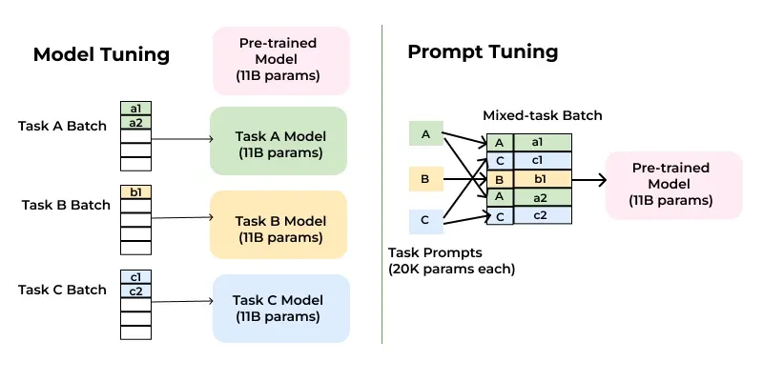

**Advantages of Prompt Tuning**

1. **Efficiency**: One of the most significant advantages of prompt tuning is its efficiency. Since only a small number of parameters (the soft prompts) are updated, the computational and memory requirements are much lower than those of full fine-tuning. This makes prompt tuning particularly appealing for large models with billions of parameters.
2. **Scalability**: Prompt tuning scales well with model size. Research has shown that as the size of the pre-trained model increases, the performance gap between prompt tuning and full fine-tuning narrows. In some cases, prompt tuning can achieve comparable or even better results than full fine-tuning, especially for very large models.
3. **Task Generalization**: By leveraging the pre-trained model's knowledge, prompt tuning can generalize better across tasks. The model retains its original capabilities while adapting to new tasks through the use of prompts.
4. **Reduced Overfitting**: Since prompt tuning modifies only a small subset of parameters, it is less prone to overfitting, especially when working with limited training data.
5. **Flexibility**: Prompt tuning allows for rapid experimentation with different tasks and prompts without the need to retrain the entire model. This flexibility is particularly valuable in scenarios where multiple tasks need to be addressed simultaneously.

**Challenges and Limitations**

While prompt tuning offers many advantages, it is not without its challenges:

1. **Prompt Design**: Crafting effective prompts can be non-trivial. The quality of the prompt can significantly impact the model's performance, and designing optimal prompts often requires domain expertise and experimentation.
2. **Interpretability**: Soft prompts are continuous vectors that lack interpretability. Unlike hand-crafted prompts, it is difficult to understand what specific information the soft prompts are encoding.
3. **Task Complexity**: While prompt tuning works well for many tasks, it may struggle with highly complex or multi-step reasoning tasks that require deeper modifications to the model's architecture.
4. **Resource Constraints**: Although prompt tuning is more efficient than full fine-tuning, it still requires access to large pre-trained models, which may not be feasible for all users due to hardware or budget constraints.

**Applications of Prompt Tuning**

Prompt tuning has found applications across a wide range of NLP tasks, including:

1. **Text Classification**: Prompt tuning can be used to classify text into categories such as sentiment, topic, or intent.
2. **Question Answering**: By providing prompts that guide the model to extract relevant information, prompt tuning can improve performance on question-answering tasks.
3. **Machine Translation**: Prompt tuning can help adapt pre-trained models for translation tasks by incorporating task-specific instructions.
4. **Summarization**: Prompt tuning can be used to generate concise summaries of long documents by guiding the model to focus on key points.
5. **Few-Shot Learning**: Prompt tuning is particularly effective in few-shot learning scenarios, where the model is given only a small number of examples for a new task. By leveraging the pre-trained model's knowledge, prompt tuning can achieve strong performance even with limited data.

**Future of Prompt Tuning**

As language models continue to grow in size and complexity, techniques like prompt tuning are likely to play an increasingly important role in making these models more accessible and practical. Researchers are actively exploring ways to improve prompt tuning, such as:

* **Automated Prompt Design**: Developing algorithms to automatically generate effective prompts, reducing the need for manual intervention.
* **Hybrid Approaches**: Combining prompt tuning with other parameter-efficient fine-tuning methods, such as adapter modules or LoRA (Low-Rank Adaptation), to further enhance performance.
* **Cross-Task Generalization**: Investigating how prompt tuning can be extended to handle multiple tasks simultaneously, enabling models to perform a wide range of functions without the need for separate fine-tuning.

By focusing on task-specific prompts rather than modifying the entire model, prompt tuning enables users to harness the power of large language models with minimal computational overhead.