**Retrieval-Augmented Generation (RAG)**

Retrieval-Augmented Generation (RAG) is an advanced AI framework that combines information retrieval with text generation models like GPT to produce more accurate and up-to-date responses. Instead of relying only on pre-trained data like traditional language models, RAG fetches relevant documents from an external knowledge source before generating an answer.

**Importance of RAG**

1. **Access to Updated Knowledge:**LLMs are trained on fixed datasets but RAG allows them to fetch fresh and real time information from external sources.
2. **Improved Accuracy:** It reduces hallucinations in LLMs and makes answers more factually correct.
3. **Domain Specific Expertise: It l**ets us use specialized datasets like medical records and legal documents to get expert-level responses without retraining the model.
4. **Cost Efficiency:** Instead of retraining massive LLMs with new data, we simply update the external knowledge base hence saving time and resources.
5. **Personalization:** RAG can retrieve user specific information like past interactions or personal data to provide more tailored and relevant responses.

**Components of RAG**

The main components of RAG are:

1. **External Knowledge Source:**Stores domain specific or general information like documents, APIs or databases.
2. **Text Chunking and Preprocessing:**Breaks large text into smaller, manageable chunks and cleans it for consistency.
3. **Embedding Model:** Converts text into numerical vectors that capture semantic meaning.
4. **Vector Database:**Stores embeddings and enables similarity search for fast information retrieval.
5. **Query Encoder:** Transforms the user’s query into a vector for comparison with stored embeddings.
6. **Retriever:**Finds and returns the most relevant chunks from the database based on query similarity.
7. **Prompt Augmentation Layer:**Combines retrieved chunks with the user’s query to provide context to the LLM.
8. **LLM (Generator):**Generates a grounded response using both the query and retrieved knowledge.
9. **Updater (Optional):**Regularly refreshes and re-embeds data to keep the knowledge base up to date.

**Working of RAG**

The system first searches external sources for relevant information based on the user’s query instead of relying only on existing training data.

1. **Creating External Data:** External data from APIs, databases or documents is chunked, converted into embeddings and stored in a vector database to build a knowledge library.
2. **Retrieving Relevant Information:**User queries are converted into vectors and matched against stored embeddings to fetch the most relevant data ensuring accurate responses.
3. **Augmenting the LLM Prompt:**Retrieved content is added to the user’s query giving the LLM extra context to work with.
4. **Answer Generation:**LLM uses both the query and retrieved data to generate a factually accurate, context aware response.
5. **Keeping Data Updated:**External data and embeddings are refreshed regularly in real time or scheduled so the system always retrieves latest information.

**What Problems does RAG solve?**

Some the problems that RAG solves are:

1. **Hallucinations**: Traditional generative models can produce incorrect information. RAG reduces this risk by retrieving verified, external data to ground responses in factual knowledge.
2. **Outdated Information**: Static models rely on training data that may become outdated. It dynamically retrieves latest information ensuring relevance and accuracy in real time**.**
3. **Contextual Relevance**: Generative models often struggle with maintaining context in complex or multi turn conversations. RAG retrieves relevant documents to enrich the context improving coherence and relevance.
4. **Domain Specific Knowledge**: Generic models may lack expertise in specialized fields. It integrates domain specific external knowledge for tailored and precise responses.
5. **Cost and Efficiency**: Fine tuning large models for specific tasks is expensive. It eliminates the need for retraining by dynamically retrieving relevant data reducing costs and computational load.
6. **Scalability Across Domains**: It is adaptable to diverse industries from healthcare to finance without extensive retraining making it highly scalable.

**Challenges**

Despite its advantages, RAG faces several challenges:

1. **Complexity**: Combining retrieval and generation adds complexity to the model requires careful tuning and optimization to ensure both components work seamlessly together.
2. **Latency**: The retrieval step can introduce latency making it challenging to deploy RAG models in real time applications.
3. **Quality of Retrieval**: The overall performance heavily depends on the quality of the retrieved documents. Poor retrieval can lead to suboptimal generation, undermining the model’s effectiveness.
4. **Bias and Fairness**: It can inherit biases present in the training data or retrieved documents, necessitating ongoing efforts to ensure fairness and mitigate biases.

**RAG Applications**

Here are some examples to illustrate the applications of RAG we discussed earlier:

1. **Question-Answering Systems**: It enables chatbots or virtual assistants to pull information from a knowledge base or documents and generate accurate, context aware answers.
2. **Content Creation and Summarization:** It can gather information from multiple sources and generate concise, simplified summaries or articles.
3. **Conversational Agents and Chatbots:** It enhances chatbots by grounding their responses in reliable data making interactions more informative and personalized.
4. **Information Retrieval:**Goes beyond traditional search by retrieving documents and generating meaningful summaries of their content.
5. **Educational Tools and Resources:**Provides students with explanations, diagrams or multimedia references tailored to their queries.

**RAG Alternatives**

Different methods can be used to generate AI outputs and each serves a unique purpose. The choice depends on what you want to achieve with your model.

**RAGFlow**

RAGFlow is an open-source, next-generation RAG engine designed to "unleash your full potential" by simplifying the creation of complex, production-grade AI applications. It provides a comprehensive framework that moves far beyond simple Q&A, enabling developers to build truly "[Agentic](https://www.google.com/search?ved=1t:260882&q=Agentic+AI&bbid=548045071468246972&bpid=196677193009778858)" systems.

Based on our research, here’s a deep dive into the powerful features that make RAGFlow a standout solution in the crowded AI landscape.

**Key Features That Set RAGFlow Apart**

From digging into its capabilities, RAGFlow isn't just a single tool but a complete ecosystem. Here are some of the most powerful features:

[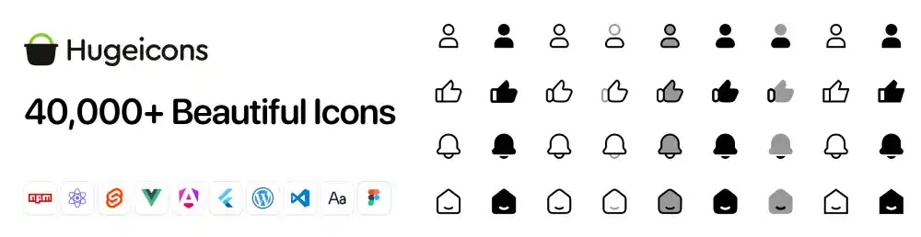](https://hugeicons.com/?via=abdulazizahwan)

* **Agent Improvements & Debugging:** RAGFlow is built for production. Features like [**step-run debugging**](https://www.google.com/search?ved=1t:260882&q=step-run+debugging+AI&bbid=548045071468246972&bpid=196677193009778858) and import/export capabilities (as noted in v0.15.0) give developers the fine-grained control needed to trace, test, and validate their agent's behavior.

* [**RAG-based Text2SQL**](https://www.google.com/search?ved=1t:260882&q=RAG+Text2SQL&bbid=548045071468246972&bpid=196677193009778858)**:** In a major leap for enterprise AI, RAGFlow implements [**Text2SQL**](https://www.google.com/search?ved=1t:260882&q=Text2SQL&bbid=548045071468246972&bpid=196677193009778858). This allows your AI to query structured SQL databases using natural language. Crucially, it achieves this *without* costly model fine-tuning, allowing it to integrate seamlessly with your existing RAG and Agent components.

* [**GraphRAG**](https://www.google.com/search?ved=1t:260882&q=GraphRAG&bbid=548045071468246972&bpid=196677193009778858)**Integration:** The future of RAG involves understanding relationships. RAGFlow has introduced support for **GraphRAG**, a technique that can reveal hidden relationships within your data, much like the "Mother of Dragons" and Jon Snow example highlighted on their blog. This is part of a broader "[RAG 2.0](https://www.google.com/search?ved=1t:260882&q=RAG+2.0&bbid=548045071468246972&bpid=196677193009778858)" vision that is more search-centric.

* **Long-Context RAG (RAPTOR):** Handling entire documents or long transcripts is a major challenge. RAGFlow implements advanced techniques like **RAPTOR (Recursive Abstractive Processing for Tree-Organized Retrieval)** to build a long-context RAG system capable of understanding and querying massive amounts of information.

RAGFlow is designed for anyone frustrated by the gap between a simple RAG proof-of-concept (POC) and a scalable, production-ready AI system.

* **Developers** who need to build complex chatbots, Q&A systems, and AI agents with multi-step reasoning.
* **Enterprises** that need to connect LLMs to their internal knowledge bases, including both unstructured documents and structured SQL databases.
* **Data Scientists & AI Researchers** who are exploring the frontiers of RAG, including GraphRAG and long-context models.

RAGFlow clearly positions itself as a serious, open-source solution for the next generation of AI. By tackling the hard problems of task orchestration, structured data queries (Text2SQL), and complex retrieval (GraphRAG), it provides the essential infrastructure to move beyond simple demos and into robust, production-grade applications.

**System Architecture and Key Features of RAGFlow**

**1. System Architecture**

RAGFlow’s architecture is designed to support its advanced features and ensure scalability and efficiency. The system is divided into several stages:​

1. **Information Extraction:** Utilizes deep document understanding models to process and extract relevant information from unstructured data.​
2. **Document Preprocessing:** Involves knowledge graph construction, document clustering, and domain-specific embedding to prepare data for indexing.​
3. **Indexing:** Employs hybrid search techniques, including full-text search and vector search, to create a comprehensive index of the processed data.
4. **Retrieval:** Implements coarse and refined ranking mechanisms, along with query rewriting based on user intent recognition, to retrieve the most relevant information.

Each stage is built around AI models that work in conjunction with the database to ensure the effectiveness of the final answers.

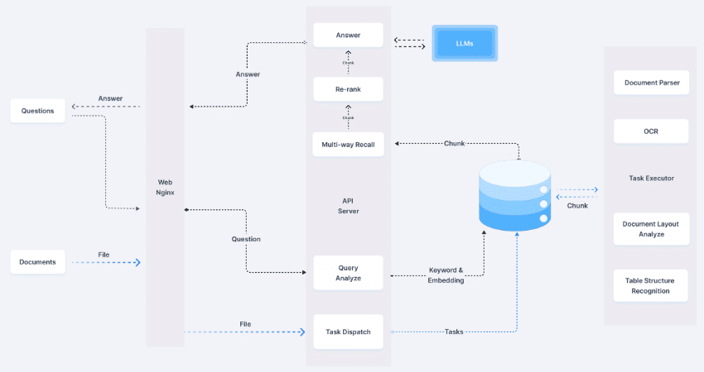

**2. Key Features**

**2.1. Deep Document Understanding**

RAGFlow employs deep document understanding to extract knowledge from unstructured data with complex formats. This approach ensures that the information ingested into the system maintains its semantic integrity, leading to more accurate and contextually relevant responses.​

**2.2. Template-Based Chunking**

The system offers intelligent and explainable template-based chunking, providing a variety of templates to handle different document structures. This flexibility enhances the system’s ability to process diverse data sources effectively.​

**2.3. Grounded Citations with Reduced Hallucinations**

To combat the issue of hallucinations in AI-generated content, RAGFlow provides visualization of text chunking, allowing for human intervention. It also offers quick access to key references and traceable citations, ensuring that generated answers are well-founded and verifiable.​

**2.4. Compatibility with Heterogeneous Data Sources**

RAGFlow supports a wide range of data formats, including Word documents, slides, Excel files, text, images, scanned copies, structured data, and web pages. This compatibility enables organizations to integrate various data sources seamlessly into the RAGFlow system.​

**2.5. Automated and Effortless RAG Workflow**

The system streamlines RAG orchestration, catering to both personal and large business needs. It offers configurable LLMs and embedding models, multiple recall paired with fused re-ranking, and intuitive APIs for seamless integration with existing business processes.​

**How to Install and Configure RAGFlow**

To set up RAGFlow, follow these steps:

**1. Install Required Dependencies**

Before you begin, ensure your system meets the following requirements:

* **Docker** (Version **24.0.0** or later)
* **Docker Compose** (Version **2.26.1** or later)

If Docker is not installed, you can download and install it from [Docker’s official website](https://www.docker.com/).

**2. Clone the RAGFlow Repository**

Open your terminal and run the following commands to clone the official RAGFlow repository:

git clone https://github.com/infiniflow/ragflow.git  
cd ragflow

**3. Start the RAGFlow Server**

Navigate to the docker directory and launch RAGFlow using Docker Compose:

cd docker  
docker compose -f docker-compose.yml up -d

This will start the required services in detached mode (-d flag). You can check if the containers are running with:

docker ps

**4. Configure the Language Model (LLM)**

Once the server is up and running:

1. Open the **RAGFlow web interface** in your browser.
2. Navigate to the **settings panel** and enter API keys for your preferred **LLM models** (e.g., OpenAI, Hugging Face, or local models).

**5. Create and Manage a Knowledge Base**

To use RAGFlow for document retrieval:

1. **Upload Documents** – Add your datasets, PDFs, or text files.
2. **Process Data** – The system will automatically **chunk** the data for efficient search and retrieval.
3. **Start Querying** – Use the RAGFlow interface or API to retrieve relevant information with context-aware responses.

**6. Verify Setup and Test Retrieval**

To ensure everything is working correctly, run a simple query using the web interface or API. If responses include properly retrieved and referenced information, your setup is complete

**Use Cases and Applications**

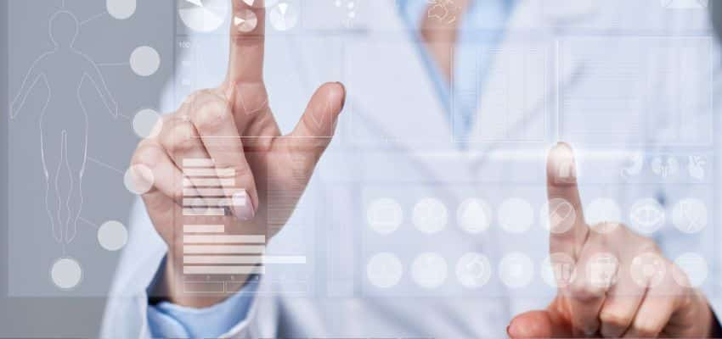

**1. Enterprise Knowledge Management**

Organizations can integrate RAGFlow into their knowledge management systems, enabling employees to quickly retrieve relevant information from vast repositories of internal and external data sources. This can significantly improve decision-making processes, reduce time spent searching for information, and enhance overall productivity.

**2. Legal and Compliance Research**

Legal professionals can utilize RAGFlow for legal document analysis, contract review, and compliance checks. By leveraging deep document understanding, the system can extract clauses, summarize lengthy contracts, and provide citation-backed responses, making legal research more efficient and accurate.

**3. Healthcare and Medical Research**

RAGFlow can assist medical professionals in retrieving the latest research papers, clinical guidelines, and patient records with precise citations. This ensures that healthcare decisions are based on the most relevant and up-to-date medical knowledge available.

**4. Financial Services**

In the financial sector, RAGFlow can support risk analysis, fraud detection, and investment research by retrieving and analyzing reports, financial statements, and regulatory documents. It enhances data-driven decision-making by providing verifiable insights.

**5. Customer Support Automation**

Businesses can [integrate RAGFlow into chatbots](https://bestarion.com/us/ai-chatbot-development-services/) and virtual assistants to provide customers with accurate, well-cited responses. This reduces dependency on human support agents while improving customer satisfaction through faster and more reliable information retrieval.

**6. Academic Research and Education**

Students and researchers can use RAGFlow to access a vast array of academic papers, books, and reports, making the research process more streamlined. By providing well-cited references, it also assists in maintaining academic integrity.

**Advantages of RAGFlow Over Traditional RAG Systems**

**Improved Accuracy and Context Awareness**

RAGFlow outperforms traditional RAG systems by incorporating deep document understanding, which ensures that retrieved documents maintain their contextual meaning. This reduces errors in retrieval and enhances response accuracy.

**Reduced Hallucinations**

By offering grounded citations and visualization of text chunking, RAGFlow significantly reduces AI hallucinations. Users can verify generated responses with traceable references, ensuring reliability.

**Flexible and Scalable Deployment**

With configurable LLMs, multiple recall mechanisms, and seamless integration through APIs, RAGFlow is highly adaptable to various business needs. Its Docker-based deployment makes scaling across different environments straightforward.

**Multimodal Data Processing**

Unlike many RAG solutions limited to text, RAGFlow supports multimodal data, including images, scanned documents, structured data, and more. This expands its usability across industries dealing with complex data types.

**Future Prospects and Enhancements**

As AI continues to evolve, RAGFlow is expected to undergo several improvements:

* **Enhanced Multilingual Capabilities:** Expanding support for more languages to serve a global user base.
* **Integration with Real-Time Data Sources:** Enabling retrieval from live data streams, news sources, and social media for more up-to-date insights.
* **Improved Query Understanding:** Leveraging AI advancements to better interpret ambiguous and complex user queries.
* **Adaptive Learning Mechanisms:** Implementing self-learning algorithms that improve accuracy based on user feedback and interactions.

**Conclusion**

RAGFlow represents a significant advancement in retrieval-augmented generation technology. By addressing the limitations of traditional RAG systems and incorporating deep document understanding, it sets a new standard for AI-driven information retrieval and generation. Whether in legal, healthcare, finance, or customer support applications, RAGFlow provides a reliable, citation-backed solution that enhances productivity and decision-making.

For those looking to integrate RAGFlow into their workflows, exploring its open-source capabilities and leveraging its modular architecture will be key steps toward harnessing its full potential.

**VectorDB**

A vector database is a specialized type of database designed to store, index and search high dimensional vector representations of data known as embeddings. Unlike traditional databases that rely on exact matches vector databases use similarity search techniques such as cosine similarity or Euclidean distance to find items that are semantically or visually similar.

Vector Database

**What are Embeddings?**

* [Embeddings](https://www.geeksforgeeks.org/nlp/what-are-vector-embeddings/) are dense numerical representations of data such as words, sentences, images or audio mapped into a continuous high dimensional space where similar items are positioned closer together.
* Machine learning models that capture semantic meaning, context and relationships within the data generates them.
* Instead of comparing raw text or media directly embeddings allow systems to measure similarity through mathematical distance metrics like cosine similarity or Euclidean distance for faster search and extraction.
* This makes them important for tasks such as semantic search, recommendation systems, clustering, classification and cross lingual matching.

Embeddings

**How do they Work?**

* Embeddings work by converting raw data like text, images or audio into dense numerical vectors that preserve meaning and relationships.
* First the input is processed through a model such as a transformer for text or a CNN for images to extract key features.
* These features are then encoded into fixed length vectors in a high dimensional space where similar items are positioned close together and dissimilar ones are farther apart.
* This spatial arrangement allows similarity to be measured mathematically enabling applications like search, recommendations and classification to operate based on meaning rather than exact matches.

**Popular Vector Databases**

* **Pinecone:**Fully managed, cloud native vector database with high scalability and low latency search.
* **Weaviate:** Open source, supports hybrid (keyword + vector) search and offers built in machine learning modules.
* **Milvus:** Highly scalable, open source database optimized for large scale similarity search.
* **Qdrant:** Open source, focuses on high recall, performance and ease of integration with AI applications.
* **Chromadb:**Lightweight, developer friendly vector database often used in LLM powered applications.

**Implementation**

This code uses FAISS to store 3 sample vectors and perform a similarity search using L2 distance. The query_vector is compared to all stored vectors and the indices and distances of the top 2 most similar vectors are returned.

**import** **faiss**

**import** **numpy** **as** **np**

data_vectors = np.array([

[0.1, 0.2, 0.3, 0.4],

[0.2, 0.1, 0.4, 0.3],

[0.9, 0.8, 0.7, 0.6],

], dtype='float32')

dimension = data_vectors.shape[1]

index = faiss.IndexFlatL2(dimension)

index.add(data_vectors)

query_vector = np.array([[0.1, 0.2, 0.3, 0.35]], dtype='float32')

distances, indices = index.search(query_vector, k=2)

print("Indices of closest vectors:", indices)

print("Distances from query:", distances)

**Output:**

*Indices of closest vectors: [[0 1]]*

*Distances from query: [[0.0025 0.0325]]*

**Applications**

* **Image and Video Search:** Finds visually similar media from a database. Feature embeddings are extracted from media files and stored in the vector database. When a new image or frame is queried, the system quickly retrieves the most visually similar results.
* **Question Answering Systems:** Retrieves the most relevant information from large knowledge bases. The system embeds both queries and stored text then compares their vectors to find the closest match. This improves accuracy compared to simple keyword matching.
* **Cross Lingual Information Retrieval:**Supports matching across multiple languages using multilingual embeddings. Text in different languages is converted into a shared embedding space. This allows searching in one language and retrieving relevant results in another.
* **Fraud and Anomaly Detection:**Identifies unusual patterns by comparing embeddings with normal data. The database can store embeddings of typical behavior and detect deviations. This helps in early identification of fraudulent or suspicious activities.