**SAAS VS PAAS VS IAAS**

Cloud computing offers three primary service models: **SaaS (Software as a Service)**, **PaaS (Platform as a Service)**, and **IaaS (Infrastructure as a Service)**. Each model caters to different business needs and technical expertise levels, providing varying degrees of control and responsibility.

MAJOR DIFFERENCES BETWEEN SaaS vs PaaS vs IaaS

|  |  |  |  |
| --- | --- | --- | --- |
| **Aspect** | **SaaS (Software as a Service)** | **PaaS (Platform as a Service)** | **IaaS (Infrastructure as a Service)** |
| DEFINITION | It delivers software applications over the internet | It provides a platform for developers to build applications | This offers virtualized computing resources over the internet |
| TARGET USERS | End-users and businesses | Developers and IT teams | System administrators and IT infrastructure teams |
| MANAGEMENT LEVEL | Fully managed by provider | Managed platform; user manages apps | User manages OS, apps, and data |
| CONTROL & FLEXIBILITY | Least control; only app settings | Moderate control over app environment | Full control over infrastructure |
| EXAMPLESS | Google Workspace, Salesforce, Dropbox | Microsoft Azure App Services, Heroku, Google App Engine | AWS EC2, Microsoft Azure VMs, Google Compute Engine |
| SETUP TIME | Instant access; no setup required | Requires app deployment and configuration | Requires setup of servers, storage, and networking |
| SCALABILITY | Limited to app capabilities | Scalable for app development | Highly scalable infrastructure |
| COST MODEL | Subscription-based | Pay-as-you-go for platform usage | Pay-as-you-go for resources used |
| MAINTENANCE | Handled entirely by provider | Provider handles platform; user maintains apps | User responsible for maintenance and updates |
| USE CASE | Email, CRM, collaboration tools | Custom app development and deployment | Hosting websites, data storage, backup, disaster recovery |

**When to Use IaaS, PaaS, or SaaS?**

| **Use Case** | **Best Choice** |
| --- | --- |
| Full control over infrastructure and software stack | IaaS |
| Need a managed development environment | PaaS |
| Want a ready-to-use software application | SaaS |
| Hosting a website with full customization | IaaS |
| Developing a web app without managing infrastructure | PaaS |
| Running a business with CRM, collaboration, and email | SaaS |

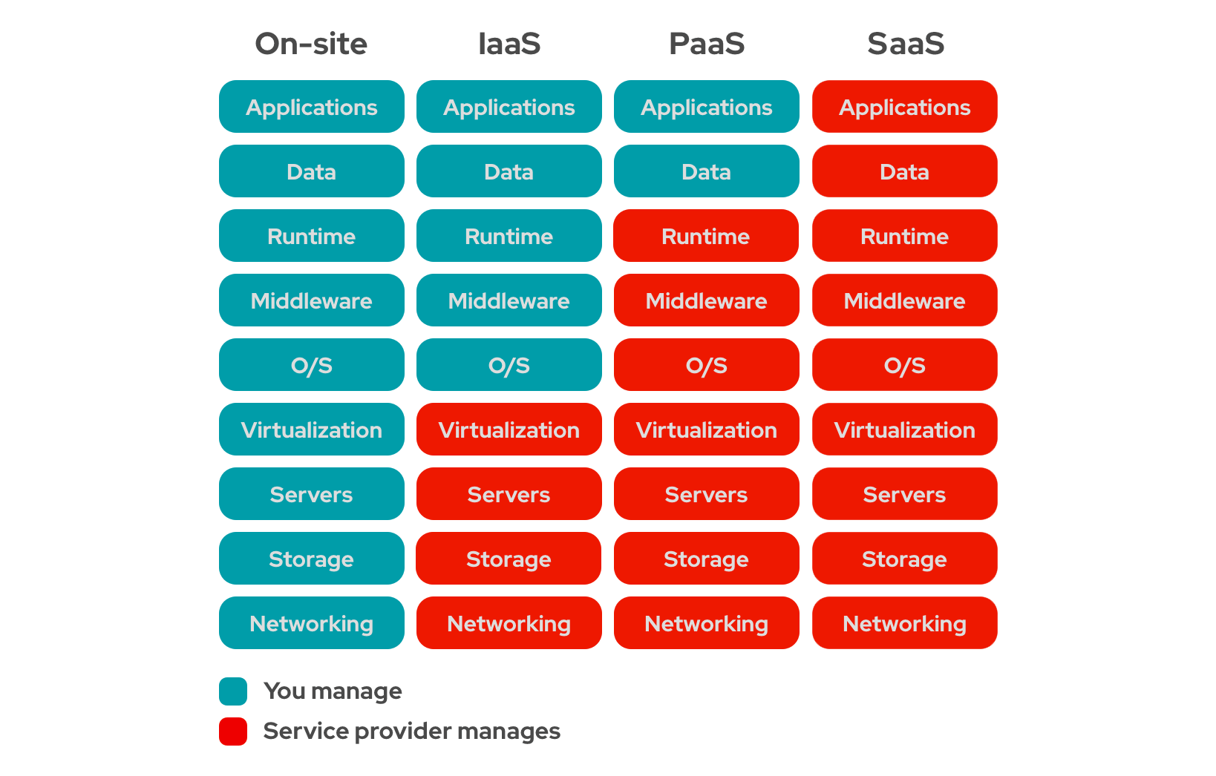

**Conclusion**

Understanding IaaS, PaaS, and SaaS helps businesses and developers choose the right cloud model based on their needs.

* **IaaS** provides full infrastructure control but requires management.
* **PaaS** simplifies development with built-in services.
* **SaaS** delivers ready-to-use applications with minimal effort.

Choosing the right model depends on factors like cost, control, scalability, and management overhead. Whether you're building scalable applications, automating workflows, or collaborating on projects, cloud computing offers a solution for every need.