**CREWAI**

CrewAI is an open-source framework that enables multiple AI agents to work together to complete complex tasks. Each agent has a specific role and they collaborate to achieve the task efficiently.

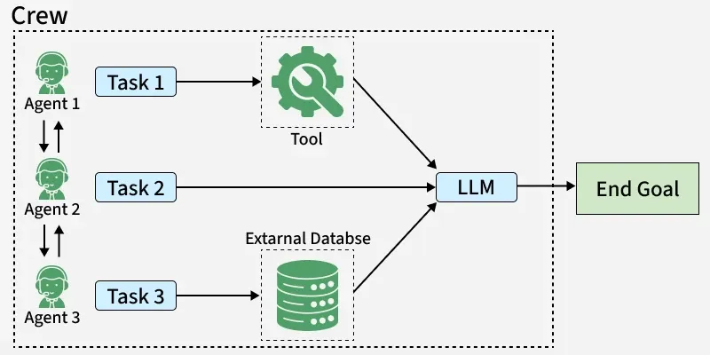

Imagine a group of people organizing a party: one person handles the planning, another handles food and drinks, while someone else manages decorations. CrewAI does the same but with [AI agents](https://www.geeksforgeeks.org/artificial-intelligence/agents-artificial-intelligence/). It can be used in event planning, content creation, software development and customer support to make tasks more efficient.

CrewAI uses features like memory retention and context awareness which ensures tasks are executed smoothly and decisions are made with the right context. It can be used in areas like event planning, content generation, research and software development.

**Setting Up Environment**

To begin using CrewAI, we need to set up our environment and install the necessary package. Here's how we can do it:

1. Installing the CrewAI Package

We will install the crewai package using pip to make all the necessary functionality available:

*!pip install crewai*

2. Setting the API Key

We will set our API key for external services like OpenAI:

import os

os.environ["OPENAI_API_KEY"] = "your-api-key-here"

Implementation of CrewAI

In this section, we will see how to use CrewAI by setting up a team of agents to work together on a party planning task.

1. Importing Necessary Libraries

Before we start working with CrewAI, we need to import the required libraries. These libraries provide the essential functions to define agents, tasks and crews.

* Agent: Defines the individual agents that perform tasks.
* Task: Describes the tasks assigned to agents.
* Crew: Groups agents and tasks together for execution.

from crewai import Agent, Task, Crew

2. Defining Agents

Agents in CrewAI are the entities that perform specific tasks. They are defined by three key aspects:

* Role: What the agent does (e.g., planning, food coordination).
* Goal: The outcome the agent works toward (e.g., creating a party plan, managing food).
* Backstory: Context or skills that describe the agent's abilities.
* allow_delegation: Determines whether the agent can assign tasks to other agents. If set to False, the agent must handle tasks themselves.
* verbose: When True, the agent provides detailed explanations about its actions and reasoning which helps in understanding what it’s doing step by step.

**3. Assigning Tasks**

Each agent is given specific tasks to complete. Tasks range from planning the party to organizing food and drinks. Tasks are linked to agents and each agent performs their task according to their goal.

We will assign each agent a task, like creating the party plan or setting up the decorations.

**4. Creating and Managing a Crew**

A Crew is a group of agents working together on the same goal. We will create a Crew by grouping our agents and tasks together. This allows them to collaborate on the overall party planning process. We will combine the agents and tasks to create the party planning Crew.

**5. Executing the Workflow**

Once the Crew is set up, we start the task execution. The agents begin working on their respective tasks. We will **kick off** the party planning process and the agents will carry out their roles. We will run the Crew to start the planning tasks.

When we run the crew, the output can be quite large because verbose mode shows the step-by-step working of each agent. For clarity, we are only showing a small sample snippet of the result

**Applications of CrewAI**

CrewAI can be applied in several areas where tasks require collaboration between specialized agents:

* **Event Planning:** AI agents plan the event, handle food and drinks, decorate the venue and manage guest entertainment.
* **Content Creation:** AI agents gather information, write articles and review content.
* **Software Development:** AI agents write and review code, ensuring it meets requirements.
* **Market Research:** AI agents gather data on trends, competitors and insights, creating reports based on findings.

**How It All Works Together**

1. The **Crew** organizes the overall operation
2. **AI Agents** work on their specialized tasks
3. The **Process** ensures smooth collaboration
4. **Tasks** get completed to achieve the goal

**When to Use Crews vs. Flows**

| **Use Case** | **Recommended Approach** | **Why?** |
| --- | --- | --- |
| **Open-ended research** | [**Crews**](https://docs.crewai.com/en/guides/crews/first-crew) | When tasks require creative thinking, exploration, and adaptation |
| **Content generation** | [**Crews**](https://docs.crewai.com/en/guides/crews/first-crew) | For collaborative creation of articles, reports, or marketing materials |
| **Decision workflows** | [**Flows**](https://docs.crewai.com/en/guides/flows/first-flow) | When you need predictable, auditable decision paths with precise control |
| **API orchestration** | [**Flows**](https://docs.crewai.com/en/guides/flows/first-flow) | For reliable integration with multiple external services in a specific sequence |
| **Hybrid applications** | Combined approach | Use [**Flows**](https://docs.crewai.com/en/guides/flows/first-flow) to orchestrate overall process with [**Crews**](https://docs.crewai.com/en/guides/crews/first-crew) handling complex subtasks |

**[​](https://docs.crewai.com/en/introduction" \l "decision-framework)**

**Decision Framework**

* **Choose**[**Crews**](https://docs.crewai.com/en/guides/crews/first-crew)**when:** You need autonomous problem-solving, creative collaboration, or exploratory tasks
* **Choose**[**Flows**](https://docs.crewai.com/en/guides/flows/first-flow)**when:** You require deterministic outcomes, auditability, or precise control over execution
* **Combine both when:** Your application needs both structured processes and pockets of autonomous intelligence

**[​](https://docs.crewai.com/en/introduction" \l "why-choose-crewai%3F)**

**Why Choose CrewAI?**

* **Autonomous Operation**: Agents make intelligent decisions based on their roles and available tools
* **Natural Interaction**: Agents communicate and collaborate like human team members
* **Extensible Design**: Easy to add new tools, roles, and capabilities
* **Production Ready**: Built for reliability and scalability in real-world applications
* **Security-Focused**: Designed with enterprise security requirements in mind
* **Cost-Efficient**: Optimized to minimize token usage and API calls