**DBMS LAB ASSIGNMENT-5**

**B NEELAKANTESWAR**

**19bcs020 T12**

1.Illustrate logical ANY, ALL and LIKE operator- the queries should be relevant to your respective databases 3 queries for each operator. One query explaining the difference between ANY and ALL.

ANY:

Queries:

1)

*SELECT S.student_id,s.first_name*

*FROM T12_studentinfo s*

*WHERE S.student_id > ANY ( SELECT S2.student_id FROM T12_studentinfo S2 WHERE S2.DOB='2001-10-08')*

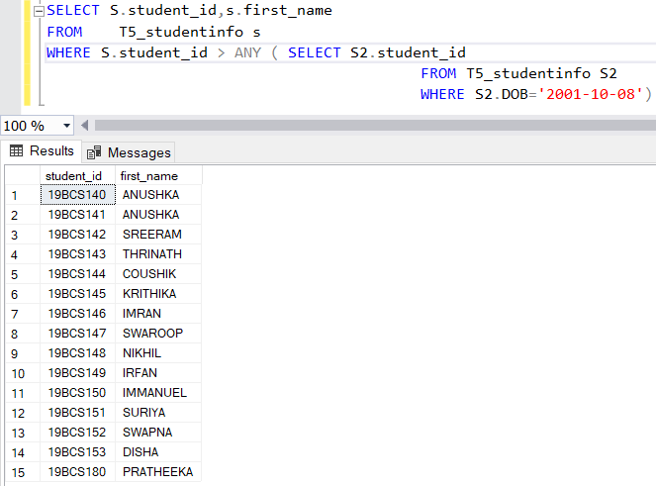

2)

*SELECT teacher_id,teacher_ph_no,salary FROM T12_staff WHERE salary >= ANY (SELECT AVG(salary) FROM T12_staff);*

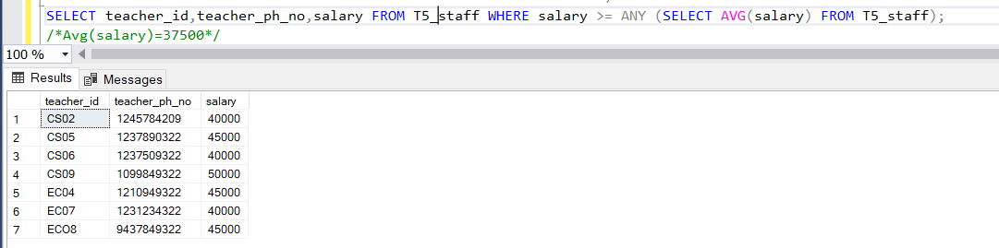

3)

*select student_id,parent_mobile_no from T12_parentinfo where student_id =*

*ANY (select student_id from T12_grades where course_id <>*

*ANY (select course_id from T12_course_staff where grade='C'));*

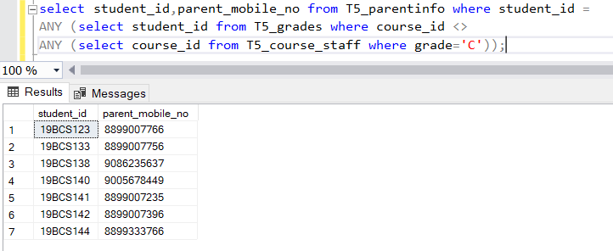

ALL:

Queries:

1)

*select course_id,student_id from T12_courses where course_id = ALL (select course_id from T12_course_staff where grade='B');*

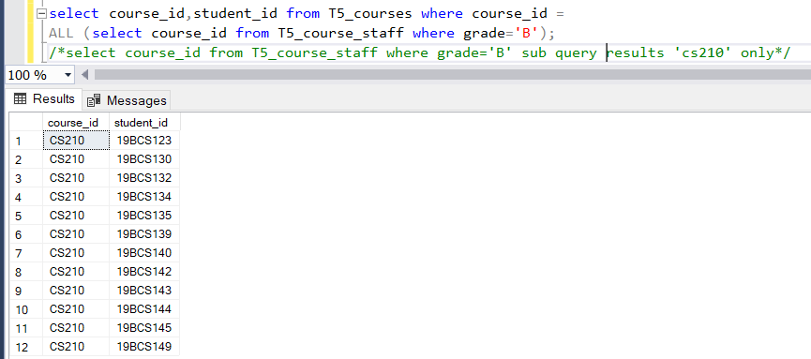

2)

*SELECT * FROM T12_staff*

*WHERE salary <= ALL (SELECT salary FROM T12_staff*

*WHERE teacher_id = ANY ( select teacher_id from T12_staff))*

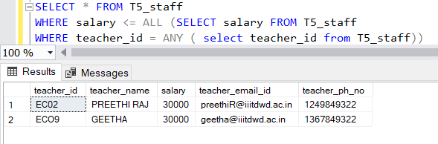

3)

*select distinct student_id from T12_courses*

*where course_id<>All(select course_id from T12_course_staff where marks<'60')*

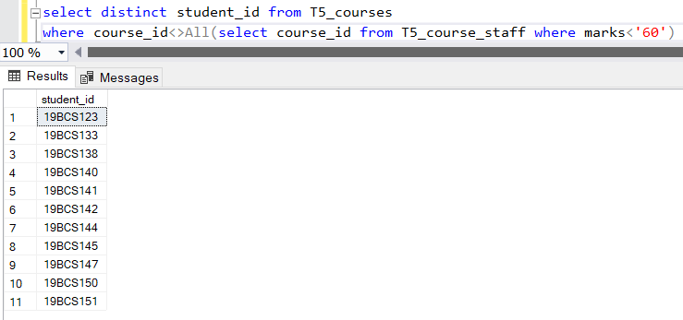

LIKE:

Queries:

1)

*select * from T12_studentinfo where DOB like '%03___';*

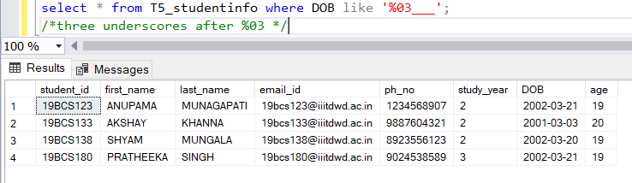

2)

*select * from T12_parentinfo where [address] like 't[ea]%' ;*

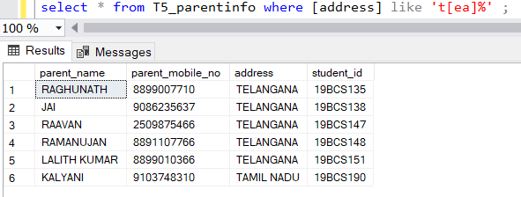

3)

*select * from T12_staff where teacher_ph_no like '9[^6-9][0-8]%' ;*

*/* results the tuples where phn numbers starting with 9, not followed by 6-9 digits and followed by 0-8 digits,and last 7 digits can be any one in 0-9*/*

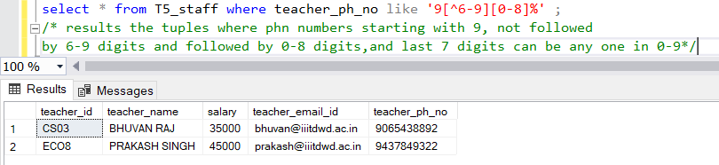

Difference between ‘ALL’ and ‘ANY’:

Query:

*select distinct course_id from T12_course_staff where grade='B-'/*sub query*/*

*select distinct course_id,student_id from T12_courses*

*where course_id <> ALL (select distinct course_id from T12_course_staff where grade='B-');*

*select course_id,student_id from T12_courses*

*where course_id <> ANY (select distinct course_id from T12_course_staff where grade='B-');*

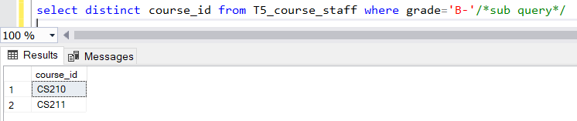

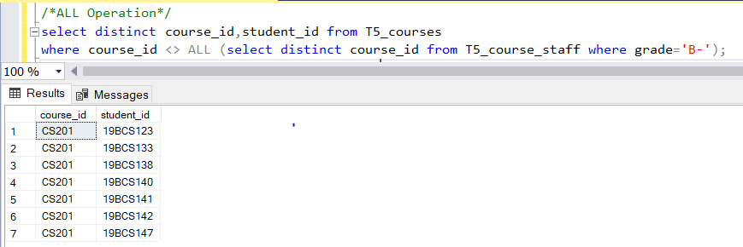

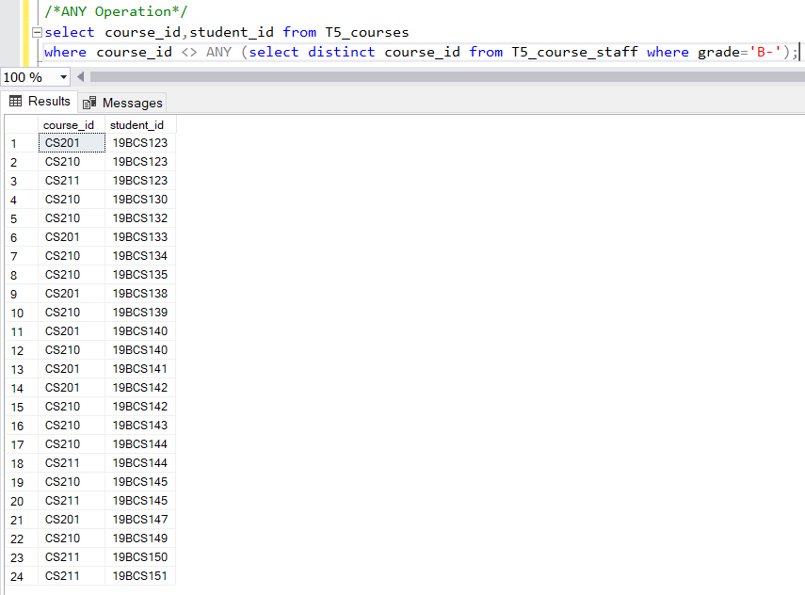

2) One query for each Aggregate function.

Queries:

*select count(student_id) as Total_students,age from T12_studentinfo group by age;*

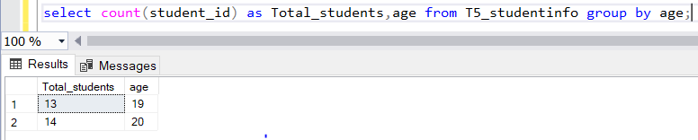

*select avg(marks) as avg_marks,student_id from T12_grades group by student_id;*

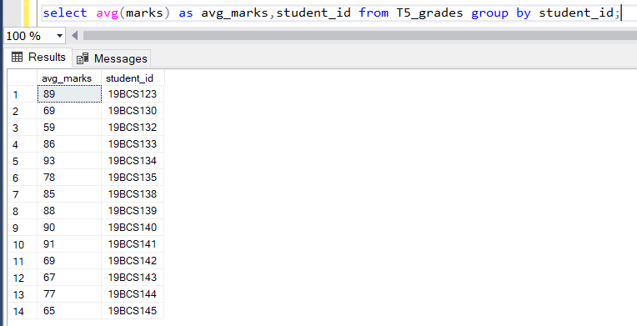

*select var(salary) as Income_variance from T12_staff;*

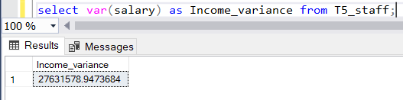

*select varp(salary) as Income_variance_forPopulation from T12_staff;*

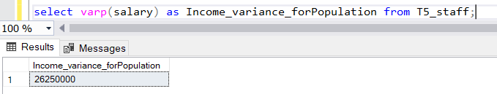

*select stdev(age) as age_deviation from T12_studentinfo;*

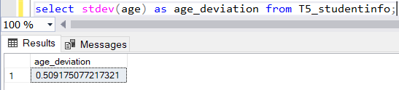

*select stdevp(age) as age_deviation_for_population from T12_studentinfo;*

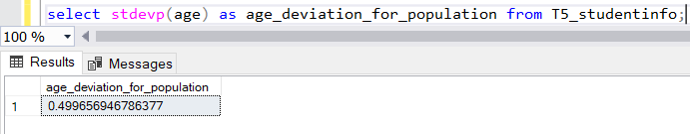

*select sum(fee_paid) as total_fee_received from T12_parentinfo;*

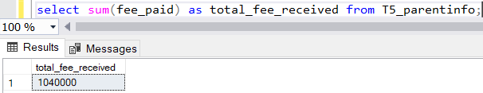

*select min(marks) as minimum_marks,course_id from T12_grades group by course_id;*

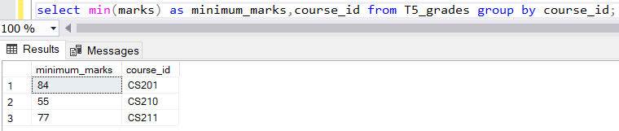

*select max(s.salary) as max_staff_salary,c.course_id from T12_staff s,T12_course_staff c where c.teacher_id=s.teacher_id group by c.course_id;*

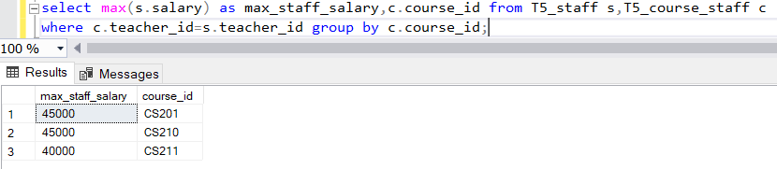

*select count_big(teacher_id) as bigint_no_staff from T12_staff;*

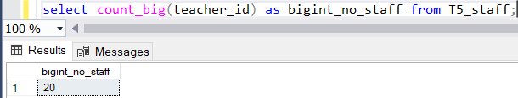

3)

ORDER BY:

Queries:

1)

*select * from T12_studentinfo order by student_id desc;*

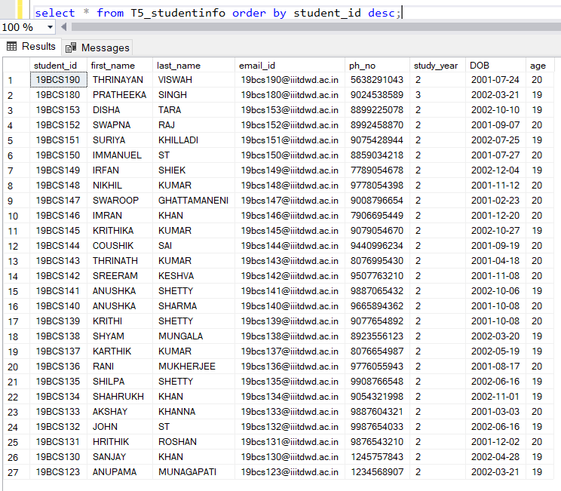

2)

*select * from T12_parentinfo order by parent_name asc,parent_mobile_no desc;*

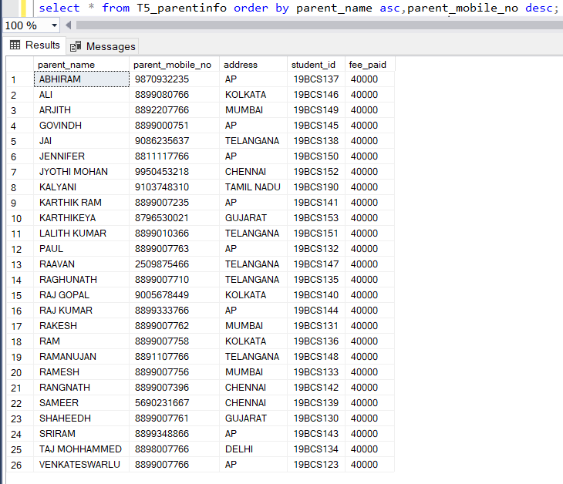

GROUP BY:

Queries:

1)

*select max(marks) as maximum_marks,course_id from T12_course_staff group by course_id;*

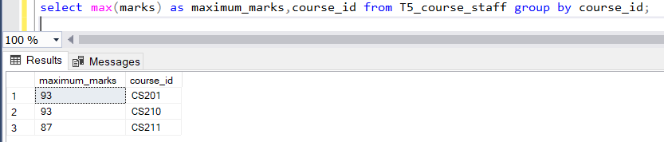

2)

*SELECT distinct COUNT(teacher_id) as No_of_teachers, course_id FROM T12_course_staff GROUP BY course_id ORDER BY COUNT(teacher_id) DESC;*

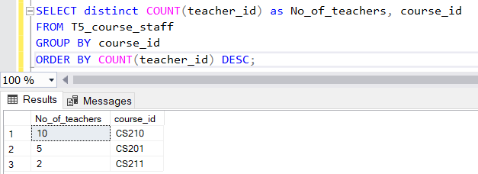

HAVING CLAUSE:

Queries:

1)

*select min(marks) as min_marks,course_id from T12_grades group by course_id having min(marks)>60;*

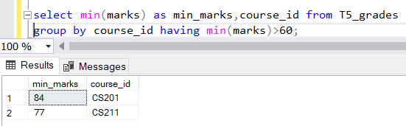

2)

*select max(s.salary) as max_staff_salary,c.course_id from T12_staff s,T12_course_staff c*

*where c.teacher_id=s.teacher_id group by c.course_id*

*having max(s.salary)>=40000 order by max(s.salary);*

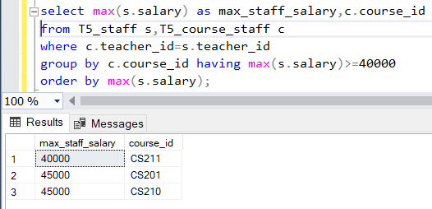

4) Use Aggregate function with group by and having.

*select avg(g.marks) as max_marks,g.course_id from T12_grades g,T12_courses c where c.course_id=g.course_id group by g.course_id having avg(marks)>80*

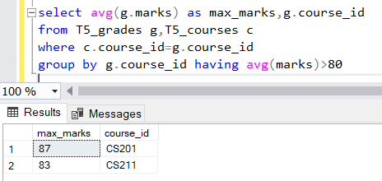

5) Write at least 3 nested queries using order by, group by and having clause.

Queries:

1)

*select avg(avg_salary) from (select avg(s.salary) as avg_salary,c.teacher_id from T12_staff s,T12_course_staff c where c.teacher_id=s.teacher_id group by c.teacher_id having avg(s.salary)>=35000) as institute_avg_package*

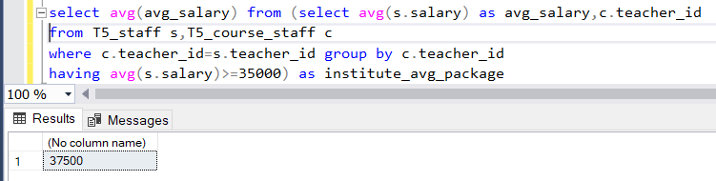

2)

*select salary,teacher_id from T12_staff*

*where teacher_id =Any ( select teacher_id from T12_course_staff*

*where course_id =any (select course_id from T12_grades*

*where grade like '[AB]%')) group by teacher_id,salary order by salary desc*

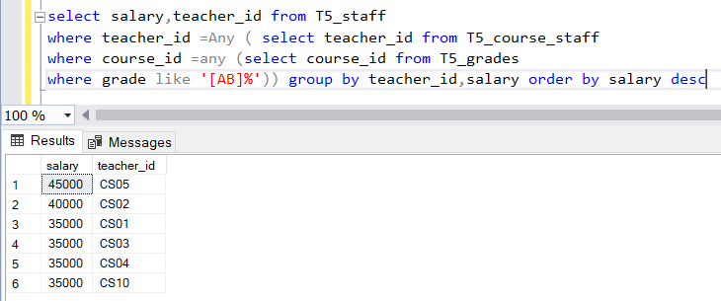

3)

*select min(s.salary) as min_staff_salary,s.teacher_id from T12_staff s,T12_course_staff c*

*where c.teacher_id=s.teacher_id group by s.teacher_id*

*having min(s.salary)<=(select avg(s1.salary) from T12_staff s1);*

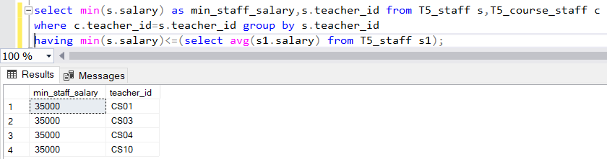

6) Illustrate the Usage of Except, Exists, Not Exists, Union, Intersection.

EXCEPT:

*SELECT * FROM T12_studentinfo where Age='19'*

*EXCEPT*

*SELECT * FROM T12_studentinfo where ph_no like '9%'*

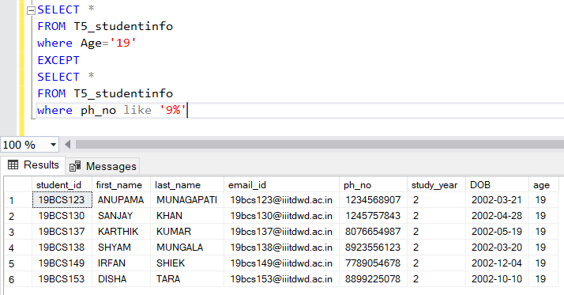

EXISTS:

*select * from T12_parentinfo p where exists (select * from T12_courses c where c.student_id=p.student_id)*

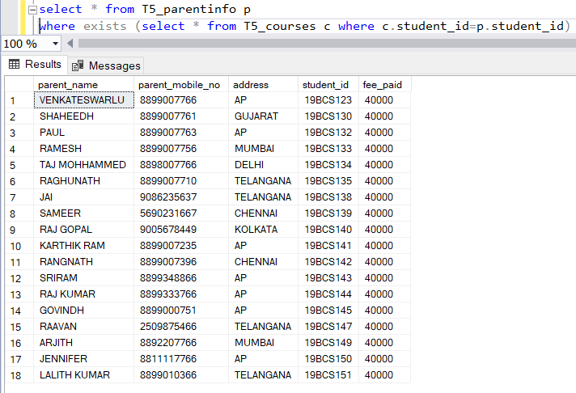

NOT EXISTS:

*select distinct s1.student_id,s1.first_name+' '+s1.last_name as full_name from T12_studentinfo as s1*

*where not exists( select * from T12_grades as g where g.student_id=s1.student_id)*

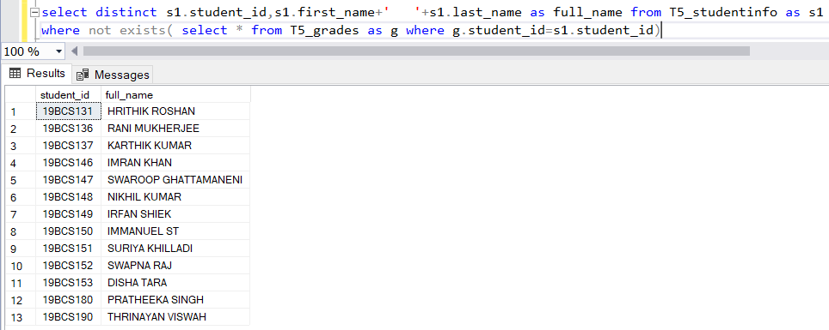

UNION:

*use school*

*(select course_id,student_id from T12_courses*

*where course_id like 'cs21[10]'*

*union*

*select course_id,student_id from T12_course_staff*

*where course_id like 'cs2[10]1') order by student_id*

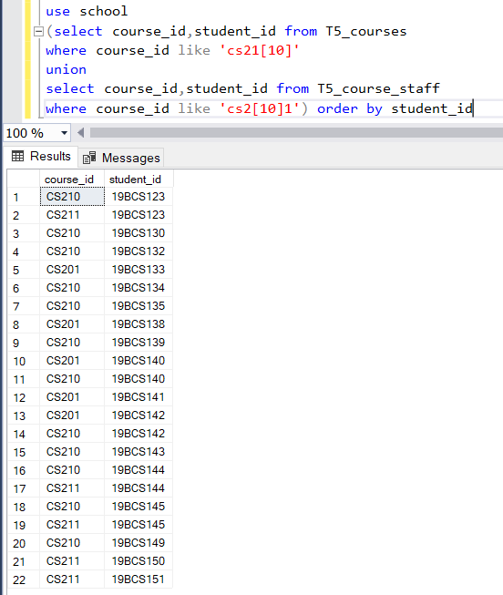

INTERSECT:

*use school*

*(select distinct teacher_id from T12_course_staff*

*intersect*

*select teacher_id from T12_staff) order by teacher_id desc*

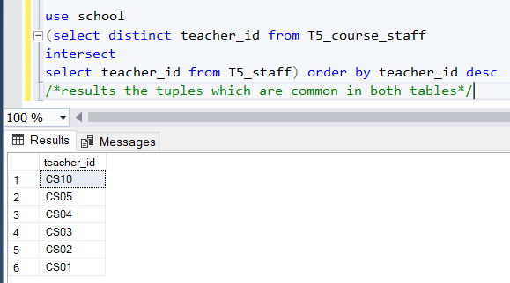

7) INNER JOIN, LEFT OUTER JOIN, RIGHT OUTER JOIN- 3 queries for each instance

Queries:

INNER JOIN:

1)

*select s.*,c.course_id*

*from T12_studentinfo s*

*inner join T12_courses c on s.student_id=c.student_id order by student_id desc;*

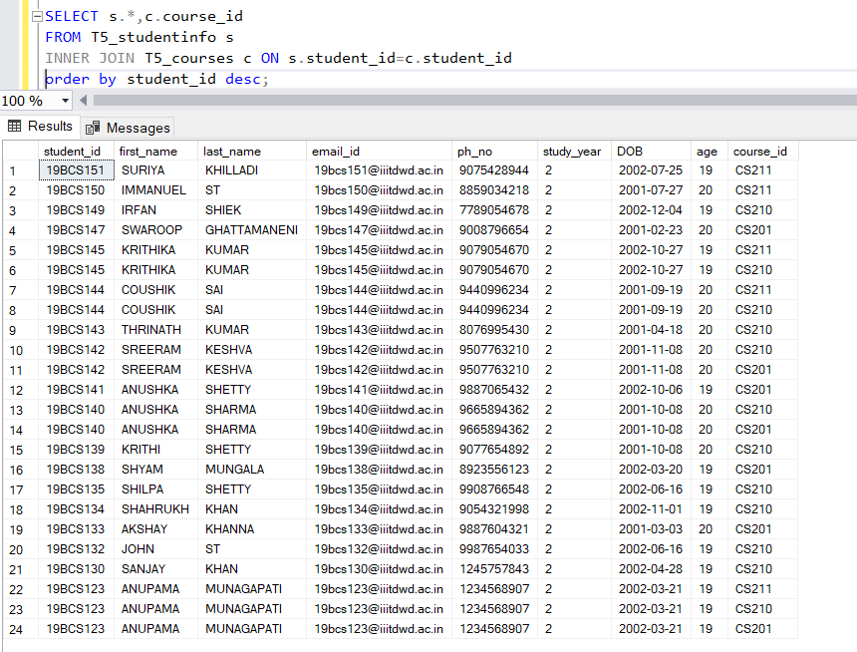

2)

*select p.parent_name,p.parent_mobile_no,s.first_name+' '+s.last_name as student_full_name,g.course_id,g.grade,g.marks*

*from ((T12_parentinfo p*

*inner join T12_studentinfo s ON p.student_id=s.student_id)*

*inner join T12_grades g ON p.student_id=g.student_id) order by g.marks desc;*

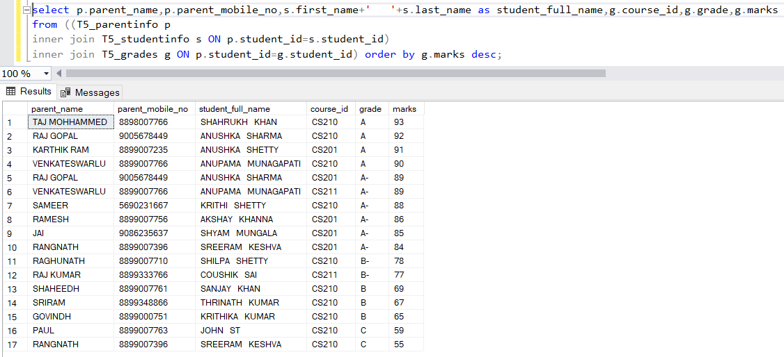

3)

*select p.student_id,p.parent_mobile_no,c.course_id,g.marks,c1.course_name*

*from (((T12_parentinfo p*

*inner join T12_course_staff c on p.student_id=c.student_id)*

*inner join T12_grades g on p.student_id=g.student_id)*

*inner join T12_courses c1 on p.student_id=c1.student_id)order by c1.course_name;*

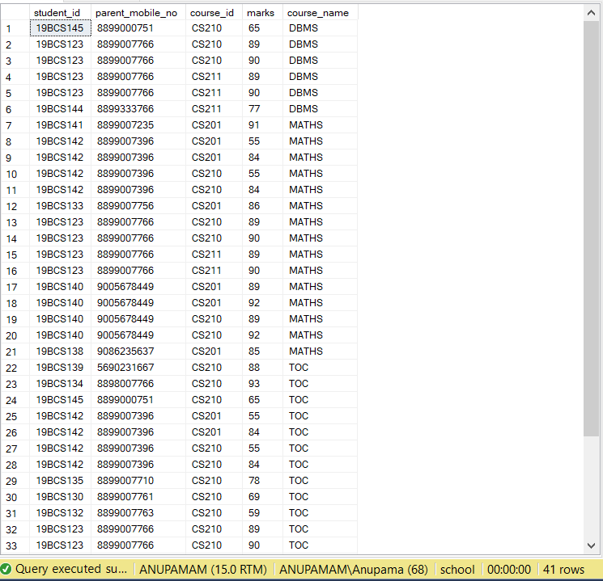

LEFT OUTER JOIN:

1)

*select s.student_id,s.first_name+' '+s.last_name as student_fullname,s.ph_no,c.course_id*

*from T12_studentinfo s*

*left outer join T12_courses c on s.student_id=c.student_id*

*order by student_id desc;*

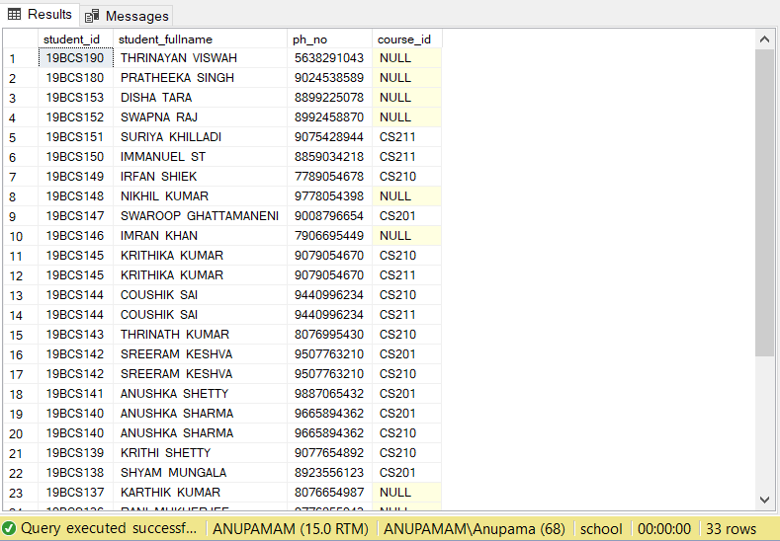

2)

*select p.student_id,p.parent_mobile_no,g.course_id,g.grade,g.marks*

*from ((T12_parentinfo p*

*left outer join T12_studentinfo s ON p.student_id=s.student_id)*

*left outer join T12_grades g ON p.student_id=g.student_id) order by s.student_id;*

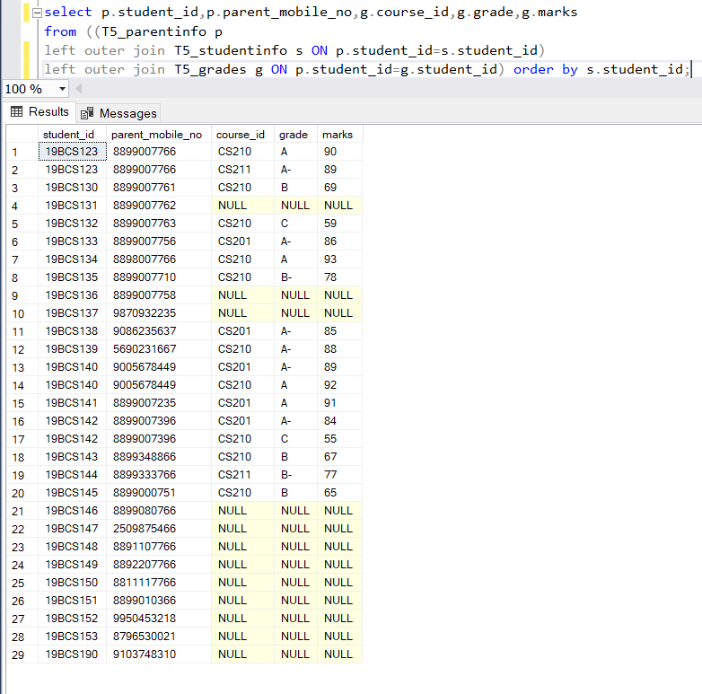

3)

*select p.student_id,p.parent_mobile_no,c.course_id,g.marks,c1.course_name*

*from (((T12_parentinfo p left outer join T12_course_staff c on p.student_id=c.student_id)*

*left outer join T12_grades g on p.student_id=g.student_id)*

*left outer join T12_courses c1 on p.student_id=c1.student_id)*

*order by c1.course_name;*

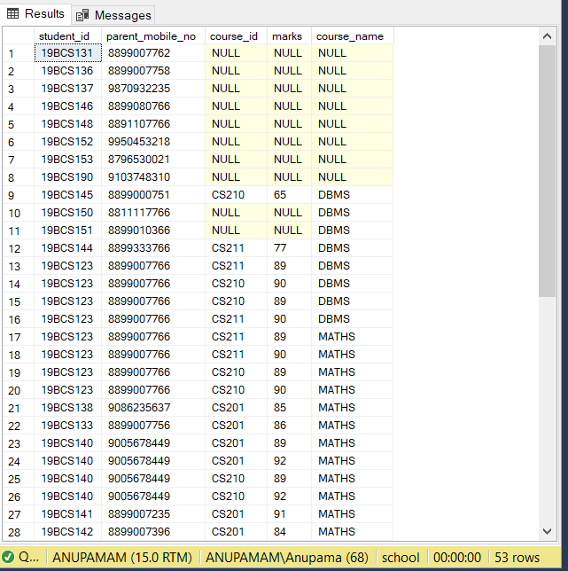

RIGHT OUTER JOIN:

1)

*use school*

*select c.course_id,s.student_id,s.first_name+' '+s.last_name as student_fullname,s.ph_no*

*from T12_studentinfo s*

*right outer join T12_courses c on s.student_id=c.student_id*

*order by course_id desc;*

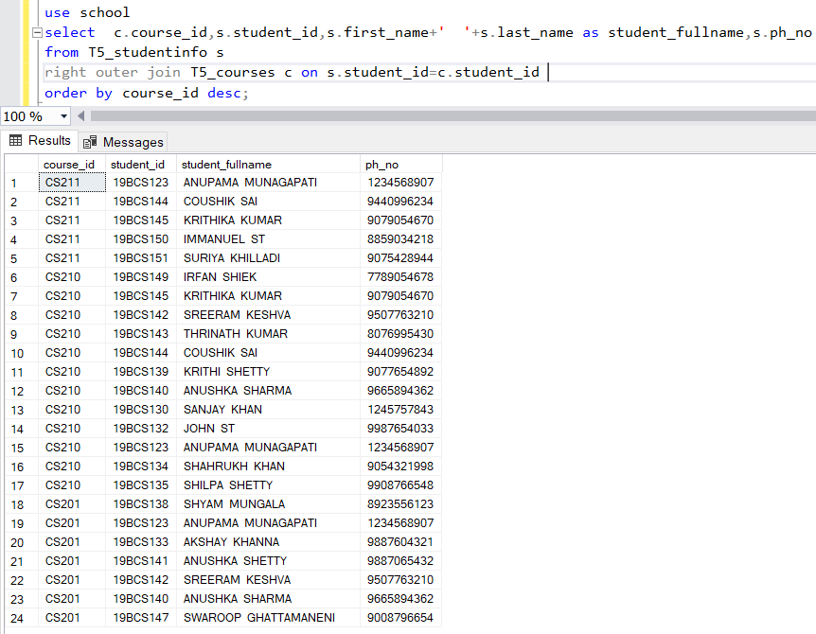

2)

*select g.grade,p.student_id,g.course_id,g.marks,p.parent_mobile_no*

*from ((T12_parentinfo p*

*right outer join T12_studentinfo s on p.student_id=s.student_id)*

*right outer join T12_grades g on p.student_id=g.student_id) order by g.grade;*

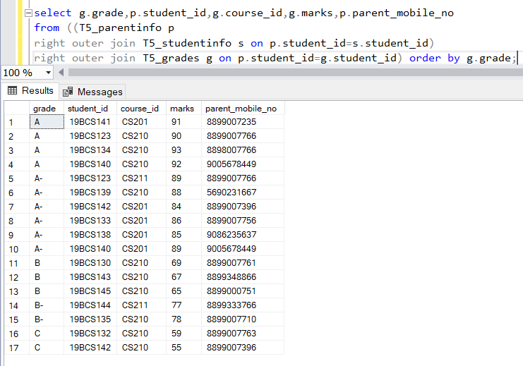

3)

*select distinct p.student_id,p.parent_mobile_no,c1.course_name*

*from (((T12_course_staff c*

*right outer join T12_courses c1 on c.student_id=c1.student_id)*

*right outer join T12_grades g on c.student_id=g.student_id)*

*right outer join T12_parentinfo p on c.student_id=p.student_id)*

*order by p.student_id;*

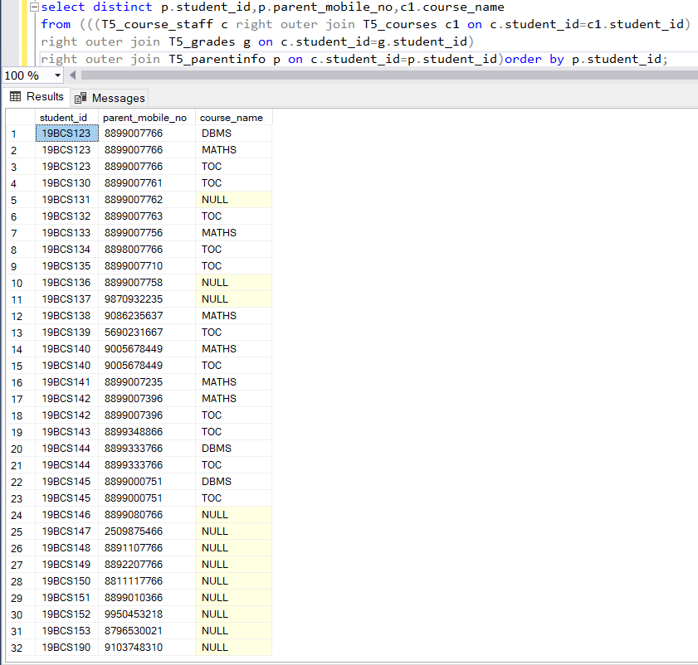

8) Use all the above condition in JOIN as well.

Query:

*select s.student_id,min(s.first_name+' '+s.last_name) as student_fullname,c.course_id*

*from T12_studentinfo s*

*inner join T12_courses c on s.student_id=c.student_id*

*group by c.course_id,s.student_id having s.student_id < '19bcs180'*

*order by student_id desc;*

