The required functionality of the MongoDB database designed for Grazioso Salvare is to be able to create, read, update, and delete data about rescue dogs. The software presents the data in the form of a dashboard that allows a user to filter and find the dogs using a geolocation chart.
The following screenshots verify the functionality of the dashboard using the following filters.

Water Rescue Filter
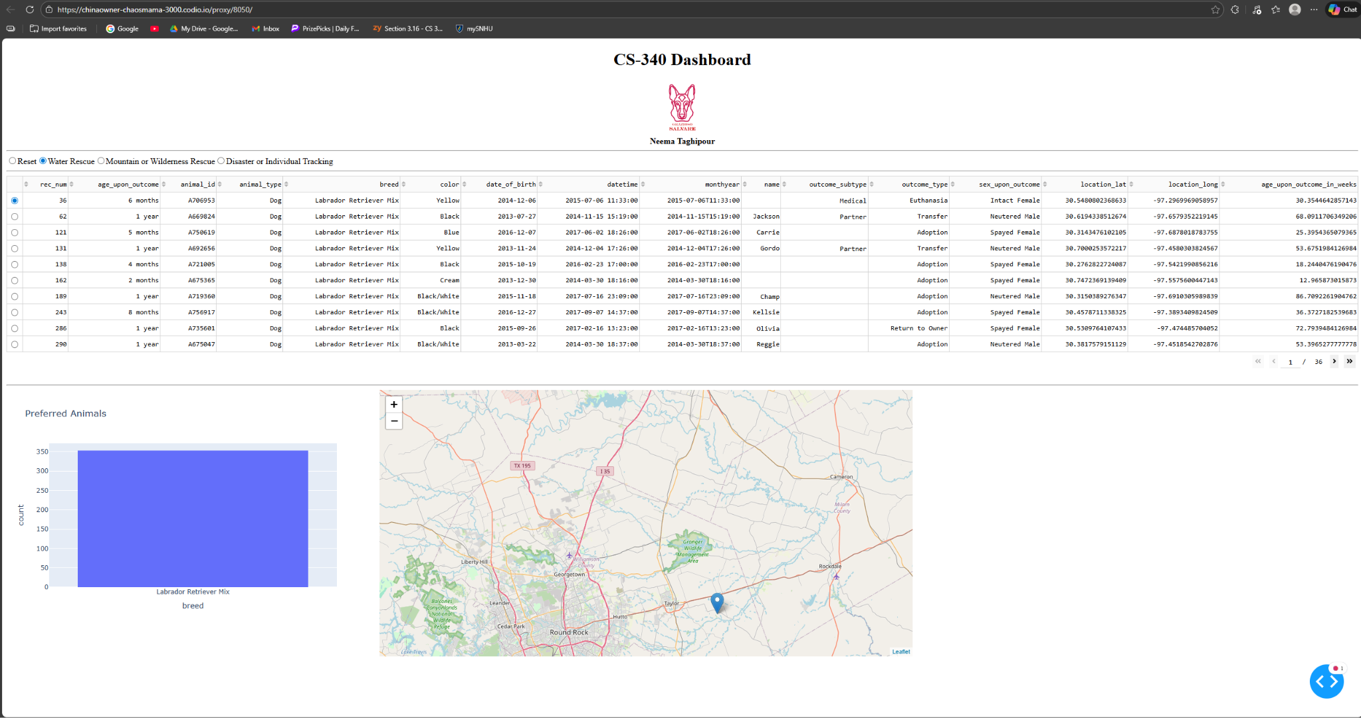
Mountain or Wilderness Rescue
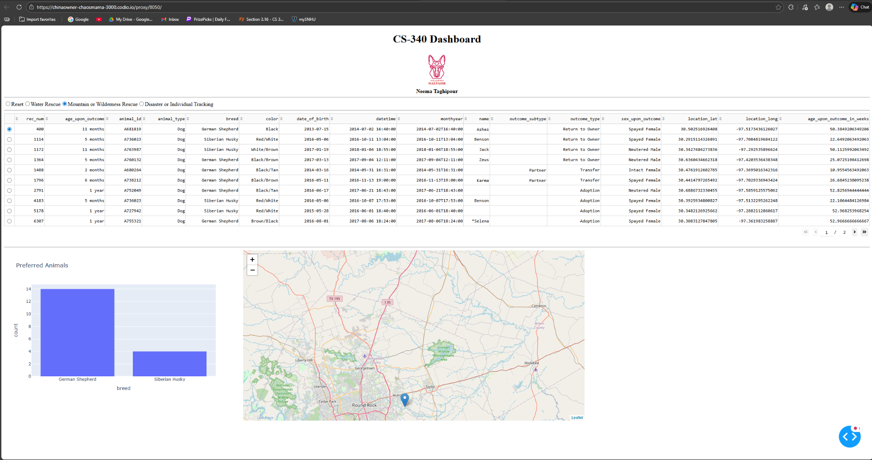

Disaster or Individual Tracking
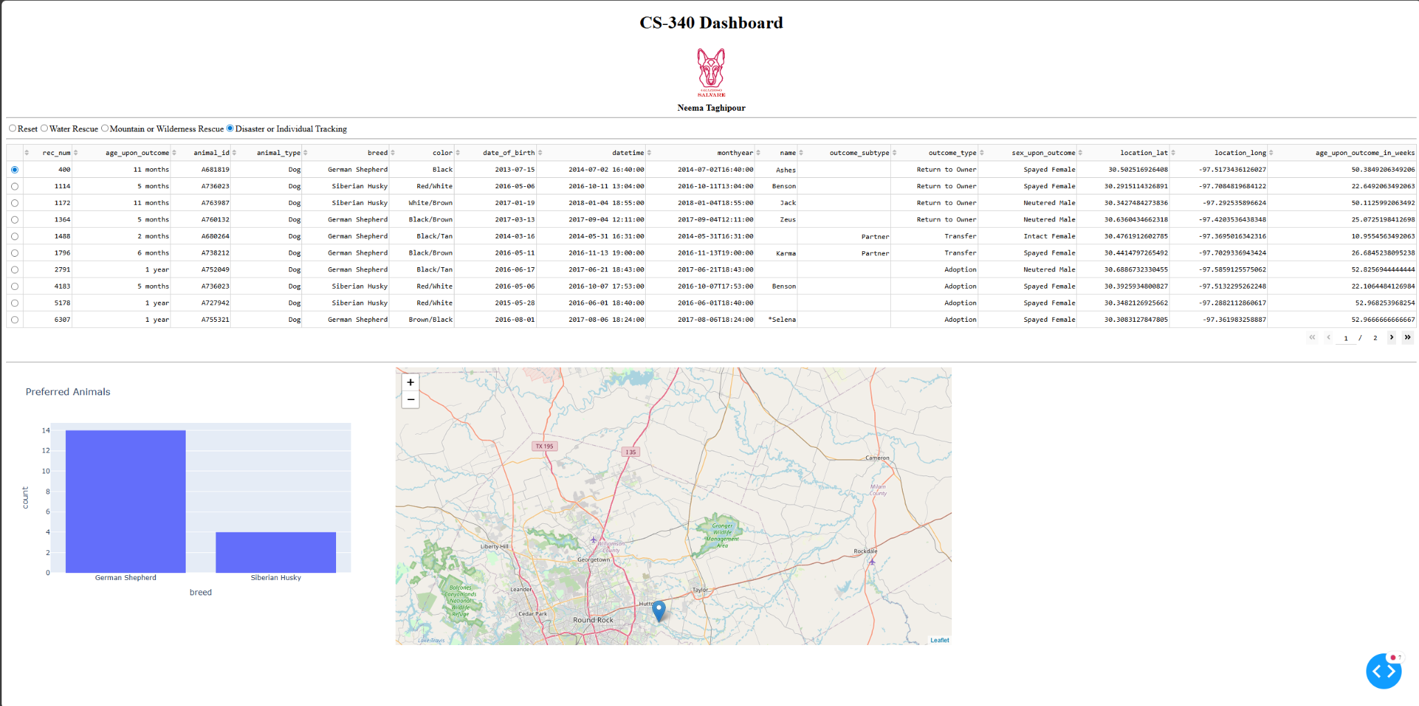

Reset (default)
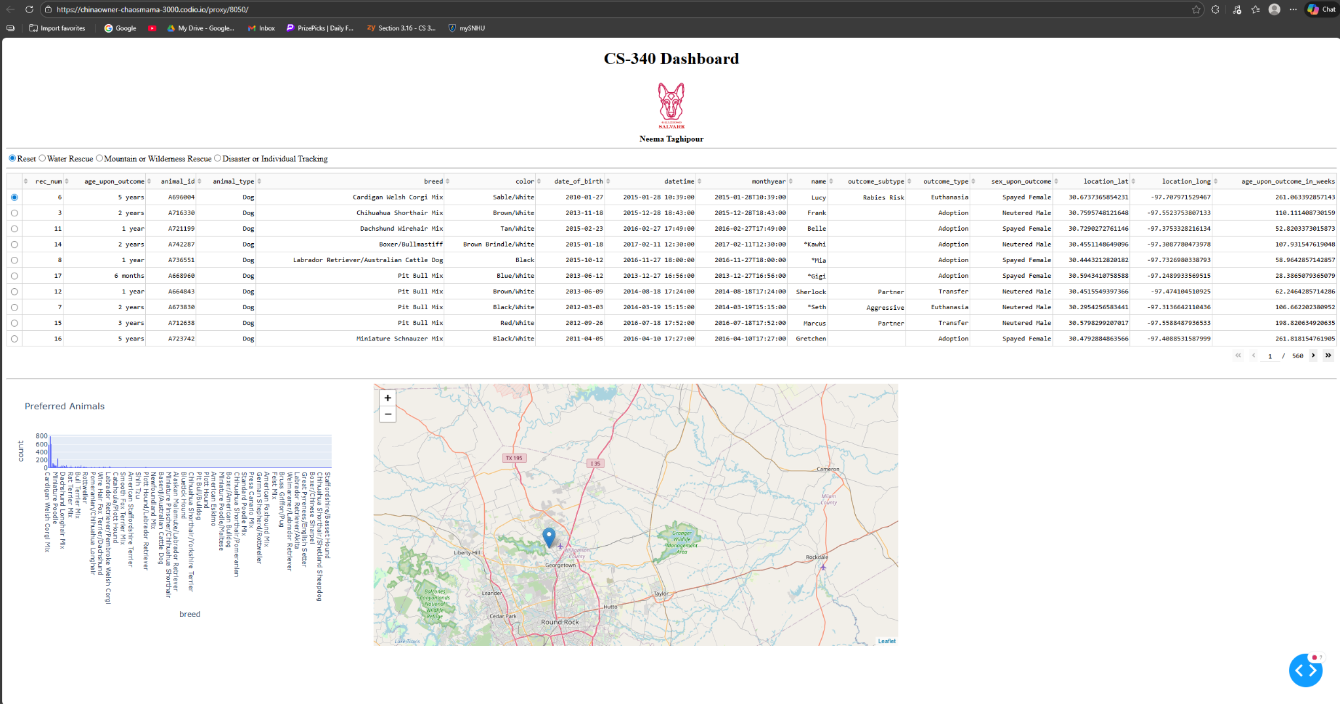

The main tool of the project was MongoDB due it’s flexible and document-based nature that works perfectly with this specific dataset. MongoDB allows for entries with various attributes which perfectly fit the breed, age, and etc of the dogs. MongoDB’s functionality with Python allowed for the use of a CRUD Python module that allows users to create, read, and update data. The framework used to build the dashboard was Dash, as it perfectly allows for UI-components that help filter through data.

The steps taken to complete the project are as follows,

- Install and start MongoDB
- Create a database user with read/write access for the application
- Create the application database and load the Austin Animal Center Outcomes data
- Configure the Python CRUD module with the database credentials
- Open the project dashboard notebook or script
- Build the interactive filters, data table, charts, and map
- Run the dashboard application
- Open the local dashboard URL in a browser
- Test each rescue filter and capture screenshots for documentation

One challenge I ran into during the project was the implementation of the geolocation chart. Since I had never done anything like this before, the task seemed very daunting to me. I ran into an issue with incorrect markers as I filtered the data. Since the chart had to update dynamically based on user input, it caused issues after loading the data for the first time.
I resolved this issue by adjusting dashboard callbacks to correctly reference the selected rows. After testing with multiple filters and ensuring the markers were correct, I was sure that I had resolved the issue.

