Payroll_NeeqFarooq: project documentation

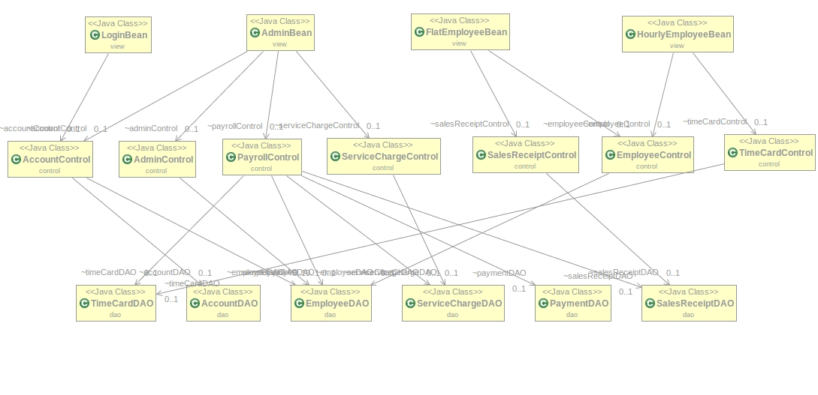
Design-level class diagram
In this visualization, the MVC pattern structure is highlighted.
- At the top level, the “Bean” classes are the code to make the web interface work;
- In the middle, there are the “Control” classes, implementing the logic to make the system work;
- At the lower level, the DAO classes are the ones which interface with the database.
From this image, it’s clear that:
- The LoginBean’s purpose it’s only the one to fetch the user’s account, and show him the correct interface (so, the AccountControl will also look to the Employee’s type);
- The AdminBean can:
  - create new accounts using AccountControl;
  - access the AdminControl functions (add, delete and modify employees);
  - access and operate the PayrollControl (run the payroll, fetch payments);
  - access the ServiceChargeControl functions (add, delete and modify service charges).
- An Employee can only:
  - submit sales receipts or timecards, depending on the type of employee;
  - access the EmployeeControl functions, that are only meant to modify some non-sensible fields (like the bank account, the address, the method of payment).

Use cases and requirements analysis
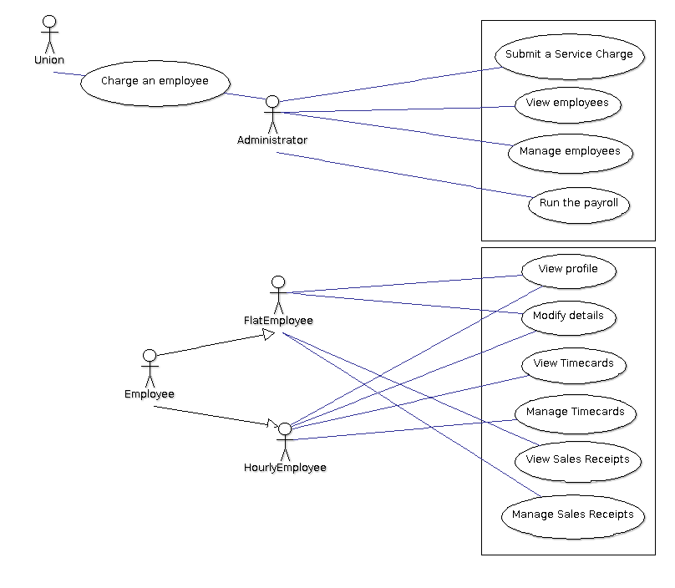
Note: that notation for the Union’s function “charge an employee” means that the Union cannot access directly the system, and must contact the Administrator in order to submit a charge.

