Industrial Internship Report on
”URL Shortener”
Prepared by
Neer Jain

Executive Summary
This report provides details of the Industrial Internship provided by upskill Campus and The IoT Academy in collaboration with Industrial Partner UniConverge Technologies Pvt Ltd (UCT).
This internship was focused on a project/problem statement provided by UCT. We had to finish the project including the report in 6 weeks’ time.
My project was a URL Shortener built using Python and Flask. It takes a long URL as input, generates a unique short code for it, stores the mapping in a database, and redirects users to the original URL whenever the shortened link is accessed.
This internship gave me a very good opportunity to get exposure to Industrial problems and design/implement solution for that. It was an overall great experience to have this internship.

TABLE OF CONTENTS
1 Preface 3
2 Introduction 4
2.1 About UniConverge Technologies Pvt Ltd 4
2.2 About upskill Campus 8
2.3 Objective 9
2.4 Reference 9
2.5 Glossary 10
3 Problem Statement 11
4 Existing and Proposed solution 12
5 Proposed Design/ Model 13
5.1 High Level Diagram (if applicable) 13
5.2 Low Level Diagram (if applicable) 13
5.3 Interfaces (if applicable) 13
6 Performance Test 14
6.1 Test Plan/ Test Cases 14
6.2 Test Procedure 14
6.3 Performance Outcome 14
7 My learnings 15
8 Future work scope 16

Preface
Over the course of this 4-week internship, I progressed from learning core Python fundamentals to designing, building, and completing a fully working URL Shortener application.
An internship like this is invaluable for career development, as it bridges the gap between classroom learning and real, hands-on project work, giving practical exposure that textbooks alone cannot provide.
My project, the URL Shortener, addresses the everyday problem of long, unwieldy URLs by converting them into short, shareable links that redirect back to the original address.
This opportunity allowed me to work through the full lifecycle of a software project, from initial planning to a completed, tested application.
The program was planned across four weeks: Week 1 focused on project planning and foundational Python concepts; Week 2 covered further Python study and the start of project development; Week 3 introduced NumPy and Pandas alongside continued development; and Week 4 was dedicated to finishing, testing, and completing the project.
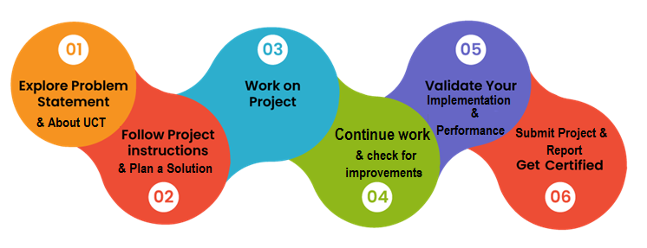
Through this internship, I learned core Python programming, worked hands-on with Flask and SQLite, and picked up data-handling libraries like NumPy and Pandas. The overall experience strengthened both my technical skills and my ability to plan and deliver a project independently.
I would like to thank my mentors and instructors for their guidance and support throughout this internship, and my peers for their valuable feedback during the project's development.
To my juniors and peers: take full advantage of opportunities like this one. Consistent, hands-on practice with real projects builds far more confidence and skill than theory alone.

Introduction

About UniConverge Technologies Pvt Ltd
A company established in 2013 and working in Digital Transformation domain and providing Industrial solutions with prime focus on sustainability and RoI.
For developing its products and solutions it is leveraging various Cutting Edge Technologies e.g. Internet of Things (IoT), Cyber Security, Cloud computing (AWS, Azure), Machine Learning, Communication Technologies (4G/5G/LoRaWAN), Java Full Stack, Python, Front end etc.

- UCT IoT Platform ()
UCT Insight is an IOT platform designed for quick deployment of IOT applications on the same time providing valuable “insight” for your process/business. It has been built in Java for backend and ReactJS for Front end. It has support for MySQL and various NoSql Databases.
- It enables device connectivity via industry standard IoT protocols - MQTT, CoAP, HTTP, Modbus TCP, OPC UA
- It supports both cloud and on-premises deployments.
It has features to
• Build Your own dashboard
• Analytics and Reporting
• Alert and Notification
• Integration with third party application(Power BI, SAP, ERP)
• Rule Engine

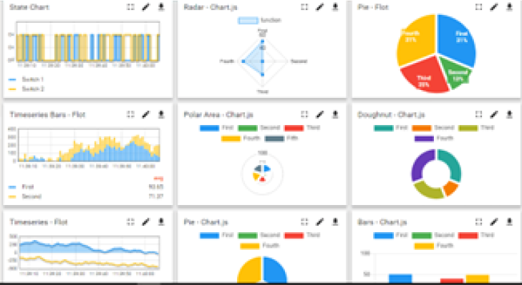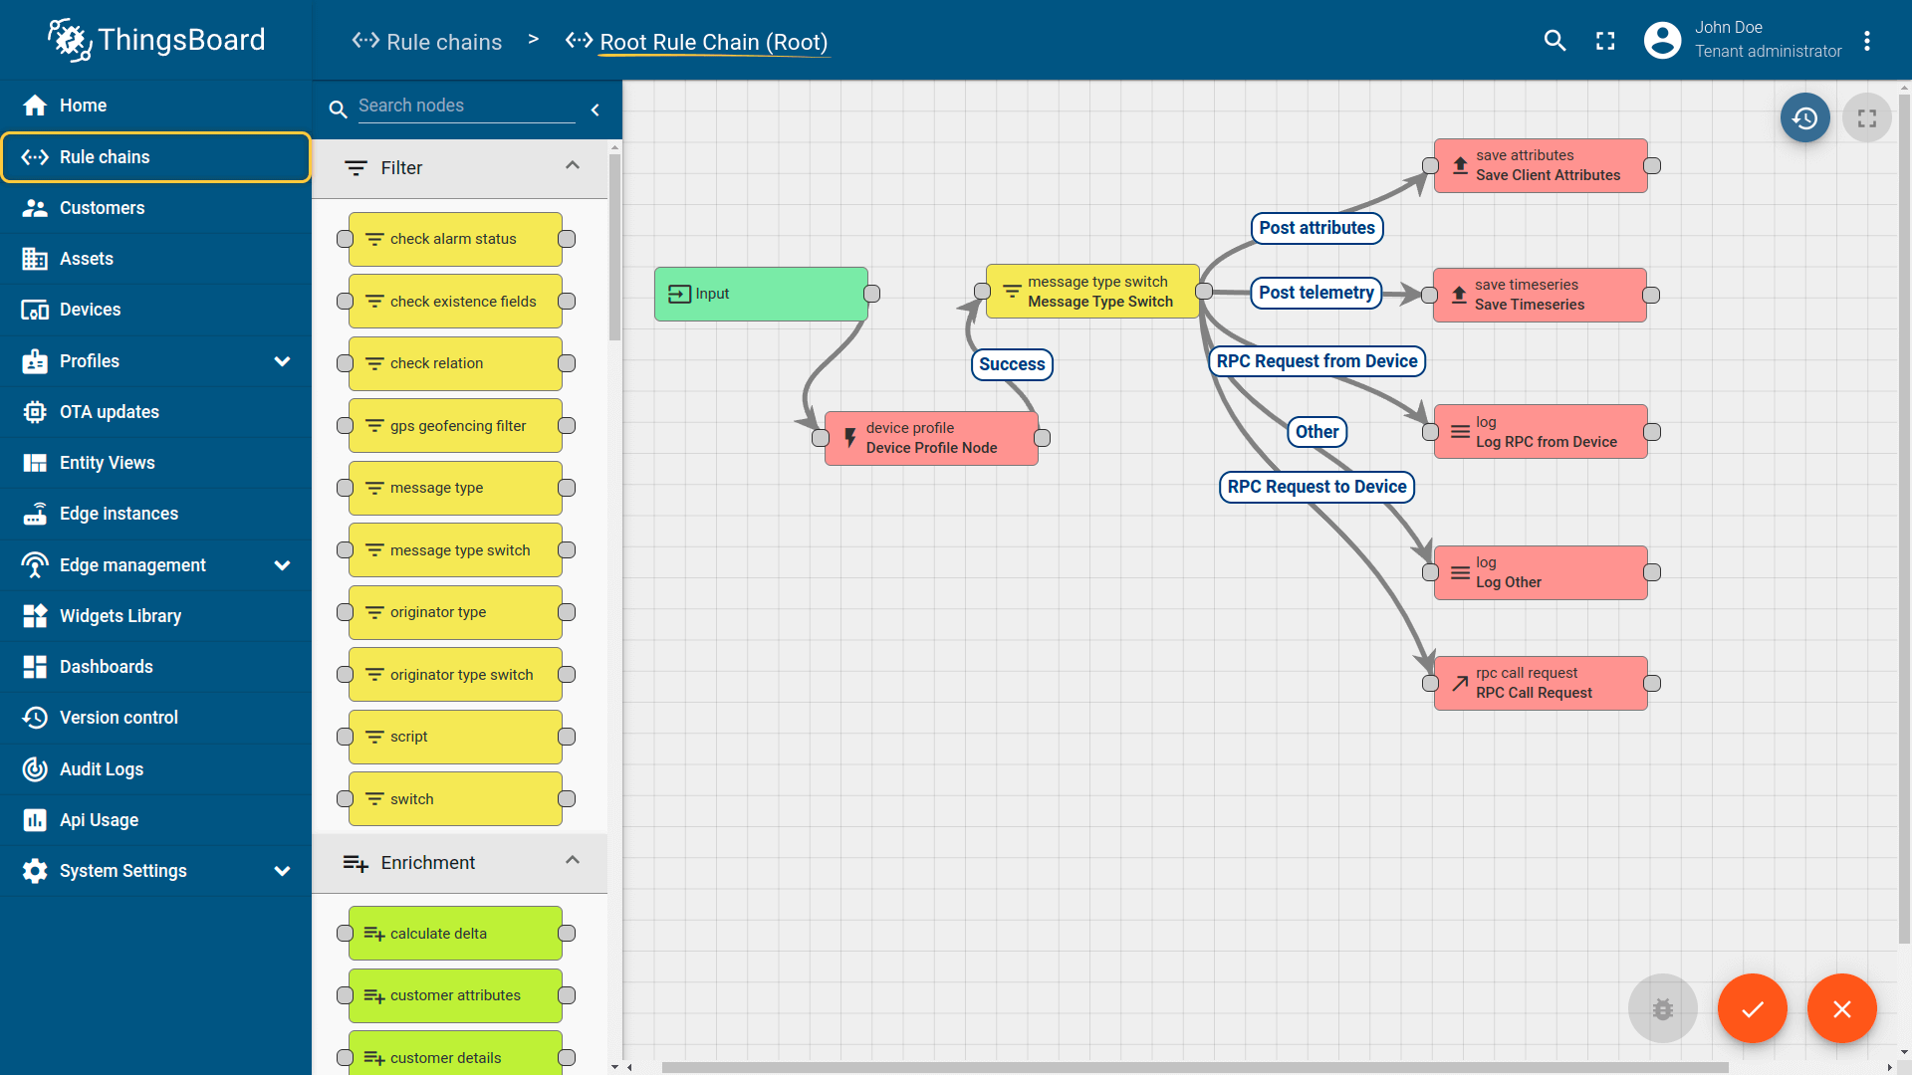

- Smart Factory Platform ()
Factory watch is a platform for smart factory needs.
It provides Users/ Factory
- with a scalable solution for their Production and asset monitoring
- OEE and predictive maintenance solution scaling up to digital twin for your assets.
- to unleased the true potential of the data that their machines are generating and helps to identify the KPIs and also improve them.
- A modular architecture that allows users to choose the service that they what to start and then can scale to more complex solutions as per their demands.
Its unique SaaS model helps users to save time, cost and money.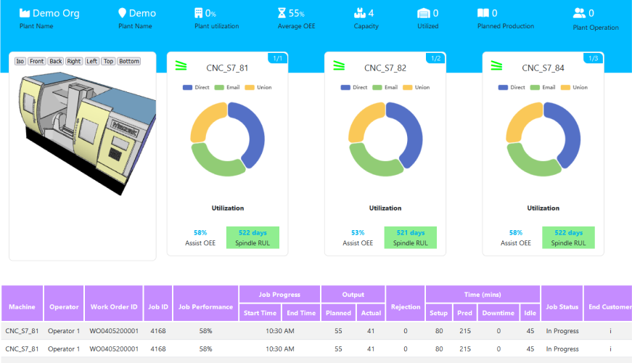

- 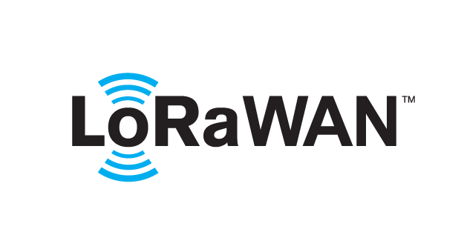 based Solution
UCT is one of the early adopters of LoRAWAN teschnology and providing solution in Agritech, Smart cities, Industrial Monitoring, Smart Street Light, Smart Water/ Gas/ Electricity metering solutions etc.
- Predictive Maintenance
UCT is providing Industrial Machine health monitoring and Predictive maintenance solution leveraging Embedded system, Industrial IoT and Machine Learning Technologies by finding Remaining useful life time of various Machines used in production process.
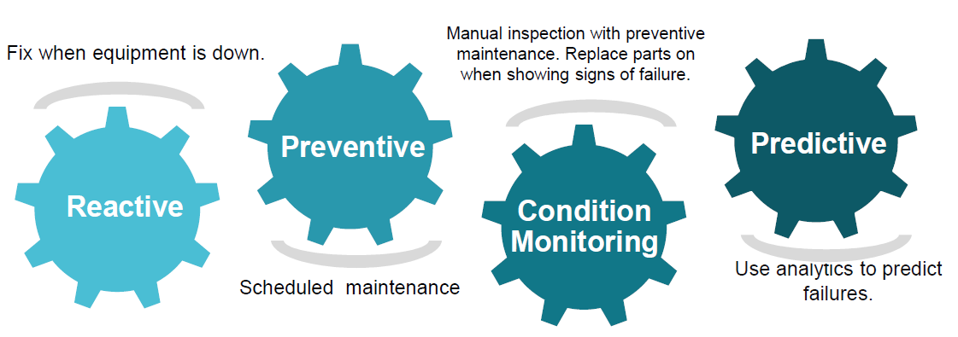

About upskill Campus (USC)
upskill Campus along with The IoT Academy and in association with Uniconverge technologies has facilitated the smooth execution of the complete internship process.
USC is a career development platform that delivers personalized executive coaching in a more affordable, scalable and measurable way.






upSkill Campus aiming to upskill 1 million learners in next 5 year
Seeing need of upskilling in self paced manner along-with additional support services e.g. Internship, projects, interaction with Industry experts, Career growth Services

https://www.upskillcampus.com/
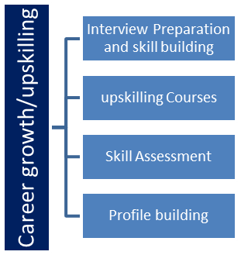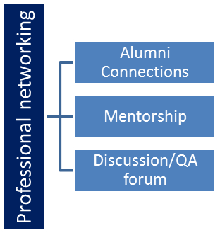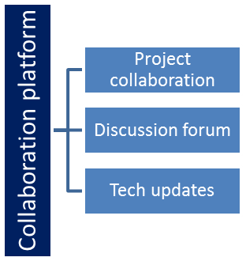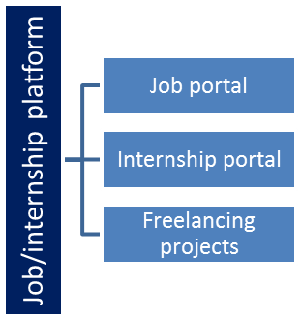

The IoT Academy
The IoT academy is EdTech Division of UCT that is running long executive certification programs in collaboration with EICT Academy, IITK, IITR and IITG in multiple domains.

Objectives of this Internship program
The objective for this internship program was to
☛ get practical experience of working in the industry.
☛ to solve real world problems.
☛ to have improved job prospects.
☛ to have Improved understanding of our field and its applications.
☛ to have Personal growth like better communication and problem solving.

Reference
[1] https://flask.palletsprojects.com/
[2] https://docs.python.org/3/
[3] https://www.sqlite.org/docs.html
[4] https://github.com/YourUsername/upskillcampus

Glossary
Terms | Acronym
Flask | Python Web Framework
SQLite | Lightweight Database
URL | Uniform Resource Locator
HTTP | HyperText Transfer Protocol
DB | Database

Problem Statement
In the assigned problem statement,
long, complex URLs are difficult to share, remember, and track. Users often need a simple way to convert lengthy links into short, manageable ones that still reliably redirect to the original destination, while also being able to store and look up these mappings efficiently.

Existing and Proposed solution

Existing URL shortening services such as Bitly and TinyURL solve this problem well but are closed, third-party platforms: users cannot see or customize how short codes are generated, cannot host the mapping data themselves, and are dependent on an external service's availability and rate limits.
The proposed solution is a self-contained URL Shortener built with Python and Flask. It accepts a long URL through a simple web form, generates a unique short code using a random alphanumeric generator, stores the original-to-short mapping in a local SQLite database, and redirects any visitor of the short link to the original URL.
The value addition is a lightweight, self-hosted alternative that gives full control over the shortening logic and stored data, and that can be extended later with features such as click analytics, custom aliases, or link expiry.

Code Submission
The complete source code for the URL Shortener project is uploaded below in this GitHub repository:
GitHub Repository: https://github.com/Neer0701/upskillcampus
Source Code: https://github.com/Neer0701/upskillcampus/blob/main/app.py

Report Submission:
This report, along with the project source code, is submitted as this Word document.

Proposed Design/ Model

The application follows a simple three-stage flow. First, the user submits a long URL through the home page form. Second, the backend generates a unique short code, checks it against the database for collisions, and stores the original-to-short mapping. Third, whenever the shortened link is visited, the backend looks up the code and redirects the user to the original URL.

High Level Diagram (if applicable)

Low Level Diagram (if applicable)

Interfaces (if applicable)
The application exposes two HTTP interfaces via Flask: a GET/POST route at "/" for submitting a long URL and displaying the resulting short link, and a GET route at "/<code>" that looks up the code and issues an HTTP redirect to the original URL. Data flows between the Flask app and the SQLite database using simple parameterized SQL queries (INSERT and SELECT) to prevent SQL injection.

Performance Test

This section covers how the URL Shortener was tested to confirm it behaves reliably rather than just working in a single demo run.
The main constraints identified were short-code uniqueness (avoiding collisions as the number of stored URLs grows) and correct handling of invalid or missing short codes on redirection.
Uniqueness is handled by generating a 6-character random alphanumeric code and enforcing a UNIQUE constraint on the short column in the database, so any collision would be rejected at the database level. Missing or invalid codes are handled explicitly, returning "URL Not Found" instead of failing.
Testing showed that submitted URLs consistently produced a working short link, and that visiting a shortened link correctly redirected to the original URL, while unknown codes correctly returned the "not found" message.
At the current small scale (a local SQLite database), lookup speed and storage were not limiting factors. At a much larger scale, the constraints would shift to database read/write throughput and code-space exhaustion.
For future, larger-scale use, recommendations include migrating from SQLite to a more concurrent database (e.g. PostgreSQL), adding a longer or hash-based code to reduce collision probability, and adding indexing on the short column for faster lookups.

Test Plan/ Test Cases
TC1: Submit a valid long URL and verify a short URL is generated. TC2: Visit the generated short URL and verify redirection to the original URL. TC3: Visit a non-existent short code and verify "URL Not Found" is returned. TC4: Submit multiple URLs and verify each gets a distinct short code.

Test Procedure
The Flask development server was run locally, and each test case was performed manually through the browser: submitting URLs via the home page form, then visiting the resulting short links and observing whether the redirect landed on the correct original page.

Performance Outcome
All four test cases passed: valid URLs consistently produced unique short codes, redirection worked correctly for valid codes, and invalid codes were handled gracefully without errors.

My learnings

Over the course of this internship, I strengthened my core Python skills and learned to build a complete, working web application from scratch using Flask and SQLite. I also picked up data-handling libraries like NumPy and Pandas, which broadened my toolkit beyond web development. Beyond the technical skills, I learned how to plan a project across multiple weeks, debug real issues like short-code collisions and edge cases, and carry a project through to completion, including testing and documentation. These experiences in end-to-end project delivery will directly support my growth as a software developer.

Future work scope

Due to the limited timeframe, a few enhancements were not implemented but could be added in the future: click analytics to track how many times each short link is visited, custom aliases so users can choose their own short code, link expiry dates, user accounts to manage personal links, and migrating from SQLite to a more scalable database for production use.

