drop DATABASE college;
create database college;
USE college;
CREATE TABLE users (
id INT PRIMARY KEY,
name VARCHAR(100),
email VARCHAR(100)
);
INSERT INTO users VALUES
(1,'Neer','neer@gmail.com'),
(2,'Rahul','rahul@gmail.com'),
(3,'Aman','aman@gmail.com');
SELECT * FROM users;

import java.sql.Connection;
import java.sql.DriverManager;
public class DB_CONNECTION {
public static Connection getConnection() {
Connection con = null;
try {
con = DriverManager.getConnection(
"jdbc:mysql://localhost:3306/college",
"root",
"Neer@1616"
);
} catch (Exception e) {
e.printStackTrace();
}
return con;
}
}

import java.sql.Connection;
import java.sql.PreparedStatement;
import java.sql.ResultSet;
public class CRUD {
public static void main(String[] args) {
CRUD obj = new CRUD();
obj.createData(4, "Rahul", "rahul@gmail.com");
obj.readData(4);
obj.updateData(
4,
"Rahul Sharma",
"rahulsharma@gmail.com"
);
obj.readData(4);
obj.readAllData();
obj.deleteData(4);
obj.readAllData();
}
public void createData(int id, String name, String email) {
try {
Connection con = DB_CONNECTION.getConnection();
String query =
"INSERT INTO users(id,name,email) VALUES(?,?,?)";
PreparedStatement ps =
con.prepareStatement(query);
ps.setInt(1, id);
ps.setString(2, name);
ps.setString(3, email);
ps.executeUpdate();
System.out.println("Data Inserted Successfully");
con.close();
} catch (Exception e) {
e.printStackTrace();
}
}
public void readData(int id) {
try {
Connection con = DB_CONNECTION.getConnection();
String query =
"SELECT * FROM users WHERE id=?";
PreparedStatement ps =
con.prepareStatement(query);
ps.setInt(1, id);
ResultSet rs =
ps.executeQuery();
if (rs.next()) {
System.out.println(
rs.getInt("id")
+ " "
+ rs.getString("name")
+ " "
+ rs.getString("email")
);
} else {
System.out.println("Record Not Found");
}
con.close();
} catch (Exception e) {
e.printStackTrace();
}
}
public void readAllData() {
try {
Connection con = DB_CONNECTION.getConnection();
String query = "SELECT * FROM users";
PreparedStatement ps =
con.prepareStatement(query);
ResultSet rs =
ps.executeQuery();
while (rs.next()) {
System.out.println(
rs.getInt("id")
+ " "
+ rs.getString("name")
+ " "
+ rs.getString("email")
);
}
con.close();
} catch (Exception e) {
e.printStackTrace();
}
}
public void updateData(int id,
String name,
String email) {
try {
Connection con = DB_CONNECTION.getConnection();
String query =
"UPDATE users SET name=?, email=? WHERE id=?";
PreparedStatement ps =
con.prepareStatement(query);
ps.setString(1, name);
ps.setString(2, email);
ps.setInt(3, id);
ps.executeUpdate();
System.out.println("Data Updated Successfully");
con.close();
} catch (Exception e) {
e.printStackTrace();
}
}
public void deleteData(int id) {
try {
Connection con = DB_CONNECTION.getConnection();
String query =
"DELETE FROM users WHERE id=?";
PreparedStatement ps =
con.prepareStatement(query);
ps.setInt(1, id);
ps.executeUpdate();
System.out.println("Data Deleted Successfully");
con.close();
} catch (Exception e) {
e.printStackTrace();
}
}
public void deleteAllData() {
try {
Connection con = DB_CONNECTION.getConnection();
String query = "DELETE FROM users";
PreparedStatement ps =
con.prepareStatement(query);
ps.executeUpdate();
System.out.println("All Data Deleted Successfully");
con.close();
} catch (Exception e) {
e.printStackTrace();
}
}
public void alterTable() {
DB_CONNECTION obj_DB_Connection =
new DB_CONNECTION();
Connection connection =
obj_DB_Connection.getConnection();
PreparedStatement ps = null;
try {
String query =
"ALTER TABLE users ADD address VARCHAR(20)";
ps = connection.prepareStatement(query);
System.out.println(ps);
ps.executeUpdate();
System.out.println(
"Column added successfully."
);
} catch (Exception e) {
System.out.println(e);
}
}
}

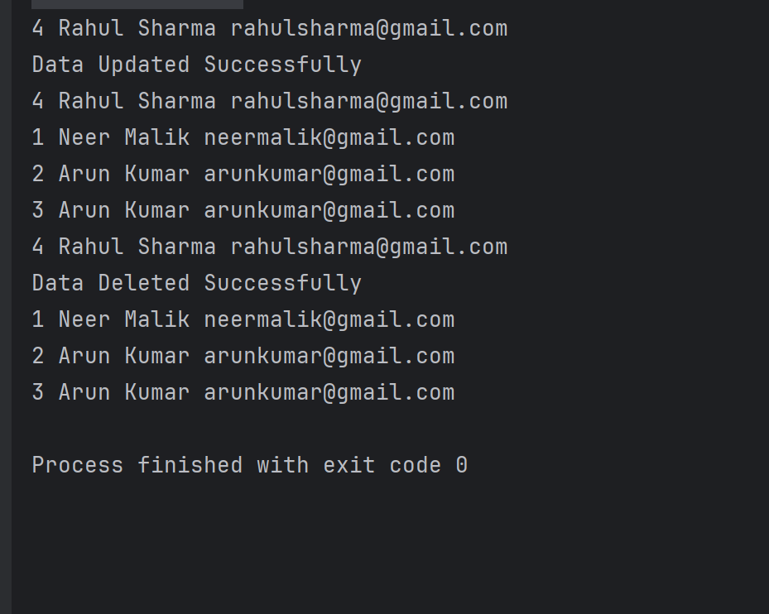

import com.mongodb.client.MongoClient;
import com.mongodb.client.MongoClients;
import com.mongodb.client.MongoDatabase;
public class MongoDBConnection {
public static void main(String[] args) {
String connectionString = "mongodb://localhost:27017";
try (MongoClient mongoClient = MongoClients.create(connectionString)) {
MongoDatabase database = mongoClient.getDatabase("testdb");
System.out.println("Connected successfully to MongoDB!");
}
}
}

