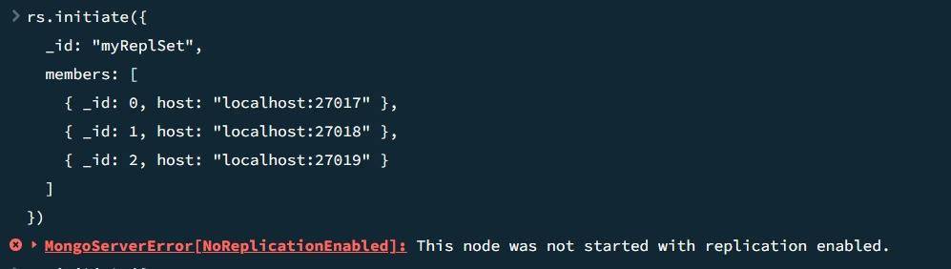

The replica set initialization command was executed on port 27017, returning a MongoServerError[NoReplicationEnabled].

