import com.mongodb.MongoClient;
import com.mongodb.client.FindIterable;
import com.mongodb.client.MongoCollection;
import com.mongodb.client.MongoDatabase;
import com.mongodb.client.model.Filters;
import com.mongodb.client.model.Updates;
import org.bson.Document;
import java.util.Arrays;
public class MongoCRUDExample {
public static void main(String[] args) {
MongoClient mongoClient =
new MongoClient("localhost", 27017);
MongoDatabase database =
mongoClient.getDatabase("CollegeDB");
MongoCollection<Document> collection =
database.getCollection("Students");
collection.deleteMany(new Document());
Document student =
new Document("id", 101)
.append("name", "John")
.append("department", "CSE")
.append("cgpa", 8.7);
collection.insertOne(student);
System.out.println("Document Inserted Successfully");
System.out.println("\nStudent Records:");
FindIterable<Document> students =
collection.find();
for (Document doc : students) {
System.out.println(doc.toJson());
}
collection.updateOne(
Filters.eq("id", 101),
Updates.set("cgpa", 9.2)
);
System.out.println("\nDocument Updated Successfully");
Document updatedStudent =
collection.find(
Filters.eq("id", 101)
).first();
System.out.println("\nUpdated Record:");
if (updatedStudent != null) {
System.out.println(updatedStudent.toJson());
}
collection.deleteOne(
Filters.eq("id", 101)
);
System.out.println("\nDocument Deleted Successfully");
collection.insertMany(
Arrays.asList(
new Document("id", 1)
.append("name", "Alice"),
new Document("id", 2)
.append("name", "Bob"),
new Document("id", 3)
.append("name", "Charlie")
)
);
System.out.println("\nMultiple Documents Inserted");
Document doc =
collection.find(
Filters.eq("id", 2)
).first();
System.out.println("\nSpecific Record:");
if (doc != null) {
System.out.println(doc.toJson());
}
collection.updateOne(
Filters.eq("id", 2),
Updates.set("name", "Bobby")
);
System.out.println("\nSpecific Record Updated");
collection.deleteOne(
Filters.eq("id", 2)
);
System.out.println("\nSpecific Record Deleted");
System.out.println("\nFinal Records:");
for (Document d : collection.find()) {
System.out.println(d.toJson());
}
mongoClient.close();
}
}

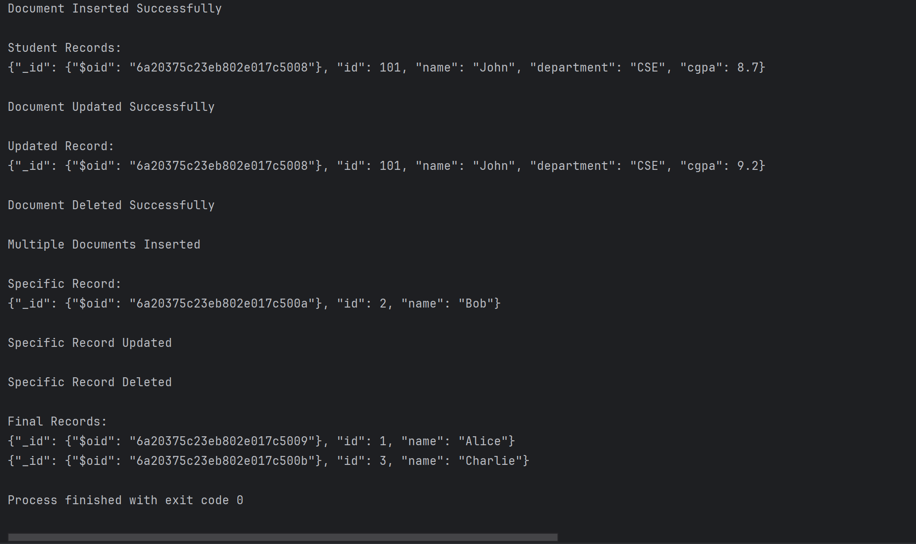

import com.mongodb.MongoClient;
import com.mongodb.client.FindIterable;
import com.mongodb.client.MongoCollection;
import com.mongodb.client.MongoDatabase;
import com.mongodb.client.model.Filters;
import com.mongodb.client.model.Updates;
import org.bson.Document;
import java.util.Arrays;
public class MongoCRUDManyExample {
public static void main(String[] args) {
MongoClient mongoClient =
new MongoClient("localhost", 27017);
MongoDatabase database =
mongoClient.getDatabase("CollegeDB");
MongoCollection<Document> collection =
database.getCollection("StudentsMany");
collection.deleteMany(new Document());
collection.insertMany(
Arrays.asList(
new Document("id", 1)
.append("name", "Alice")
.append("department", "CSE")
.append("cgpa", 8.0),
new Document("id", 2)
.append("name", "Bob")
.append("department", "CSE")
.append("cgpa", 7.5),
new Document("id", 3)
.append("name", "Charlie")
.append("department", "ECE")
.append("cgpa", 8.2),
new Document("id", 4)
.append("name", "David")
.append("department", "CSE")
.append("cgpa", 7.8)
)
);
System.out.println("Multiple Documents Inserted");
System.out.println("\nAll Records:");
FindIterable<Document> students =
collection.find();
for (Document doc : students) {
System.out.println(doc.toJson());
}
collection.updateMany(
Filters.eq("department", "CSE"),
Updates.set("department", "Computer Science")
);
System.out.println("\nMultiple Documents Updated");
for (Document doc : collection.find()) {
System.out.println(doc.toJson());
}
collection.deleteMany(
Filters.eq("department", "Computer Science")
);
System.out.println("\nMultiple Documents Deleted");
System.out.println("\nFinal Records:");
for (Document doc : collection.find()) {
System.out.println(doc.toJson());
}
mongoClient.close();
}
}
