pom.xml
<?xml version="1.0" encoding="UTF-8"?>
<project xmlns="http://maven.apache.org/POM/4.0.0"
xmlns:xsi="http://www.w3.org/2001/XMLSchema-instance"
xsi:schemaLocation="http://maven.apache.org/POM/4.0.0
http://maven.apache.org/xsd/maven-4.0.0.xsd">
<modelVersion>4.0.0</modelVersion>
<groupId>org.example</groupId>
<artifactId>JUnitAdvancedExercises</artifactId>
<version>1.0-SNAPSHOT</version>
<properties>
<maven.compiler.source>24</maven.compiler.source>
<maven.compiler.target>24</maven.compiler.target>
<project.build.sourceEncoding>UTF-8</project.build.sourceEncoding>
<junit.version>5.10.2</junit.version>
</properties>
<dependencies>
<dependency>
<groupId>org.junit.jupiter</groupId>
<artifactId>junit-jupiter</artifactId>
<version>${junit.version}</version>
<scope>test</scope>
</dependency>
<dependency>
<groupId>org.junit.platform</groupId>
<artifactId>junit-platform-suite</artifactId>
<version>1.10.2</version>
<scope>test</scope>
</dependency>
</dependencies>
<build>
<plugins>
<plugin>
<groupId>org.apache.maven.plugins</groupId>
<artifactId>maven-surefire-plugin</artifactId>
<version>3.2.5</version>
</plugin>
</plugins>
</build>
</project>

EvenChecker.java
package org.example;
public class EvenChecker {
public boolean isEven(int number) {
return number % 2 == 0;
}
}

ExceptionThrower.java
package org.example;
public class ExceptionThrower {
public void throwException() {
throw new IllegalArgumentException("Invalid Input");
}
}

PerformanceTester.java
package org.example;
public class PerformanceTester {
public void performTask() throws InterruptedException {
Thread.sleep(1000);
System.out.println("Task Completed");
}
}

EvenCheckerTest.java
package org.example;
import org.junit.jupiter.params.ParameterizedTest;
import org.junit.jupiter.params.provider.ValueSource;
import static org.junit.jupiter.api.Assertions.*;
public class EvenCheckerTest {
EvenChecker checker = new EvenChecker();
@ParameterizedTest
@ValueSource(ints = {2,4,6,8,10,100})
void testEvenNumbers(int number) {
assertTrue(checker.isEven(number));
}
@ParameterizedTest
@ValueSource(ints = {1,3,5,7,9,11})
void testOddNumbers(int number) {
assertFalse(checker.isEven(number));
}
}

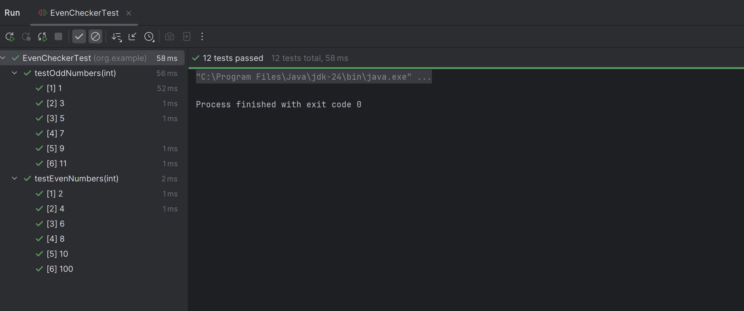

ExceptionThrowerTest.java
package org.example;
import org.junit.jupiter.api.Test;
import static org.junit.jupiter.api.Assertions.*;
public class ExceptionThrowerTest {
ExceptionThrower obj = new ExceptionThrower();
@Test
void testException() {
IllegalArgumentException exception =
assertThrows(IllegalArgumentException.class,
() -> obj.throwException());
assertEquals("Invalid Input", exception.getMessage());
}
}

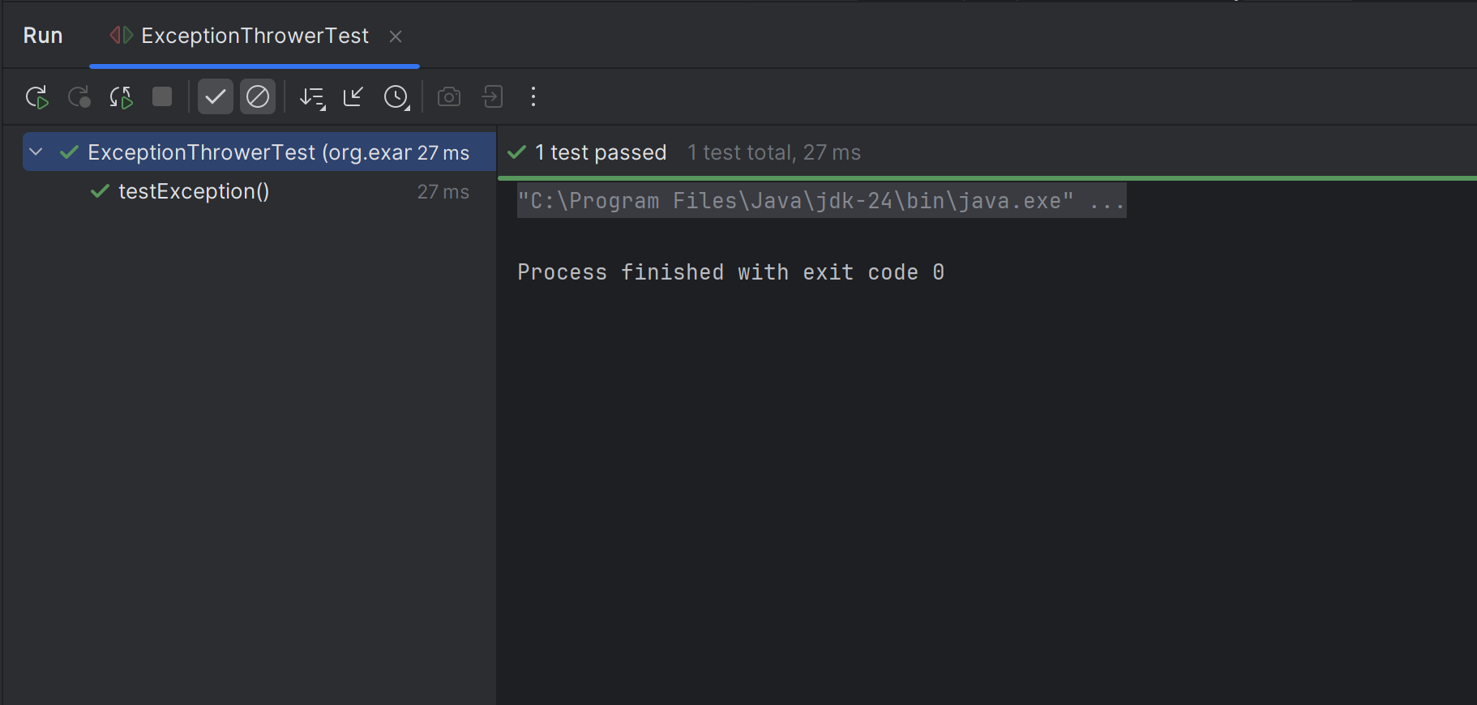

OrdererTests.java
package org.example;
import org.junit.jupiter.api.Order;
import org.junit.jupiter.api.Test;
import org.junit.jupiter.api.TestMethodOrder;
import org.junit.jupiter.api.MethodOrderer;
@TestMethodOrder(MethodOrderer.OrderAnnotation.class)
public class OrderedTests {
@Test
@Order(1)
void firstTest() {
System.out.println("Executing First Test");
}
@Test
@Order(2)
void secondTest() {
System.out.println("Executing Second Test");
}
@Test
@Order(3)
void thirdTest() {
System.out.println("Executing Third Test");
}
}

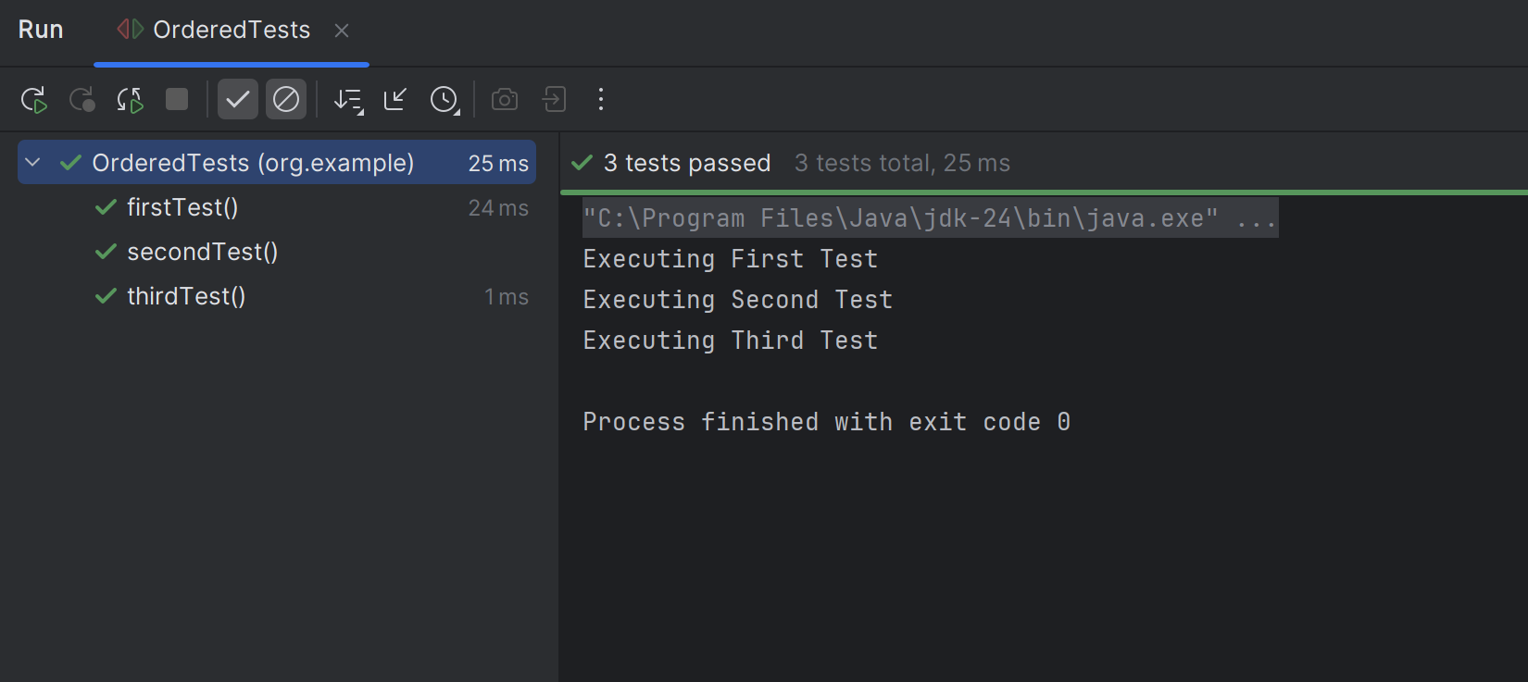

PerformanceTesterTest.java
package org.example;
import org.junit.jupiter.api.Test;
import java.time.Duration;
import static org.junit.jupiter.api.Assertions.assertTimeout;
public class PerformanceTesterTest {
PerformanceTester tester = new PerformanceTester();
@Test
void testPerformance() {
assertTimeout(Duration.ofSeconds(2), () -> {
tester.performTask();
});
}
}

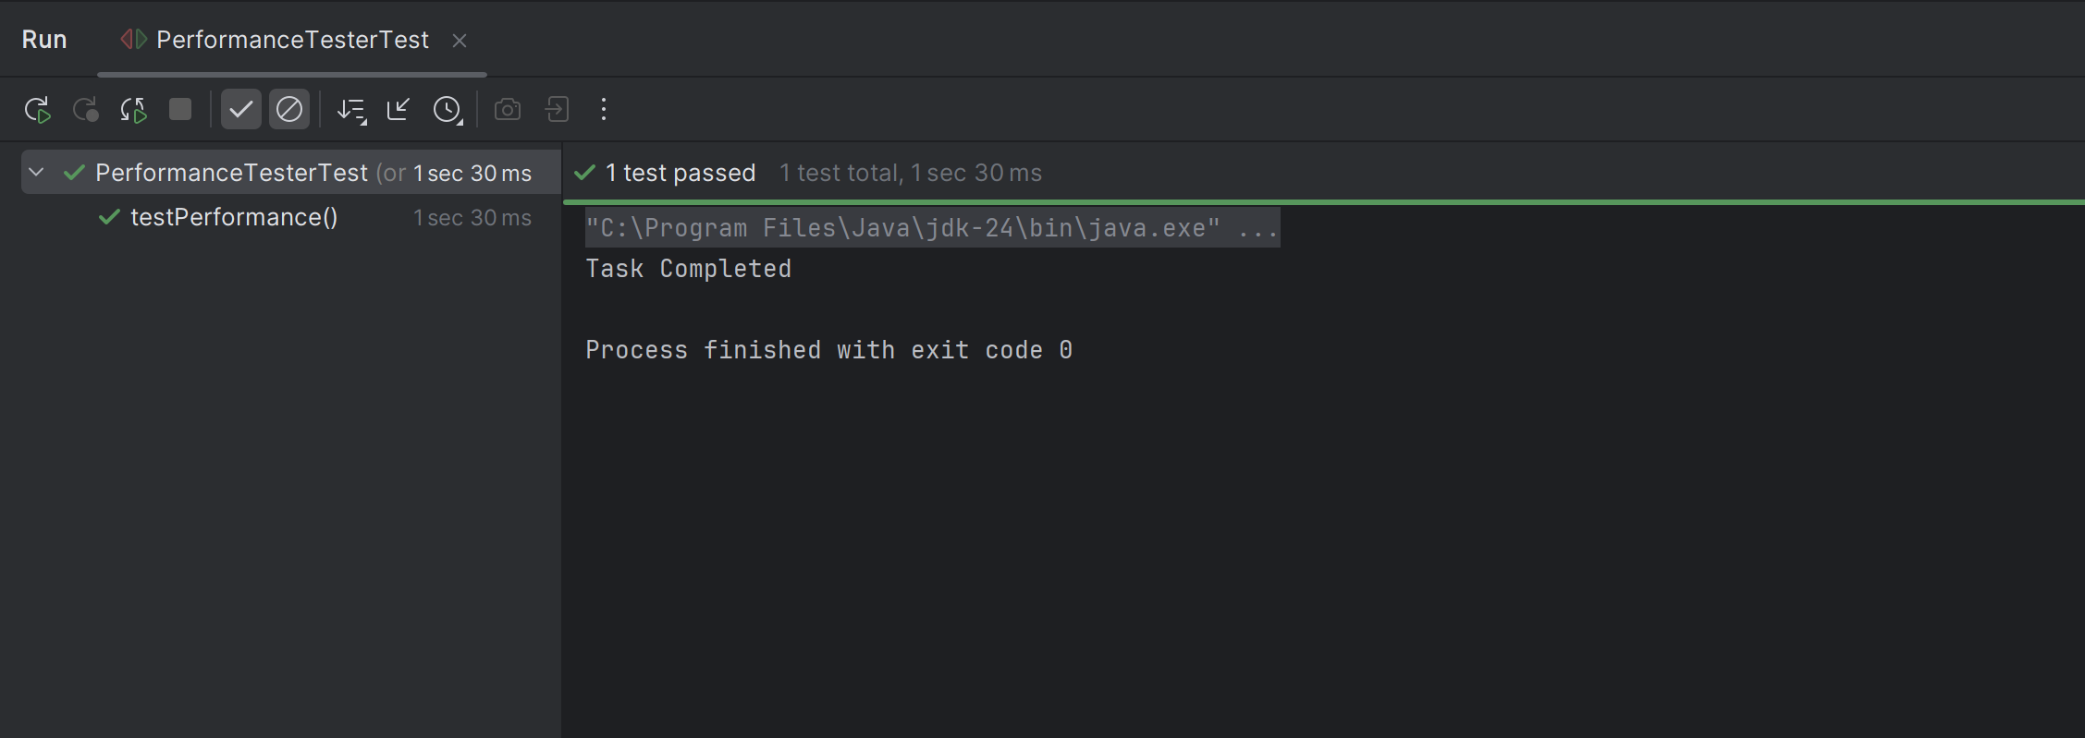

AllTests.java
package org.example;
import org.junit.platform.suite.api.SelectClasses;
import org.junit.platform.suite.api.Suite;
@Suite
@SelectClasses({
EvenCheckerTest.class,
ExceptionThrowerTest.class,
PerformanceTesterTest.class,
OrderedTests.class
})
public class AllTests {
}

