pom.xml
<?xml version="1.0" encoding="UTF-8"?>
<project xmlns="http://maven.apache.org/POM/4.0.0"
xmlns:xsi="http://www.w3.org/2001/XMLSchema-instance"
xsi:schemaLocation="http://maven.apache.org/POM/4.0.0 http://maven.apache.org/xsd/maven-4.0.0.xsd">
<modelVersion>4.0.0</modelVersion>
<groupId>org.example</groupId>
<artifactId>JUnitExercises</artifactId>
<version>1.0-SNAPSHOT</version>
<properties>
<maven.compiler.source>24</maven.compiler.source>
<maven.compiler.target>24</maven.compiler.target>
<project.build.sourceEncoding>UTF-8</project.build.sourceEncoding>
</properties>
<dependencies>
<dependency>
<groupId>junit</groupId>
<artifactId>junit</artifactId>
<version>4.13.2</version>
<scope>test</scope>
</dependency>
</dependencies>
</project>
Calculator.java
package org.example;
public class Calculator {
public int add(int a, int b) {
return a + b;
}
public int subtract(int a, int b) {
return a - b;
}
public int multiply(int a, int b) {
return a * b;
}
public int divide(int a, int b) {
return a / b;
}
}

CalculatorTest.java
package org.example;
import org.junit.Test;
import static org.junit.Assert.*;
public class CalculatorTest {
@Test
public void testAdd() {
Calculator calculator = new Calculator();
int result = calculator.add(2, 3);
assertEquals(5, result);
}
@Test
public void testSubtract() {
Calculator calculator = new Calculator();
int result = calculator.subtract(10, 4);
assertEquals(6, result);
}
@Test
public void testMultiply() {
Calculator calculator = new Calculator();
int result = calculator.multiply(5, 6);
assertEquals(30, result);
}
@Test
public void testDivide() {
Calculator calculator = new Calculator();
int result = calculator.divide(20, 4);
assertEquals(5, result);
}
}

Output
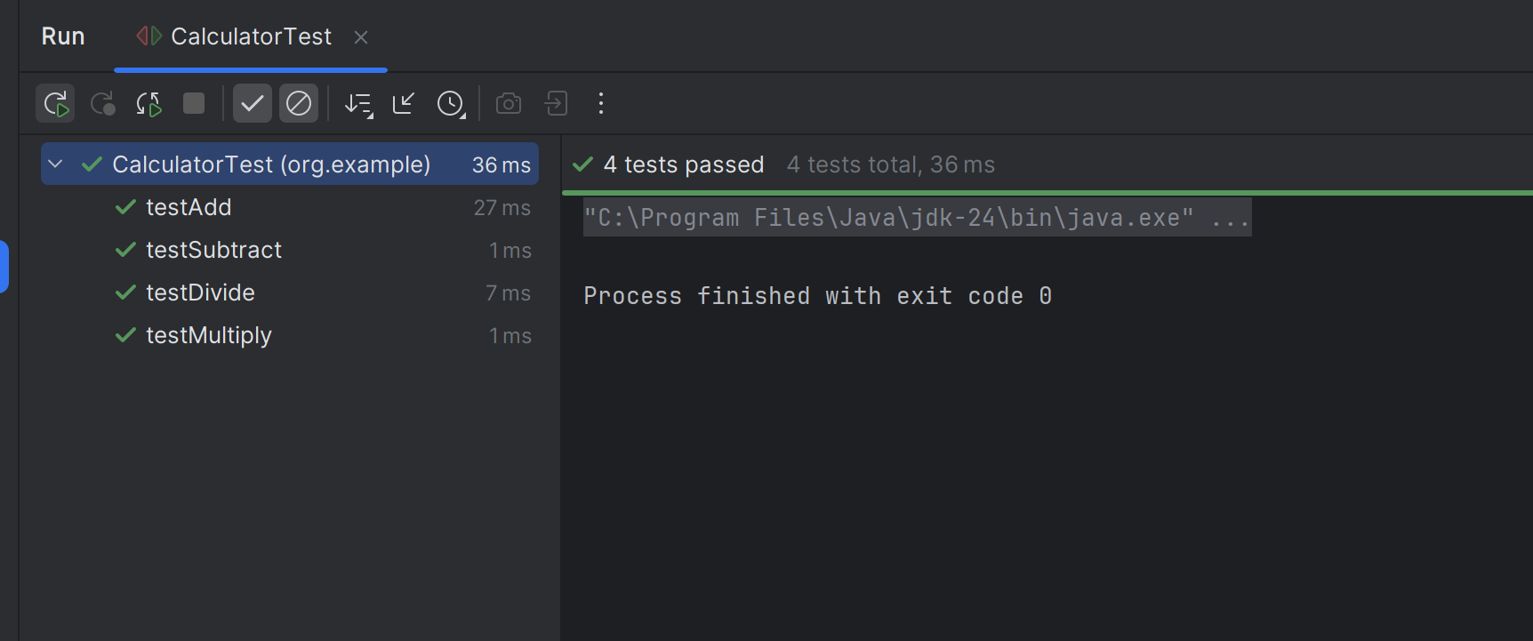

AssertionsTest.java
package org.example;
import org.junit.Test;
import static org.junit.Assert.*;
public class AssertionsTest {
@Test
public void testAssertions() {
assertEquals(5,2+3);
assertTrue(5>3);
assertFalse(5<3);
assertNull(null);
assertNotNull(new Object());
}
}
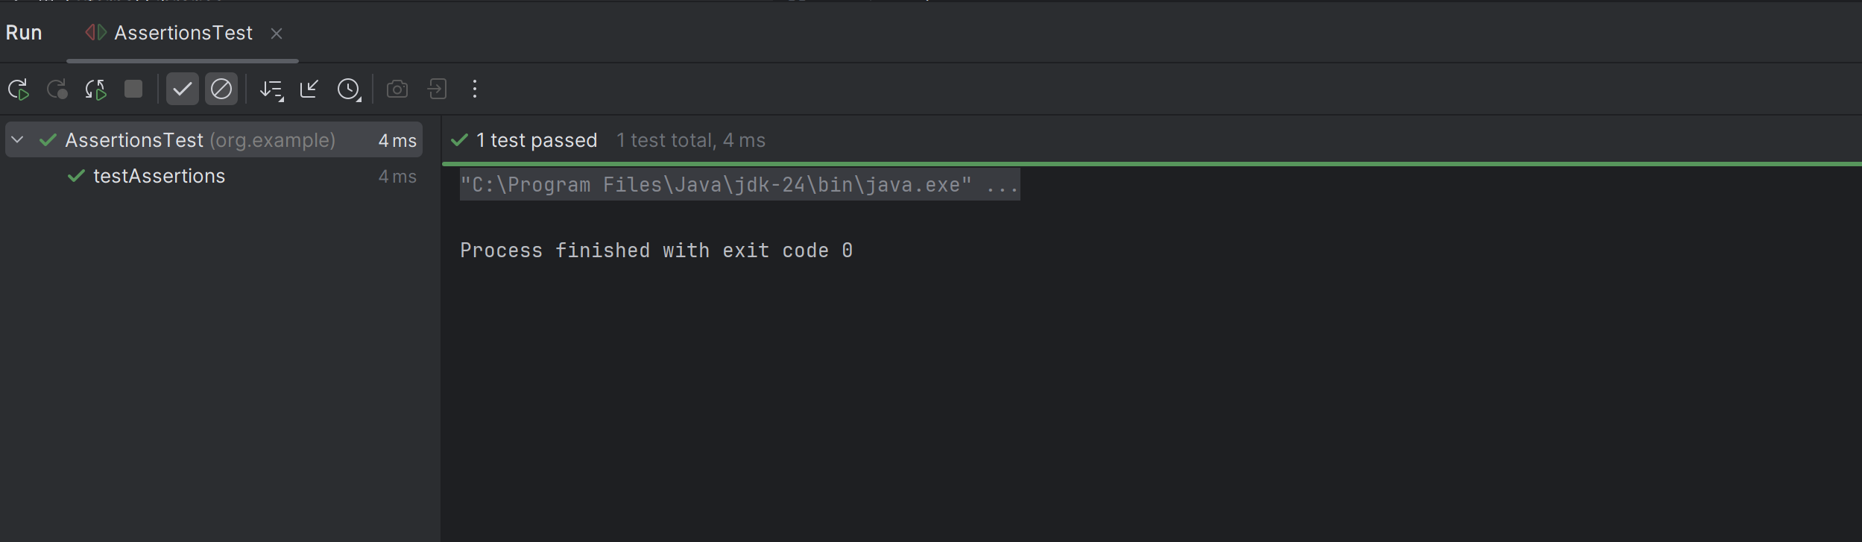

CalculatorAAATest.java
package org.example;
import org.junit.After;
import org.junit.Before;
import org.junit.Test;
import static org.junit.Assert.*;
public class CalculatorAAATest {
private Calculator calculator;
@Before
public void setUp() {
calculator = new Calculator();
System.out.println("Setup executed");
}
@After
public void tearDown() {
System.out.println("Teardown executed");
}
@Test
public void testAddition() {
// Arrange
int a = 4;
int b = 5;
// Act
int result = calculator.add(a, b);
// Assert
assertEquals(9, result);
}
@Test
public void testMultiplication() {
// Arrange
int a = 3;
int b = 4;
// Act
int result = calculator.multiply(a, b);
// Assert
assertEquals(12, result);
}
}

