Exercise 1
CalculatorService.java
package org.example;
import org.springframework.stereotype.Service;
@Service
public class CalculatorService {
public int add(int a, int b) {
return a + b;
}
}
CalculatorServiceTest.java
package org.example;
import org.junit.jupiter.api.Test;
import org.springframework.beans.factory.annotation.Autowired;
import org.springframework.boot.test.context.SpringBootTest;
import static org.junit.jupiter.api.Assertions.assertEquals;
@SpringBootTest
class CalculatorServiceTest {
@Autowired
private CalculatorService calculatorService;
@Test
void testAdd() {
assertEquals(8, calculatorService.add(5, 3));
}
}
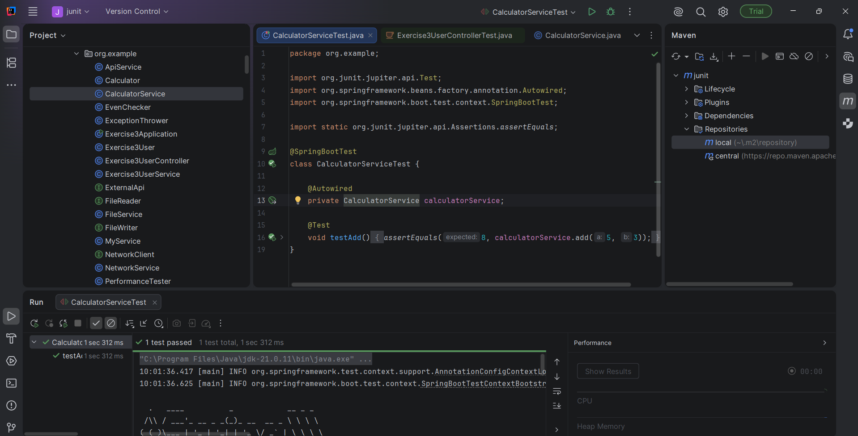

Exercise 2: Mocking a Repository in a Service Test
UserRepository.java
package org.example;
import java.util.Optional;
public interface UserRepository {
Optional<User> findById(Long id);
}

User.java
package org.example;
public class User {
private Long id;
private String name;
public User() {
}
public User(Long id, String name) {
this.id = id;
this.name = name;
}
public Long getId() {
return id;
}
public void setId(Long id) {
this.id = id;
}
public String getName() {
return name;
}
public void setName(String name) {
this.name = name;
}
}
UserService.java
package org.example;
public class UserService {
private final UserRepository userRepository;
public UserService(UserRepository userRepository) {
this.userRepository = userRepository;
}
public User getUserById(Long id) {
return userRepository.findById(id).orElse(null);
}
}
UserServiceTest.java
package org.example;
import org.junit.jupiter.api.Test;
import java.util.Optional;
import static org.junit.jupiter.api.Assertions.assertEquals;
import static org.mockito.Mockito.mock;
import static org.mockito.Mockito.when;
class UserServiceTest {
@Test
void testGetUserById() {
UserRepository mockRepository = mock(UserRepository.class);
User user = new User();
user.setId(1L);
user.setName("John");
when(mockRepository.findById(1L))
.thenReturn(Optional.of(user));
UserService userService =
new UserService(mockRepository);
User result = userService.getUserById(1L);
assertEquals("John", result.getName());
}
}
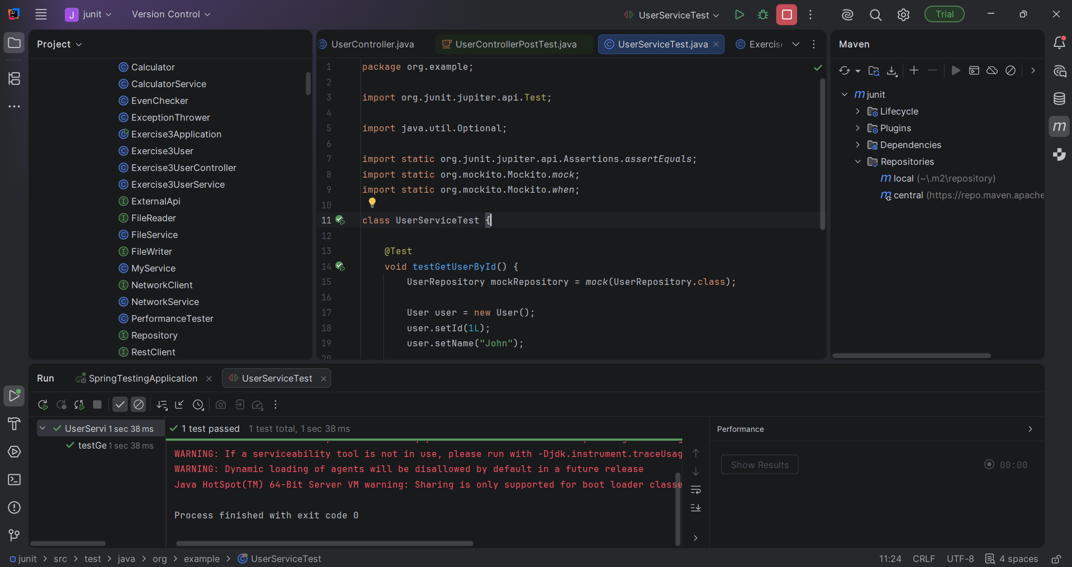
Exercise 3: Testing a REST Controller with MockMvc
Exercise3Application.java
package org.example;
import org.springframework.boot.autoconfigure.SpringBootApplication;
@SpringBootApplication
public class Exercise3Application {
}
Exercise3User.java
package org.example;
public class Exercise3User {
private Long id;
private String name;
public Exercise3User() {
}
public Exercise3User(Long id, String name) {
this.id = id;
this.name = name;
}
public Long getId() {
return id;
}
public void setId(Long id) {
this.id = id;
}
public String getName() {
return name;
}
public void setName(String name) {
this.name = name;
}
}
Exercise3UserController.java
package org.example;
import org.springframework.http.ResponseEntity;
import org.springframework.web.bind.annotation.*;
@RestController
@RequestMapping("/exercise3/users")
public class Exercise3UserController {
private final Exercise3UserService userService;
public Exercise3UserController(Exercise3UserService userService) {
this.userService = userService;
}
@GetMapping("/{id}")
public ResponseEntity<Exercise3User> getUser(
@PathVariable("id") Long id) {
return ResponseEntity.ok(
userService.getUserById(id)
);
}
}
Exercise3UserService.java
package org.example;
import org.springframework.stereotype.Service;
@Service
public class Exercise3UserService {
public Exercise3User getUserById(Long id) {
return new Exercise3User(id, "John");
}
}
Exercise3UserControllerest.java
package org.example;
import org.junit.jupiter.api.Test;
import org.springframework.beans.factory.annotation.Autowired;
import org.springframework.boot.test.autoconfigure.web.servlet.WebMvcTest;
import org.springframework.boot.test.mock.mockito.MockBean;
import org.springframework.test.context.ContextConfiguration;
import org.springframework.test.web.servlet.MockMvc;
import static org.mockito.Mockito.when;
import static org.springframework.test.web.servlet.request.MockMvcRequestBuilders.get;
import static org.springframework.test.web.servlet.result.MockMvcResultMatchers.jsonPath;
import static org.springframework.test.web.servlet.result.MockMvcResultMatchers.status;
@WebMvcTest(Exercise3UserController.class)
@ContextConfiguration(classes = Exercise3Application.class)
class Exercise3UserControllerTest {
@Autowired
private MockMvc mockMvc;
@MockBean
private Exercise3UserService userService;
@Test
void testGetUser() throws Exception {
Exercise3User user =
new Exercise3User(1L, "John");
when(userService.getUserById(1L))
.thenReturn(user);
mockMvc.perform(get("/exercise3/users/1"))
.andExpect(status().isOk())
.andExpect(jsonPath("$.id").value(1))
.andExpect(jsonPath("$.name").value("John"));
}
}
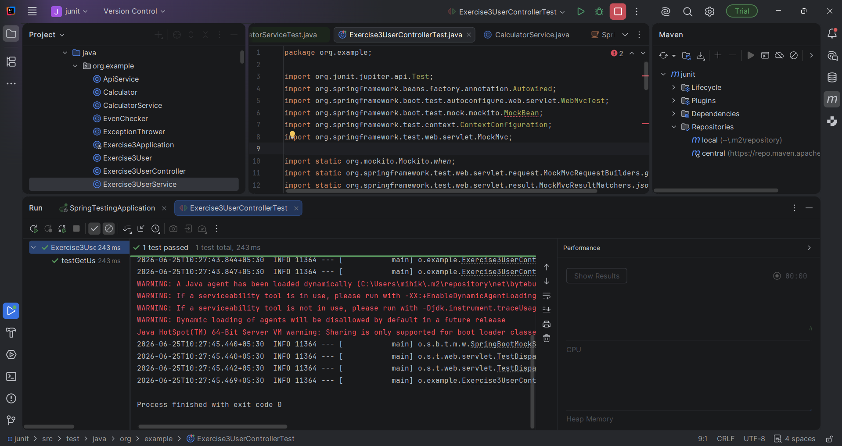
Exercise 4: Integration Test with Spring Boot
Exercise4Application.java
package org.example.exercise4;
import org.springframework.boot.autoconfigure.SpringBootApplication;
@SpringBootApplication
public class Exercise4Application {
}

Exercise4User.java
package org.example.exercise4;
import jakarta.persistence.*;
@Entity
public class Exercise4User {
@Id
@GeneratedValue(strategy = GenerationType.IDENTITY)
private Long id;
private String name;
public Exercise4User() {
}
public Exercise4User(String name) {
this.name = name;
}
public Long getId() {
return id;
}
public String getName() {
return name;
}
public void setName(String name) {
this.name = name;
}
}

Exercise4UserController.java
package org.example.exercise4;
import org.springframework.http.ResponseEntity;
import org.springframework.web.bind.annotation.*;
@RestController
@RequestMapping("/exercise4/users")
public class Exercise4UserController {
private final Exercise4UserService service;
public Exercise4UserController(
Exercise4UserService service) {
this.service = service;
}
@GetMapping("/{id}")
public ResponseEntity<Exercise4User> getUser(
@PathVariable("id") Long id) {
return ResponseEntity.ok(
service.getUser(id)
);
}
}
Exercise4UserRepository.java
package org.example.exercise4;
import org.springframework.data.jpa.repository.JpaRepository;
public interface Exercise4UserRepository
extends JpaRepository<Exercise4User, Long> {
}
Exercise4UserService.java
package org.example.exercise4;
import org.springframework.stereotype.Service;
@Service
public class Exercise4UserService {
private final Exercise4UserRepository repository;
public Exercise4UserService(
Exercise4UserRepository repository) {
this.repository = repository;
}
public Exercise4User getUser(Long id) {
return repository.findById(id).orElse(null);
}
}
Exercise4RefactorTest.java
package org.example.exercise4;
import org.junit.jupiter.api.Test;
import org.springframework.beans.factory.annotation.Autowired;
import org.springframework.boot.test.context.SpringBootTest;
import org.springframework.boot.test.context.SpringBootTest.WebEnvironment;
import org.springframework.boot.test.web.client.TestRestTemplate;
import org.springframework.boot.test.web.server.LocalServerPort;
import static org.junit.jupiter.api.Assertions.*;
@SpringBootTest(
classes = Exercise4Application.class,
webEnvironment = WebEnvironment.RANDOM_PORT)
class Exercise4IntegrationTest {
@LocalServerPort
private int port;
@Autowired
private TestRestTemplate restTemplate;
@Autowired
private Exercise4UserRepository repository;
@Test
void testFullFlow() {
Exercise4User savedUser =
repository.save(
new Exercise4User("John"));
Exercise4User result =
restTemplate.getForObject(
"http://localhost:" +
port +
"/exercise4/users/" +
savedUser.getId(),
Exercise4User.class);
assertNotNull(result);
assertEquals("John",
result.getName());
}
}
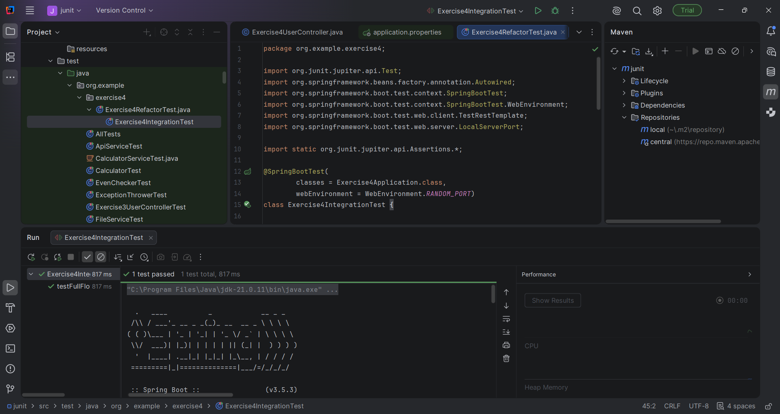

Exercise 5: Test Controller POST Endpoint
ExerciseApplication.java
package org.example.exercise5;
import org.springframework.boot.autoconfigure.SpringBootApplication;
@SpringBootApplication
public class Exercise5Application {
}
Exercise5User.java
package org.example.exercise5;
public class Exercise5User {
private Long id;
private String name;
public Exercise5User() {
}
public Exercise5User(Long id, String name) {
this.id = id;
this.name = name;
}
public Long getId() {
return id;
}
public void setId(Long id) {
this.id = id;
}
public String getName() {
return name;
}
public void setName(String name) {
this.name = name;
}
}
Exercise5UserService.java
package org.example.exercise5;
import org.springframework.stereotype.Service;
@Service
public class Exercise5UserService {
public Exercise5User saveUser(
Exercise5User user) {
return user;
}
}
Exercise5UserController.java
package org.example.exercise5;
import org.springframework.http.ResponseEntity;
import org.springframework.web.bind.annotation.*;
@RestController
@RequestMapping("/exercise5/users")
public class Exercise5UserController {
private final Exercise5UserService userService;
public Exercise5UserController(
Exercise5UserService userService) {
this.userService = userService;
}
@PostMapping
public ResponseEntity<Exercise5User> createUser(
@RequestBody Exercise5User user) {
return ResponseEntity.ok(
userService.saveUser(user));
}
}
Exercise5UserControllerTest.java
package org.example.exercise5;
import com.fasterxml.jackson.databind.ObjectMapper;
import org.junit.jupiter.api.Test;
import org.springframework.beans.factory.annotation.Autowired;
import org.springframework.boot.test.autoconfigure.web.servlet.WebMvcTest;
import org.springframework.boot.test.mock.mockito.MockBean;
import static org.mockito.ArgumentMatchers.any;
import org.springframework.test.context.ContextConfiguration;
import org.springframework.test.web.servlet.MockMvc;
import static org.mockito.Mockito.when;
import static org.springframework.test.web.servlet.request.MockMvcRequestBuilders.post;
import static org.springframework.test.web.servlet.result.MockMvcResultMatchers.*;
@WebMvcTest(Exercise5UserController.class)
@ContextConfiguration(classes = Exercise5Application.class)
class Exercise5UserControllerTest {
@Autowired
private MockMvc mockMvc;
@Autowired
private ObjectMapper objectMapper;
@MockBean
private Exercise5UserService userService;
@Test
void testCreateUser() throws Exception {
Exercise5User user =
new Exercise5User(1L, "John");
when(userService.saveUser(any(Exercise5User.class)))
.thenReturn(user);
mockMvc.perform(
post("/exercise5/users")
.contentType("application/json")
.content(
objectMapper
.writeValueAsString(user)
)
)
.andExpect(status().isOk())
.andExpect(jsonPath("$.id")
.value(1))
.andExpect(jsonPath("$.name")
.value("John"));
}
}
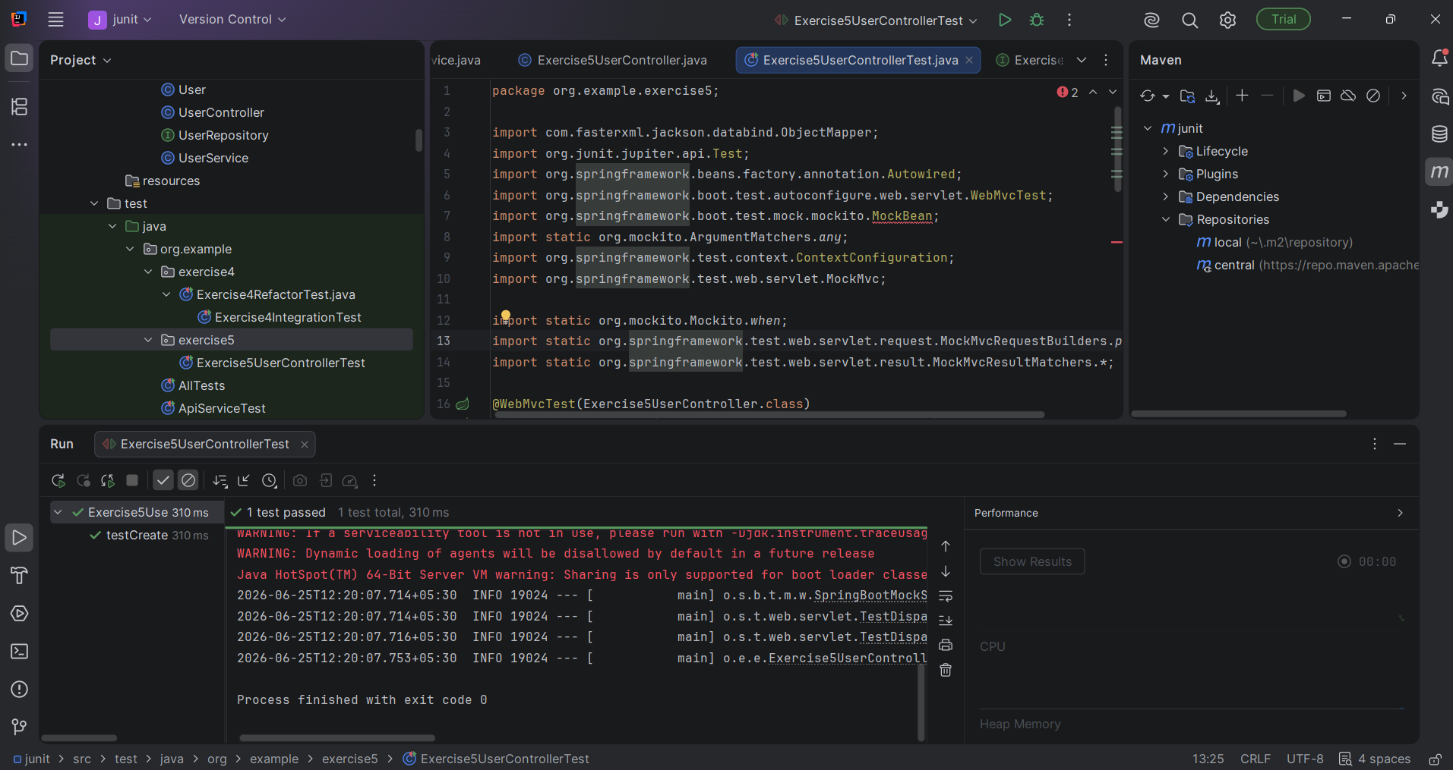

Exercise 6: Test Service Exception Handling
Exercise6User.java
package org.example.exercise6;
public class Exercise6User {
private Long id;
private String name;
public Exercise6User() {
}
public Exercise6User(Long id, String name) {
this.id = id;
this.name = name;
}
public Long getId() {
return id;
}
public String getName() {
return name;
}
}

Exercise6UserRepository.java
package org.example.exercise6;
import java.util.Optional;
public interface Exercise6UserRepository {
Optional<Exercise6User> findById(Long id);
}

Exercise6UserService.java
package org.example.exercise6;
import java.util.NoSuchElementException;
public class Exercise6UserService {
private final Exercise6UserRepository repository;
public Exercise6UserService(
Exercise6UserRepository repository) {
this.repository = repository;
}
public Exercise6User getUserById(Long id) {
return repository.findById(id)
.orElseThrow(() ->
new NoSuchElementException(
"User not found"));
}
}
Exercise6UserServiceTest.java
package org.example.exercise6;
import org.junit.jupiter.api.Test;
import java.util.NoSuchElementException;
import java.util.Optional;
import static org.junit.jupiter.api.Assertions.*;
import static org.mockito.Mockito.*;
class Exercise6UserServiceTest {
@Test
void testUserNotFound() {
Exercise6UserRepository repository =
mock(Exercise6UserRepository.class);
when(repository.findById(1L))
.thenReturn(Optional.empty());
Exercise6UserService service =
new Exercise6UserService(repository);
NoSuchElementException exception =
assertThrows(
NoSuchElementException.class,
() -> service.getUserById(1L)
);
assertEquals(
"User not found",
exception.getMessage()
);
}
}
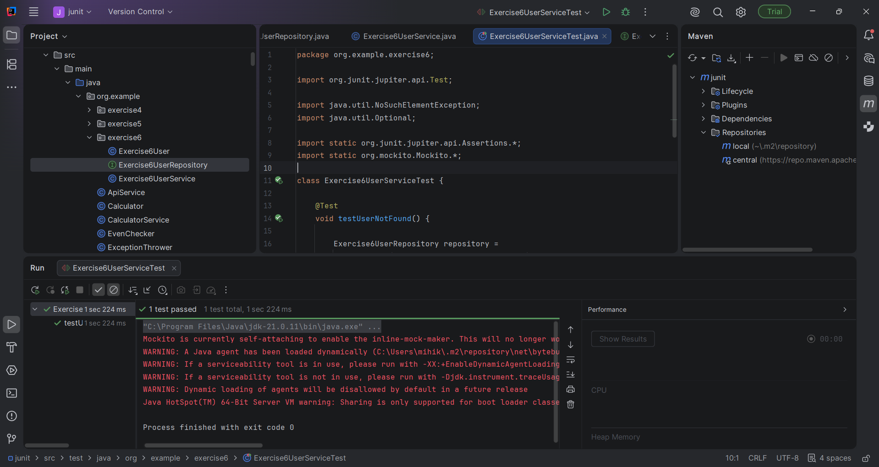
Exercise 7: Test Custom Repository Query
Exercise7Application.java
package org.example.exercise7;
import org.springframework.boot.autoconfigure.SpringBootApplication;
@SpringBootApplication
public class Exercise7Application {
}

Exercise7User.java
package org.example.exercise7;
import jakarta.persistence.*;
@Entity
public class Exercise7User {
@Id
@GeneratedValue(strategy = GenerationType.IDENTITY)
private Long id;
private String name;
public Exercise7User() {
}
public Exercise7User(String name) {
this.name = name;
}
public Long getId() {
return id;
}
public String getName() {
return name;
}
public void setName(String name) {
this.name = name;
}
}
Exercise7UserRepository.java
package org.example.exercise7;
import org.springframework.data.jpa.repository.JpaRepository;
import java.util.List;
public interface Exercise7UserRepository
extends JpaRepository<Exercise7User, Long> {
List<Exercise7User> findByName(String name);
}
Exercise7UserRepositoryTest.java
package org.example.exercise7;
import org.junit.jupiter.api.Test;
import org.springframework.beans.factory.annotation.Autowired;
import org.springframework.boot.test.autoconfigure.orm.jpa.DataJpaTest;
import org.springframework.test.context.ContextConfiguration;
import java.util.List;
import static org.junit.jupiter.api.Assertions.*;
@DataJpaTest
@ContextConfiguration(classes = Exercise7Application.class)
class Exercise7UserRepositoryTest {
@Autowired
private Exercise7UserRepository repository;
@Test
void testFindByName() {
repository.save(
new Exercise7User("John"));
repository.save(
new Exercise7User("John"));
repository.save(
new Exercise7User("Mike"));
List<Exercise7User> users =
repository.findByName("John");
assertEquals(2, users.size());
assertEquals(
"John",
users.getFirst().getName()
);
}
}
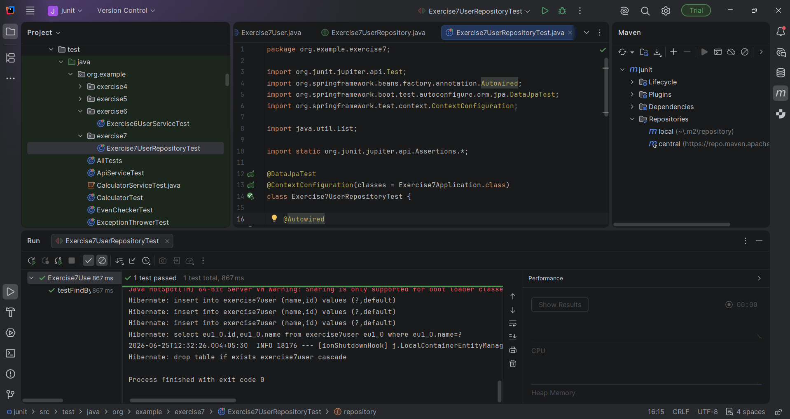

Exercise 8: Test Controller Exception Handling
Exercise8Applcation.java
package org.example.exercise8;
import org.springframework.boot.autoconfigure.SpringBootApplication;
@SpringBootApplication
public class Exercise8Application {
}
Exercise8UserService.java
package org.example.exercise8;
import org.springframework.stereotype.Service;
import java.util.NoSuchElementException;
@Service
public class Exercise8UserService {
public String getUser(Long id) {
throw new NoSuchElementException(
"User not found");
}
}
Exercise8UserController.java
package org.example.exercise8;
import org.springframework.web.bind.annotation.*;
@RestController
@RequestMapping("/exercise8/users")
public class Exercise8UserController {
private final Exercise8UserService service;
public Exercise8UserController(
Exercise8UserService service) {
this.service = service;
}
@GetMapping("/{id}")
public String getUser(
@PathVariable("id") Long id) {
return service.getUser(id);
}
}
GlobalExceptionHandler.java
package org.example.exercise8;
import org.springframework.http.*;
import org.springframework.web.bind.annotation.*;
import java.util.NoSuchElementException;
@ControllerAdvice
public class GlobalExceptionHandler {
@ExceptionHandler(
NoSuchElementException.class)
public ResponseEntity<String> handleNotFound(
NoSuchElementException ex) {
return ResponseEntity
.status(HttpStatus.NOT_FOUND)
.body("User not found");
}
}
Exercise8ControllerExceptionTest.java
package org.example.exercise8;
import org.junit.jupiter.api.Test;
import org.springframework.beans.factory.annotation.Autowired;
import org.springframework.boot.test.autoconfigure.web.servlet.WebMvcTest;
import org.springframework.context.annotation.Import;
import org.springframework.test.web.servlet.MockMvc;
import static org.springframework.test.web.servlet.request.MockMvcRequestBuilders.get;
import static org.springframework.test.web.servlet.result.MockMvcResultMatchers.*;
@WebMvcTest(Exercise8UserController.class)
@Import({
Exercise8UserService.class,
GlobalExceptionHandler.class
})
class Exercise8ControllerExceptionTest {
@Autowired
private MockMvc mockMvc;
@Test
void testExceptionHandling() throws Exception {
mockMvc.perform(
get("/exercise8/users/1"))
.andExpect(
status().isNotFound())
.andExpect(
content().string(
"User not found"));
}
}
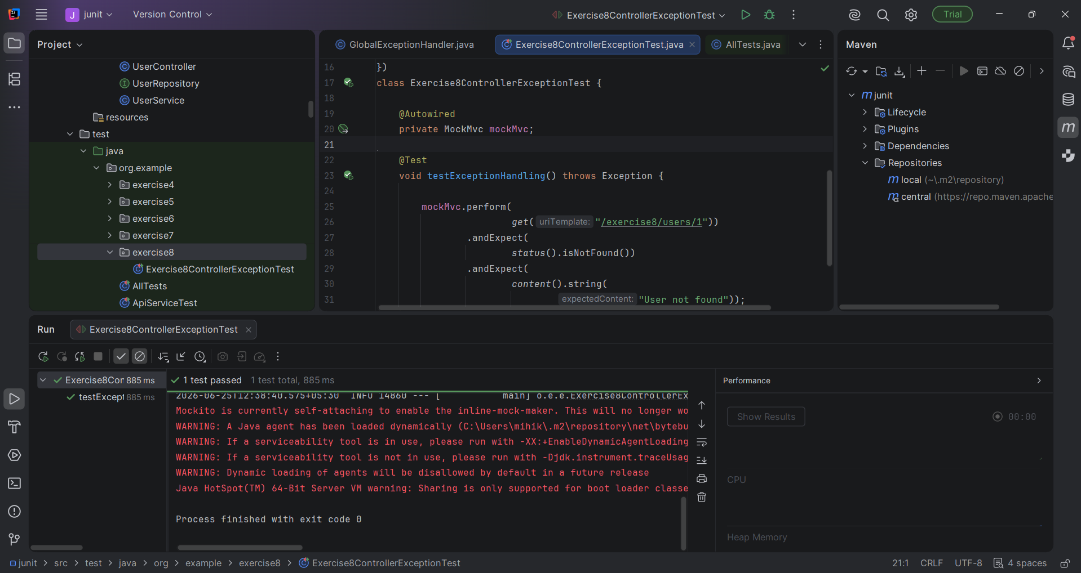

Exercise 9: Parameterized Test with Junit
Exercise9Calculator.java
package org.example.exercise9;
public class Exercise9Calculator {
public int add(int a, int b) {
return a + b;
}
}
Exercise9CalculatorTest.java
package org.example.exercise9;
import org.junit.jupiter.params.ParameterizedTest;
import org.junit.jupiter.params.provider.CsvSource;
import static org.junit.jupiter.api.Assertions.assertEquals;
class Exercise9CalculatorTest {
private final Exercise9Calculator calculator =
new Exercise9Calculator();
@ParameterizedTest
@CsvSource({
"1, 2, 3",
"5, 10, 15",
"100, 200, 300",
"-1, 1, 0"
})
void testAdd(
int a,
int b,
int expected) {
assertEquals(
expected,
calculator.add(a, b)
);
}
}
