pom.xml
<?xml version="1.0" encoding="UTF-8"?>
<project xmlns="http://maven.apache.org/POM/4.0.0"
xmlns:xsi="http://www.w3.org/2001/XMLSchema-instance"
xsi:schemaLocation="http://maven.apache.org/POM/4.0.0 http://maven.apache.org/xsd/maven-4.0.0.xsd">
<modelVersion>4.0.0</modelVersion>
<groupId>org.example</groupId>
<artifactId>MockitoAdvancedExercise</artifactId>
<version>1.0-SNAPSHOT</version>
<properties>
<maven.compiler.source>21</maven.compiler.source>
<maven.compiler.target>21</maven.compiler.target>
<project.build.sourceEncoding>UTF-8</project.build.sourceEncoding>
</properties>
<dependencies>
<dependency>
<groupId>org.junit.jupiter</groupId>
<artifactId>junit-jupiter</artifactId>
<version>5.10.2</version>
<scope>test</scope>
</dependency>
<dependency>
<groupId>org.mockito</groupId>
<artifactId>mockito-core</artifactId>
<version>5.12.0</version>
<scope>test</scope>
</dependency>
</dependencies>
</project>

ApiService.java
package org.example;
public class ApiService {
private RestClient restClient;
public ApiService(RestClient restClient) {
this.restClient = restClient;
}
public String fetchData() {
return "Fetched " + restClient.getResponse();
}
}

FileReader.java
package org.example;
public interface FileReader {
String read();
}

FileWriter.java
package org.example;
public interface FileWriter {
void write(String content);
}
FileService.java
package org.example;
public class FileService {
private FileReader fileReader;
private FileWriter fileWriter;
public FileService(FileReader fileReader, FileWriter fileWriter) {
this.fileReader = fileReader;
this.fileWriter = fileWriter;
}
public String processFile() {
String content = fileReader.read();
fileWriter.write(content);
return "Processed " + content;
}
}

NetworkClient.java
package org.example;
public interface NetworkClient {
String connect();
}

NetworkService.java
package org.example;
public class NetworkService {
private NetworkClient networkClient;
public NetworkService(NetworkClient networkClient) {
this.networkClient = networkClient;
}
public String connectToServer() {
return "Connected to " + networkClient.connect();
}
}

Repository.java
package org.example;
public interface Repository {
String getData();
}

RestClient.java
package org.example;
public interface RestClient {
String getResponse();
}

Service.java
package org.example;
public class Service {
private Repository repository;
public Service(Repository repository) {
this.repository = repository;
}
public String processData() {
return "Processed " + repository.getData();
}
}

ApiServiceTest.java
package org.example;
import org.junit.jupiter.api.Test;
import static org.junit.jupiter.api.Assertions.assertEquals;
import static org.mockito.Mockito.*;
public class ApiServiceTest {
@Test
public void testServiceWithMockRestClient() {
RestClient mockRestClient = mock(RestClient.class);
when(mockRestClient.getResponse()).thenReturn("Mock Response");
ApiService apiService = new ApiService(mockRestClient);
String result = apiService.fetchData();
assertEquals("Fetched Mock Response", result);
}
}

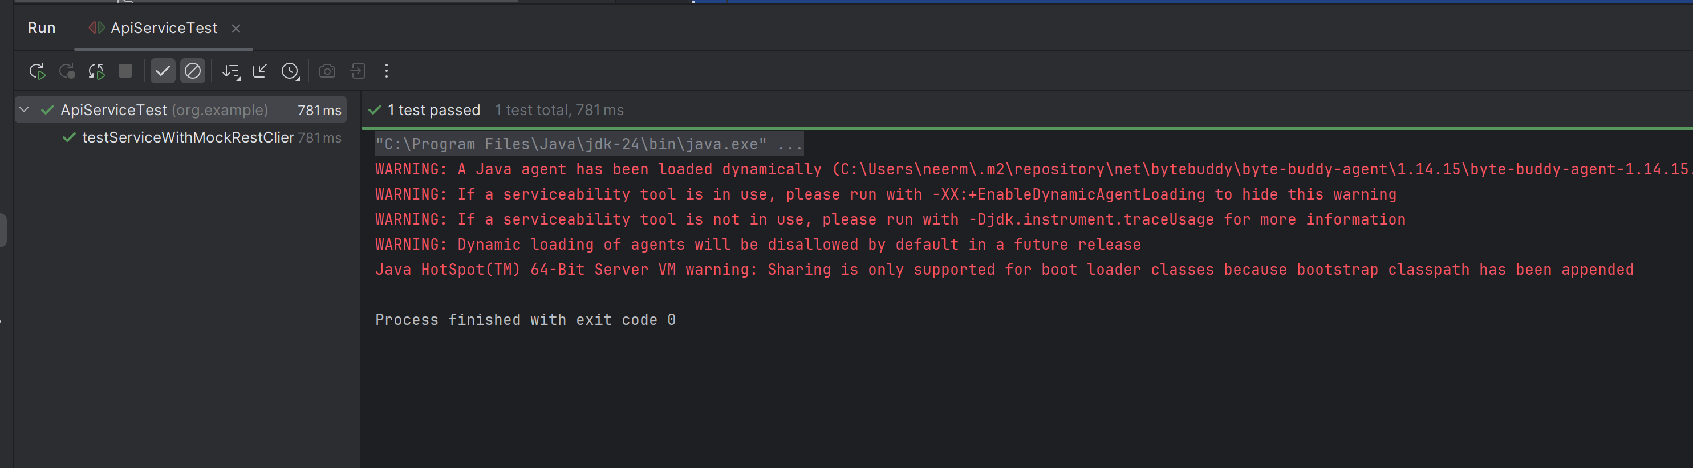

FileServiceTest.java
package org.example;
import org.junit.jupiter.api.Test;
import static org.junit.jupiter.api.Assertions.assertEquals;
import static org.mockito.Mockito.*;
public class FileServiceTest {
@Test
public void testServiceWithMockFileIO() {
FileReader mockFileReader = mock(FileReader.class);
FileWriter mockFileWriter = mock(FileWriter.class);
when(mockFileReader.read()).thenReturn("Mock File Content");
FileService fileService =
new FileService(mockFileReader, mockFileWriter);
String result = fileService.processFile();
assertEquals("Processed Mock File Content", result);
verify(mockFileWriter).write("Mock File Content");
}
}

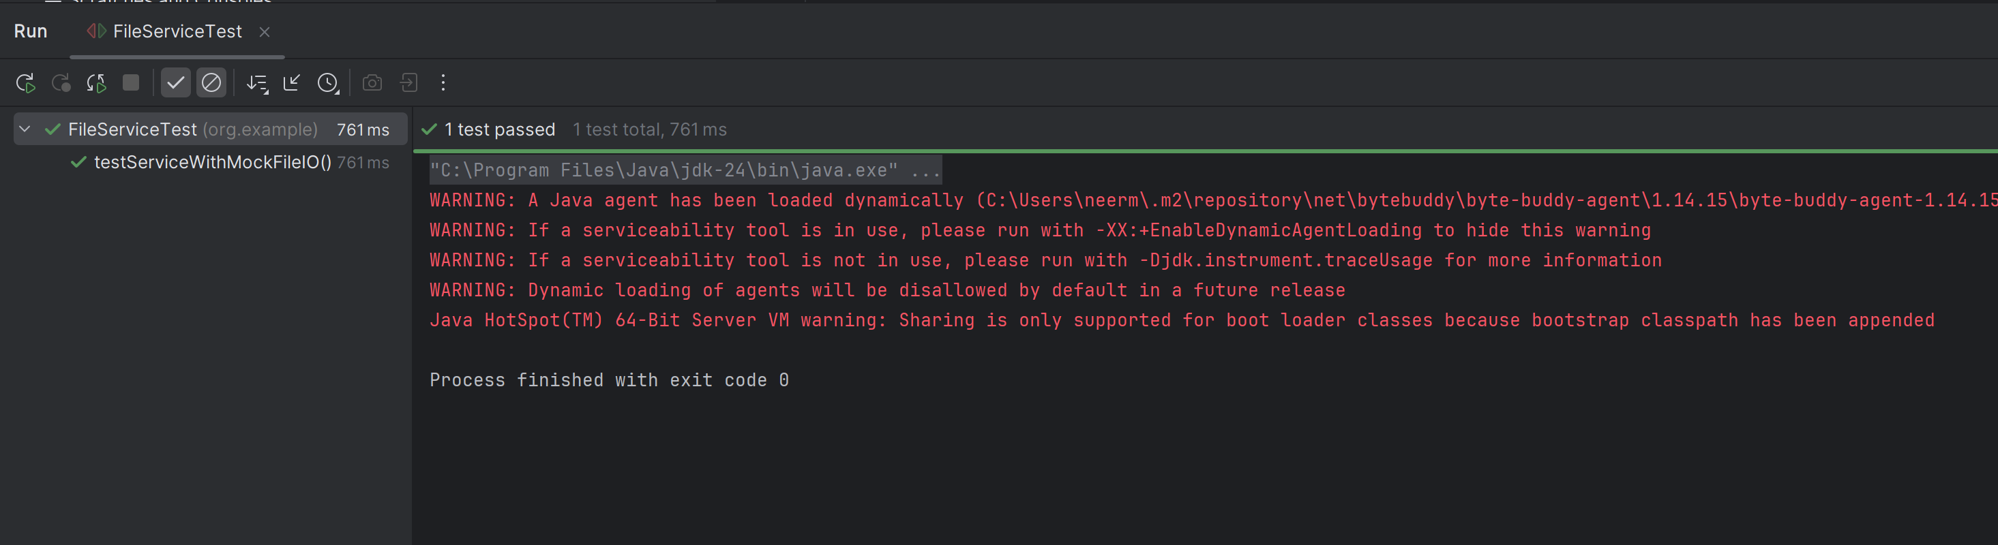

MultiReturnServiceTest.java
package org.example;
import org.junit.jupiter.api.Test;
import static org.junit.jupiter.api.Assertions.assertEquals;
import static org.mockito.Mockito.*;
public class MultiReturnServiceTest {
@Test
public void testServiceWithMultipleReturnValues() {
Repository mockRepository = mock(Repository.class);
when(mockRepository.getData())
.thenReturn("First Mock Data")
.thenReturn("Second Mock Data");
Service service = new Service(mockRepository);
String firstResult = service.processData();
String secondResult = service.processData();
assertEquals("Processed First Mock Data", firstResult);
assertEquals("Processed Second Mock Data", secondResult);
}
}

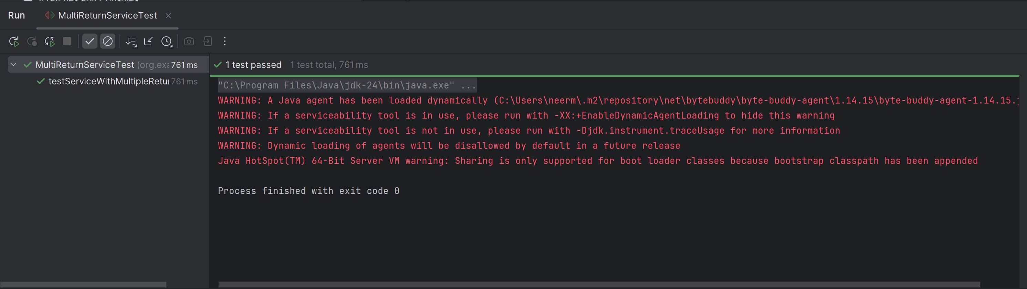

NetworkServiceTest.java
package org.example;
import org.junit.jupiter.api.Test;
import static org.junit.jupiter.api.Assertions.assertEquals;
import static org.mockito.Mockito.*;
public class NetworkServiceTest {
@Test
public void testServiceWithMockNetworkClient() {
NetworkClient mockNetworkClient = mock(NetworkClient.class);
when(mockNetworkClient.connect()).thenReturn("Mock Connection");
NetworkService networkService =
new NetworkService(mockNetworkClient);
String result = networkService.connectToServer();
assertEquals("Connected to Mock Connection", result);
}
}

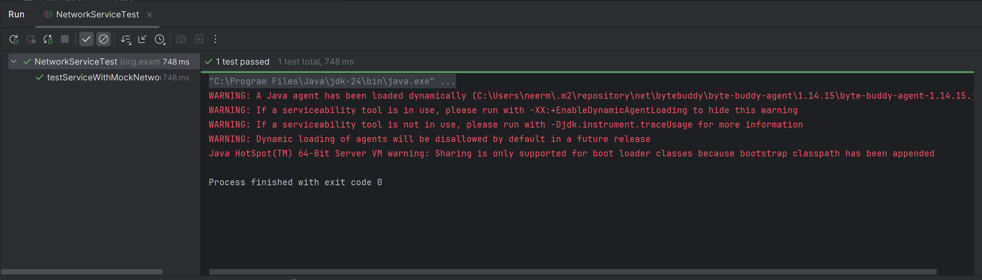

ServiceTest.java
package org.example;
import org.junit.jupiter.api.Test;
import static org.junit.jupiter.api.Assertions.assertEquals;
import static org.mockito.Mockito.*;
public class ServiceTest {
@Test
public void testServiceWithMockRepository() {
Repository mockRepository = mock(Repository.class);
when(mockRepository.getData()).thenReturn("Mock Data");
Service service = new Service(mockRepository);
String result = service.processData();
assertEquals("Processed Mock Data", result);
}
}

