Exercise 1: Mocking a Service Dependency in a Controller Test
Exercise1User.java
package org.example.mock1;
public class Exercise1User {
private Long id;
private String name;
public Exercise1User() {
}
public Exercise1User(Long id, String name) {
this.id = id;
this.name = name;
}
public Long getId() {
return id;
}
public String getName() {
return name;
}
public void setId(Long id) {
this.id = id;
}
public void setName(String name) {
this.name = name;
}
}
Exercise1UserService.java
package org.example.mock1;
import org.springframework.stereotype.Service;
@Service
public class Exercise1UserService {
public Exercise1User getUserById(Long id) {
return new Exercise1User(id, "John");
}
}
Exercise1UserController.java
package org.example.mock1;
import org.springframework.http.ResponseEntity;
import org.springframework.web.bind.annotation.*;
@RestController
@RequestMapping("/mock1/users")
public class Exercise1UserController {
private final Exercise1UserService userService;
public Exercise1UserController(
Exercise1UserService userService) {
this.userService = userService;
}
@GetMapping("/{id}")
public ResponseEntity<Exercise1User> getUser(
@PathVariable("id") Long id) {
return ResponseEntity.ok(
userService.getUserById(id)
);
}
}
Exercise1Application.java
package org.example.mock1;
import org.springframework.boot.autoconfigure.SpringBootApplication;
@SpringBootApplication
public class Exercise1Application {
}
Exercise1UserControllerTest.java
package org.example.mock1;
import org.junit.jupiter.api.Test;
import org.springframework.beans.factory.annotation.Autowired;
import org.springframework.boot.test.autoconfigure.web.servlet.WebMvcTest;
import org.springframework.boot.test.mock.mockito.MockBean;
import org.springframework.test.context.ContextConfiguration;
import org.springframework.test.web.servlet.MockMvc;
import static org.mockito.Mockito.when;
import static org.springframework.test.web.servlet.request.MockMvcRequestBuilders.get;
import static org.springframework.test.web.servlet.result.MockMvcResultMatchers.*;
@WebMvcTest(Exercise1UserController.class)
@ContextConfiguration(classes = Exercise1Application.class)
class Exercise1UserControllerTest {
@Autowired
private MockMvc mockMvc;
@MockBean
private Exercise1UserService userService;
@Test
void testGetUser() throws Exception {
Exercise1User user =
new Exercise1User(1L, "John");
when(userService.getUserById(1L))
.thenReturn(user);
mockMvc.perform(
get("/mock1/users/1"))
.andExpect(status().isOk())
.andExpect(jsonPath("$.id")
.value(1))
.andExpect(jsonPath("$.name")
.value("John"));
}
}
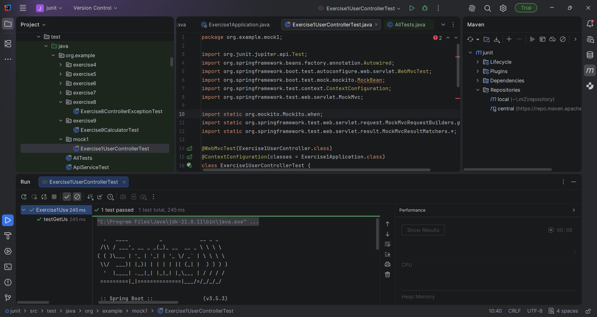

Exercise 2: Mocking a Repository in a Service Test
Exercise2User.java
package org.example.mock2;
public class Exercise2User {
private Long id;
private String name;
public Exercise2User() {
}
public Exercise2User(Long id, String name) {
this.id = id;
this.name = name;
}
public Long getId() {
return id;
}
public String getName() {
return name;
}
}
Exercise2UserRepository.java
package org.example.mock2;
import java.util.Optional;
public interface Exercise2UserRepository {
Optional<Exercise2User> findById(Long id);
}
Exercise2UserService.java
package org.example.mock2;
public class Exercise2UserService {
private final Exercise2UserRepository repository;
public Exercise2UserService(
Exercise2UserRepository repository) {
this.repository = repository;
}
public Exercise2User getUserById(Long id) {
return repository.findById(id)
.orElse(null);
}
}
Exercise2UserServiceTest.java
package org.example.mock2;
import org.junit.jupiter.api.Test;
import java.util.Optional;
import static org.junit.jupiter.api.Assertions.*;
import static org.mockito.Mockito.*;
class Exercise2UserServiceTest {
@Test
void testGetUserById() {
Exercise2UserRepository repository =
mock(Exercise2UserRepository.class);
Exercise2User user =
new Exercise2User(1L, "John");
when(repository.findById(1L))
.thenReturn(Optional.of(user));
Exercise2UserService service =
new Exercise2UserService(repository);
Exercise2User result =
service.getUserById(1L);
assertNotNull(result);
assertEquals(
"John",
result.getName()
);
}
}
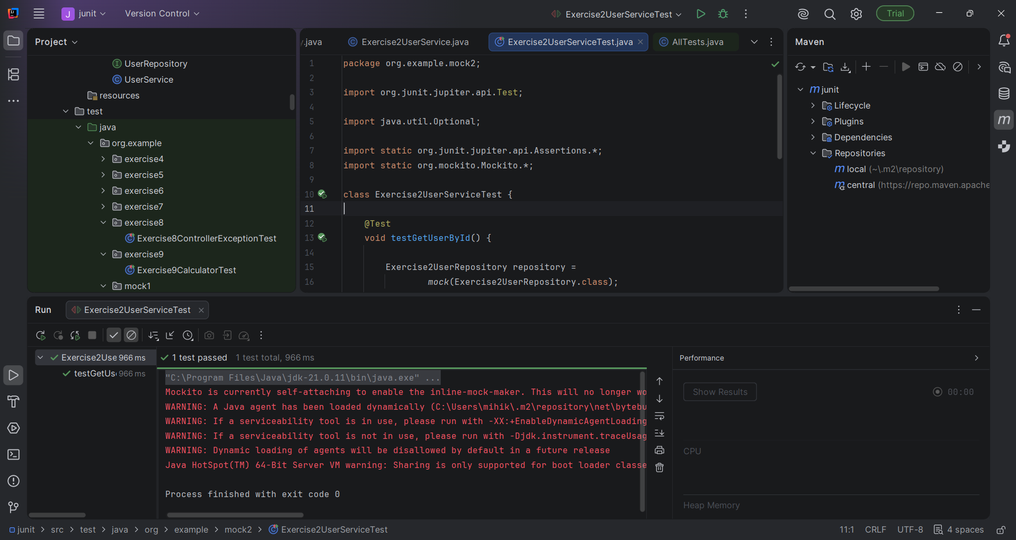

Exercise 3: Mocking a Service Dependency in an Integration Test
Exercise3User.java
package org.example.mock3;
public class Exercise3User {
private Long id;
private String name;
public Exercise3User() {
}
public Exercise3User(Long id, String name) {
this.id = id;
this.name = name;
}
public Long getId() {
return id;
}
public String getName() {
return name;
}
}

Exercise3UserService.java
package org.example.mock3;
import org.springframework.stereotype.Service;
@Service
public class Exercise3UserService {
public Exercise3User getUserById(Long id) {
return new Exercise3User(id, "John");
}
}

Exercise3UserController.java
package org.example.mock3;
import org.springframework.http.ResponseEntity;
import org.springframework.web.bind.annotation.*;
@RestController
@RequestMapping("/mock3/users")
public class Exercise3UserController {
private final Exercise3UserService service;
public Exercise3UserController(
Exercise3UserService service) {
this.service = service;
}
@GetMapping("/{id}")
public ResponseEntity<Exercise3User> getUser(
@PathVariable("id") Long id) {
return ResponseEntity.ok(
service.getUserById(id)
);
}
}

Exercise3Application.java
package org.example.mock3;
import org.springframework.boot.autoconfigure.SpringBootApplication;
@SpringBootApplication
public class Exercise3Application {
}

Exercise3IntegrationTest.java
package org.example.mock3;
import org.junit.jupiter.api.Test;
import org.springframework.beans.factory.annotation.Autowired;
import org.springframework.boot.test.autoconfigure.web.servlet.AutoConfigureMockMvc;
import org.springframework.boot.test.context.SpringBootTest;
import org.springframework.boot.test.mock.mockito.MockBean;
import org.springframework.test.web.servlet.MockMvc;
import static org.mockito.Mockito.when;
import static org.springframework.test.web.servlet.request.MockMvcRequestBuilders.get;
import static org.springframework.test.web.servlet.result.MockMvcResultMatchers.*;
@SpringBootTest(classes = Exercise3Application.class)
@AutoConfigureMockMvc
class Exercise3IntegrationTest {
@Autowired
private MockMvc mockMvc;
@MockBean
private Exercise3UserService service;
@Test
void testGetUser() throws Exception {
Exercise3User user =
new Exercise3User(1L, "John");
when(service.getUserById(1L))
.thenReturn(user);
mockMvc.perform(
get("/mock3/users/1"))
.andExpect(status().isOk())
.andExpect(jsonPath("$.id")
.value(1))
.andExpect(jsonPath("$.name")
.value("John"));
}
}
