pom.xml
<project xmlns="http://maven.apache.org/POM/4.0.0"
xmlns:xsi="http://www.w3.org/2001/XMLSchema-instance"
xsi:schemaLocation="http://maven.apache.org/POM/4.0.0
http://maven.apache.org/xsd/maven-4.0.0.xsd">
<modelVersion>4.0.0</modelVersion>
<groupId>org.example</groupId>
<artifactId>SLF4JLoggingDemo</artifactId>
<version>1.0-SNAPSHOT</version>
<properties>
<maven.compiler.source>21</maven.compiler.source>
<maven.compiler.target>21</maven.compiler.target>
</properties>
<dependencies>
<dependency>
<groupId>org.slf4j</groupId>
<artifactId>slf4j-api</artifactId>
<version>1.7.30</version>
</dependency>
<dependency>
<groupId>ch.qos.logback</groupId>
<artifactId>logback-classic</artifactId>
<version>1.2.3</version>
</dependency>
</dependencies>
</project>

Exercise1Logging.java
package org.example;
import org.slf4j.Logger;
import org.slf4j.LoggerFactory;
public class Exercise1Logging {
private static final Logger logger =
LoggerFactory.getLogger(Exercise1Logging.class);
public static void main(String[] args) {
logger.error("This is an error message");
logger.warn("This is a warning message");
}
}
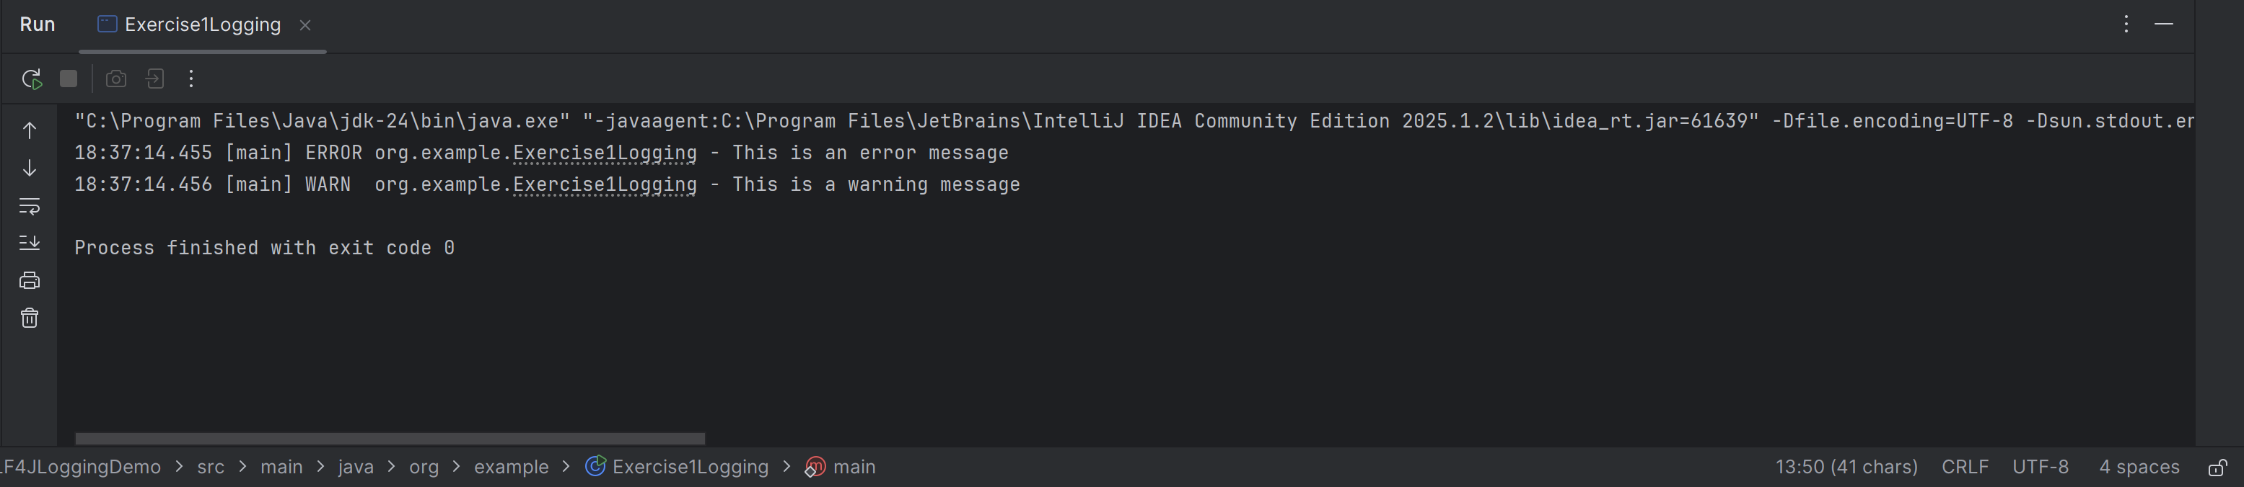

Exercise2ParameterizedLogging.java
package org.example;
import org.slf4j.Logger;
import org.slf4j.LoggerFactory;
public class Exercise2ParameterizedLogging {
private static final Logger logger =
LoggerFactory.getLogger(Exercise2ParameterizedLogging.class);
public static void main(String[] args) {
String name = "Neer";
int age = 20;
double salary = 50000;
logger.info("Employee Name : {}", name);
logger.info("Employee Age : {}", age);
logger.info("Employee Salary : {}", salary);
logger.info("Employee {} is {} years old.", name, age);
}
}
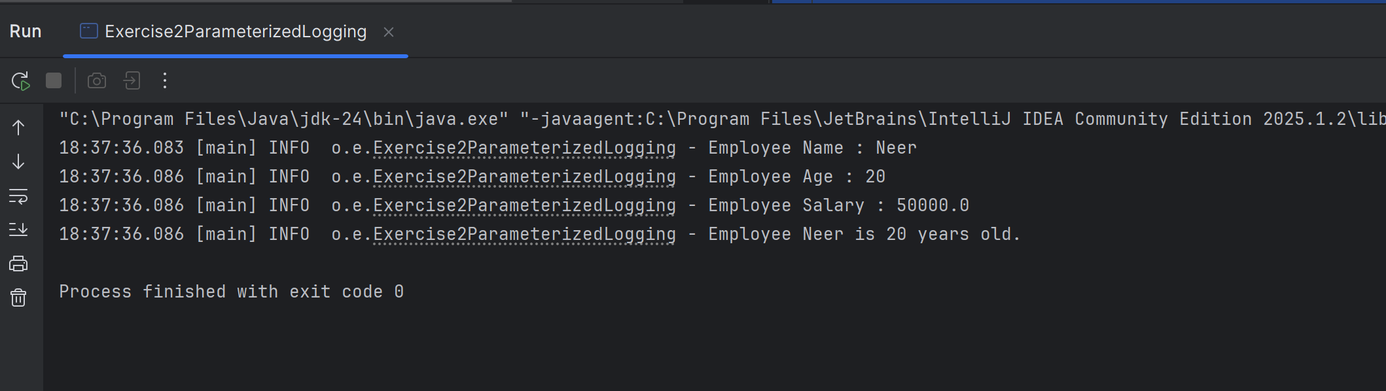
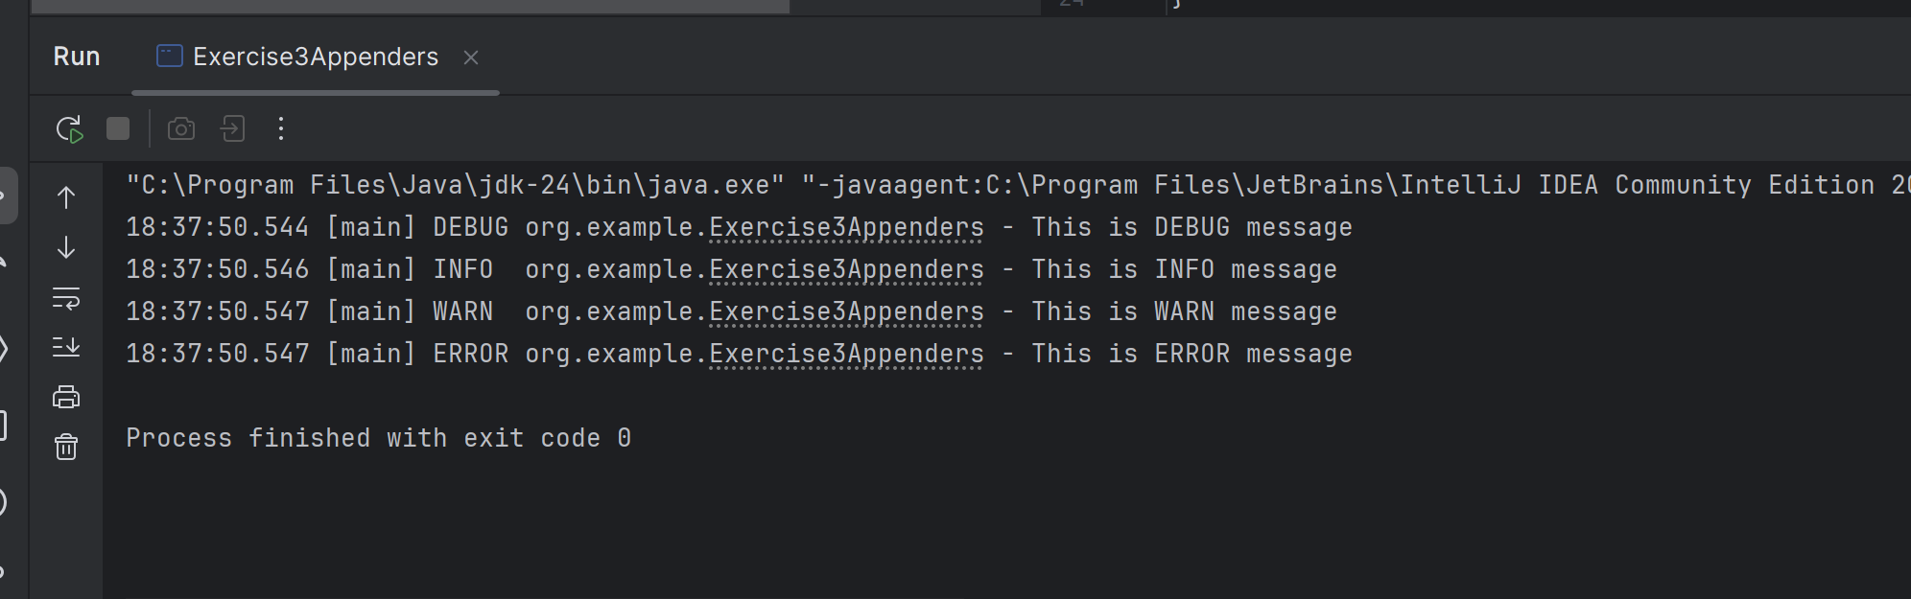

Due to all this app.log has been created which is
app.log
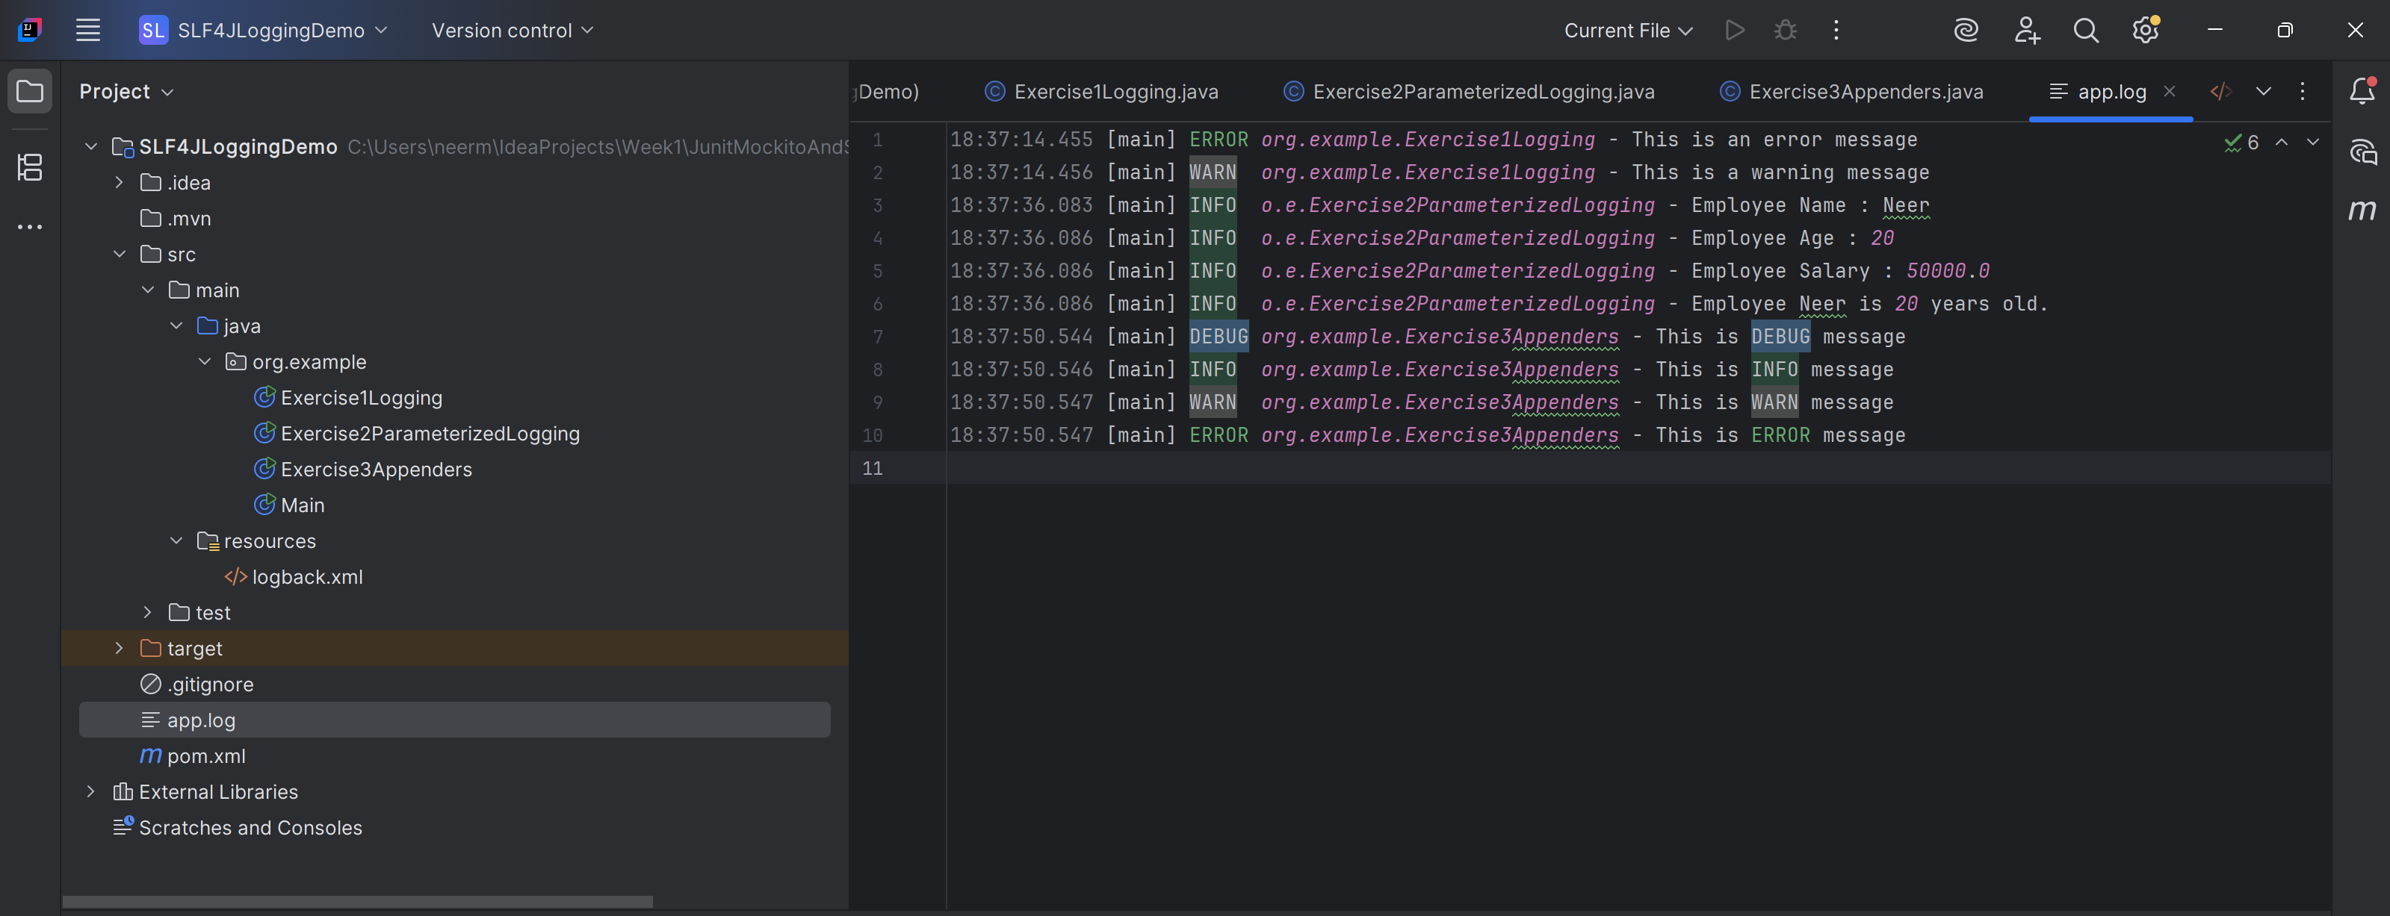

Exercise3Appenders.java
package org.example;
import org.slf4j.Logger;
import org.slf4j.LoggerFactory;
public class Exercise3Appenders {
private static final Logger logger =
LoggerFactory.getLogger(Exercise3Appenders.class);
public static void main(String[] args) {
logger.trace("This is TRACE message");
logger.debug("This is DEBUG message");
logger.info("This is INFO message");
logger.warn("This is WARN message");
logger.error("This is ERROR message");
}
}

loggback.xml
<configuration>
<appender name="console"
class="ch.qos.logback.core.ConsoleAppender">
<encoder>
<pattern>
%d{HH:mm:ss.SSS} [%thread] %-5level %logger{36} - %msg%n
</pattern>
</encoder>
</appender>
<appender name="file"
class="ch.qos.logback.core.FileAppender">
<file>app.log</file>
<append>true</append>
<encoder>
<pattern>
%d{HH:mm:ss.SSS} [%thread] %-5level %logger{36} - %msg%n
</pattern>
</encoder>
</appender>
<root level="debug">
<appender-ref ref="console"/>
<appender-ref ref="file"/>
</root>
</configuration>

