application.properties
spring.application.name=spring-learn
server.port=8083

Country.java
package com.cognizant.springlearn.model;
public class Country {
private String code;
private String name;
public Country() {
}
public Country(String code, String name) {
this.code = code;
this.name = name;
}
public String getCode() {
return code;
}
public void setCode(String code) {
this.code = code;
}
public String getName() {
return name;
}
public void setName(String name) {
this.name = name;
}
@Override
public String toString() {
return "Country{" +
"code='" + code + '\'' +
", name='" + name + '\'' +
'}';
}
}

CountryList.java

package com.cognizant.springlearn.model;
import java.util.List;
public class CountryList {
private List<Country> countryList;
public List<Country> getCountryList() {
return countryList;
}
public void setCountryList(List<Country> countryList) {
this.countryList = countryList;
}
}

Country.xml
<?xml version="1.0" encoding="UTF-8"?>

<beans xmlns="http://www.springframework.org/schema/beans"
xmlns:xsi="http://www.w3.org/2001/XMLSchema-instance"
xsi:schemaLocation="
http://www.springframework.org/schema/beans
https://www.springframework.org/schema/beans/spring-beans.xsd">

<!-- India Bean -->

<bean id="country"
class="com.cognizant.springlearn.model.Country">

<property name="code" value="IN"/>
<property name="name" value="India"/>

</bean>

<!-- List of Countries -->

<bean id="countryList"
class="com.cognizant.springlearn.model.CountryList">

<property name="countryList">

<list>

<bean class="com.cognizant.springlearn.model.Country">
<property name="code" value="IN"/>
<property name="name" value="India"/>
</bean>

<bean class="com.cognizant.springlearn.model.Country">
<property name="code" value="US"/>
<property name="name" value="United States"/>
</bean>

<bean class="com.cognizant.springlearn.model.Country">
<property name="code" value="JP"/>
<property name="name" value="Japan"/>
</bean>

<bean class="com.cognizant.springlearn.model.Country">
<property name="code" value="DE"/>
<property name="name" value="Germany"/>
</bean>

</list>

</property>

</bean>

</beans>
SpringLearnApplication.java
package com.cognizant.springlearn;

import org.springframework.boot.SpringApplication;
import org.springframework.boot.autoconfigure.SpringBootApplication;
import org.springframework.context.annotation.ImportResource;

@SpringBootApplication
@ImportResource({"classpath:country.xml"})
public class SpringLearnApplication {

public static void main(String[] args) {
SpringApplication.run(SpringLearnApplication.class, args);
}

}
HelloController.java
package com.cognizant.springlearn.controller;
import org.slf4j.Logger;
import org.slf4j.LoggerFactory;
import org.springframework.web.bind.annotation.GetMapping;
import org.springframework.web.bind.annotation.RestController;
@RestController
public class HelloController {
private static final Logger LOGGER =
LoggerFactory.getLogger(HelloController.class);
@GetMapping("/hello")
public String sayHello() {
LOGGER.info("START");
String message = "Hello World!!";
LOGGER.info("END");
return message;
}
}

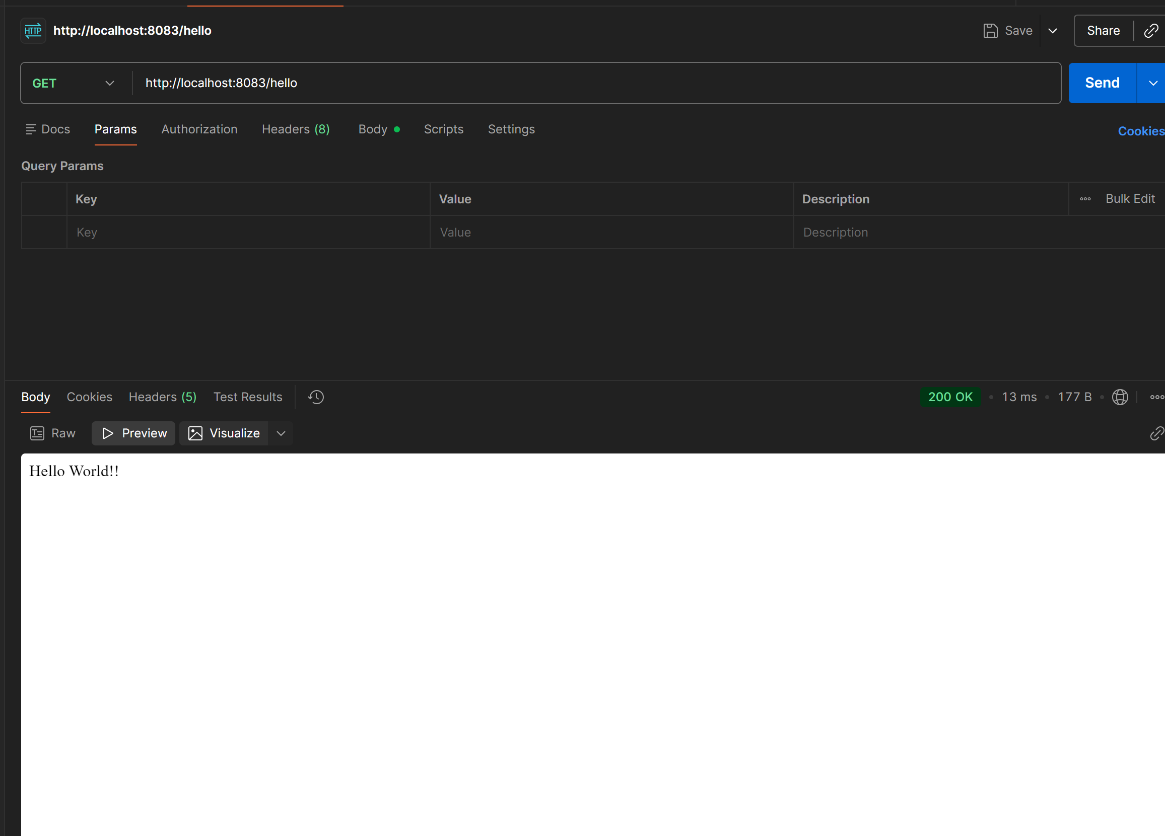

CountryController.java
package com.cognizant.springlearn.controller;

import com.cognizant.springlearn.model.Country;
import org.slf4j.Logger;
import org.slf4j.LoggerFactory;
import org.springframework.context.ApplicationContext;
import org.springframework.context.support.ClassPathXmlApplicationContext;
import org.springframework.web.bind.annotation.RequestMapping;
import org.springframework.web.bind.annotation.RestController;

@RestController
public class CountryController {

private static final Logger LOGGER =
LoggerFactory.getLogger(CountryController.class);

@RequestMapping("/country")
public Country getCountryIndia() {

LOGGER.info("START");

ApplicationContext context =
new ClassPathXmlApplicationContext("country.xml");

Country country = context.getBean("country", Country.class);

LOGGER.info("Country : {}", country);

LOGGER.info("END");

return country;
}

}
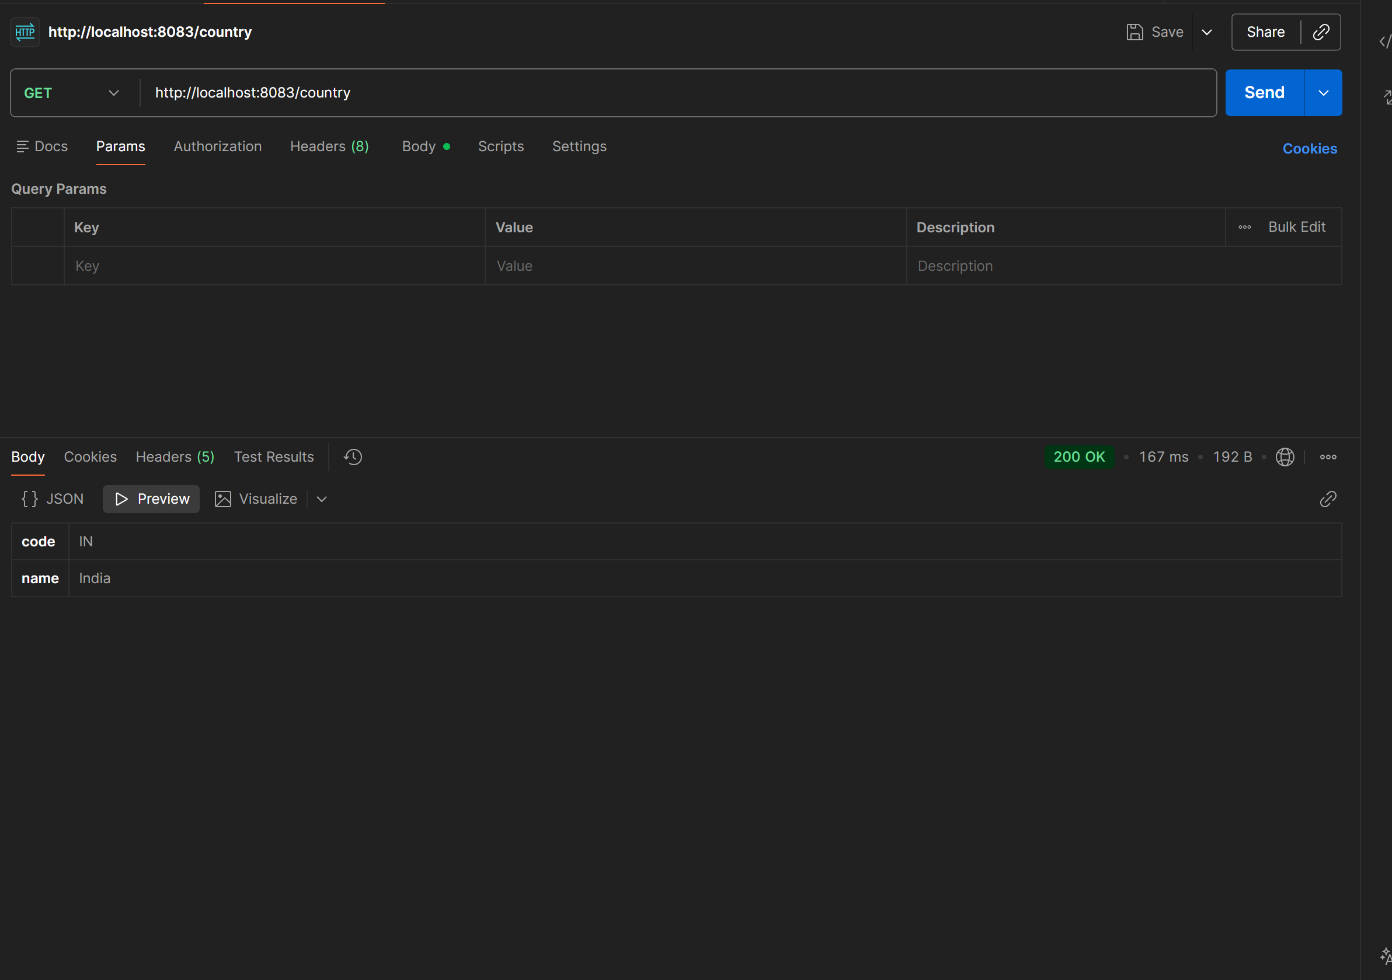

CountryService.java
package com.cognizant.springlearn.service;

import com.cognizant.springlearn.model.Country;
import com.cognizant.springlearn.model.CountryList;
import org.springframework.context.ApplicationContext;
import org.springframework.context.support.ClassPathXmlApplicationContext;
import org.springframework.stereotype.Service;

import java.util.List;

@Service
public class CountryService {

public List<Country> getAllCountries() {

ApplicationContext context =
new ClassPathXmlApplicationContext("country.xml");

CountryList countryList =
context.getBean("countryList", CountryList.class);

return countryList.getCountryList();
}

}

CountryController.java
package com.cognizant.springlearn.controller;

import com.cognizant.springlearn.model.Country;
import com.cognizant.springlearn.service.CountryService;
import org.slf4j.Logger;
import org.slf4j.LoggerFactory;
import org.springframework.beans.factory.annotation.Autowired;
import org.springframework.context.ApplicationContext;
import org.springframework.context.support.ClassPathXmlApplicationContext;
import org.springframework.web.bind.annotation.GetMapping;
import org.springframework.web.bind.annotation.RequestMapping;
import org.springframework.web.bind.annotation.RestController;

import java.util.List;

@RestController
public class CountryController {

private static final Logger LOGGER =
LoggerFactory.getLogger(CountryController.class);

@Autowired
private CountryService countryService;

@RequestMapping("/country")
public Country getCountryIndia() {

LOGGER.info("START");

ApplicationContext context =
new ClassPathXmlApplicationContext("country.xml");

Country country = context.getBean("country", Country.class);

LOGGER.info("Country : {}", country);

LOGGER.info("END");

return country;
}

@GetMapping("/countries")
public List<Country> getAllCountries() {

LOGGER.info("START");

List<Country> countries = countryService.getAllCountries();

LOGGER.info("END");

return countries;
}

}
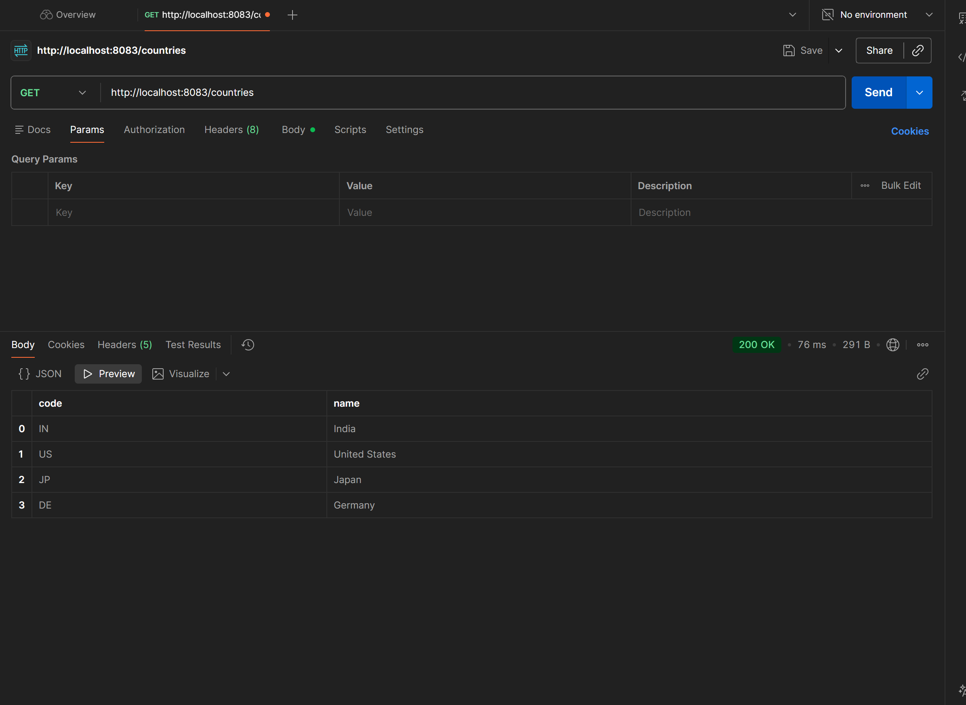

CountryService.java
package com.cognizant.springlearn.service;

import com.cognizant.springlearn.model.Country;
import com.cognizant.springlearn.model.CountryList;
import org.springframework.context.ApplicationContext;
import org.springframework.context.support.ClassPathXmlApplicationContext;
import org.springframework.stereotype.Service;

import java.util.List;

@Service
public class CountryService {

public List<Country> getAllCountries() {

ApplicationContext context =
new ClassPathXmlApplicationContext("country.xml");

CountryList countryList =
context.getBean("countryList", CountryList.class);

return countryList.getCountryList();
}

public Country getCountry(String code) {

List<Country> countries = getAllCountries();

for (Country country : countries) {

if (country.getCode().equalsIgnoreCase(code)) {
return country;
}

}

return null;
}

}

CountryController.java
package com.cognizant.springlearn.controller;
import com.cognizant.springlearn.model.Country;
import com.cognizant.springlearn.service.CountryService;
import org.slf4j.Logger;
import org.slf4j.LoggerFactory;
import org.springframework.beans.factory.annotation.Autowired;
import org.springframework.context.ApplicationContext;
import org.springframework.context.support.ClassPathXmlApplicationContext;
import org.springframework.web.bind.annotation.GetMapping;
import org.springframework.web.bind.annotation.PathVariable;
import org.springframework.web.bind.annotation.RequestMapping;
import org.springframework.web.bind.annotation.RestController;
import java.util.List;
@RestController
public class CountryController {
private static final Logger LOGGER =
LoggerFactory.getLogger(CountryController.class);
@Autowired
private CountryService countryService;
@RequestMapping("/country")
public Country getCountryIndia() {
LOGGER.info("START");
ApplicationContext context =
new ClassPathXmlApplicationContext("country.xml");
Country country = context.getBean("country", Country.class);
LOGGER.info("Country : {}", country);
LOGGER.info("END");
return country;
}
@GetMapping("/countries")
public List<Country> getAllCountries() {
LOGGER.info("START");
List<Country> countries = countryService.getAllCountries();
LOGGER.info("END");
return countries;
}
@GetMapping("/countries/{code}")
public Country getCountry(@PathVariable String code) {
LOGGER.info("START");
Country country = countryService.getCountry(code);
LOGGER.info("END");
return country;
}
}

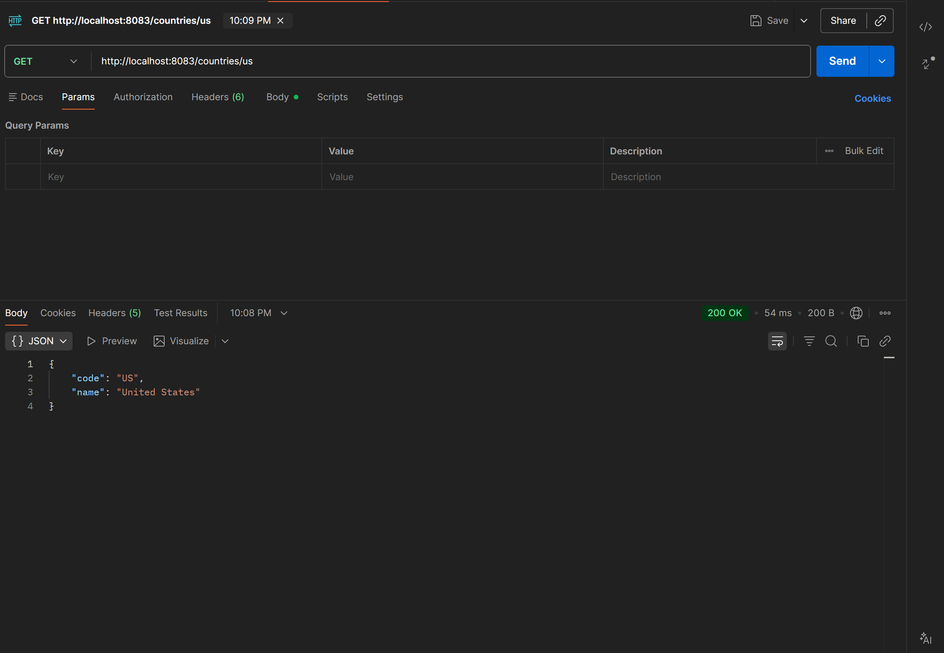
CountryService.java
package com.cognizant.springlearn.service;

import com.cognizant.springlearn.exception.CountryNotFoundException;
import com.cognizant.springlearn.model.Country;
import com.cognizant.springlearn.model.CountryList;
import org.springframework.context.ApplicationContext;
import org.springframework.context.support.ClassPathXmlApplicationContext;
import org.springframework.stereotype.Service;

import java.util.List;

@Service
public class CountryService {

public List<Country> getAllCountries() {

ApplicationContext context =
new ClassPathXmlApplicationContext("country.xml");

CountryList countryList =
context.getBean("countryList", CountryList.class);

return countryList.getCountryList();
}

public Country getCountry(String code) throws CountryNotFoundException {

List<Country> countries = getAllCountries();

for (Country country : countries) {

if (country.getCode().equalsIgnoreCase(code)) {
return country;
}

}

throw new CountryNotFoundException();

}

}
CountryNotFoundException.java
package com.cognizant.springlearn.exception;
import org.springframework.http.HttpStatus;
import org.springframework.web.bind.annotation.ResponseStatus;
@ResponseStatus(value = HttpStatus.NOT_FOUND, reason = "Country not found")
public class CountryNotFoundException extends Exception {
public CountryNotFoundException() {
super();
}
public CountryNotFoundException(String message) {
super(message);
}
}

CountryController.java
package com.cognizant.springlearn.controller;

import com.cognizant.springlearn.exception.CountryNotFoundException;
import com.cognizant.springlearn.model.Country;
import com.cognizant.springlearn.service.CountryService;
import org.slf4j.Logger;
import org.slf4j.LoggerFactory;
import org.springframework.beans.factory.annotation.Autowired;
import org.springframework.context.ApplicationContext;
import org.springframework.context.support.ClassPathXmlApplicationContext;
import org.springframework.web.bind.annotation.GetMapping;
import org.springframework.web.bind.annotation.PathVariable;
import org.springframework.web.bind.annotation.RequestMapping;
import org.springframework.web.bind.annotation.RestController;

import java.util.List;

@RestController
public class CountryController {

private static final Logger LOGGER =
LoggerFactory.getLogger(CountryController.class);

@Autowired
private CountryService countryService;

@RequestMapping("/country")
public Country getCountryIndia() {

LOGGER.info("START");

ApplicationContext context =
new ClassPathXmlApplicationContext("country.xml");

Country country = context.getBean("country", Country.class);

LOGGER.info("Country : {}", country);

LOGGER.info("END");

return country;
}

@GetMapping("/countries")
public List<Country> getAllCountries() {

LOGGER.info("START");

List<Country> countries = countryService.getAllCountries();

LOGGER.info("END");

return countries;
}

@GetMapping("/countries/{code}")
public Country getCountry(@PathVariable String code)
throws CountryNotFoundException {

LOGGER.info("START");

Country country = countryService.getCountry(code);

LOGGER.info("END");

return country;
}
}
Output
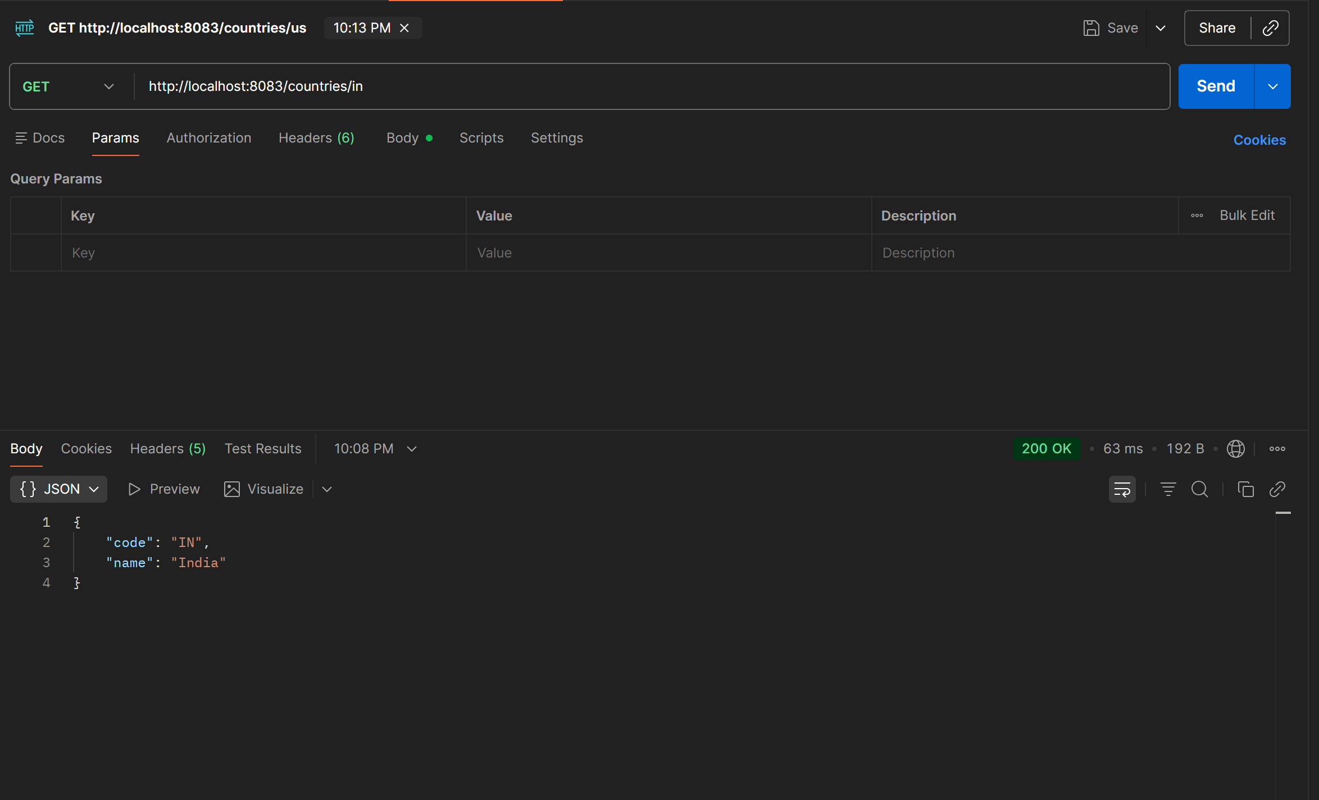

SpringLearnApplication.java
package com.cognizant.springlearn;

import com.cognizant.springlearn.controller.CountryController;
import org.junit.jupiter.api.Test;
import org.springframework.beans.factory.annotation.Autowired;
import org.springframework.boot.test.autoconfigure.web.servlet.AutoConfigureMockMvc;
import org.springframework.boot.test.context.SpringBootTest;
import org.springframework.test.web.servlet.MockMvc;
import org.springframework.test.web.servlet.ResultActions;

import static org.junit.jupiter.api.Assertions.assertNotNull;
import static org.springframework.test.web.servlet.request.MockMvcRequestBuilders.get;
import static org.springframework.test.web.servlet.result.MockMvcResultMatchers.*;

@SpringBootTest
@AutoConfigureMockMvc
class SpringLearnApplicationTests {

@Autowired
private CountryController countryController;

@Autowired
private MockMvc mvc;

@Test
void contextLoads() {

assertNotNull(countryController);

}

@Test
void testGetCountry() throws Exception {

ResultActions actions = mvc.perform(get("/country"));

actions.andExpect(status().isOk());

actions.andExpect(jsonPath("$.code").exists());
actions.andExpect(jsonPath("$.code").value("IN"));

actions.andExpect(jsonPath("$.name").exists());
actions.andExpect(jsonPath("$.name").value("India"));

}

@Test
void testGetCountryException() throws Exception {

ResultActions actions =
mvc.perform(get("/countries/az"));

actions.andExpect(status().isNotFound());

}

}

SpringApplicationTest.java
package com.cognizant.springlearn;
import com.cognizant.springlearn.controller.CountryController;
import org.junit.jupiter.api.Test;
import org.springframework.beans.factory.annotation.Autowired;
import org.springframework.boot.test.autoconfigure.web.servlet.AutoConfigureMockMvc;
import org.springframework.boot.test.context.SpringBootTest;
import org.springframework.test.web.servlet.MockMvc;
import org.springframework.test.web.servlet.ResultActions;
import static org.junit.jupiter.api.Assertions.assertNotNull;
import static org.springframework.test.web.servlet.request.MockMvcRequestBuilders.get;
import static org.springframework.test.web.servlet.result.MockMvcResultMatchers.*;
@SpringBootTest
@AutoConfigureMockMvc
class SpringLearnApplicationTests {
@Autowired
private CountryController countryController;
@Autowired
private MockMvc mvc;
@Test
void contextLoads() {
assertNotNull(countryController);
}
@Test
void testGetCountry() throws Exception {
ResultActions actions = mvc.perform(get("/country"));
actions.andExpect(status().isOk());
actions.andExpect(jsonPath("$.code").exists());
actions.andExpect(jsonPath("$.code").value("IN"));
actions.andExpect(jsonPath("$.name").exists());
actions.andExpect(jsonPath("$.name").value("India"));
}
@Test
void testGetCountryException() throws Exception {
ResultActions actions =
mvc.perform(get("/countries/az"));
actions.andExpect(status().isNotFound());
}
}

