Application.properties
spring.application.name=springlearn

server.port=8090

logging.level.com.cognizant.springlearn=DEBUG
Country.java
package com.cognizant.springlearn.model;

import jakarta.validation.constraints.NotNull;
import jakarta.validation.constraints.Size;

public class Country {

@NotNull
@Size(min = 2, max = 2, message = "Country code should be 2 characters")
private String code;

private String name;

public Country() {
}

public Country(String code, String name) {
this.code = code;
this.name = name;
}

public String getCode() {
return code;
}

public void setCode(String code) {
this.code = code;
}

public String getName() {
return name;
}

public void setName(String name) {
this.name = name;
}

@Override
public String toString() {
return "Country{" +
"code='" + code + '\'' +
", name='" + name + '\'' +
'}';
}
}
Department.java
package com.cognizant.springlearn.model;

import jakarta.validation.constraints.NotBlank;
import jakarta.validation.constraints.NotNull;
import jakarta.validation.constraints.Size;

public class Department {

@NotNull
private Integer id;

@NotBlank
@Size(min = 1, max = 30)
private String name;

public Department() {
}

public Department(Integer id, String name) {
this.id = id;
this.name = name;
}

public Integer getId() {
return id;
}

public void setId(Integer id) {
this.id = id;
}

public String getName() {
return name;
}

public void setName(String name) {
this.name = name;
}
}
Skill.java
package com.cognizant.springlearn.model;

import jakarta.validation.constraints.NotBlank;
import jakarta.validation.constraints.NotNull;
import jakarta.validation.constraints.Size;

public class Skill {

@NotNull
private Integer id;

@NotBlank
@Size(min = 1, max = 30)
private String name;

public Skill() {
}

public Skill(Integer id, String name) {
this.id = id;
this.name = name;
}

public Integer getId() {
return id;
}

public void setId(Integer id) {
this.id = id;
}

public String getName() {
return name;
}

public void setName(String name) {
this.name = name;
}
}

Employee.java
package com.cognizant.springlearn.model;

import com.fasterxml.jackson.annotation.JsonFormat;
import jakarta.validation.Valid;
import jakarta.validation.constraints.Min;
import jakarta.validation.constraints.NotBlank;
import jakarta.validation.constraints.NotNull;
import jakarta.validation.constraints.Size;

import java.util.Date;
import java.util.List;

public class Employee {

@NotNull
private Integer id;

@NotBlank
@Size(min = 1, max = 30)
private String name;

@NotNull
@Min(0)
private Double salary;

@NotNull
private Boolean permanent;

@JsonFormat(shape = JsonFormat.Shape.STRING, pattern = "dd/MM/yyyy")
private Date dateOfBirth;

@Valid
private Department department;

@Valid
private List<Skill> skills;

public Employee() {
}

public Employee(Integer id, String name, Double salary, Boolean permanent,
Date dateOfBirth, Department department, List<Skill> skills) {
this.id = id;
this.name = name;
this.salary = salary;
this.permanent = permanent;
this.dateOfBirth = dateOfBirth;
this.department = department;
this.skills = skills;
}

public Integer getId() {
return id;
}

public void setId(Integer id) {
this.id = id;
}

public String getName() {
return name;
}

public void setName(String name) {
this.name = name;
}

public Double getSalary() {
return salary;
}

public void setSalary(Double salary) {
this.salary = salary;
}

public Boolean getPermanent() {
return permanent;
}

public void setPermanent(Boolean permanent) {
this.permanent = permanent;
}

public Date getDateOfBirth() {
return dateOfBirth;
}

public void setDateOfBirth(Date dateOfBirth) {
this.dateOfBirth = dateOfBirth;
}

public Department getDepartment() {
return department;
}

public void setDepartment(Department department) {
this.department = department;
}

public List<Skill> getSkills() {
return skills;
}

public void setSkills(List<Skill> skills) {
this.skills = skills;
}
}

CountryDao.java
package com.cognizant.springlearn.dao;

import com.cognizant.springlearn.model.Country;
import org.springframework.stereotype.Repository;

import java.util.ArrayList;
import java.util.List;

@Repository
public class CountryDao {

private static final List<Country> countryList = new ArrayList<>();

static {
countryList.add(new Country("IN", "India"));
countryList.add(new Country("US", "United States"));
countryList.add(new Country("JP", "Japan"));
countryList.add(new Country("AU", "Australia"));
}

public List<Country> getAllCountries() {
return countryList;
}

public Country getCountry(String code) {
return countryList.stream()
.filter(country -> country.getCode().equalsIgnoreCase(code))
.findFirst()
.orElse(null);
}

public Country addCountry(Country country) {
countryList.add(country);
return country;
}

public Country updateCountry(Country country) {

for (int i = 0; i < countryList.size(); i++) {

if (countryList.get(i).getCode().equalsIgnoreCase(country.getCode())) {
countryList.set(i, country);
return country;
}

}

return null;
}

public boolean deleteCountry(String code) {

return countryList.removeIf(c ->
c.getCode().equalsIgnoreCase(code));

}

}
EmployeeDao.java
package com.cognizant.springlearn.dao;

import com.cognizant.springlearn.model.Department;
import com.cognizant.springlearn.model.Employee;
import com.cognizant.springlearn.model.Skill;
import org.springframework.stereotype.Repository;

import java.text.SimpleDateFormat;
import java.util.ArrayList;
import java.util.Arrays;
import java.util.List;

@Repository
public class EmployeeDao {

private static final List<Employee> employeeList = new ArrayList<>();

static {

try {

Department department = new Department(1, "Engineering");

List<Skill> skills = Arrays.asList(
new Skill(1, "Java"),
new Skill(2, "Spring Boot")
);

Employee employee = new Employee(
1,
"Rahul",
65000.0,
true,
new SimpleDateFormat("dd/MM/yyyy").parse("15/08/2001"),
department,
skills
);

employeeList.add(employee);

} catch (Exception e) {
e.printStackTrace();
}

}

public List<Employee> getAllEmployees() {
return employeeList;
}

public Employee getEmployee(int id) {

return employeeList.stream()
.filter(e -> e.getId() == id)
.findFirst()
.orElse(null);

}

public void updateEmployee(Employee employee) {

for (int i = 0; i < employeeList.size(); i++) {

if (employeeList.get(i).getId().equals(employee.getId())) {

employeeList.set(i, employee);
return;

}

}

}

public void deleteEmployee(int id) {

employeeList.removeIf(e -> e.getId() == id);

}

}
CountryService.java
package com.cognizant.springlearn.service;

import com.cognizant.springlearn.dao.CountryDao;
import com.cognizant.springlearn.model.Country;
import org.springframework.beans.factory.annotation.Autowired;
import org.springframework.stereotype.Service;

import java.util.List;

@Service
public class CountryService {

@Autowired
private CountryDao countryDao;

public List<Country> getAllCountries() {
return countryDao.getAllCountries();
}

public Country getCountry(String code) {
return countryDao.getCountry(code);
}

public Country addCountry(Country country) {
return countryDao.addCountry(country);
}

public Country updateCountry(Country country) {
return countryDao.updateCountry(country);
}

public boolean deleteCountry(String code) {
return countryDao.deleteCountry(code);
}
}
EmployeeService.java
package com.cognizant.springlearn.service;

import com.cognizant.springlearn.dao.EmployeeDao;
import com.cognizant.springlearn.model.Employee;
import org.springframework.beans.factory.annotation.Autowired;
import org.springframework.stereotype.Service;

import java.util.List;

@Service
public class EmployeeService {

@Autowired
private EmployeeDao employeeDao;

public List<Employee> getAllEmployees() {
return employeeDao.getAllEmployees();
}

public Employee getEmployee(int id) {
return employeeDao.getEmployee(id);
}

public void updateEmployee(Employee employee) {
employeeDao.updateEmployee(employee);
}

public void deleteEmployee(int id) {
employeeDao.deleteEmployee(id);
}
}
CountryController.java
package com.cognizant.springlearn.controller;

import com.cognizant.springlearn.model.Country;
import com.cognizant.springlearn.service.CountryService;
import org.springframework.beans.factory.annotation.Autowired;
import org.springframework.web.bind.annotation.*;

import java.util.List;

@RestController
@RequestMapping("/countries")
public class CountryController {

@Autowired
private CountryService countryService;

@GetMapping
public List<Country> getAllCountries() {
return countryService.getAllCountries();
}

@GetMapping("/{code}")
public Country getCountry(@PathVariable String code) {
return countryService.getCountry(code);
}

}

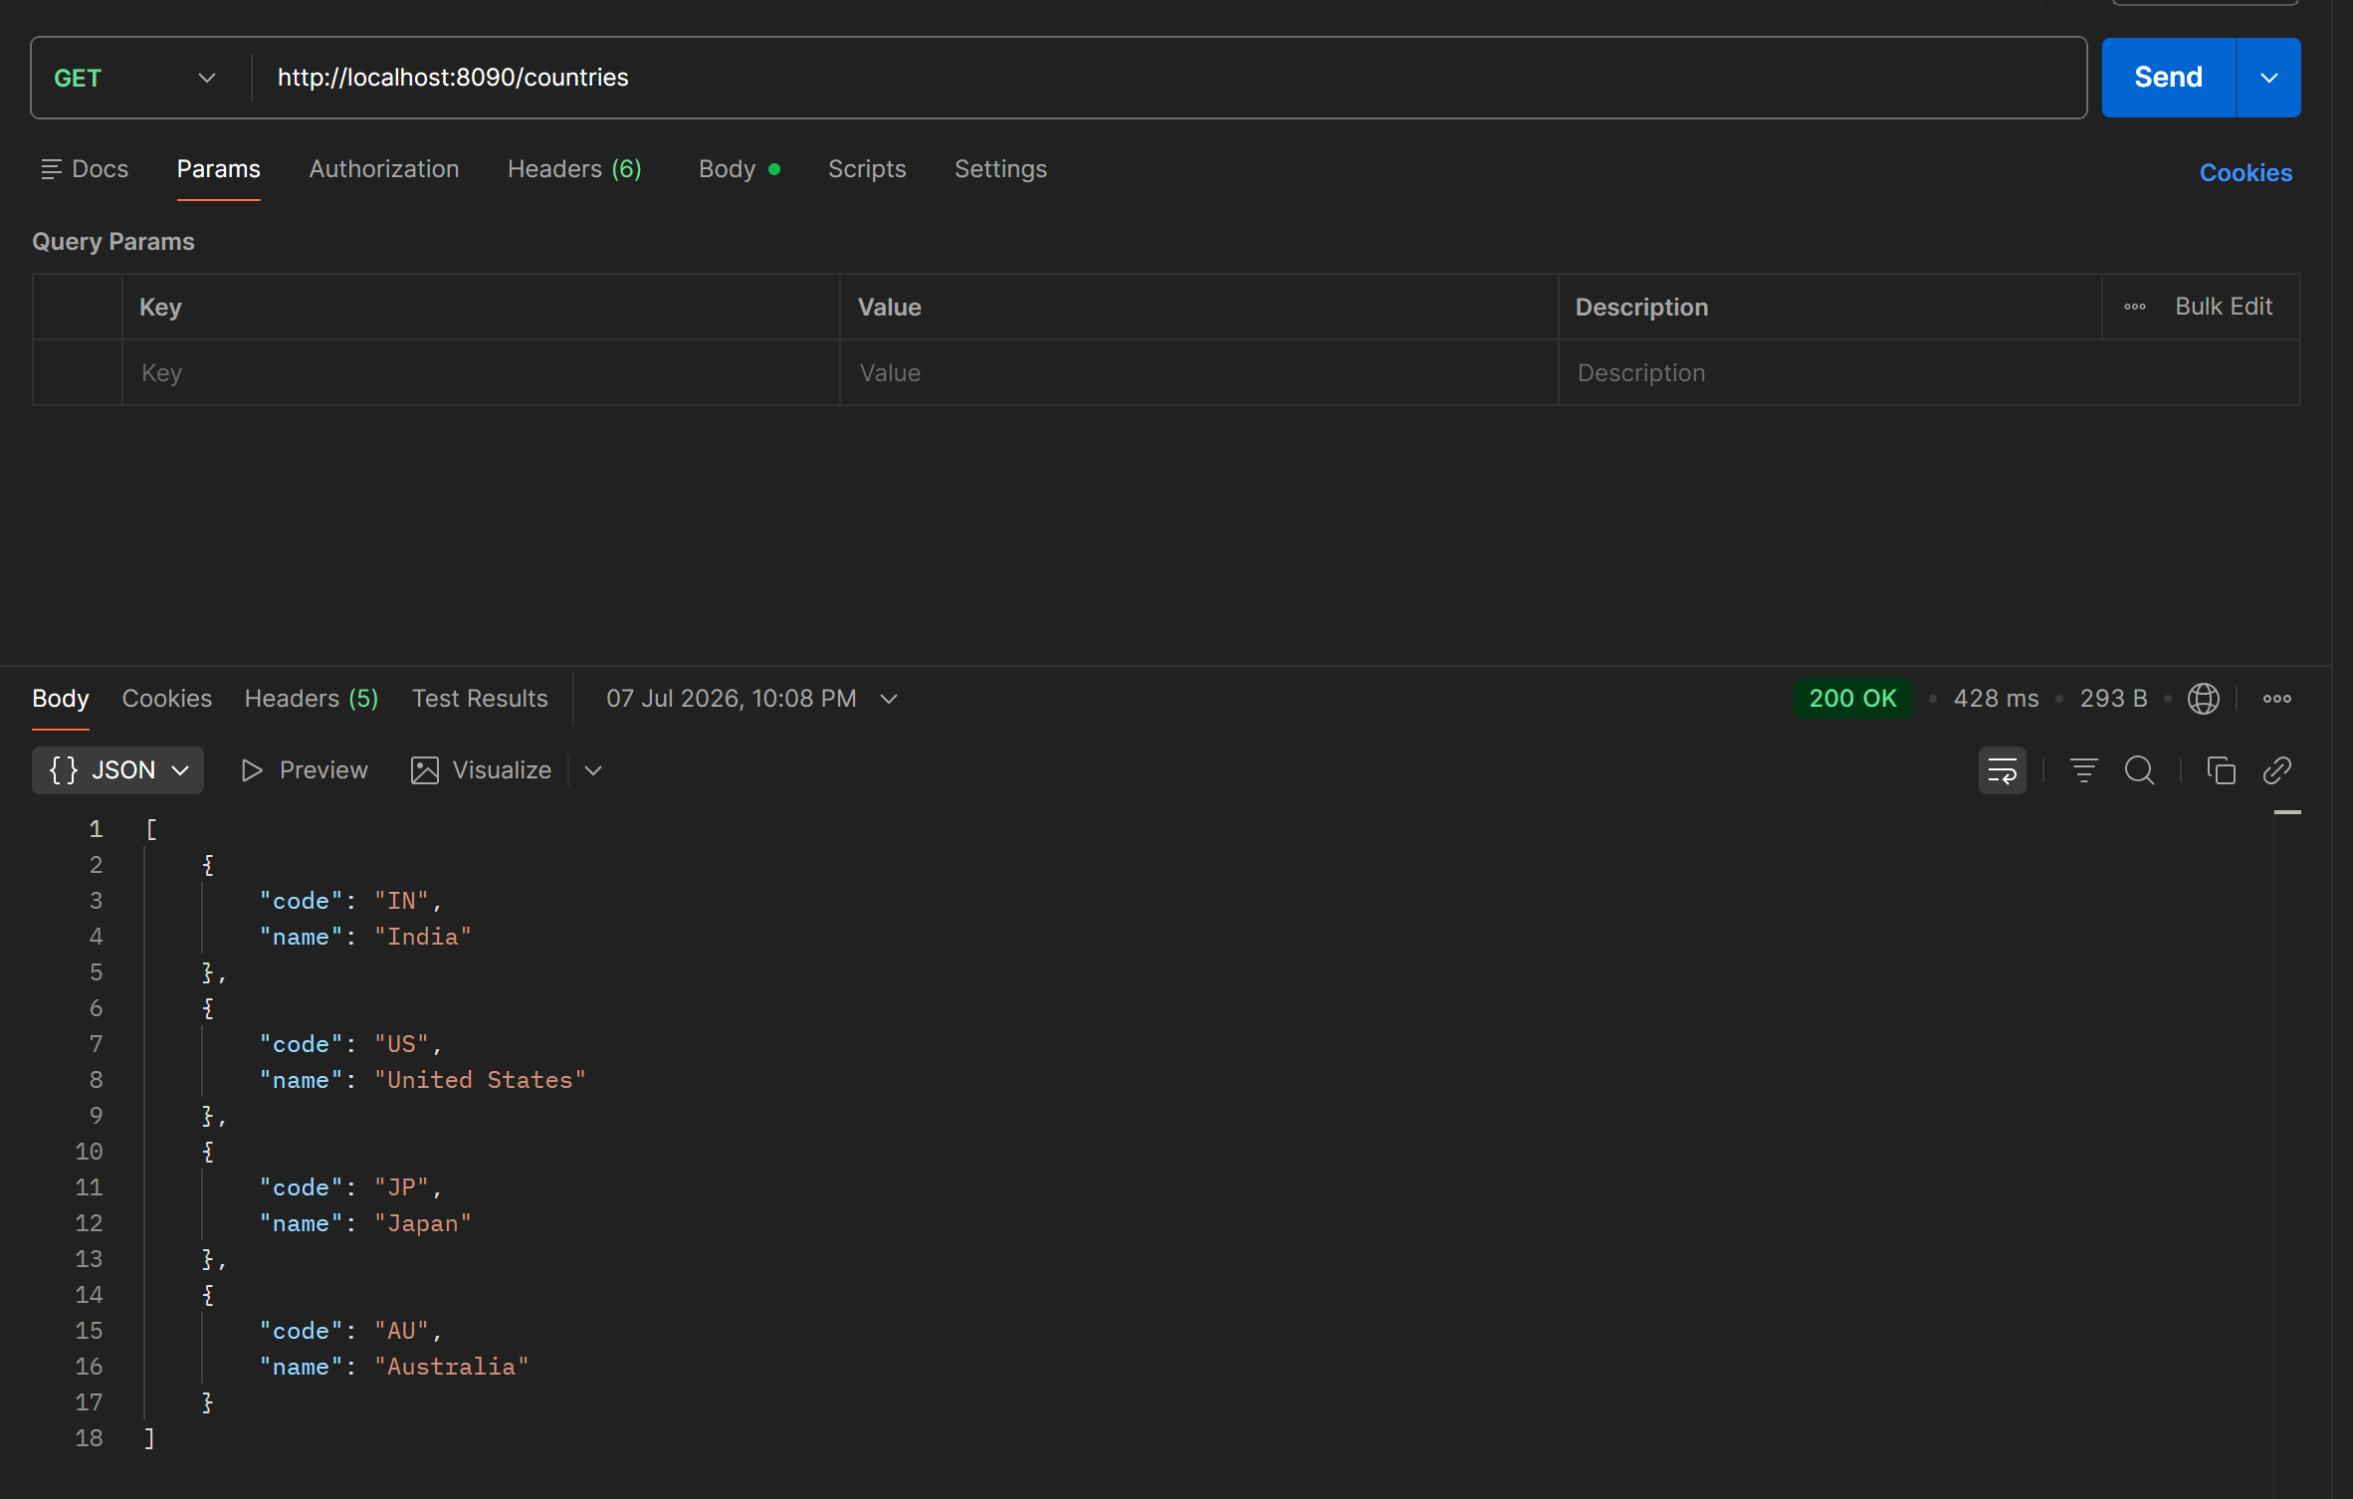
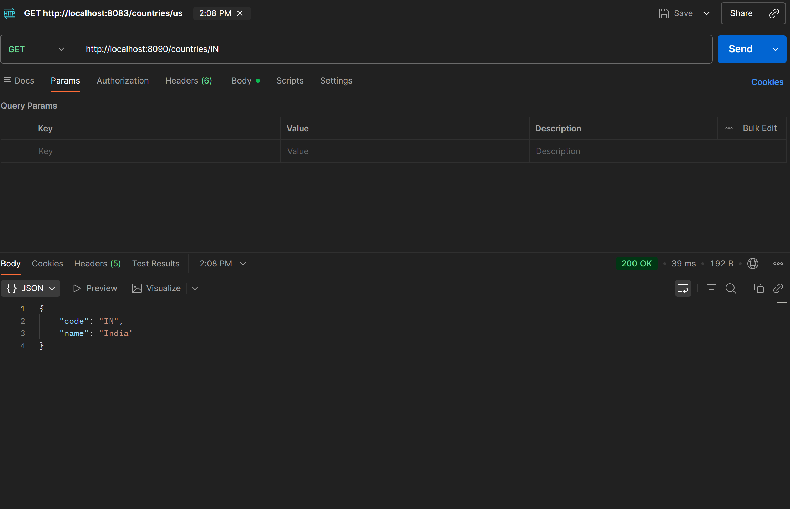
Latest CountryController.java
package com.cognizant.springlearn.controller;

import com.cognizant.springlearn.model.Country;
import com.cognizant.springlearn.service.CountryService;
import jakarta.validation.Valid;
import org.springframework.beans.factory.annotation.Autowired;
import org.springframework.web.bind.annotation.*;

import java.util.List;

@RestController
@RequestMapping("/countries")
public class CountryController {

@Autowired
private CountryService countryService;

@GetMapping
public List<Country> getAllCountries() {
return countryService.getAllCountries();
}

@GetMapping("/{code}")
public Country getCountry(@PathVariable String code) {
return countryService.getCountry(code);
}

@PostMapping
public Country addCountry(@RequestBody @Valid Country country) {

System.out.println("Start");

System.out.println(country);

return countryService.addCountry(country);
}
}
GlobalExceptionHandler.java
package com.cognizant.springlearn.exception;

import org.springframework.http.HttpHeaders;
import org.springframework.http.HttpStatusCode;
import org.springframework.http.ResponseEntity;
import org.springframework.web.bind.MethodArgumentNotValidException;
import org.springframework.web.bind.annotation.ControllerAdvice;
import org.springframework.web.context.request.WebRequest;
import org.springframework.web.servlet.mvc.method.annotation.ResponseEntityExceptionHandler;

import java.util.Date;
import java.util.LinkedHashMap;
import java.util.List;
import java.util.Map;

@ControllerAdvice
public class GlobalExceptionHandler extends ResponseEntityExceptionHandler {

@Override
protected ResponseEntity<Object> handleMethodArgumentNotValid(
MethodArgumentNotValidException ex,
HttpHeaders headers,
HttpStatusCode status,
WebRequest request) {

System.out.println("Start");

Map<String, Object> body = new LinkedHashMap<>();

body.put("timestamp", new Date());
body.put("status", status.value());

List<String> errors = ex.getBindingResult()
.getFieldErrors()
.stream()
.map(error -> error.getDefaultMessage())
.toList();

body.put("errors", errors);

System.out.println("End");

return new ResponseEntity<>(body, headers, status);
}
}

EmployeeNotFoundException.java
package com.cognizant.springlearn.exception;

import org.springframework.http.HttpStatus;
import org.springframework.web.bind.annotation.ResponseStatus;

@ResponseStatus(HttpStatus.NOT_FOUND)
public class EmployeeNotFoundException extends Exception {

public EmployeeNotFoundException(String message) {
super(message);
}

}

EmployeeDao.java
package com.cognizant.springlearn.dao;

import com.cognizant.springlearn.exception.EmployeeNotFoundException;
import com.cognizant.springlearn.model.Department;
import com.cognizant.springlearn.model.Employee;
import com.cognizant.springlearn.model.Skill;
import org.springframework.stereotype.Repository;

import java.text.SimpleDateFormat;
import java.util.ArrayList;
import java.util.Arrays;
import java.util.List;

@Repository
public class EmployeeDao {

private static final List<Employee> employeeList = new ArrayList<>();

static {

try {

Department department = new Department(1, "Engineering");

List<Skill> skills = Arrays.asList(
new Skill(1, "Java"),
new Skill(2, "Spring Boot")
);

employeeList.add(
new Employee(
1,
"Rahul",
65000.0,
true,
new SimpleDateFormat("dd/MM/yyyy").parse("15/08/2001"),
department,
skills
)
);

} catch (Exception e) {
e.printStackTrace();
}

}

public List<Employee> getAllEmployees() {
return employeeList;
}

public Employee getEmployee(int id) {

return employeeList.stream()
.filter(e -> e.getId() == id)
.findFirst()
.orElse(null);

}

public void updateEmployee(Employee employee)
throws EmployeeNotFoundException {

for (int i = 0; i < employeeList.size(); i++) {

if (employeeList.get(i).getId().equals(employee.getId())) {

employeeList.set(i, employee);
return;

}

}

throw new EmployeeNotFoundException(
"Employee not found with id " + employee.getId());

}

public void deleteEmployee(int id)
throws EmployeeNotFoundException {

Employee employee = getEmployee(id);

if (employee == null) {

throw new EmployeeNotFoundException(
"Employee not found with id " + id);

}

employeeList.remove(employee);

}

}
EmployeeService.java
package com.cognizant.springlearn.service;

import com.cognizant.springlearn.dao.EmployeeDao;
import com.cognizant.springlearn.exception.EmployeeNotFoundException;
import com.cognizant.springlearn.model.Employee;
import org.springframework.beans.factory.annotation.Autowired;
import org.springframework.stereotype.Service;

import java.util.List;

@Service
public class EmployeeService {

@Autowired
private EmployeeDao employeeDao;

public List<Employee> getAllEmployees() {
return employeeDao.getAllEmployees();
}

public Employee getEmployee(int id) {
return employeeDao.getEmployee(id);
}

public void updateEmployee(Employee employee)
throws EmployeeNotFoundException {

employeeDao.updateEmployee(employee);

}

public void deleteEmployee(int id)
throws EmployeeNotFoundException {

employeeDao.deleteEmployee(id);

}

}
EmployeeController.java
package com.cognizant.springlearn.controller;

import com.cognizant.springlearn.exception.EmployeeNotFoundException;
import com.cognizant.springlearn.model.Employee;
import com.cognizant.springlearn.service.EmployeeService;
import jakarta.validation.Valid;
import org.springframework.beans.factory.annotation.Autowired;
import org.springframework.web.bind.annotation.*;

import java.util.List;

@RestController
@RequestMapping("/employees")
public class EmployeeController {

@Autowired
private EmployeeService employeeService;

@GetMapping
public List<Employee> getAllEmployees() {

return employeeService.getAllEmployees();

}

@GetMapping("/{id}")
public Employee getEmployee(@PathVariable int id) {

return employeeService.getEmployee(id);

}

@PutMapping
public void updateEmployee(
@RequestBody @Valid Employee employee)
throws EmployeeNotFoundException {

employeeService.updateEmployee(employee);

}

@DeleteMapping("/{id}")
public void deleteEmployee(
@PathVariable int id)
throws EmployeeNotFoundException {

employeeService.deleteEmployee(id);

}

}
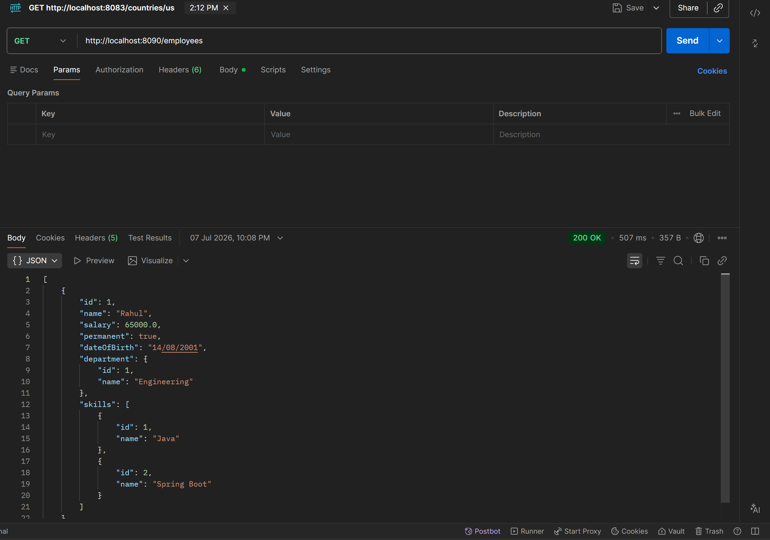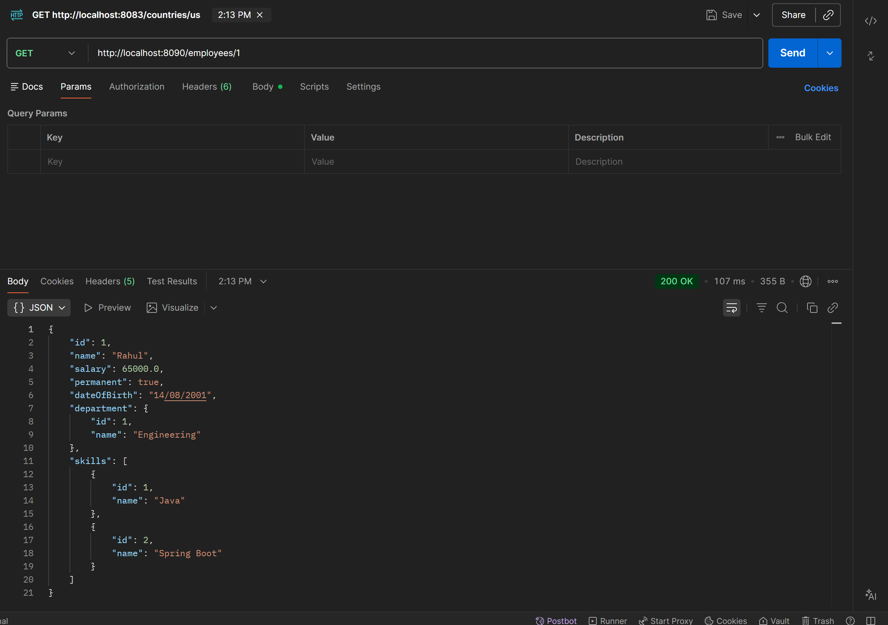
GlobalExceptionHandler.java
package com.cognizant.springlearn.exception;

import com.fasterxml.jackson.databind.exc.InvalidFormatException;
import org.springframework.http.HttpHeaders;
import org.springframework.http.HttpStatusCode;
import org.springframework.http.ResponseEntity;
import org.springframework.http.converter.HttpMessageNotReadableException;
import org.springframework.web.bind.MethodArgumentNotValidException;
import org.springframework.web.bind.annotation.ControllerAdvice;
import org.springframework.web.context.request.WebRequest;
import org.springframework.web.servlet.mvc.method.annotation.ResponseEntityExceptionHandler;

import java.util.ArrayList;
import java.util.Date;
import java.util.LinkedHashMap;
import java.util.List;
import java.util.Map;

@ControllerAdvice
public class GlobalExceptionHandler extends ResponseEntityExceptionHandler {

@Override
protected ResponseEntity<Object> handleMethodArgumentNotValid(
MethodArgumentNotValidException ex,
HttpHeaders headers,
HttpStatusCode status,
WebRequest request) {

Map<String, Object> body = new LinkedHashMap<>();

body.put("timestamp", new Date());
body.put("status", status.value());

List<String> errors = ex.getBindingResult()
.getFieldErrors()
.stream()
.map(error -> error.getDefaultMessage())
.toList();

body.put("errors", errors);

return new ResponseEntity<>(body, headers, status);
}

@Override
protected ResponseEntity<Object> handleHttpMessageNotReadable(
HttpMessageNotReadableException ex,
HttpHeaders headers,
HttpStatusCode status,
WebRequest request) {

Map<String, Object> body = new LinkedHashMap<>();

body.put("timestamp", new Date());
body.put("status", status.value());
body.put("error", "Bad Request");

if (ex.getCause() instanceof InvalidFormatException invalidFormatException) {

for (InvalidFormatException.Reference reference :
invalidFormatException.getPath()) {

body.put("message",
"Incorrect format for field '" +
reference.getFieldName() + "'");

}
}

return new ResponseEntity<>(body, headers, status);
}

}

