Application.properties
spring.application.name=greet-service
GreetController.java
package com.cognizant.greetservice.controller;

import org.springframework.web.bind.annotation.GetMapping;
import org.springframework.web.bind.annotation.RestController;

@RestController
public class GreetController {

@GetMapping("/greet")
public String sayHello() {
return "Hello World!!";
}
}
GreetServiceApplication.java
package com.cognizant.greetservice;

import org.springframework.boot.SpringApplication;
import org.springframework.boot.autoconfigure.SpringBootApplication;

@SpringBootApplication
public class GreetServiceApplication {

public static void main(String[] args) {
SpringApplication.run(GreetServiceApplication.class, args);
}

}

Output
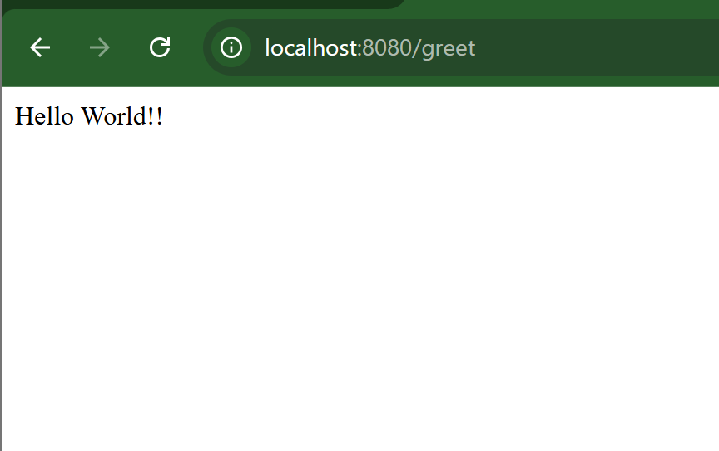
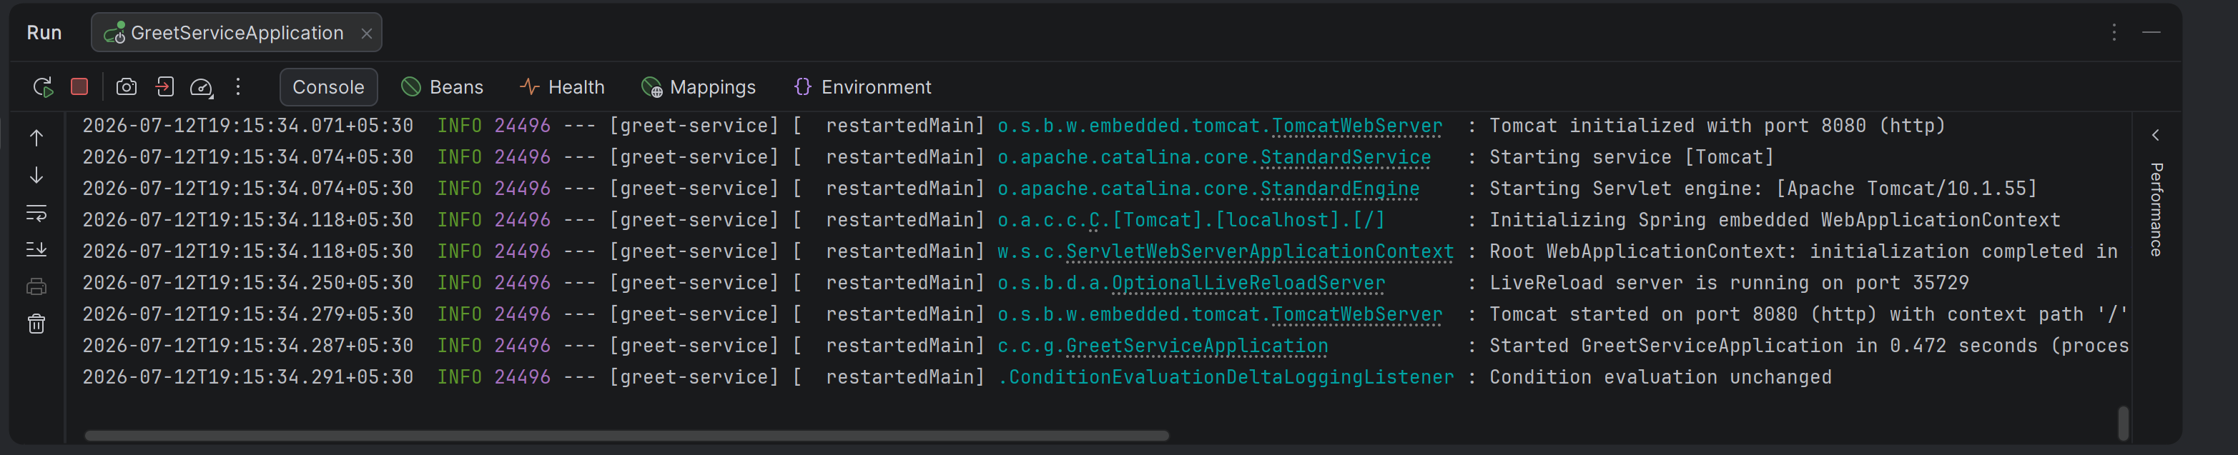

EurekaServa

Application.properties
spring.application.name=eureka-server

server.port=8761

eureka.client.register-with-eureka=false
eureka.client.fetch-registry=false
EurekaServerApplication.java
package com.cognizant.eurekaserver;

import org.springframework.boot.SpringApplication;
import org.springframework.boot.autoconfigure.SpringBootApplication;
import org.springframework.cloud.netflix.eureka.server.EnableEurekaServer;

@SpringBootApplication
@EnableEurekaServer
public class EurekaServerApplication {

public static void main(String[] args) {
SpringApplication.run(EurekaServerApplication.class, args);
}

}

Output
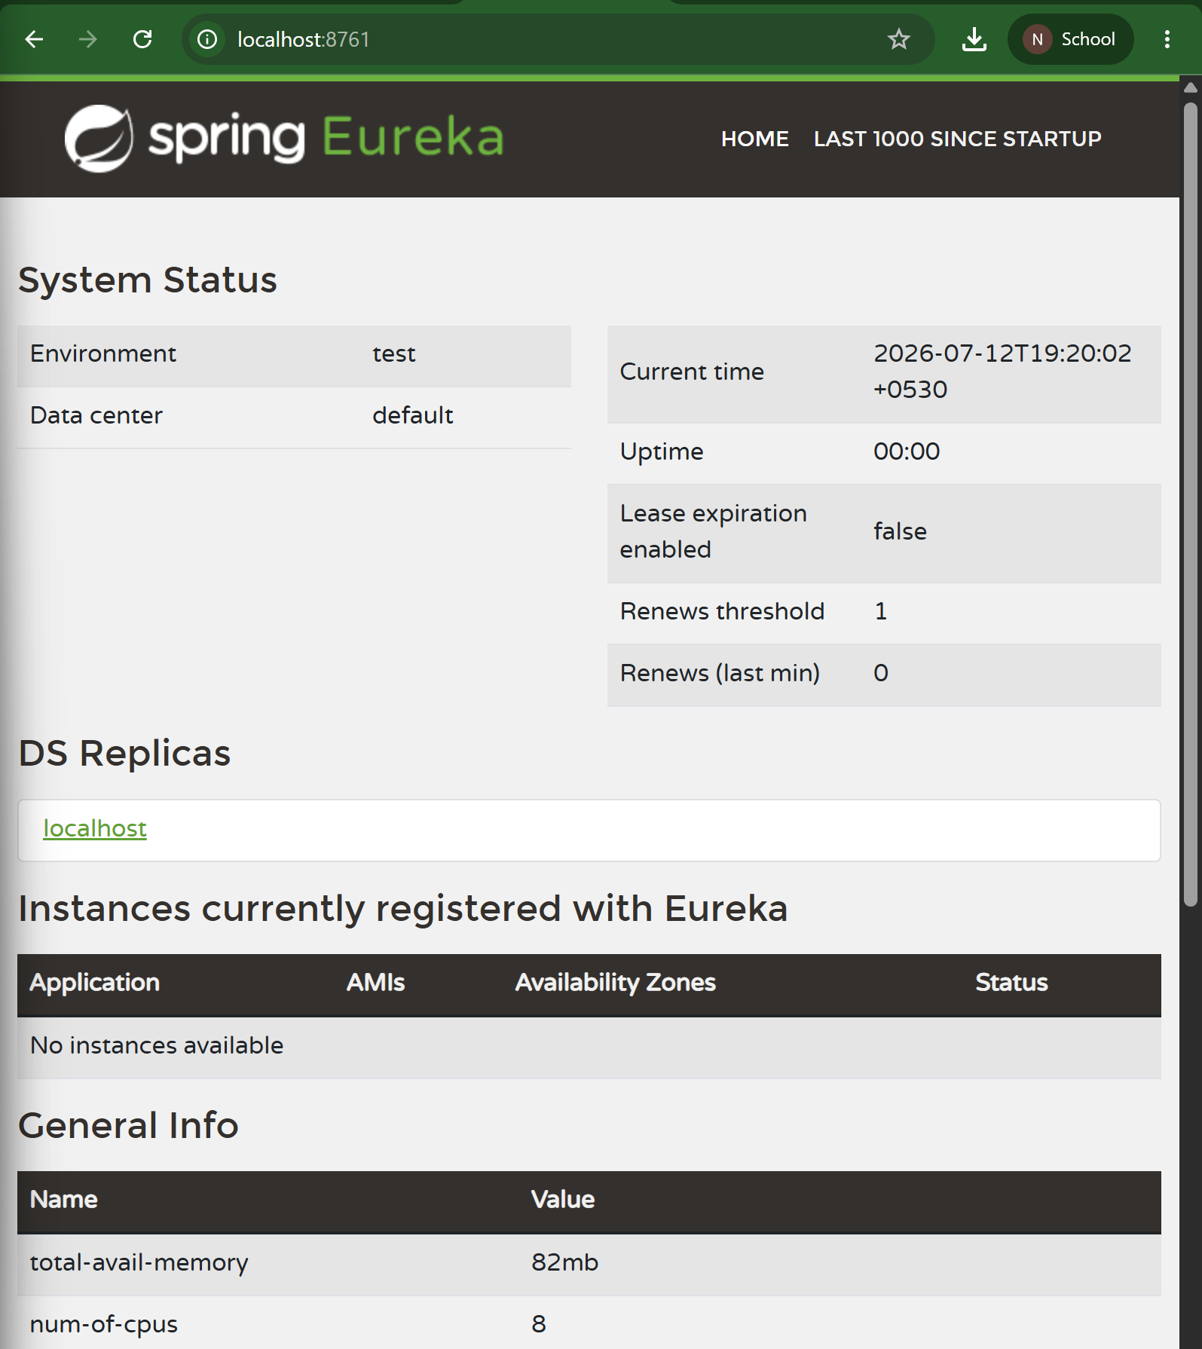

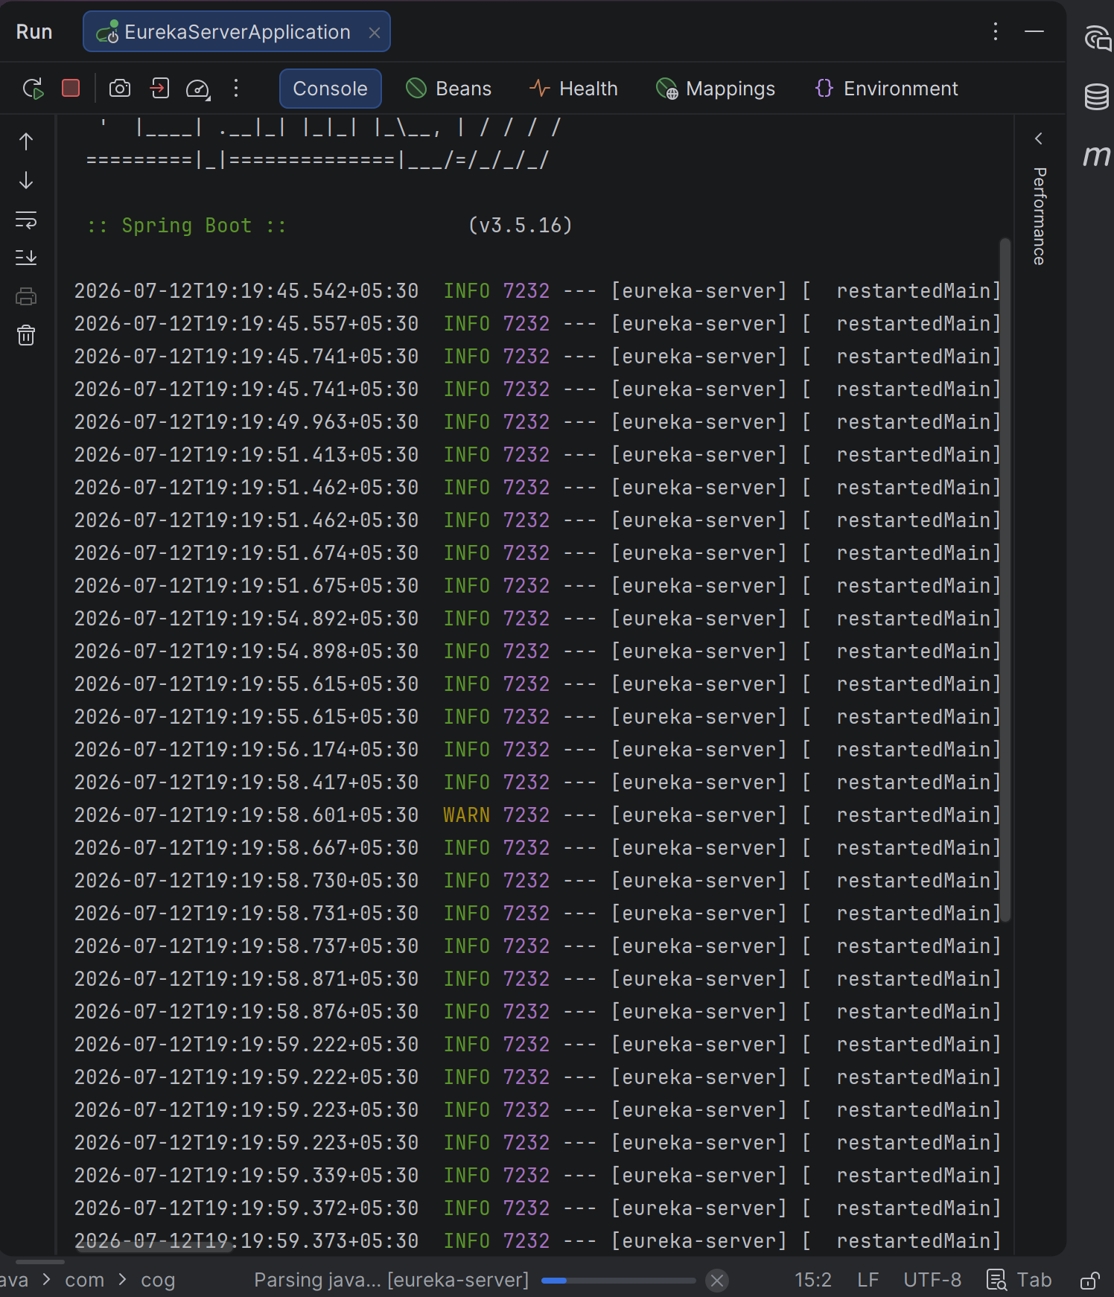
Greet-service
Pom.xml
<?xml version="1.0" encoding="UTF-8"?>
<project xmlns="http://maven.apache.org/POM/4.0.0" xmlns:xsi="http://www.w3.org/2001/XMLSchema-instance"
xsi:schemaLocation="http://maven.apache.org/POM/4.0.0 https://maven.apache.org/xsd/maven-4.0.0.xsd">
<modelVersion>4.0.0</modelVersion>
<parent>
<groupId>org.springframework.boot</groupId>
<artifactId>spring-boot-starter-parent</artifactId>
<version>3.5.16</version>
<relativePath/> <!-- lookup parent from repository -->
</parent>
<groupId>com.cognizant</groupId>
<artifactId>greet-service</artifactId>
<version>0.0.1-SNAPSHOT</version>
<name/>
<description/>
<url/>
<licenses>
<license/>
</licenses>
<developers>
<developer/>
</developers>
<scm>
<connection/>
<developerConnection/>
<tag/>
<url/>
</scm>
<properties>
<java.version>21</java.version>
<spring-cloud.version>2025.0.0</spring-cloud.version>
</properties>
<dependencies>
<dependency>
<groupId>org.springframework.boot</groupId>
<artifactId>spring-boot-starter-web</artifactId>
</dependency>
<dependency>
<groupId>org.springframework.boot</groupId>
<artifactId>spring-boot-devtools</artifactId>
<scope>runtime</scope>
<optional>true</optional>
</dependency>
<dependency>
<groupId>org.springframework.boot</groupId>
<artifactId>spring-boot-starter-test</artifactId>
<scope>test</scope>
</dependency>
<dependency>
<groupId>org.springframework.cloud</groupId>
<artifactId>spring-cloud-starter-netflix-eureka-client</artifactId>
</dependency>
</dependencies>
<dependencyManagement>
<dependencies>
<dependency>
<groupId>org.springframework.cloud</groupId>
<artifactId>spring-cloud-dependencies</artifactId>
<version>${spring-cloud.version}</version>
<type>pom</type>
<scope>import</scope>
</dependency>
</dependencies>
</dependencyManagement>
<build>
<plugins>
<plugin>
<groupId>org.springframework.boot</groupId>
<artifactId>spring-boot-maven-plugin</artifactId>
</plugin>
</plugins>
</build>
</project>

Application.properties
spring.application.name=greet-service
server.port=8080
eureka.client.service-url.defaultZone=http://localhost:8761/eureka

GreetServiceApplication.java
package com.cognizant.greetservice;
import org.springframework.boot.SpringApplication;
import org.springframework.boot.autoconfigure.SpringBootApplication;
@SpringBootApplication
public class GreetServiceApplication {
public static void main(String[] args) {
SpringApplication.run(GreetServiceApplication.class, args);
}
}

Output
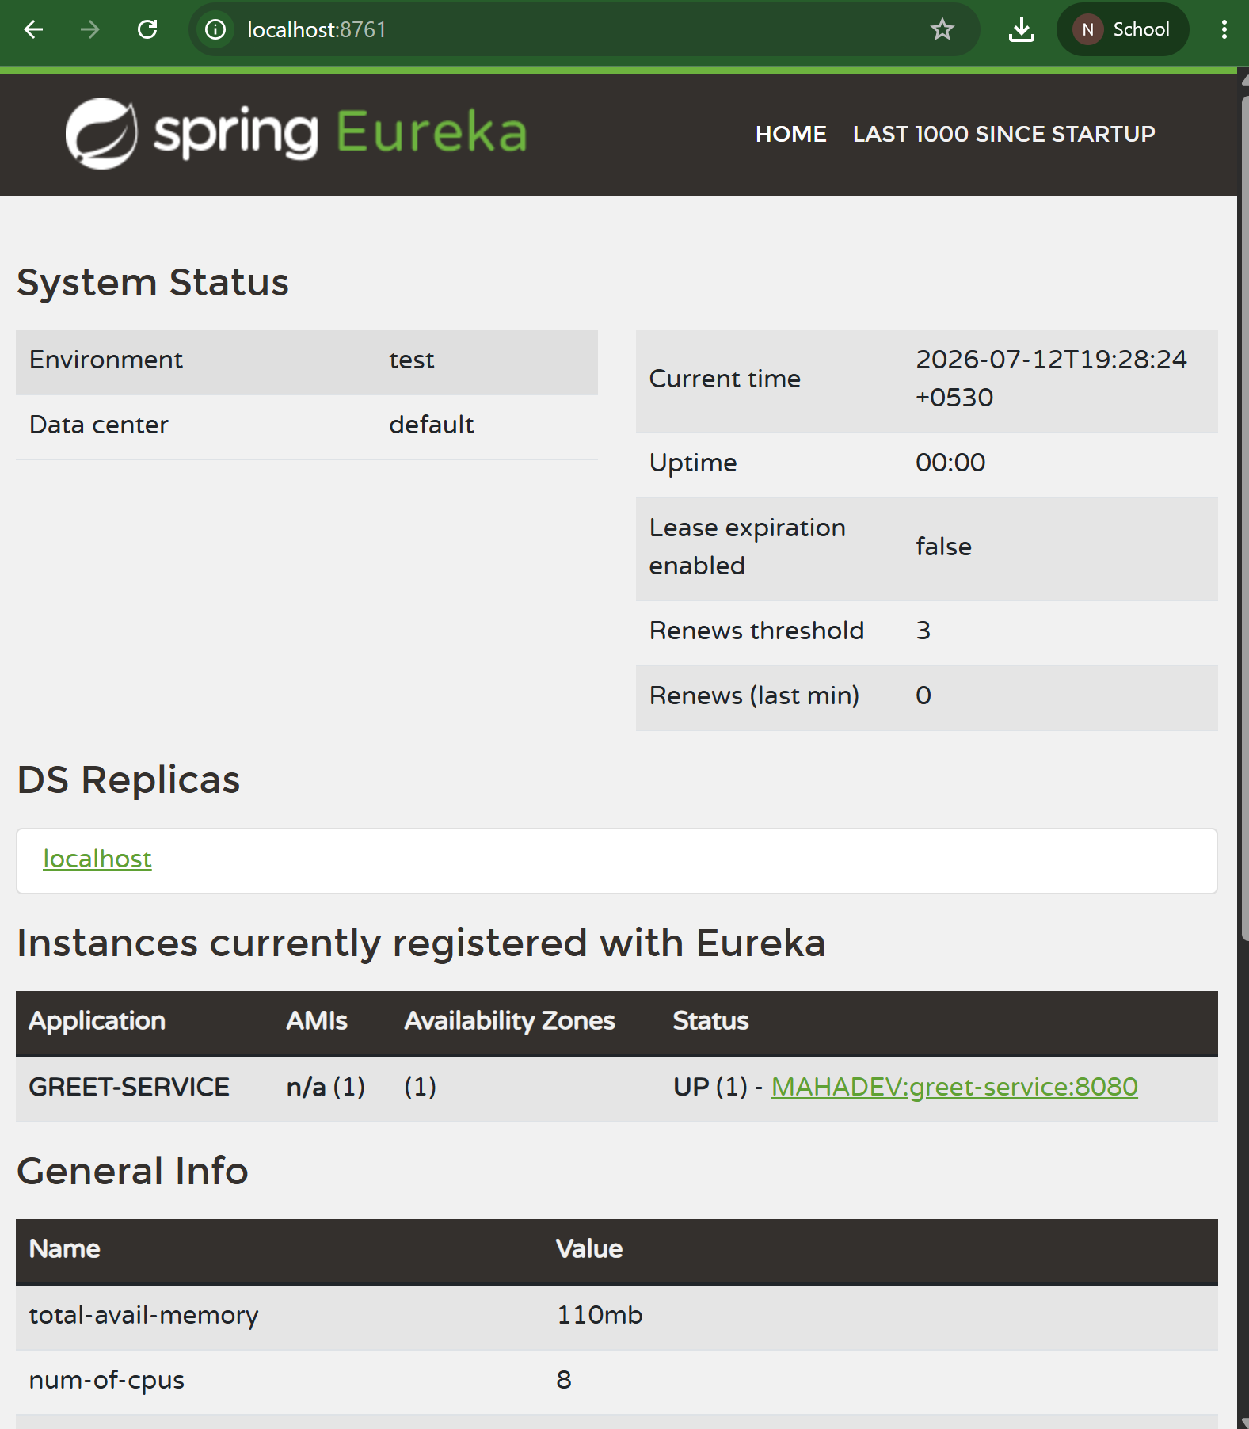
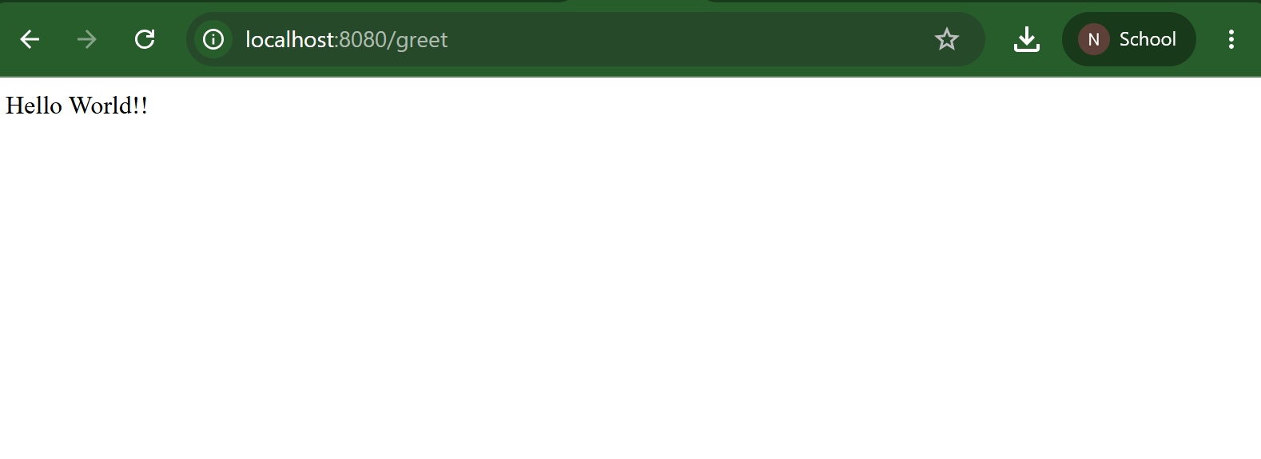
Api-gateway
Application.properties
spring.application.name=api-gateway
server.port=9090
eureka.client.service-url.defaultZone=http://localhost:8761/eureka
spring.cloud.gateway.server.webmvc.routes[0].id=greet-service
spring.cloud.gateway.server.webmvc.routes[0].uri=lb://GREET-SERVICE
spring.cloud.gateway.server.webmvc.routes[0].predicates[0]=Path=/greet-service/**
spring.cloud.gateway.server.webmvc.routes[0].filters[0]=StripPrefix=1

ApiGatewayApplication.java
package com.cognizant.apigateway;
import org.springframework.boot.SpringApplication;
import org.springframework.boot.autoconfigure.SpringBootApplication;
@SpringBootApplication
public class ApiGatewayApplication {
public static void main(String[] args) {
SpringApplication.run(ApiGatewayApplication.class, args);
}
}

pom.xml
<?xml version="1.0" encoding="UTF-8"?>
<project xmlns="http://maven.apache.org/POM/4.0.0" xmlns:xsi="http://www.w3.org/2001/XMLSchema-instance"
xsi:schemaLocation="http://maven.apache.org/POM/4.0.0 https://maven.apache.org/xsd/maven-4.0.0.xsd">
<modelVersion>4.0.0</modelVersion>
<parent>
<groupId>org.springframework.boot</groupId>
<artifactId>spring-boot-starter-parent</artifactId>
<version>3.5.16</version>
<relativePath/> <!-- lookup parent from repository -->
</parent>
<groupId>com.cognizant</groupId>
<artifactId>api-gateway</artifactId>
<version>0.0.1-SNAPSHOT</version>
<name/>
<description/>
<url/>
<licenses>
<license/>
</licenses>
<developers>
<developer/>
</developers>
<scm>
<connection/>
<developerConnection/>
<tag/>
<url/>
</scm>
<properties>
<java.version>21</java.version>
<spring-cloud.version>2025.0.3</spring-cloud.version>
</properties>
<dependencies>
<dependency>
<groupId>org.springframework.cloud</groupId>
<artifactId>spring-cloud-starter-gateway-server-webmvc</artifactId>
</dependency>
<dependency>
<groupId>org.springframework.cloud</groupId>
<artifactId>spring-cloud-starter-netflix-eureka-client</artifactId>
</dependency>
<dependency>
<groupId>org.springframework.boot</groupId>
<artifactId>spring-boot-devtools</artifactId>
<scope>runtime</scope>
<optional>true</optional>
</dependency>
<dependency>
<groupId>org.springframework.boot</groupId>
<artifactId>spring-boot-starter-test</artifactId>
<scope>test</scope>
</dependency>
</dependencies>
<dependencyManagement>
<dependencies>
<dependency>
<groupId>org.springframework.cloud</groupId>
<artifactId>spring-cloud-dependencies</artifactId>
<version>${spring-cloud.version}</version>
<type>pom</type>
<scope>import</scope>
</dependency>
</dependencies>
</dependencyManagement>
<build>
<plugins>
<plugin>
<groupId>org.springframework.boot</groupId>
<artifactId>spring-boot-maven-plugin</artifactId>
</plugin>
</plugins>
</build>
</project>
Output
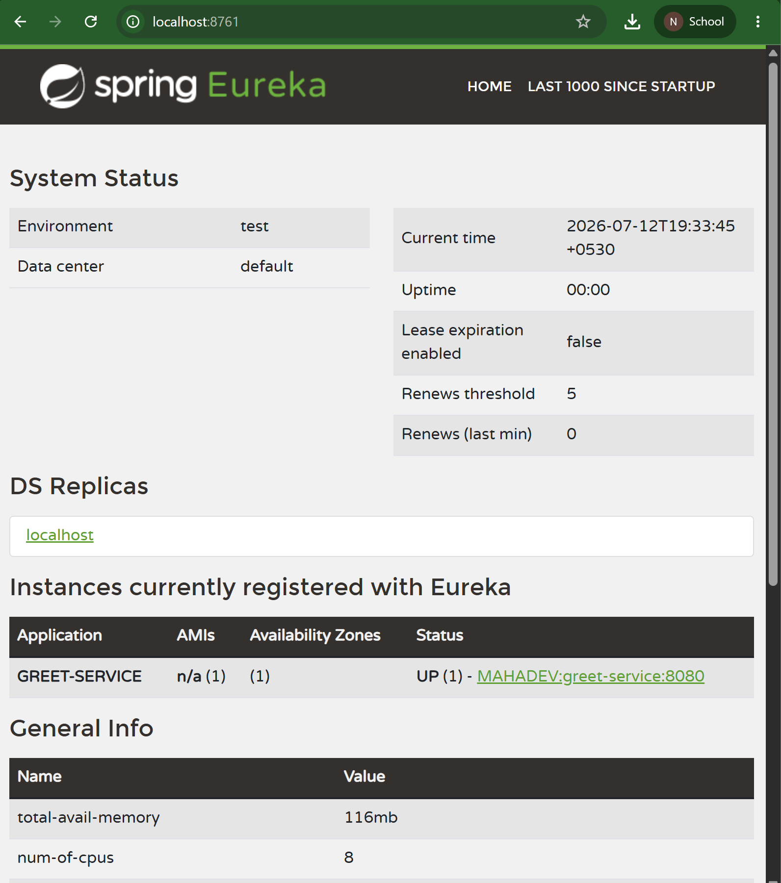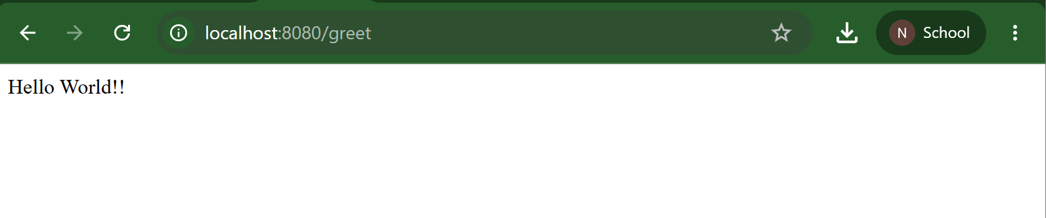
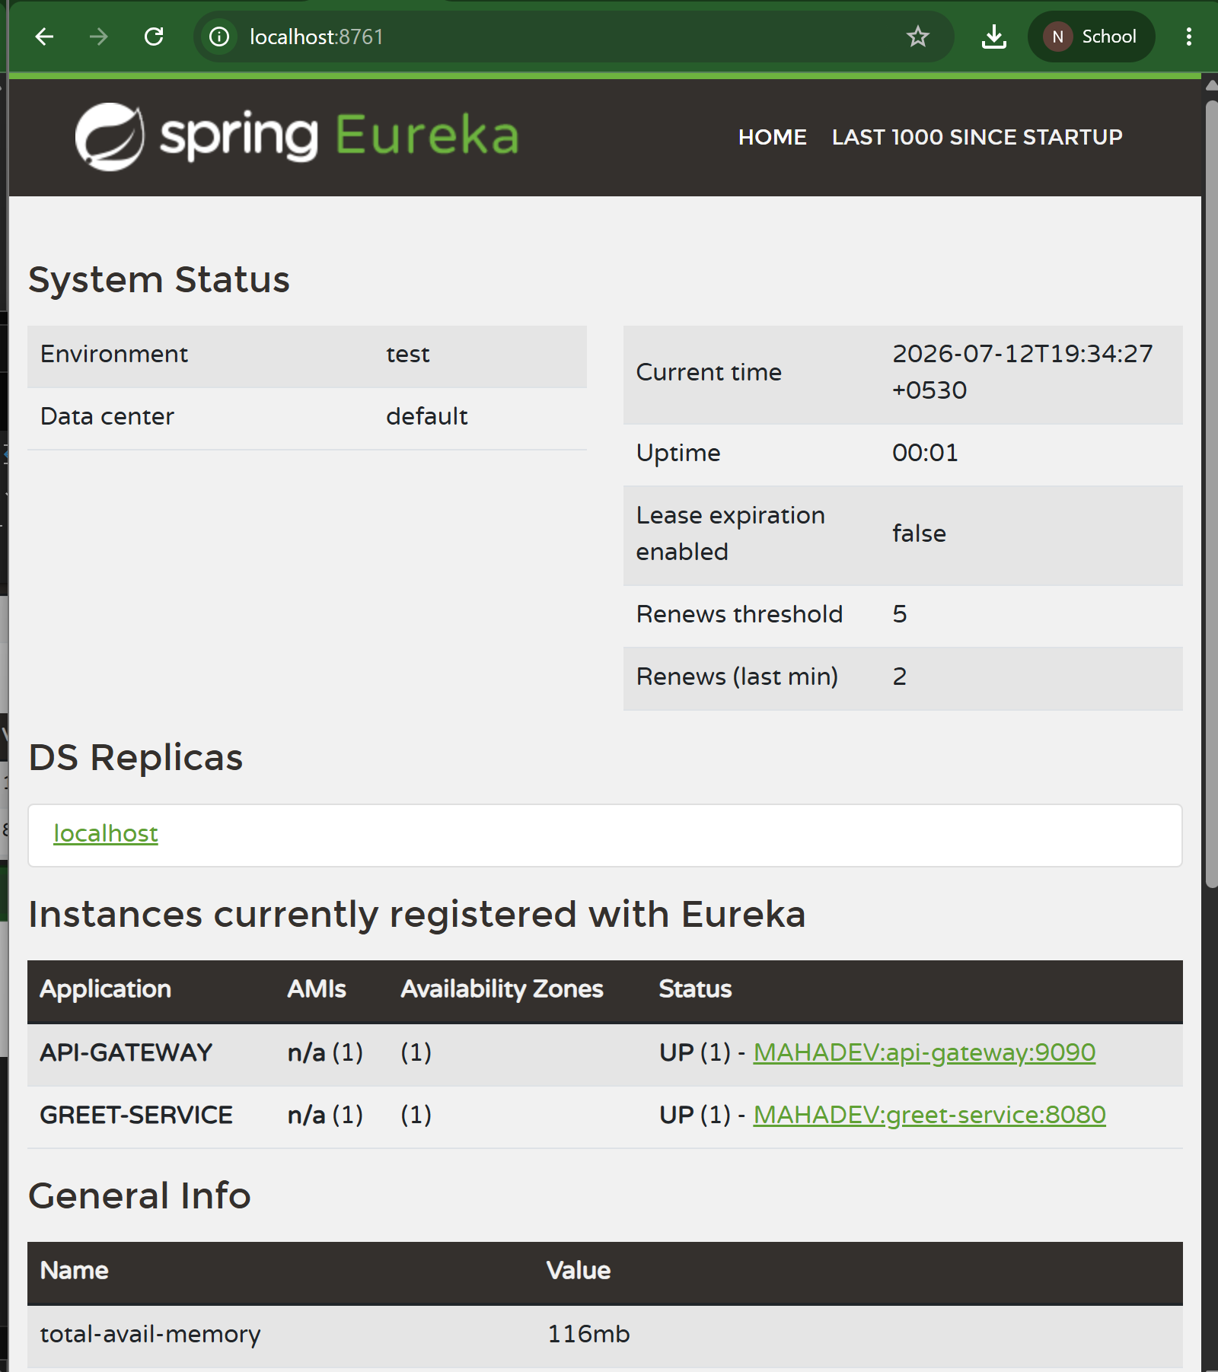
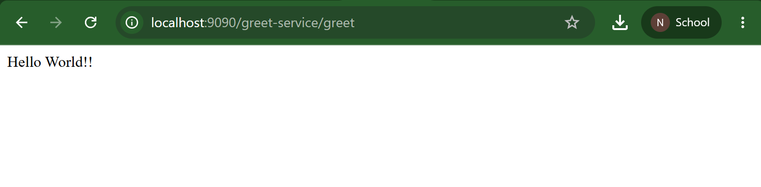

LogFilter.java
package com.cognizant.apigateway.filter;

import org.slf4j.Logger;
import org.slf4j.LoggerFactory;
import org.springframework.stereotype.Component;
import org.springframework.web.servlet.function.HandlerFilterFunction;
import org.springframework.web.servlet.function.ServerResponse;

@Component
public class LogFilter {

private static final Logger LOGGER = LoggerFactory.getLogger(LogFilter.class);

public HandlerFilterFunction<ServerResponse, ServerResponse> log() {

return (request, next) -> {

LOGGER.info("Incoming Request : {} {}",
request.method(),
request.uri());

return next.handle(request);
};
}
}

Output
