ID Card Detection & Penalty Mechanism

In this project as per your requirement we have implemented Yolov5 to detect ID card and if ID card not wearing then application will send alert message to given mail id and while sending application will predict Roll No of that person.

To run project double click on run.bat to get below screen

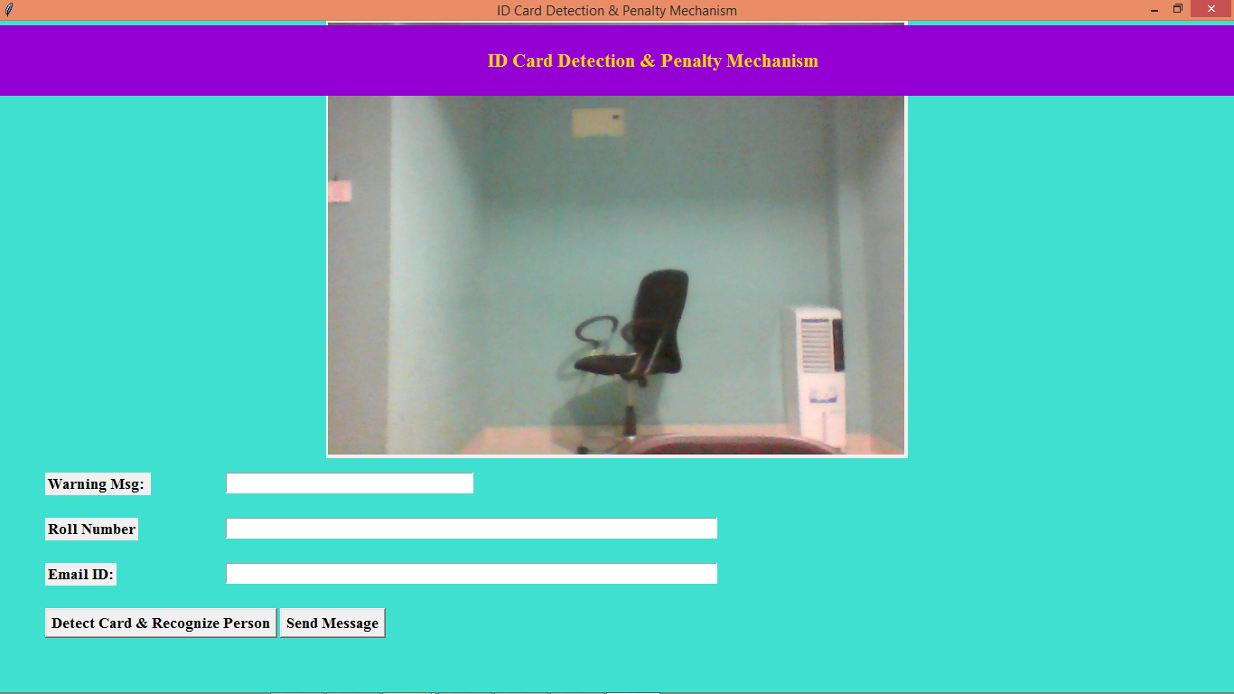

In above screen camera started and now person can come in front of camera and then click on ‘Detect Card & Recognize Person’ button to detect card and perform remaining activity

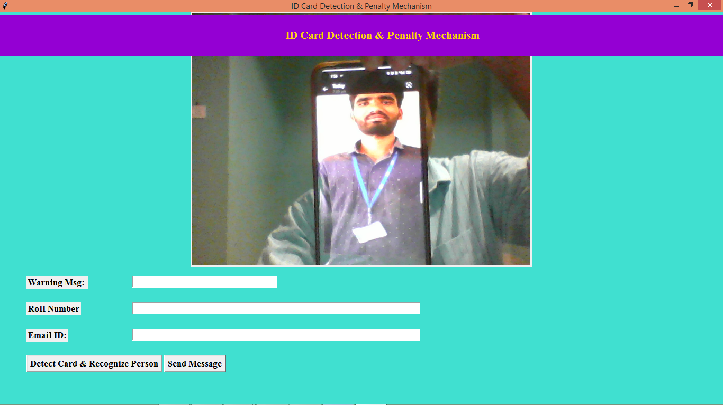

In above screen showing face of your given data only so model should work only for your faces and now click on ‘Detect Card’ button to get below output

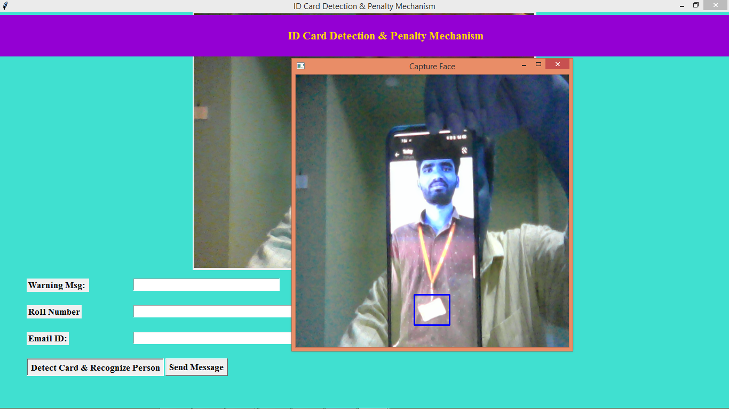

In above screen in blue colour bounding box application detected card and it will not do any further processing and just close above image to test with other web cam images

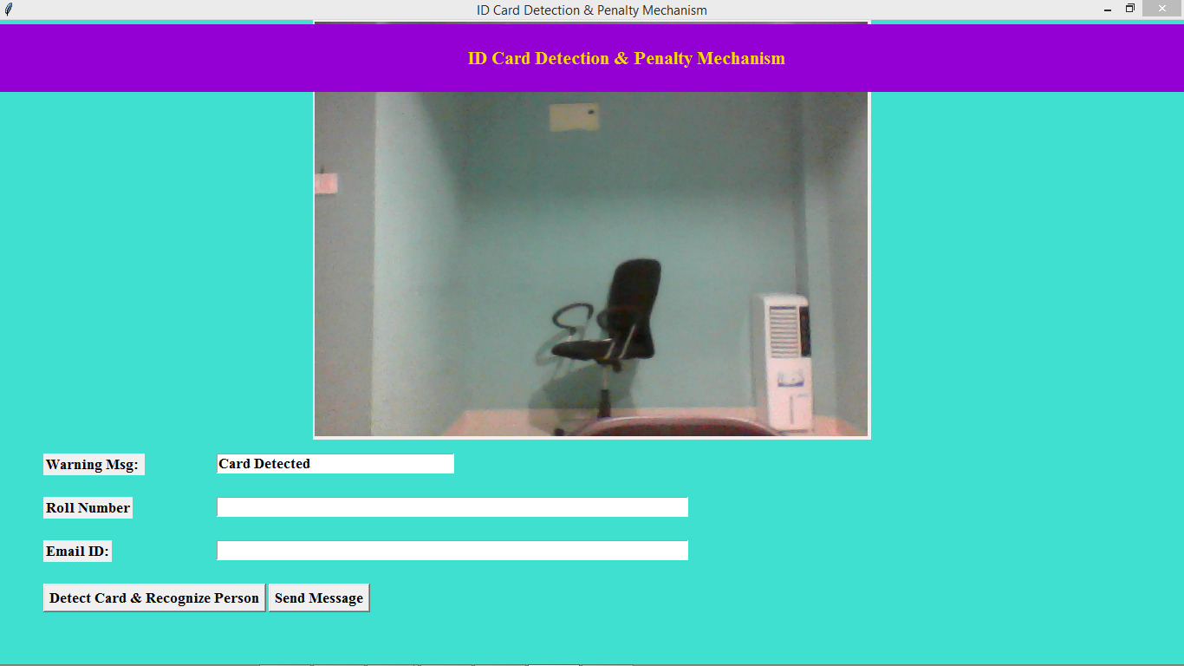

In above screen in warning message text field can see output as ‘Card Detected’ and now test without card

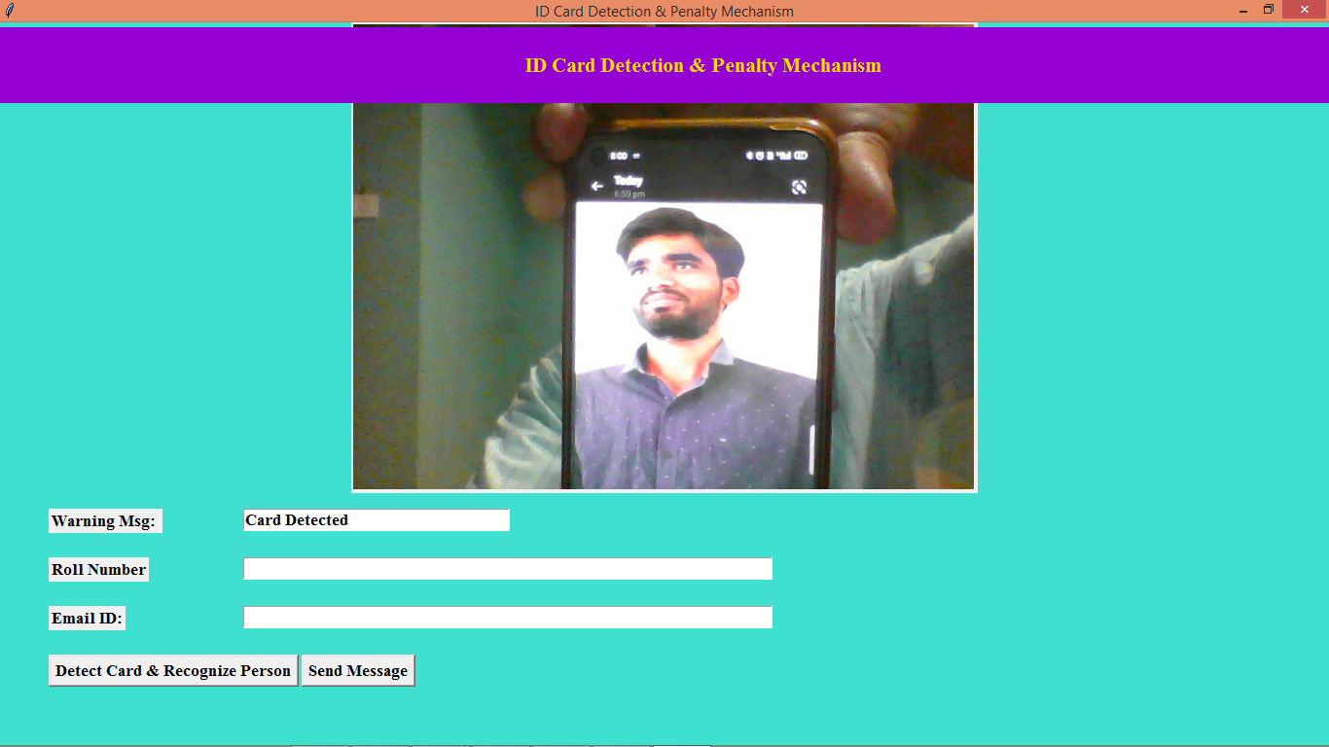

In above screen showing face in camera without ID card and then click on ‘Detect Card’ button to get below faces

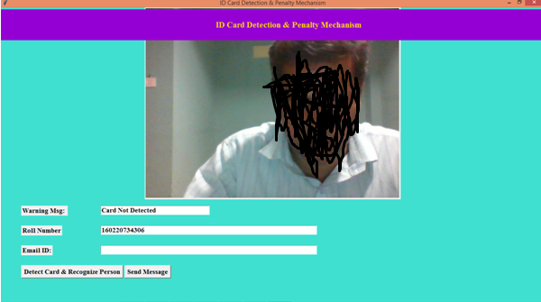

In above screen in warning text field can see output as ‘Card Not Detected’ and then in roll no text field can see predicted roll number and now enter email ID in 3rd text field and click ‘Send Message’ to send alert

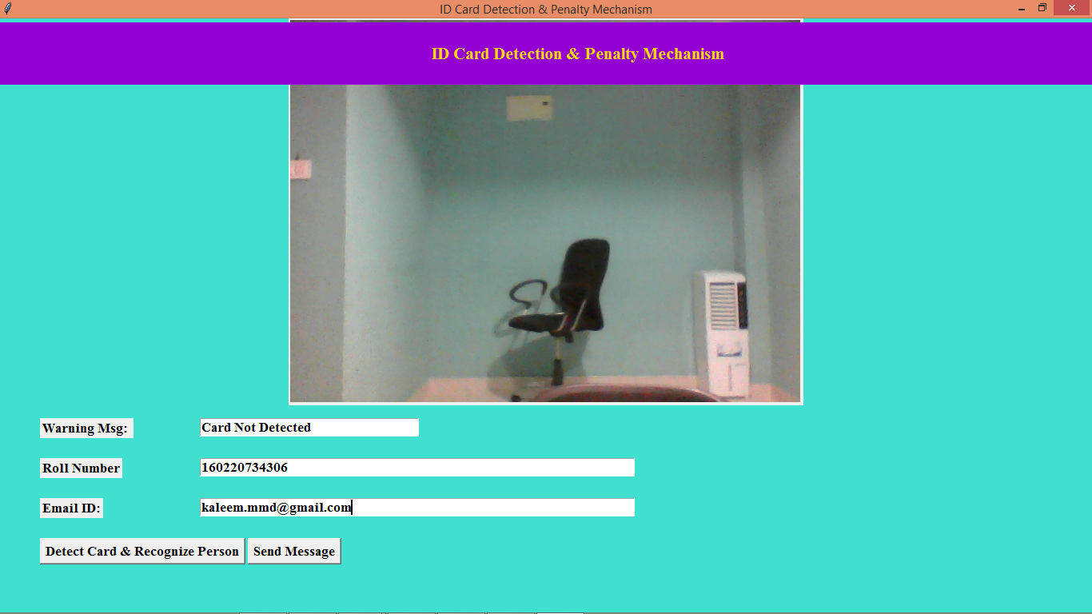

In above screen entered email ID and then press button to send email and then will get below email

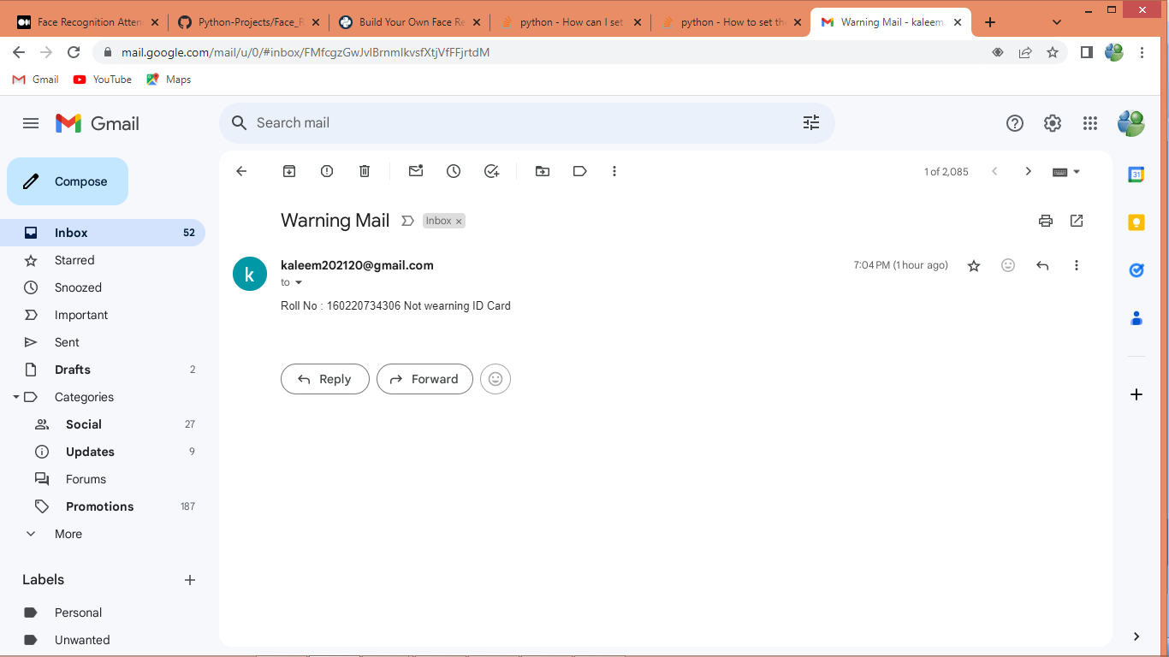

In above screen can see warning email received from application