A REPORT

ON

MONTE CARLO SIMULATION INTEGRATED MACHINE LEARNING MODEL FOR COST OVERRUN PREDICTION IN HYDROELECTRIC PROJECTS

BY
NEERAJ GURUNATHAN 2024ADPS0441U

AT

IIT ROORKEE, UTTARAKHAND,INDIA

A Practice School – I station of



BITS Pilani, Dubai Campus
Dubai International Academic City, Dubai
UAE

(JUNE 2026 – JULY 2026)

BITS Pilani, Dubai Campus
Dubai International Academic City, Dubai
UAE

Station: IIT ROORKEE Centre: INDIA

Date of Start: 10 June 2026 Date of Submission: 12 July 2026

Title of the Project: MONTE CARLO SIMULATION INTEGRATED MACHINE LEARNING MODEL FOR COST OVERRUN PREDICTION FOR HYDROELECTRIC PROJECTS

ID No. / Name of the student: 2024ADPS0441U NEERAJ GURUNATHAN

Discipline of Student: B.E MATHEMATICS AND COMPUTING

Name(s) and Designation(s) of the Expert(s): Professor Deepak Khare

Name of the PS Faculty: Dr. Brij Kishore Pandey

Key Words: Construction Planning , Project Management, Risk Management, Machine learning

Project Area(s): Machine learning,Monte Carlo methods, Water resources and development department

Abstract : Cost overruns remain a significant challenge in the planning and execution of hydroelectric projects, often resulting in substantial economic and scheduling impacts. This study evaluates the application of mathematical and computational techniques for predicting cost overruns in hydroelectric projects located in Uttarakhand and Himachal Pradesh, India. Project data were compiled from government reports and other authorized sources such as ICIMOD,IMD etc. and then pre processed to ensure consistency and reliability. Five machine learning models were developed and evaluated using statistical performance metrics, including Mean Absolute Error (MAE), Symmetric Mean Absolute Percentage Error (SMAPE), and the coefficient of determination (R²). The best-performing model which came to be Random Forest (R^2=0.316) which was subsequently integrated with Monte Carlo simulation to estimate prediction uncertainty through confidence intervals and to facilitate risk-based classification of project cost overruns. The proposed framework provides not only cost overrun predictions but also an estimate of the associated uncertainty with respect to new Hydro Electric power projects data, thereby supporting more informed decision-making during project planning and risk assessment.

Signature of Student Signature of PS Faculty
Date: Date:

ACKNOWLEDGEMENTS

I would like to express my sincere gratitude to everyone who support and continue to guide me through my Practice School – I Internship.

First I would like to thank Mr. Souri Bannerjee, Director of Birla Institute of Technology and Science, Dubai Campus, for providing students with the opportunity to gain practical industry experience through the Practice School programme.

I would also like to thank Professor Deepak Khare for his constant guidance and support throughout our internship. His trust in my work and his support in facilitating the resources required for my projects greatly contribute to my learning experience.

My sincere gratitude also goes to Professor Brij Kishore Pandey, PS Coordinator for his trust and support in me and coordinating between students and the station.

I would also like to thank Mr. Prashant Chauhan , Ms. Deepika Kapri and Mr.Abhishek Gupta our seniors in the groundwater lab who provided us with support and professional insights for our project.

Finally I would also express my deepest gratitude to my parents for their constant encouragement, patience and support throughout my academic journey.

Neeraj Gurunathan
2024ADPS0441U

List of Figures

Figure no. | Figure | Pg. no.
1.1 | Methodology workflow for cost-overrun prediction and risk classification
1.2 | lOcations of hydro-electric projects
1.3 | study area
2.1 | Distributions of the 8 Lasso-retained features
2.2 | Pearson correlation heatmap - target and selected features
3.1 | LOOCV predicted vs. actual cost overrun (Random Forest model)
3.2 | Simulated cost-overrun risk profile for a representative Medium Risk project

List of Tables

Table number | Table | Pg No
3.1 | Summary statistics - target and Lasso-retained features
3.2 | Monte Carlo risk-tier thresholds
4.1 | Correlation and fit-quality metrics
4.2 | Theil's U and normalised mean squared error (NMSE)
4.3 | Percentage-based error metrics
4.4 | Error-magnitude metrics
4.5 | Akaike Information Criterion (AIC)

Contents

Abstract
Acknowledgement
List of Figures
List of Tables

S.no | Description | Page No.
 | Chapter -1: Introduction
1.1 | Problem Statement | 1
1.2 | Objectives of the Study | 2
1.3 | Scope | 3
 | Chapter 2: Literature Review
2.1 | hydro-power Projects | 4
2.2 | Hydroelectric Project Cost Overrun | 4
2.3 | Cost Overrun Prediction with Machine Learning | 5
2.4 | Point Prediction with Machine Learning | 5
2.5 | Overview of the Five Machine Learning Models Used in This Study | 6
2.6 | Confidence Intervals and Risk Classification from ML Models | 7
2.7 | Monte Carlo Simulation | 8
2.8 | Monte Carlo Simulation Integrated with Machine Learning | 9
2.9 | Environmental and Climatic Factors in hydro-power Cost Estimation | 9
2.10 | Synthesis | 11
 | Chapter 3: Materials and Methods
3.1 | Methodology Overview | 13
3.2 | Study Area | 13
3.3 | Data Sources and Variables | 13
3.4 | Descriptive Statistics | 13
3.5 | Feature Selection Using Lasso Regression | 15
3.6 | Machine Learning Models | 17
3.7 | Evaluation Metrics | 17
3.8 | Monte Carlo Simulation Methodology | 17
3.9 | Risk Classification Framework | 18
 | Chapter 4: Results and Discussion
4.1 | Comparative Model Performance | 19
4.2 | Best-Performing Model Selection | 21
4.3 | Monte Carlo Simulation and Risk Classification Results | 21
4.4 | Discussion | 22
 | Chapter 5: Conclusion and Future Scope
5.1 | Conclusion | 25
5.2 | Future Scope | 25
 | References | 27

CHAPTER 1: INTRODUCTION
Hydro-power is still the engine room of the world’s renewable electricity production. Global installed hydro-power capacity was close to 1,469 GW at the end of 2025, and more than 1,100 GW of new capacity were in development stages ranging from feasibility studies to actual construction [1]. The steady growth of this sector, however, masks a persistent and well-understood reality that hydro-power projects are relentlessly prone to running over budget. The tendency of major dams to significantly exceed their initial cost projections has made cost overruns a common and well recognized issue in the field of infrastructure economics [2]. According to Central Electricity Authority’s (CEA) the Himalayan states of India provide striking examples, with some projects having overspent their approved budgets by more than 200% and finishing more than a decade later than planned [3]. Such outcomes are by no means unique to hydro-power: systematic literature reviews of transport and public infrastructure mega-projects reveal that almost nine out of ten such projects experience some form of cost overrun, with consistent underestimation in both sectors over time despite improvements in estimation methodology [4][5]. Because projects in the Himalayas do not follow a traditional building mold, mountain surroundings make hydro-power production particularly challenging. A tunnel in this location might come across cracked rock, flash floods, or landslide-prone areas only a few kilometers from the excavation site, in contrast to, instance, a tunnel in a more stable geological area.
Cost overruns are also a result of the complexities that accompany this kind of development, such as those involving unpredictable geology, scope expansion during construction, difficulties acquiring land and permits, the increasing cost of materials and labour, and disruptions caused by seasonal monsoon weather that can suspend work for weeks [6][7]. Overruns in hydroelectric projects have extensive financial and economic consequences. Delays not only cost investors money, but they also hinder anticipated revenue collection and, if the project's economic viability is called into doubt it may even result in project abandonment [8][9]. As a result, taking these risks into account early in the planning stages and properly accounting for them is not simply an administrative formality but a crucial necessity for effective project management. Studies of machine-driven tunnel excavation in the Himalayas have shown that machine-learning analysis of drilling data can accurately predict tunnel blockages and slowdowns using factors such as rock-mass characteristics, torque, and thrust[10].
The risk of slope failure in this region further amplifies the potential for cost overruns, as research into landslide hazard in the Himalayan Region links the probability of a landslide with variables such as rainfall and proximity to road or drainage lines, which also correlate with cost overruns in hydro-power projects [11][12]. The multifaceted and interdependent aspects that lead to cost overruns in the context of mountain environments were too complex for the previous methods of evaluating the cost and schedule risk for projects, which included unit-cost benchmarks and expert intuition.
These conventional methods frequently examine cost drivers separately and neglect to take into account the intricate, non-linear connections that are typical of this kind of infrastructure. [13][14]. Machine-learning approaches, however, take a fundamentally different tack: instead of imposing a rigid structure on the data, they learn how to model project characteristics and cost outcomes based on real-world data [15][16][17]. Even when machine learning (ML) yields a precise predicted overrun, however, this is only half the picture. A single cost prediction does not indicate its level of certainty or the range of possible costs. Therefore, conventional cost and schedule risk analysis employs Monte Carlo simulation to translate uncertainty in project inputs into a probability distribution of potential outcomes[NO_PRINTED_FORM][18]. The study looks into integration of modelling cost overruns in Himalayan hydro-power projects using ML and further combining the suitable high-performing ML model using Monte-Carlo simulation method to develop calibrated uncertainty estimates for classifying projects in Risk category. Ensemble machine-learning models based on tree learners, in particular, have demonstrated superior performance over standalone methods for various cost-estimation tasks in the early stages of construction, including the estimation of power-plant costs and building construction costs.[19] [20] . This performance is generally attributed to the ability of ensemble tree-based learning methods to recursively identify and correct estimation errors in a gradient-boosting approach [NO_PRINTED_FORM].
1.1 Problem Statement
Uttarakhand and Himachal Pradesh present a confluence of active tectonics, steep monsoonal rainfall, and glacier-fed runoff that typical deterministic cost-estimation approaches cannot effectively accommodate[21][22]. While anecdotal explanations of overruns in these states commonly cite poor geology, harsh and unpredictable weather, and delays in funding and land acquisition [NO_PRINTED_FORM] these explanations seldom translate into concrete quantitative predictions that planners or investors can use when making decisions about committing capital [8][NO_PRINTED_FORM] The single-point estimates generated by conventional models do little to illuminate the potential range of actual costs,[23][NO_PRINTED_FORM][24] which is crucial for assessing the feasibility and schedule of a project, as well as for financing and in some cases the survival of the project itself.
The broad literature on mega projects has highlighted the problem of optimism biases among estimators working within an approval system that reward favourable predictions a phenomenon documented by numerous studies in public infrastructure and found to persist in some nine out of ten large construction projects around the world, irrespective of industry or methodology [25][4]. Consequently, there is a clear need for a data-driven method capable of not only predicting a likely overrun but also communicating this uncertainty in a way that aids decision-making [NO_PRINTED_FORM][26].

1.2 Objectives of Study
The study has five interrelated objectives.
- First, to collate a database of hydro-power projects in Uttarakhand and Himachal Pradesh that merges anthropogenic, geographical and hydro-meteorological variables drawn from sources like the India Meteorological Department high-resolution rainfall archive [27], Google Earth Engine [28], the International Centre for Integrated Mountain Development [29], [30] and government project records.
- Second, to identify from an initial set of ~55 candidate features, the key predictive features based on a Lasso based feature selection approach [31], [32], [33].

Third, to train and compare five ML regression models namely; Lasso [31], Gaussian Process Regression [34], [35], Random Forest [36], [9], [NO_PRINTED_FORM], XGBoost [37], [38] and CatBoost [39] on the selected features for predicting hydro-power cost overruns.

Fourth, to select the optimal performing model on the basis of various fit quality metrics, correlations and information theoretic criteria.

Fifth, to embed the best performing model within a Monte Carlo simulation utilizing its own historic prediction residuals [26], [18], [40] in order to provide a calibrated estimate of its prediction uncertainty, then convert this estimate into a risk-tier classification of projects [23], [24].

1.3 Scope

The study is intentionally limited to the domain of hydro-power projects in the Indian states of Uttarakhand and Himachal Pradesh, chosen because of the high density of existing and prospective projects within this area, coupled with reasonable availability of project specific, geographic and climatic data [NO_PRINTED_FORM]. Data are collated from a combination of government project documents, the IMD's gridded rainfall data [27], remotely sensed imagery via Google Earth Engine [28] and hazard inventory information from the ICIMOD [29]. The scope encompasses the entirety of the analytical chain: initial data collation and cleaning for project, climatic and geographic attributes; feature selection using Lasso [31], [32], [NO_PRINTED_FORM]; training and benchmarking of the five regression models; identification of the best performer on various assessment criteria; and, finally, encapsulation of the best model within a Monte Carlo simulation using residuals for quantifying prediction uncertainty and risk classification [26], [18], [40], [23], [24]. Model validation is conducted using standard small sample estimation practices with resampling to estimate out of sample generalizability [41] rather than a fixed train-test split, while hyperparameters for the complex ensemble models were optimized via sequential model-based optimization [42] as opposed to exhaustive grid searches.

CHAPTER 2 LITERATURE REVIEW
2.1 Hydro-power Projects
Hydro-power represents the world’s largest source of renewable electricity generation and contributes to grid flexibility in over 150 countries, with approximately 1,469 GW of operational installed capacity at the end of 2025 and an additional 1,100 GW of projects in the planning or construction pipeline. Within India, the sector’s capacity is predominantly situated in the Himalayan states, leveraging a natural advantage of glacial or snow-melt fed perennial rivers unmatched in lowland regions. Himachal Pradesh, for example, concentrates projects along the Ravi, Beas, Chenab, Satluj and Yamuna rivers, cumulatively the backbone of the nation’s hydro-power sector. This concentration of built and pipeline projects along with readily available, multi-decade data for project, climatic and geographic parameters renders Uttarakhand and Himachal Pradesh an apt region for the empirical exploration of cost overruns in hydro-power development. Even in this highly concentrated regional context, individual hydro-power projects have been found to experience cost overruns as high as 40-175% compared to sanctioned budgets, often compounded by construction delays [NO_PRINTED_FORM].
2.2 Hydroelectric Project Cost Overrun
Cost overrun typically defined as the deviation between the sanctioned and actual expenditure of a project remains one of the most vexing and studied issues in hydroelectric project execution. Factors such as prolonged multi-year construction timelines, heavy capital investment, demanding technical requirements, geological uncertainty and susceptibility to extreme climatic events make hydro-power particularly prone to overruns, and these are often systemic rather than isolated occurrences [NO_PRINTED_FORM]. Poorly calibrated or intentionally optimistic technical estimates at the project planning phase have repeatedly been cited as a key cause of overruns for large infrastructure projects globally. This pattern is not unique to the hydro-power sector or to India. Comprehensive reviews of large public infrastructure projects have concluded that approximately nine in ten schemes miss their budgeted cost due to a combination of genuine forecasting error and the institutional incentives encouraging planners to favour preferred projects over more practical alternatives [43]. Such under-estimation has been identified since the early 2000s in the transportation and public works sectors, and is exacerbated by project size and complexity; indeed, early comparative analyses of power generation projects in developing countries found greater cost overruns in larger and more technologically complex projects [44]. A seminal World Bank study of 58 hydro-power dams highlighted both significant, project-level variation in cost overruns and proposed moving beyond solely pre-construction estimation to reference class forecasting: comparison against the historical, ex post costs of analogous completed projects [NO_PRINTED_FORM]. A longer-term perspective, encompassing major dams constructed from 1975 to 2005, revealed pervasive patterns of cost and schedule overruns globally, with similar outcomes still observed for projects completed after 2000, suggesting that improvements in management techniques and technology have yet to address underlying cost inflation. Moreover, inter-project comparisons indicate that hydro-power construction faces proportionally greater risks of cost overruns than other forms of electricity generation infrastructure. The cost overruns associated with hydro-power development in India's Himalayan states are particularly pronounced, with reports of overruns exceeding 500% and delays of over a decade, commonly attributed to factors like challenging geology, heavy monsoon precipitation, financial disruptions and difficult terrain. Analyses of South Asian hydro-power delay similarly identify variation orders, site-specific geological challenges, and stakeholder disputes as common causes, and even within broader infrastructure contexts, South Asian project overruns defy simple linear modelling, showing better performance with ML based approaches. Collectively, these findings strongly suggest that standardized cost estimation methods are insufficient for accurately predicting the cost risk associated with large Himalayan hydro-power projects, which is multifactorial and site-dependent. Further, evidence from within India reinforces this perspective; surveys of hydro-power projects in Himachal Pradesh indicate overruns of 40-175%, predominantly driven by stakeholder disagreements, construction challenges and transport issues [NO_PRINTED_FORM], while other studies suggest that systemic approaches combining root cause analysis with aligned project incentives are required to mitigate these trends [45].
2.3 Cost Overrun Prediction with Machine Learning
For all the weaknesses of traditional deterministic methods, the fact that ML (ML) is a technique designed to capture the non-linear relationships between costs drivers that traditional linear regression ignores has made it the machine tool of choice for cost estimation. ML techniques allow the analyst to omit any specification of how variables interact: the relationship between technical, financial and management factors defining a project are simply extracted by algorithms directly from the data. The best performance often comes from ensemble techniques - multiple base learners whose predictions are averaged, such as Random Forest, gradient boosting and XGBoost - which are noted to have lower variance than single models and better accuracy, a trend that holds across fields as diverse as clinical medicine (disease- and fracture-risk prediction [46], [47]) and appliance-level energy forecasting in smart buildings [48]. This consistent benefit suggests testing different families of ML models rather than focusing on one ahead of time. The ability to leverage unstructured project data via text-mining has also proved valuable for cost prediction, supplementing structured data in several applications, often with ensemble random forests and meta-heuristic optimization [49].
2.4 Point Prediction with Machine Learning
Most construction-cost prediction work based on ML (as described in the preceding section) seeks to generate a single number, or “point estimate,” representing the cost or cost overrun percentage. One study by Sohrabi and Noorzai combined risk-based case-based reasoning with ML and achieved better point-prediction accuracy for water-project cost estimation than prior methods, incorporating historical data cases into the model directly. Building on a dataset of 125 building-construction projects from Iran, Turkyilmaz and Polat applied ML to risk factors to model construction cost overrun fairly well. Separately, researchers have used ensemble models trained on pre-contract bid data to classify potential cost overruns [50], or used XGBoost on Ghana’s historical project data to forecast cost overruns with SHAP values explaining feature importance. In a study comparing 15 different regressions on 836 public projects, CatBoost was found to be the most successful model, with variation orders the dominant feature [51].
The problem with almost all this work (including some quite recent additions) is its overreliance on the single metric of point prediction accuracy while saying relatively little about model calibration i.e., whether the confidence values it produces, if any, truly correspond to real outcome variability. Yet for stakeholders such as financiers, planners and project sponsors, the range of possible outcomes and the associated risks are just as important, if not more so, than the single expected value. Furthermore, nearly all of these models were built on project-specific data (e.g., contract type, budget size, duration) with little regard for geographic or climatic variables which dominate cost risks in settings like the Himalaya. One persistent practical problem is small training samples, a characteristic that shifts typical validation procedures from a single held-out test set towards more robust resampling-based estimates of generalisation performance and favors automatic sample-efficient hyperparameter tuning over manual methods.
2.5 Overview of the Five Machine Learning Models Used in This Study
In the current study we will compare five different regression models from three broader families of approaches: a penalized linear model, a non-parametric probabilistic model, and three forms of ensemble tree-based models.
Lasso (Least Absolute Shrinkage and Selection Operator) regression, a generalization of ordinary least squares, is penalized using the L1 norm, driving many of the estimated coefficients exactly to zero, thus effecting variable selection. This is useful in situations with a long list of candidate predictors compared to the number of data points, as is the case here. The broader class of L1-penalized models, including Lasso, is thoroughly surveyed by Hastie et al., and Lasso for feature selection has been used effectively beyond its origin in linear models, in domains ranging from fracture risk estimation in clinical medicine [47] to cancer marker selection [52] to building energy forecasting [48]. Such work indicates a high degree of generality of L1-penalized models to small, high-dimensional datasets, which are also characteristic of many medical and other data analyses, as well as those assembled for this study. For situations in which variables are correlated (as will be the case with climate and geography variables), elastic net regression-which incorporates both L1 and L2 penalty terms-performs more gracefully than Lasso [53].
Gaussian Process Regression (GPR) is a non-parametric, Bayesian method for regression that represents the response variable as drawn from a probability distribution over functions. Unlike point prediction methods, GPR generates a full posterior distribution over the output, providing a natural measure of uncertainty and being particularly well suited to small data problems where confidence intervals matter as much as the point estimate. Methods for extending GPR to multiple, correlated response variables exist as well. For details, see [54]. GPR is often the first choice for non-parametric regression problems when predictive uncertainty is as important as the point prediction.
Random Forest is a popular and powerful ensemble learning technique for classification and regression. It builds an ensemble of decision trees, by taking bootstrap samples of the data and, for each tree, using only a random subset of the predictor variables for each decision split. The final prediction is obtained by averaging the predictions of individual trees. The variability between the trees at a particular point in the space of predictors, indicates the degree of confidence that can be placed in a particular prediction [55]. Uncertainty estimation via random sub-sampling of individual tree predictions has also been demonstrated well beyond construction, as in predicting land cover in remotely sensed images and forest stand ages. Random forest has been applied to modeling infrastructure costs overruns specifically in South Asia. This technique traces its roots back to classification and regression trees [56], and is implemented in most major open-source ML libraries.
XGBoost (Extreme Gradient Boosting) is a popular gradient-boosting algorithm, where trees are sequentially built in an ensemble to correct each other's mistakes. Thanks to regularization techniques and optimizations for speed, it is a successful algorithm in numerous domains including cost estimation of infrastructure and construction projects. In construction, XGBoost has already been used as a standalone predictor of cost overrun, as well as a classifier for delay-risk analysis in high-rise buildings [57]. Even in geotechnically complex environments, it consistently outperforms. XGBoost, among other ensemble methods, has been used to model TBM performance in Himalayan geology for cross-project datasets of net penetration rate and produced $R^2$ values greater than 0.95 under diverse and difficult rock conditions [10].
CatBoost is another gradient-boosting variant that utilizes an ordered boosting methodology to eliminate the prediction bias often caused by the boosting approach on small datasets, while at the same time incorporating mechanisms that handle categorical variables efficiently without requiring extensive pre-processing. These features make CatBoost a powerful and practical tool for a small dataset such as the one collected in this research (n = 45). In fact, it has already shown superior predictive performance over other competing algorithms (outperforming 15 algorithms) in a similar task predicting cost overrun in construction projects in Jordan [51].

2.6 Confidence Intervals and Risk Classification from Machine Learning Models
There is increasing evidence suggesting that predictions derived from ML models are most useful in high-stakes scenarios when supplemented by calibrated uncertainty information, rather than solely as point estimates [58]. For tree ensembles like Random Forests, jackknifing the individual trees within the bagged ensemble is a commonly used method to construct standard errors and confidence intervals around predictions [55]. Quantile Regression Forests extend this notion by not only using the point estimate but also retaining the full distribution of response values in each tree's terminal node, thereby enabling the trained model to directly estimate any quantile of the prediction distribution and consequently empirically estimate prediction intervals [NO_PRINTED_FORM]. A similar Monte Carlo technique based on simulated errors can approximate uncertainty even when a closed-form interval cannot be derived, and this approach is applicable for Random Forests in general. An analogous method (Random Forest plus Monte Carlo) was applied recently for estimating stand age from remote sensing data, another case in which a small sample size is combined with a spatially variable phenomenon, similarly to the cost estimation task for Himalayan hydro-power. Foundational research on cross-validation notes the possibility of underestimating the true generalization error on small and high-dimensional datasets due to improper resampling techniques, a consideration of crucial importance when calculating uncertainty measures on a dataset of the size used in this study.
While both point and interval predictions are valuable, project planners and financiers often find it easier to understand predictions based on discrete risk tiers (e.g. Low,Medium, and High risk) than on continuous interval estimates. Risk tiers distill the central prediction and its associated tail risk into a form that is compatible with how project risk is managed in practice. Conformal prediction represents another robust statistical method for generating prediction sets, the output of which are sets guaranteed (in a distribution-free sense) to include the true outcome with a specified probability, irrespective of the underlying model and data distribution [NO_PRINTED_FORM], [59]. Both conformal prediction and its variants are the subject of ongoing research into more reliable uncertainty estimation in deep and ML across numerous techniques ranging from bayesian approximation to ensemble-based error quantification [60]. The approach taken in this research therefore incorporates both statistically validated prediction intervals and risk-tier classification, aiming for maximal usability for its intended users: planners and financiers.
2.7 Monte Carlo Simulation
Monte Carlo simulation is an established method for propagating uncertainty through a model, using repeated sampling from specified input variable probability distributions to build up the output variable's probability distribution. For cost and schedule risk analysis, Monte Carlo is a standard method for converting a point estimate for cost or duration into a comprehensive probability distribution, which planners can then use to extract desired percentiles (e.g. A 90% likelihood that actual costs will fall below a given figure).
Its greatest strength lies in its ability to calculate results without assumptions about symmetric or normally distributed prediction errors, an advantage that makes it well-suited for right-skewed cost data like that found in this study, where the tail is determined not by average costs, but by rare severe overruns.
The underlying idea of Monte Carlo, i.e. Approximating a complex, possibly intractable distribution through random sampling, can be traced back to pioneering work in applied statistics and reliability engineering well before its adoption in project cost risk management, and the related method of the bootstrap in statistics is based on a similar resampling framework for building confidence intervals around statistics without distributional assumptions [61].
2.8 Monte Carlo Simulation Integrated with Machine Learning
More recently, a Monte Carlo approach has been used to build calibrated uncertainty into the predictions of ML models themselves, offering an alternative to bare point forecasts. Several hybrid approaches have shown that combining the two yields prediction intervals with lower uncertainty and higher accuracy compared to either method alone, such as using MC dropout in combination with conformal prediction [59], [58]. A particularly powerful method for small datasets like the 45-project sample collected here is residual-resampling of model predictions, i.e. Adding errors from predictions of a model (e.g.Random Forest's out-of-bag errors) to a new prediction to generate the distribution of plausible outcomes for that prediction. By relying directly on the history of a model's own predictions, this method requires no assumptions about the form of the error distribution, and is effective for smaller datasets where explicit estimation of distributional properties is difficult. A closely related random-forest-plus-Monte-Carlo pair for estimating stand age under similar conditions has recently been demonstrated, suggesting the broad applicability of this methodology for combining small, spatially heterogeneous datasets with the robustness of residual-resampling. There is, however, no evidence in the literature of this approach being applied specifically to predict cost overruns of hydroelectric projects in Uttarakhand and Himachal Pradesh.
Bootstrap resampling of residuals works in the same general way as is applied here to a trained statistical model's own historical prediction errors, instead of to the raw data, an approach established in the general theory of statistical inference [61].

2.9 Site-specific Environmental and Climatic Factors Affecting Cost
hydro-power cost estimations are unusualy sensitive to terrain and climate of the location where the project is situated. Adverse site-specific conditions drive up cost through multiple channels, including delays due to weather, damage to ongoing work from storms, access constraints and need for additional construction, such as tunnels or retaining structures. Climate change exacerbates this exposure through shifts in availability, distribution and timing of water, along with changes in temperature extremes, surface soil moisture and ET.
Changes in surface water are correlated with changing precipitation patterns and evapotranspiration; these factors can significantly influence the availability of water for construction processes such as concrete pouring.
An independent analysis of extreme rainfall events across the north-west Himalaya from satellite data indicates that recent decades have seen significant increases in the intensity and frequency of short duration high rainfall events within exactly the districts in this study; a trend identified as likely attributable to increasing interaction between the summer monsoon and mid-latitude weather patterns [62], [63]. The ETCCDI has derived a standard suite of indicators of temperature and precipitation extremes based on daily observation; metrics such as frequency of days with high precipitation, longest consecutive dry spells and intensity of high rainfall are of direct relevance to excavation and tunneling activity, concreting, construction logistics, site access, and any activities sensitive to high water levels in construction areas [64]. In the high mountain region of the Himalaya, glacial lake outburst floods (GLOFs), landslides, and generally unstable slopes pose particular hazards [64]. Over 1,000 potentially hazardous glacial lakes have been recorded throughout the Hindu Kush Himalaya and rupture of any such lake can flood downstream areas (including hydro-power facilities), generate sediment loads that significantly delay operations and add substantial costs for repairs or debris removal.
The October 2023 GLOF at South Lhonak Lake in Sikkim, which washed out a major hydro-power plant on the Teesta river, provides a sobering example of how this risk translates directly to cost and schedule in reality [65].
A specific survey of Himalayan hydro-power assets, including both operating and proposed projects, showed that a large proportion of facilities were at risk from GLOF hazards, advocating this should be treated as a direct input to project risk analysis rather than as a secondary concern. Similarly, detailed analysis modelling the Himalayan energy-water nexus indicates the considerable scale of glacial lake risk is inherently difficult to ascertain with precision and thus warrants probabilistic assessment. A further, direct analysis shows the frequency of high rainfall events has more than doubled in the Sutlej and upper Ganga river basins in recent decades and attribute much of the change to shifts in the monsoon, not natural variability [66]; an earlier analysis of hundreds of potentially dangerous lakes across the Koshi, Gandaki, and Karnali river basins confirms the scope of glacial lake risk throughout the region [29].
Landslides caused by heavy rain or earthquakes can isolate the project site and damage already installed equipment [64]. Environmental protection costs can also arise if a project is located in a protected area, depending on local and national regulations and on the level of environmental sensitivity. In spite of the large number of relevant environmental and geo-physical risk factors that affect construction costs in the Himalayan context, these factors are notably underrepresented in existing research on construction cost overrun prediction.
Geotechnical site exposure further aggravates the climate risk; studies of landslides across Uttarakhand demonstrate the predominance of high rainfall intensity and proximity to drainage or roads in predicting the likelihood of slope failure, with similar findings for neighboring Himachal Pradesh and Sikkim [67], [68].
Geology-specific risk from tunneling can be addressed in real-time through TBM operation data, with jamming events being predictable from drilling parameters approximately one ring ahead, a capability that complements ex ante risk assessments [NO_PRINTED_FORM].
2.10 Synthesis
We have presented a substantial body of evidence demonstrating that hydro-power cost overruns occur as the result of complex interactions between technical, financial, managerial, operational, geological, and environmental factors [NO_PRINTED_FORM]. While ML models have already proven to be effective at identifying patterns in project risk and performance data [50], [51], prior studies have tended to focus primarily on finance, project management skills, and generalized project features. In the Himalayan region, geo-environmental factors are paramount and, consequently, have been inadequately captured in such analyses [64].
Moreover, the vast majority of existing ML-based cost-overrun estimations provide point-estimates only, ignoring the uncertainty associated with project development and risk management [58].
This is reflected in the historical experience with dam construction worldwide, where optimistic technical evaluations and perverse incentives for approval, not specific design failures, have repeatedly been identified as sources of overrun across time and space [43], while even early analyses of large developing country infrastructure projects noted that overrun magnitudes increased with project size and complexity [44]. This study makes two key contributions in filling these gaps: we propose an ML model for hydro-power cost overrun in the Himalayas that incorporates not only conventional project characteristics but also environmental, climatic, and geo-physical data such as terrain, weather, ETCCDI indices, GLOF risk, and landslide susceptibility. Five different algorithms - Lasso, Gaussian Process Regression, Random Forest, XGBoost, and CatBoost were evaluated in a predictive task based on the framework in Section 2.5, to select the best performer.
This model was subsequently coupled with Monte Carlo simulation on its prediction residuals, as described in Section 2.8, to produce calibrated measures of prediction uncertainty that are then translated into a risk tier classification useful for decision-making by project planners, financiers, and sponsors who operate in uncertain environments.

CHAPTER 3: MATERIALS AND METHODS
This chapter presents the data, feature-engineering pipeline, candidate machine-learning models, evaluation metrics, and the Monte Carlo simulation and risk-classification procedure that, together, constitute the cost-overrun prediction framework developed herein.
3.1 Methodology Overview
Our methodology follows a three-phase workflow (Figure 1.1): (1) Data Preparation, (2) Modelling and Feature Selection, and (3) Risk Output. Phase one compiles project-, geography-, and hydro-meteorological-associated features into a study dataset of around 55 variables collected from the Indian Meteorological Department (IMD), Google Earth Engine (GEE), International Centre for Integrated Mountain Development (ICIMOD), and government project reports, and then cleaned and standardised for modelling. In phase two, the Lasso regression algorithm [31], [32], [53] is used to shrink the candidate set to eight parsimonious predictors. Four models - Gaussian Process Regression (GPR) [34], [NO_PRINTED_FORM], [54], Random Forest [36], [56], XGBoost [37], [38], and CatBoost [39] - are trained on these eight features and compared. In phase three, this output model is paired with a Monte Carlo resampling method [23], [18], [40] derived from the jackknife approach used for random-forest confidence interval construction [26], [69], [55], to generate prediction-uncertainty intervals and segment projects according to cost-overrun risk.
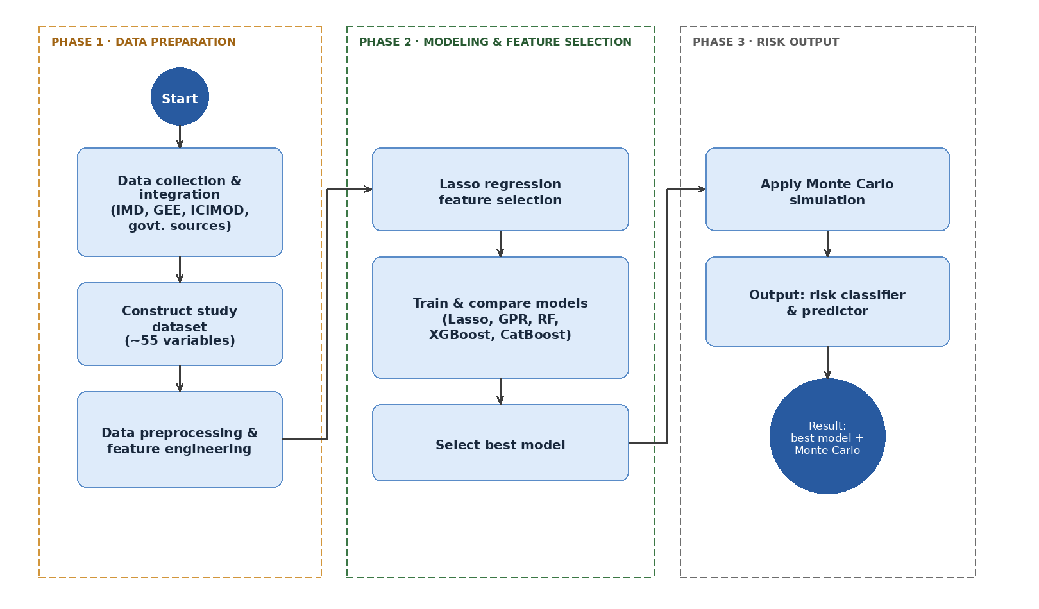
Figure 1.1: Methodology workflow for cost-overrun prediction and risk classification

3.2 Study Area
The study site encompasses two adjoining states of the Indian Himalaya, Uttarakhand and Himachal Pradesh, that account for the majority of India’s currently installed, under-construction and proposed hydro-power generation capacity. Uttarakhand spans roughly from 28°43’ to 31°28’ N and 77°35’ to 81°02’ E, covering about 53,500 km2; it is bordered by the Tibetan Autonomous Region of China to the north, Nepal to the east and Himachal Pradesh to the north-west [11]. About 86% of its terrain is mountainous or hill, ranging from the subtropical Shiwalik foothills, through the Lesser and Great Himalayan ranges, to peaks exceeding 7,000 m. The rivers that dominate the hydrology of Uttarakhand are the Bhagirathi, Alaknanda, Ramganga and upper Yamuna systems that form the larger Ganga river basin. Himachal Pradesh is located immediately to the north-west of Uttarakhand, centered approximately at 32.1° N, 77.6° E, with an area of about 55,700 km2, across the Outer, Lesser and Great Himalayan zones [67]. The river systems here are mostly comprised of the snow-and glacier-fed Chenab, Ravi, Beas, Sutlej and, in its lower reaches, the Yamuna; several of these river sources are located above 4,500 m and are perennial as a result of melt-water.
The two states were selected due to three, interrelated reasons: Firstly, they host one of the most significant concentrations of hydro-power schemes in India Uttarakhand has an installed hydro-power generation capacity of approximately 3,900 MW while Himachal Pradesh has an estimated exploitable hydro-power potential of roughly 18,540 MW, with only just over half of this having been developed thus far [21], [70]. Secondly, they fall within the highest resolution (0.25 o x 0.25 o) gridded observation grid of IMD, offering a temporally extensive and spatially consistent record of daily rainfall and temperature values, aggregable at project construction window timescales [27]. Thirdly, the region is prone to well-documented climate and geomorphology risks relevant to construction cost performance, such as steep and tectonically active slopes [22], landslide frequency [11], [67], exposure to glacial lake outburst floods (GLOF) [29], [30] and an increasing frequency of extreme rainfall events [NO_PRINTED_FORM], [63], [66] which have caused catastrophic multi-hazard cascade events, such as the Sikkim floods of October 2023 [NO_PRINTED_FORM]. As such, the approach herein incorporates not just conventional project-related, but also geomorphic and climate-driven features.
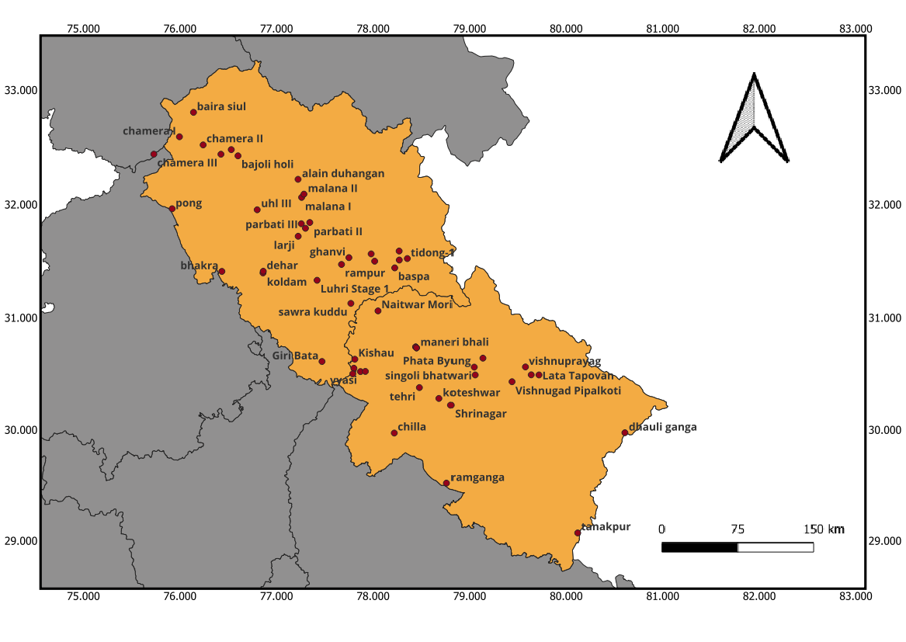
Figure 1.2 Locations of Hydro-electric Projects
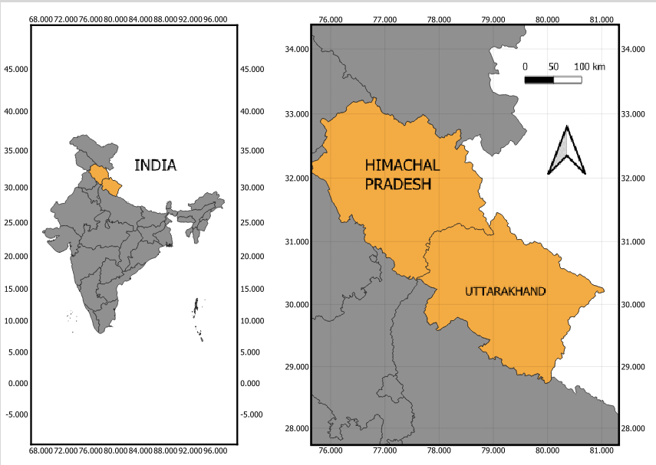
Figure 1.2 Study Area

3.3 Data Sources and Variables
Data from four primary sources was used to construct the dataset for this study on climate, project and geospatial attributes: The IMD was used for a 0.25o x 0.25o resolution dataset of gridded daily maximum temperature and precipitation [27]. Satellite data acquired from Google Earth Engine (GEE) provided terrain and other satellite-derived geospatial variables [28]. GLOF and other regional datasets were obtained from the International Centre for Integrated Mountain Development (ICIMOD) [29], [29]. Finally, data on individual project costs and schedules were sourced from a collection of Indian government detailed project reports (DPRs) and completion reports. A total of roughly 55 project-level variables was assembled in three broadly defined groups - anthropogenic, geographic and hydro-meteorological - including base cost, cost per MW (initial) and schedule slippage.
The dependent variable was taken as percentage cost overrun and, after a round of Lasso feature selection (see section 3.4 below), eight predicting variables were selected for the final models (see table 3.1). These features and the corresponding response variable were then cleaned and standardised prior to modeling: outliers were identified and addressed, gaps in data were imputed, or in cases where this was not feasible, the specific record removed, the numerical features were scaled, and where relevant, composite variables were generated by aggregating daily climate data over each project’s identified construction duration. This process results in a final analysis dataset of 45 completed projects.

3.4 Descriptive Statistics
Table 3.1 provides descriptive statistics for the 45-project (N = 45) cleaned dataset described above, comprising the dependent variable and eight selected features that will be used in the models presented in chapter 4. The dependent variable shows substantial positive skew, ranging from 59.08% to 551.73% with an average of 107.06% and a median value of 71.56%. The standard deviation is large, at 118.34 percentage points, largely driven by the handful of exceptionally high cost overruns in the sample.
Table 3.1: Summary statistics - target and Lasso-retained features
 | Mean | StdDev | Min | Median | Max
Cost overrun pct | 107.6 | 118.34 | -59.08 | 71.56 | 551.73
Schedule overrun pct | 113.62 | 100.06 | -50 | 100.0 | 433.33
Cost per MW | 5.26 | 4.03 | 0.1 | 5.18 | 16.06
Initial cost | 1402.81 | 1814.47 | 9.0 | 873.61 | 10600.0
R30mm | 95.16 | 77.67 | 11.0 | 75 | 355.0
Nearest pilgrim | 56.19 | 35.74 | 5.55 | 58.1 | 187.44
Steep frac. 25 | 0.61 | 0.17 | 0.09 | 0.64 | 0.83
Slope mean deg | 27.91 | 6.22 | 8.52 | 29.01 | 36.18
Catchement radius (Km) | 40.31 | 34.42 | 8 | 28.75 | 126.16
CWD mean | 25.27 | 11.31 | 8.86 | 22.08 | 50.0

Figure 3.1 (see accompanying results) plots the distributions for each of the features retained. Initial cost and total 30 mm-threshold rainfall (R30mm) are strongly right-skewed (most projects with low values and a few large projects/high rainfall outliers). Cost per MW is bimodal (peaks at around 1-2 crore/MW and 5-7 crore/MW). Mean slope and fraction of steep terrain are left-skewed, which is not surprising given that most projects analysed sit on fairly steep, uneven land typical of mountainous catchments [22]. Catchment radius and mean consecutive wet days (CWD) are both right-skewed (a few projects with large catchments / high CWDs).
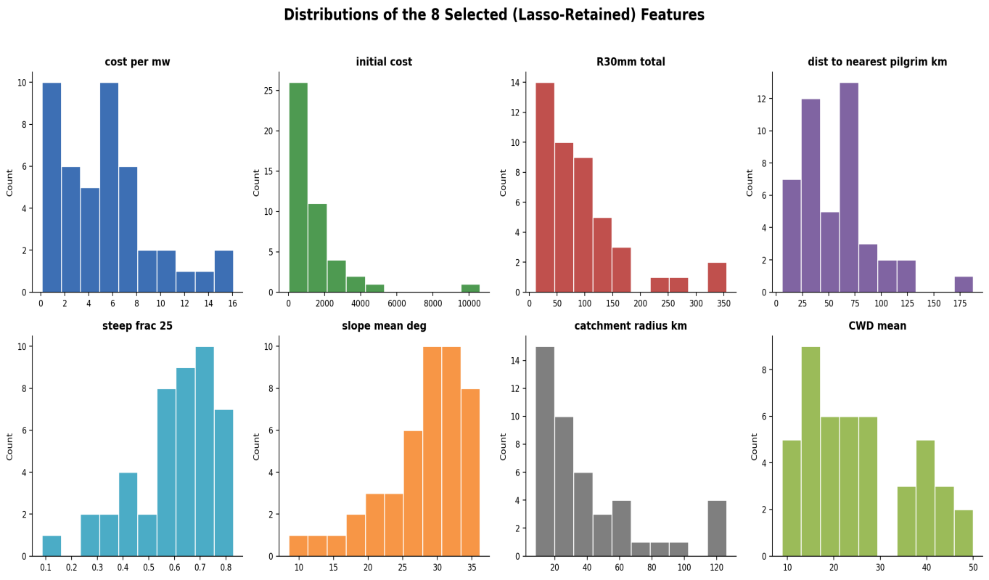

Figure 3.1: Distributions of the 8 Lasso-retained features
3.5 Feature Selection (Lasso) Results
Given the number of candidate features (approximately 55) significantly exceeds the number of available project samples (45), Lasso regression [31], [32] was used to penalize and shrink the coefficient vector for each feature and to select and rank important predictors prior to full model training (Chapter 4). The L1 penalty on coefficients, which Lasso applies, performs variable selection and regularization simultaneously and tends to be better than plain ordinary least squares when there are many more potential predictors than sample observations [33]. For these reasons, Lasso is a common choice for pre-screening variables when sample sizes are limited, including recent work that combines it with ensembles for feature reduction [52], [47], [48]. Lasso selected the following eight features for further modeling: Cost per MW, initial cost, total 30 mm-threshold rainfall (R30mm), distance to nearest population or pilgrimage centre, fraction of steep terrain (>25), mean slope, catchment radius, and mean consecutive wet days (CWD).
Figure 3.2 shows the pairwise Pearson correlations between cost overrun and the selected predictor variables. Cost per MW exhibits the strongest linear relationship with cost overrun (r = -0.60), followed by CWD mean (r = 0.50), initial cost (r = -0.36), catchment radius (r = 0.34), and both mean slope and steep-terrain fraction (approximately r = -0.30 each). The negative correlations of cost per MW, initial cost, and the terrain variables indicate that projects with higher capital costs or steeper terrain in this dataset tended to experience lower percentage cost overruns, whereas larger catchments and regions with higher mean consecutive dry days were associated with greater cost overruns. Most of the remaining variables show relatively weak linear relationships with the target, suggesting that their influence may be non-linear or dependent on interactions with other factors.
Two pairs of features are highly collinear and appear to represent similar physical characteristics: steep-terrain fraction and mean slope (r = 0.99), and CWD mean and catchment radius (r = 0.80). Although multicollinearity can be problematic for linear models, these features were retained because the tree-based ensemble methods used later in this study are relatively robust to correlated predictors [71].
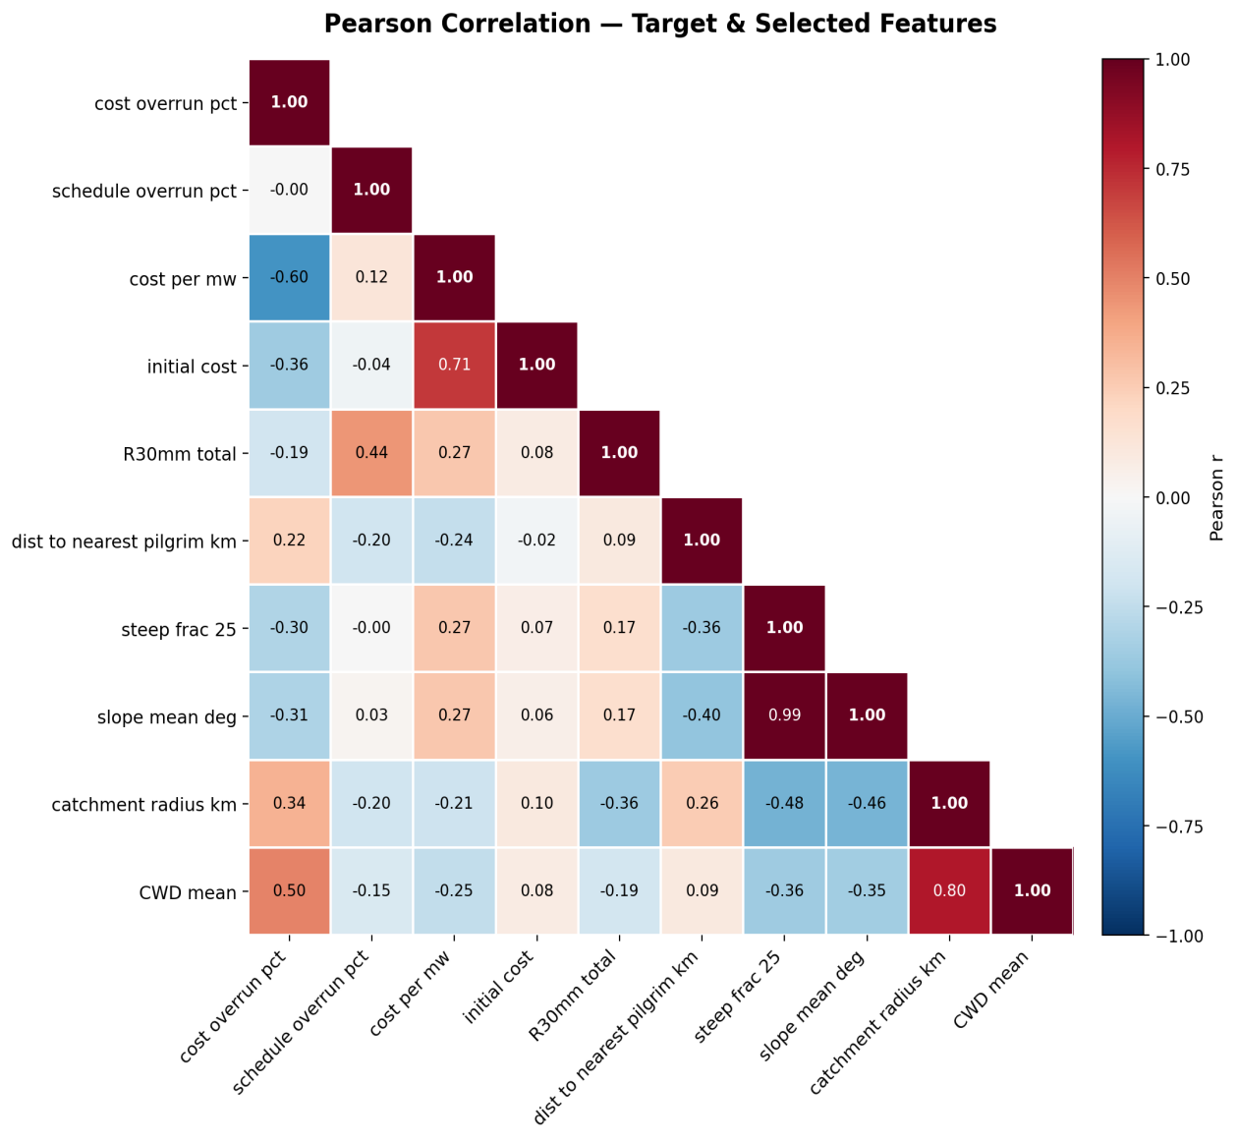
Figure 3.2: Pearson correlation heatmap - target and selected features

3.6 Machine Learning Models
In Section 3.4, Lasso regression was used purely for its feature selection properties. Since the correlation analysis in the previous section reveals complex and nonlinear relationships between cost overrun and candidate features, Lasso is unlikely to yield maximum predictive accuracy on its own. Rather, it serves to pre-screen a more manageable and informative subset of the variables before more flexible modeling approaches are applied. The practice of using Lasso-style selection followed by a more powerful predictor is common in many cost prediction studies. In this work, four models were fitted to the selected feature set: a Gaussian Process Regression (GPR) model, a probabilistic, non-parametric model that directly provides a predictive distribution for the output [34], [35], [54]; a Random Forest model, which involves bootstrapping many trees and averaging their predictions [36], [56]; and two gradient-boosting machine algorithms, XGBoost [NO_PRINTED_FORM] and CatBoost [39]. Together, these models represent a mix of a non-parametric method and three tree-based ensemble approaches, all known for good performance in construction and infrastructure-cost estimation [13], [15], [38], [51], [72], [19], [20], including very recent examples on construction cost overruns that use ensemble tree methods combined with explainable AI approaches [NO_PRINTED_FORM], [73].
3.7 Evaluation Metrics
Models are evaluated using standard measures that cover four different types of performance characteristics. Model fit/correlation: R, Spearman’s rho, Pearson’s r, Explained variance, Nash-Sutcliffe Efficiency (NSE), Willmott’s index of agreement d, Refined Index of Agreement (RIoA) and modified Kling-Gupta Efficiency (mKGE). Errors in proportion to the base prediction: Theil’s U and Normalized Mean Squared Error (NMSE). Errors as percentages of range/absolute values: Normalized RMSE (NRMSE, expressed as a % of range), Symmetric Mean Absolute Percentage Error (SMAPE), Percentage Bias (PBIAS). Absolute errors: RMSE, Mean Absolute Error (MAE), standard deviation of residuals, and Mean Bias Error (MBE), plus Akaike Information Criterion (AIC) for model fit. Since the sample size is small (N = 45), all models are assessed using leave-one-out cross-validation, which was chosen over k-fold or single-split validation for robustness at small sample sizes [41], though some instability remains even with LOOCV.
3.8 Monte Carlo Simulation Methodology
The Random Forest selected in Chapter 4 outputs a single value predicting cost overrun for a given project. This is not representative of model uncertainty; two similar projects may be predicted to have the same cost overrun, but underlying uncertainty may be quite different [26], [69]. To address this, we augment the Random Forest output with a Monte Carlo simulation to create a distribution of possible costs rather than a single estimate, reflecting model confidence and capturing risk. This technique has been a staple of cost-risk engineering for decades [23], [18] and has been combined recently with Random Forest methods to better model and analyze prediction uncertainty and drivers [40]. The predicted cost overrun is equivalent to the average (bias-adjusted) forecast of all individual trees. Rather than applying a fixed error distribution, uncertainty is estimated empirically using the model’s leave-one-out cross-validation performance: for each training project, every other project is removed and predicted, creating 45 “real” predictions against actual costs, and thus 45 error values [26], [41]. Then, for a new project, 10,000 historical error values are sampled randomly (with replacement) and added to the point prediction. The result is a distribution of 10,000 simulated cost outcomes, mimicking residual-bootstrap estimation of prediction intervals for ensemble models [NO_PRINTED_FORM], [55], [61]. This band will naturally widen if trees predict much more erratically than usual; in no case will it shrink beyond the minimum historical residual value (a conservative design in line with recent calls for interval forecasts that are valid under distribution drift [24], [59], [58], [60]).
3.9 Risk classification Framework
A classification is determined for the cost-overrun risk of the project in question based on how the Monte Carlo results for this project rank against measures of its P50, Pmean, P70, P90, and P95 values, aligned with the case-based and classification based risk framework proposed for construction and water projects in [13], [15], [50], [57], and [74]. Table 3.2 The project cost overrun-risk bands cutoffs were determined based on the percentiles of observed cost overrun of the 33% and 67% in the reference-class data rather than arbitrary rounded values-making this consistent with an empirical, reference-class style of forecasting cost risk in mega-projects [75], [25], [5], and [43].
Table 3.3: Monte Carlo risk-tier thresholds
RISK TIER | Predicted cost overrun
LOW RISK | <= 46.9%
MEDIUM RISK | 46.9-108.6%
HIGH RISK | >108.6%

CHAPTER 4: RESULTS AND DISCUSSION
4.1 Comparative Model Performance
Tables 4.1-4.5 report the performance of the four candidate models (Random Forest, CatBoost, GPR and XGBoost) across the full metric suite described in Section 3.7
Table 4.1: Correlation and fit-quality metrics
METRIC | RANDOM FOREST | CATBOOST | GPR | XGBOOST
Pearson r | 0.622 | 0.689 | 0.533 | 0.508
Spearman rho | 0.612 | 0.654 | 0.621 | 0.595
R^2 | 0.316 | 0.277 | 0.219 | 0.210
Explained Variance | 0.370 | 0.357 | 0.259 | 0.252
NSE | 0.316 | 0.277 | 0.219 | 0.210
Willmott’s d | 0.663 | 0.597 | 0.542 | 0.552
RIoA | 0.616 | 0.628 | 0.612 | 0.595
mKGE | 0.431 | 0.355 | 0.267 | 0.297

Table 4.2: Theil's U and normalised mean squared error (NMSE)

Metric | Random Forest | CatBoost | GPR | XGBoost
Thiels U | 0.377 | 0.410 | 0.408 | 0.407
NMSE | 0.684 | 0.724 | 0.781 | 0.790

Table 4.3: Percentage-based error metrics
Metric | Random Forest | CatBoost | GPR | XGBoost
NRMSE % range | 15.85 | 16.29 | 16.93 | 17.03
SMAPE % | 77.88 | 68.33 | 71.67 | 74.94
PBIAS % | -25.46 | -30.94 | -21.79 | -22.40

Table 4.4: Error-magnitude metrics
Metric | Random Forest | CatBoost | GPR | XGBoost
RMSE | 96.81 | 99.53 | 103.4 | 104.0
MAE | 64.77 | 62.84 | 65.55 | 68.33
STD. Residuals | 92.89 | 93.86 | 100.7 | 101.2
BIAS MBE | -27.26 | -33.12 | -23.33 | -23.98

Table 4.5: Akaike Information Criterion (AIC)

Metric | Random Forest | CatBoost | GPR | XGBoost
AIC | 427.5 | 430.0 | 433.5 | 434.0

Random Forest was the best performing model. Random Forest produced the highest values for most important evaluation parameters: R (0.316), Explained Variance (0.370), NSE (0.316), Willmott's d (0.663), and mKGE (0.431). Random Forest also produced the lowest values for RMSE (96.81), NRMSE (15.85%), Theil's U (0.377), NMSE (0.684), residual standard deviation (92.89), and AIC (427.5), signifying it to be the best model for overall prediction.
CatBoost had the highest correlation to the actual values (Pearson’s r = 0.689 and Spearman's = 0.654) and the lowest MAE (62.84) and SMAPE (68.33%).
GPR had the lowest prediction bias (MBE = -23.33 and PBIAS = -21.79%) and XGBoost performed the poorest on most evaluation metrics. The negative bias for all four models signifies that the cost overruns tend to be underestimated. This is largely attributable to the fact that some projects have a large extent of cost overruns which is harder for the model to fit with 45 projects.

4.2 Best-Performing Model Selection
Based on the analysis presented in Section 4.1, the best-performing model is the Random Forest. It provides the best overall compromise between accuracy of prediction and stability of performance, as evidenced by the lowest AIC and RMSE and the highest values of R², Explained Variance, NSE, Willmott's d, and mKGE. Although CatBoost yielded a better correlation and a lower MAE, Random Forest performed better on the aggregate of performance measures and is thus chosen for the Monte Carlo simulation described in Section 4.3. Figure 4.1 compares the leave-one-out cross-validation (LOOCV) predictions from the chosen Random Forest model against the actual cost-overrun values.

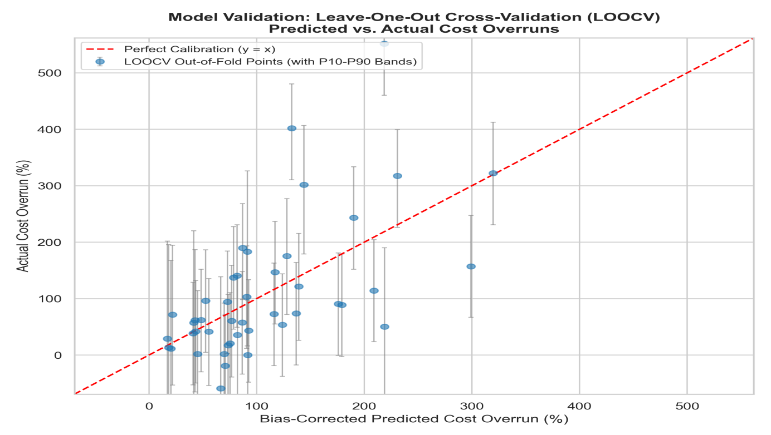Figure 4.1: LOOCV predicted vs. actual cost overrun (Random Forest model)

The Random Forest model predicts cost overruns in the range of approximately 0–150% accurately, with predictions lying close to the 1:1 line, but with a higher degree of prediction uncertainty for very large values of cost overrun. Predictions for projects with very high cost overrun are clearly underestimates, which given the low number of data points is expected; this is precisely the motivation for applying the Monte Carlo simulation described in Section 4.3 instead of relying on a single point prediction.

4.3 Monte Carlo Simulation and Risk Classification Results
Following the methodology described in Section 3.8, the Random Forest model's point prediction for each project is combined with 10,000 resampled historical prediction errors to generate a full distribution of plausible cost-overrun outcomes. Figure 4.2 shows the simulated distribution for a representative project, assigned to Medium Risk under the framework of Section 3.9.
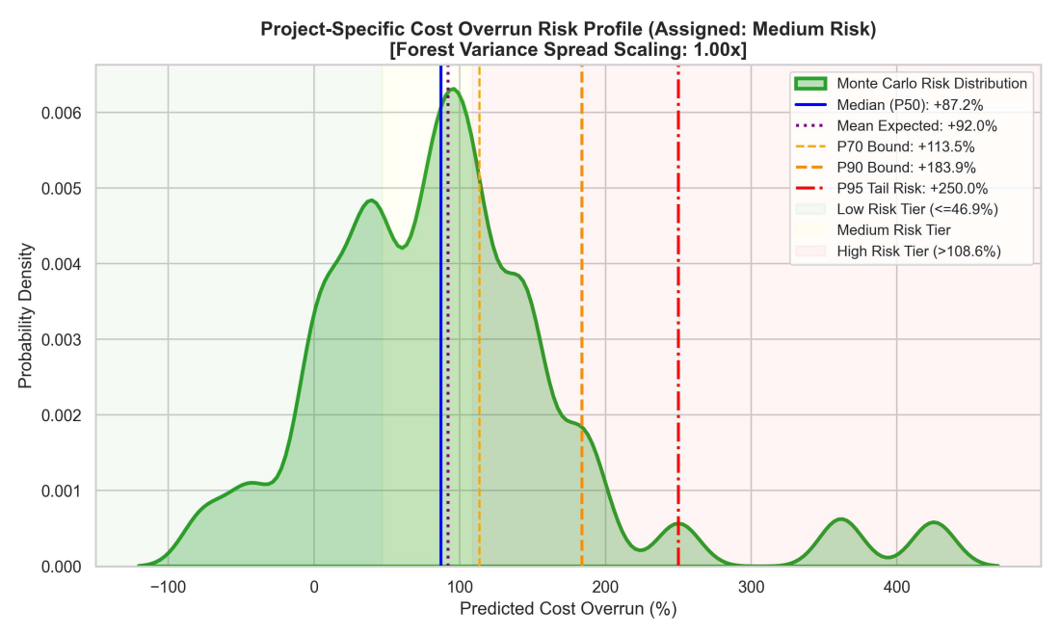
Figure 4.2: Simulated cost-overrun risk profile for a representative Medium Risk project
The 10,000 simulated outcomes give a median (P50) of +87.2% and a mean of +92.0%, with the mean sitting slightly above the median, meaning the distribution leans further into high-overrun territory than low. Further out, the P70 bound is +113.5%, P90 is +183.9%, and P95 reaches +250.0%, so in roughly one scenario out of twenty, the model considers an overrun of two-and-a-half times the original budget to be plausible. For the representative project shown, the individual trees of the forest agreed with one another about as much as would be expected from the training set, so no additional spread adjustment was required (widening factor of 1.00×).

4.4 Discussion
The comparative results from Section 4.1 corroborate the expectation established in the literature review (Section 2.3) that ensemble tree-based learners should be more adept than a purely linear model at capturing the nonlinear and collinear associations among project, terrain, and climate features suggested by Figure 3.2. The performance superiority of Random Forest over CatBoost and XGBoost on the aggregate fit and information-theoretic metrics generally align with comparable literature in construction cost estimation; indeed, a study by Meharie and Shaik [9] found that a Random Forest model significantly outperformed an artificial neural network and support vector machine when forecasting the cost of highway construction projects in Ethiopia, noting that its bagging structure helps to prevent overfitting when dealing with small and noisy project data sets. Similarly, in the prediction of power plant construction costs, a Random Forest model showed better performance than support vector regression and k-nearest neighbour approaches [7], and Random Forest has been shown to perform competitively, if not superiorly, to artificial neural networks when predicting the prices of residential buildings [38].
Together, these examples suggest that while Random Forest does not hold a universally dominant position, it often performs particularly well on small, heterogeneous tabular data sets, such as the one used in this study (n = 45).
This is relevant given the modest absolute level of prediction achieved in this work (R = 0.316 for Random Forest). Project cost-overrun prediction from an N=45 project data set is an inherently high-variance, low-sample-size problem, and a growing literature on the behavior of Random Forest in these settings points towards an explanation for its superiority to the single-model GPR and the boosting-based XGBoost as seen in Tables 4.1-4.5. Ensembles of bootstrap-aggregated trees have been found to be relatively robust to low sample sizes, to degrade more slowly than individual models when the number of training instances is small, and to do so because of the way averaging over many independently sampled trees may reduce variance even if any one individual tree is a poor estimator. This could suggest that the gap between Random Forest and the boosting models could shrink with a larger training sample size, as considered in Section 5.2.
The consistent negative bias seen across all four models in Table 4.4, that the cost overruns in the largest instances were underestimated, replicates a phenomenon documented broadly in infrastructure cost forecasting.
For example, in a statistical analysis of 258 transport projects, Flyvbjerg, Holm and Buhl [69] observed a systematic discrepancy where initial estimates were far lower than actual final costs and proposed that optimism bias and strategic misrepresentation in the appraisal process are a better explanation than random error for this consistent pattern of underestimation. While the negative bias of this study stems not from deliberate misrepresentation but from the statistical modeling limitation of sparse representation of extreme-overrun cases in the data, in practice, the two biases would reinforce each other: if project proponents already have incentive to underestimate expected costs during the project appraisal process, then an ML model trained on realized project cost histories will perpetuate some part of that same bias unless it is addressed, as done in this study through the use of the Monte Carlo residual-resampling in Section 3.8. This highlights the inadequacy of relying on only a point estimate of cost overrun for high-stakes project appraisal and explains why the Monte Carlo layer, that adjusts for uncertainty rather than for systematic bias of the central estimate, is an important complement, and not a superficial add-on, to the Random Forest model.
The approach used in Section 3.8, of resampling Random Forest’s leave-one-out residuals to form an empirical error distribution, is part of a broader family of techniques for creating prediction intervals for tree-based forecasts that includes the jackknife and infinitesimal-jackknife variance estimators [26], and quantile regression forests [76]. In light of the right-skewed and heavy-tailed nature of the cost-overrun target variable (as documented in Table 3.1), residual resampling was preferred over parametric approaches due to the failure of the latter to accommodate assumptions about symmetric errors, hence leading to the asymmetric distribution shown in Figure 4.2 (where the mean is slightly higher than the median at +92.0% and +87.2%, respectively). From a pragmatic point of view, the risk tiers generated in Section 3.9 and represented by the typical Medium Risk profile in Figure 4.2 are intended to highlight the practical value of the framework for planners and financiers: instead of offering a single estimate of approximately +87% cost overrun, the P95 bound of +250% indicates that the actual cost overrun could conceivably be 2.5 times the original budget, and therefore, provides a basis to set more informed contingency reserves compared to simply using a point estimate.
These insights align with broader arguments in the project risk-management literature that forecast percentiles (rather than points) derived from a Monte Carlo simulation should serve as the basis for contingency decisions [23].
In addition to these observations, several limitations warrant acknowledgment. First, although N=45 was sufficient for the tree ensembles considered here, this sample size remains small with respect to the approximately 55 potential predictors evaluated, necessitating feature reduction via Lasso (as described in Section 3.5) and thus limiting statistical power. Second, the moderate R = 0.316 achieved indicates that 68% of cost overrun variation was unexplained by the eight retained project, terrain and climate factors, and other unmodeled variables (e.g., contractual, financing, or governance characteristics) were presumably influential. Third, as the Monte Carlo layer is based on 45 individual leave-one-out residuals, the tails of the resulting simulated distributions (such as the P95 bound shown in Figure 4.2) are, themselves, based on estimates of extreme cases and should be interpreted cautiously.

CHAPTER 5: CONCLUSION AND FUTURE SCOPE
5.1 Conclusion
In this study, we propose and apply a machine-learning framework combined with Monte Carlo simulation for predicting cost overrun and cost-overrun classification of hydroelectric projects in Uttarakhand and Himachal Pradesh. A dataset of 55 anthropogenic, geographic and hydro-meteorological variables was constructed from IMD, GEE, ICIMOD and government sources across 45 projects, and this data was used in ML modelling after variable selection via Lasso regression yielding eight predicting variables: cost per MW, initial cost, cumulative rainfall of < 30 mm, proximity to the closest population or pilgrimage site, fraction of area in steep terrain, radius of catchment area, mean slope and mean consecutive wet days. Four machine-learning algorithms (Gaussian Process Regression, Random Forest, XGBoost and CatBoost) were applied, trained, and compared across statistical (correlation, fit quality, magnitude of error) and information theoretic (AIC) performance metrics.
The top performing technique (Random Forest; R=0.316, RMSE=96.81, AIC=427.5) was used in conjunction with Monte Carlo simulation to produce probability distributions of projected cost-overrun values for individual projects, a confidence range of potential cost-overrun and to define categories of risk (Low/Medium/High).
A example application of this framework indicated that the median cost-overrun forecast was 87.2% (50th percentile) with a 95th percentile cost overrun estimate as high as 250%, thereby underscoring the critical role of considering full risk distributions and tail risks, not single cost-overrun point forecasts, in the budgetary planning processes of future hydro-power projects within this region. As discussed in Section 4.4, this critical need is corroborated by extensive evidence of optimism bias within construction and infrastructure cost forecasting literature, and analogous support of Random Forest's success in similar datasets.

5.2 Future Scope

- Expanding the dataset beyond the existing 45 hydroelectric projects to a larger data set covering more hydroelectric projects throughout the Himalayan regions so as to constrain the present bands of uncertainty and improve generalization ability of model.
- Incorporating real time hydro-meteorologic time-series data stream into the existing model so as to enable a dynamic assessment of project risks during actual construction.
- Developing time series forecasting models, either by using a deep learning or hybrid time-series approach for estimating economic variables such as labor and material cost index or to account for extremely high cost overrun project in the data.
- Integrating the developed risk classifier into a risk management tool with the ability to produce a Monte Carlo driven output with scenarios and sensitivity analyses for use by project planners and financing agencies.

References
[1] International Hydropower Association, “2026 World Hydropower Outlook,” IHA, London, U.K., 2026.
[2] A. Ansar, B. Flyvbjerg, A. Budzier, and D. Lunn, “Should we build more large dams? The actual costs of hydro-power megaproject development,” Energy Policy, vol. 69, pp. 43–56, Jun. 2014.
[3] “Himalayan dams become economic burdens: lessons for Etalin.” Dialogue Earth, 2021. [Online]. Available: https://www.dialogueearth.org/
[4] B. Flyvbjerg, “Survival of the unfittest: why the worst infrastructure gets built—and what we can do about it,” Oxford Review of Economic Policy, vol. 25, no. 3, pp. 344–367, 2009.
[5] B. Flyvbjerg, “What you should know about megaprojects and why: an overview,” Project Management Journal, vol. 45, no. 2, pp. 6–19, 2014.
[6] B. K. Sovacool, A. Gilbert, and D. Nugent, “An international comparative assessment of construction cost overruns for electricity infrastructure,” Energy Research & Social Science, vol. 3, pp. 152–160, 2014.
[7] T. Azam, W. S. Jiang, S. A. Malik, S. Y. Malik, and M. Nilofar, “An analysis of causes of delay and cost overrun in construction of hydro-power project,” Journal of Public Affairs, p. e2285, 2020.
[8] D. Kumar and S. S. Katoch, “Sustainability suspense of small hydro-power projects: A study from western Himalayan region of India,” Renewable Energy, vol. 76, pp. 220–233, 2015.
[9] J. M. Andrić, S. Lin, Y. Cheng, and B. Sun, “Determining Cost and Causes of Overruns in Infrastructure Projects in South Asia,” Sustainability, vol. 16, no. 24, p. 11159, 2024.
[10] T. B. Katuwal, K. K. Panthi, and C. B. Basnet, “Machine learning approach for prediction of TBM performance and risk of jamming in Himalayan geology using a cross-project tunnelling database,” Scientific Reports, 2026, doi: 10.1038/s41598-025-34273-z.
[11] V. Gupta, S. Kumar, R. Kaur, and R. S. Tandon, “Regional-scale landslide susceptibility assessment for the hilly state of Uttarakhand, NW Himalaya, India,” Journal of Earth System Science, vol. 131, no. 1, p. 2, 2022.
[12] S. Debnath and K. L. Daga, “Building Climate-Resilient Hydropower: Slope Stability,” 2026.
[13] H. Sohrabi and E. Noorzai, “Risk-supported case-based reasoning approach for cost overrun estimation of water-related projects using ML,” Engineering, Construction and Architectural Management, vol. 31, no. 2, pp. 544–570, 2024.
[14] A. Khodabakhshian, “Machine learning for risk management in construction projects,” PhD Thesis, Politecnico di Milano, 2023.
[15] A. H. Turkyilmaz and G. Polat, “Risk-based completion cost overrun ratio estimation in construction projects using machine learning classification algorithms: A case study,” Buildings, vol. 14, no. 11, p. 3541, 2024.
[16] M. S. H. Hriday and A. Rehman, “Artificial Intelligence and Machine Learning Applications in Construction Project Management: Enhancing Scheduling, Cost Estimation, and Risk Mitigation,” International Journal of Business and Economics Insights, vol. 5, no. 3, pp. 30–64, 2025.
[17] S. D. Datta, M. Islam, M. H. R. Sobuz, S. Ahmed, and M. Kar, “Artificial intelligence and machine learning applications in the project lifecycle of the construction industry: A comprehensive review,” Heliyon, vol. 10, p. e26888, 2024.
[18] R. L. Harrison, “Introduction to Monte Carlo simulation,” in AIP Conference Proceedings, 2010, pp. 17–21.
[19] Z. Zheng, L. Zhou, H. Wu, and L. Zhou, “Construction cost prediction system based on Random Forest optimized by the Bird Swarm Algorithm,” Mathematical Biosciences and Engineering, vol. 20, no. 8, pp. 15044–15074, 2023.
[20] S. F. M. Alazawy, M. A. Ahmed, S. H. Raheem, H. Imran, L. F. A. Bernardo, and H. A. S. Pinto, “Explainable machine learning to predict the construction cost of power plant based on random forest and Shapley method,” CivilEng, vol. 6, no. 2, p. 21, 2025.
[21] S. Sharma and J. C. Kuniyal, “hydro-power development and policies in India: A case of Himachal Pradesh in the northwestern Himalaya, India,” Energy Sources, Part B: Economics, Planning, and Policy, vol. 11, no. 4, pp. 377–384, 2016.
[22] W. Schwanghart, M. Ryan, and O. Korup, “Topographic and seismic constraints on the vulnerability of Himalayan hydro-power,” Geophysical Research Letters, vol. 45, pp. 8985–8992, 2018.
[23] A. J. Barreras, “Risk management: Monte Carlo simulation in cost estimating,” in Proc. PMI Global Congress 2011—North America, Dallas, TX, USA: Project Management Institute, 2011.
[24] H. Tyralis and G. Papacharalampous, “A review of predictive uncertainty estimation with machine learning,” Artificial Intelligence Review, vol. 57, p. 94, 2024.
[25] B. Flyvbjerg, M. S. Holm, and S. L. Buhl, “Underestimating costs in public works projects: Error or lie?,” Journal of the American Planning Association, vol. 68, no. 3, pp. 279–295, 2002.
[26] S. Wager, T. Hastie, and B. Efron, “Confidence intervals for random forests: The jackknife and the infinitesimal jackknife,” Journal of Machine Learning Research, vol. 15, pp. 1625–1651, 2014.
[27] D. S. Pai, L. Sridhar, M. Rajeevan, O. P. Sreejith, N. S. Satbhai, and B. Mukhopadhyay, “Development of a new high spatial resolution (0.25° × 0.25°) long period (1901–2010) daily gridded rainfall data set over India and its comparison with existing data sets over the region,” MAUSAM, vol. 65, no. 1, pp. 1–18, 2014.
[28] N. Gorelick, M. Hancher, M. Dixon, S. Ilyushchenko, D. Thau, and R. Moore, “Google Earth Engine: Planetary-scale geospatial analysis for everyone,” Remote Sensing of Environment, vol. 202, pp. 18–27, 2017.
[29] International Centre for Integrated Mountain Development (ICIMOD), “Inventory of Glacial Lakes and Identification of Potentially Dangerous Glacial Lakes in the Koshi, Gandaki, and Karnali River Basins of Nepal, the Tibet Autonomous Region of China, and India,” ICIMOD, Kathmandu, Nepal, 2011.
[30] W. Schwanghart, R. Worni, C. Huggel, M. Stoffel, and O. Korup, “Uncertainty in the Himalayan energy–water nexus: Estimating regional exposure to glacial lake outburst floods,” Environmental Research Letters, vol. 11, p. 074005, 2016.
[31] R. Tibshirani, “Regression shrinkage and selection via the lasso,” Journal of the Royal Statistical Society: Series B, vol. 58, no. 1, pp. 267–288, 1996.
[32] J. Ranstam and J. A. Cook, “LASSO regression,” British Journal of Surgery, vol. 105, no. 10, p. 1348, 2018.
[33] D. Vidaurre, C. Bielza, and P. Larrañaga, “A Survey of L1 Regression,” International Statistical Review, vol. 81, no. 3, pp. 361–387, 2013.
[34] C. K. I. Williams and C. E. Rasmussen, “Gaussian processes for regression,” in Advances in Neural Information Processing Systems 8, 1996, pp. 514–520.
[35] B. Wang and T. Chen, “Gaussian process regression with multiple response variables,” Chemometrics and Intelligent Laboratory Systems, vol. 142, pp. 159–165, 2015.
[36] L. Breiman, “Random forests,” Machine Learning, vol. 45, pp. 5–32, 2001.
[37] T. Chen and C. Guestrin, “XGBoost: A scalable tree boosting system,” in Proc. 22nd ACM SIGKDD Int. Conf. Knowledge Discovery and Data Mining (KDD ’16), 2016, pp. 785–794.
[38] G. H. Coffie and S. K. F. Cudjoe, “Using extreme gradient boosting (XGBoost) machine learning to predict construction cost overruns,” International Journal of Construction Management, vol. 24, no. 16, pp. 1742–1750, 2024.
[39] L. Prokhorenkova, G. Gusev, A. Vorobev, A. V. Dorogush, and A. Gulin, “CatBoost: unbiased boosting with categorical features,” in Advances in Neural Information Processing Systems 31 (NeurIPS 2018), 2018, pp. 6639–6649.
[40] J. Zeng, J. Liu, L. Li, and others, “Combining Random Forest and Monte Carlo Method to Determine the Driving Factors and Uncertainty of Forest Age Prediction in Northwest China,” Chinese Geographical Science, vol. 36, pp. 144–156, 2026.
[41] R. Kohavi, “A study of cross-validation and bootstrap for accuracy estimation and model selection,” in Proc. 14th International Joint Conference on Artificial Intelligence (IJCAI), 1995, pp. 1137–1143.
[42] J. Snoek, H. Larochelle, and R. P. Adams, “Practical Bayesian optimization of machine learning algorithms,” in Advances in Neural Information Processing Systems 25 (NeurIPS 2012), 2012, pp. 2951–2959.
[43] B. Flyvbjerg, “Top ten behavioral biases in project management: an overview,” Project Management Journal, vol. 52, no. 6, pp. 531–546, 2021.
[44] R. W. Bacon and J. E. Besant-Jones, “Estimating construction costs and schedules: Experience with power generation projects in developing countries,” Energy Policy, vol. 26, no. 4, pp. 317–333, 1998.
[45] “From Delay to Delivery: Tackling Time and Cost Risks in hydro-power Projects,” International Journal for Research in Applied Science & Engineering Technology (IJRASET), vol. 13, no. 12, 2025.
[46] D. A. Godse, S. Gothane, V. Balpande, M. V. Bramhe, K. P. Karule, and A. T. Mokashi, “Hybrid Feature Selection and Ensemble Learning for Multi-Disease Prediction in Smart Healthcare Systems,” International Journal of Special Education, 2026.
[47] Y. Shi, J. Fang, J. Li, K. Yu, and J. Zhu, “Fracture risk prediction in diabetes patients based on Lasso feature selection and Machine Learning,” Computer Methods in Biomechanics and Biomedical Engineering, 2024, doi: 10.1080/10255842.2024.2400325.
[48] N. S. Bennett and M. S. Islam, “Hybrid Lasso-random forest framework for energy prediction using wireless sensor networks in low-energy buildings,” Scientific Reports, 2026.
[49] T. P. Williams and J. Gong, “Predicting construction cost overruns using text mining, numerical data and ensemble classifiers,” Automation in Construction, vol. 43, pp. 23–29, 2014.
[50] H. Moon, T. P. Williams, H. S. Lee, and M. Park, “Predicting project cost overrun levels in bidding stage using ensemble learning,” Journal of Asian Architecture and Building Engineering, vol. 19, no. 6, pp. 586–599, 2020.
[51] M. M. Hamdan, M. Thneibat, and K. Hyari, “Predicting cost overrun in construction projects using machine learning algorithms: the case of Jordan,” Engineering, Construction and Architectural Management, 2025, doi: 10.1108/ECAM-09-2024-1209.
[52] W. Royhan and others, “Feature Selection Using Ensemble Lasso Regression, Random Forest and Recursive Feature Elimination Methods in Breast Cancer Classification,” in Proc. 2025 Int. Conf. Computer Sciences Engineering and Technology Innovation (ICOCSETI), IEEE, 2025.
[53] H. Zou and T. Hastie, “Regularization and variable selection via the elastic net,” Journal of the Royal Statistical Society: Series B, vol. 67, no. 2, pp. 301–320, 2005.
[54] C. E. Rasmussen and C. K. I. Williams, Gaussian Processes for Machine Learning. Cambridge, MA: MIT Press, 2006.
[55] B. Ramosaj, “Interpretable Machines: Constructing Valid Prediction Intervals with Random Forests,” arXiv preprint arXiv:2103.05766, 2021.
[56] L. Breiman, J. H. Friedman, R. A. Olshen, and C. J. Stone, Classification and Regression Trees. Boca Raton, FL: Chapman & Hall/CRC, 1984.
[57] M. O. Sanni-Anibire, R. M. Zin, and S. O. Olatunji, “Machine learning model for delay risk assessment in tall building projects,” International Journal of Construction Management, vol. 22, no. 11, pp. 2134–2143, 2022.
[58] A. N. Angelopoulos and S. Bates, “A Gentle Introduction to Conformal Prediction and Distribution-Free Uncertainty Quantification,” arXiv preprint arXiv:2107.07511, 2022.
[59] D. Bethell, S. Gerasimou, and R. Calinescu, “Robust uncertainty quantification using conformalised Monte Carlo prediction,” in Proc. AAAI Conference on Artificial Intelligence, 2024, pp. 20939–20948.
[60] M. Abdar and others, “A review of uncertainty quantification in deep learning: Techniques, applications and challenges,” Information Fusion, vol. 76, pp. 243–297, 2021.
[61] B. Efron and R. J. Tibshirani, An Introduction to the Bootstrap. New York: Chapman & Hall, 1993.
[62] V. Bharti, C. Singh, J. Ettema, and T. A. Turkington, “Spatiotemporal characteristics of extreme rainfall events over the northwest Himalaya using satellite data,” International Journal of Climatology, vol. 36, no. 12, pp. 3949–3962, 2016.
[63] R. K. Vellore, M. L. Kaplan, R. Krishnan, J. M. Lewis, S. Sabade, and N. Deshpande, “Monsoon-extratropical circulation interactions in Himalayan extreme rainfall,” Climate Dynamics, vol. 46, pp. 3517–3546, 2016.
[64] X. Zhang et al., “Indices for monitoring changes in extremes based on daily temperature and precipitation data,” WIREs Climate Change, vol. 2, no. 6, pp. 851–870, 2011.
[65] D. H. Shugar and others, “The Sikkim flood of October 2023: Drivers, causes, and impacts of a multihazard cascade,” Science, 2025, doi: 10.1126/science.ads2659.
[66] “Extreme rainfall events have more than doubled in Himalayas.” Dialogue Earth, 2021. [Online]. Available: https://dialogue.earth/
[67] R. K. Dhiman and others, “Landslide susceptibility mapping in the Himalayas: An integrated geospatial and machine learning approach-based study of the Chandra-Bhaga Basin, Himachal Pradesh, India,” Geological Journal, 2026.
[68] Md. Nawazuzzoha et al., “Advanced machine learning models for landslide susceptibility mapping in South Sikkim Himalayas, India,” Geological Journal, 2025.
[69] J. W. Coulston, C. E. Blinn, V. A. Thomas, and R. H. Wynne, “Approximating prediction uncertainty for random forest regression models,” Photogrammetric Engineering & Remote Sensing, vol. 82, no. 3, pp. 189–197, 2016.
[70] “Hydro Power Scenario in Himachal Pradesh,” Electrical India Magazine. 2024. [Online]. Available: https://www.electricalindia.in/hydro-power-scenario-in-himachal-pradesh/
[71] T. Hastie, R. Tibshirani, and J. Friedman, The Elements of Statistical Learning: Data Mining, Inference, and Prediction, 2nd ed. New York: Springer, 2009.
[72] S. Shoar, N. Chileshe, and J. D. Edwards, “Machine learning-aided engineering services’ cost overruns prediction in high-rise residential building projects: Application of random forest regression,” Journal of Building Engineering, vol. 50, p. 104102, 2022.
[73] M. T. Nguyen, V. T. Phan, and H. L. Tran, “An explainable XGBoost model for predicting cost overruns in construction projects,” Asian Journal of Civil Engineering, 2026, doi: 10.1007/s42107-026-01686-8.
[74] A. Shaktawat and S. Vadhera, “Risk management of hydro-power projects for sustainable development: a review,” Environment, Development and Sustainability, vol. 23, no. 1, pp. 45–76, 2021.
[75] O. Awojobi and G. P. Jenkins, “Managing the cost overrun risks of hydroelectric dams: An application of reference class forecasting techniques,” Renewable and Sustainable Energy Reviews, vol. 63, pp. 19–32, 2016.
[76] N. Meinshausen, “Quantile regression forests,” Journal of Machine Learning Research, vol. 7, pp. 983–999, 2006.

