**Communication Engineering**

**Experiment 1**

1. **Periodic Function**

%Ploting of Sine Function

clc;

clear all;

close all;

figure;

t=[-10:0.1:10];

a=sin(t);

subplot(3,2,1);

plot(t,a);

xlabel('time ui21cs35');

ylabel('amplitude ui21cs35');

axis([-10 10 -2 2]);

title('sinwave ui21cs35');

%COS FUNCTION

t=[-10:0.1:10];

a=sin(t);

subplot(3,2,2);

plot(t,a);

xlabel('time ui21cs35');

ylabel('amplitude ui21cs35');

axis([-10 10 -2 2]);

title('coswave ui21cs35');

%tan function

t=[-10:0.1:10];

a=tan(t);

subplot(3,2,3);

plot(t,a);

xlabel('time ui21cs35');

ylabel('amplitude ui21cs35');

axis([-10 10 -2 2]);

title('tanwave_ui21cs35');

%square function

t=[-10:0.1:10];

a=square(t);

subplot(3,2,4);

plot(t,a);

xlabel('time ui21cs35');

ylabel('amplitude ui21cs35');

axis([-10 10 -2 2]);

title('square wave ui21cs35');

%triangular function

t=[-10:0.1:10];

a=sawtooth(t,0);

subplot(3,2,5);

plot(t,a);

xlabel('time ui21cs35');

ylabel('amplitude ui21cs35');

axis([-10 10 -2 2]);

title('triangular wave ui21cs35');

%sawtooth function

t=[-10:0.1:10];

a=sawtooth(t,0.5);

subplot(3,2,6);

plot(t,a);

xlabel('time ui21cs35');

ylabel('amplitude ui21cs35');

axis([-10 10 -2 2]);

title('sawtooth wave ui21cs35');

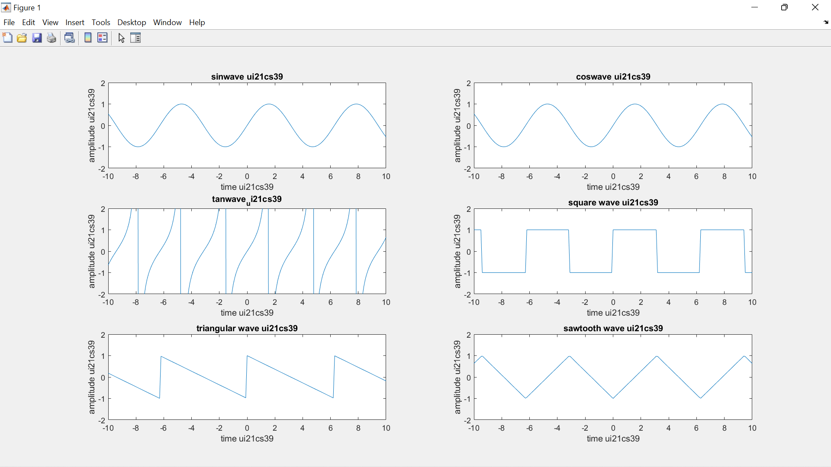

1. **Aperiodic Function**

clc;

clear all;

close all;

figure;

t=[-10:0.1:10];

a=(t>=0); %unit step function

subplot(3,2,1);

plot(t,a);

xlabel('time ui21cs35');

ylabel('amplitude ui21cs35');

axis([-10 10 -2 2]);

title('unit step ui21cs35');

t=[-10:0.1:10];

a=(t==0);% unit impulse function

subplot(3,2,2);

plot(t,a);

xlabel('time ui21cs35');

ylabel('amplitude ui21cs35');

axis([-10 10 -2 2]);

title('unit impulse ui21cs35');

%rampsignal

t=[-10:0.1:10];

a=(t);

subplot(3,2,3);

plot(t,a);

xlabel('time ui21cs35');

ylabel('amplitude ui21cs35');

axis([-10 10 -2 2]);

title('ramp ui21cs35');

%signum function

t=[-10:0.1:10];

a=sign(t);

subplot(3,2,4);

plot(t,a);

xlabel('time ui21cs35');

ylabel('amplitude ui21cs35');

axis([-10 10 -2 2]);

title('signum ui21cs35');

%exponential function

t=[-10:0.1:10];

a=exp(t);

subplot(3,2,5);

plot(t,a);

xlabel('time ui21cs35');

ylabel('amplitude ui21cs35');

axis([-10 10 -2 2]);

title('exponentialui21cs35');

%rectangular function

t=[-10:0.1:10];

a=rectpuls(t);

subplot(3,2,6);

plot(t,a);

xlabel('time ui21cs35');

ylabel('amplitude ui21cs35');

axis([-10 10 -2 2]);

title('rectangular ui21cs35');

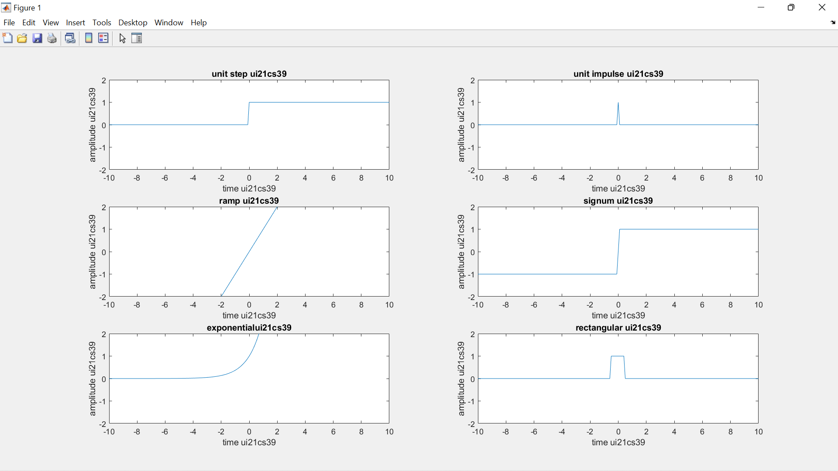

**Experiment 2**

clc;

clear all;

close all;

figure;

%sine

t=[-10:0.1:10];

a=sin(t);

subplot(6,2,1);

plot(t,a);

xlabel('time UI21CS35');

ylabel('amplitude UI21CS35');

axis([-10 10 -2 2]);

title('sinwave UI21CS35');

y=fftshift(abs(fft(a)));

subplot(6,2,2);

plot(y);

xlabel('time UI21CS35');

ylabel('amplitude UI21CS35');

title('sinwave UI21CS35');

%cosine

t=[-10:0.1:10];

a=cos(t);

subplot(6,2,3);

plot(t,a);

xlabel('time UI21CS35');

ylabel('amplitude UI21CS35');

axis([-10 10 -2 2]);

title('cosine UI21CS35');

y=fftshift(abs(fft(a)));

subplot(6,2,4);

plot(y);

xlabel('time UI21CS35');

ylabel('amplitude UI21CS35');

title('cosine UI21CS35');

%exponential

t=[-10:0.1:10];

a=exp(t);

subplot(6,2,5);

plot(t,a);

xlabel('time UI21CS35');

ylabel('amplitude UI21CS35');

axis([-10 10 -2 2]);

title('exponential UI21CS35');

y=fftshift(abs(fft(a)));

subplot(6,2,6);

plot(y);

xlabel('time UI21CS35');

ylabel('amplitude UI21CS35');

title('exponential UI21CS35');

%rectagular pulse

t=[-10:0.1:10];

a=rectpuls(t);

subplot(6,2,7);

plot(t,a);

xlabel('time UI21CS35');

ylabel('amplitude UI21CS35');

axis([-10 10 -2 2]);

title('rectagular pulse UI21CS35');

y=fftshift(abs(fft(a)));

subplot(6,2,8);

plot(y);

xlabel('time UI21CS35');

ylabel('amplitude UI21CS35');

title('rectagular pulse UI21CS35');

%sinc wave

t=[-10:0.1:10];

a=sinc(t);

subplot(6,2,9);

plot(t,a);

xlabel('time UI21CS35');

ylabel('amplitude UI21CS35');

axis([-10 10 -2 2]);

title('sinc wave UI21CS35');

y=fftshift(abs(fft(a)));

subplot(6,2,10);

plot(y);

xlabel('time UI21CS35');

ylabel('amplitude UI21CS35');

title('sinc wave UI21CS35');

%impulse

t=[-10:0.1:10];

a=(t==0);

subplot(6,2,11);

plot(t,a);

xlabel('time UI21CS35');

ylabel('amplitude UI21CS35');

axis([-10 10 -2 2]);

title('impulse UI21CS35');

y=fftshift(abs(fft(a)));

subplot(6,2,12);

plot(y);

xlabel('time UI21CS35');

ylabel('amplitude UI21CS35');

title('impulse UI21CS35');

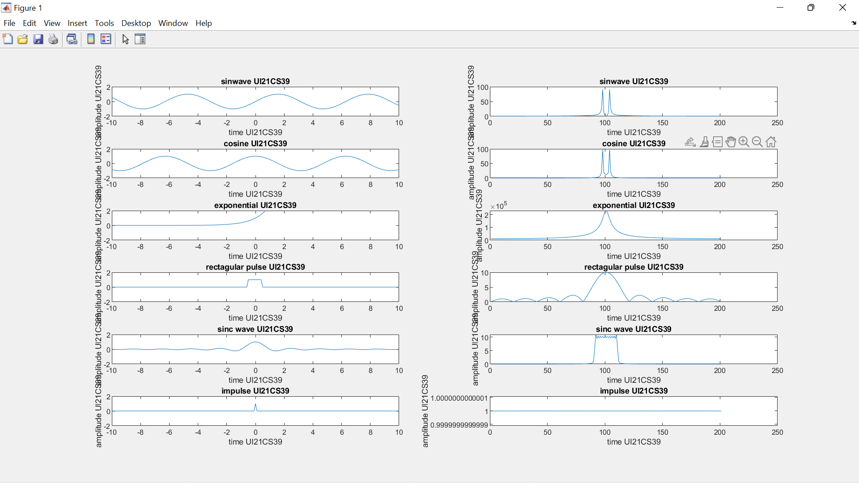

**Experiment 3**

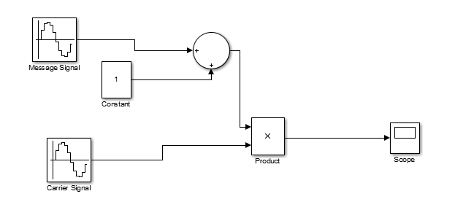

**t=[-10:0.01:10];**

**fm=1000;**

**fc=10000;**

**Am=10;**

**Ac=20;**

**m=Am/Ac;**

**pi=3.14;**

**Em=Am*cos(2*pi*fm*t);**

**subplot(6,1,1);**

**plot(t,Em);**

**title('Modulating signal-UI21CS35');**

**Ec=Ac*cos(2*pi*fc*t);**

**subplot(6,1,2);**

**plot(t,Ec);**

**title('carrier signal-UI21CS35');**

**Eam=Ac*[1+m*cos(2*pi*fm*t)].*cos(2*pi*fc*t);**

**subplot(6,1,3);**

**plot(t,Eam);**

**title('AM signal for "m<1"-UI21CS35');**

**Am=20;**

**Ac=20;**

**m=Am/Ac;**

**Eam=Ac*[1+m*cos(2*pi*fm*t)].*cos(2*pi*fc*t);**

**subplot(6,1,4);**

**plot(t,Eam);**

**title('AM signal for "m=1"-UI21CS35');**

**Am=40;**

**Ac=20;**

**m=Am/Ac;**

**Eam=Ac*[1+m*cos(2*pi*fm*t)].*cos(2*pi*fc*t);**

**subplot(6,1,5);**

**plot(t,Eam);**

**title('AM signal for "m>1"-UI21CS35');**

**D = Eam.*Ec;**

**[B,A] = butter(5,1/22,'low');**

**F = filter(B,A,D);**

**subplot(6,1,6);**

**plot(t,F);**

**title('Demodulated Signal-UI21CS35')**

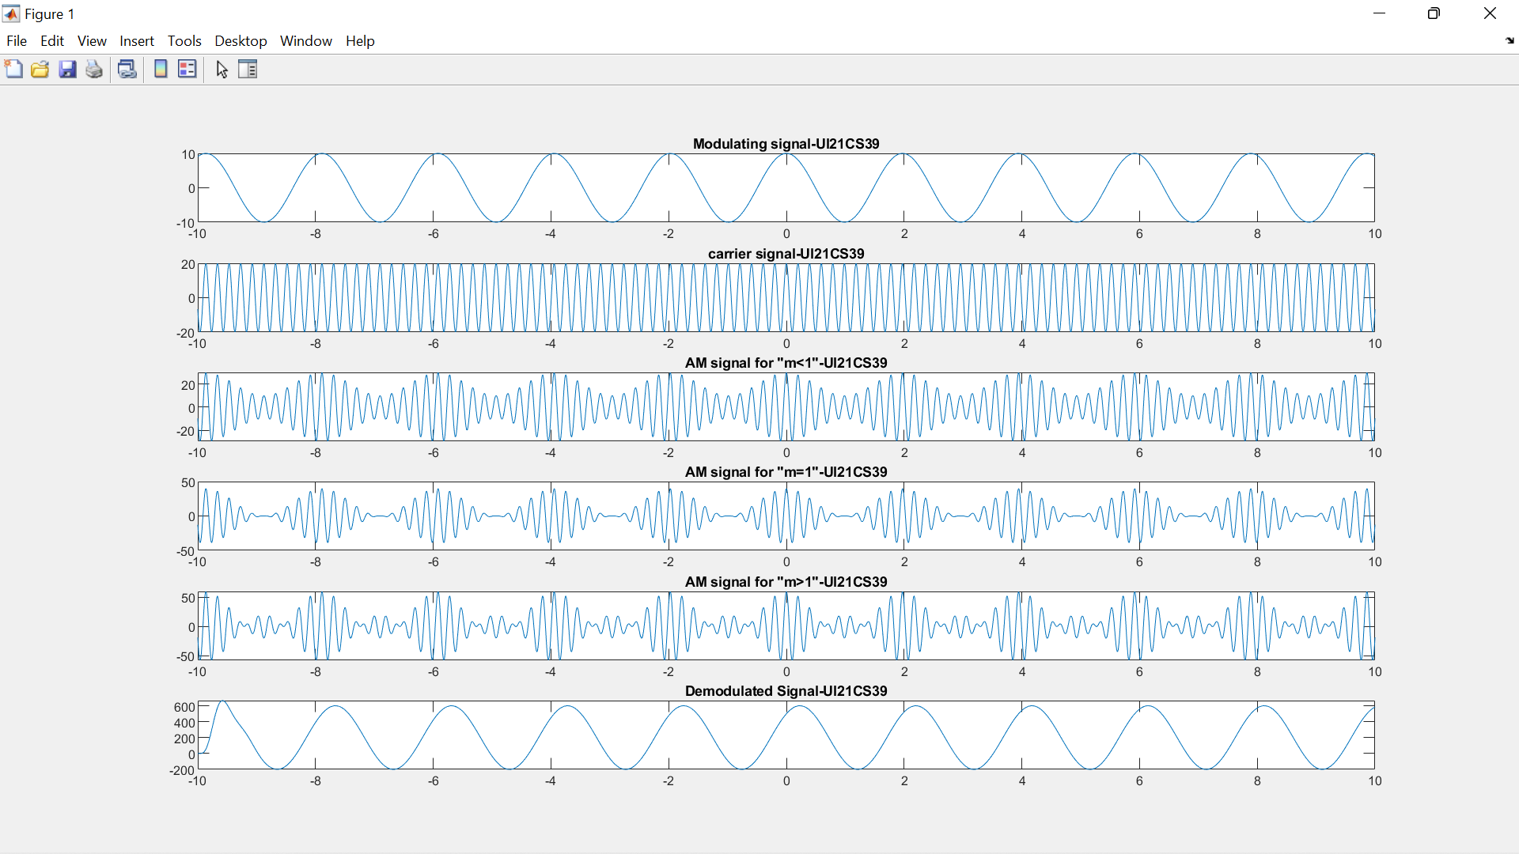

**M<1**

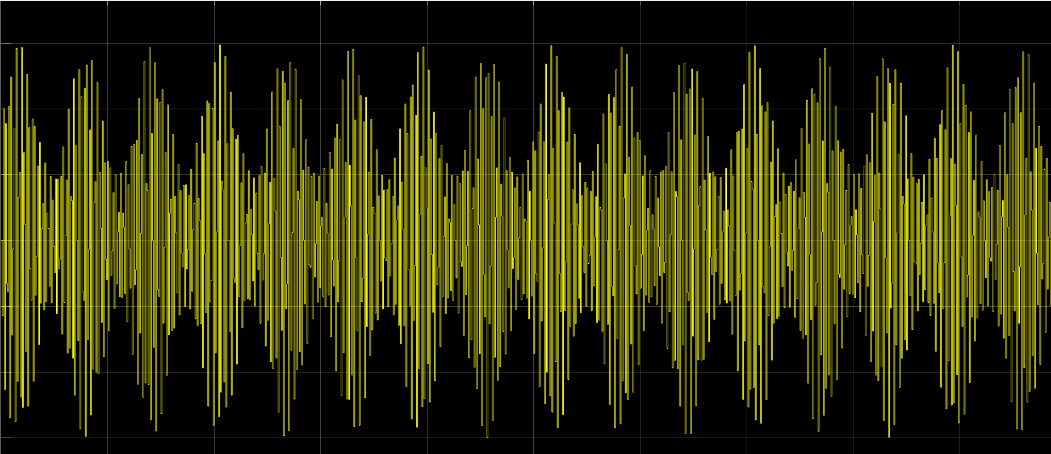

**M=1**

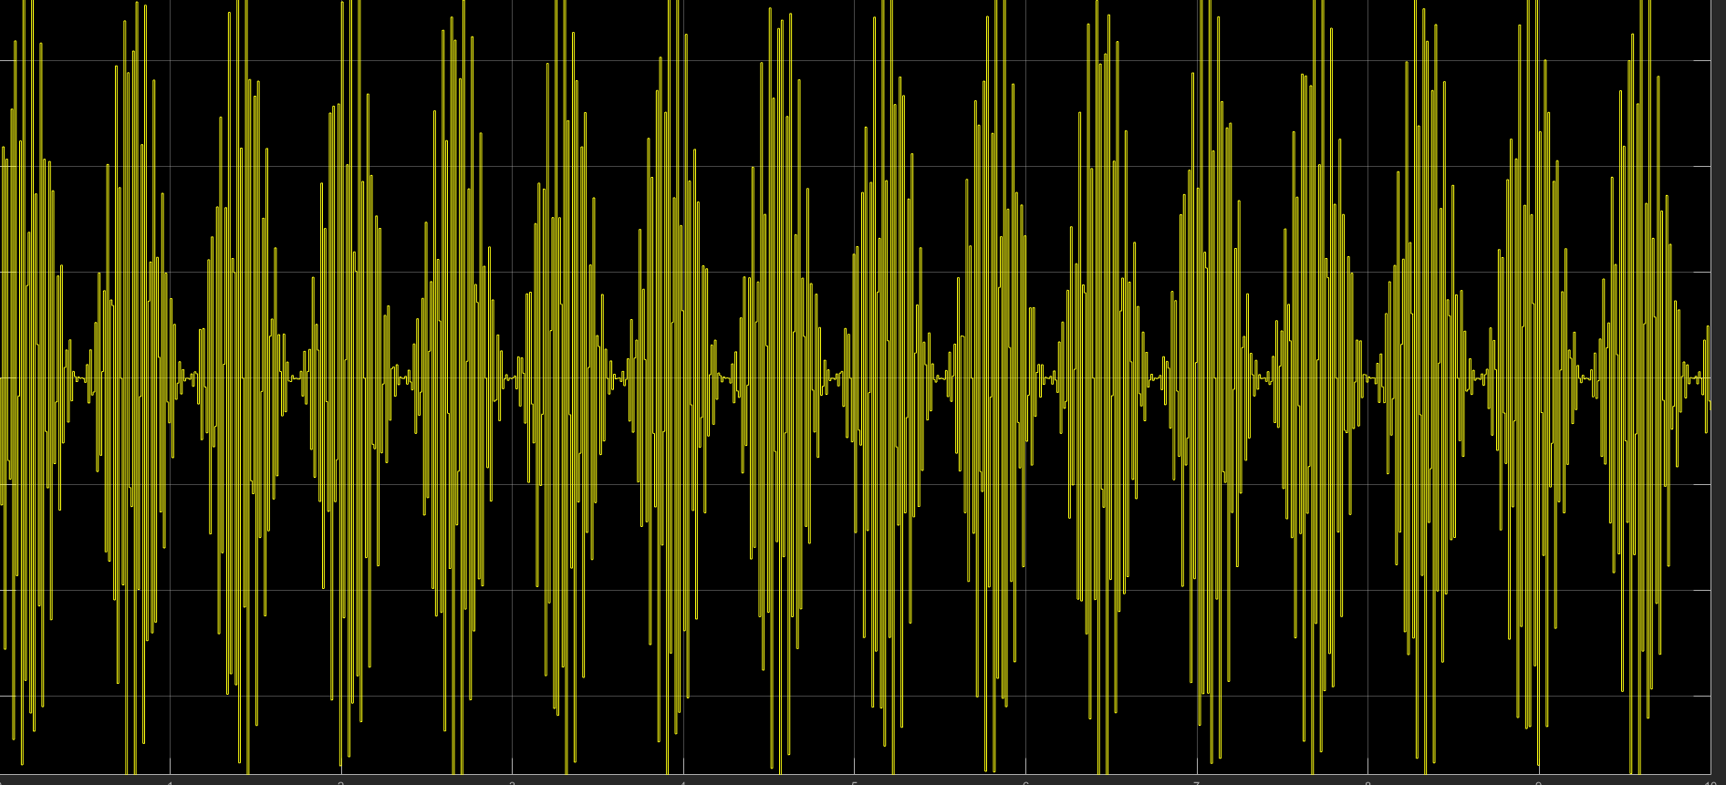

**M>1**

