Project Report

on

Fake News Detection

Neeraj Singh, 11707114, KM031, Roll no 40

1. Collection of Database

I took the dataset from DataFlair.com. The dataset consists of all the districts in India and the number of each type of crime committed. This dataset is of the year 2014. The URL for the dataset is:

<https://github.com/15hu/Criminal-Behaviour-Analysis-and-Segmentation/blob/master/crime_data.csv>

1. Implementation Code with Comment Lines

# -*- coding: utf-8 -*-

"""

1.Name- Arun Yadav

Reg.id-11711181

2.Name-Neeraj Singh

Reg.id-11707098

"""

"""

Spyder Editor

This is a temporary script file.

"""

# Dataset Downloaded from Kaggle.com

import pandas as pd

from sklearn.model_selection import train_test_split

from sklearn.feature_extraction.text import TfidfVectorizer

from sklearn.linear_model import PassiveAggressiveClassifier

from sklearn.svm import LinearSVC

from sklearn.ensemble import RandomForestClassifier

from sklearn.tree import DecisionTreeClassifier

from sklearn.linear_model import LogisticRegression

from sklearn.metrics import accuracy_score

df=pd.read_csv('C:\\Users\\LENOVO\\Downloads\\news.csv')

#Get shape and head

df.shape

df.head()

#Get the labels

labels=df.label

labels.head()

#Split the dataset

x_train,x_test,y_train,y_test=train_test_split(df['text'], labels, test_size=0.2, random_state=7)

#Initialize a TfidfVectorizer.For the stopping word

tfidf_vectorizer=TfidfVectorizer(stop_words='english', max_df=0.7)

Classifier=[PassiveAggressiveClassifier,DecisionTreeClassifier,RandomForestClassifier,LinearSVC,LogisticRegression]

Name=['PassiveAggressiveClassifier','DecisionTreeClassifier','RandomForestClassifier','LinearSVC','LogisticRegression']

# Fit and transform train set, transform test set

tfidf_train=tfidf_vectorizer.fit_transform(x_train)

tfidf_test=tfidf_vectorizer.transform(x_test)

for i in range(0,5):

if(i==0):

p=Classifier[i](max_iter=50);

else:

p=Classifier[i]();

p.fit(tfidf_train,y_train)

#DataFlair - Predict on the test set and calculate accuracy

y_pred=p.predict(tfidf_test)

score=accuracy_score(y_test,y_pred)

print('Accuracy with '+Name[i]+'Algorithm is:'+str(round(score*100,2)))

3.Output

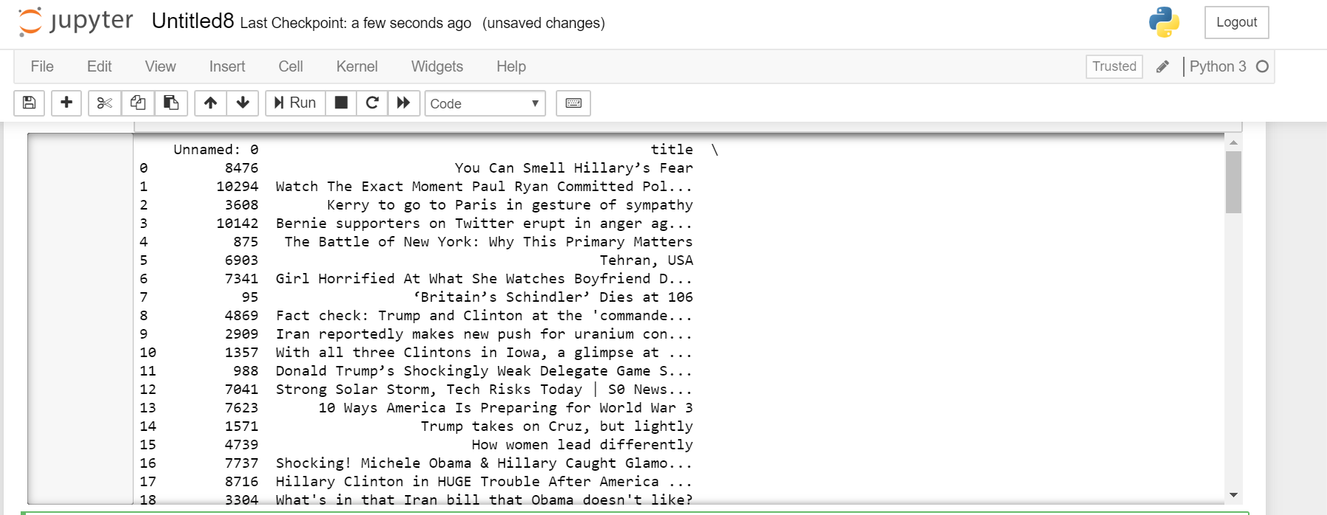

4.Output

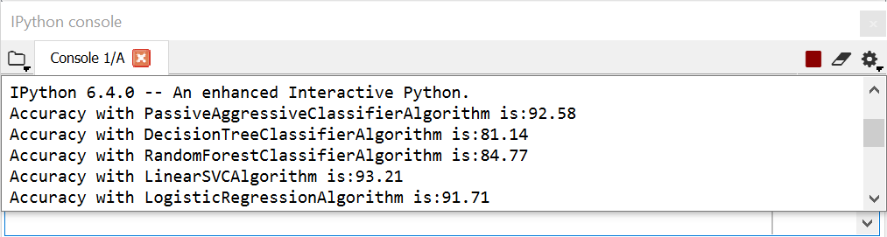

4.Github Repository

The link of my project repository is:

<https://github.com/Arun1717/int247-machine-learning-project-2020-kem031-rollno_40_53/blob/master/Fake_News_Detection.py>