NEONEX MINDX

EDTECH
Education • Learning • Internship • Projects • Careers • Community
DOMAIN: neonexmindx.com | Dedicated Education Vertical

STRATEGY & EXPERIENCE | PLATFORM & SERVICES | SECURITY & OPERATIONS
MASTER HIGH-LEVEL DESIGN (HLD) + LOW-LEVEL DESIGN (LLD)
Prepared as an implementation blueprint • Version 1.0 • 02 November 2026

Document control & purpose
Item | Definition
Document | NeoNex MindX EdTech – Master HLD & LLD
Purpose | Define the complete EdTech operating platform, user experiences, services, data ownership, integrations and delivery plan.
Business boundary | Education vertical only. IT consultancy client operations remain on the separate technology domain and platform boundary.
Status | Proposed architecture for validation and implementation planning.
Version | 1.0 – 02 November 2026
Audience | Founder, product owner, architects, developers, QA, operations, academic and placement teams.

Architecture principle
Build a complete learner lifecycle platform: discover → enquire → enrol → learn → practice → submit projects → complete internships → prepare for interviews → access opportunities → join alumni community. Keep education data and workflows independent from the IT consultancy vertical.

1. Executive summary
NeoNex MindX EdTech is designed as a digital education and career-development ecosystem. It combines the public education website, lead and admission operations, LMS, student information, trainer operations, assessments, project submission and evaluation, internships, placement assistance, interview practice, community, messaging, announcements, calendar, notifications, fees and finance.
The platform should support the complete lifecycle of a learner while providing controlled workspaces for trainers, mentors, academic administrators, placement staff, finance staff and management.

1.1 Outcomes
- Provide a consistent experience from first enquiry through alumni engagement.
- Give students one dashboard for learning, deadlines, projects, internships, career preparation and communication.
- Give trainers and mentors structured tools for classes, attendance, evaluation, feedback and supervision.
- Give the Placement Assistance Cell an employer, opportunity, application and interview pipeline.
- Provide management with measurable academic, operational, financial and career outcomes.
- Automate reminders, announcements, approvals and routine administrative workflows.

2. Scope, users and domain boundary
User persona | Primary responsibilities | Access boundary
Prospective learner | Explore courses, submit enquiry, book counselling | Public pages and own enquiry
Student | Learning, attendance, assessments, projects, internship, career profile | Own record, assigned cohorts and permitted community spaces
Trainer | Classes, learning content, attendance, assessment | Assigned courses, batches and students
Mentor / Evaluator | Project reviews, internship supervision, feedback | Assigned projects/interns only
Placement officer | Employers, jobs, eligibility, applications, outcomes | Placement records and consented candidate profiles
Employer / Recruiter | Post roles, review permitted profiles, shortlist | Employer organization and authorized candidates
Finance staff | Fees, invoices, receipts, refunds and reconciliation | Financial records by assigned scope
Academic admin | Courses, batches, schedules, policies and approvals | Education operations
Management | Business KPIs and authorized approvals | Aggregated reporting plus explicitly authorized records
Alumni | Community, mentoring and referrals | Own profile and approved alumni spaces

Strict separation
This document covers the EdTech vertical only. The IT consultancy public website, client onboarding portal, client project management, consultancy contracts and client billing are specified in a separate architecture document.

3. Product and subdomain structure
Proposed host | Experience | Notes
neonexmindx.com | Official EdTech public website | Courses, programmes, faculty, outcomes, enquiries, reviews, events and admissions.
learn.neonexmindx.com | Student learning portal | Learning dashboard, course content, attendance, assessments and progress.
community.neonexmindx.com | Student and alumni community | Forums, groups, mentoring, job referrals and moderated discussions.
careers.neonexmindx.com | Career and placement portal | Jobs, internships, applications, placement status and employer interactions.
practice.neonexmindx.com | Interview practice portal | Mock interviews, question banks, coding and aptitude practice.
admin.neonexmindx.com | Internal administration | Role-specific operations and management dashboards.
api.neonexmindx.com | API entry point | Versioned API gateway; internal services remain private.
auth.neonexmindx.com | Identity entry point | Central authentication for the EdTech domain.

All hostnames are proposed. Configure DNS, TLS, cookies, redirect allowlists and identity callback URLs only after the domain and deployment plan are approved.

4. Functional capability map
Domain | Capabilities
Public website & admissions | Service/course catalogue, programme pages, enquiry forms, counselling booking, lead capture, application and admission status.
CRM & sales | Lead assignment, source tracking, counselling, follow-up, conversion, pipeline and communication history.
LMS | Courses, modules, lessons, learning resources, cohorts, live sessions, progress, completion and certificates.
Student information | Student profile, enrolment, batch, academic history, documents, status and consent.
Trainer information | Trainer profile, skills, availability, allocation, workload and feedback.
Academic operations | Timetable, attendance, assessments, results, academic calendar and course quality.
Projects & evaluation | Project catalogue, allocation, teams, milestones, repository links, submission versions, rubrics, viva and rework.
Internship management | Programme creation, applications, selection, allocation, mentor, tasks, logbook, review and completion.
Placement assistance | Employer CRM, job postings, eligibility, candidate matching, applications, interviews and outcomes.
Interview practice | Question banks, coding/aptitude exercises, mock interviews, scoring and improvement plans.
Community & alumni | Discussion spaces, alumni directory, mentorship, job referrals, events and moderation.
Finance | Course fees, instalments, discounts, invoices, receipts, refunds, payment allocation and reconciliation.
Collaboration | Messaging, announcements, calendar, notifications, tasks and approvals.
Analytics | Admissions funnel, learning progress, completion, trainer utilization, internship and placement outcomes.

5. End-to-end learner lifecycle
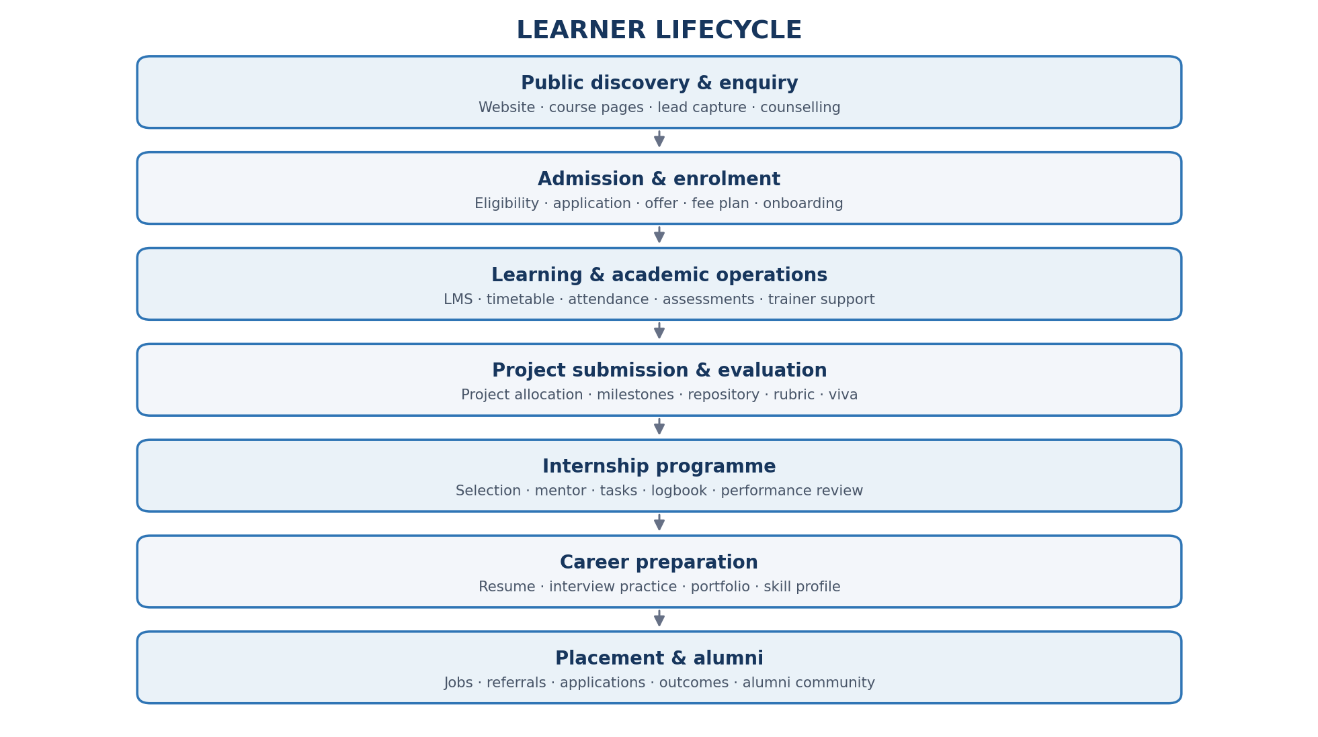
Figure 1. End-to-end EdTech learner lifecycle.

6. Detailed module requirements

6.1 LMS and academic management
- Course catalogue, course versions, modules, lessons, resources and prerequisites.
- Batch/cohort creation, trainer assignment, class timetable, attendance and session links.
- Learning progress, completion rules, assessments, quiz attempts and grade records.
- Content publishing workflow with draft, review, approved, published and retired states.
- Course feedback, trainer feedback, student support and academic intervention flags.

6.2 Project submission and evaluation portal
- Support individual and team projects, project briefs, objectives, expected deliverables and eligibility.
- Track milestones, task ownership, due dates, repository URL, branches/tags and demo links.
- Accept code archives, documents, datasets, presentations, videos and links with file validation.
- Maintain immutable submission versions, timestamps, submitter identity and receipt.
- Assign mentor, reviewer and viva panel; configure rubric by programme/project type.
- Rubric dimensions may include requirements coverage, technical correctness, code quality, testing, documentation, originality and presentation.
- Support review comments, scoring, moderation, re-submission, appeals and final approval.
- Similarity/plagiarism checks are indicators for human review, not automatic proof of misconduct.

6.3 Complete internship management
- Create internal, employer-sponsored and client-sponsored internship programmes with separate policies.
- Define role, skills, duration, eligibility, capacity, supervisor, deliverables and assessment criteria.
- Support application, screening, selection, offer, acceptance, onboarding and allocation.
- Provide intern workspace with tasks, attendance, daily logs, weekly reports, learning objectives and evidence.
- Mentor dashboard for feedback, review cadence, attendance exceptions and escalation.
- Final evaluation, completion approval, certificate eligibility and portfolio evidence.
- Track withdrawal, extension, pause, incomplete and rework outcomes with reasons.

6.4 Placement Assistance Cell
- Employer/recruiter records, contacts, agreements, company verification and relationship history.
- Job and internship requisitions with role, skills, location, compensation disclosure, eligibility and expiry.
- Candidate profile with explicit consent, resume versions, skills, projects, certificates and preferences.
- Eligibility rules and shortlisting; keep human review for consequential decisions.
- Application pipeline, interview rounds, feedback, offer, joining and outcome tracking.
- Placement support status must be clear and must not imply a guaranteed job unless contractually agreed.

6.5 Interview preparation and simulator
- Question banks by role, skill, difficulty and interview round.
- Aptitude, technical MCQ, coding exercises, SQL/Python tasks and HR question practice.
- Mock interview booking with human mentors and configurable evaluation rubrics.
- AI-assisted text or voice practice with question generation and feedback, subject to consent.
- Feedback should explain evidence, strengths, gaps and suggested practice; avoid unsupported personality or hiring claims.
- Store session history, candidate consent, retention rules and improvement trends.

6.6 Community, messaging and announcements
- Separate public/community posts, private conversations and official announcements.
- Spaces for courses, batches, projects, technical topics, alumni, mentors and job referrals.
- Direct messages and group chats with membership checks, block/report/moderation and retention policy.
- Official announcements can target all students, selected courses, batches, trainers, alumni or placement cohorts.
- Job referrals need verification, expiry, source attribution, consent and moderation.
- Provide search, attachments, reactions, threaded discussions and report handling.

6.7 Calendar and notifications
- Unified EdTech calendar for classes, assessments, counselling, deadlines, internships, interviews and events.
- Availability slots, recurring events, attendee responses, reschedule/cancel and timezone support.
- Notification preferences by channel and category; in-app, email, push and approved messaging providers.
- Scheduled reminders, retries, delivery tracking, deduplication, quiet hours and escalation.
- Read/acknowledgement tracking for mandatory policy or academic announcements.

6.8 Fees, invoices and finance
- Fee plans, discounts, scholarships, instalment schedules, due dates and student account ledger.
- Invoice and receipt numbering, tax configuration, credit notes, refunds and reconciliation.
- Payment provider adapters; never store card CVV or raw card credentials.
- Webhook signature validation, idempotency, payment state machine and audit history.
- Finance reports for collections, receivables, refunds, discounts and ageing.

7. High-level technical architecture
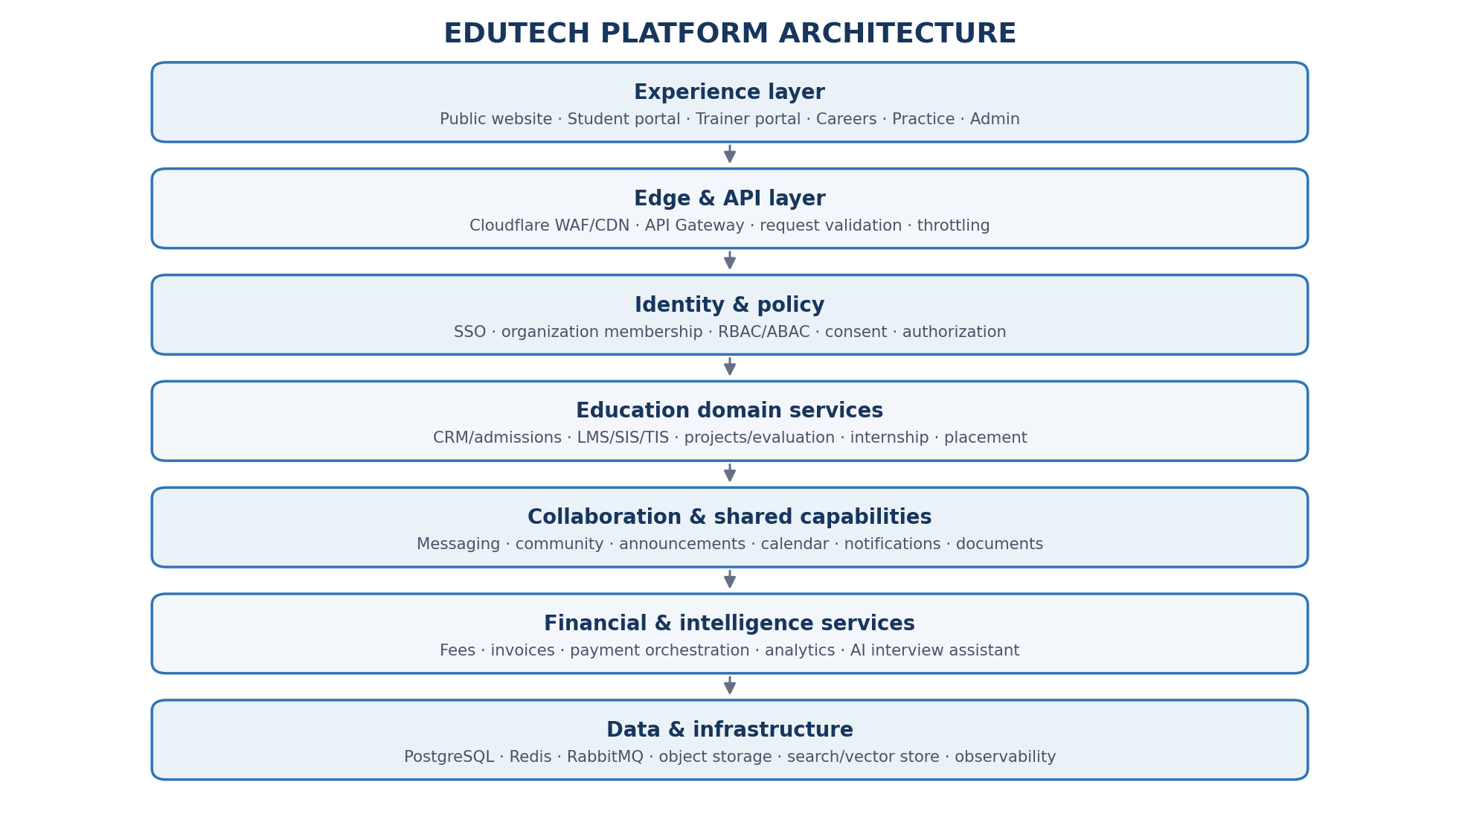
Figure 2. EdTech high-level architecture.

8. Service catalogue and ownership
Service boundary | Owns | Key integrations
Identity & access | Users, memberships, roles, permissions, sessions | All portals and services
Admissions & CRM | Leads, enquiries, counselling, applications | Public site, finance, notifications
Academic core | Courses, batches, enrolments, trainer allocation | LMS, calendar, student profile
Learning & assessment | Content progress, attendance, assessments, results | Academic core, notifications, analytics
Project & evaluation | Project briefs, allocations, submissions, rubrics, reviews | LMS, Git provider, documents
Internship | Programmes, applications, allocations, logs, reviews | Calendar, mentors, certificates
Career & placement | Employers, jobs, applications, referrals, outcomes | Career portal, community, consent
Interview practice | Question banks, sessions, attempts, feedback | AI gateway, calendar, career profile
Community & communications | Spaces, conversations, messages, announcements | Identity, notification, moderation
Calendar & scheduling | Events, slots, attendees, recurrence | All modules, external calendars
Notification orchestration | Templates, preferences, delivery, retries | Email, push, SMS/WhatsApp providers
Finance & payments | Fee accounts, invoices, payment orders, refunds | Provider adapters, ledger, receipts
Documents | Files, metadata, versions, access grants | Projects, internship, finance, agreements
Analytics | Aggregated reporting models and metrics | Read-only event/data pipelines

9. Core data model (logical)
Entity group | Representative entities | Relationship notes
Identity | User, Role, Permission, Membership, Consent | One identity may hold multiple authorized roles; no duplicate user record per portal.
Academic | StudentProfile, Course, CourseVersion, Batch, Enrollment, TrainerProfile | Enrollment links a student to a course/cohort and governed academic status.
Assessment | Assessment, Question, Attempt, Result, Attendance | Keep attempts and published results auditable.
Projects | ProjectBrief, ProjectTeam, Assignment, Milestone, Submission, Evaluation, Rubric | Submission is versioned; evaluation references a specific submission version.
Internship | Programme, Application, Placement, LogEntry, MentorReview, Completion | Application state and programme state are separate.
Career | Employer, Job, CandidateProfile, Application, Referral, InterviewRound, Offer | Candidate visibility requires consent and eligibility checks.
Community | Space, Membership, Post, Conversation, Message, Announcement | Audience membership and visibility must be checked server-side.
Calendar | Calendar, Event, Attendee, AvailabilitySlot, Reminder | Events can reference source records such as class or interview.
Finance | FeePlan, StudentAccount, Invoice, InvoiceLine, PaymentOrder, Transaction, Refund | Ledger movements and payment events must be auditable.
Documents | Document, Version, Attachment, AccessGrant | Object storage keys are private; authorization is checked before download.

10. API and event design
Expose versioned domain APIs through the gateway. Keep internal service APIs private and enforce authorization in the owning service, not only at the gateway.
API area | Example endpoints
Admissions | POST /v1/admissions/enquiries; POST /v1/admissions/applications; GET /v1/admissions/{id}
Academic | GET /v1/academic/courses; POST /v1/academic/enrollments; POST /v1/academic/attendance
Projects | POST /v1/projects/{id}/submissions; GET /v1/projects/{id}/evaluations
Internships | POST /v1/internships; POST /v1/internships/{id}/applications; POST /v1/internship-placements/{id}/logs
Career | GET /v1/career/jobs; POST /v1/career/applications; POST /v1/career/referrals
Interview | POST /v1/interview/sessions; POST /v1/interview/sessions/{id}/attempts
Calendar | POST /v1/calendar/events; POST /v1/calendar/availability
Communication | POST /v1/communications/conversations; POST /v1/announcements
Finance | POST /v1/finance/invoices; POST /v1/payments/orders

Event | Typical consumers
student.enrolled | LMS, finance, notification, analytics
class.scheduled | Calendar, notification
project.submitted | Evaluation, mentor notification, audit
evaluation.completed | Student dashboard, notification, analytics
internship.assigned | Calendar, mentor, notification
internship.completed | Career profile, certificate, analytics
job.published | Career portal, eligible audience notification
interview.scheduled | Calendar, candidate and interviewer notification
payment.completed | Student account, invoice, receipt, reconciliation

11. Roles and permission model
Role | Typical permissions | Restrictions
Student | Own learning, submissions, profile, applications, messages | Cannot view other student records or unassigned evaluation data.
Trainer | Assigned course/batch, attendance, content and assessments | No access to unrelated batches or finance administration.
Mentor/evaluator | Assigned internship/project review and rubric | Cannot change published policy or unrelated results.
Placement officer | Employer/job pipeline and consented candidate profiles | Sensitive student records remain restricted.
Recruiter | Own job requisitions and approved candidate profiles | No access to private academic or financial records.
Finance | Fees, invoices, refunds and reconciliation | No unrestricted academic or placement access.
Academic admin | Course, batch, schedule and academic approvals | Financial and identity administration remain separately controlled.
Platform admin | Configuration and operational controls | Privileged actions require audit and least privilege.

12. Security, privacy and governance
- Use OIDC/OAuth2 SSO, MFA for privileged roles and short-lived access tokens.
- Apply server-side RBAC and ABAC using role, business unit, cohort, assignment, ownership and consent.
- Use least-privilege database credentials; consider PostgreSQL row-level security for shared tables.
- Keep object storage private and use short-lived authorized download links.
- Validate every webhook signature and use idempotency keys for financial operations.
- Encrypt data in transit and at rest; manage secrets outside source control.
- Record sensitive changes, grade publication, refunds, access grants and administrator actions in audit logs.
- Define retention, deletion, consent and data export procedures for student and candidate information.
- AI retrieval and chatbot tools must inherit the user's permissions; do not expose one student's records to another.
- Use synthetic data in development and masked data in testing.

13. Analytics and management dashboards
Dashboard | Core measures
Admissions | Enquiries, source, counselling conversion, applications, enrolments, cost per acquisition where available
Academic | Attendance, learning progress, assessment completion, course completion, at-risk learners
Projects | Submission timeliness, review turnaround, rework, rubric distribution, completion
Internships | Applications, allocation, attendance/logs, mentor reviews, completion
Placement | Eligible learners, applications, interview progression, offers, joining and employer engagement
Finance | Fees billed, collected, outstanding, ageing, refunds, discounts and reconciliation
Operations | Trainer workload, room/session utilization, support volume and notification delivery
Community | Active participation, event engagement, referral activity and moderation metrics

14. Recommended technology stack
Layer | Recommended baseline | Notes
Frontend | React / Next.js | Separate branded apps or portal surfaces; shared design system is acceptable.
Backend | Python / FastAPI | Domain modules with explicit contracts.
API gateway | Kong or equivalent | Routing, rate limiting, API policies and observability.
Identity | Keycloak / OIDC provider | SSO and role/membership management.
Database | PostgreSQL | Domain-owned schemas/databases and controlled credentials.
Cache | Redis | Cache and short-lived coordination; avoid using cache as source of truth.
Messaging/events | RabbitMQ initially | Use outbox, retries and dead-letter handling.
Files | MinIO / S3-compatible storage | Private buckets, lifecycle and access grants.
Search/AI | PostgreSQL full text; pgvector/Qdrant when needed | Permission-aware retrieval.
Realtime | WebSockets | Chat, live updates and presence where justified.
Observability | OpenTelemetry, Prometheus, Grafana | Logs, metrics, traces and alerts.
Deployment | Docker + CI/CD | Start without Kubernetes unless scale/operations justify it.

15. Delivery roadmap
Phase | Scope | Exit criteria
0 – Foundation | Domain/DNS, identity, roles, gateway, audit, CI/CD, database conventions | SSO, environments, access policies, backups and deployment pipeline verified.
1 – Admissions & LMS core | Public website, enquiries, CRM, courses, batches, student portal, attendance | A learner can enquire, enrol and access assigned learning.
2 – Academic outcomes | Assessments, project portal, submission versioning, rubric and evaluation | A project can be assigned, submitted, reviewed and finalized.
3 – Internship & career | Internship lifecycle, employer records, jobs, referrals and placement pipeline | Internship and placement workflows operate with consent and audit.
4 – Collaboration | Community, messaging, announcements, calendar and notifications | Targeted communications and reminders are reliable and permission-aware.
5 – Interview & AI | Question bank, practice sessions, AI-assisted feedback and student assistant | AI tools are permission-controlled, evaluated and monitored.
6 – Finance & analytics | Fee engine, invoices, payment orchestration, reconciliation and dashboards | Financial states reconcile and management metrics are validated.

16. Non-functional requirements and acceptance criteria
Area | Baseline requirement / acceptance test
Security | Unauthorized cross-student, cross-batch and cross-role access tests must fail.
Privacy | Candidate profile visibility requires recorded consent and revocation handling.
Reliability | Financial webhooks and event consumers are idempotent; failed messages can be retried safely.
Auditability | Grade changes, refunds, approvals and privileged access changes record actor, time and reason.
Performance | Set measurable targets after expected concurrent users and workload are estimated; test peak class and submission periods.
Accessibility | Keyboard navigation, clear labels, contrast and responsive layouts are tested.
Usability | Student dashboard surfaces next class, pending work, deadlines and important notices.
Recoverability | Backups are restored in scheduled tests; recovery objectives are documented.
Data quality | Course, student, batch and finance identifiers are consistent and validated.
AI safety | Assistant cannot retrieve unauthorized records or execute sensitive actions without approved workflows.

17. Decisions required before detailed build
- Confirm exact EdTech domain/subdomain names and whether the existing CRM/LMS codebase will be reused.
- Confirm course, batch, fee and certificate policies.
- Define internship tracks and whether external employer/client-sponsored internships are in scope at launch.
- Define placement assistance terms, employer verification and candidate consent language.
- Choose payment providers and validate merchant onboarding, settlement and refund requirements.
- Define expected user volumes, concurrent sessions, storage and video delivery requirements.
- Approve retention, privacy, accessibility and support policies.

18. Glossary
Term | Meaning
HLD | High-Level Design: system context, components, interactions and deployment.
LLD | Low-Level Design: service boundaries, data entities, APIs, events and rules.
RBAC | Role-Based Access Control.
ABAC | Attribute-Based Access Control.
RLS | PostgreSQL Row-Level Security.
Outbox pattern | Persist business change and event record atomically, then publish reliably.
RAG | Retrieval-Augmented Generation.
SIS / TIS | Student Information System / Trainer Information System.

