A Trimester – 1 Class Project Report on
AERORESERVE: FLIGHT BOOKING & SEAT ALLOCATION SYSTEM
Submitted in the partial fulfillment of the requirements for
26CS5101E – Computational Thinking and Programming
Master of Technology In
Artificial Intelligence & Data Science
By
Student ID Student Name
2601150023 T. Neeraj
under the supervision of
Dr. G. Syam Prasad
Professor


DEPARTMENT OF ARTIFICIAL INTELLIGENCE AND DATA SCIENCE

CERTIFICATE
This is to certify that the Trimester – 1 Class Project Report entitled “AeroReserve: Flight Booking & Seat Allocation System” is being submitted by T. Neeraj - 2601150023 submitted in partial fulfillment the requirements for the course 26CS5101E – Computational Thinking and Programming, Master of Technology in Artificial Intelligence and Data Science to the K L University is a record of Bonafide work carried out under our guidance and supervision during the academic year 2026 – 2027.
Dr. G. Syam Prasad
Project Supervisor

Signature

DEPARTMENT OF ARTIFICIAL INTELLIGENCE AND DATA SCIENCE

DECLARATION
The Trimester -1 Class Project Report entitled “AeroReserve: Flight Booking & Seat Allocation System” is a record of Bonafide work of T. Neeraj - 2601150023 submitted in partial fulfillment the requirements for the course 26CS5101E – Computational Thinking and Programming, Master of Technology in Artificial Intelligence and Data Science to the K L University.
T. Neeraj - 2601150023

ACKNOWLEDGEMENT
It is great pleasure for me to express my gratitude to our honorable President Sri. Koneru Satyanarayana, for giving the opportunity and platform with facilities in accomplishing the trimester - 1 class project report.
I express sincere gratitude to HOD of AI&DS Dept. Dr. M. Venkata Naresh for his leadership and constant motivation provided in successful completion of our academic semester. I record it as my privilege to deeply thank for providing us the efficient faculty and facilities to make our ideas into reality.
I express my sincere thanks to our project supervisor Dr. G. Syam Prasad for his novel association of ideas, encouragement, appreciation, and intellectual zeal which motivated us to venture this project successfully.
Finally, it is pleased to acknowledge the indebtedness to all those who devoted themselves directly or indirectly to make this project report success.

ABSTRACT
AeroReserve is a flight-booking and seat-allocation application developed using Python, FastAPI, SQLAlchemy, SQLite and a browser interface with Server-Sent Events. It helps users search dated direct and connecting itineraries between seven sample Indian airports, compare fares in four cabins, preview cabin seat maps, reserve seats for up to six passengers under one PNR, cancel bookings, and see seat maps update live. All schedules and fares are fictional. The project applies computational thinking through problem decomposition, abstraction (a dated flight and cabin as the unit of inventory), pattern recognition, algorithm design (a bounded route search with a 45-minute minimum connection and three seat-allocation policies), data structures and complexity analysis. Safety measures include sorted flight locking, a seat re-check before commit, and one transaction for all legs of a booking. The implementation includes 45 automated tests; the recorded validation run reports 93.1% coverage and a 50-thread race for 36 Economy seats that confirmed 36, rejected 14 and produced no duplicate seat. Concurrency guarantees apply to a single application process only.

INDEX

S. No | TITLE | PAGE NO
1 | Introduction | 1
2 | Problem Statement | 2
3 | System Architecture and Technologies | 3
4 | Problem Solving & Computational Thinking | 5
5 | Programming & Data Structures | 7
6 | Software Design & Engineering | 8
7 | Functional Programming & Concurrency | 10
8 | Software Quality & DevOps Practices | 12
9 | AI-Assisted Software Engineering | 13
10 | Algorithms, Complexity and Performance | 14
11 | Implementation and User Workflow | 16
12 | Testing, Results and Limitations | 17
13 | Conclusion and Future Enhancements | 18
14 | References | 19

1. INTRODUCTION
AeroReserve is a browser-based flight-booking demonstration designed to show how a booking system keeps seat inventory correct. It searches a dated fictional timetable, builds direct and connecting itineraries, quotes fares by cabin, reserves seats on every flight leg under one PNR, and pushes live seat-map updates to open browsers. The interface is served by FastAPI and is intended for local use.
The project is relevant to Computational Thinking and Programming because it converts a practical problem into a sequence of smaller tasks: schedule generation, route search, seat allocation, pricing, booking, cancellation, persistence and live updates. Each task has a defined responsibility and can be tested separately.

1.1 Objectives:
• Search dated direct and connecting itineraries (up to two connections) between sample airports.
• Offer Economy, Premium Economy, Business and First cabins with cabin-specific seat maps.
• Reserve seats for every leg of an itinerary under one PNR, and cancel the whole booking.
• Show an itemised fare and push seat-map changes to connected browsers without polling.
• Prevent two bookings from receiving the same seat within a running application process.
• Store bookings, booking legs and audit entries in a local SQLite database.

2. PROBLEM STATEMENT
A flight is not a long-lived train that repeats one seat map over many days. Each departure on each date is a separate inventory, and a seat label such as 01A on one flight has no relation to the same label on another. Travellers also need connecting flights, where each leg must join at the same airport with enough time to change aircraft. One booking must hold seats on every leg or none, and two users must never be given the same seat on the same flight.

2.1 Proposed Solution:
AeroReserve treats a dated flight and cabin as the unit of inventory, searches a daily fictional timetable for itineraries of up to three legs, and allocates seats for each leg with a selectable policy. One booking row and one ordered row per leg are saved in a single database transaction, a per-flight lock protects the allocation step, and an in-process event bus feeds Server-Sent Events to open seat maps.

2.2 Scope:
The sample network has seven airports (VGA, HYD, BLR, BOM, DEL, MAA and GOI) and 27 daily flight templates, materialised as dated instances from today through the next 180 days in Indian Standard Time. An itinerary has at most three flight legs and every transfer needs a layover of at least 45 minutes. The application has no airline feed, payment, login or identity verification, and all fares are illustrative.

2.3 Expected Outcomes:
The expected outcome is a working local application that searches and books itineraries, shows seat maps, keeps seats consistent under concurrent requests inside one process, and updates connected browsers. The supplied project includes automated tests for routing, seats, fares, booking, the API, live events and a threaded seat race.

3. SYSTEM ARCHITECTURE AND TECHNOLOGIES
The application uses a browser interface, a FastAPI backend, a booking service with domain models, a repository over SQLAlchemy, and a local SQLite database. The browser sends requests to API routes; the routes call the service, which searches, allocates seats, saves bookings and publishes events.

3.1 Architecture Flow:
• Browser UI: search form, itinerary list, seat-map preview, booking panel and native EventSource for live updates.
• FastAPI: REST routes, Pydantic validation, structured error responses and the SSE endpoint.
• Booking service: route search, fare quote, seat allocation, PNR creation, cancellation and event publishing.
• Flight lock manager and event bus: process-local locks and bounded per-flight event queues.
• Repository and database: SQLAlchemy sessions, atomic booking writes and audit rows in SQLite.
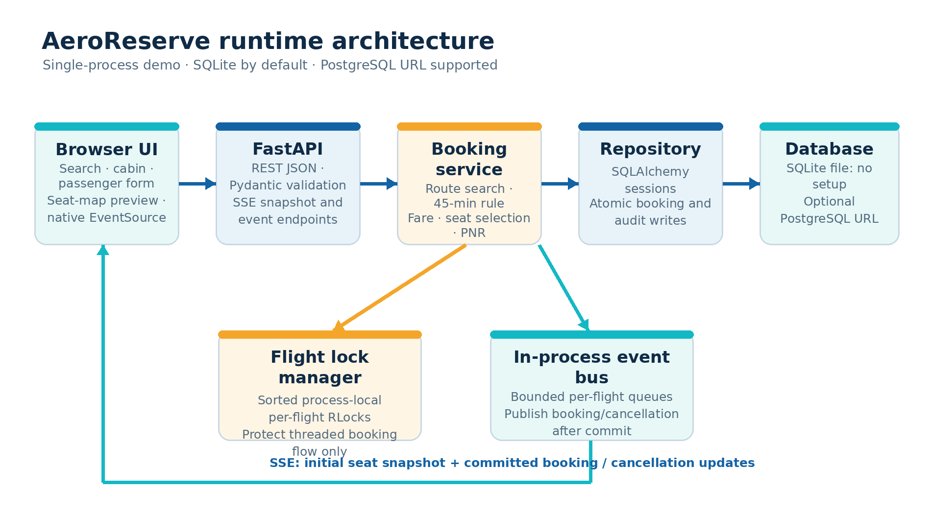
Figure 3.1: Runtime architecture of AeroReserve

3.2 Technology Stack:
• Python 3.11 or newer: domain logic, service and command-line interface.
• FastAPI, Pydantic and Uvicorn: HTTP routes, validation and server.
• SQLAlchemy 2: persistence; SQLite by default and an optional PostgreSQL URL through Psycopg 3.
• HTML, CSS and JavaScript: the single-page interface served from the API.
• pytest, Hypothesis, mypy (strict) and Ruff: tests and static checks.
• Docker, Docker Compose and GitHub Actions: deployment files and the CI workflow.

3.3 Main Modules:
Module | Responsibility
models.py | Airport, Flight, Itinerary, Passenger, Seat, BookingLeg, Booking, FareQuote and CabinClass
schedule.py | Sample airports and the 27 fictional daily flight templates; dated instances
availability.py | Cabin layouts, seat maps and the three seat-allocation policies
service.py | FlightBookingService, EventBus, FlightLockManager and error types
repository.py / db.py | Transactions, seat-occupancy queries, audit tail, engine and table definitions
api.py / cli.py | FastAPI application with SSE endpoint; command-line interface
web/index.html | Self-contained browser page

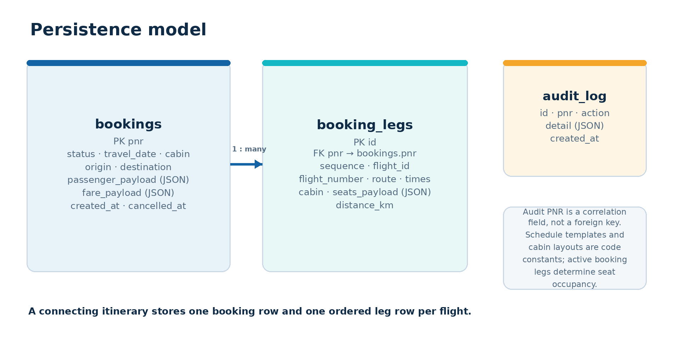
Figure 3.2: Persistence model

4. PROBLEM SOLVING & COMPUTATIONAL THINKING
The project applies the computational thinking process by splitting a broad booking problem into smaller, testable tasks and selecting algorithms that suit each task.

4.1 Problem Decomposition:
The system separates schedule generation, itinerary search, seat selection, fare calculation, booking persistence and live updates. Each concern lives in its own module, so the core rules can be tested without starting the web server.

4.2 Abstraction:
The central abstraction is the dated flight instance. A flight template becomes an instance with an identifier such as AS110-2026-10-14, and inventory is keyed by the pair (flight_id, cabin). A connecting itinerary is an ordered tuple of one to three flights, and a booking is one PNR owning one seat assignment per leg.

4.3 Pattern Recognition:
Airports and flights form a graph, so itinerary search is a bounded path search. Choosing k seats from a cabin is a small assignment problem. One booking with many viewers is publish and subscribe, and seat occupancy is derived from confirmed bookings instead of being stored a second time.

4.4 Algorithm Selection:
A depth-bounded route walk finds itineraries; a visited-airport set prevents loops; greedy policies pick seats; sorted lock ordering prevents deadlock; and a multi-key sort ranks results by arrival time, number of connections, distance and flight identifiers. The project does not use dynamic programming, backtracking or branch-and-bound because its tasks do not present those optimisation problems.

4.5 Complexity Analysis:
Operation | Complexity | Notes
Itinerary search | O(Σ bⁱ), i = 1…3, plus O(P log P) | b = outgoing flights, P = paths found; a bound for the sample graph
First-fit / family-aware | O(C) | C = seats in a cabin, at most 36
Window-first | O(C log C) | Sorts the free seats
Fare quote | O(L) | L = legs, at most 3
Lock ordering | O(L log L) | Sorted flight identifiers
Seat occupancy lookup | O(B) | Scan of active booking legs for a flight and cabin

4.6 Consistency as a Design Constraint:
Every booking is checked before it is saved: all legs must join at one airport with at least 45 minutes between them, chosen seats are re-checked while the flight locks are held, and all legs are written in one transaction. Cancelled bookings keep their rows as history but stop occupying seats.

5. PROGRAMMING & DATA STRUCTURES
Python is used for the domain model, search, allocation, service, persistence, API and command-line interface. The implementation uses standard collections and typed value objects.

5.1 Data Structures:
• Dictionaries map airport codes to outgoing flights and flight IDs to locks.
• Sets and frozensets hold visited airports and occupied seat labels.
• Tuples hold the ordered legs of an itinerary and the seats of a booking leg.
• Frozen dataclasses with slots model Airport, Flight, Passenger, Seat, BookingLeg and Booking.
• A string enumeration (CabinClass) restricts cabins to Economy, Premium Economy, Business and First.
• A bounded queue per subscriber carries live events without unbounded memory growth.

5.2 Cabin Layouts:
Each cabin is a small layout constant of rows, column letters and the column after which the aisle falls. Labels combine a cabin code, a two-digit row and a column letter, and each seat records whether it is a window seat and whether an aisle follows it.
Cabin | Layout | Seats | Fare per km
Economy | 6 rows × ABCDEF, aisle after C | 36 | Rs 3.80
Premium Economy | 3 rows × ABCD, aisle after B | 12 | Rs 5.50
Business | 2 rows × ABCD, aisle after B | 8 | Rs 9.50
First | 1 row × ABCD, aisle after B | 4 | Rs 15.00

5.3 Context Managers and Generators:
FlightLockManager.acquire_many() is a context manager that releases every lock even if an error occurs. The SSE endpoint and EventBus.stream() are asynchronous generators that yield a snapshot, events and heartbeats, and the FastAPI lifespan handler is an asynchronous context manager.

5.4 Type Hints and Validation:
All public functions carry type hints and the source passes mypy in strict mode. Dataclass __post_init__ methods validate domain rules, for example that every transfer is at the same airport and at least 45 minutes long, and Pydantic validates HTTP payloads.

6. SOFTWARE DESIGN & ENGINEERING
The application is organised into separate modules for the model, schedule, seat logic, service, repository, API and command line. The dependency direction is API to service to domain and repository.

6.1 Separation of Responsibilities:
The API layer validates requests and maps errors, the service owns the booking workflow and rules, and the repository owns SQLAlchemy reads and writes. Tests can therefore supply a temporary SQLite repository and verify persisted seat assignments after a concurrent race.

6.2 Design Patterns Used:
Pattern | Where | Problem solved
Service / Facade | FlightBookingService | One entry point for search, quote, book and cancel
Repository | BookingRepository | SQLAlchemy details stay out of the service
Observer / Pub-Sub | EventBus | Booking is decoupled from viewers of a flight
Strategy (by name) | allocate_seats(strategy=...) | Three seat policies chosen per request
Application Factory | create_app | Each test builds an isolated application
Value Object | Frozen dataclasses | Immutable data shared safely across threads

6.3 Seat Allocation Policies:
Policy | Behaviour
first-fit | First free labels in row and column order
window-first | Window seats first, then row and column order
family-aware | First contiguous same-row block not crossing the aisle; falls back to first-fit

These are greedy per-request policies, not global optimisers.

6.4 Error Handling:
Domain failures use one PlatformError hierarchy (InvalidSearch, InvalidBooking, NoItinerary, CapacityError and BusyError). The API converts them to structured JSON errors.

6.5 API Design:
Method | Endpoint | Purpose
GET | /api/airports | List the sample airports
GET | /api/flights/search | Dated itineraries with availability and quote
GET | /api/flights/{flight_id}/seats | Cabin-specific seat map
GET | /api/flights/{flight_id}/events | SSE snapshot, then booking and cancellation events
POST | /api/bookings/quote | Recalculate an itinerary quote
POST | /api/bookings | Reserve all legs under one PNR (HTTP 201)
GET | /api/bookings/{pnr} | Retrieve a booking
POST | /api/bookings/{pnr}/cancel | Cancel and release seats on every leg
GET | /api/health | Database, bookings, subscribers and lock counters
GET | /api/admin/audit | Recent persisted audit entries

7. FUNCTIONAL PROGRAMMING & CONCURRENCY
Parts of the project are written as functions that take explicit inputs and return values. Concurrency is used in the service and API, and its limits are stated explicitly.

7.1 Functional Decomposition:
cabin_seats builds a layout, allocate_seats chooses labels from the free seats, seat_map formats a cabin and quote computes fares, all without hidden state. Persistence, locks and event publication stay in the service and repository flow, so the allocation logic can be tested on its own.
def allocate_seats(cabin, passenger_count, occupied, strategy="family-aware"):
occupied_set = set(occupied)
free = [s for s in cabin_seats(cabin) if s.label not in occupied_set]
...

7.2 Concurrency Model:
Work | Mechanism | Why
Seat allocation on a flight | threading.RLock per flight, in sorted order | Short critical section; avoids deadlock
Blocking service calls from async routes | run_in_threadpool | Keeps the event loop responsive
Live seat updates | Async generator over a bounded queue | Push to many clients without polling
Concurrency demonstration | ThreadPoolExecutor in the stress command | Creates many contenders

7.3 Preventing Double Booking:
The booking method acquires the locks of every flight in the itinerary in sorted flight-ID order, reads occupied seats, allocates seats for each leg and re-checks them against the latest occupancy. Only then does it build one PNR and write the booking, every leg row and an audit row in a single transaction. Locks are released and one event per leg is published afterwards.
with self.locks.acquire_many(itinerary.flight_ids):
for flight in itinerary.flights:
occupied = self.repository.booked_seats(flight.flight_id, cabin)
labels = allocate_seats(cabin, n, occupied, strategy)
latest = self.repository.booked_seats(flight.flight_id, cabin)
if set(labels) & latest:
raise CapacityError(...)
self.repository.save(booking, distances)

7.4 Server-Sent Events:
The SSE endpoint subscribes before it takes the initial seat snapshot, so a concurrent update is either in the snapshot or queued as an event and is never missed. Each subscriber has a bounded queue that drops its oldest event when full, and clients refresh the authoritative seat map after each event.

7.5 Concurrency Boundary:
The lock manager and event bus live inside one application process, and the database stores each leg's seats as a JSON list with no unique row per seat. The threaded race test therefore supports a single-process claim only. Safe multi-worker booking would need shared transactional inventory locking or a per-seat uniqueness constraint, plus a shared event broker such as Redis or PostgreSQL LISTEN/NOTIFY, and separate multi-process tests.

8. SOFTWARE QUALITY & DEVOPS PRACTICES
Software quality is addressed through modular implementation, automated tests, static checks and a CI workflow.

8.1 Test Coverage in the Project:
Test file | Tests | What it covers
test_availability.py | 9 | Cabin capacities, labels, allocation policies, aisle-aware block
test_booking.py | 9 | Direct and connecting bookings, per-date and per-cabin inventory, cancellation
test_routing.py | 7 | Search bounds, cycle avoidance, 45-minute rule
test_cli.py | 5 | Command-line search, booking and cancellation
test_api.py | 4 | HTTP responses, validation and error mapping
test_db.py | 4 | Default SQLite, PostgreSQL URL selection, engine set-up
test_properties.py | 3 | Hypothesis checks of seats and fares
test_events.py | 2 | Event delivery and bounded queues
test_concurrency.py | 1 | 50 threads racing for Economy seats on one flight
test_sse_live.py | 1 | Live SSE over a local Uvicorn server

8.2 Static Quality Checks:
• Ruff checks linting and formatting for src, tests and scripts.
• mypy runs in strict mode over the source tree.
• pytest-cov reports statement and branch coverage; python -m build produces the package.

8.3 Continuous Integration:
The GitHub Actions workflow installs the package with development extras and runs Ruff, mypy, pytest with coverage and the package build on Python 3.11 and 3.12. A Dockerfile and a Docker Compose file with a PostgreSQL service are provided. These, the Windows launchers and remote CI were not executed during validation.

8.4 Execution and Dependencies:
The project requires Python 3.11 or newer. Install it with python -m pip install -e ".[dev]", start it with python -m uvicorn aerobooking.api:app --host 0.0.0.0 --port 8000 and open http://localhost:8000. The first run creates aerobooking.db and its tables automatically. Run the tests with pytest -q.

9. AI-ASSISTED SOFTWARE ENGINEERING
AI-assisted engineering is one of the areas in the Project Defence requirements. For this project, AI assistance was used for implementation, test and document drafts, and its output was checked before being accepted.

9.1 Specification-First Development:
The scope was fixed first: a full airline conversion with dated and cabin-specific search, connecting itineraries, a 45-minute minimum connection, one PNR per itinerary, fictional schedules, no live feed, payment or login, and SQLite by default with an optional PostgreSQL URL. Work then proceeded in slices (domain, schedule, seats, repository, service, API, command line, web page) with tests run for each.

9.2 Review and Validation:
Issue found in review | How it was handled
Family-aware allocation could treat seats across the aisle as adjacent | Added an aisle-specific test and an aisle-aware block search
PNR confirmation was lost when search results refreshed after booking | Fixed the interface to preserve the confirmation
Date and cabin semantics of the route graph were unclear | Made dated, cabin-specific inventory explicit
Early report text over-stated persistence and locking | Corrected to JSON seat storage and single-process locking
Live updates were only unit tested | Added a test with a real Uvicorn server and SSE

9.3 Responsible Use:
AI assistance supports development but does not replace understanding. The student remains responsible for explaining the code, design choices, test evidence and limitations, and for any disclosure of AI assistance that the course requires. Only fictional passenger names should be used with the demo.

10. ALGORITHMS, COMPLEXITY AND PERFORMANCE

10.1 Itinerary Search Algorithm:
• Validate the airports, the date and max_connections (0 to 2).
• Group the date's flights by origin airport and sort each group by departure time.
• Walk from the origin, adding a flight only if its destination has not been visited.
• For a transfer, require the next departure to be at least 45 minutes after the previous arrival.
• Stop at the destination or at max_connections + 1 legs.
• Sort results by arrival time, connections, total distance and flight identifiers.
For VGA to DEL the sample network returns the non-stop AS110, the one-stop AS101 + AS205 (75-minute layover at HYD) and two-stop options such as AS101 + AS206 + AS306. The validation record lists five itineraries for 14 October 2026, with AS110 first.
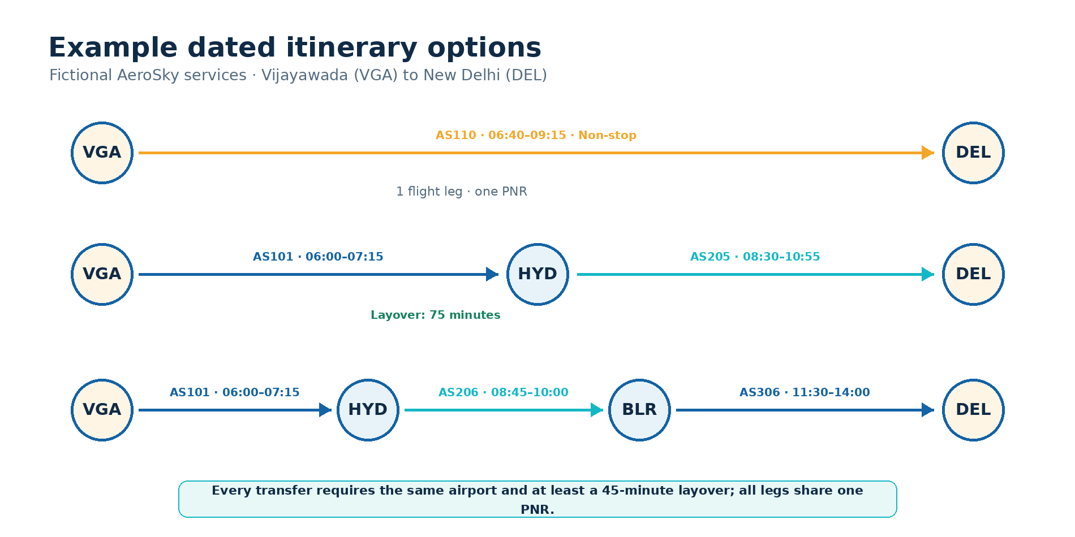
Figure 10.1: Example VGA to DEL itinerary options

10.2 Seat Allocation Algorithm:
• Build the cabin's seats and remove the occupied labels.
• Raise an error if fewer seats are free than passengers.
• Family-aware: scan each row for a run of free seats that does not cross the aisle.
• Window-first: sort free seats with window seats first; otherwise sort by row and column.
• Return the first n labels.

10.3 Fare Calculation:
Each leg is charged distance × cabin rate × passengers. The quote adds 5% of the subtotal as illustrative tax and Rs 99 per passenger as a service fee. For one Economy passenger on AS110 (1,370 km): Rs 5,206.00 + Rs 260.30 tax + Rs 99.00 fee = Rs 5,565.30. For two Economy passengers on AS101 and AS205 (270 km and 1,250 km): Rs 11,552.00 + Rs 577.60 + Rs 198.00 = Rs 12,327.60. These are academic constants, not real fares.

10.4 Performance Considerations:
The sample network is small, so search and allocation are cheap, but the project does not include a timing benchmark and no latency or throughput claim is made. Seat occupancy is derived from booking legs on each request, which is simple but would need an indexed inventory model at larger scale.

11. IMPLEMENTATION AND USER WORKFLOW

11.1 Installation:
• Install Python 3.11 or newer.
• Extract the project and open the airline_reservation folder in a terminal.
• Create and activate a virtual environment.
• Install the package: python -m pip install -e ".[dev]".
• Start the server: python -m uvicorn aerobooking.api:app --host 0.0.0.0 --port 8000.
• Open http://localhost:8000 in a browser (API documents are at /docs).

11.2 Searching Flights:
The user picks origin and destination airports, a date, the passenger count and a cabin. The application lists non-stop, one-stop and two-stop itineraries with flight numbers, times, fare and seats left on every leg. The default demonstration route is Vijayawada (VGA) to New Delhi (DEL).

11.3 Booking Seats:
The user selects an itinerary, enters fictional passenger details, and chooses an allocation policy. The seat map is a preview with a tab for each leg; the server chooses the seats at booking time and returns one PNR with the seat assignment for each leg.
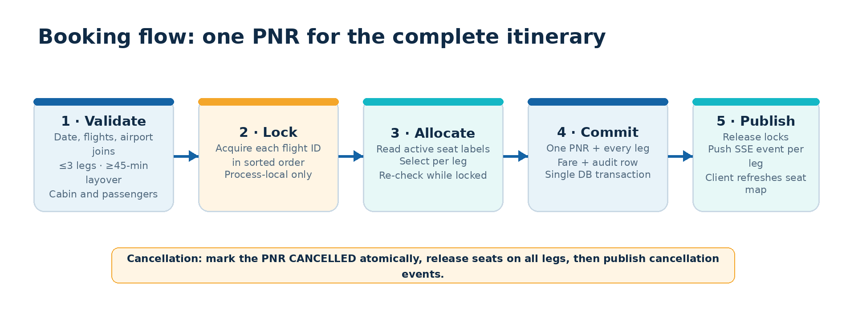
Figure 11.1: Booking flow with one PNR for the complete itinerary

11.4 Live Updates and Cancellation:
A second browser tab on the same flight receives an SSE snapshot and then refreshes its seat map when a booking or cancellation is committed. Cancellation by PNR marks the booking CANCELLED, frees seats on every leg and publishes release events.

11.5 Command Line:
aerobooking airports
aerobooking search --from VGA --to DEL --date 2026-10-14 --connections 2
aerobooking book --from VGA --to DEL --date 2026-10-14 -p 'Asha Rao:22'
aerobooking booking <PNR>
aerobooking cancel <PNR>
aerobooking stress --flight AS110 --threads 50

12. TESTING, RESULTS AND LIMITATIONS

12.1 Recorded Validation Results:
The project's validation record is dated 13 October 2026 and comes from a Linux sandbox with Python 3.13. These results were not re-run for this report.
Command | Observed result
ruff check src tests scripts | All checks passed
ruff format --check src tests scripts | 23 files already formatted
mypy | No issues found in 9 source files
pytest -q --cov=aerobooking --cov-branch | 45 passed; 93.1% statement and branch coverage
python -m build | Source distribution and wheel built

12.2 Thread Race Result:
A clean temporary SQLite database was used with the stress command for flight AS110, whose Economy cabin has 36 seats.
Measure | Result
Attempts | 50
Confirmed | 36
Rejected | 14
Duplicate seat assignments | 0

This result is for 50 threads handled by one application process. It is not a throughput benchmark and is not evidence of multi-process, PostgreSQL, network or production-scale correctness.

12.3 Limitations:
• Schedules and fares are fictional; there is no airline feed, payment, login or identity check.
• The lock manager and event bus are process-local, so multiple workers are not supported.
• Seats are stored as a JSON list per leg with no per-seat uniqueness constraint in the database.
• PostgreSQL, Docker and Compose, the Windows launchers and remote CI were not validated.
• Seat maps are a preview; the server picks the seats.
• Search covers one day of a small fixed network, not live or multi-day schedules.

12.4 Safety Recommendations:
Use only fictional passenger names. The demo has no login, access control or privacy controls and must not be exposed to untrusted networks or used with real passenger data.

13. CONCLUSION AND FUTURE ENHANCEMENTS
AeroReserve shows how an airline booking problem can be decomposed into schedule, search, seat, pricing and booking concerns. A dated flight and cabin as the unit of inventory kept availability simple, a bounded route walk produced direct and connecting itineraries, and sorted locking with a re-check and one transaction kept all legs of a PNR consistent in the recorded single-process stress test.

13.1 Future Enhancements:
• Model seat inventory as one row per seat with a unique constraint and test PostgreSQL row locking.
• Add a shared event broker (Redis or LISTEN/NOTIFY) so several workers can serve live updates.
• Let passengers pick specific seats, and add waitlists, return trips and multi-day connections.
• Add authentication, privacy controls and a payment step before handling real passengers.
• Add PostgreSQL and Docker integration tests and measure performance on representative loads.

14. REFERENCES
• Project Defence & Demonstration: Computational Thinking and Programming, supplied course document.
• AeroReserve project source code: src/aerobooking, tests, docs and scripts.
• Python documentation: https://docs.python.org/3/
• FastAPI documentation: https://fastapi.tiangolo.com/
• SQLAlchemy documentation: https://docs.sqlalchemy.org/
• PostgreSQL documentation: https://www.postgresql.org/docs/
• MDN Server-sent events: https://developer.mozilla.org/en-US/docs/Web/API/Server-sent_events
• pytest documentation: https://docs.pytest.org/
• Hypothesis documentation: https://hypothesis.readthedocs.io/
• mypy documentation: https://mypy.readthedocs.io/
• Ruff documentation: https://docs.astral.sh/ruff/
• GitHub Actions documentation: https://docs.github.com/actions

