COMPUTER NETWORKS PROJECT
Private Network Service Platform
Phase 1: Build and Observe - Project Report
Team NOAA
This report documents the design, implementation and verification of a private network service platform built on four Macs sharing one private network. It covers a private DNS server, two backend applications, an nginx reverse proxy and load balancer, HTTPS using our own certificate authority, HTTP caching, packet-level analysis, and five deliberate failure demonstrations.
Team member | Machine | Main responsibility
Om | Mac 1 | Private DNS server (dnsmasq) and test client
Neeraj | Mac 2 | Edge: nginx reverse proxy, load balancer, HTTPS (TLS)
Ayush | Mac 3 | Backend A (port 3001), backend code, HTTP caching
Aparna | Mac 4 | Backend B (port 3002), test client, Wireshark captures, evidence folder

Project at a glance
Team: NOAA Private domain: app.noaa.test, api.noaa.test
Network: Rishihood Learner College Wi-Fi, subnet 10.7.0.0/19 (255.255.224.0), gateway 10.7.0.1
Machines: Mac 1 (DNS) 10.7.11.132, Mac 2 (edge) 10.7.11.79, Mac 3 (Backend A) 10.7.11.131, Mac 4 (Backend B) 10.7.11.144
Source and evidence: github.com/Neeraj-singh140805/noaa-private-network-service-platform

1. Introduction

1.1 Project overview
We built a small-scale version of how the internet works, running entirely on our own four laptops. When a browser opens a website name, many things happen within milliseconds: the name is resolved, a connection is opened, the connection is secured, and a server somewhere produces the answer. In this project we built every piece of that journey ourselves and then proved that it works using standard tools (dig, curl and Wireshark).
Design principle
The application is simple on purpose. The network is the project. The focus is on name resolution, transport, encryption, proxying, caching and failure behaviour rather than on application features.

Objectives
- Set up a private LAN of four machines with documented addressing and verified connectivity.
- Run our own DNS server that answers for private names under noaa.test.
- Run two identical backend applications that can be told apart by an identity header.
- Place a single edge server (nginx) in front of the backends as a reverse proxy and round-robin load balancer.
- Serve the application over HTTPS using a certificate signed by our own certificate authority.
- Demonstrate HTTP caching with Cache-Control, ETag and 304 Not Modified.
- Capture and analyse real traffic to show DNS, the TCP handshake, the TLS handshake and encrypted data.
- Demonstrate five failure scenarios and explain which layer failed in each.

1.2 The journey of one request
Everything in this project concerns one request travelling from a client to a backend and back:
- The client uses the name app.noaa.test.
- The client asks our DNS server (Mac 1) for the IP address of this name.
- DNS answers with the IP address of Mac 2.
- The client opens a TCP connection to Mac 2.
- The client and Mac 2 set up TLS (HTTPS).
- nginx on Mac 2 receives the request and passes it to Backend A (Mac 3) or Backend B (Mac 4).
- The backend replies and nginx returns the reply to the client.
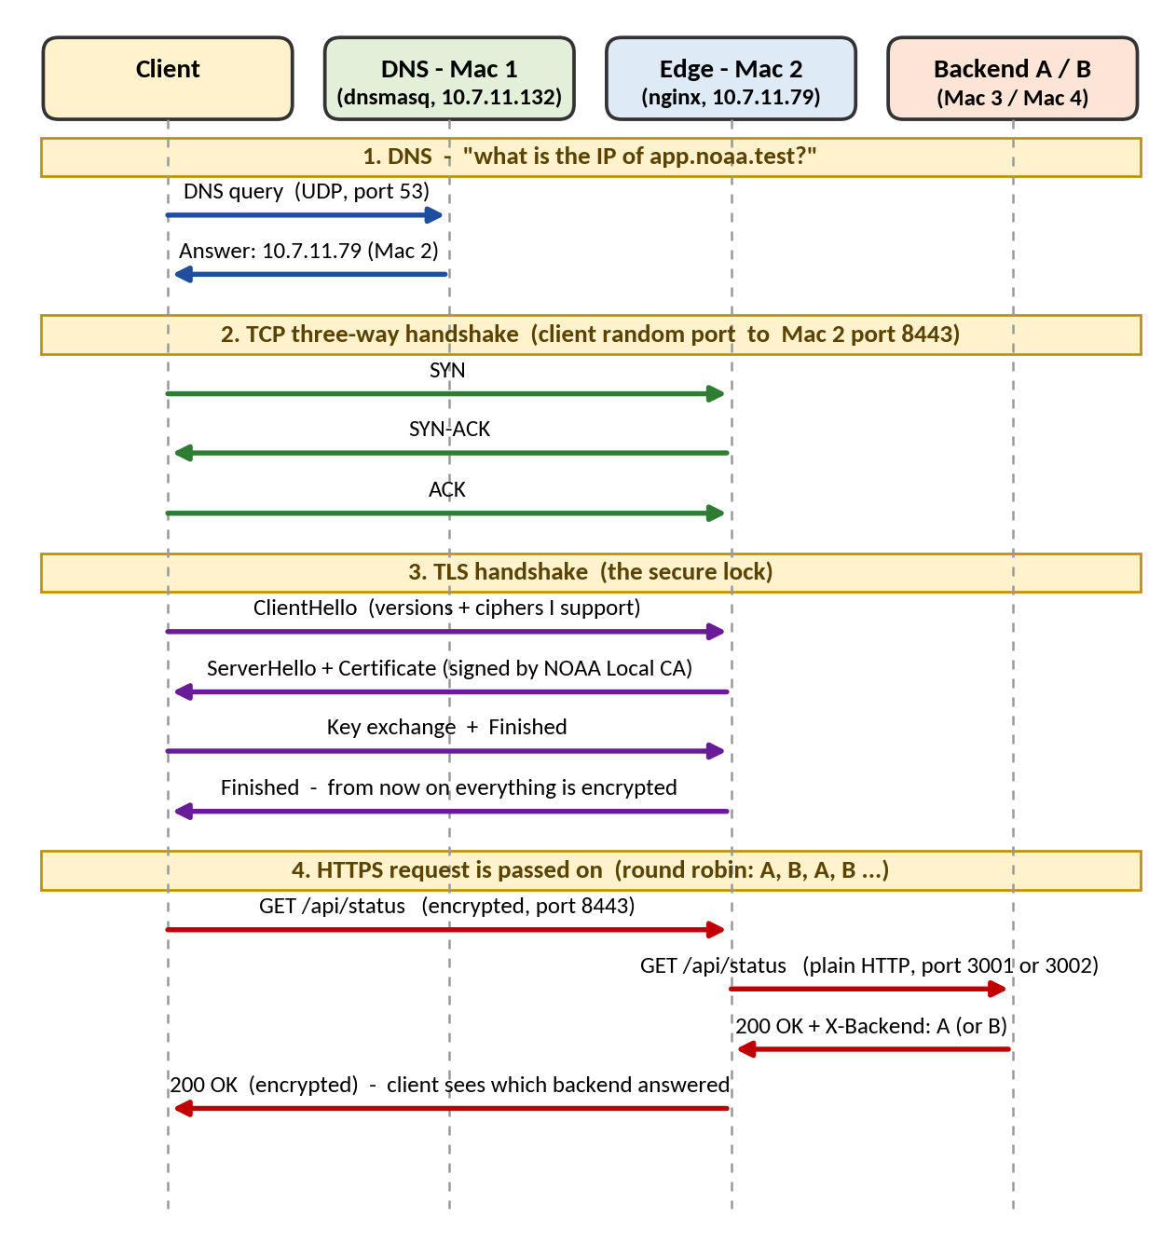
Figure 1: The full journey of one HTTPS request (DNS, then TCP, then TLS, then HTTP through nginx to a backend)

1.3 Analogy: sending a letter
Real-life action | Network step | Tool / machine in our project
Look up a friend's address in a phone book | DNS - turns a name into an IP | dnsmasq on Mac 1
Phone them and ask "can you hear me?" | TCP three-way handshake (SYN, SYN-ACK, ACK) | Client to Mac 2, port 8443
Put the letter in a locked box only they can open | TLS / HTTPS encryption | Certificate on nginx, our own CA
A receptionist who passes your request to a free staff member | Reverse proxy and load balancer | nginx on Mac 2
The staff members who do the work | Backends A and B | Python apps on Mac 3 and Mac 4

1.4 System topology
All four Macs are connected to the same private network, the Rishihood Learner College Wi-Fi (10.7.11.x). Each Mac plays one role, and each role has a cloud equivalent, which makes the small setup resemble a real cloud deployment.
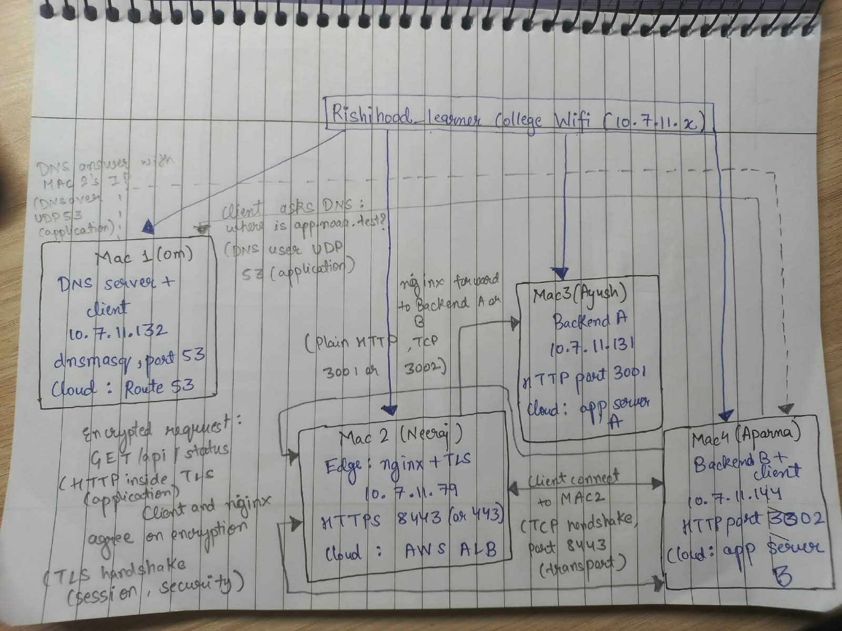
Figure 2: Network topology of Team NOAA - four Macs on the college Wi-Fi (10.7.11.x), with the DNS, TCP and TLS exchanges marked
Mac | Role | IP address | What runs on it | Cloud equivalent
Mac 1 | DNS server and test client | 10.7.11.132 | dnsmasq (UDP 53), dig, curl | Route 53
Mac 2 | Edge: reverse proxy and load balancer | 10.7.11.79 | nginx, TLS certificate (HTTPS 8443) | Cloud load balancer (AWS ALB)
Mac 3 | Backend A | 10.7.11.131 | Small app on port 3001 | App server instance A
Mac 4 | Backend B and test client | 10.7.11.144 | Small app on port 3002 | App server instance B

1.5 Terminology
Term | Meaning
IP address | The address of a machine on the network.
DNS | A phone book. It turns a name into an IP. It does not connect to anything.
Port | A door number on a machine. One machine can run many services, each on its own port.
TCP | The way two machines agree to talk reliably (three-way handshake: SYN, SYN-ACK, ACK).
TLS / HTTPS | Encryption on top of TCP, so nobody in the middle can read the data.
Reverse proxy | One front-door server that takes requests and passes them to hidden servers behind it.
Load balancer | Shares requests between more than one backend so no single one is overloaded.
Certificate | An ID card for the server, signed by someone the client trusts.
CA (Certificate Authority) | The trusted signer of certificates. We created our own CA for our private network.
Round robin | Taking turns: A, B, A, B ... The default way nginx shares requests.

2. Team Roles and Responsibilities
Each member took the hands-on lead for one machine and a set of tasks, while all four members worked on the shared parts of the project and understand the whole system.
Person | Mac | Role | Main tasks
Om | Mac 1 | Private DNS server and test client | A (LAN), B (DNS), failures 1 and 2
Neeraj | Mac 2 | Edge: nginx, load balancer, HTTPS | D (nginx), E (TLS), failure 4
Ayush | Mac 3 | Backend A (port 3001) | C (backend code), F (caching), failure 3
Aparna | Mac 4 | Backend B (port 3002) and test client | C (run B), G (Wireshark), failure 5

Detailed responsibilities
Person | Hands-on work | Owns (deliverable)
Neeraj (Mac 2, the edge) | Task D: nginx reverse proxy and load balancing  Task E: TLS certificate and HTTPS setup  Failure demo: both backends stopped (502) | Architecture Document (topology, request flow diagram)
Om (Mac 1, DNS) | Task A: LAN setup, IP table, ping checks, topology diagram (with Neeraj)  Task B: dnsmasq DNS server and client DNS settings  Failure demos: wrong DNS server, wrong DNS record  DNS part of the Wireshark evidence | Configuration Bundle (with Neeraj)
Ayush (Mac 3, Backend A) | Task C: wrote the backend code and ran it as Backend A (port 3001)  Task F: HTTP caching (Cache-Control, ETag, 304)  Failure demo: one backend stopped | Backend Source Code (GitHub repository)
Aparna (Mac 4, Backend B and client) | Task C: ran the same code as Backend B (port 3002)  Task G: main Wireshark captures (DNS, TCP, TLS, ports)  Failure demo: wrong destination port | Evidence Folder (screenshots, pcap files)

Step 1 was shared by all four members, each of whom recorded the details of their own Mac. Every member captured the evidence for their own steps and Aparna consolidated it into the Evidence Folder.

Order of work
Step 1 (LAN) came first. Steps 2 (DNS) and 3 (backends) were carried out in parallel. Step 4 (nginx and load balancing) required both of them to be complete. Step 5 (HTTPS) was added on top of Step 4, after which Step 6 (caching) and Step 7 (packet capture) were done. The failure demonstrations in Step 8 were carried out last, once the whole system was working.

3. Implementation
The system was built in eight steps. Each step below states what was done and why, how it was implemented, and how it was verified.
Step | Topic | Task | Owner | Mac
1 | LAN setup | A | Everyone | All
2 | Private DNS server | B | Om | Mac 1
3 | Two backend apps | C | Ayush, Aparna | Mac 3, Mac 4
4 | nginx edge and load balancer | D | Neeraj | Mac 2
5 | HTTPS with TLS | E | Neeraj | Mac 2
6 | HTTP caching | F | Ayush | Mac 3
7 | Packet capture analysis | G | Aparna (with Om for DNS) | Mac 4
8 | Failure demonstrations | - | Shared | All

3.1 Step 1: LAN setup (Task A)
What | All four Macs were placed on the same private Wi-Fi network and each Mac's network details were recorded.
Why | Every other step depends on the machines being able to reach each other.
Verification | All pairs of Macs could ping each other with 0% packet loss and the IP inventory table was completed.

All four Macs were connected to the same network, the Rishihood Learner College Wi-Fi. Laptop-to-laptop traffic is allowed on this network, so the machines could reach each other directly. On each Mac the network details were read with the following commands (Wi-Fi is en0):
Terminal
ipconfig getifaddr en0 # IP address
ifconfig en0 | grep -E "inet |ether" # IP, netmask, MAC address
route -n get default | grep gateway # default gateway

The details were recorded in the IP inventory table, which forms part of the Architecture Document:
Mac | Person | Role | IP address | Subnet mask | Gateway | Iface | MAC address
1 | Om | DNS | 10.7.11.132 | 255.255.224.0 | 10.7.0.1 | en0 | ee:0c:61:8f:c2:3a
2 | Neeraj | Edge | 10.7.11.79 | 255.255.224.0 | 10.7.0.1 | en0 | 9e:fd:43:78:1c:41
3 | Ayush | Backend A | 10.7.11.131 | 255.255.224.0 | 10.7.0.1 | en0 | e2:b4:55:e5:e3:07
4 | Aparna | Backend B | 10.7.11.144 | 255.255.224.0 | 10.7.0.1 | en0 | 62:6e:5a:aa:68:21

The subnet mask 255.255.224.0 (0xffffe000 in the ifconfig output) is a /19 network, so all four addresses belong to the same subnet (10.7.0.0 to 10.7.31.255) and share the default gateway 10.7.0.1.

Connectivity was then tested between every pair of machines in both directions using ping -c 4 <other_mac_ip>. Each test completed with 0% packet loss.
 | Mac 1 | Mac 2 | Mac 3 | Mac 4
Mac 1 | - | ping | ping | ping
Mac 2 | ping | - | ping | ping
Mac 3 | ping | ping | - | ping
Mac 4 | ping | ping | ping | -

The topology was drawn by hand (Figure 2): four machines on the college Wi-Fi, with the IP address, role, port and cloud equivalent of each, and the DNS, TCP and TLS exchanges marked on the diagram.
Addressing note
IP addresses can change when a Mac reconnects (DHCP). The DNS record and the nginx upstream list both contain these addresses, so they were re-checked whenever something stopped working; if an address changes, both must be updated.

3.2 Step 2: Private DNS server (Task B)
What | dnsmasq was installed on Mac 1 so that it answers queries for our private names.
Why | DNS turns app.noaa.test into the IP of Mac 2. The project required our own DNS rather than the internet DNS.
Why .test? | The .test domain is reserved for testing. .local was avoided because macOS uses it for its own mDNS and this causes problems.
Verification | dig app.noaa.test from two different Macs returned the IP of Mac 2, with Mac 1 shown as the DNS server in the SERVER: line of the output.
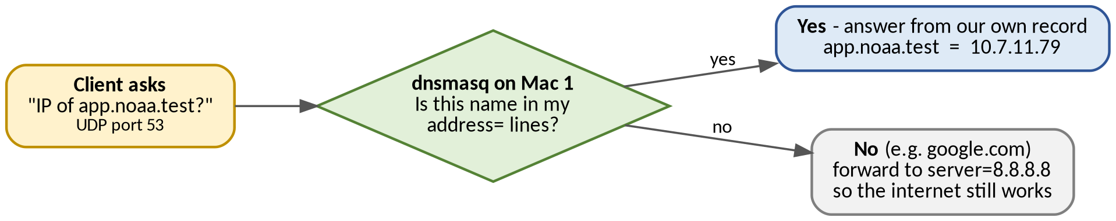
Figure 3: How dnsmasq decides what to answer

Installation and configuration
Terminal
brew install dnsmasq

The configuration file is /opt/homebrew/etc/dnsmasq.conf on Apple Silicon (/usr/local/etc/dnsmasq.conf on Intel). The following lines were added:
dnsmasq.conf
listen-address=10.7.11.132,127.0.0.1
bind-interfaces
address=/app.noaa.test/10.7.11.79
address=/api.noaa.test/10.7.11.79
server=8.8.8.8

Config line | Meaning
listen-address=10.7.11.132,127.0.0.1 | Answer DNS questions arriving on Mac 1's LAN IP and on localhost.
bind-interfaces | Only bind to the addresses listed above.
address=/app.noaa.test/10.7.11.79 | Our own record. Both names point to Mac 2, the edge.
address=/api.noaa.test/10.7.11.79 | Second record, same target.
server=8.8.8.8 | Send all other names (such as google.com) to a normal DNS server so the internet keeps working.

The service was started with sudo because DNS uses port 53, and tested on Mac 1 itself:
Terminal
sudo brew services start dnsmasq
dig @10.7.11.132 app.noaa.test # ANSWER section shows Mac 2's IP

Two other Macs were then configured to use Mac 1 as their DNS server (System Settings, Network, Wi-Fi, Details, DNS, with 10.7.11.132 added at the top) or by command, and tested from those clients:
Terminal
sudo networksetup -setdnsservers Wi-Fi 10.7.11.132
dig app.noaa.test
nslookup app.noaa.test

# DNS cache flush when answers looked old or wrong
sudo dscacheutil -flushcache; sudo killall -HUP mDNSResponder

Key points
DNS only finds the IP. The TCP and HTTPS connection is a separate step that happens afterwards.
DNS uses port 53 over UDP.

3.3 Step 3: Two backend apps (Task C)
What | A very small web app was written and run on Mac 3 (as Backend A) and Mac 4 (as Backend B).
Why | Traffic needed a destination, and the two backends had to be distinguishable so that load balancing could be proved. Every response therefore carries the backend name.
Verification | Both backends answered requests from another Mac, each showing its own name.

Application requirements
Requirement | Detail
GET / | Returns a simple page saying the backend is running.
GET /api/status | Returns JSON such as {"backend": "A", "status": "ok"} with the header Cache-Control: no-store.
GET /api/info | Returns fixed JSON with an ETag and Cache-Control: max-age=60 (used in Step 6). Answers 304 if If-None-Match matches.
Header X-Backend | Every response carries X-Backend: A (or B) so the responder can be identified.
Listen on 0.0.0.0 | The app listens on all interfaces, not only 127.0.0.1, so other Macs can reach it.
Ports | 3001 for Backend A, 3002 for Backend B.

The application is a Python program with no extra libraries (full code in Appendix A, saved as backend.py). The same file runs on both Macs; only two environment variables change:
Terminal
# Mac 3 (Ayush)
BACKEND=A PORT=3001 python3 backend.py

# Mac 4 (Aparna)
BACKEND=B PORT=3002 python3 backend.py

Each backend was tested from another Mac by IP address (testing only), checking for the X-Backend header. Where macOS asked whether to allow incoming connections, the connection was allowed.
Terminal
curl -i http://10.7.11.131:3001/api/status
curl -i http://10.7.11.144:3002/api/status

3.4 Step 4: nginx edge and load balancer (Task D)
What | nginx on Mac 2 became the single front door. Clients talk only to Mac 2, and nginx passes requests to A and B in turns.
Why | This is what a cloud load balancer does. The client never needs to know the backend IPs, and backends can be added, removed or restarted without the client noticing.
Verification | Repeated requests to the same name alternated between A and B.
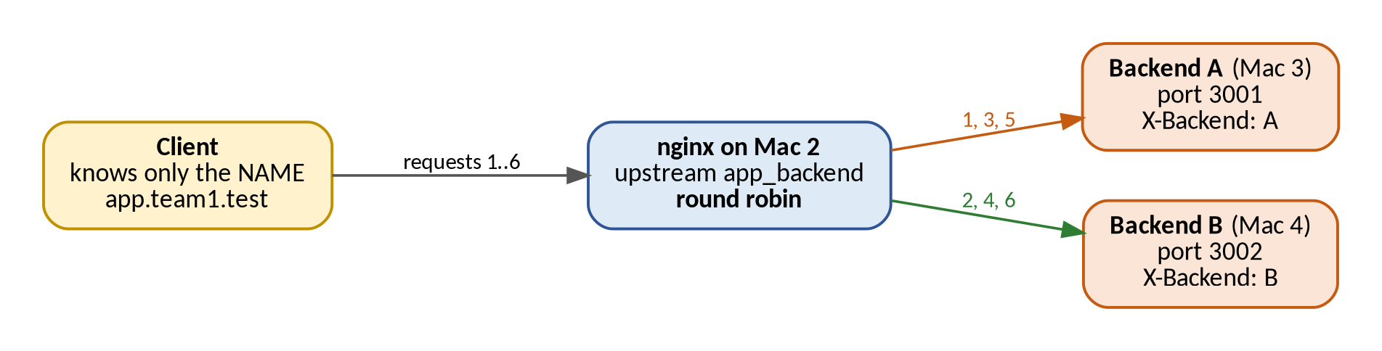
Figure 4: nginx hides the backends and shares requests round-robin
Terminal
brew install nginx

nginx was installed with Homebrew and configured in /opt/homebrew/etc/nginx/nginx.conf (the final file is stored in the repository at config/nginx/nginx.conf). The following was added inside the http { } block; the TLS directives of this server block are described in Step 5:
nginx.conf
upstream app_backend {
server 10.7.11.131:3001;
server 10.7.11.144:3002;
}

server {
listen 8443 ssl; # TLS directives: see Step 5
server_name app.noaa.test api.noaa.test;
location / {
proxy_pass http://app_backend;
proxy_set_header Host $host;
proxy_set_header X-Real-IP $remote_addr;
proxy_set_header X-Forwarded-For $proxy_add_x_forwarded_for;
proxy_set_header X-Forwarded-Proto $scheme;
}
}

Piece | Meaning
upstream app_backend { ... } | A named group of backend servers. With no extra settings nginx uses round robin: A, B, A, B ...
listen 8443 ssl | nginx accepts client connections on this port (8443 was used instead of 443). A second server block, which listens on 443 for the edge IP 10.7.11.79, is also present in the final file.
server_name | Which names this server block answers for.
proxy_pass http://app_backend | Forward the request to the upstream group (this is what makes it a reverse proxy).
proxy_set_header Host $host | Keep the original name the client asked for.
proxy_set_header X-Real-IP $remote_addr | Tell the backend the real client IP. X-Forwarded-For and X-Forwarded-Proto pass the client chain and the original scheme.

The configuration was checked with nginx -t (it initially failed on an unresolved placeholder address and passed once the real backend addresses were entered), nginx was restarted with Homebrew, and balancing was tested from a client using the name, not an IP address:
Terminal
nginx -t # checks the configuration: "syntax is ok", "test is successful"
brew services restart nginx # start / reload after a change

for i in {1..6}; do
echo "Request $i"
curl -sS --cacert ca.crt -D - -o /dev/null https://app.noaa.test:8443/api/status | grep -i '^x-backend:'
done

The loop printed the backends in the order A, B, A, B, A, B, showing that nginx shares requests round-robin.
Key points
The client does not need the backend IPs because nginx hides them.
nginx plays the same role as an AWS ALB / GCP Load Balancer.

3.5 Step 5: HTTPS with TLS (Task E)
What | nginx was configured to serve HTTPS with a certificate that the clients trust.
Why | HTTPS encrypts traffic so nobody on the Wi-Fi can read it. A browser only trusts certificates signed by an authority it knows. On our private network nobody knows our authority, so we created our own CA and made every client Mac trust it.
Verification | curl and the browser opened https://app.noaa.test:8443 with no warning, and A and B still alternated.
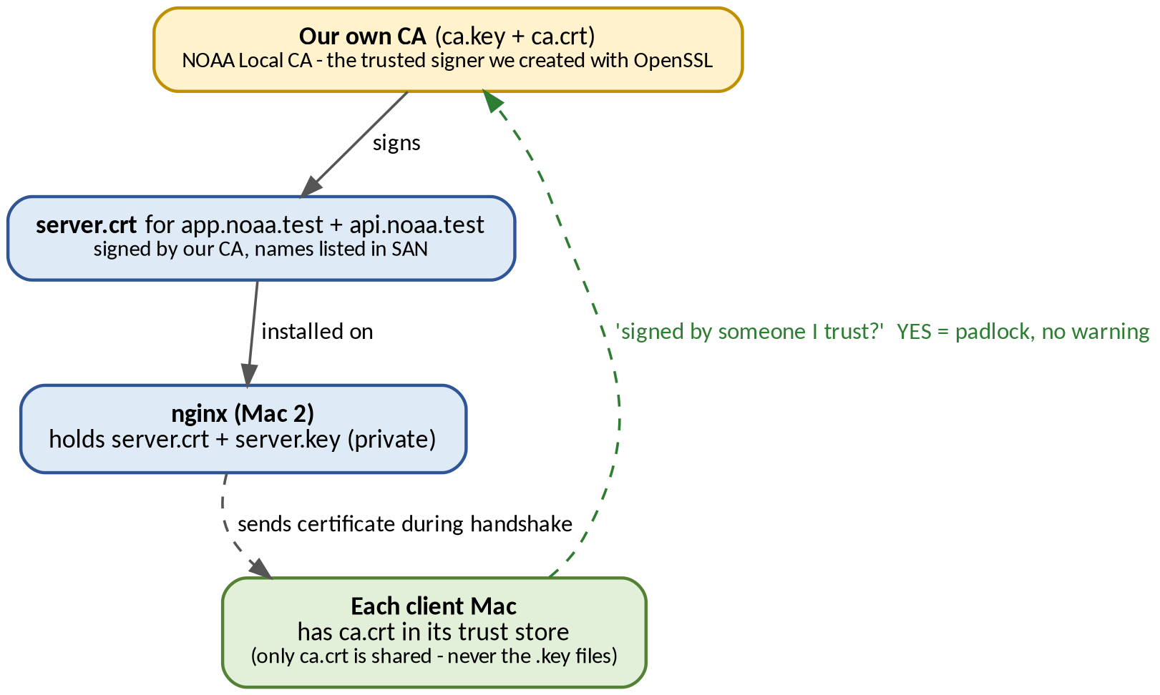
Figure 5: Chain of trust - our CA signs the server certificate, clients trust our CA

Creating the CA and the server certificate (OpenSSL)
All certificate work was done in a folder called certs. First, our own CA (the trusted signer) was created:
Terminal
openssl genrsa -out ca.key 2048
openssl req -x509 -new -key ca.key -days 365 -out ca.crt -subj "/CN=NOAA Local CA"

Next, the server key and a signing request were created:
Terminal
openssl genrsa -out server.key 2048
openssl req -new -key server.key -out server.csr -subj "/CN=app.noaa.test"

Modern clients check the names in the Subject Alternative Name (SAN) list, not the CN, so a san.ext file was created:
san.ext
subjectAltName=DNS:app.noaa.test,DNS:api.noaa.test
basicConstraints=CA:FALSE

The server certificate was then signed with our CA:
Terminal
openssl x509 -req -in server.csr -CA ca.crt -CAkey ca.key -CAcreateserial \
-out server.crt -days 365 -extfile san.ext

nginx TLS configuration
TLS directives were added to the nginx server block that listens on 8443:
nginx.conf (TLS block)
server {
listen 8443 ssl;
http2 on;
server_name app.noaa.test api.noaa.test;
ssl_certificate /path/to/certs/server.crt;
ssl_certificate_key /path/to/certs/server.key;
ssl_protocols TLSv1.2 TLSv1.3;
location / {
proxy_pass http://app_backend;
proxy_set_header Host $host;
proxy_set_header X-Real-IP $remote_addr;
proxy_set_header X-Forwarded-For $proxy_add_x_forwarded_for;
proxy_set_header X-Forwarded-Proto $scheme;
}
}

The configuration was validated with nginx -t and nginx was reloaded.

Trusting the CA on the clients
ca.crt was sent to every client Mac (by AirDrop) and added to the system trust store:
Terminal
sudo security add-trusted-cert -d -r trustRoot -k /Library/Keychains/System.keychain ca.crt

Private key handling
The private keys ca.key and server.key stayed on Mac 2 and were never shared. Only `ca.crt` was distributed to the clients.

The setup was tested without the -k flag (which would skip certificate checking). On the test client the CA certificate was supplied to curl with --cacert ca.crt; where the CA is installed in the system keychain this flag is not needed, and the examples in this report omit it. The output confirmed that the certificate verified correctly:
Terminal
curl -v https://app.noaa.test:8443/api/status

What each OpenSSL file is for
File | What it is | Who gets it
ca.key | Private key of NOAA Local CA - can sign any certificate | Nobody - kept secret on Mac 2
ca.crt | Public certificate of our CA (the "trusted signer") | Every client Mac (added to trust store)
server.key | Private key of the server | Nobody - only nginx reads it
server.csr | Signing request: "please sign a certificate for this key and name" | Only used to create the certificate
san.ext | List of valid names (SAN) for the certificate | Only used while signing
server.crt | Signed certificate for app.noaa.test and api.noaa.test | nginx sends it to every client in the handshake

The TLS handshake
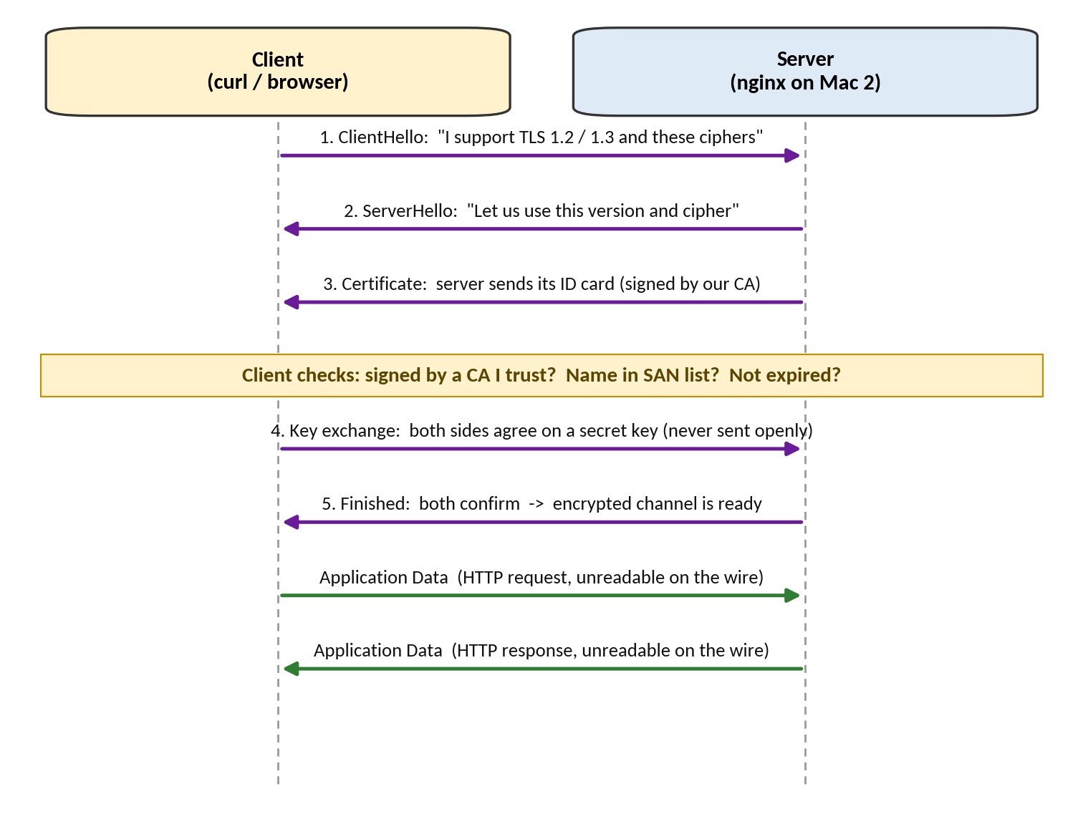
Figure 6: The TLS handshake step by step
# | Message | What happens
1 | ClientHello | Client says which TLS versions and ciphers it supports.
2 | ServerHello | Server picks one.
3 | Certificate | Server sends its ID card.
4 | Key exchange | Both sides agree on a secret key (without sending it openly).
5 | Finished | Both confirm, and from now on all data is encrypted.

Where TLS ends. TLS ends at nginx. The hop from nginx to the backend is plain HTTP inside our LAN.
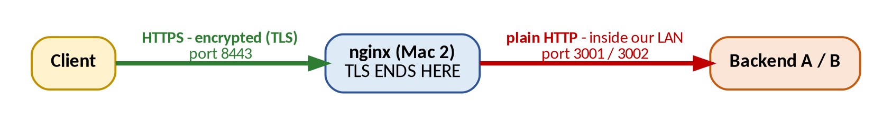
Figure 7: TLS is terminated at nginx; the backend hop is plain HTTP
Key points
The client trusts the certificate because it was signed by our CA, which is in the client's trust store, and the name is present in the certificate's SAN list.
TLS ends at nginx, and the nginx-to-backend hop is not encrypted.

3.6 Step 6: HTTP caching (Task F)
What | We showed that the app can tell clients "you can reuse this answer" and that clients can ask "has it changed?"
Why | Caching saves time and bandwidth, and CDNs work on this idea. The /api/info endpoint in the backend code implements it.
Verification | The response headers showed Cache-Control and ETag, and a conditional request returned 304 Not Modified.
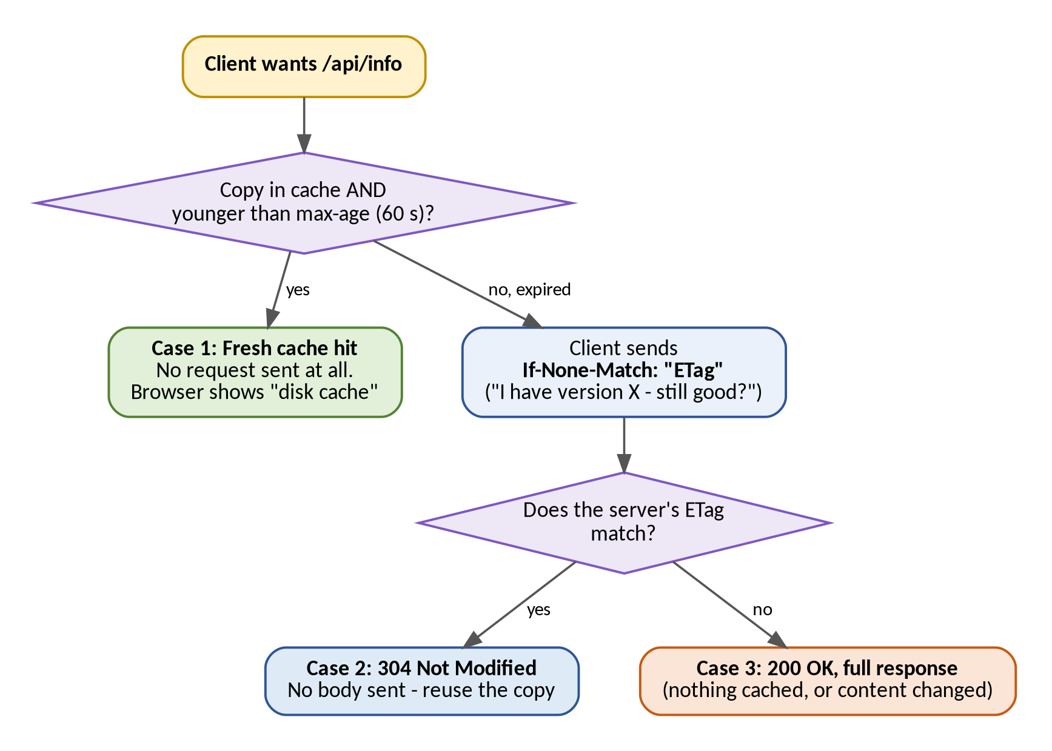
Figure 8: What happens when a client asks for /api/info - the three cases
Case | Condition | What happens
1. Fresh cache hit | Answer is still within max-age | Client does not even contact the server.
2. Conditional request | max-age ran out | Client asks "I have version X, is it still good?" Server says 304, no data sent again.
3. Full new request | Nothing in cache, or content changed | Full 200 response is sent.

Header | Sent by | Meaning
Cache-Control: max-age=60 | Server | You may reuse this answer for 60 seconds without asking.
Cache-Control: no-store | Server | Never cache this (used on /api/status for contrast).
ETag: "..." | Server | A fingerprint (hash) of the content - the "version number".
If-None-Match: "..." | Client | Sends back the ETag: "only send data if it differs from this version".
304 Not Modified | Server | Your copy is still good. No body.

The caching behaviour was demonstrated in three ways:
- Headers. curl -I https://app.noaa.test:8443/api/info showed Cache-Control: max-age=60 and an ETag.
- Conditional request. Sending the ETag value back in If-None-Match returned 304 Not Modified with no body.
- Browser. In Developer Tools (Network tab) the first load returned 200, a reload within 60 seconds was served from the disk or memory cache, and a forced reload produced a 304.
Terminal
curl -I https://app.noaa.test:8443/api/info
curl -I -H 'If-None-Match: "PASTE_ETAG_HERE"' https://app.noaa.test:8443/api/info
curl -I https://app.noaa.test:8443/api/status # no-store, for contrast

3.7 Step 7: Packet capture analysis (Task G)
What | The network traffic of one client request was recorded and each protocol in it was identified.
Why | "It works" is not enough. Packet analysis shows why it works.
Verification | A saved capture file and annotated screenshots show DNS, the TCP handshake, the TLS handshake and encrypted application data.

Wireshark was installed (brew install --cask wireshark) and the capture was run on the Wi-Fi interface (en0) of Mac 4, a client that is not Mac 1. If Mac 1 queried its own DNS server, the query would stay inside the machine (loopback) and never appear on en0. The DNS cache was flushed before each capture so that a real DNS query appeared, then one request was made while capturing:
Terminal
sudo dscacheutil -flushcache; sudo killall -HUP mDNSResponder
curl -v https://app.noaa.test:8443/api/status

# command-line alternative to the Wireshark window
sudo tcpdump -i en0 -w phase1.pcap host 10.7.11.132 or host 10.7.11.79

Two capture files were saved: phase1_full.pcapng (normal request, TLS 1.3) and phase1_tls12.pcapng (the same request with --tls-max 1.2). In TLS 1.3 the certificate is encrypted and cannot be seen in Wireshark, so TLS 1.2 was forced for one capture to make the Certificate packet visible:
Terminal
curl -v --tls-max 1.2 https://app.noaa.test:8443/api/status

Wireshark display filters used
What was shown | Filter | What was observed
DNS | dns | Query from the client and response with Mac 2's IP. Port 53/UDP.
TCP handshake | tcp.port == 8443 | SYN, SYN-ACK, ACK. Client's random (ephemeral) port and server port 8443.
TLS handshake | tls.handshake | ClientHello, ServerHello, Certificate, key exchange, ChangeCipherSpec.
Encrypted data | tls.record.content_type == 23 | "Application Data", which is unreadable.

TCP reliability. In the TCP packets the sequence and acknowledgement numbers were examined (with relative sequence numbers enabled under Edit, Preferences, Protocols, TCP). Every chunk of data gets a number and the receiver confirms what it received, which is how TCP provides reliable delivery.
Load balancing. Six consecutive curl requests showed the X-Backend header alternating between A and B.

Port table
Layer | Client side | Server side
DNS | 10.7.11.144, random port (6106 observed) / UDP | 10.7.11.132, port 53 / UDP
HTTPS | 10.7.11.144, random port (54793 observed) / TCP | 10.7.11.79, port 8443 / TCP

The client ephemeral ports are the values observed in the captures and change from one connection to the next.

Protocols mapped to layers
Layer | Protocols in our project | Where it was seen
Application | DNS, HTTP | dig answer, curl output, X-Backend header
Session / Security | TLS | ClientHello, Certificate, "Application Data"
Transport | TCP, UDP | SYN/ACK and ports (TCP); DNS on port 53 (UDP)
Network | IP | Source and destination IPs of the Macs
Link | Ethernet / Wi-Fi | MAC addresses, en0 interface

3.8 Step 8: Failure demonstrations
What | The setup was broken on purpose in five ways, the behaviour was observed and explained, and then everything was restored.
Why | It shows understanding of the system and not only the setup steps.

Every failure demonstration followed the same method:
- A "before" capture showing that the service works.
- The failure was triggered.
- An "after" capture showing the failure.
- Everything was restored and shown working again.
- The layer that broke, and why, was explained.
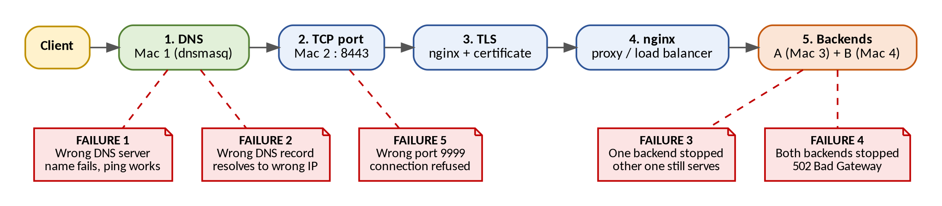
Figure 9: Where each of the five failures breaks the request path

Failure 1: Wrong DNS server on a client (Om)
Trigger | On a client Mac (Mac 4), DNS was pointed at a server that does not exist.
Observation | The name failed to resolve, but ping by IP still worked.
Explanation | DNS and IP connectivity are separate. The network is fine; only the "phone book" is unreachable.
Layer | DNS

Trigger and show
networksetup -getdnsservers Wi-Fi # current value noted first
sudo networksetup -setdnsservers Wi-Fi 10.255.255.1 # a DNS server that does not exist
sudo dscacheutil -flushcache; sudo killall -HUP mDNSResponder
networksetup -getdnsservers Wi-Fi # shows the wrong DNS
dig +time=2 +tries=1 app.noaa.test # fails: "no servers could be reached"
ping -c 3 10.7.11.79 # still works

Restore: sudo networksetup -setdnsservers Wi-Fi 10.7.11.132, flush the cache, and dig app.noaa.test resolved again.

Failure 2: DNS record points to a wrong IP (Om)
Trigger | On Mac 1, the record address=/app.noaa.test/10.7.11.79 was changed to an IP that does not run nginx (10.7.11.131) and dnsmasq was restarted.
Observation | DNS answered normally, but the client landed on the wrong machine and the connection failed.
Explanation | DNS is only a directory. It does not check that the address is the right server.
Layer | DNS (the data is wrong)

Trigger and show
# on Mac 1
cp /opt/homebrew/etc/dnsmasq.conf ~/dnsmasq.backup # backup first
# edit the address=/app.noaa.test/... line to 10.7.11.131
sudo brew services restart dnsmasq

# on the client: flush cache, then
dig app.noaa.test # resolves, but to the WRONG IP
curl -v --max-time 5 https://app.noaa.test:8443/api/status # fails: refused or timeout

Restore: the backup was copied back to /opt/homebrew/etc/dnsmasq.conf, dnsmasq restarted, the client cache flushed, and dig returned the correct IP again.

Failure 3: One backend stopped (Ayush)
Trigger | On Mac 3, Ctrl + C stopped the Backend A application. (Wi-Fi was not switched off, because nginx would then wait for a timeout and the demo would be slow.)
Observation | The service kept working through Backend B.
Explanation | nginx noticed that A refuses connections and sent traffic to the healthy server. The client saw nothing wrong.
Layer | Application (handled by the edge)

Show (from a client, and on Mac 2)
for i in 1 2 3 4 5 6; do curl -sI https://app.noaa.test:8443/api/status | grep -E "HTTP|X-Backend"; done

# on Mac 2 - shows "connection refused" for A
tail -5 /opt/homebrew/var/log/nginx/error.log
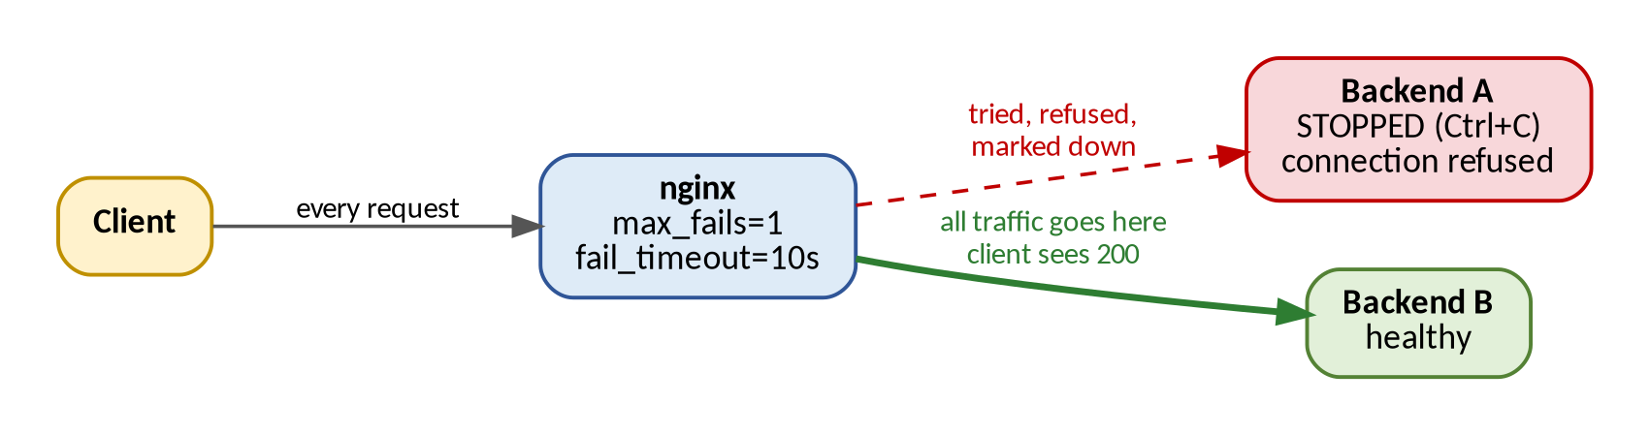
Figure 10: Failure 3 - nginx marks A as down and sends everything to B
Restore: Backend A was started again (BACKEND=A PORT=3001 python3 backend.py). After about 10 seconds (the default fail_timeout of nginx) the loop again showed A and B alternating.

nginx failover behaviour
No extra settings were needed in the upstream block. By default nginx treats a server as unavailable after one failed attempt (max_fails=1) and waits 10 seconds (fail_timeout=10s) before trying it again, which is why the service kept working through Backend B and why Backend A rejoined shortly after it was restarted.

Failure 4: Both backends stopped (Neeraj)
Trigger | Backend A (Mac 3) and Backend B (Mac 4) were both stopped with Ctrl + C.
Observation | DNS and TLS still worked, but the page showed 502 Bad Gateway.
Explanation | The edge (nginx) is alive but has nothing behind it. 502 means "I am a gateway and the server behind me gave no good answer". This shows where the edge ends and the backend begins.
Layer | Application, behind the edge

Show (from a client)
dig app.noaa.test # DNS still works
curl -v https://app.noaa.test:8443/api/status # TLS handshake completes, then 502

Restore: both backends were started again and the service worked normally.

Failure 5: Wrong destination port (Aparna)
Trigger | No change was needed on any server; the wrong port was used from a client.
Observation | The host was reachable (DNS resolved, IP worked), but the TCP connection to that port was refused.
Explanation | The IP finds the machine, the port finds the service. Nothing listens on port 9999.
Layer | TCP (port)

Show (from a client)
curl -v --max-time 5 https://app.noaa.test:9999/api/status # fails: connection refused
nc -vz 10.7.11.79 8443 # succeeded (open)
nc -vz 10.7.11.79 9999 # failed (refused)

As an extra, the command was also run while capturing in Wireshark with the filter tcp.flags.reset == 1, which showed the server answering the SYN with an RST (reset).

Summary of the failure demonstrations
# | What we broke | What we saw | Layer that broke
1 | Wrong DNS server | Name fails, ping by IP works | DNS
2 | Wrong DNS record | Resolves, but wrong machine | DNS (data is wrong)
3 | One backend stopped | Still works via the other | Application (handled by edge)
4 | Both backends stopped | DNS and TLS fine, 502 | Application behind the edge
5 | Wrong port | Connection refused | TCP (port)

4. Verification Summary
The completed system satisfies the following requirements.
Requirement | How it was verified
A client resolves app.noaa.test to Mac 2's IP using our own DNS server. | dig app.noaa.test; the SERVER: line shows Mac 1
The application opens over HTTPS with no certificate warning and no IP in the URL. | Browser padlock; curl -v without -k reports "SSL certificate verify ok"
Both Backend A and Backend B answer through the load balancer. | X-Backend header alternating A, B, A, B
DNS, the TCP handshake and the TLS handshake are visible in a packet capture. | Wireshark files phase1_full.pcapng and phase1_tls12.pcapng
HTTP caching works as designed. | Cache-Control: max-age=60, ETag, and a 304 Not Modified response
The system behaves as expected under five failure scenarios. | Before, after and restored results for each failure demonstration

5. Evidence and Deliverables

5.1 Evidence folder structure
All proof is organised by task in the project repository so that any item can be found quickly:
https://github.com/Neeraj-singh140805/noaa-private-network-service-platform
noaa-private-network-service-platform/
architecture/ network-topology.png, request-flow.png
config/
nginx/nginx.conf final nginx configuration
tls/README.md TLS setup notes (OpenSSL steps)
evidence/phase1/
01-lan/ IP details, ping tests, topology diagram
02-dns/ dig / nslookup (app and api), client DNS settings
03-backend/ Backend A and Backend B status
04-nginx/ installation, nginx -t
05-tls/ certificate generation, verification, nginx TLS validation
06-caching/ Cache-Control, ETag, 304
07-wireshark/ DNS, TCP, TLS, encrypted data, load balancing, port table
08-failures/ before / after / restored for the five failures
README.md

5.2 Evidence index
Task | Evidence | Location
A - LAN | IP details of all four Macs; ping tests from each Mac; hand-drawn topology diagram | evidence/phase1/01-lan/
B - DNS | dig and nslookup for app.noaa.test and api.noaa.test; DNS settings of both client Macs | evidence/phase1/02-dns/
C - Backends | Backend A (10.7.11.131:3001) and Backend B (10.7.11.144:3002) status responses | evidence/phase1/03-backend/
D - nginx | nginx installation, configuration test ("syntax is ok"), backend connectivity | evidence/phase1/04-nginx/; config/nginx/nginx.conf
E - TLS | Certificate generation, certificate verification (issuer, subject, SAN, validity), nginx TLS validation | evidence/phase1/05-tls/; config/tls/README.md
F - Caching | Cache-Control and ETag headers, 304 Not Modified, browser Network tab | evidence/phase1/06-caching/
G - Wireshark | DNS query/response, TCP handshake, sequence/acknowledgement numbers, ClientHello/ServerHello, TLS 1.2 certificate, Change Cipher Spec, encrypted application data, six-request load-balancing test, port table; captures phase1_full.pcapng and phase1_tls12.pcapng | evidence/phase1/07-wireshark/
Failures | Wrong DNS server, wrong DNS record, one backend stopped, both backends stopped, wrong port (before / after / restored) | evidence/phase1/08-failures/
Video | Demonstration of the full flow and the failure scenarios | video/phase1_demo.mp4

5.3 Deliverables
Deliverable | Owner | Contents
Architecture Document | Neeraj | Topology diagram, machine and IP table, request flow diagram with protocol layers
Configuration Bundle | Neeraj and Om | dnsmasq.conf, nginx.conf, TLS setup notes (the OpenSSL steps), backend launch instructions
Backend Source Code | Ayush | backend.py and helper scripts on GitHub or as a zip
Evidence Folder | Aparna | Screenshots and exports: dig/nslookup, curl/browser headers, Wireshark (DNS, TCP, TLS), caching demo, every failure demo
Phase 1 Video | All | One recording of the full flow and the failure demonstrations

6. Troubleshooting Approach and Issues Resolved
When something stopped working, the layers were checked from the bottom up: DNS first, then TCP, then TLS, then the application. The flowchart also shows which failure demonstration matches each symptom.
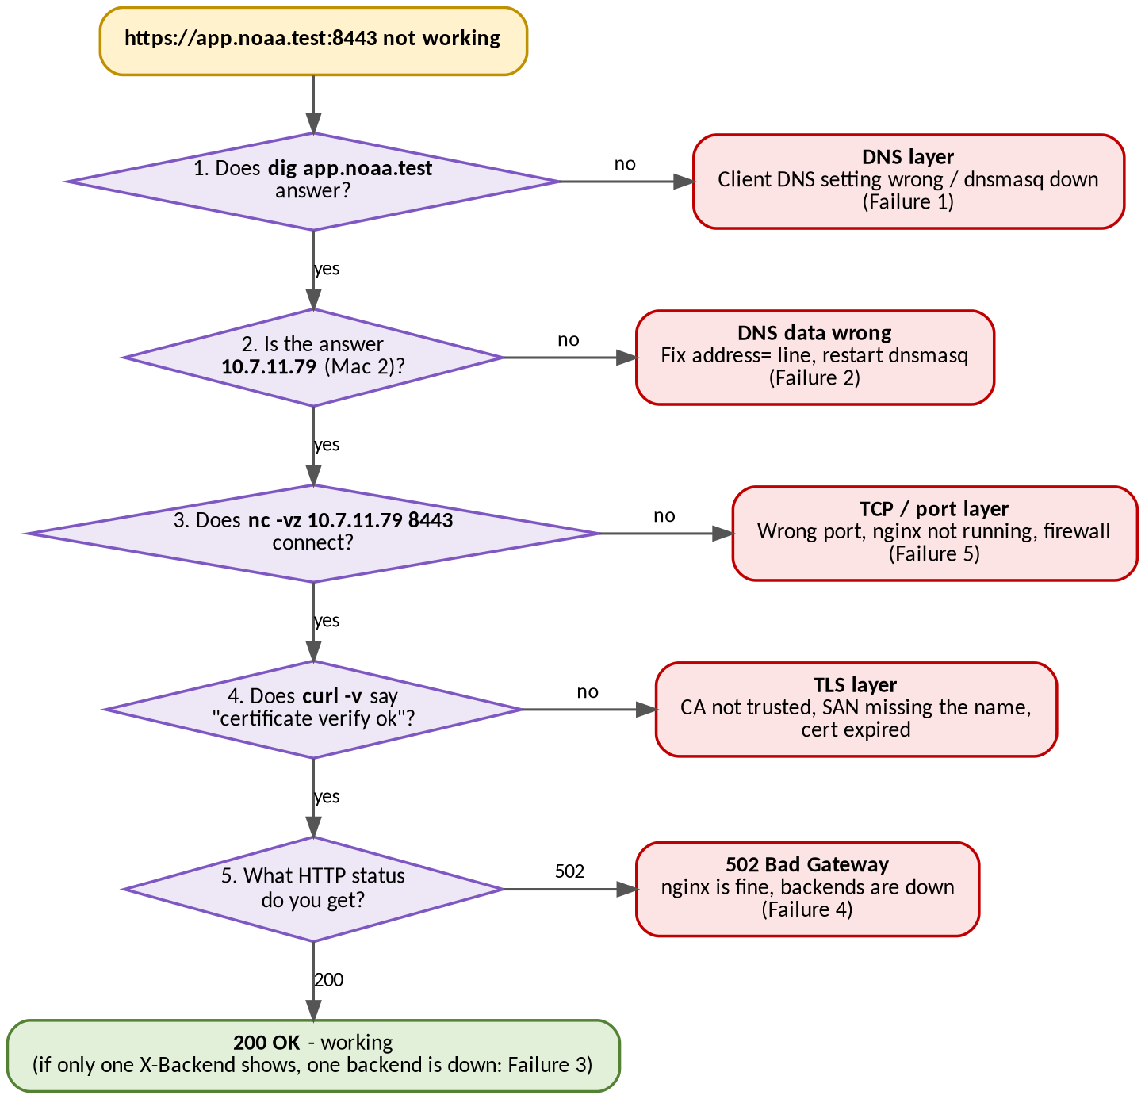
Figure 11: Troubleshooting flowchart - DNS, then TCP, then TLS, then application
Problem | Likely cause | Fix
Ping between Macs fails | Wi-Fi client isolation, or different networks | Use a network that allows device-to-device traffic
dig shows wrong or old answer | DNS cache, or the client is not using Mac 1 | Flush cache, check the SERVER: line in dig
dnsmasq will not start | Something else already uses port 53 | Run sudo lsof -i :53 to see what
Backend unreachable from other Mac | Bound to 127.0.0.1, or macOS firewall | Bind to 0.0.0.0, allow incoming connections
Browser shows certificate warning | CA not trusted, or SAN missing the name | Add ca.crt to keychain, check san.ext
nginx will not start | Port already used, or typo in config | sudo nginx -t, check the ports used (443/8443)
Everything broke suddenly | A Mac got a new IP | Re-check the IP table, update dnsmasq and nginx

7. Conclusion
Phase 1 produced a working private network service platform on four machines. A client can use a name, resolve it through our own DNS server, open a reliable TCP connection to the edge, establish a TLS session secured by our own certificate authority, and have nginx forward the request to one of two backends that are shared in round-robin fashion. Caching was demonstrated with Cache-Control, ETag and 304 responses, Wireshark captures confirmed each protocol at the packet level, and the five failure demonstrations showed how a fault at each layer appears to the client. The final network uses the private domain noaa.test and the four machines 10.7.11.132 (DNS), 10.7.11.79 (edge), 10.7.11.131 (Backend A) and 10.7.11.144 (Backend B). The same setup can be reused for further extensions without being rebuilt.

Appendix A: backend.py (complete code)
Python, no extra libraries. Run on Mac 3 as Backend A and on Mac 4 as Backend B (see Step 3).
backend.py
import json, os, hashlib
from http.server import BaseHTTPRequestHandler, HTTPServer

NAME = os.environ.get("BACKEND", "A")
PORT = int(os.environ.get("PORT", "3001"))

class Handler(BaseHTTPRequestHandler):
def send_it(self, code, body, ctype="application/json", extra=None):
data = body.encode()
self.send_response(code)
self.send_header("Content-Type", ctype)
self.send_header("Content-Length", str(len(data)))
self.send_header("X-Backend", NAME)
for k, v in (extra or {}).items():
self.send_header(k, v)
self.end_headers()
if self.command != "HEAD": # HEAD (curl -I) gets headers only, no body
self.wfile.write(data)

def do_HEAD(self):
self.do_GET()

def do_GET(self):
if self.path == "/":
self.send_it(200, f"<h1>Backend {NAME} is running</h1>", "text/html")
elif self.path == "/api/status":
self.send_it(200, json.dumps({"backend": NAME, "status": "ok"}),
extra={"Cache-Control": "no-store"})
elif self.path == "/api/info":
# Caching demo (Step 6): same content on every backend, so same ETag
body = json.dumps({"info": "this content rarely changes"})
etag = '"' + hashlib.md5(body.encode()).hexdigest() + '"'
if self.headers.get("If-None-Match") == etag:
self.send_it(304, "", extra={"ETag": etag,
"Cache-Control": "max-age=60"})
else:
self.send_it(200, body, extra={"ETag": etag,
"Cache-Control": "max-age=60"})
else:
self.send_it(404, json.dumps({"error": "not found"}))

HTTPServer(("0.0.0.0", PORT), Handler).serve_forever()

How the code maps to the requirements
Part of the code | Why it is there
NAME, PORT from environment variables | One file serves as both A and B - only the variables change.
send_header("X-Backend", NAME) | Shows which backend answered (proof of load balancing).
HTTPServer(("0.0.0.0", PORT), ...) | Listens on all interfaces so other Macs (nginx) can reach it.
/api/status with no-store | Always fresh - used to show alternating A / B and as a no-cache contrast.
/api/info with ETag + max-age=60 | Caching demo: fresh hit, 304 on If-None-Match, or full 200.
ETag = md5 of the body | Same content on A and B gives the same ETag, so caching works whichever backend answers.
do_HEAD calls do_GET | curl -I sends HEAD; headers are returned without a body.

Appendix B: Complete Configuration at a Glance

dnsmasq.conf (Mac 1)
Mac 1
listen-address=10.7.11.132,127.0.0.1
bind-interfaces
address=/app.noaa.test/10.7.11.79
address=/api.noaa.test/10.7.11.79
server=8.8.8.8

nginx.conf - inside http { } (Mac 2)
Mac 2 (config/nginx/nginx.conf in the repository)
map $upstream_addr $backend_name {
"10.7.11.131:3001" A;
"10.7.11.144:3002" B;
}

upstream app_backend {
server 10.7.11.131:3001;
server 10.7.11.144:3002;
}

# HTTPS on 443, addressed by the edge IP
server {
listen 443 ssl;
server_name 10.7.11.79;
ssl_certificate <certs>/server.crt;
ssl_certificate_key <certs>/server.key;
location / {
proxy_pass http://app_backend;
proxy_set_header Host $host;
proxy_set_header X-Real-IP $remote_addr;
proxy_set_header X-Forwarded-For $proxy_add_x_forwarded_for;
proxy_set_header X-Forwarded-Proto $scheme;
}
error_page 500 502 503 504 /50x.html;
location = /50x.html { root html; }
}

# HTTPS on 8443, addressed by name (main service)
server {
listen 8443 ssl;
http2 on;
server_name app.noaa.test api.noaa.test;
ssl_certificate <certs>/server.crt;
ssl_certificate_key <certs>/server.key;
ssl_protocols TLSv1.2 TLSv1.3;
location / {
proxy_pass http://app_backend;
proxy_set_header Host $host;
proxy_set_header X-Real-IP $remote_addr;
proxy_set_header X-Forwarded-For $proxy_add_x_forwarded_for;
proxy_set_header X-Forwarded-Proto $scheme;
}
}

Port and service summary
Service | Machine | Port / protocol
DNS (dnsmasq) | Mac 1 | 53 / UDP
nginx HTTPS (main service) | Mac 2 | 8443 / TCP
nginx HTTPS (edge IP) | Mac 2 | 443 / TCP
Backend A | Mac 3 | 3001 / TCP
Backend B | Mac 4 | 3002 / TCP

