ADBMS NOTES

Module1: (8Hrs)

Text Books:
- Database System Concepts by Sudarshan, Korth (McGraw-Hill Education)
- Fundamentals of Database System By Elmasari &Navathe- Pearson Education

References Books:
- An introduction to Database System – Bipin Desai, Galgotia Publications
- Database System: concept, Design & Application by S.K.Singh (Pearson Education)
- Database management system by leon &leon (Vikas publishing House).
- Database Modeling and Design: Logical Design by Toby J. Teorey, Sam S. Lightstone, and Tom
Nadeau, “”, 4th Edition, 2005, Elsevier India Publications, New Delhi
- Fundamentals of Database Management System – Gillenson, Wiley India

Introduction:Module-1:
LECTURE-1: Introduction to Data

What is data?
Data are the known facts or figures that have implicit meaning. It can also be defined as it is the representation of facts, concepts or instructions in a formal manner, which is suitable for understanding and processing. Data can be represented in alphabets (A-Z, a-z), digits (0-9) and using special characters (+,-.#,$, etc)
e.g: 25, “ajit” etc.
Database:
A database is organized collection of related data of an organization stored in formatted way which is shared by multiple users.

The main feature of data in a database are:
    - It must be well organized
    - It is related
    - It is accessible in a logical order without any difficulty
    - It is stored only once

For example consider the roll no, name, address of a student stored in a student file. It is collection of related data with an implicit meaning. Data in the database may be persistent, integrated and shared.

Why Database:

In order to overcome the limitation of a file system, a new approach was required. Hence a database approach emerged. A database is a persistent collection of logically related data. The initial attempts were to provide a centralized collection of data. A database has a self describing nature. It contains not only the data sharing and integration of data of an organization in a single database.
A small database can be handled manually but for a large database and having multiple users it is difficult to maintain it. In that case a computerized database is useful.
The advantages of database system over traditional, paper based methods of record keeping are:
- Compactness: No need for large amount of paper files
- Speed: The machine can retrieve and modify the data more faster way then human being
- Less drudgery: Much of the maintenance of files by hand is eliminated
- Accuracy: Accurate, up-to-date information is fetched as per requirement of the user at any time.

Database Management System (DBMS):
A database management system consists of collection of related data and refers to a set of programs for defining, creation, maintenance and manipulation of a database.

Function of DBMS:

- Defining database schema: it must give facility for defining the database structure also specifies access rights to authorized users.
- Manipulation of the database: The dbms must have functions like insertion of record into database, updation of data, deletion of data, retrieval of data
- Sharing of database: The DBMS must share data items for multiple users by maintaining consistency of data.
- Protection of database: It must protect the database against unauthorized users.
- Database recovery: If for any reason the system fails DBMS must facilitate data base recovery.

Advantages of DBMS:

Reduction of redundancies:
Centralized control of data by the DBA avoids unnecessary duplication of data and effectively reduces the total amount of data storage required avoiding duplication in the elimination of the inconsistencies that tend to be present in redundant data files.

Sharing of Data:
A database allows the sharing of data under its control by any number of application programs or users.

Data Integrity:
Data integrity means that the data contained in the database is both accurate and consistent. Therefore data values being entered for storage could be checked to ensure that they fall with in a specified range and are of the correct format.

Data Security:
The DBA who has the ultimate responsibility for the data in the dbms can ensure that proper access procedures are followed including proper authentication to access to the DataBase System and additional check before permitting access to sensitive data.

Conflict Resolution:
DBA resolve the conflict on requirements of various user and applications. The DBA chooses the best file structure and access method to get optional performance for the application.

Data Independence:
Data independence is usually considered from two points of views; physically data independence and logical data independence.
DBMS contains information about a particular enterprise
  - Collection of interrelated data DATABASE
  - Set of programs to access the data
  - An environment that is both convenient and efficient to use

File:
File is a collection of related data stored in secondary memory.

I)Database System Applications
Present each application with a scenario:
Application Area | Real-Time Scenario to Explain
Banking | ATM withdrawal updates in central DB instantly
e-Commerce | Amazon cart, payments, order DB
Airlines | Live seat availability update
Social Media | Facebook stores posts, likes, comments
Healthcare | Patient history stored safely
Education | University registration (students can relate easily)
  - File Oriented Approach:
The traditional file oriented approach to information processing each application has a separate master file and its own set of personal file.
In file oriented approach the program dependent on the files and files dependent upon the programs.
Real-Time Application Example: COLLEGE MANAGEMENT SYSTEM(ETLAB)

Scenario Without DBMS (File System)
Each department stores its own files:
- Department keeps one file for student list
- Exam cell keeps separate grade file
- Library keeps membership file
- Office maintains a tuition-fee file
Problems:
- Same student details stored 5–6 times → redundancy
- If phone number updated in one file but not others → inconsistency
- Very slow searches → poor performance
- Files can get corrupted → no recovery

Scenario WITH DBMS (College ERP)
A central database stores:
- Student Table
- Course Table
- Marks Table
- Fees Table
- Attendance Table
Applications like Student Portal / Faculty Portal fetch data directly.

II). Merits (Advantages) of DBMS Over File System
1. Reduced Data Redundancy Single Student Record → no redundancy
Only one copy of data is stored.
2. Data Consistency Updated once → available everywhere. Changes reflect everywhere
3. Improved Data Sharing Multiple departments access the same DB.
4. Centralized SecurityDBA controls who sees/changes data. Security STRONG

5. Multi-user Access with Concurrency Control Multiple students can register at the same time without errors.
6. Backup and RecoverySystem automatically restores data.
7. Better Data Integrity Constraints like PRIMARY KEY ensure error-free data.
8. Faster Access to Data Indexes and queries make retrieval fast.

Demerits (Limitations) of DBMS
1. High Cost of Hardware & Software
Installing Oracle/MySQL servers is expensive for small businesses.
2. Requires Trained Professionals
A DBA must manage the system—needs expertise.
3. Higher Complexity
Designing schemas, normalization, security → needs skills.
4. Centralized Database Failure Affects All Users
If DB server goes down, college ERP stops working.
5. Higher Maintenance Cost
Regular updates, backups, tuning → time + money.

111)Disadvantages of file oriented approach:
  - Data redundancy and inconsistency:
The same information may be written in several files. This redundancy leads to higher storage and access cost. It may lead data inconsistency that is the various copies of the same data may present at multiple places for example a changed customer address may be reflected in single file but not else where in the system.

Difficulty in accessing data :
The conventional file processing system do not allow data to be retrieved in a convenient and efficient manner according to user choice.

Data isolation :
Because data are scattered in various files and files may be in different formats with new application programs to retrieve the appropriate data is difficult.

Integrity Problems:
Developers enforce data validation in the system by adding appropriate code in the various application program. How ever when new constraints are added, it is difficult to change the programs to enforce them.

Atomicity:
It is difficult to ensure atomicity in a file processing system when transaction failure occurs due to power failure, networking problems etc. (atomicity: either all operations of the transaction are reflected properly in the database or non are)

Concurrent access:
In the file processing system it is not possible to access the same file for transaction at same the time.

Security problems:
There is no security provided in file processing system to secure the data from unauthoriz- ed user access.

LECTURE-2: DBMS

DATA ABSTRACTION/ 3 level Architecture of DBMS

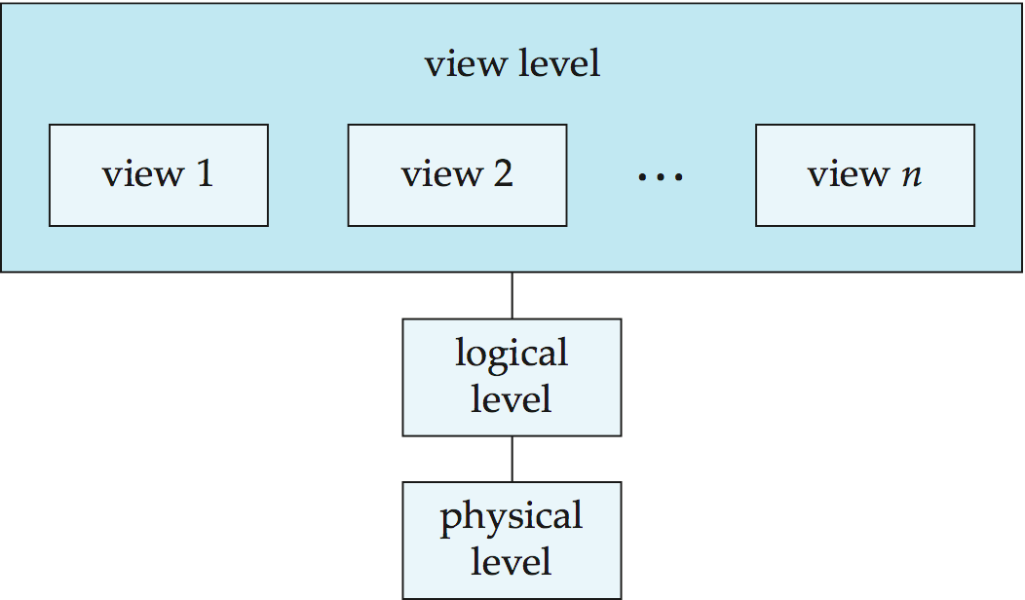
Physical level: describes how a record (e.g., instructor) is stored.
Logical level: describes data stored in database, and the relationships among the data.
type instructor = record
ID : string;
name : string;
dept_name : string;
salary : integer;
end;
View level: application programs hide details of data types. Views can also hide information (such as an employee’s salary) for security purposes.

Example: ATM Machine

“When you withdraw money at an ATM, do you see the internal database structure?”

- User only sees balance, options, confirmation screen → View Level
- Application sees account tables, procedures, logic → Logical Level
- Bank server deals with how data is stored in blocks, indexes → Physical Level

2. EXPLAIN WHY DATA ABSTRACTION IS NEEDED

“Data Abstraction hides the complexity of storage and shows only the necessary information.”

IN THE College System.
1.View Level (What the user sees)
Only necessary information is displayed BASED ON THE TYPE OF USER
Real-time example: College Student Portal
Students see Name,Courses,Attendance,Marks
They don’t see table names or storage details.
This is VIEW LEVEL.

2. Logical Level (What data is stored & relationships)
Database designer sees:
All Table definitions,Attributes,Relationships,Data types,Constraints
Example:
STUDENT(RegNo, Name, Dept, Phone)
COURSE(CourseID, Title, Credits)
ENROLL(RegNo, CourseID, Grade)
This is the LOGICAL LEVEL, where schema is designed.

3. Physical Level (How data is stored internally)
DBMS handles:
- File organization
- B-trees, hashing
- Data blocks
- Indexing
- Disk allocation
Example:
- Student table stored in disk blocks
- Index built on RegNo
- Data compressed or partitioned
Students never see this → PHYSICAL LEVEL.

4. A SIMPLE 1-MINUTE ANALOGY
Use a car analogy:
Level | Car Analogy
View Level | Driver sees steering, speedometer
Logical Level | Mechanic understands wiring, engine layout
Physical Level | Manufacturing plant designs pistons, nuts, metal components

Database Users :

1.Naive Users :
Users who need not be aware of the presence of the database system or any other system supporting their usage are considered naïve users . A user of an automatic teller machine falls on this category.Online Users :
These are users who may communicate with the database directly via an online terminal or indirectly via a user interface and application program. These users are aware of the database system and also know the data manipulation language system.

2.Application Programmers :
Professional programmers who are responsible for developing application programs or user interfaces utilized by the naïve and online user falls into this category.

3.Database Administration :
A person who has central control over the system is called database administrator . The function of DBA are :
- Creation and modification of conceptual Schema definition
- Implementation of storage structure and access method.
- Schema and physical organization modifications .
- Granting of authorization for data access.
- Integrity constraints specification.
- Execute immediate recovery procedure in case of failures
- Ensure physical security to database

Lecture 3:Database language :

- Data definition language (DDL) :
DDL is used to define database objects .The conceptual schema is specified by a set of definitions expressed by this language. It also gives some details about how to implement this schema in the physical devices used to store the data. This definition includes all the entity sets and their associated attributes and their relationships. The result of DDL statements will be a set of tables that are stored in special file called data dictionary.

Data Manipulation Language (DML) :
A DML is a language that enables users to access or manipulate data stored in the database. Data manipulation involves retrieval of data from the database, insertion of new data into the database and deletion of data or modification of existing data.

There are basically two types of DML:
  - Procedural: Which requires a user to specify what data is needed and how to get it.
  - Non-Procedural: which requires a user to specify what data is needed with out specifying how to get it.

Data Control Language (DCL):
This language enables user to grant authorization and canceling authorization of database objects.

LECTURE-4: Elements of DBMS

Elements of DBMS or DBMS ARCHITECTURE

DML Pre-Compiler:
It converts DML statements embedded in an application program to normal procedure calls in the host language. The pre-complier must interact with the query processor in order to generate the appropriate code.

DDL Compiler:
The DDL compiler converts the data definition statements into a set of tables. These tables contains information concerning the database and are in a form that can be used by other components of the dbms.

File Manager:
File manager manages the allocation of space on disk storage and the data structure used to represent information stored on disk.

Database Manager:
A database manager is a program module which provides the interface between the low level data stored in the database and the application programs and queries submitted to the system.

The responsibilities of database manager are:

- Interaction with File Manager: The data is stored on the disk using the file system which is provided by operating system. The database manager translate the different DML statements into low-level file system commands so the database manager is responsible for the actual storing, retrieving and updating of data in the database.

- Integrity Enforcement: The data values stored in the database must satisfy certain constraints (eg: the age of a person can't be less then zero). These constraints are specified by DBA. Data manager checks the constraints and if it satisfies then it stores the data in the database.

- Security Enforcement: Data manager checks the security measures for database from unauthorized users.

- Backup and Recovery: Database manager detects the failures occur due to different causes (like disk failure, power failure, deadlock, software error) and restores the database to original state of the database.

- Concurrency Control: When several users access the same database file simultaneously, there may be possibilities of data inconsistency. It is responsible of database manager to control the problems occur for concurrent transactions.

Query Processor:
The query processor used to interpret to online user’s query and convert it into an efficient series of
operations in a form capable of being sent to the data manager for execution. The query processor

uses the data dictionary to find the details of data file and using this information it create query plan/access plan to execute the query.

Data Dictionary:
Data dictionary is the table which contains the information about database objects. It contains information like
- external, conceptual and internal database description
- description of entities, attributes as well as meaning of data elements
- synonyms, authorization and security codes
- database authorization

The data stored in the data dictionary is called meta data.

DBMS STRUCTURE:
Naïve user
Database manager
DBMS
Data dictionary
Data file
File manager
Ddl compiler
Query processor
Dml precomplier
Application prog obj code
Ddl compiler
System calls
Application programs
DBA
On line user
Application programers

Qn: What are the 4 significant differences between a File-Processing System and a DBMS.

Ans: Some major differences between a database management system and a file-processing system are:
  - Both systems contain a collection of data and a set of programs which access that data. A database management system coordinates both the physical and the logical access to the data, whereas a file-processing system coordinates only the physical access.

  - A database management system reduces the amount of data duplication by ensuring that a physical piece of data is available to all programs authorized to have access to it, where as data written by one program in a file-processing system may not be readable by another program.

  - A database management system is designed to allow flexible access to data (i.e., queries), whereas a file-processing system is designed to allow predetermined access to data (i.e., compiled programs).

  - A database management system is designed to coordinate multiple users accessing the same data at the same time. A file-processing system is usually designed to allow one or more programs to access different data files at the same time. In a file-processing system, a file can be accessed by two programs concurrently only if both programs have read-only access to the file.

Que: Explain the difference between physical and logical data independence.

Ans:

- Physical data independence is the ability to modify the physical scheme without making it necessary to rewrite application programs. Such modifications include changing from unblocked to blocked record storage, or from sequential to random access files.

- Logical data independence is the ability to modify the conceptual scheme without making it necessary to rewrite application programs. Such a modification might be adding a field to a record; an application program’s view hides this change from the program.

Que: List five responsibilities of a database management system. For each responsibility, explain the problems that would arise if the responsibility were not discharged.

Ans: A general purpose database manager (DBM) has five responsibilities:
- interaction with the file manager.
- integrity enforcement.
- security enforcement.
- backup and recovery.
- concurrency control.

If these responsibilities were not met by a given DBM (and the text points out that sometimes a responsibility is omitted by design, such as concurrency control on a single-user DBM for a micro computer) the following problems can occur, respectively:

- No DBM can do without this, if there is no file manager interaction then nothing stored in the files can be retrieved.

- Consistency constraints may not be satisfied, when account balances could go below the minimum allowed, employees could earn too much overtime (e.g.,hours > 80) or, airline pilots may fly more hours than allowed by law.

- Unauthorized users may access the database, or users authorized to access part of the

database may be able to access parts of the database for which they lack authority. For example, a high school student could get access to national defense secret codes, or employees could find out what their supervisors earn.

- Data could be lost permanently, rather than at least being available in a consistent state that existed prior to a failure.

- Consistency constraints may be violated when intgrity constraints failed in a transaction. For example, incorrect bank balances might be reflected due to simultaneous withdrawals and deposits, and so on.

Que. What are five main functions of a database administrator?

Ans: Five main functions of a database administrator are:

  - To create the scheme definition
  - To define the storage structure and access methods
  - To modify the scheme and/or physical organization when necessary
  - To grant authorization for data access
  - To specify integrity constraints

EXERCISE:

- What is database management system?
- What are the disadvantage of file processing system?
- State advantage and disadvantage of database management system.
- What are different types of database users?
- What is data dictionary and what are its contents?
- What are the functions of DBA?
- What are the different database languages? Explain with example.
- Explain the three layer architecture of DBMS.
- Differentiate between physical data independence and logical data independence.
- Explain the functions of database manager.

U2
The Entity-Relationship Model (ER Model) is a conceptual model for designing a databases. This model represents the logical structure of a database, including entities, their attributes and relationships between them.
- Entity: An objects that is stored as data such as Student, Course or Company.
- Attribute: Properties that describes an entity such as StudentID, CourseName, or EmployeeEmail.
- Relationship: A connection between entities such as "a Student enrolls in a Course".
Components of ER Diagram
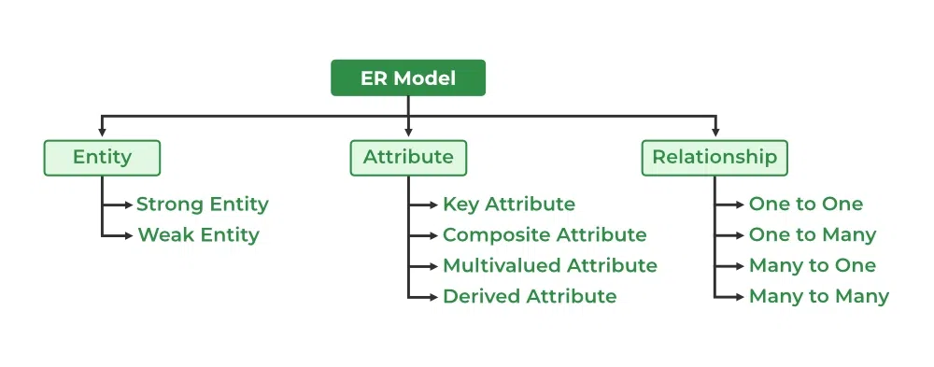
The graphical representation of this model is called an Entity-Relation Diagram (ERD).
ER Model in Database Design Process
We typically follow the below steps for designing a database for an application.
- Gather the requirements (functional and data) by asking questions to the database users.
- Create a logical or conceptual design of the database. This is where ER model plays a role. It is the most used graphical representation of the conceptual design of a database.
- After this, focus on Physical Database Design (like indexing) and external design (like views)
Why Use ER Diagrams In DBMS?
- ER diagrams represent the E-R model in a database, making them easy to convert into relations (tables).
- These diagrams serve the purpose of real-world modeling of objects which makes them intently useful.
- Unlike technical schemas, ER diagrams require no technical knowledge of the underlying DBMS used.
- They visually model data and its relationships, making complex systems easier to understand.
Symbols Used in ER Model
ER Model is used to model the logical view of the system from a data perspective which consists of these symbols:
Symbols used in ER Diagram
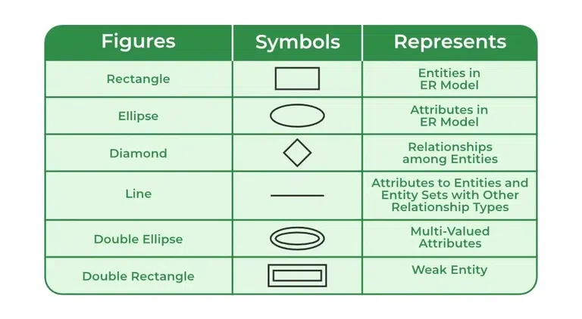

What is an Entity?
An Entity represents a real-world object, concept or thing about which data is stored in a database. It act as a building block of a database. Tables in relational database represent these entities.
Example of entities:
- Real-World Objects: Person, Car, Employee etc.
- Concepts: Course, Event, Reservation etc.
- Things: Product, Document, Device etc.
The entity type defines the structure of an entity, while individual instances of that type represent specific entities.
What is an Entity Set?
An entity refers to an individual object of an entity type, and the collection of all entities of a particular type is called an entity set. For example, E1 is an entity that belongs to the entity type "Student," and the group of all students forms the entity set.
In the ER diagram below, the entity type is represented as:

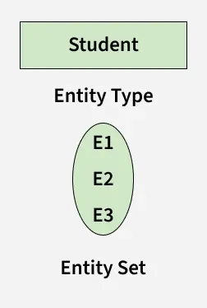
Entity Set
We can represent the entity sets in an ER Diagram but we can't represent individual entities because an entity is like a row in a table, and an ER diagram shows the structure and relationships of data, not specific data entries (like rows and columns). An ER diagram is a visual representation of the data model, not the actual data itself.
Types of Entity
There are two main types of entities:
1. Strong Entity
A Strong Entity is a type of entity that has a key Attribute that can uniquely identify each instance of the entity. A Strong Entity does not depend on any other Entity in the Schema for its identification. It has a primary key that ensures its uniqueness and is represented by a rectangle in an ER diagram.
2. Weak Entity
A Weak Entity cannot be uniquely identified by its own attributes alone. It depends on a strong entity to be identified. A weak entity is associated with an identifying entity (strong entity), which helps in its identification. A weak entity are represented by a double rectangle. The participation of weak entity types is always total. The relationship between the weak entity type and its identifying strong entity type is called identifying relationship and it is represented by a double diamond.
Example:
A company may store the information of dependents (Parents, Children, Spouse) of an Employee. But the dependents can't exist without the employee. So dependent will be a Weak Entity Type and Employee will be identifying entity type for dependent, which means it is Strong Entity Type.

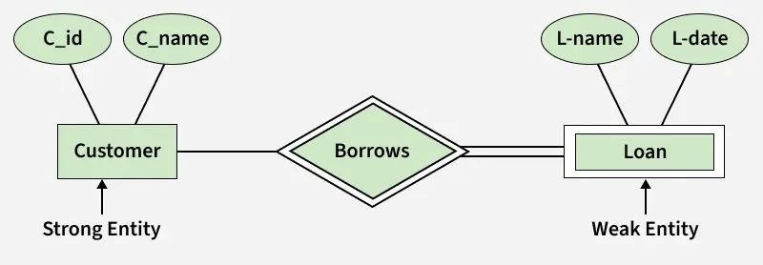

strong Entity and Weak Entity
Attributes in ER Model

Attributes are the properties that define the entity type. For example, for a Student entity Roll_No, Name, DOB, Age, Address, and Mobile_No are the attributes that define entity type Student. In ER diagram, the attribute is represented by an oval.
Attribute

Types of Attributes
1. Key Attribute
The attribute which uniquely identifies each entity in the entity set is called the key attribute. For example, Roll_No will be unique for each student. In ER diagram, the key attribute is represented by an oval with an underline.
Key Attribute
2. Composite Attribute
An attribute composed of many other attributes is called a composite attribute. For example, the Address attribute of the student Entity type consists of Street, City, State, and Country. In ER diagram, the composite attribute is represented by an oval comprising of ovals.
Composite Attribute
3. Multivalued Attribute
An attribute consisting of more than one value for a given entity. For example, Phone_No (can be more than one for a given student). In ER diagram, a multivalued attribute is represented by a double oval.
Multivalued Attribute
4. Derived Attribute
An attribute that can be derived from other attributes of the entity type is known as a derived attribute. e.g.; Age (can be derived from DOB). In ER diagram, the derived attribute is represented by a dashed oval.
Derived Attribute
The Complete Entity Type Student with its Attributes can be represented as:
Entity and Attributes
Relationship Type and Relationship Set
A Relationship Type represents the association between entity types. For example, ‘Enrolled in’ is a relationship type that exists between entity type Student and Course. In ER diagram, the relationship type is represented by a diamond and connecting the entities with lines.
Entity-Relationship Set
A set of relationships of the same type is known as a relationship set. The following relationship set depicts S1 as enrolled in C2, S2 as enrolled in C1, and S3 as registered in C3.

