Full Name: Neeraj Kumar
Project Name: Linux Capstone Project 1
Submission Date: 29th Oct 2026
Operating System Used: Amazon Linux 2023 (EC2)

Topics Covered: Linux File System | User & Permission Management | chmod & chown | Process Management | crontab | File Navigation | Text Processing | System Information Commands | Pipes & Filters
Environment: AWS EC2 t2. micro (Amazon Linux 2023) — Free Tier OR Local VirtualBox VM (CentOS/Ubuntu)
Project Architecture
Linux Server (EC2 or VM)
├── Users & Groups
│ ├── alice (developer)
│ ├── bob (developer)
│ └── charlie (manager)
├── Directory Structure
│ ├── /project/dev/
│ ├── /project/manager/
│ └── /project/shared/
├── Permissions
│ ├── dev group → /project/dev/ (read/write)
│ ├── manager group → /project/manager/ (read/write)
│ └── everyone → /project/shared/ (read/write)
└── Automation
└── crontab (daily system report)

Setup — Launch Your Environment
Option A — AWS EC2 (Free Tier):
- Launch a t2. micro Amazon Linux 2023 instance
- Security Group: allow SSH port 22 from My IP only
- Connect via SSH: ssh -i "your-key.pem" ec2-user@<public-ip>

Option B — Local VirtualBox VM:
- Open VirtualBox. Start your Linux VM (CentOS or Ubuntu)
- Open the terminal inside the VM
- All commands are the same regardless of which option you choose

Phase 1 — System Information & File System Exploration
Step 1: Gather system information
Run the following commands and screenshot each output:

Commands:
# Basic system info
uname -a
hostname
whoami
id
uptime
date
cal

# OS information
cat /etc/os-release

# Hardware info
nproc
free -h
df -h
lsblk

Output:
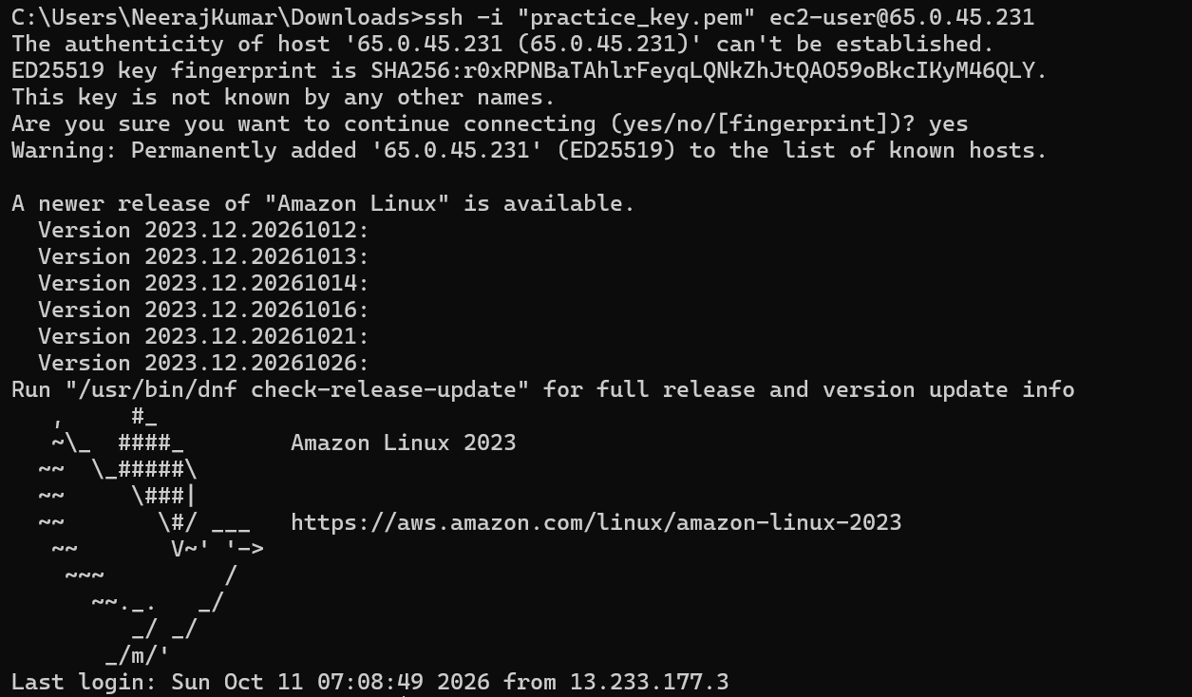
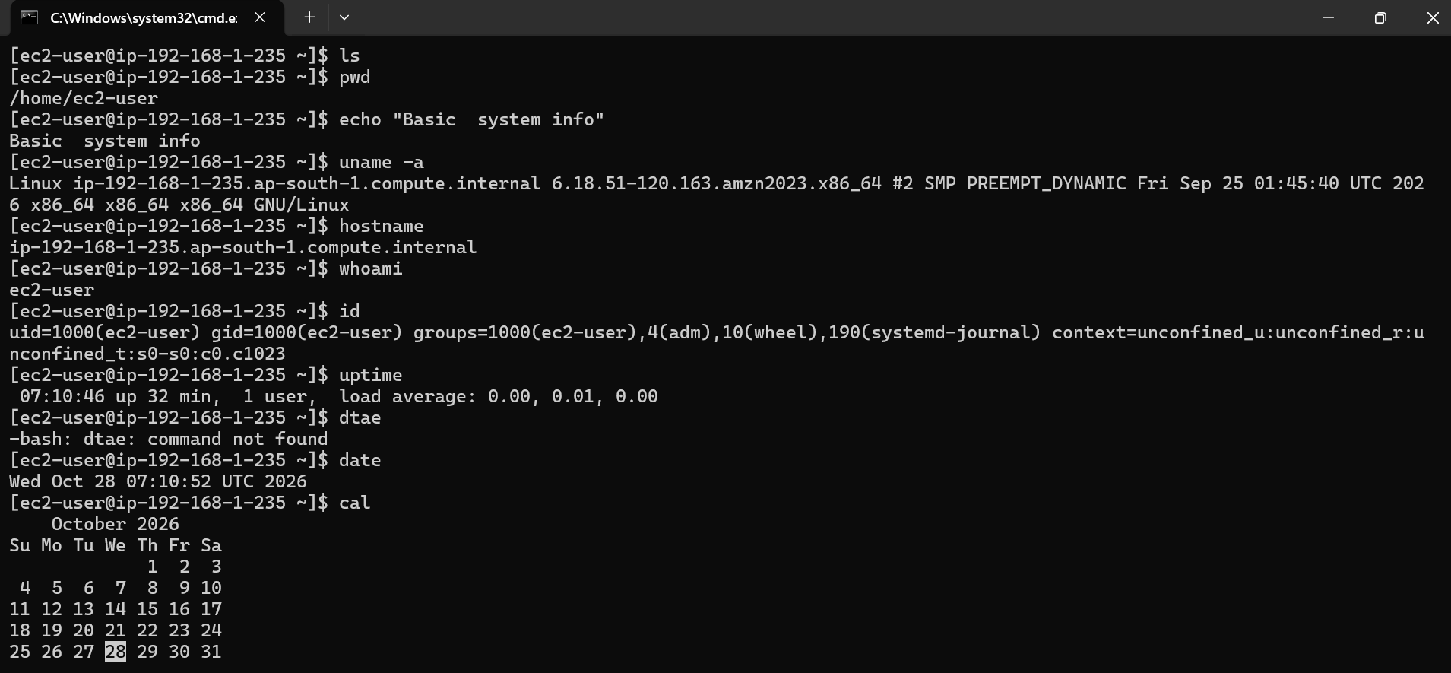
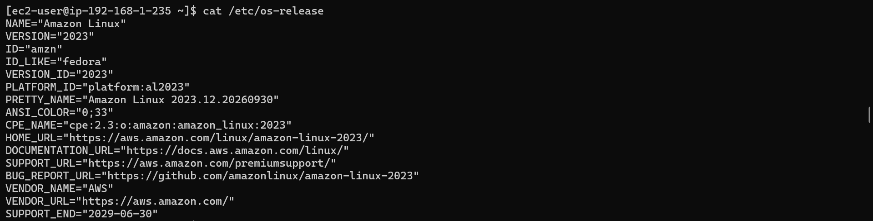
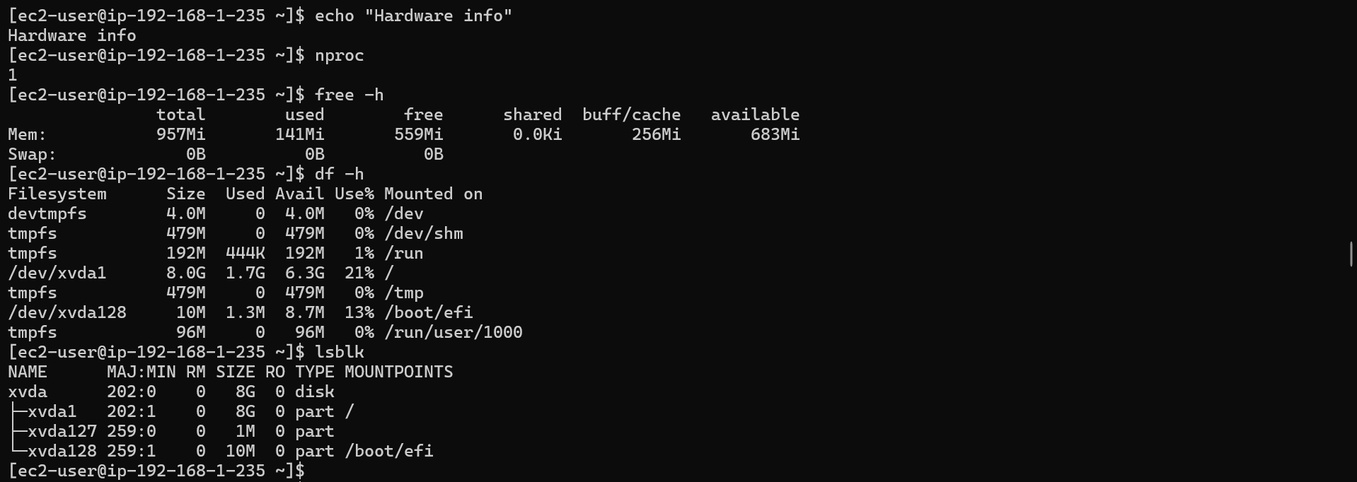

Step 2: Explore the Linux file system structure
Navigate through and document the purpose of each directory:

Commands:
ls /
ls /etc
ls /var/log
ls /home
ls /tmp
ls /usr/bin

# Show full path at all times
pwd

# Navigate using absolute paths
cd /var/log
pwd
ls -la

# Navigate using relative paths
cd ../../tmp
pwd
cd ~
pwd

Create a table in your Google Doc listing each directory and its purpose: /, /etc, /var, /home, /tmp, /usr, /bin, /sbin, /opt.

Outputs:
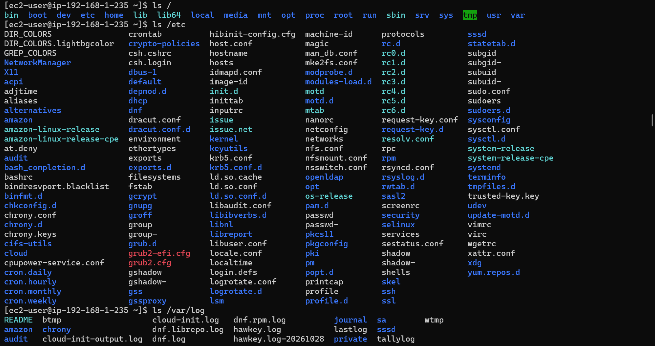

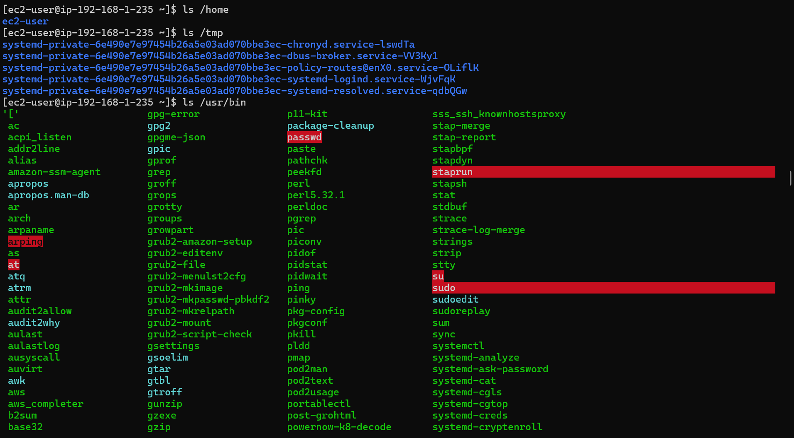
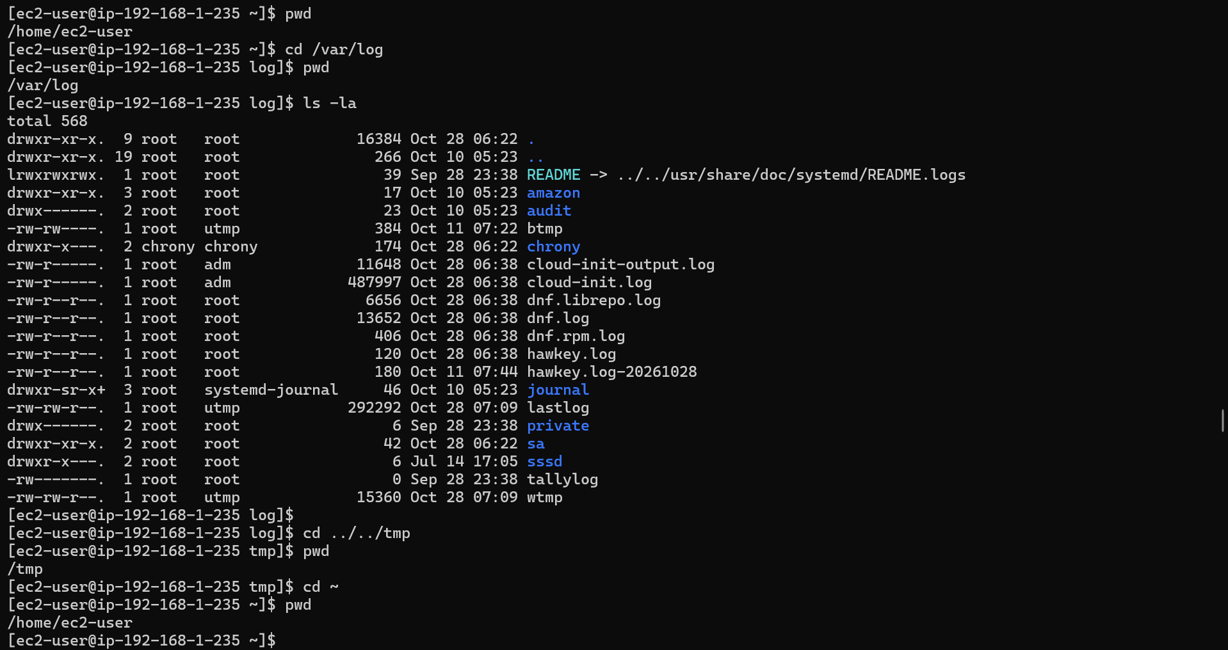

Create a table in your Google Doc listing each directory and its purpose: /, /etc, /var, /home, /tmp, /usr, /bin, /sbin, /opt.

Directory |  | Purpose | Examples of Contents
/ | Root directory. The top-level directory that contains all other directories and files. |  | /etc, /home, /usr, /var
/etc | Stores system-wide configuration files for the operating system and installed services. |  | Network settings, user configuration, service configuration
/var | Stores variable data that changes during system operation. |  | Log files (/var/log), caches, mail queues, databases
/home | Contains the personal directories of regular users, including their files and settings. |  | /home/alex, documents, downloads, user configuration
/tmp | Stores temporary files created by applications and users. These files may be deleted automatically. |  | Temporary files, application working files
/usr | Contains most user-space applications, libraries, documentation, and shared resources installed on the system. |  | /usr/bin, /usr/lib, /usr/share
/bin | Contains essential user commands needed for basic system operation, such as commands used to manage files and run programs. |  | ls, cp, mv, cat
/sbin | Contains system administration utilities used for system maintenance, booting, and recovery. |  | fsck, reboot, ip
/opt | Used for optional or third-party application software, often installed in separate application directories. |  | /opt/google, /opt/myapp

Step 3: Create the project directory structure

Commands:
# Switch to root
sudo su -

# Create main project directory
mkdir -p /project/dev
mkdir -p /project/manager
mkdir -p /project/shared

# Verify structure
ls -la /project/
tree /project/
# Install if needed: yum install tree -y

Outputs:
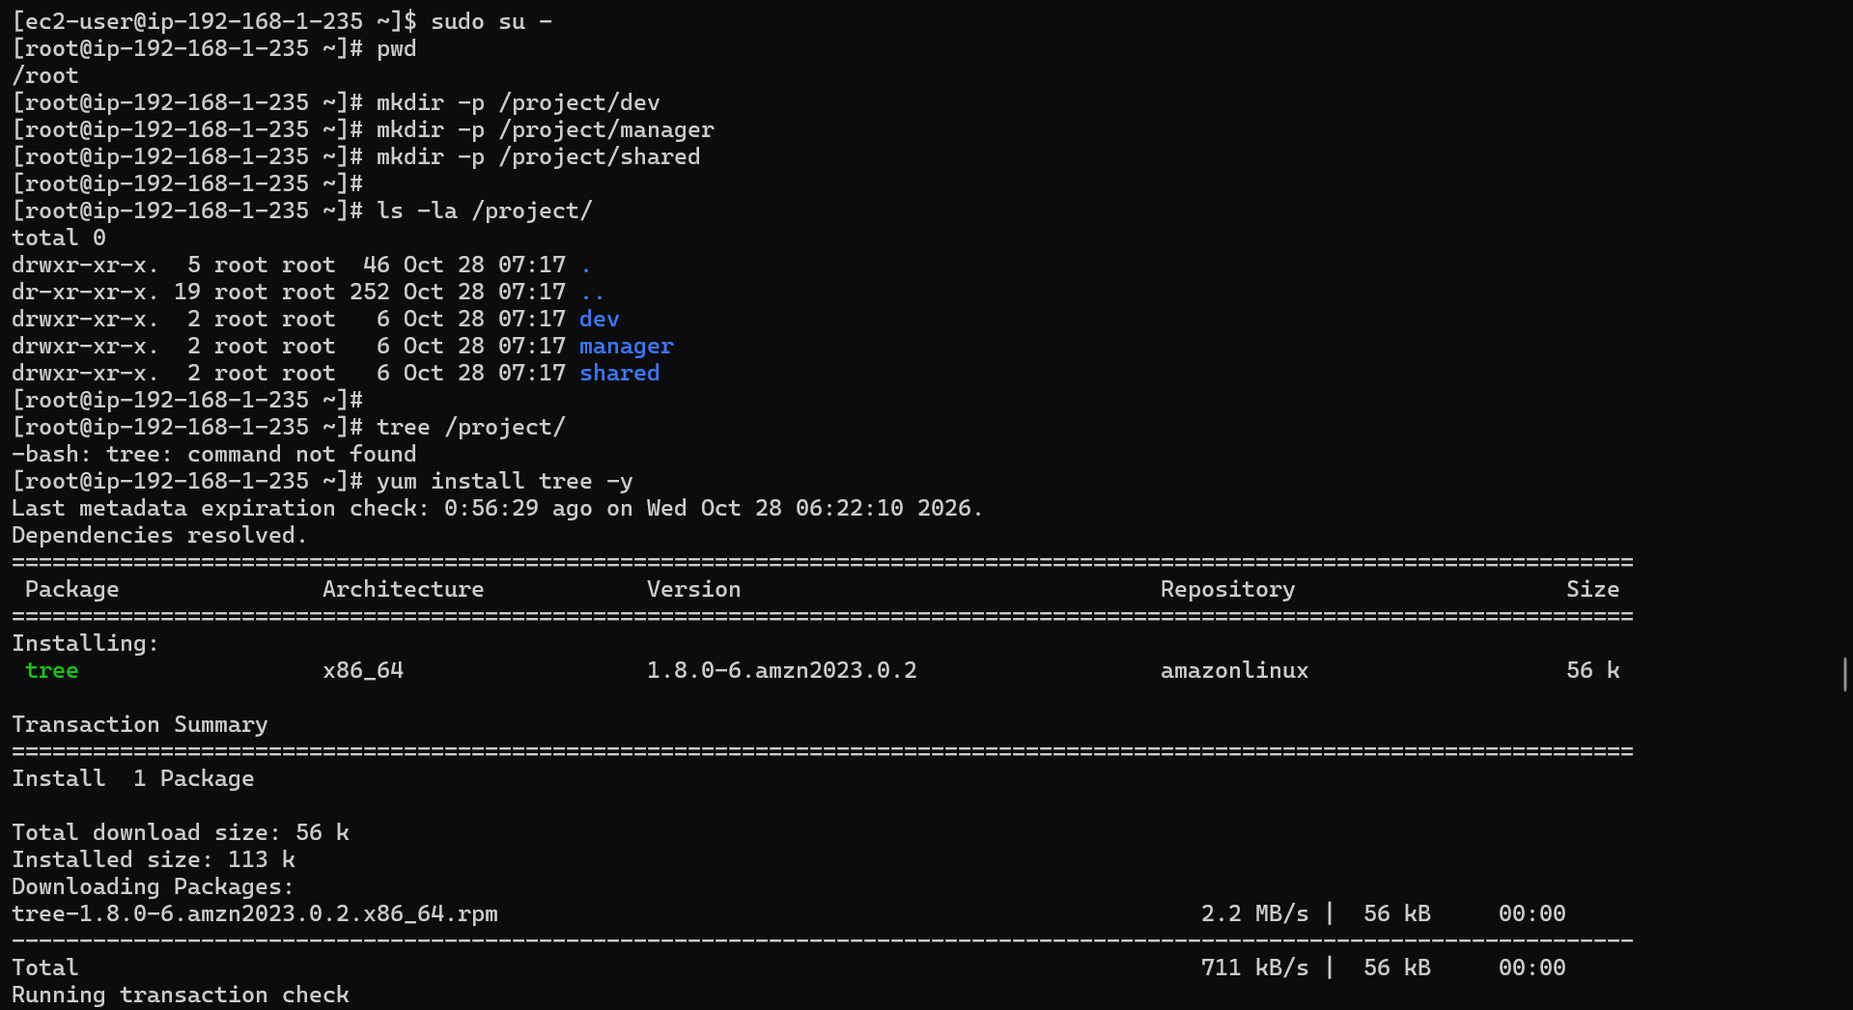
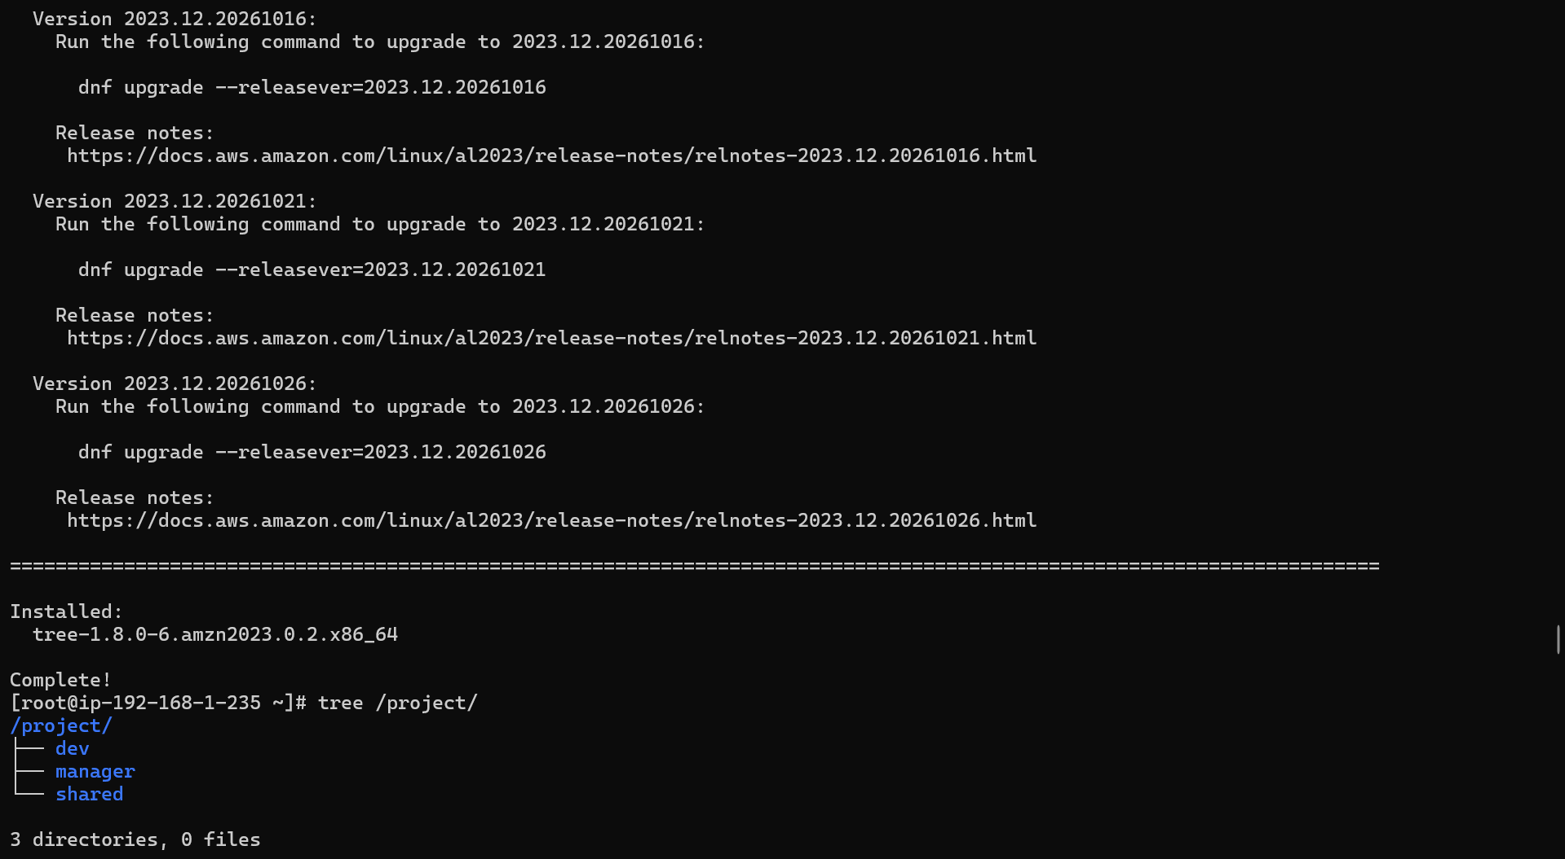

Phase 2 — User, Group & Permission Management
Step 4: Create users and groups

Commands:
# Create groups
groupadd developers
groupadd managers

# Create users
useradd -m -g developers -s /bin/bash alice
useradd -m -g developers -s /bin/bash bob
useradd -m -g managers -s /bin/bash charlie

# Set passwords
echo "alice:Alice@123" | chpasswd
echo "bob:Bob@123" | chpasswd
echo "charlie:Charlie@123" | chpasswd

# Verify users created
cat /etc/passwd | grep -E "alice|bob|charlie"
cat /etc/group | grep -E "developers|managers"

# Check user IDs
id alice
id bob
id charlie

Outputs:
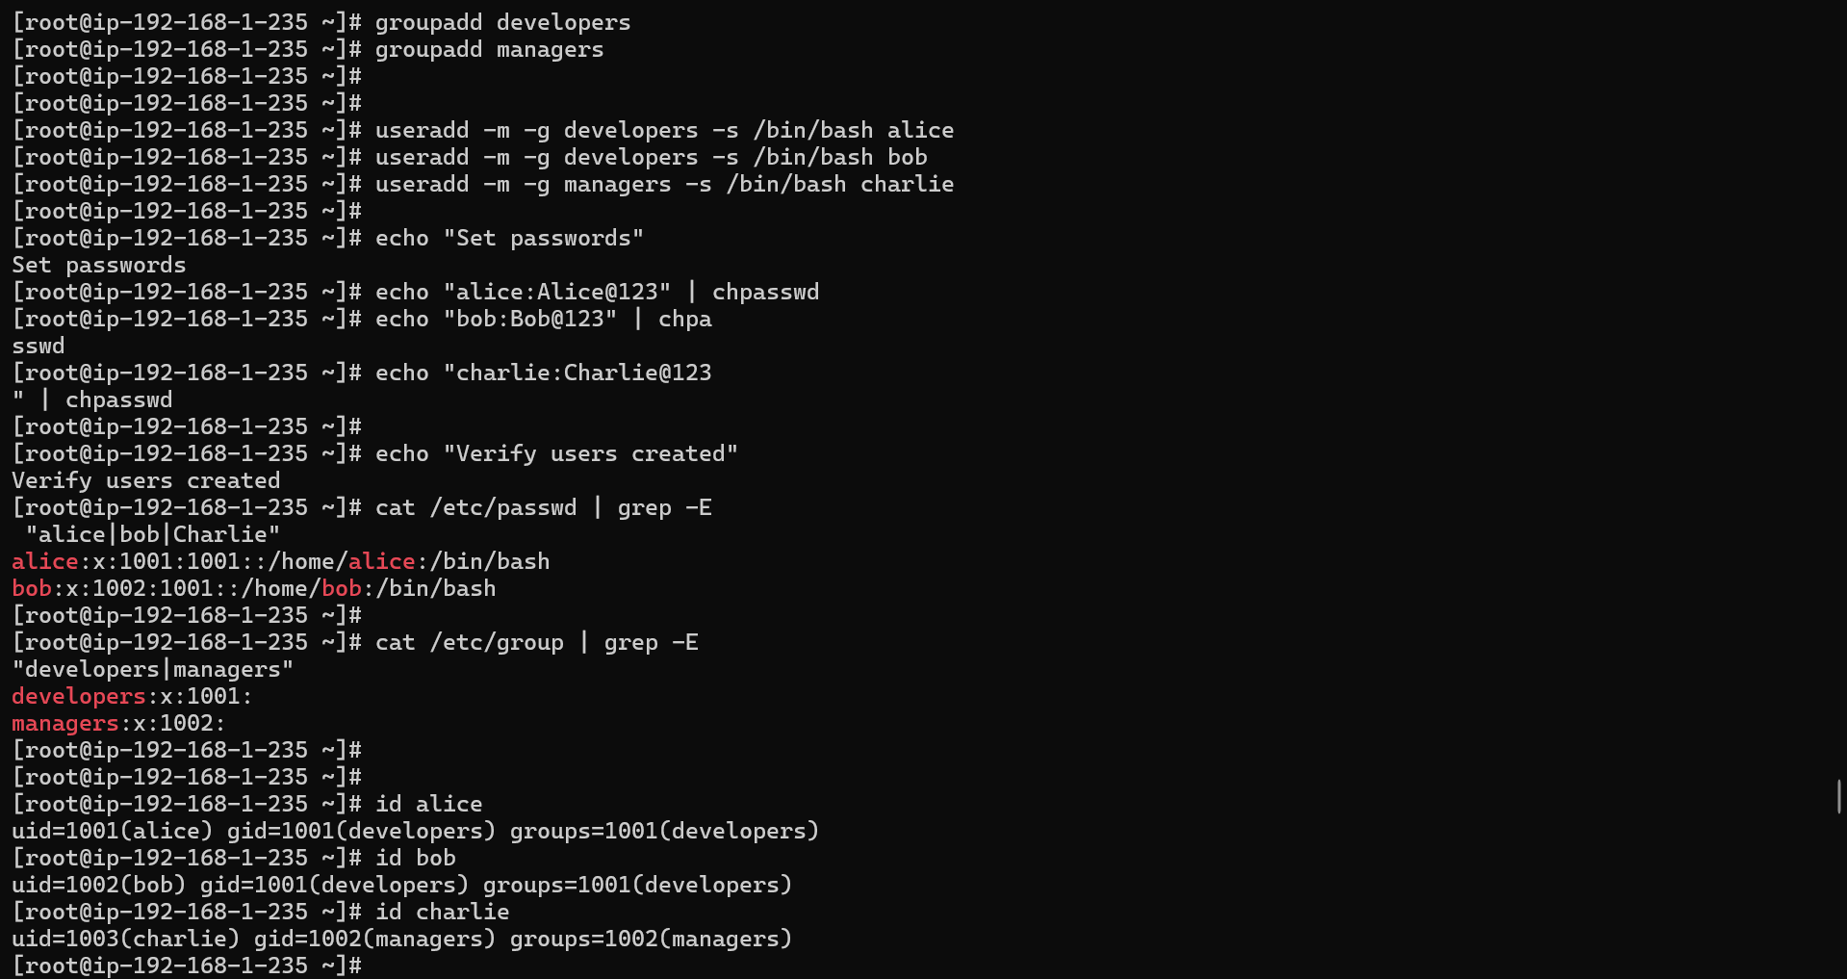
Step 5: Set directory permissions

Commands:
# Set ownership of directories
chown -R root:developers /project/dev
chown -R root:managers /project/manager
chown -R root:root /project/shared

# Set permissions
chmod 770 /project/dev # owner+group: full, others: none
chmod 770 /project/manager # owner+group: full, others: none
chmod 777 /project/shared # everyone: full access

# Verify permissions
ls -la /project/

# Display permissions in detail
stat /project/dev
stat /project/manager
stat /project/shared

Outputs:
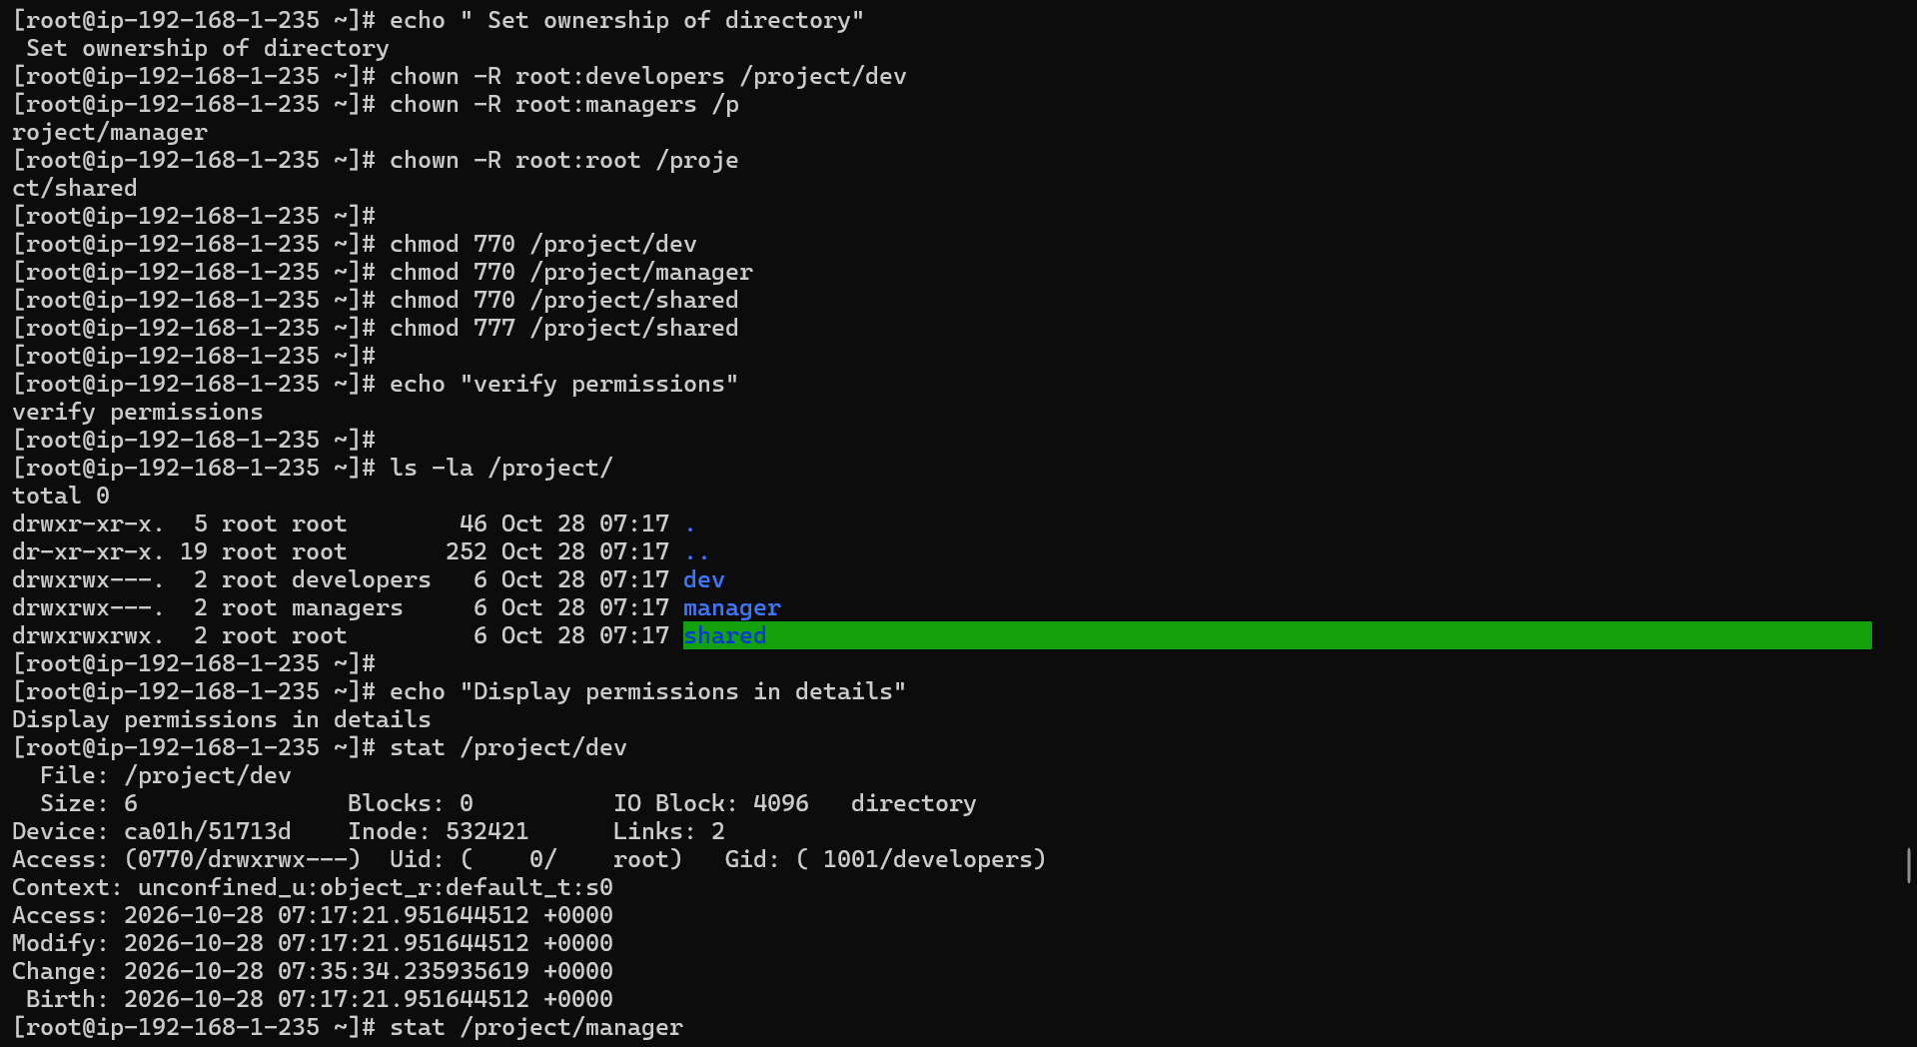
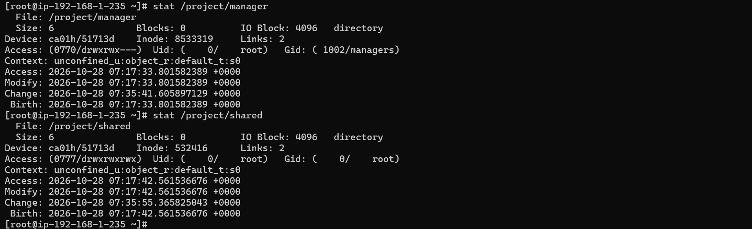

Step 6: Test permissions as each user

Commands:
# Switch to alice (developer)
su - alice
touch /project/dev/alice_file.txt # should succeed
touch /project/manager/alice_file.txt # should FAIL
touch /project/shared/alice_shared.txt # should succeed
exit

# Switch to charlie (manager)
su - charlie
touch /project/manager/charlie_report.txt # should succeed
touch /project/dev/charlie_file.txt # should FAIL
touch /project/shared/charlie_shared.txt # should succeed
exit

Screenshot all permission denied errors and successful operations.

Outputs:
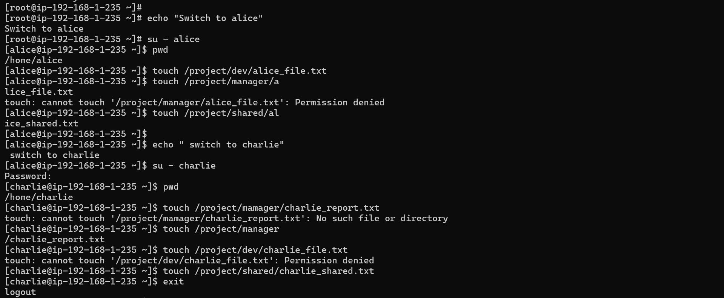
Step 7: Work with ACL (Access Control List)

Commands:
# Give charlie read access to /project/dev without changing group
setfacl -m u:charlie:r-x /project/dev
getfacl /project/dev

# Verify charlie can now read dev directory
su - charlie
ls /project/dev # should now work
touch /project/dev/test.txt # should still FAIL (read only)
exit

Outputs:
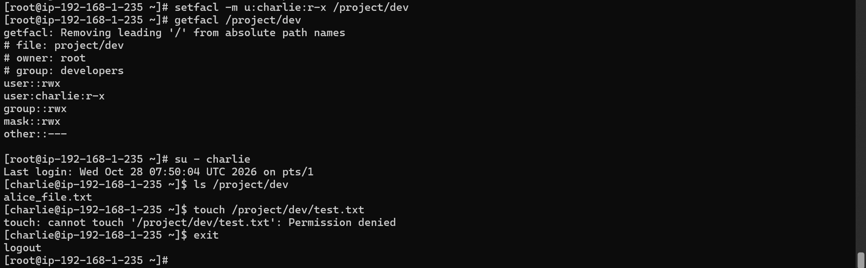

Step 8: Configure password aging

Commands:
# Set password policy for alice
chage -M 90 -m 7 -W 14 alice

# View password aging info
chage -l alice
chage -l bob

# View /etc/shadow for password info (first field is encrypted password)
grep -E "alice|bob|charlie" /etc/shadow

Outputs:
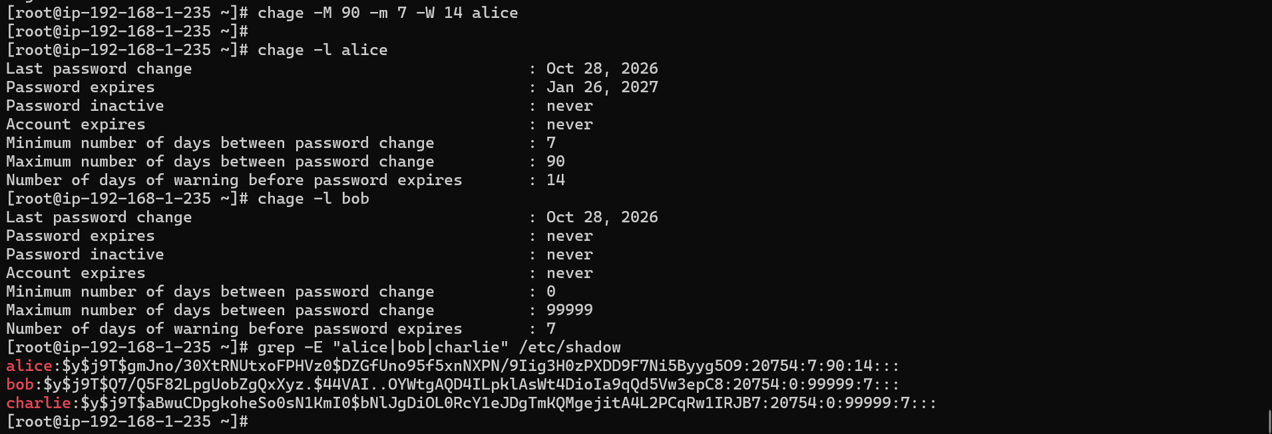

Phase 3 — File Operations & Text Processing
Step 9: Create and manage project files
Commands:
# Create sample files with content
cat > /project/shared/team_members.txt << EOF
alice,developer,alice@company.com,85000
bob,developer,bob@company.com,82000
charlie,manager,charlie@company.com,95000
diana,developer,diana@company.com,80000
eve,manager,eve@company.com,92000
EOF

cat > /project/shared/server_log.txt << EOF
2024-01-15 08:00:01 INFO Server started successfully
2024-01-15 08:05:22 INFO User alice logged in
2024-01-15 08:10:45 ERROR Database connection failed
2024-01-15 08:10:47 INFO Retrying database connection
2024-01-15 08:10:50 INFO Database connection restored
2024-01-15 08:30:11 WARNING High CPU usage detected: 85%
2024-01-15 09:00:00 INFO Backup started
2024-01-15 09:15:00 INFO Backup completed successfully
2024-01-15 09:30:22 ERROR Disk space below 10%
2024-01-15 10:00:01 INFO User bob logged in
EOF

Outputs:
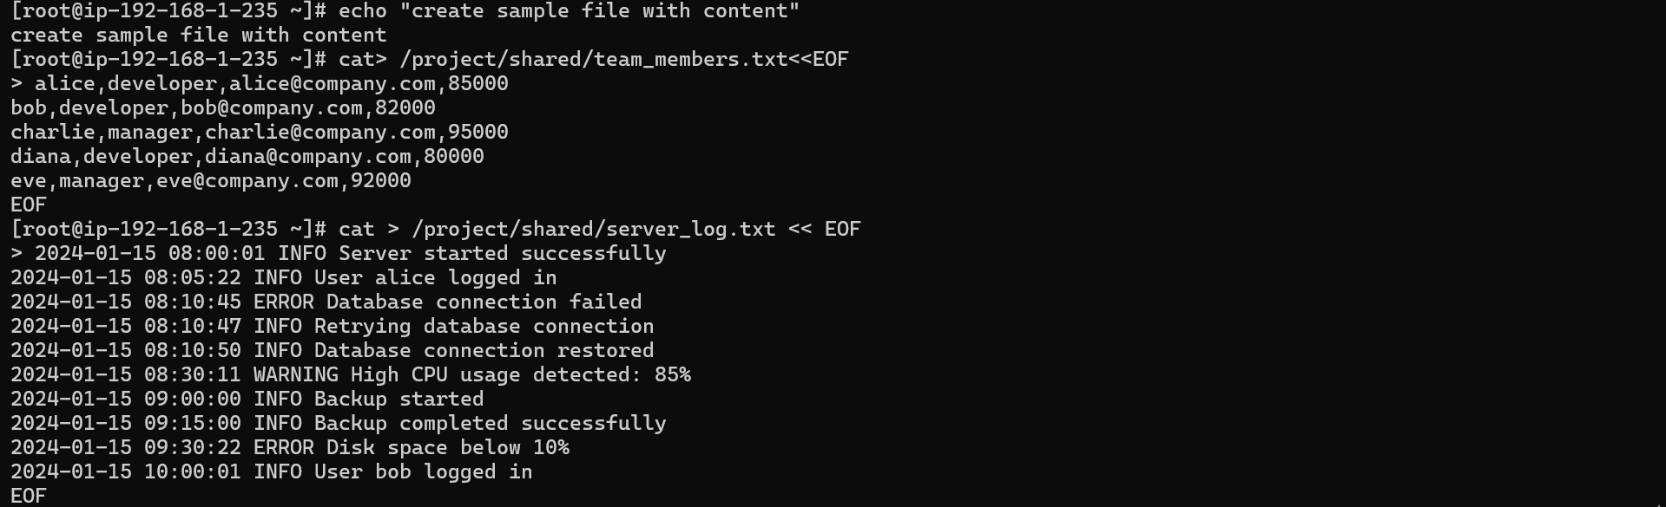
Step 10: Text processing commands Run each command and screenshot the output:

Commands:
# cat - display file
cat /project/shared/team_members.txt

# grep - search for patterns
grep "ERROR" /project/shared/server_log.txt
grep "INFO" /project/shared/server_log.txt
grep -c "ERROR" /project/shared/server_log.txt # count errors

# awk - extract specific fields
awk -F',' '{print $1, $3}' /project/shared/team_members.txt
awk -F',' '{print "Name:", $1, "| Salary:", $4}' /project/shared/team_members.txt

# sort - sort file contents
sort /project/shared/team_members.txt
sort -t',' -k4 -n /project/shared/team_members.txt # sort by salary

# wc - word/line count
wc -l /project/shared/server_log.txt
wc -w /project/shared/team_members.txt

# uniq - find unique lines
cat /project/shared/server_log.txt | grep -o "INFO\|ERROR\|WARNING" | sort | uniq -c

# sed - stream editor
sed 's/ERROR/CRITICAL/g' /project/shared/server_log.txt
sed -n '/ERROR/p' /project/shared/server_log.txt
# pipes and filters combined
cat /project/shared/server_log.txt | grep "ERROR" | awk '{print $1, $2, $5}' | sort

Outputs:
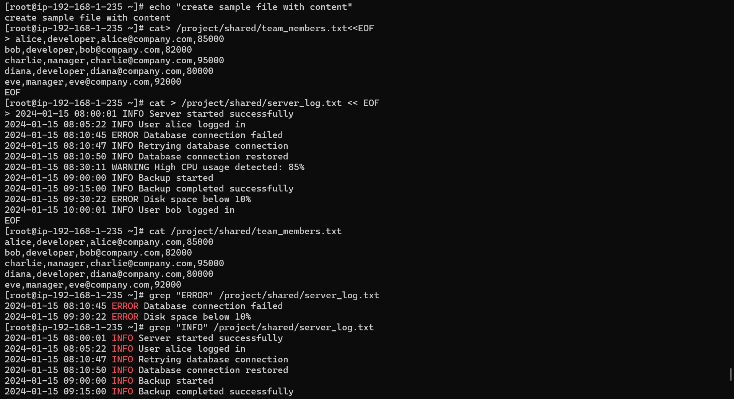

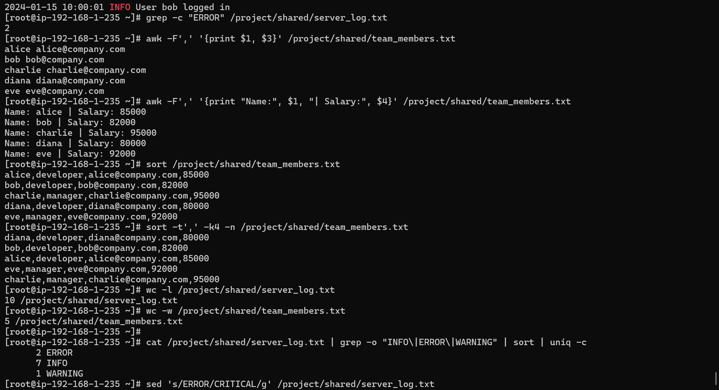
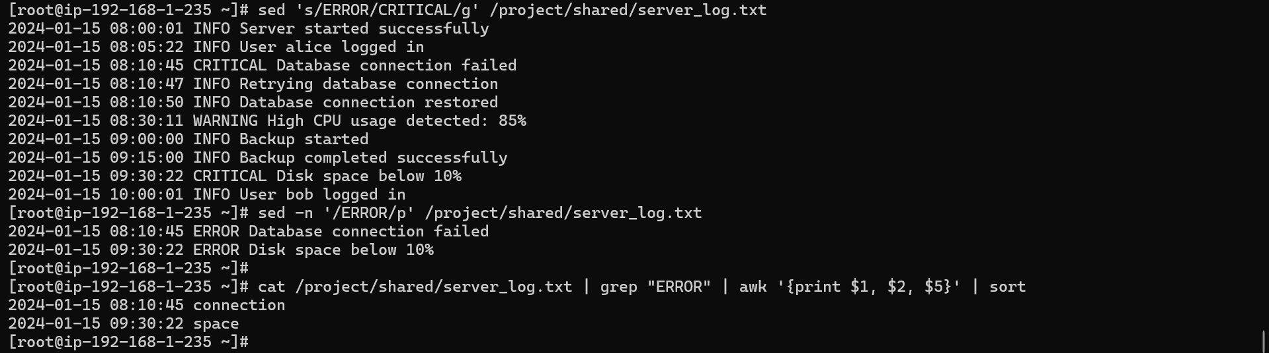

Step 11: Compression and archiving
Commands:
# Copy files to compress
cp /project/shared/team_members.txt /tmp/
cp /project/shared/server_log.txt /tmp/

# gzip compression
gzip /tmp/team_members.txt
ls -lh /tmp/team_members.txt.gz

# gunzip
gunzip /tmp/team_members.txt.gz
ls -lh /tmp/team_members.txt

# tar archiving
tar -cvf /tmp/project_backup.tar /project/shared/
ls -lh /tmp/project_backup.tar

# tar with gzip compression
tar -czvf /tmp/project_backup.tar.gz /project/shared/
ls -lh /tmp/project_backup.tar.gz

# Extract
tar -xzvf /tmp/project_backup.tar.gz -C /tmp/restored/
ls /tmp/restored/project/shared/

Outputs:
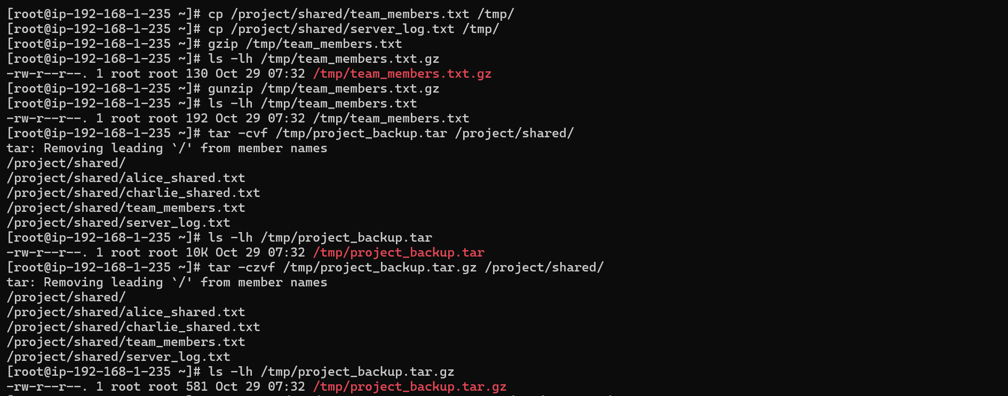
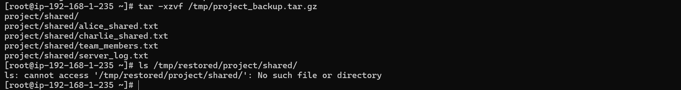

Phase 4 — Process Management & Automation
Step 12: Process management

Commands:
# View running processes
ps aux
ps aux | grep httpd
ps -ef | head -20
# Top - interactive process viewer
top -b -n 1 | head -20 # non-interactive single snapshot

# Install and run a background process for testing
yum install httpd -y # EC2: yum | Ubuntu: apt install apache2 -y
systemctl start httpd
systemctl status httpd
systemctl enable httpd

# Find the process ID
ps aux | grep httpd
pgrep httpd

# Kill and restart
systemctl stop httpd
systemctl status httpd
systemctl start httpd

Outputs:
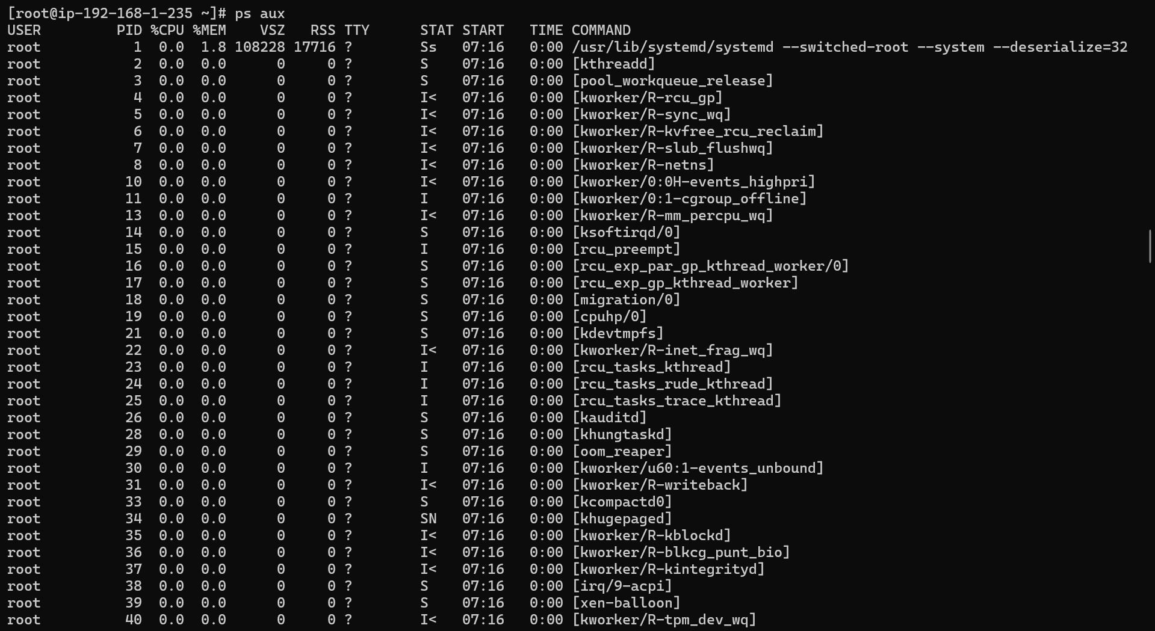
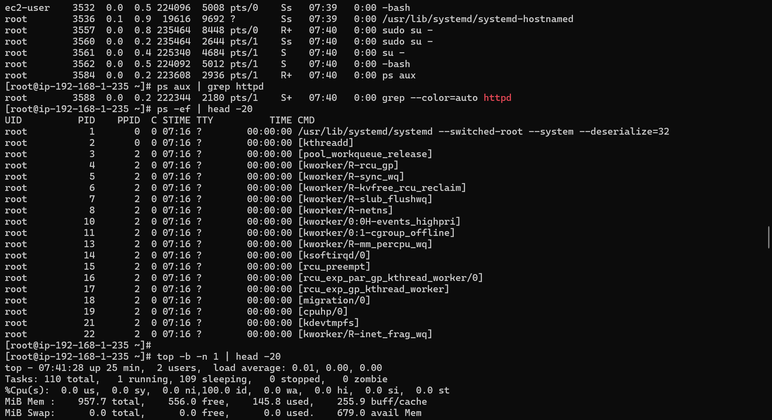
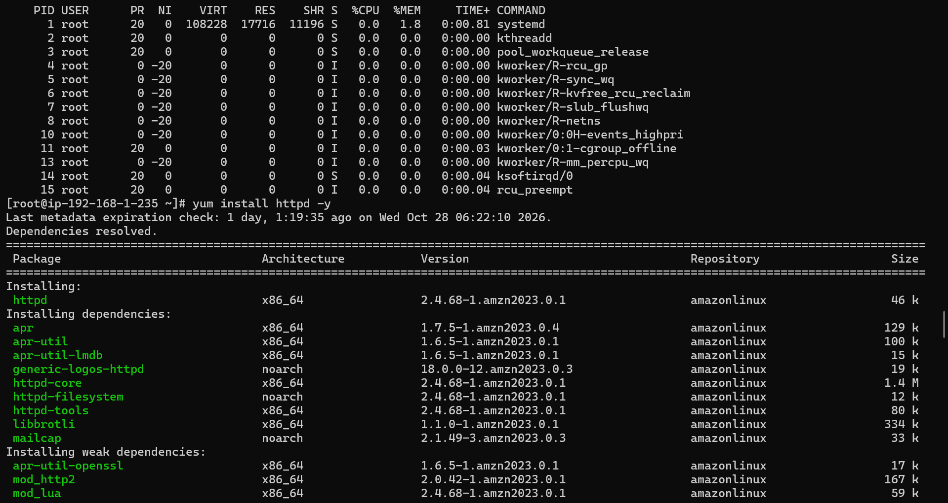
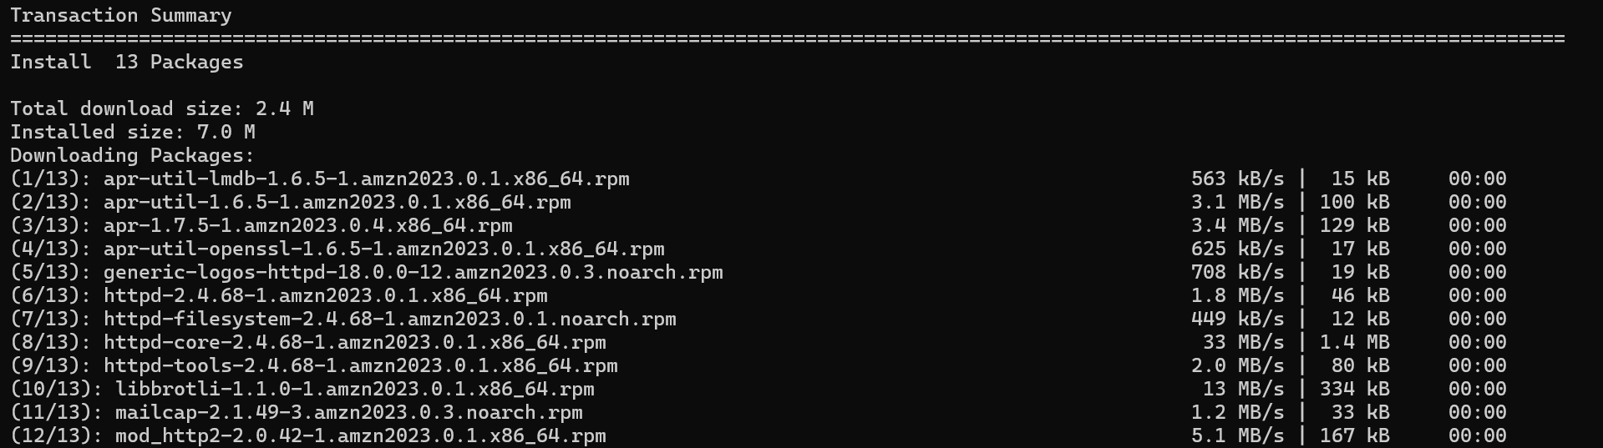
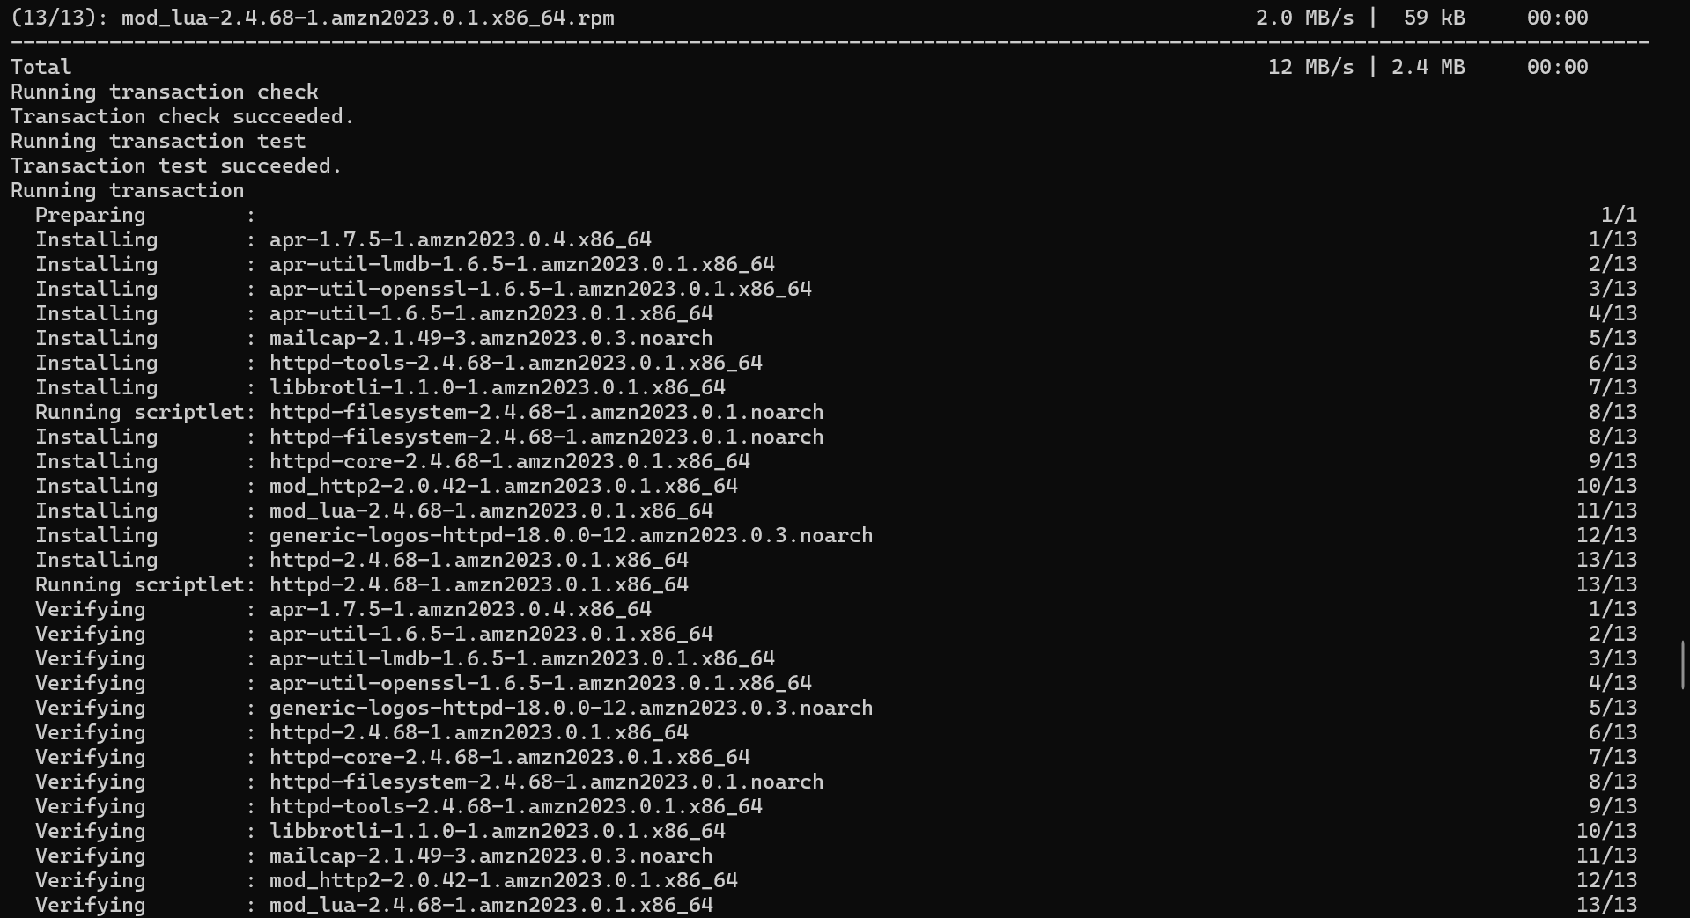
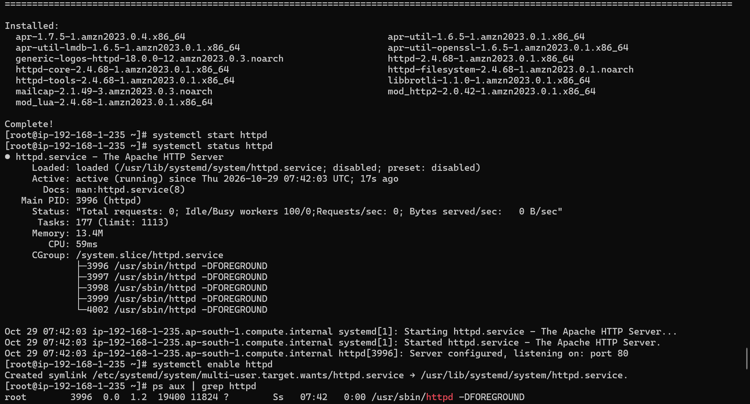
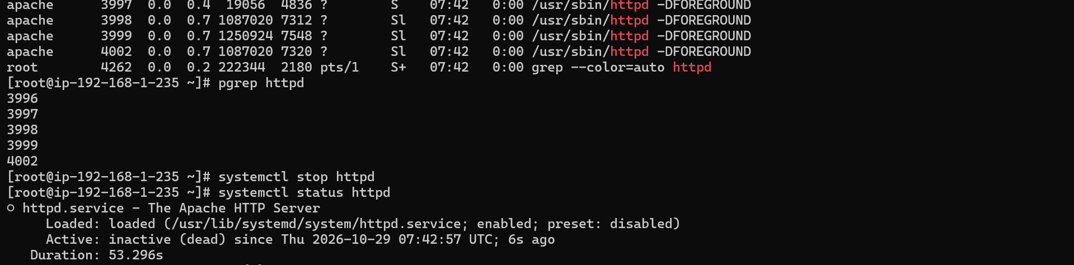
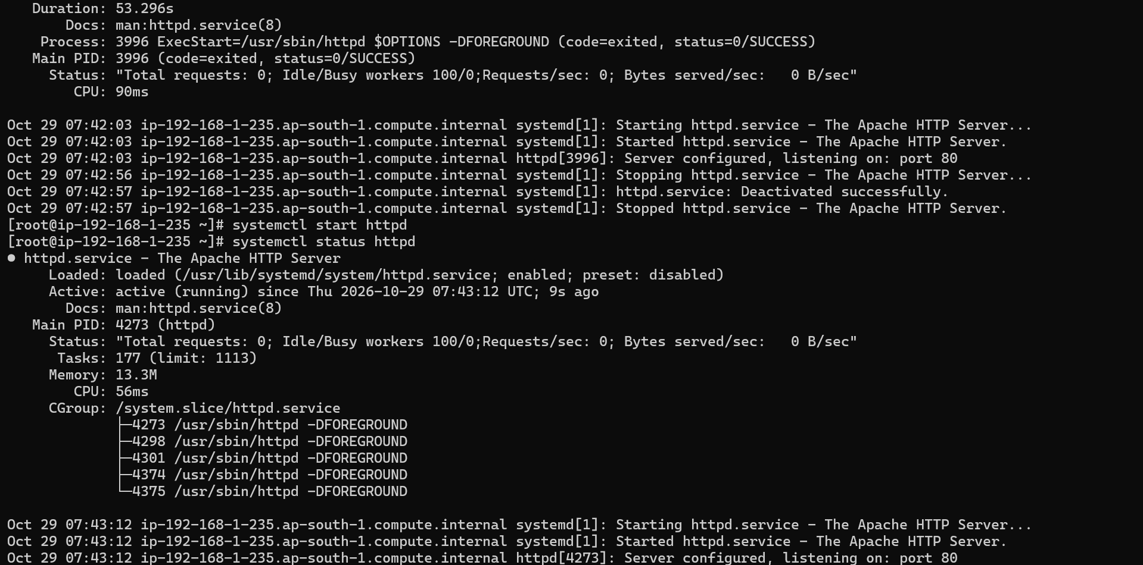

Step 13: Automate a daily system report with crontab

Commands:
# Create the report script
cat > /usr/local/bin/daily_report.sh << 'EOF'
#!/bin/bash

REPORT_FILE="/var/log/daily_report_$(date +%Y%m%d).txt"

echo "=====================================" > $REPORT_FILE
echo "Daily System Report - $(date)" >> $REPORT_FILE
echo "=====================================" >> $REPORT_FILE
echo "" >> $REPORT_FILE

echo "--- System Info ---" >> $REPORT_FILE
hostname >> $REPORT_FILE
uptime >> $REPORT_FILE
echo "" >> $REPORT_FILE

echo "--- Disk Usage ---" >> $REPORT_FILE
df -h >> $REPORT_FILE
echo "" >> $REPORT_FILE

echo "--- Memory Usage ---" >> $REPORT_FILE
free -h >> $REPORT_FILE
echo "" >> $REPORT_FILE

echo "--- Top 5 CPU Processes ---" >> $REPORT_FILE
ps aux --sort=-%cpu | head -6 >> $REPORT_FILE
echo "" >> $REPORT_FILE

echo "--- Logged In Users ---" >> $REPORT_FILE
who >> $REPORT_FILE
echo "" >> $REPORT_FILE

echo "--- Recent Error Logs ---" >> $REPORT_FILE
tail -20 /var/log/messages 2>/dev/null || tail -20 /var/log/syslog 2>/dev/null >> $REPORT_FILE

echo "Report saved to: $REPORT_FILE"
EOF

# Make it executable
chmod +x /usr/local/bin/daily_report.sh

# Test run the script manually
/usr/local/bin/daily_report.sh
cat /var/log/daily_report_$(date +%Y%m%d).txt

# Schedule with crontab (run every day at 6 AM)
crontab -e
# Add this line:
# 0 6 * * * /usr/local/bin/daily_report.sh

# Verify crontab
crontab -l

Outputs:
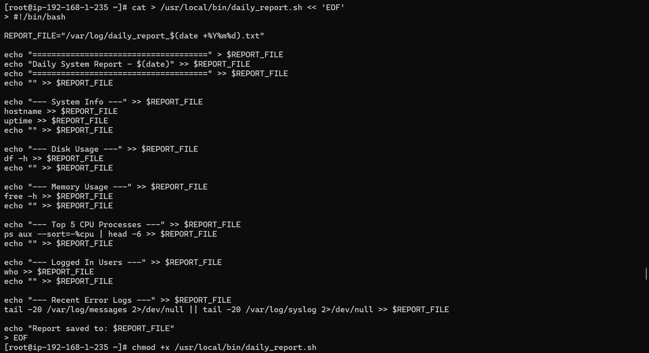
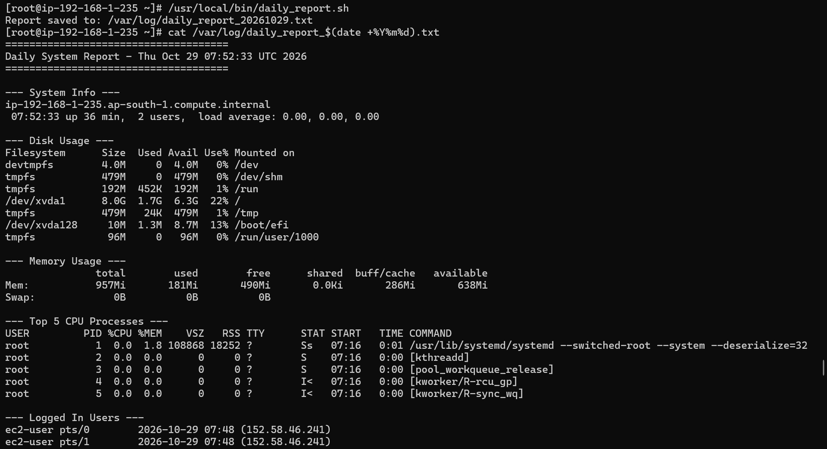
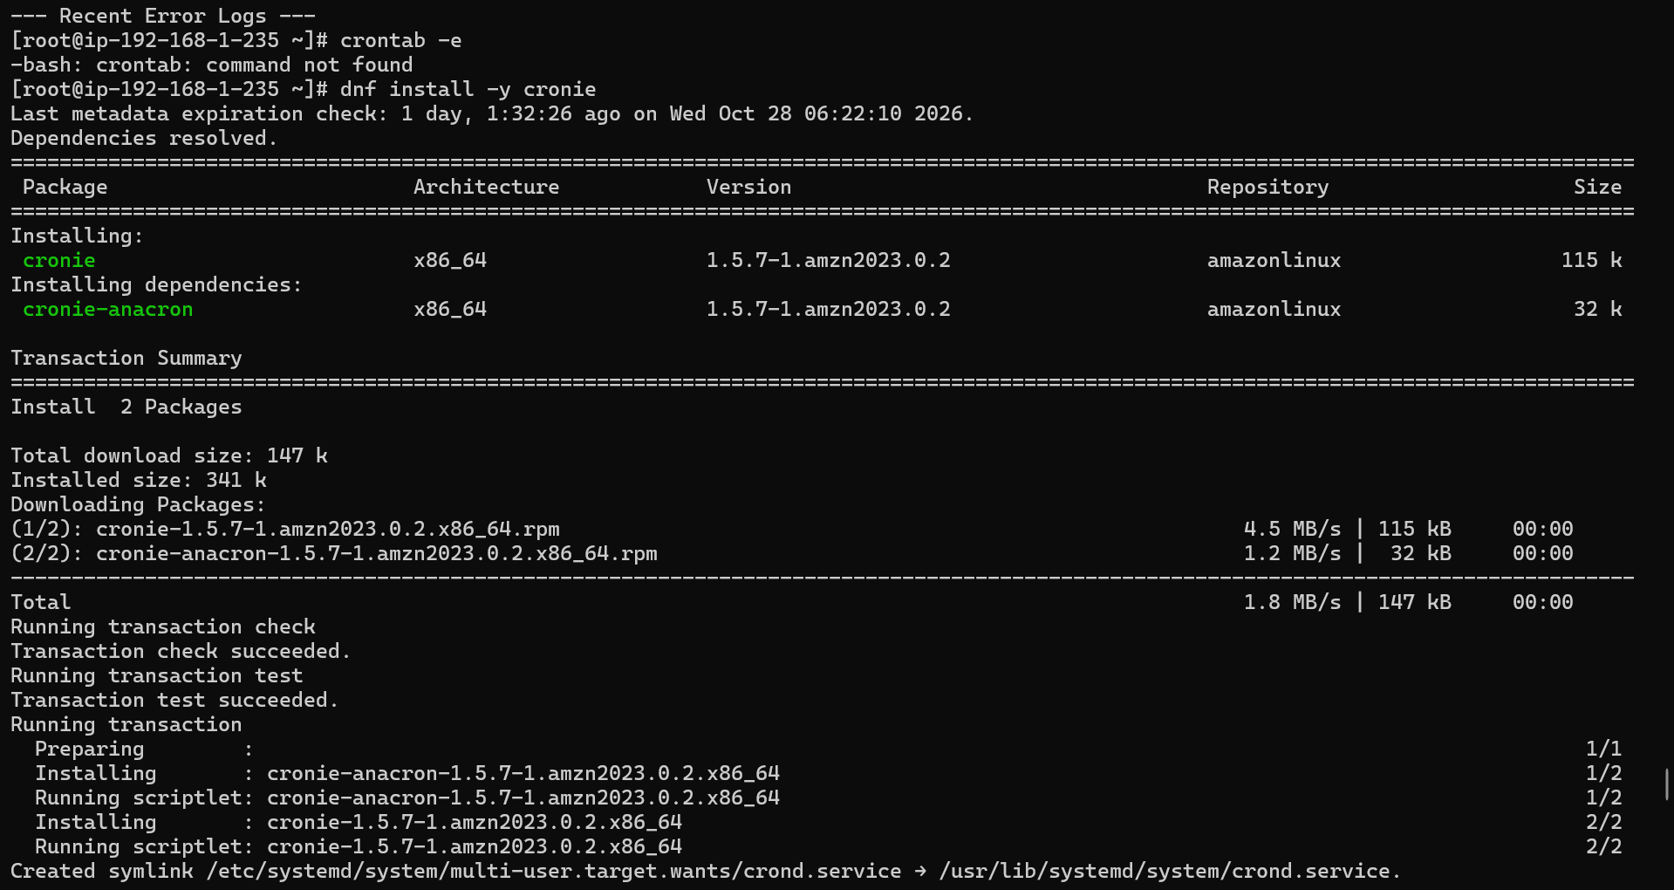

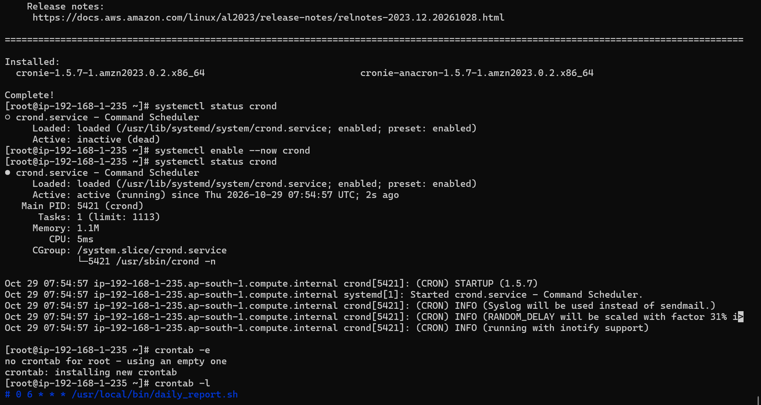

Step 14: Environment variables

Commands:
# View current environment variables
env
printenv PATH
printenv HOME

# Create custom environment variables
export PROJECT_DIR="/project"
export ADMIN_EMAIL="admin@company.com"
export SERVER_ENV="production"

# Verify
echo $PROJECT_DIR
echo $ADMIN_EMAIL
echo $SERVER_ENV

# Make permanent (add to profile)
echo 'export PROJECT_DIR="/project"' >> ~/.bashrc
echo 'export ADMIN_EMAIL="admin@company.com"' >> ~/.bashrc
source ~/.bashrc

# Verify after reload
echo $PROJECT_DIR

Outputs:
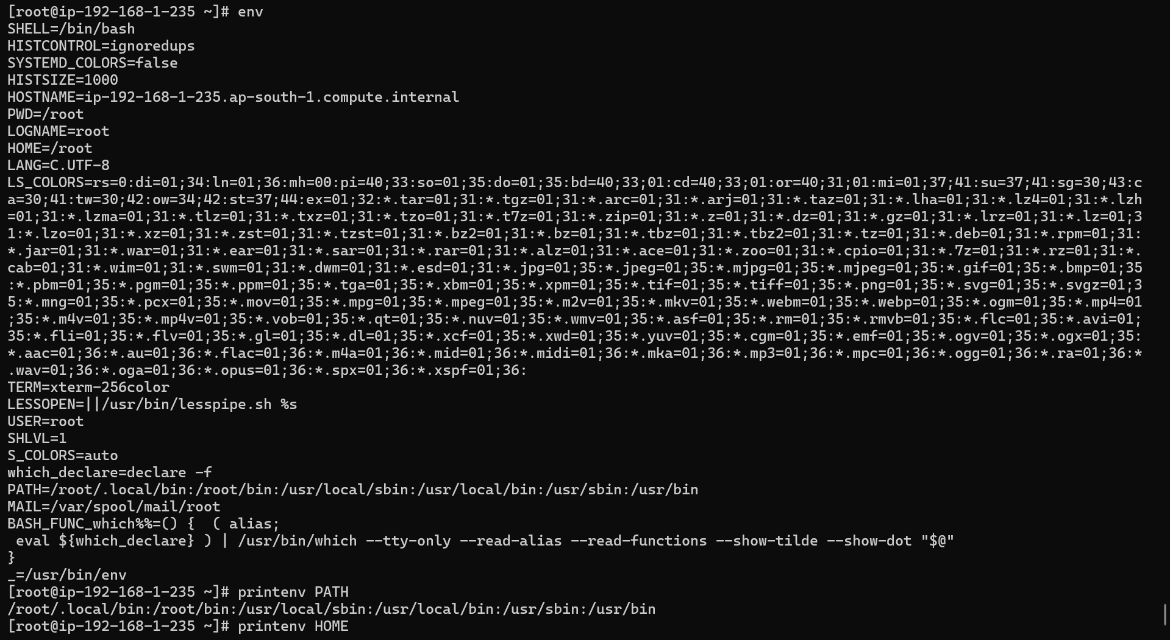
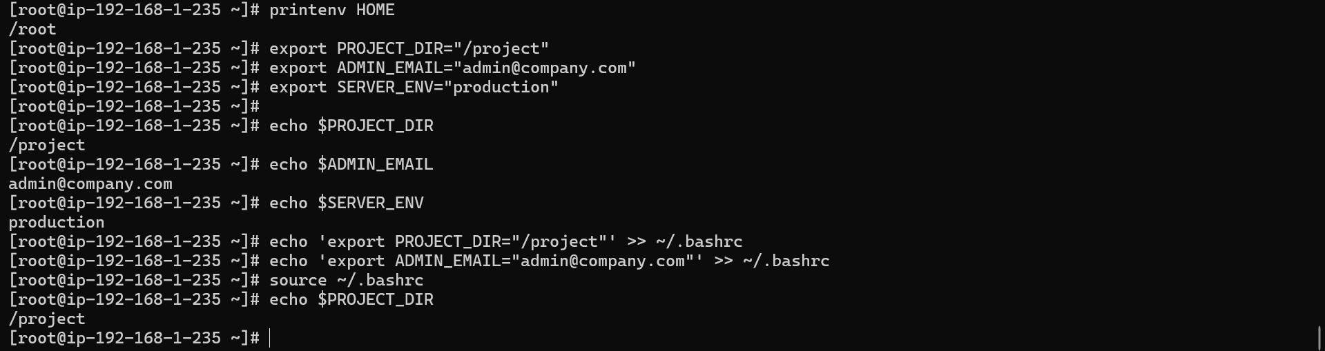

Step 15: Final system verification

Commands:
# Show all users created
cat /etc/passwd | grep -E "alice|bob|charlie"

# Show all groups
cat /etc/group | grep -E "developers|managers"

# Show directory permissions
ls -la /project/

# Show crontab
crontab -l

# Show running services
systemctl list-units --type=service --state=running

# Show disk usage
df -h

# Show memory
free -h

# Show system uptime
uptime

# Show who is logged in
who
w
last | head -10

Outputs:
