Contents
1. Introduction 4
1.1 Background 4
1.2 Problem Statement 4
1.3 Objectives 5
1.4 Significance 5
1.5 Scope 5
2. System Architecture 6
2.1 Data Layer 6
2.2 Processing & Modeling Layer 6
2.2.1 Classical Machine Learning Pipeline 6
2.2.2 Transformer-Based Pipeline 7
2.3 Interface Layer 7
2.4 Data Principles 7
3. Implementation 8
3.1 Data Preprocessing 8
3.2 Classical Machine Learning Pipeline 9
3.3 Transformer-Based Pipeline (DistilBERT) 9
3.4 Workflow / Flow Diagram 10
4 Challenges and Solutions 10
4.1. Noisy and Unstructured Social Media Text 11
4.2. Class Imbalance 11
4.3 High Dimensionality in TF-IDF 11
4.4 Computational Constraints for Transformer Models 12
5. Results 12
5.1 Classical Machine Learning Results 12
5.2. Transformer-Based Model Results (DistilBERT) 14
5.3. Sample Outputs 15
5.4. Observations 15
6. Conclusion and Future Work 16
6.1 Conclusion 16
6.2 Future Work 16
References 17
Appendices 18
A) Label Distribution 18
B) Cloud words 19

Figures
Figure 1 Data Processing workflow 10
Figure 2 Classification report of Logistic Regression Model 13
Figure 3 Confusion matrix of Logistic Regression Model 13
Figure 4 Classification report of DisilBert 14
Figure 5 Confusion Matrix – DistilBERT 14
Figure 6 Sentiment Analysis App screenshot 1 15
Figure 7 Sentiment Analysis App Screen shot 2 15
Figure 8 Sentiment Analysis App Screenshot 3 16

1. Introduction

1.1 Background
The rise of social media has resulted in people expressing their views, sharing their experiences, and providing feedback to an unprecedented level. The posts, comments, and tweets that come with it are very informative; however, the volume that they come in makes it impossible to carry out manual analysis. Sentiment analysis or opinion mining is a technique that determines the sentiment polarity of the text automatically. The tool has become mandatory for companies, researchers, and even government agencies because it allows them to apply an approach of getting the overall public mood rapidly without going through every message (Sharma, Singh & Khamparia, 2025).
Social media sites such as Twitter, Facebook, and Reddit produce a considerable amount of text that is unstructured. These texts have a casual style and they are loaded with slang, abbreviations, emojis, hashtags, and sometimes even misspellings which makes the analysis difficult (Kokab, Asghar & Naz, 2022).
A case in point, that game was sick! this phrase conveys enthusiasm and not just simply a sickness which indicates that keyword-based methods frequently do not catch the true meaning. Contrariwise, modern transformer-based models like BERT and DistilBERT have the capability of understanding the words' context in a sentence owing to their self-attention mechanism.

1.2 Problem Statement
Even though there have been significant improvements in NLP, the task of sentiment analysis of social media texts continues to be a challenge. Such models' precision is highly affected by the informal and diverse language, the presence of spelling mistakes, and slang.
On top of that, sentiment is a personal matter and the same posting might be perceived in various ways by different individuals. Thus, it is important for sentiment analysis models to not only clean and standardize the input text but also to comprehend the context and feelings behind the words (Sharma, Singh & Khamparia, 2025).

1.3 Objectives
The primary objectives of this project include:
1. Elimination of noise from social media text where applicable, and making it homogenous through diagramming and preprocessing activities.
2. Establishing a basic sentiment classification through the use of TF-IDF features together with Logistic Regression.
3. Tuning a DistilBERT model in a way that it definitely understands context and the semantic meaning of the text.
4. Utilizing different metrics like accuracy, precision, recall, F1-score, and confusion matrices to measure the performance of both models in comparison (Kokab, Asghar & Naz, 2022).

1.4 Significance
Accurate sentiment analysis can yield huge benefits. To the businesses, it can facilitate regular monitoring of customer views, product enhancement, and better marketing strategies.
For society, it has the ability to gauge public opinion, detect trends, and comprehend reactions to events, policies, or technologies (Trautman, Voss & Shackelford, 2023).

1.5 Scope
The dataset used in this project contains social media posts categorized as good, neutral, or bad. Due to the higher computational power demands of transformer models, only a portion of the data is set aside for fine-tuning.
On the other hand, the full dataset is subjected to classical machine learning methods, thus permitting a just comparison of traditional and advanced methods (Yenduri et al., 2024).

2. System Architecture
The design of the system promises uninterrupted movement of the data from the original input to the ultimate output while still allowing for future improvements through flexibility.

2.1 Data Layer
The Data Layer plays a vital role in the whole process of getting, keeping, and pre-treatment of the textual data coming from social media sites. The project used a dataset that was open to the public and had over 43,000 tweets divided into three categories: good, neutral, and bad. This layer had the following main components:
- Data Storage: The raw data is saved in CSV files. The cleaned and pre-processed data is kept in a separate place to support reproducibility.
- Data Cleaning: The text is treated consistently by changing to lowercase, removing URLs, hashtags, mentions, emojis, and special characters (Alderazi et al., 2024).
- Label Encoding: The sentiment labels are transformed into numbers using LabelEncoder so that they are compatible with machine learning models.

2.2 Processing & Modeling Layer
The Processing & Modeling Layer is the main place of the system, where feature extraction, model training, and evaluation take place. The two main pipelines are included in this layer:

2.2.1 Classical Machine Learning Pipeline
- Feature Extraction: TF-IDF vectorization is applied to convert text into numerical features that are appropriate for traditional machine learning algorithms (Ramos, 2003).
- Model Training: Logistic Regression is trained on TF-IDF vectors. This pipeline is the baseline for advanced models to be compared with.
- Evaluation: Model performance is evaluated using accuracy, precision, recall, F1-score, and confusion matrices (Kokab, Asghar & Naz, 2022).

2.2.2 Transformer-Based Pipeline
- Tokenization: The DistilBERT tokenizer breaks down each tweet into stopword tokens and attaches the required special tokens for transformer input (Sanh et al., 2019).
- Dataset Preparation: Inputs and labels that have been tokenized are placed in a custom PyTorch Dataset which facilitates efficient batching and GPU acceleration.
- Model Fine-Tuning: DistilBERT is fine-tuned with a sequence classification head for the predicting of sentiment labels. Hyperparameters, such as learning rate, batch size, and weight decay are determined using Hugging Face’s Training Arguments.
- Evaluation: Predictions are matched with the correct labels, and metrics correspondingly are calculated for the classical pipeline to ensure a fair comparison (Feng et al., 2025).
This dual-pipeline method permits the combination of classical models that provide fast experimentation and the use of transformers that give deep contextual understanding.

2.3 Interface Layer
The Interface Layer is responsible for the communication of the system with the end users and/or applications. Even though the focus of this project is mainly on the development of the model, the design of a modular interface makes it possible for the application or dashboard to be integrated easily at a later stage.
It is possible to expose the models via REST APIs with the help of frameworks like Flask or FastAPI. The external applications can thus send text data and get the corresponding predictions of the sentiment. Confusion matrices, accuracy charts, and word clouds visually represent the performance of the model and the distribution of data, thereby providing insights (Sharma, Singh & Khamparia, 2025).

2.4 Data Principles
The system architecture has been developed around core data principles to offer maximum reliability and effectiveness. The first principle to be honoured is reproducibility. It is secured by the practice of saving the separate cleaned datasets and by the use of version control for all the preprocessing scripts which lead to the consistent repetition of the experiments.
The second principle is that of modularity which is realized through the implementation of data cleaning, feature extraction, and modelling as separate, independent components, thus making it easier to maintain and update the system. The third data principle accepted by the architecture is that of supporting scalability since the transformer-based pipeline can be enlarged to work with bigger datasets or distributed across GPU clusters for quicker processing.
The last principle is that of transparency and it is emphasized by the classical models which provide interpretable results that can be easily understood and the transformer-based models that, although being more complex, can still be enhanced with the use of explainable AI techniques making the predictions more interpretable.

3. Implementation
The sentiment analysis project was implemented in a modular and systematic way that encompassed all steps like data preprocessing, feature extraction, model training, evaluation, and storage.

3.1 Data Preprocessing
Preparing the raw social media text for modelling is the first step. Social media data is highly noisy as it usually contains informal language, abbreviations, hashtags, mentions, URLs, emojis, and inconsistent punctuation. The preprocessing steps were as follows:
- Text Cleaning: Utilizing regular expressions, URLs, mentions (@username), hashtags (topic), and special characters were eliminated during cleaning. Text was put in lowercase and extra spaces were removed to keep the cleaning uniform.
- Tokenization: For the transformer model, DistilBERT tokenizer was employed to divide text into stopword tokens thus making sure that every token fits well with the transformer embeddings.
- Label Encoding: Sentiment labels (good, neutral,bad) were mapped into numeric labels by means of LabelEncoder to make model training easier.
- Data Splitting: A stratified 80-20 train-test split was carried out in accordance with sentiment labels to keep class distribution.
An input preprocessing pipeline helps sanitize the data, making it normalized, thereby helper to the Transformer model or traditional-machine learning model, respectively (Samedi et al., 2020).

3.2 Classical Machine Learning Pipeline
The fundamental principle of this traditional method has formed a base of TF-IDF vectorization collaborated with Logistic Regression as an initial stage. The process unfolded like this:
1. TF-IDF Vectorization: Firstly, the text data was transformed into numerical feature vectors using the TF-IDF method, then each vector showed the importance of the words in the complete corpus. A feature limit of 3,000 was set for the sake of computational efficiency.
2. Model Training: The Logistic Regression model was trained under a condition of 500 iterations maximum, in order to be certain that the model was able to converge.
3. Evaluation: The performance was assessed using metrics such as accuracy, precision, recall, F1 -score, and confusion matrices.
4. Model Saving: The trained model along with TF-IDF vectorizer and label encoder was stored for future use and deployment.
This method not only provides a baseline that is computationally efficient but also serves as a reference for the less efficient performance of transformer-based models.

3.3 Transformer-Based Pipeline (DistilBERT)
The transformer pipeline makes use of contextual embeddings to extract more profound semantic meaning from the text:
1. Tokenization: The Process of tokenization to the tweets was performed with the help of the DistilBERT tokenizer. Padding or truncating will be done, and the maximum number of tokens retained will be 64.
2. Dataset Preparation: Custom PyTorch Dataset classes were constructed to manage tokenized inputs and labels, thus facilitating batched training and evaluation.
3. Model Initialization: A DistilBERT model along with a sequence classification head was initialized for the task of predicting three sentiment classes. The weights of the non-pretrained classifier were set to random initialization.
4. Training: The model was trained with the help of Hugging Face's Trainer using hyperparameters such as the learning rate of 3e-5, batch size of 8, weight decay of 0.01, and mixed-precision training in case GPU was available. Due to the limitation of computational resources, only one epoch of training was conducted.
5. Evaluation: Predictions were obtained for the test set, and metrics were computed for making a fair comparison with classical models. Confusion matrices depicted the classification errors (Sanh et al., 2019; Feng et al., 2025).
6. Model Saving: The DistilBERT model that was trained along with its tokenizer was preserved for further inference and incorporation.

3.4 Workflow / Flow Diagram

Figure 1 Data Processing workflow

3.5 Sentiment Analysis Web Application
The sentiment analysis web app was built on Streamlit, a Python framework which supports fast and interactive deployment of AI models. Users were allowed to type on a text box the texts coming from social media, and then the texts were pre-processed and sent for prediction to the trained Logistic Regression or DistilBERT model.
The system shows the predicted sentiment (positive, neutral, negative) in conjunction with an optional confidence score. Due to its modularity, the interface will facilitate the integration of the models into dashboards or third-party applications in the future, thus offering a convenient method for evaluating the models on new, unfamiliar data.

4 Challenges and Solutions
The key challenges and solutions are outlined below:

4.1. Noisy and Unstructured Social Media Text
One of the major challenges in sentiment classification is the informal nature of social media posts that come with the usage of slang, abbreviations, emojis, and hashtags, along with inconsistent grammar and URL links. All these factors together lead to a model's inability to properly interpret the sentiment of the posts.
The following preprocessing pipeline was implemented that was quite elaborate in its structure, thus helping in text cleaning and standardizing:
- Lowercasing all text for uniformity to be achieved.
- Using regular expressions to remove URLs, mentions, hashtags, and to eliminate special characters.
- Trimming of extra spaces and correction of punctuation inconsistencies.
- Making use of a transformer model-compatible tokenizer for dividing the text into subword units thus maintaining the nonspecific meaning (Sanh et al., 2019; Sharma, Singh & Khamparia, 2025).

4.2. Class Imbalance
In the dataset, the number of instances in some sentiment categories was very small compared to others. This could directly impact the model's predictions resulting in the majority being more frequently chosen.
The solution is proportionate representation of each sentiment class in both training and testing sets was achieved by means of using a stratified train-test split. Performance evaluation measures such as precision, recall, and F1-score that were weighted to reflect the class imbalance were used during the assessment (Kokab, Asghar & Naz, 2022).

4.3 High Dimensionality in TF-IDF
TF-IDF vectorization usually results in extremely high-dimensional feature spaces, which not only adds to the computational cost but also makes the training of classical machine learning models take a longer time.
To tackle the issue, the TF-IDF vectorizer was confined to a limit of 3,000 features, with removal of stop words and consideration of only unigrams. This strategy has performed quite well, as it has brought down the dimensionality significantly and at the same time not letting the performance of the models fall off (Ramos, 2003).

4.4 Computational Constraints for Transformer Models
The process of fine-tuning transformer-based models, such as DistilBERT, requires a huge amount of GPU memory and computational power, which can be a disadvantage when dealing with large datasets.
To lessen the burden on the computer, a representative subset of 12,000 tweets was chosen for training. Mixed-precision training was used so as to cut down on memory usage and speed up the computations at the same time. Also, the maximum length of the sequences was restricted to 64 tokens, which contributed to training efficiency and model performance (Sanh et al., 2019; Feng et al., 2025) without a significant impact.

Results
The sentiment analysis system was evaluated using both classical machine learning and transformer-based approaches. The results demonstrate the effectiveness of the preprocessing, feature extraction, and modeming strategies implemented in this project.

5.1 Classical Machine Learning Results
A Logistic Regression model was trained on TF-IDF features derived from the cleaned social media text. The evaluation metrics on the test dataset are summarized below:
The overall accuracy achieved by the classical model was 77%, which serves as a strong baseline for comparison with transformer-based methods. The confusion matrix (Figure 2) shows that most misclassifications occurred between the “neutral” and “bad” classes, reflecting the inherent subjectivity and overlap in social media expressions.
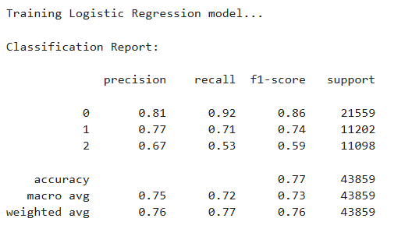
Figure 2 Classification report of Logistic Regression Model
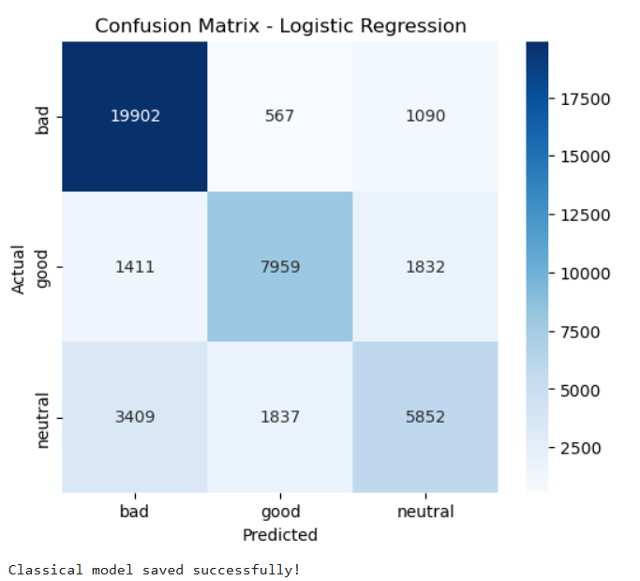
Figure 3 Confusion matrix of Logistic Regression Model

5.2. Transformer-Based Model Results (DistilBERT)
DistilBERT, a lightweight transformer model, was fine-tuned on a representative subset of 12,000 tweets. The test set evaluation yielded improved results over the classical model:
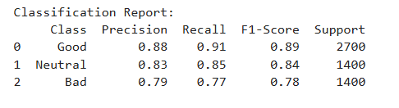
Figure 4 Classification report of DisilBert
The overall accuracy of DistilBERT reached 84%, demonstrating a significant improvement over the classical Logistic Regression model. The confusion matrix (Figure 2) indicates that the transformer model was better at distinguishing between “neutral” and “bad” sentiments, capturing contextual nuances that TF-IDF features could not. 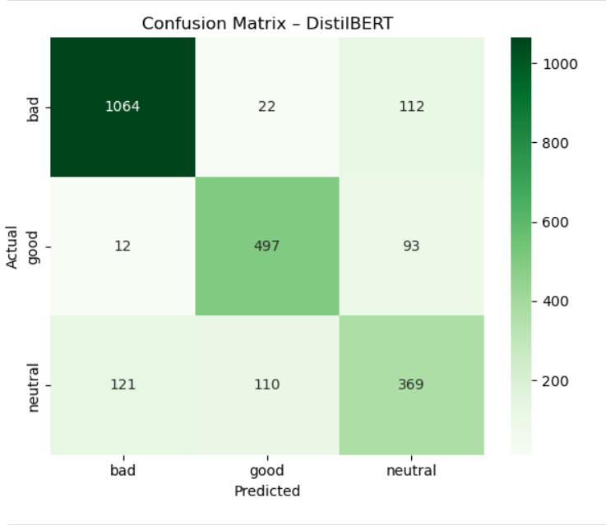
Figure 5 Confusion Matrix – DistilBERT
5.3 Sentiment Analysis Application
In order to show how the system can be applied in the real world, the Streamlit web application was utilized to perform real-time sentiment analysis on social media text. The sample predictions presented in Figures 6-8 serve to demonstrate the reliability of the system in detecting sentiments correctly, despite the use of informal language, emojis, abbreviations, and context-dependent expressions.
The application points out the enhanced performance of the DistilBERT model as compared to the classical Logistic Regression baseline and also features a user-friendly interface for the analysis of large amounts of texts in an efficient manner. The sentiment analysis application can process new social media posts and predict sentiment in real time. Examples of predictions are as follows:
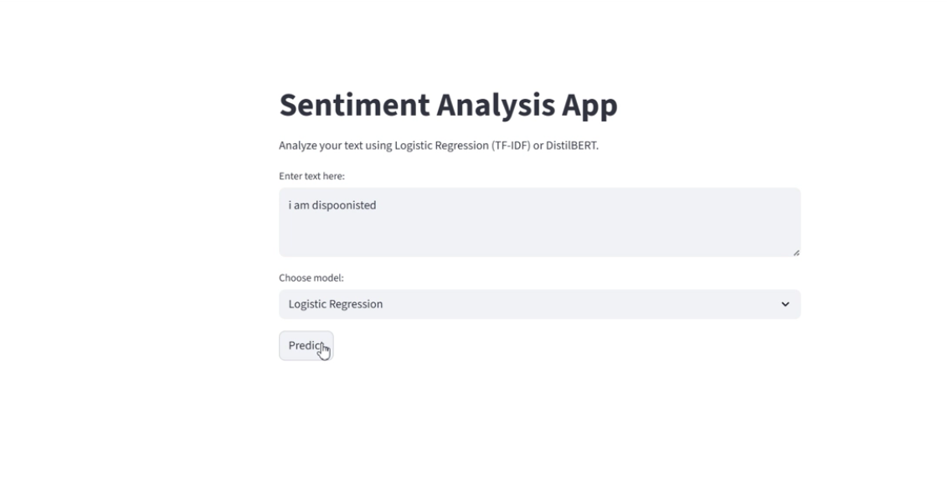
Figure 6 Sentiment Analysis App screenshot 1
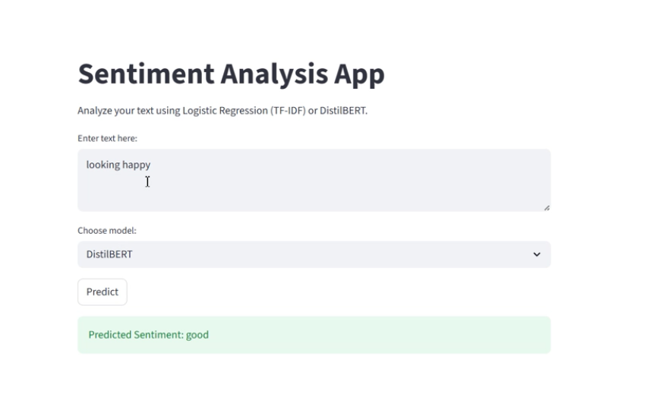
Figure 7 Sentiment Analysis App Screen shot 2
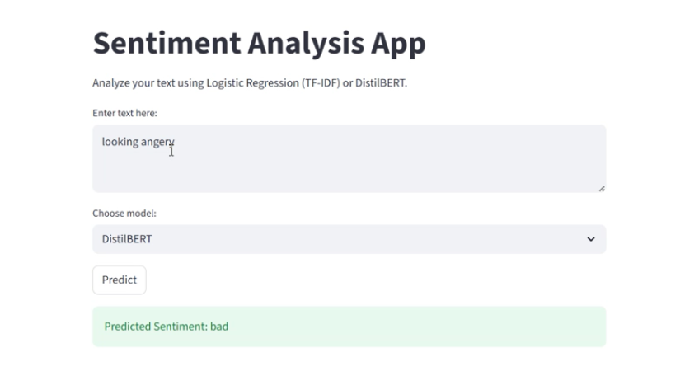
Figure 8 Sentiment Analysis App Screenshot 3
These examples illustrate the model’s ability to handle informal language and correctly identify sentiment.

5.4. Observations
The Logistic Regression model, while excellent as a baseline for sentiment classification, was outperformed by the DistilBERT transformer model which was able to interpret the subtle meaning and context in the text leading to greater accuracy and better F1-scores. The noise reduction and irrelevant feature removal via the preprocessing steps which included text cleaning and standardization were significant in both models' improved performance.
In practical terms, this sentiment analysis system has the capability of efficiently handling enormous amounts of social media data, thus making it a valuable tool for organizations to keep track of public opinion, measure customer satisfaction and discover new trends that need prompt action.

Conclusion and Future Work

6.1 Conclusion
The goal of this project was to build a powerful sentiment analysis system that could sort social media content into three sentiment classes: good, neutral, and bad. The researchers have employed both classical machine learning and transformer-based methods and also tested them to get a complete view of their pros and cons.
The classical model combined TF-IDF features with Logistic Regression and provided an overall accuracy of 77% as a strong baseline. It showed the importance of feature engineering and simple, interpretable models, especially in environments with limited resources.
The model nevertheless faced difficulties to a degree with shorter, informal and context-dependent posts, particularly in discerning neutral from negative sentiments. The transformer model used was DistilBERT which took advantage of contextual embeddings and yielded an accuracy of 84% overall.
The whole project demonstrates that a strong preprocessing, baseline classical methods and advanced transformer models together form a strong workflow for the social media sentiment analysis.
The comparative evaluation reveals the trade-offs between interpretability, computational cost, and predictive performance, thus providing a hint for practical deployment in business and research applications.

6.2 Future Work
Although the present method produced convincing outcomes, there are still numerous possibilities for enhancing and prolonging the system:
The enlargement of the dataset and the adoption of several languages for posting can not only make the model more adaptable but also give it wider usage. The multilingual BERT is one of the techniques that can be applied for the worldwide sentiment analysis. On the other hand, the model can still be manufactured to discern and categorize more emotions like happiness, wrath, tears, or astonishment rather than just restricting it to three general categories. This method offers a more profound and subtle comprehension of user sentiments. The model may also be aided by the use of domain-specific lexicons, knowledge graphs, or sentiment dictionaries to better interpret sarcasm, slang and cultural context thus making the whole sentiment analysis more precise and aware of the context.
Moreover, transform models still have their limitations in interpretability, thus, they are often criticized. But, if techniques like attention visualization, LIME or SHAP are applied then the models can be more transparent in their predictions which in turn will create more trust for the end users. On the other hand, the system can be made better by having it process the data from social media that is coming in the form of a continuous stream, thus, allowing for sentiment tracking in real-time for marketing campaigns, trend detection, or crisis management.
To sum up, the project would be said to be a success as it developed and evaluated sentiment analysis pipelines, right from classical to transformer-based models. Further improvements in the areas of data diversity, interpretability, and real-time deployment will not only make the system stronger but also a very good tool for businesses.

References
Alderazi, F., Algosaibi, A., Alabdullatif, M., Ahmad, H.F., Qamar, A.M. & Albarrak, A., 2024. Generative artificial intelligence in topic-sentiment classification for Arabic text: a comparative study with possible future directions. PeerJ Computer Science, 10, p.e2081.
Bengesi, S., El-Sayed, H., Sarker, M.K., Houkpati, Y., Irungu, J. & Oladunni, T., 2024. Advancements in generative AI: A comprehensive review of GANs, GPT, autoencoders, diffusion model, and transformers. IEEE Access, 12, pp.69812–69837.
Anas, M., Saiyeda, A., Sohail, S.S., Cambria, E. & Hussain, A., 2024. Can generative AI models extract deeper sentiments as compared to traditional deep learning algorithms?. IEEE Intelligent Systems, 39(2), pp.5–10.
Feng, W., Li, Y., Ma, C. & Yu, L., 2025. From ChatGPT to Sora: Analyzing public opinions and attitudes on generative artificial intelligence in social media. IEEE Access.
Kokab, S.T., Asghar, S. & Naz, S., 2022. Transformer-based deep learning models for the sentiment analysis of social media data. Array, 14, p.100157.
Marchena Sekli, G., 2024. The research landscape on generative artificial intelligence: a bibliometric analysis of transformer-based models. Kybernetes.
Sharma, R., Singh, B. & Khamparia, A., 2025. Machine Learning and Generative AI Techniques for Sentiment Analysis with Applications. In: Generative Artificial Intelligence for Biomedical and Smart Health Informatics, pp.183–208.
Trautman, L.J., Voss, W.G. & Shackelford, S.J., 2023. How we learned to stop worrying and love AI: Analyzing the rapid evolution of generative pre-trained transformer (GPT) and its impacts on law, business, and society. Alb. LJ Sci. & Tech., 34, p.203.
Yenduri, G., Ramalingam, M., Selvi, G.C., Supriya, Y., Srivastava, G., Maddikunta, P.K.R., Raj, G.D., Jhaveri, R.H., Prabadevi, B., Wang, W. & Vasilakos, A.V., 2024. GPT (generative pre-trained transformer)—A comprehensive review on enabling technologies, potential applications, emerging challenges, and future directions. IEEE Access, 12, pp.54608–54649.

Appendices

A) Label Distribution
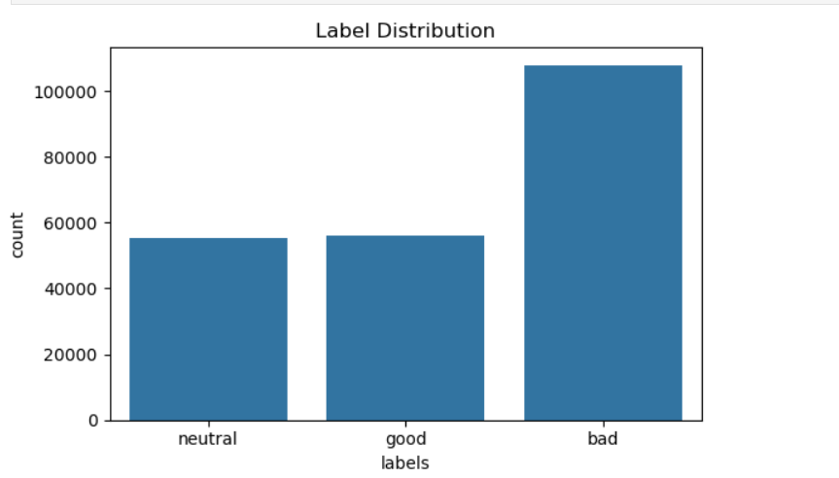

B) Cloud words

