

**COURSE PERIOD: 02/11/2020 TO 12/11/2020**

**CSE 130-IoT-1**

**STUDENT PRACTICE WORKBOOK**

**NAME :** Neeraj Boyapati

**UNIQUE ID :** E0320031

**YEAR :** 2020

**QUARTER :** 1

**PROGRAMME :** Computer Science Engineering

**STREAM :** Artificial Intelligence and Data Analytics

**FACULTY NAME :** Prasath P

**ACADEMIC YEAR :** 2020-2021

**CATEGORY :** Basic Electronics

**DATE OF TASK :**  05-11-2020 **TASK NUMBER :** 1

**Create an application using electrical component listed below:**

**1. Transistor**

**2. LED or Bulb**

**3. Diode**

**4. DC motor**

**5. Gear motor**

**6. Buzzer**

**Choose any component for your application and explain why you need that component and explain about the application you have created.**

***EXPLANATION :***

**Diode** : A **Diode** is a semiconductor device that essentially acts as a one-way switch for current. It allows current to flow easily in one direction, but severely restricts current from flowing in the opposite direction.

The most common function of a **diode** is to allow an electric current to pass in one direction (called the **diode's** forward direction), while blocking it in the opposite direction (the reverse direction).

**Application :** I have made a application in the Tinkercad by using a BreadBoard, along with many other components mentioned above in the question. This application is of collection of multiple components which are supposed to run during the execution of the application like a Bulb, DC motor, Buzzer, and a Gear motor and which are used in the proper execution of the application like the Diode which is mentioned above, NPN transistor, Pushbutton, Power Supply for the voltage source and resistors to restrict the excess current flow and to avoid the damage to electric components.

In the created application the power supply supplies the voltage to the breadboard for the components to work on. It is further connected to a diode and a NPN transistor prior to the components for the proper flow of the current through the circuit. Later all the components are connected to a Push button so that the circuit will be running with the flow of current when the push button is pressed along with the functioning of all the components.

***CIRCUIT DIAGRAM-TINKERCAD :***

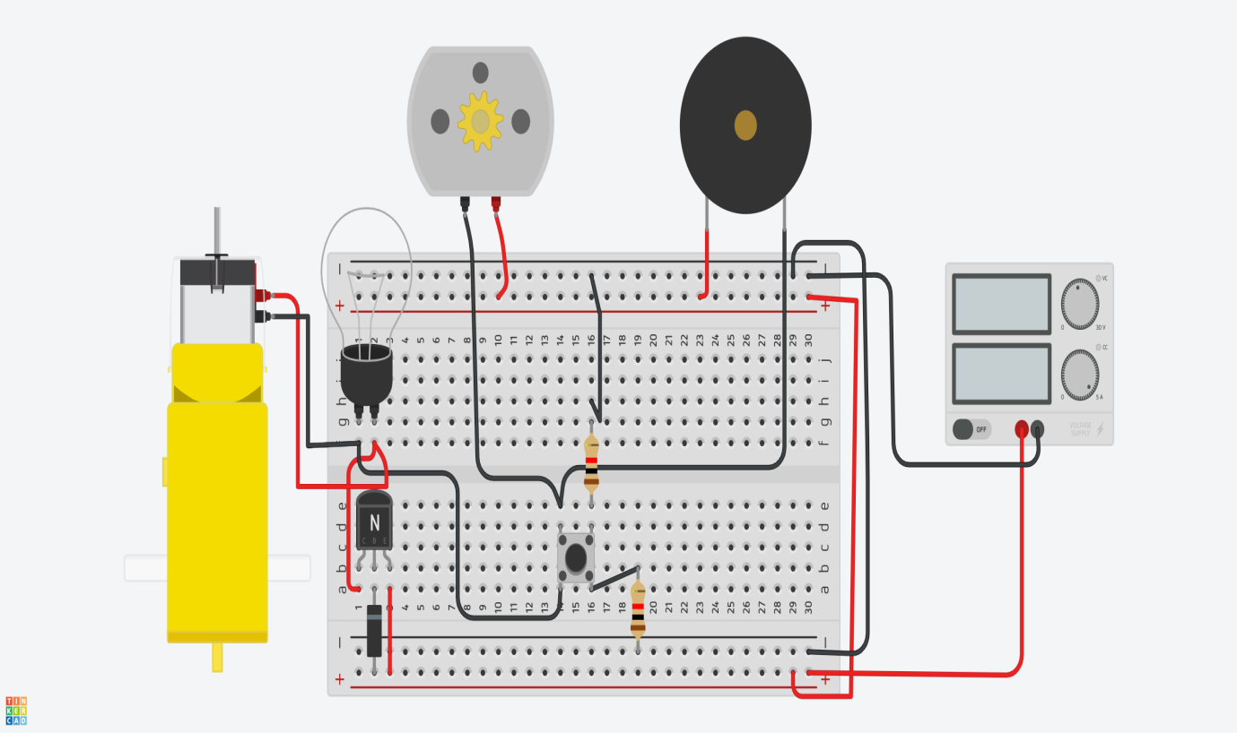

***OUTPUT :***  When the Push button is pressed after the stimulation of the application, all the components will start to function in their respective manner until the Push button is released. All the components will again continue to function whenever the push button is pressed during the time of stimulation .

***TINKERCAD-LINK :*** https://www.tinkercad.com/things/2iqtE4WE25L-epic-tumelo-juttuli/editel?sharecode=4QUFJ1XIf5-mpx0cOaB_hqMrR7XmnZUcnVoS2rN1G54