OPERATING SYSTEMS LAB
System Calls, Processes, CPU Scheduling and IPC
Task 2
Operating Systems Lab Environment Setup – Ubuntu, WSL, VS Code & Python
Item | Details
Assignment | Task 2 of 3 (5 marks)
Submission type | Evidence report (screenshots and terminal output)
Host system | macOS (Apple Silicon)
Linux environment | Ubuntu 24.04 via Multipass (WSL is Windows-only)
Date | 8 October 2026

1. Objective
To set up the Operating Systems lab environment and verify the required tools (Ubuntu Linux, WSL or its Linux equivalent, Visual Studio Code and Python) by checking installed versions and running a basic test program.

2. Environment and Evidence Labels
Windows Subsystem for Linux (WSL) is available only on Windows, so it cannot be installed on a Mac. Multipass, Canonical’s tool for running Ubuntu virtual machines on macOS, was used as the equivalent. Every piece of evidence in this report carries one of two labels:
macOS evidence captured on the Mac itself. Ubuntu / Multipass evidence relating to the Ubuntu VM.
Component | Environment | Evidence | Status
Visual Studio Code | macOS | Figure 1, Figure 2 | Installed, version shown
Python 3 and pip | macOS | Terminal excerpt 3.1 | Installed, version shown
Python test program | macOS | Figure 2, Excerpt 3.4 | Ran successfully
Multipass | Ubuntu / Multipass | Excerpt 4.1 | Installed
Ubuntu 24.04 VM | Ubuntu / Multipass | Excerpt 4.2 | Not accessible (error shown)

3. macOS Evidence
ENVIRONMENT: macOS (host machine, Apple Silicon, macOS 26.7.1)

3.1 Python and macOS Version
Commands run in the macOS Terminal to show the macOS version and the installed Python and pip versions.
[macOS] TERMINAL EXCERPT 3.1 (from the original terminal session)
neerajjoshi@Neerajs-MacBook-Air ~ % python3 --version
Python 3.14.4
neerajjoshi@Neerajs-MacBook-Air ~ % sw_vers
ProductName: macOS
ProductVersion: 26.7.1
BuildVersion: 25G241
neerajjoshi@Neerajs-MacBook-Air ~ % pip3 --version
pip 26.0.1 from /Library/Frameworks/Python.framework/Versions/3.14/lib/python3.14/site-packages/pip (python 3.14)

3.2 Visual Studio Code Version
The code command was run in the VS Code integrated terminal to confirm that VS Code is installed.
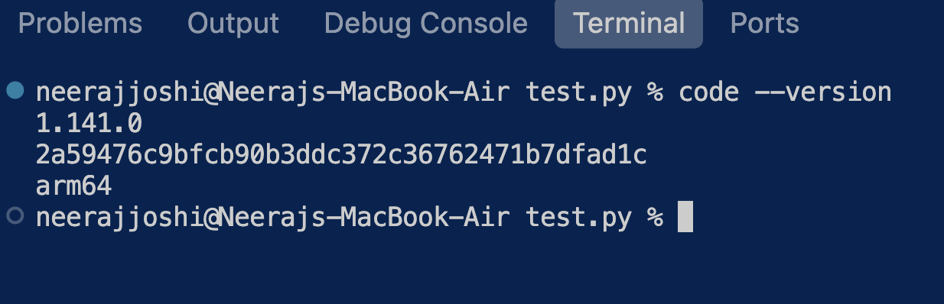
Figure 1 [macOS]: Output of “code --version” showing VS Code 1.141.0 (arm64)

3.3 VS Code with Python Program and Execution
The Python test program task.py was opened in VS Code and executed from its integrated terminal. The program prints a confirmation message, the Python version and the platform.
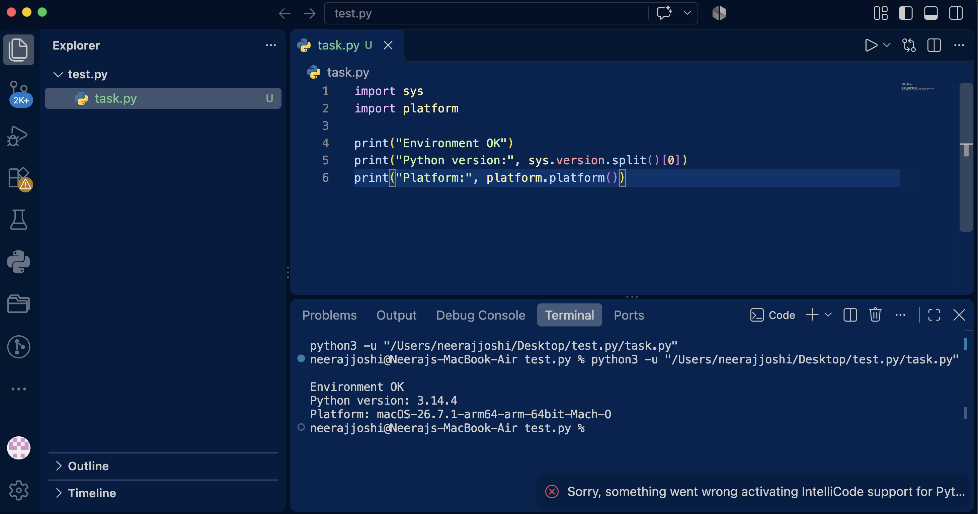
Figure 2 [macOS]: VS Code with the Python program open and its output (Python 3.14.4, macOS)
Observations:
- The program ran successfully and printed “Environment OK”.
- The output reports Python 3.14.4 on macOS (arm64).
- The Python extension icon is present in the VS Code activity bar.
- The notification at the bottom right refers to IntelliCode, an optional add-on; it did not stop the program from running.

3.4 Test Program Run in the macOS Terminal
[macOS] TERMINAL EXCERPT 3.4 (from the original terminal session)
neerajjoshi@Neerajs-MacBook-Air ~ % python3 test.py
Environment OK
Python version: 3.14.4
Platform: macOS-26.7.1-arm64-arm-64bit-Mach-O

4. Ubuntu / Multipass Evidence
ENVIRONMENT: Ubuntu 24.04 via Multipass (WSL equivalent on macOS)

4.1 Multipass Installation
Multipass was installed on the Mac with Homebrew. The lines below are taken from the installer output; the password prompt that appeared between them is omitted.
[Ubuntu / Multipass] TERMINAL EXCERPT 4.1 (from the original terminal session; [...] marks omitted lines)
neerajjoshi@Neerajs-MacBook-Air ~ % brew install --cask multipass
[...]
==> Installing Cask multipass
[...]
installer: The install was successful.

4.2 Access to the Ubuntu VM
When the Multipass client was used to reach the Ubuntu VM, it returned a permission error and could not connect to the Multipass service:
[Ubuntu / Multipass] TERMINAL EXCERPT 4.2 (from the original terminal session)
neerajjoshi@Neerajs-MacBook-Air ~ % multipass list
[error] [client] Caught an unhandled exception: failed to open file '/usr/local/etc/multipassd/multipass_root_cert.pem': Permission denied(13)
neerajjoshi@Neerajs-MacBook-Air ~ % multipass shell oslab
[error] [client] Caught an unhandled exception: failed to open file '/usr/local/etc/multipassd/multipass_root_cert.pem': Permission denied(13)

As a result, no command output from inside Ubuntu is included in this report. Commands such as cat /etc/os-release and uname -a in the same session ran on macOS (they report Darwin) and are therefore not presented as Ubuntu evidence.

5. Summary
Requirement | Environment | Result
VS Code installed and version checked | macOS | Done. Version 1.141.0 (Figure 1)
Python installed and version checked | macOS | Done. Python 3.14.4, pip 26.0.1 (Excerpt 3.1)
Basic test program executed | macOS | Done. Output in Figure 2 and Excerpt 3.4
Ubuntu / WSL equivalent installed | Ubuntu / Multipass | Multipass installed (Excerpt 4.1)
Ubuntu version and test program verified | Ubuntu / Multipass | Not completed: VM not accessible (Excerpt 4.2)

6. Conclusion
Visual Studio Code and Python were installed and verified on macOS, and a Python test program ran successfully there. Multipass was installed to provide Ubuntu in place of the Windows-only WSL, but the Ubuntu virtual machine could not be accessed because of a permission error, so verification inside Ubuntu was not completed.

