A Project Report On

FLAPPY BIRD GAME

Submitted in partial fulfillment of the requirement for the BCA Semester-4 Python Programming Subject Final Examination.
BACHELOR OF COMPUTER APPLICATIONS
(B.C.A.)

Academic Year 2025 – 26

Student Name- NEERAJ KUMAR PANDEY
Enrollment No-92400527321
Internal Guide
Prof. Tirth Bhadeshiya



Rajkot-Morbi Road, At &PO :Gauridad, Rajkot 360 003. Gujarat. India.
CONTENTS

Chapters | Particulars | Page No.
1 | SYNOPSIS
2  2.1  2.2  2.3  2.4 | PREAMBLE  General Introduction  Statement of Problem  Objective and Scope of the Study  Module Description with functionality
3  3.1  3.2  3.3  3.4 | SYSTEM DESIGN AND DEVELOPMENT  Data Flow Diagram (DFD)  Table Structure  Menu Design  Screen Design (Screen shots with short description)
4 | CONCLUSION
5 | LEARNING DURING PROJECT WORK
6  6.1  6.2 | BIBLIOGRAPHY  Online References  Offline References

1-SYNOPSIS

- Flappy Bird is a simple and fun game where the player controls a small bird. The bird keeps moving forward automatically, and the player has to make it fly up by pressing a key or clicking the mouse. Gravity pulls the bird down, so the player must keep tapping to keep it in the air.

- In the game, there are pipes that come from the right side of the screen. The bird has to pass through the gaps between these pipes without touching them. If the bird hits a pipe or falls to the ground, the game ends. Every time the bird successfully passes a pipe, the player gets one point.

- The main goal of the game is to score as many points as possible. It is easy to understand but difficult to master because it needs good timing and quick reactions. Flappy Bird is a good beginner project that helps in learning basic game development concepts like movement, collision, and scoring.

2-PREAMBLE

- Flappy Bird is a small and simple game created for fun and learning. The game is easy to understand and can be played by anyone. It helps beginners learn how games work and how to control objects on the screen.

- In this game, the player controls a bird that keeps moving forward. The player has to tap a key or click the mouse to make the bird fly upward. If the player does nothing, the bird falls down because of gravity.

- The game has pipes that come from the right side of the screen. The bird must pass through the gaps between these pipes. The player needs good timing and focus to avoid hitting the pipes or the ground.

- Each time the bird crosses a pipe successfully, the player gets a point. The score increases as the player continues playing. The game becomes more challenging as the player tries to get a higher score.

- This project is useful for learning basic programming and game development. It includes simple concepts like movement, collision detection, and score counting. Flappy Bird is a great example of a beginner-friendly game project.

2.1-General Introduction

- Flappy Bird is a simple and popular arcade game for fun and learning.

- The player controls a bird that moves forward automatically.

- The bird must pass through gaps between pipes without touching them.

- The player earns points for each successful pass.

- The game teaches basic concepts like movement, gravity, and collision detection.

2.2-Statement of Problem

- To design a simple game where a bird moves continuously and needs player control.

- To create obstacles (pipes) that the bird must avoid while flying.

- To implement gravity and movement to make the game realistic and challenging.

- To detect collisions between the bird and pipes or ground accurately.

- To develop a scoring system that increases when the bird passes obstacles.
2.3-Objective and Scope of the Study

- To develop a simple and interactive Flappy Bird game.

- To understand game concepts like movement, gravity, and collision detection.

- To create a scoring system and improve programming skills.

- To provide entertainment for users of all age groups.

- To serve as a base for future improvements and advanced game development.

2.4- Module Description with Functionality

- Game Initialization Module – Initializes the game window, loads resources (images, sounds), and sets initial values like score and position.

- Bird Control Module – Controls the movement of the bird, including upward motion on key press and downward motion due to gravity.

- Obstacle (Pipe) Module – Generates pipes at regular intervals and moves them from right to left across the screen.

- Collision Detection Module – Checks whether the bird collides with pipes or the ground and ends the game if a collision occurs.

- Score Management Module – Tracks and updates the score whenever the bird successfully passes through pipes and displays it on the screen.

2.4.1- Game Initialization Module

- This module starts the game and prepares everything before the game begins like screen, score, and objects.

- Functionality:-

- Game window is created
- Images and sounds are loaded
- Bird position is set
- Score is initialized to zero
- Game settings like speed are set

2.4.2- Bird Control Module

- This module controls the movement of the bird in the game.

- Functionality:-

1. Bird moves up on key press
2. Gravity pulls bird down
3. Bird position updates continuously
4. Smooth movement is maintained
5. Bird stays within screen

2.4.3- Obstacle (pipe) Module

- This module creates and manages pipes as obstacles.

- Functionality:-

- Pipes are generated regularly
- Pipes move from right to left
- Gap between pipes is created
- Old pipes are removed
- New pipes are added

2.4.4 – Collision Detection Module

- This module checks if the bird hits anything.

- Functionality:-

- Detects collision with pipes
- Detects collision with ground
- Ends game on collision
- Stops game movement
- Triggers game over

2.4.5- Score Management Module

- This module handles the scoring system.

- Functionality:-

- Score increases when bird passes pipe
- Score is displayed on screen
- Updates score continuously
- Resets score on restart
- Stores high score (optional)

3-SYSTEM DESIGN AND DEVELOPMENT

- The system design of the Flappy Bird game is based on a simple and modular approach. The game is divided into different parts like bird movement, pipe generation, collision detection, and scoring. Each part works together to make the game run smoothly and efficiently.

- The development of this game is done using the Python programming language with the Pygame library. Pygame helps in creating the game window, handling graphics, and managing user input like keyboard or mouse. It also provides functions for animation and sound.

- In the design phase, the game window size, background, bird image, and pipe structure are decided. The bird is placed at a fixed starting position, and pipes are generated at regular intervals. Gravity is applied to make the bird fall naturally, which makes the game more realistic.

- During development, different modules are implemented step by step. First, the game screen is initialized, then bird movement is added. After that, pipes are created and moved, and collision detection is implemented to end the game when needed. Finally, the scoring system is added.

- The final system is tested to ensure smooth gameplay and correct functionality. Errors are fixed, and performance is improved. The result is a simple and interactive game that demonstrates basic concepts of game design and development using Pygame.

3.1-Data Flow Diagram (DFD)

The Data Flow Diagram represents how data moves in the Flappy Bird game system:

- The user gives input by pressing a key or mouse click to control the bird.

- The system takes this input and moves the bird upward.

- Gravity is applied, and the bird moves downward automatically.

- Pipes are generated and move from right to left as obstacles.

- The system checks for collision between the bird and pipes or ground.

- If there is no collision, the score increases when the bird passes pipes.

- If a collision happens, the game ends and output is shown as “Game Over” with score.

[User]
↓
[Input: key press / click]
↓
[Bird Movement]
↓
[Gravity Effect]
↓
[Pipe Generation]
↓
[Collision Detection]
↓
[Score Update]
↓
[Display]

3.2-Table Structure

FIELD | DESCRIPTION
Player _ID | Unique ID of player
Player_Name | Name of the player
Score | Points Scored by player
High_Score | Highest score by player
Game_Data | Data when game is played
Game_Time | Duration of gameplay

Table 3.2.1

- The system stores game-related data which consists of the following fields:

- Player_ID: Unique identification for each player

- Player_Name: Name of the player

- Score: Score achieved in one game session

- High_Score: Highest score of the player

- Game_Date: Date on which game is played

- Game_Time: Total time of gameplay

These fields are used to track player performance and improve the gaming experience.

3.3- Menu Design

- The system provides a simple menu for user interaction. The player can start the game, view score, or exit the game using this menu.

- Example Menu:

- Start Game
- View High Score
- Instructions
- Restart Game
- Exit

- Description:-

- Start Game: Begins the game and the bird starts moving.

- View High Score: Shows the highest score achieved.

- Instructions: Displays how to play the game.

- Restart Game: Restarts the game after game over.

- Exit: Closes the game.

3.4-Screen Design

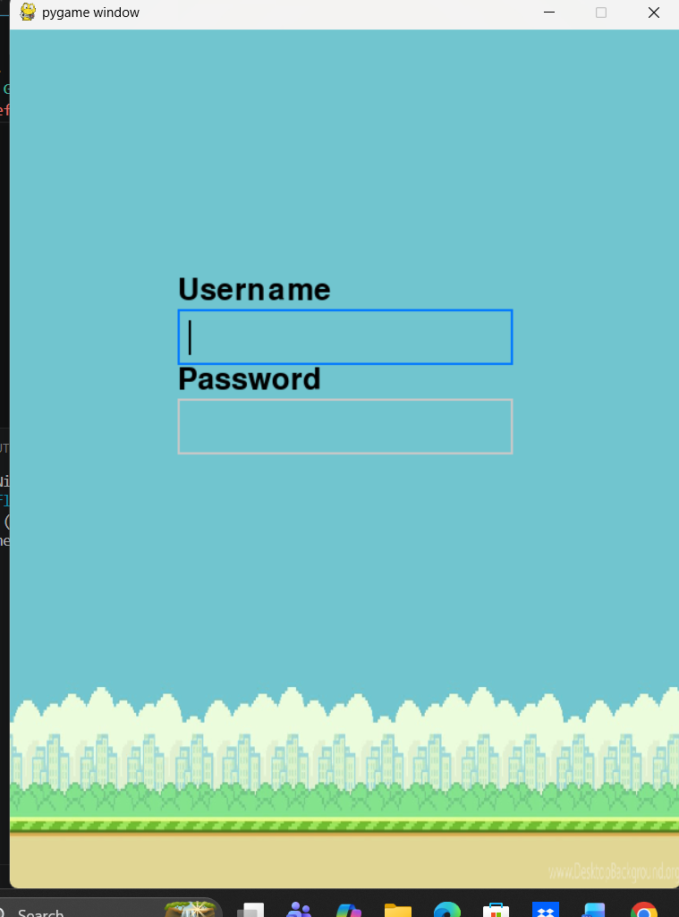

Fig-3.4.1- Login screen page

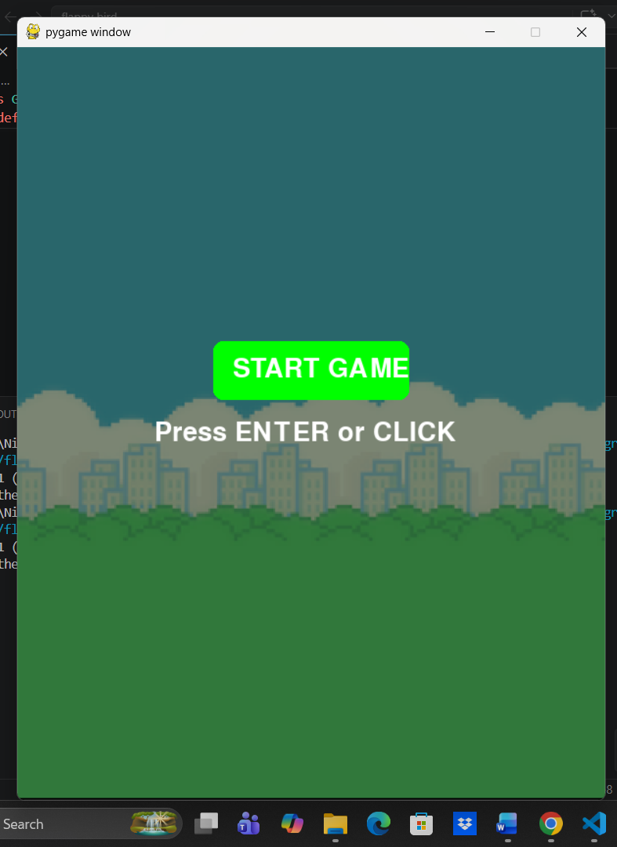

Fig-3.4.2- Start game page

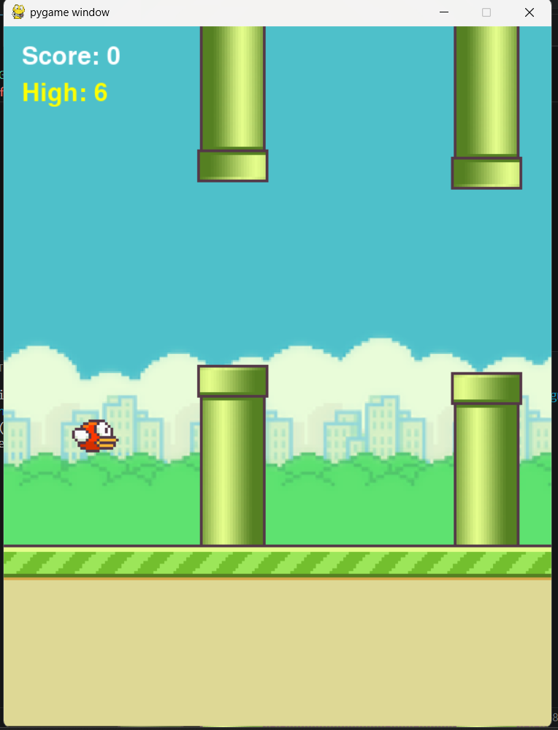

Fig-3.4.3- Playing games page

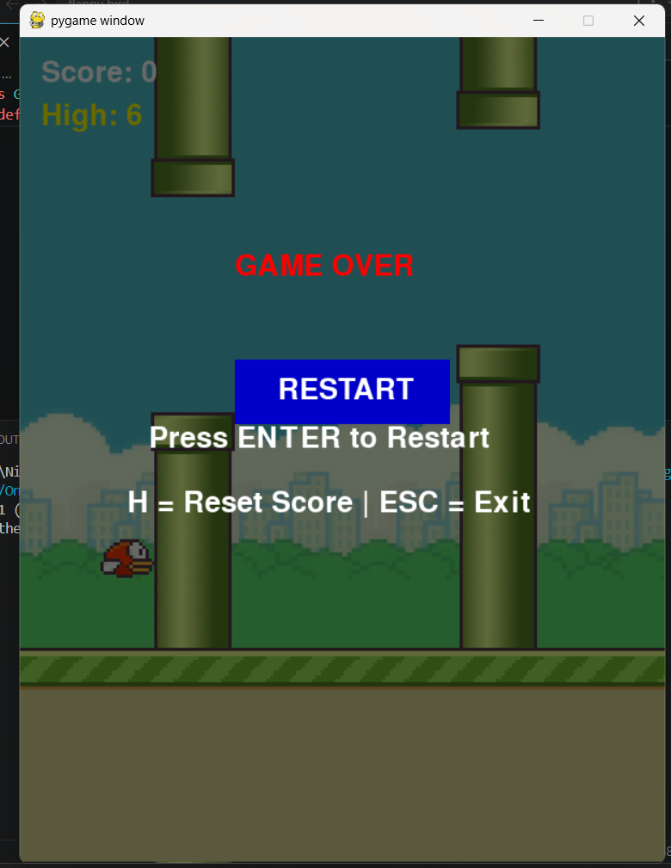

Fig-3.4.4- Restart,resetscore, exit button page
4-CONCLUSION

- The Flappy Bird game project is a simple and interesting game developed using Python and Pygame. It helps in understanding the basic concepts of game development in an easy way. The game is interactive and provides a fun experience to the user.

- In this project, we learned how to control objects on the screen, apply gravity, and handle user input. We also implemented important features like pipe generation, collision detection, and scoring system, which are essential for any game.

- The project also improved our programming and problem-solving skills. It helped us understand how different modules work together to create a complete game. We also learned how to design a user-friendly interface and smooth gameplay.

- Overall, the Flappy Bird game is a good beginner-level project. It can be further improved by adding better graphics, sound effects, and more features. This project provides a strong base for developing more advanced games in the future.

5-LEARNING DURING PROJECT WORK

- During this project, we learned the basics of Python programming and how to use the Pygame library for game development. We understood how to create a game window, display images, and handle user input like keyboard or mouse.

- We also learned important concepts like movement and gravity. We implemented how the bird moves up when a key is pressed and falls down due to gravity. This helped us understand how objects behave in a game environment.

- Another important learning was collision detection and scoring system. We learned how to detect when the bird hits pipes or the ground and how to increase the score when the bird successfully passes obstacles.

- Overall, this project improved our problem-solving and programming skills. We also learned how to design a simple and user-friendly game. It gave us confidence to create more advanced games in the future.

6-BIBLIOGRAPHY

6.1-Online References:

- https://www.pygame.org

- https://docs.python.org

- https://www.w3schools.com/python

- https://www.geeksforgeeks.org/python-programming-language

- https://stackoverflow.com

- https://chat.openai.com
6.2-Offline References:

- Python Programming Textbook
- Pygame Learning Notes
- Class Notes and lab Manual
- Computer Programming Books

FIGURE INDEX
Sr. No. | Figure No. | Particulars | Page No.
1 | 3.4.1 | Login page | 18
2 | 3.4.2 | Start game | 18
3 | 3.4.3 | Playing game page | 19
4 | 3.4.4 | Restart,resetscore, exit button page | 19
5
6
7
8
9

