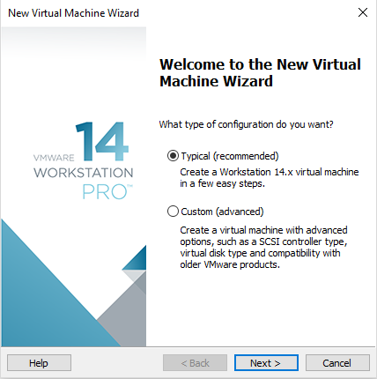
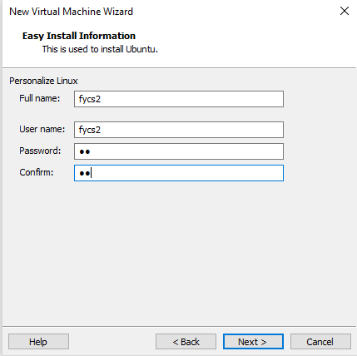
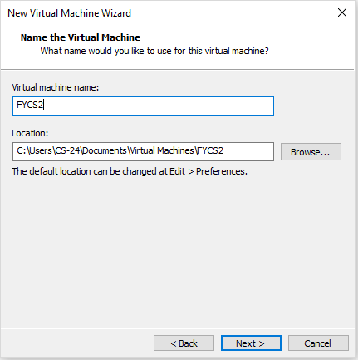
STEP 1)- PRESS ON TYPICAL THEN CLICK NEXT

STEP2)-TYPE FULL NAME, USER NAME, PASSWORD THEN CONFIRM PASSWORD
THEN CLICK NEXT

STEP3)-ENTER VIRTUAL MACHINE NAME AND ALSO GIVE LOCATION THEN CLICK NEXT
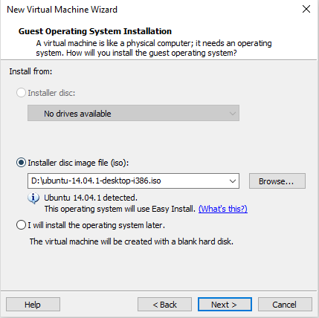
STEP4)-BROWSE ON UBUNTU 14.04 THEN CLICK ON NEXT

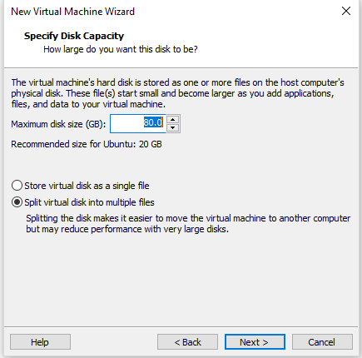
STEP5)-SELECT SPACE OF THE DISK THEN CLICK NEXT

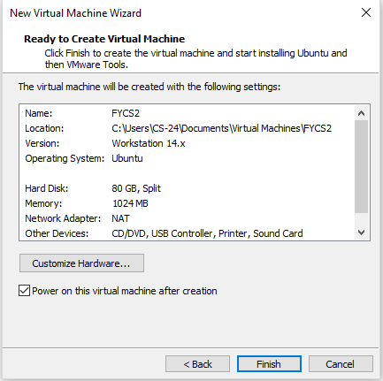

STEP6)-CLICK ON FINISH UBUNTU IS INSTALLED
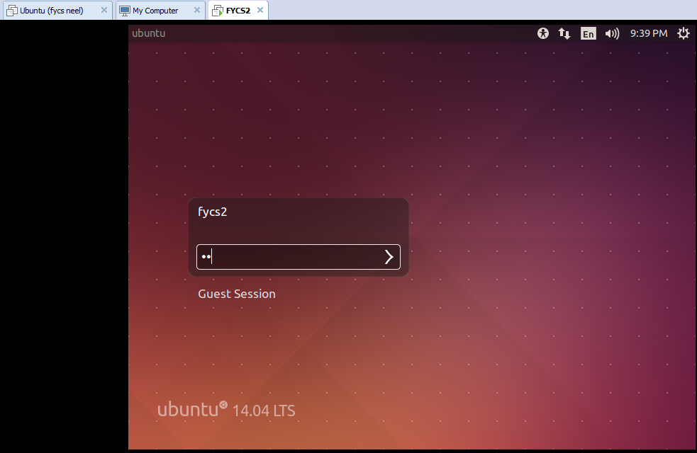
STEP7)-ENTER YOUR PASSWORD
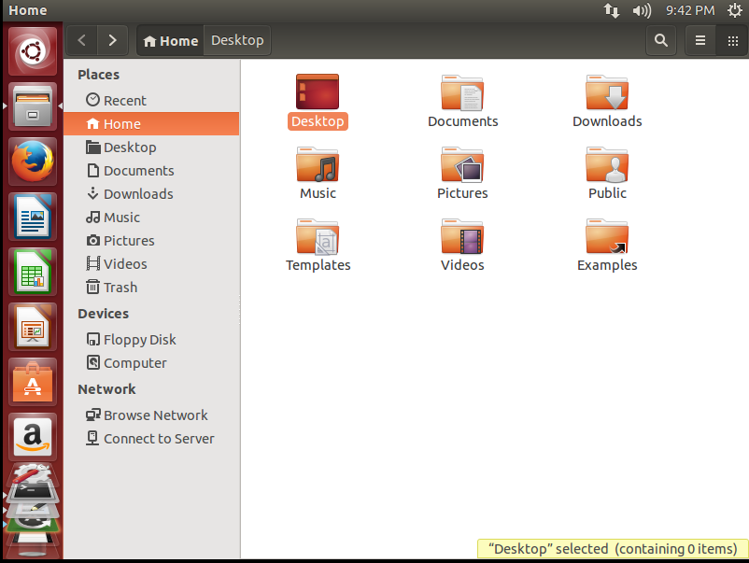
UBUNTU IS LOGGED IN

