

mini project report

IMAGE RESIZER

UE20CS352– OOAD with JAVA

***Submitted by:***

|  |  |
| --- | --- |
| **Tushar N Kumar**  **Tellakula Mohan Sai**  **Neeraj Gopalakrishnan**  **Tejas Goyal** | **PES1UG20CS473**  **PES1UG20CS468**  **PES1UG21CS824**  **PES1UG20CS466** |

Under the guidance

|  |
| --- |
| **Prof. Priya Badrinath**  Professor  PES University |

**January - May 2023**

**DEPARTMENT OF COMPUTER SCIENCE AND ENGINEERING**

FACULTY OF ENGINEERING

**PES UNIVERSITY**

# **TABLE OF CONTENT**

1. Problem Statement Pg.no: 3
2. Models Pg.no: 4-11
3. Architectural Patterns Pg.no: 12
4. Design Patterns Pg.no: 13
5. Link To Codebase Pg.no: 13
6. Contributions Pg.no: 13
7. Screenshots Pg.no: 14-19

# **Problem Statement**

Image Resizer is a Java-based tool that allows you to resize images in bulk, with minimal effort. With Image Resizer, you can quickly reduce the size of your images, making them easier to manage and store.

## Features:

* This tool allows the users to resize multiple images at once.
* It provides an efficient and customizable way to reduce the size of images for various purposes, such as web optimization or storage management.
* The tool supports various image formats, including JPEG and PNG.
* It also provides the user with a user-friendly UI that would make the tool much easier to use for a layman.
* Users can specify the output size of the images using custom dimensions or percentage values.
* The tool also supports batch processing of multiple images, allowing users to resize large numbers of images with just a few clicks.
* Additionally, users can specify the quality level of the output images.

The Image Resizer is a useful tool for anyone who needs to manage and optimize large numbers of images quickly and efficiently.

# **MODELS**

## **use CASE DIAGRAM:**

Image Cropping using Aspect Ratio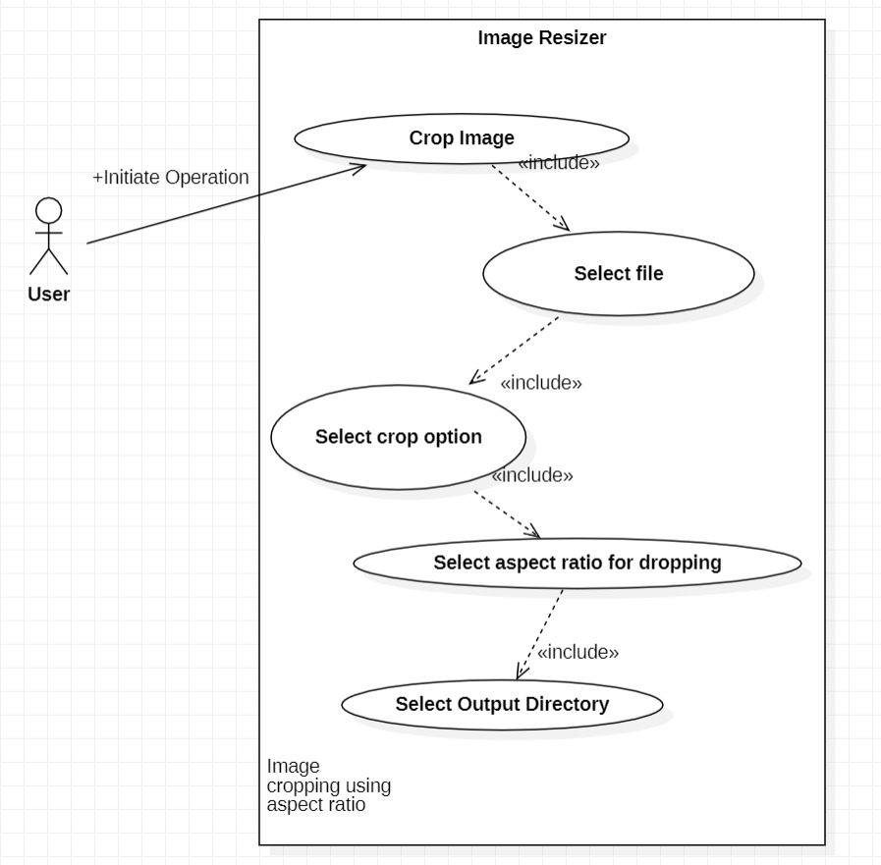

**Name:** Image cropping using aspect Ratio

**Actor:** Software user

**Summary / Overview:** Crops the image selected by the user according to the aspect ratio specified by him/her.

**Pre-condition :** None.

**Description :**

a. The user will the crop image option.

b. User will select the file to be cropped.

c. User will enter the required aspect ratio.

d. The image is cropped accordingly.

e. User selects the directory for the output image to be stored.

**Exceptions :**

a. Image file format not supported.

b. Output file directory may be restricted.

**Alternate Flows :** None

**Post Conditions :** None

Image Resizer using batch processing and file size

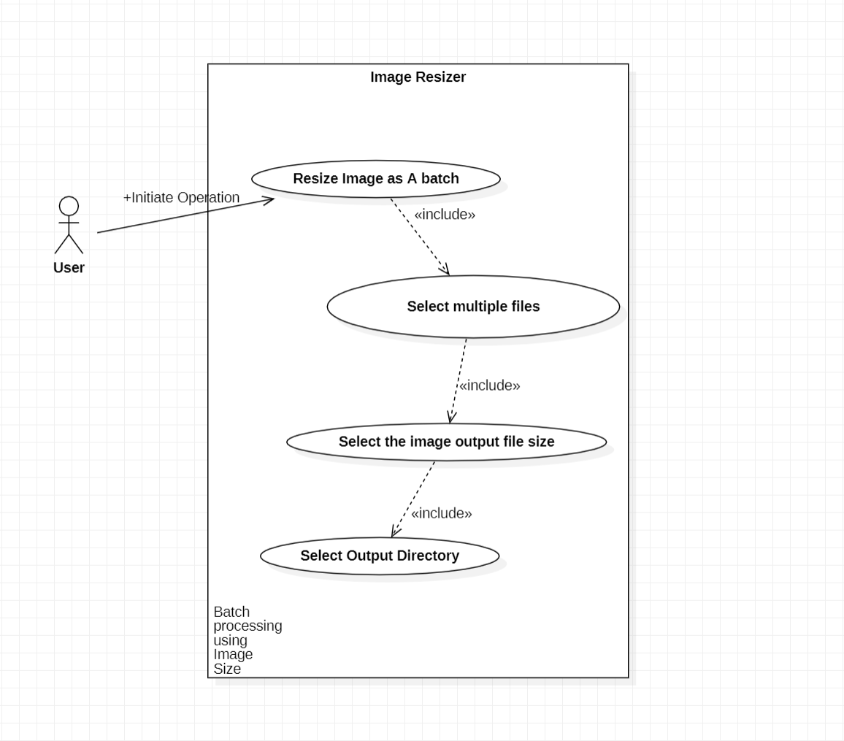

**Name :** Image resizer using batch processing and file size

**Actor:** Software user

**Summary / overview :** this functionality allows the user to resize the image using batch processing.

**Pre-condition :** none

**Description :**

A. User selects resize image as a batch option.

B. Then multiple files to be resized are selected.

C. The user selects the images output size.

D. User then selects the directory in which the processed images need to be stored.

**Exceptions :**

A. Image file format not supported.

B. Output file directory may be restricted.

**Alternate flows :** none

**Post conditions :** image after processing is stored in aforementioned director

Image resizing as batch processing using Pixel density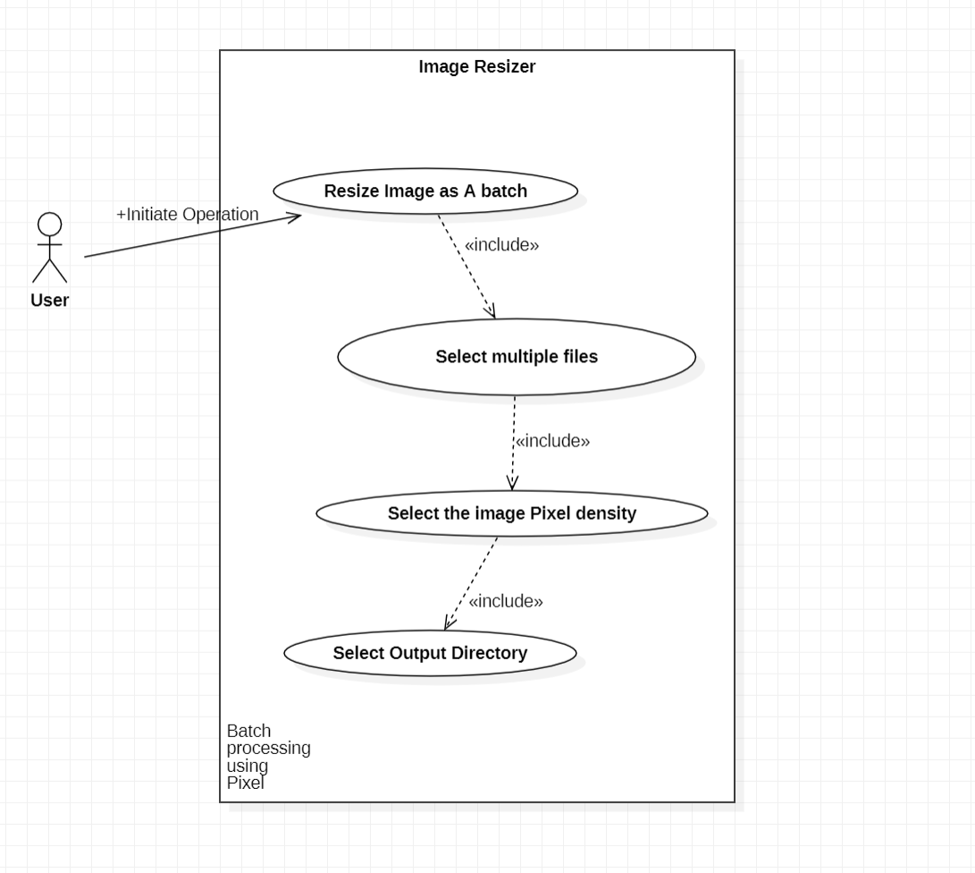

**Name :** Image Resizer using Batch processing and Pixel density

**Actor:** Software user

**Summary / Overview :** This functionality allows the user to resize multiple images by specifying pixel density.

**Pre-condition :** None

**Description :**

a. User selects resize image as single image option.

b. Then image to be resized is selected.

c. The user selects the images output size.

d. User then selects the directory in which the processed images need to be stored.

**Exceptions :**

a. Image file format not supported.

b. Output file directory may be restricted.

**Alternate Flows :** None

**Post Conditions :** Image after processing is stored in aforementioned directory

Image Upscaling

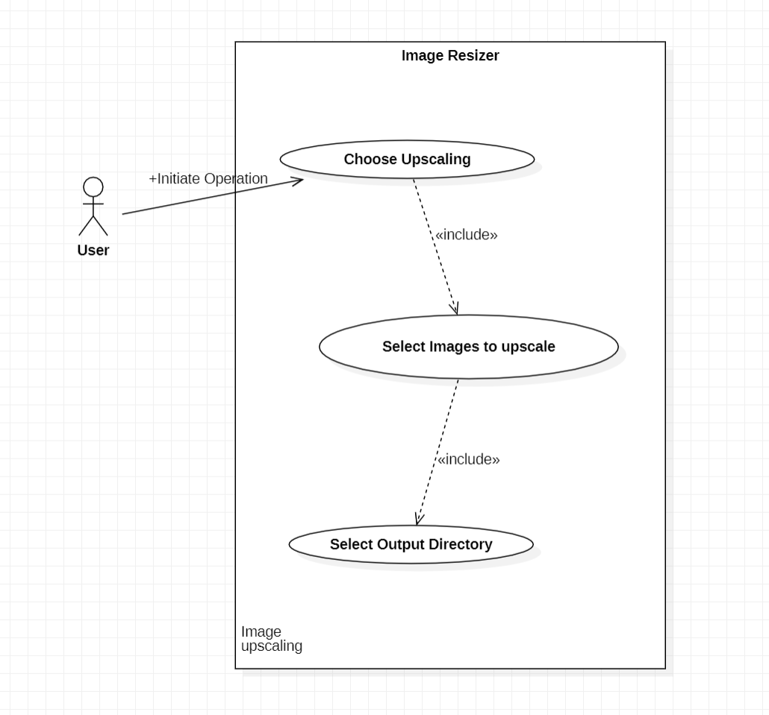

**Name :** Image Upscaling

**Actor:** Software user

**Summary / overview :** This functionality allows the user to upscale the image.

**Pre-condition :** none

**Description :**

A. User selects upscale image option.

B. Then file to be upscaled is selected.

C. User then selects the directory in which the processed images need to be stored.

**Exceptions :**

A. Image file format not supported.

B. Output file directory may be restricted.

**Alternate flows :** none

**Post conditions :** image after processing is stored in aforementioned directory.

format changing 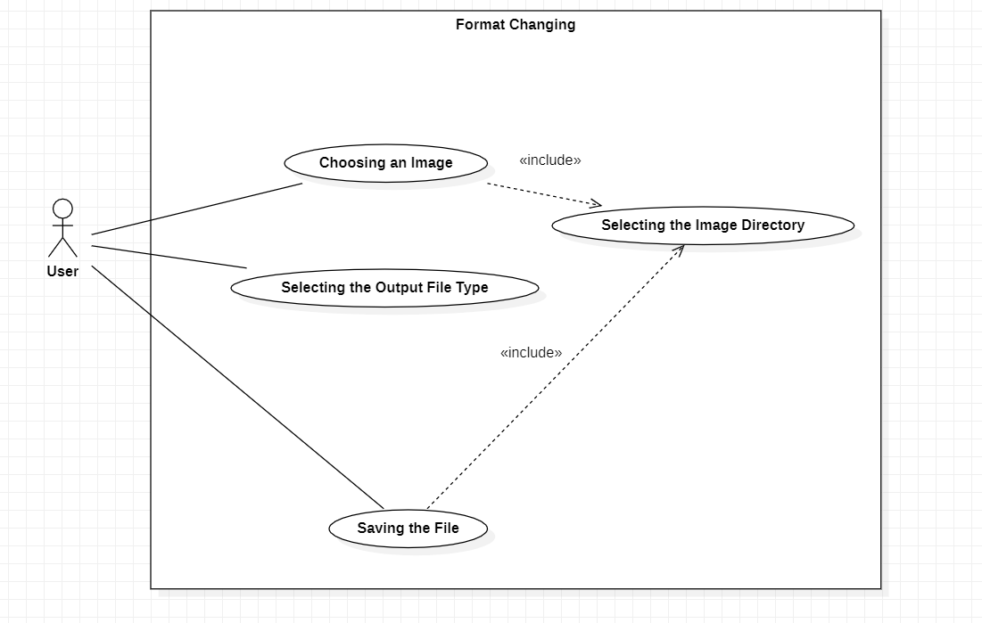

**Name :** Image resizer using batch processing and pixel density

**Actor:** Software user

**Summary / overview :** This functionality allows the user to resize multiple images by specifying pixel density.

**Pre-condition :** none

**Description :**

A. User selects resize image as single image option.

B. Then image to be resized is selected.

C. The user selects the images output size.

D. User then selects the directory in which the processed images need to be stored.

**Exceptions :**

A. Image file format not supported.

B. Output file directory may be restricted.

**Alternate flows :** none

**Post conditions :** image after processing is stored in aforementioned directory

Image resizer using pixel density

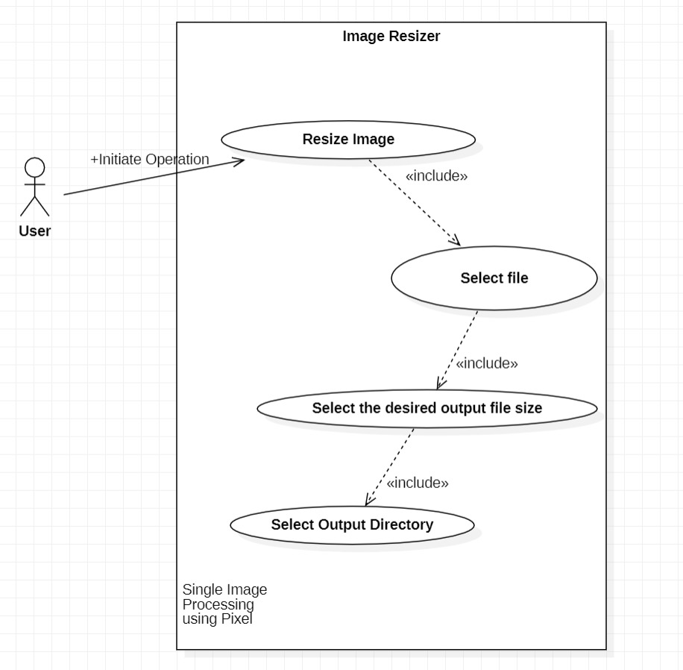

**Name :** Image resizer using pixel density

**Actor:** software user

**Summary / overview :** this functionality allows the user to resize the image by specifying the pixel density.

**Pre-condition :** none

**Description :**

A. User selects resize image as single image option.

B. Then image to be resized is selected.

C. The user selects the images output size as pixel.

D. User then selects the directory in which the processed images need to be stored.

**Exceptions :**

A. Image file format not supported.

B. Output file directory may be restricted.

**Alternate flows :** none

**Post conditions :** image after processing is stored in aforementioned directory

# Class DIAGRAM:

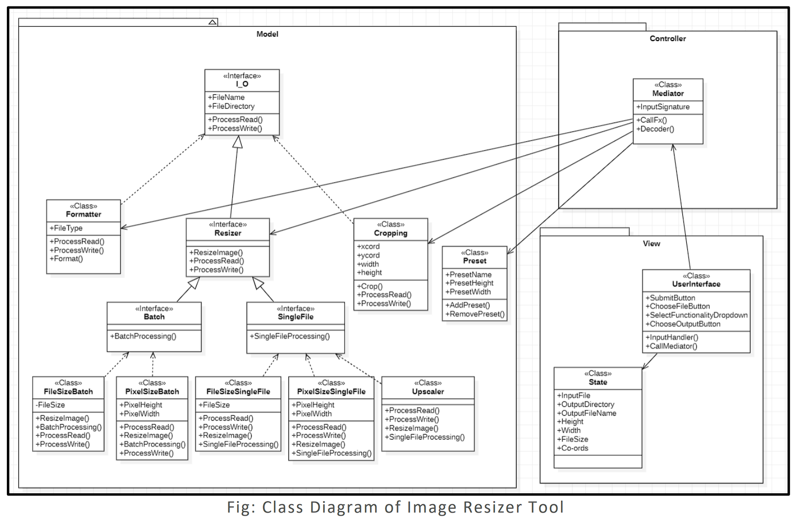

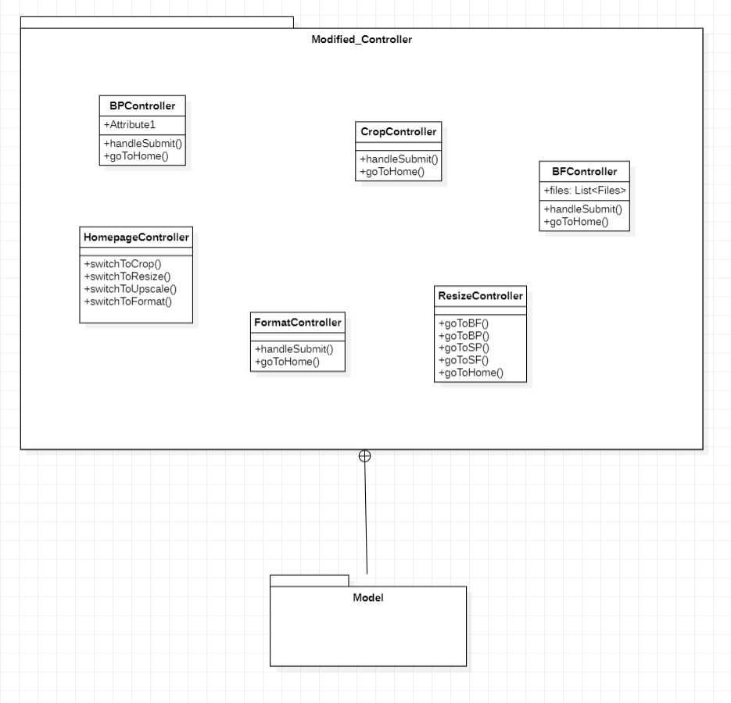

Fig: Reimagined class diagram of the controller as per implementation

# **ARCHITECTURAL PATTERN**

For this project, we have employed the MVC architectural pattern.

### View:

**1.) User Interface:** It follows Indirection principle as it doesn’t directly communicate with

classes of Model rather uses Mediator for communication.

**2.) State:** It follows Information Expert principle because it stores all the information.

### Controller:

**1.) Mediator:** It follows Controller principle because it mediates control between all the

model elements.

**2.) Single Responsibility Principle:** Each of the controller acts as a mediator only between the

### Model:

**1.) Resizer<interface>:** It follows Interface Segregation principle, Open Close principle

and Polymorphism

**2.) Formatter:** It follows Single Responsibility principle

**3.) Cropping:** It follows Single Responsibility principle

**4.) FileSizeBatch:** It follows Single Responsibility principle and Dependency Inversion

**5.) PixelSizeBatch:** It follows Single Responsibility principle and Dependency Inversion

**6.) FileSizeSingleFile:** It follows Single Responsibility principle

**7.) PixelSizeSingleFile:** It follows Single Responsibility principle

**8.) Upscaler:** It follows Single Responsibility principle

# **DESIGN PATTERN**

**Creation Design Pattern:**

**Builder pattern:** All the controllers build the object from another class by running generating an instance of that class, the builder however is used in the resize controller as it generates the resize based of the number of files being fed to the class’s constructor.

**Structural Design Pattern:**

**Composite Pattern:** The Resizer object one for the file size and one for the pixel-based resizing are made of composite objects or children objects like the ImagesIO object. This nesting is also seen when we use the G2D object to generate new images from old images.

**Behavioural Design Pattern:**

**Iterator Pattern:** The Batch processing class processes the images in an iterative manner without showing the underlying which is said to be the iterator pattern’s design.

**Strategy Pattern:** The strategy patter implements subprocesses and uses them interchangeably

# **LINK TO CODEBASE**

# [https://github.com/NeerajG03/Image-Resizer-Using-Java](https://github.com/NeerajG03/Image-Resizer-Using-Java%20)

# **CONTRIBUTIONS**

**Tushar N Kumar:** Format Changing, Upscaling of images and has-a relationship connection.

**Tellakula Mohan Sai:** Image cropping using aspect ratio, Image resizing using pixel density and controller connection.

**Neeraj Gopalakrishnan:** Image Resizer using batch processing and file size, UI creation, controller connection and process building.

**Tejas Goyal:** Image resizing using file size and Image resizing as batch processing using Pixel density

# **SCREENSHOTS**

Home Page

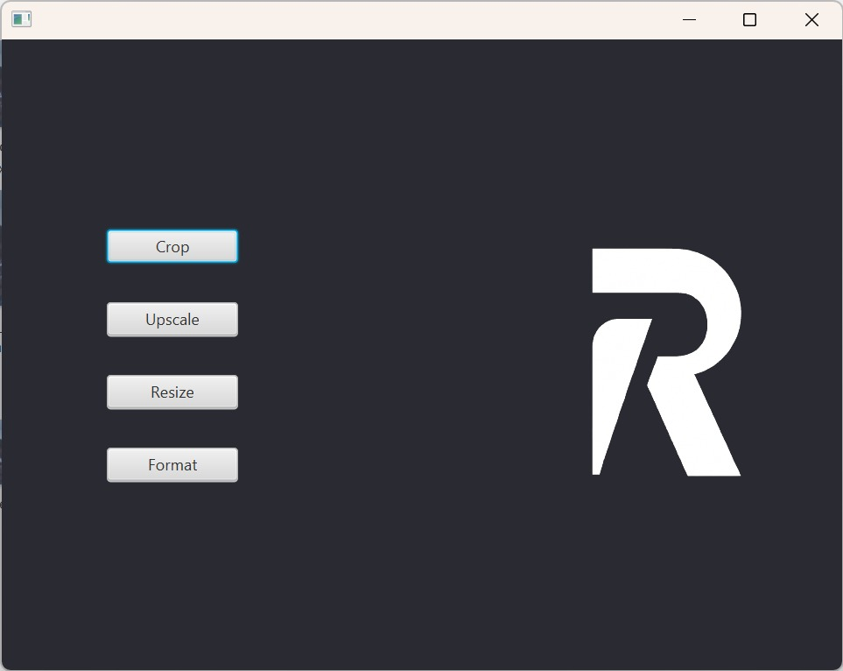

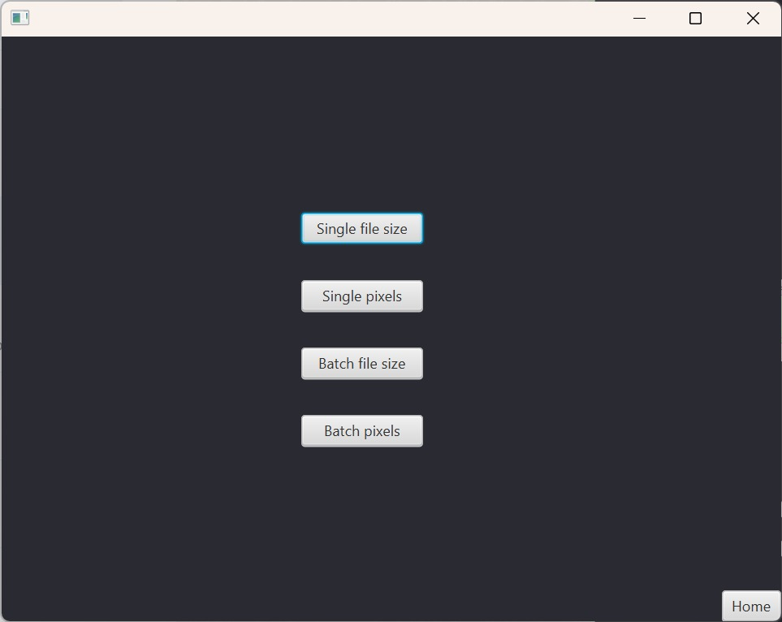Resize Home Page

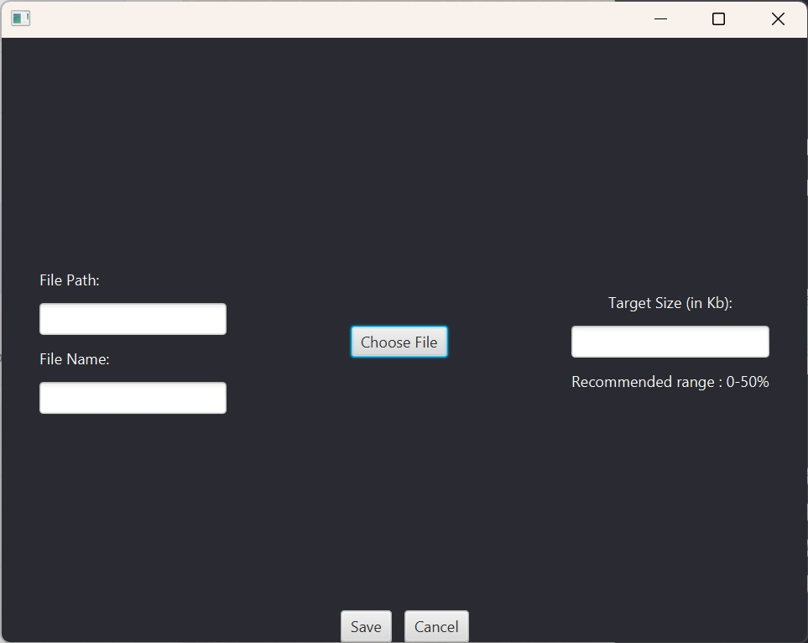Single file size resizer page

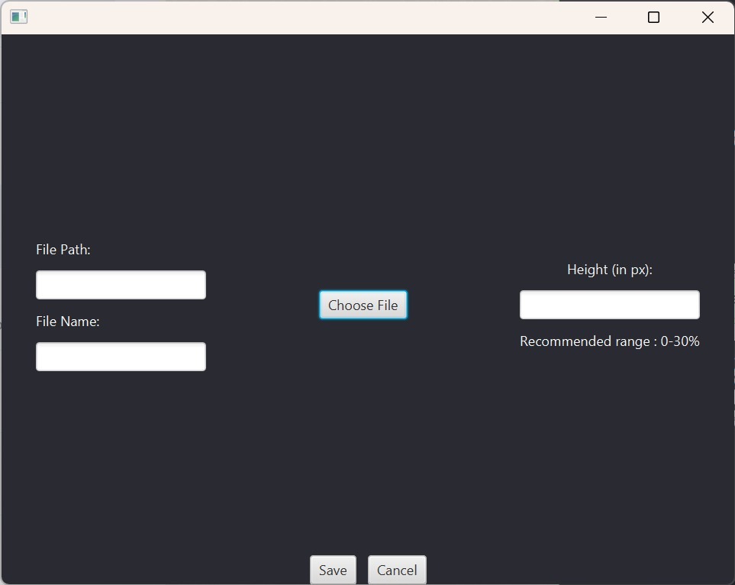Single pixel resize page

Upscale page

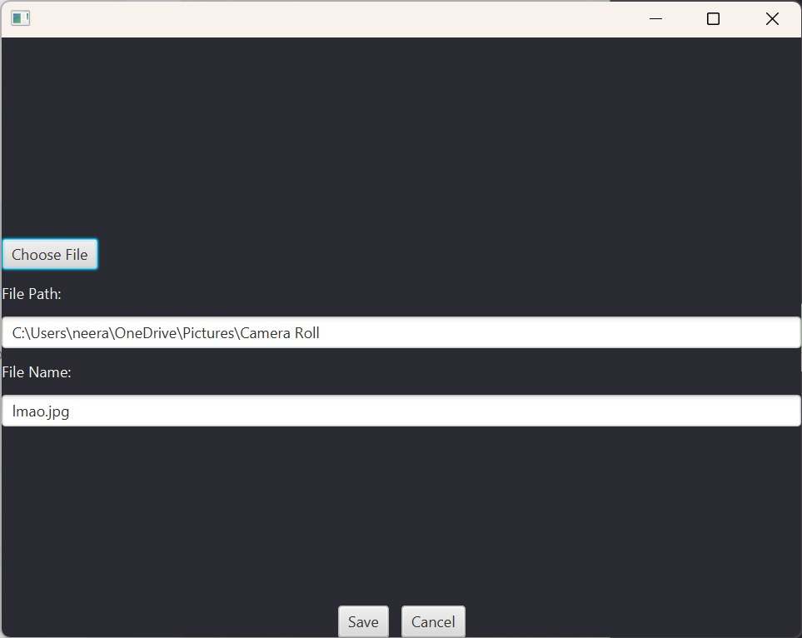

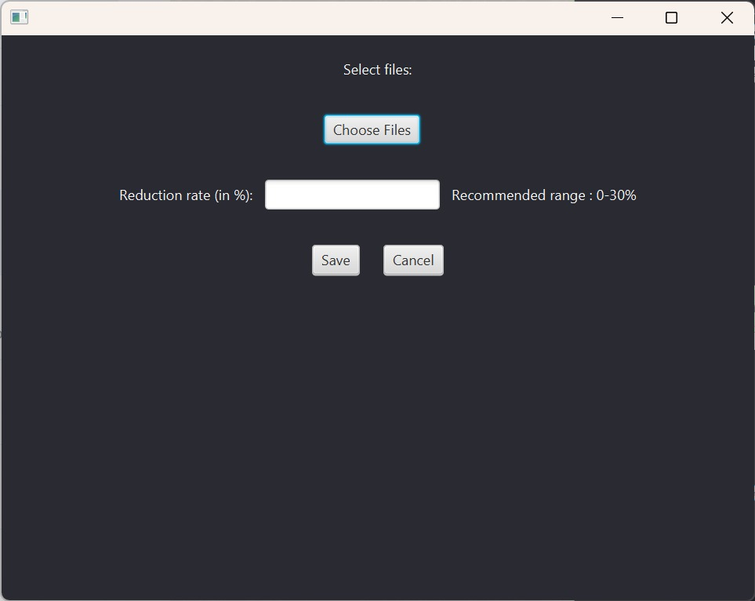Batch file size resizer page

Batch pixel resize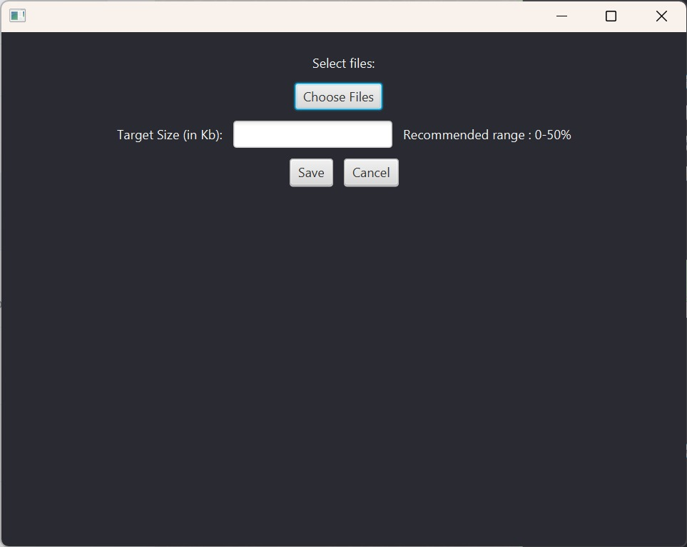

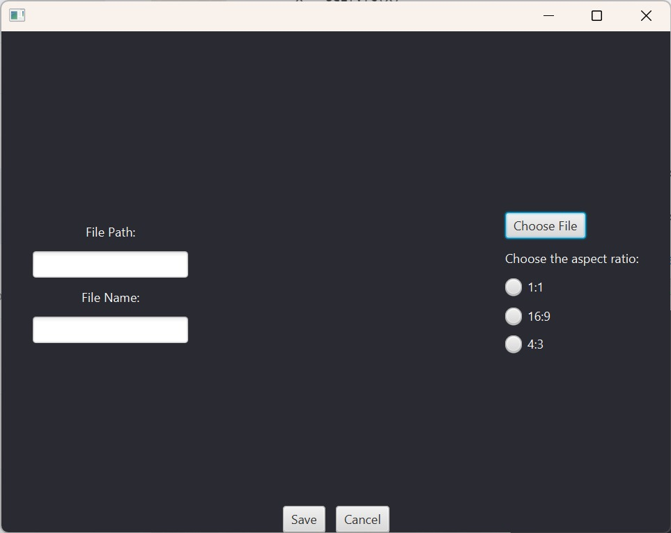Croppage

Format page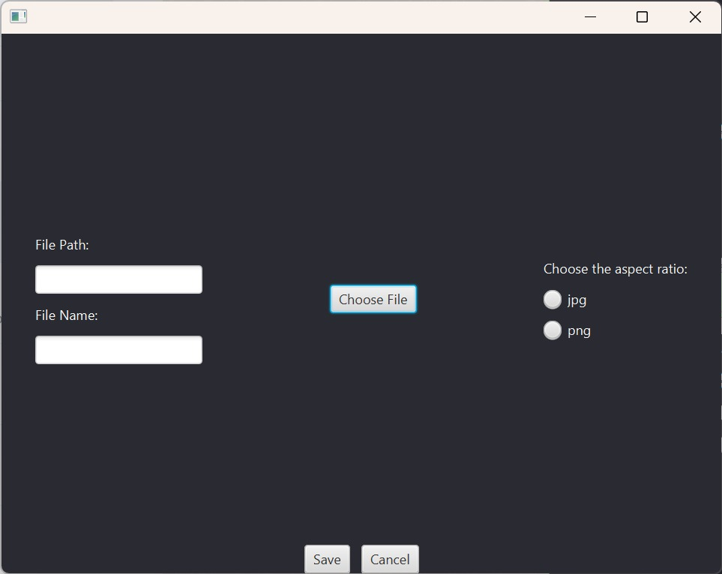

File selector UI

