DELHI TECHNOLOGICAL UNIVERSITY

**DEPARTMENT OF COMPUTER SCIENCE AND ENGINEERING**



**CO 202: DATABASE MANAGEMENT SYSTEMS**

PRACTICAL FILE

**Submitted To: Submitted By:**

**Ms. Indu Singh Neeraj Sharma**

**Assistant Professor 2K19/CO/244**

**Department of CSE, DTU A4 Batch Group 1**

**TABLE OF CONTENTS**

|  |  |  |  |
| --- | --- | --- | --- |
| **S.NO** | **Title** | **Date** | **Page No.** |
| 5 | Case Study 1: Railway Management  System | March 12, 2021 | 3 – 4 |
| 6 | Creating Entity-Relationship Diagram, Entity Tables and Relationship Tables | Match 12, 2021 | 5-7 |
| 7. | Implementing DDL and DML commands. | March 22, 2021 | 8-17 |
| 8. | Performing Simple Queries. | March 29, 2021 | 17-20 |
| 9. | Implementation of Simple Joins | March 31, 2021 | 20-24 |
|  |  |  |  |
|  |  |  |  |
|  |  |  |  |
|  |  |  |  |

# EXPERIMENT 5

**CASE STUDY: RAILWAY MANAGEMENT SYSTEM**.

**PROBLEM STATEMENT:**

* Railway Reservation System will maintain the information about Reservation like Passenger name, Id etc.
* Railway Reservation System will maintain the information about passenger like Personal details and Official detail.
* System will maintain the information about train like Train no., Train name.
* Railway Reservation System will maintain the information about the seat availability like Source station, Destination station, Date, Train no., Class, Arrival time.
* Railway Reservation System will maintain the information about the Account like, Date, PNR and Amount.
* Railway Reservation System will maintain the information about the Train for cancellation like PNR, No. of seat, Date.

# ASSUMPTIONS:

* One Passenger can reserve N seats in one train.
* One Passenger can pay the Ticket Rate by only one account.
* One Passenger can cancel the N seats at one time. Passenger details can be Personal or Official.

# ER DIAGRAM DESCRIPTION:

* **Identification of Entities:**
  1. PASSENGER (Personal Id, Name, Age, Sex, Phone No, Address, Office Name, Office Address, Office Phone)
  2. TRAIN (Train No., Train Name, Duration, First Station, Last Station)
  3. RESERVATION (Reservation No., Passenger Id, Passenger Name, Train Number, Number of Seats, Reservation Date)
  4. PASS_ACCOUNT (PNR, Account Holder Name, Date of Booking, Amount)
  5. CANCELLATION (Cancellation No., PNR, Train No., Train Name, Class, Number of Seats, Reservation Date)
  6. SEAT AVAILABILITY (Train No., Total Seats, Reservation Date, Class, Quota, Available Seats)
  7. TICKET (Train No., Ticket Price)

# Identification of Relationships:

1. RESERVATION: PASSENGER (N:1)
2. RESERVATION: TRAIN (N:M)
3. TRAIN: SEAT AVAILABILITY (N:M)
4. TRAIN: PASS_ACCOUNT (N:1)

# CONCLUSION:

This experiment helped us to analyse the problem of the case study and make certain assumptions that will be helpful in studying the problem. It also helped us identify the key entities and their respective attributes which can be used to create relations. It helps us to construct ER diagrams.

**EXPERIMENT 6**

**AIM:** Creating Entity-Relationship Diagram, Entity Tables and Relationship Tables

# THEORY

Entity Relationship Diagrams are used to define the relationships between various entities. The Entities and Relationships had been identified in Experiment 5. As observed, there are seven key entities and four major relationships. They are listed below.

# Identification of Entities:

1. PASSENGER (Personal Id, Name, Age, Sex, Phone No, Address, Office Name, Office Address, Office Phone)
2. TRAIN (Train No., Train Name, Duration, First Station, Last Station)
3. RESERVATION (Reservation No., Passenger Id, Passenger Name, Train Number, Number of Seats, Reservation Date)
4. PASS_ACCOUNT (PNR, Account Holder Name, Date of Booking, Amount)
5. CANCELLATION (Cancellation No., PNR, Train No., Train Name, Class, Number of Seats, Reservation Date)
6. SEAT AVAILABILITY (Train No., Total Seats, Reservation Date, Class, Quota, Available Seats)
7. TICKET (Train No., Ticket Price)

# Identification of Relationships:

1. RESERVATION: PASSENGER (N:1)
2. RESERVATION: TRAIN (N:M)
3. TRAIN: SEAT AVAILABILITY (N:M)
4. TRAIN: PASS_ACCOUNT (N:1)

The relevant Entity Relationship Diagram has been shown below.

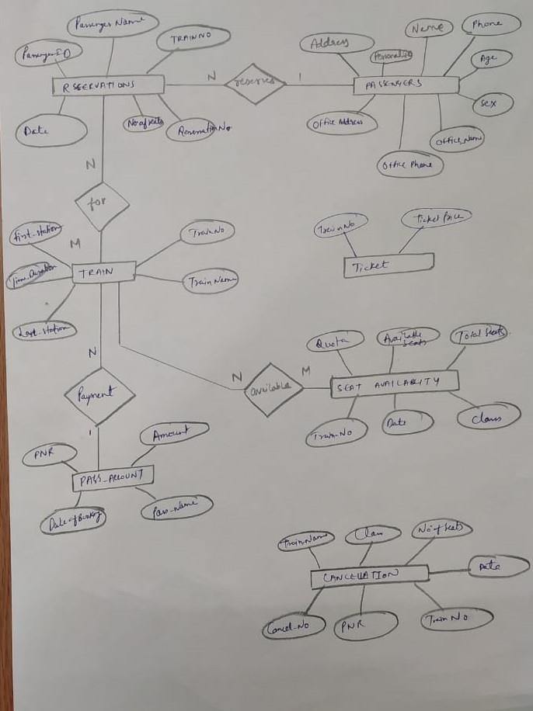

# CONCLUSION:

This experiment helped us simplify the case study and identify the number of table that need to be made, the attribute that they should contain as well as visualize the relationships between them.

# EXPERIMENT 7

**AIM:** Implementing DDL and DML commands.

# THEORY

**DDL Commands:**

DDL stands for Database Definition Language. These types of SQL commands are used to define the database schema. It is used to create or modify database objects and deals with the description of the database schema. The most commonly used DDL commands are:

1. **CREATE TABLE:** This command is used to create a new relation in the database.

**Syntax:** CREATE TABLE table_name (Attribute1, Datatype,

Attribute2, Datatype…)

1. **ALTER TABLE:** This command is used to add, delete or manipulate attributes in a

relation.

**Syntax:** ALTER TABLE table_name ADD Attibute_Name datatype;

1. **DROP TABLE:** This command is used to remove or delete a relation from a

database

**Syntax:** DROP TABLE table_name;

1. **TRUNCATE:** This command is used to erase complete data from an existing

relation **Syntax:** TRUNCATE TABLE table_name;

# Implementing DDL Commands:

We will be implementing the CREATE and ALTER Table commands for this case study. The results are shown below.

# CREATE:

1. **PASSENGERS TABLE:**

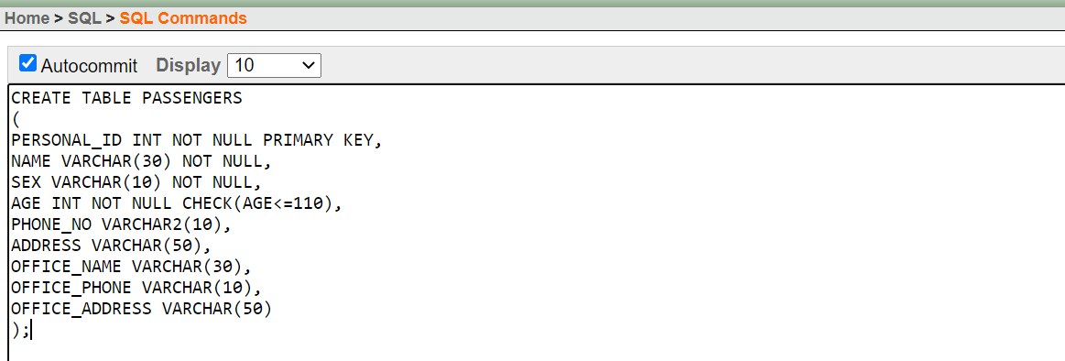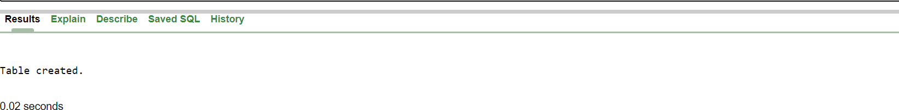

1. **RESERVATION TABLE:**

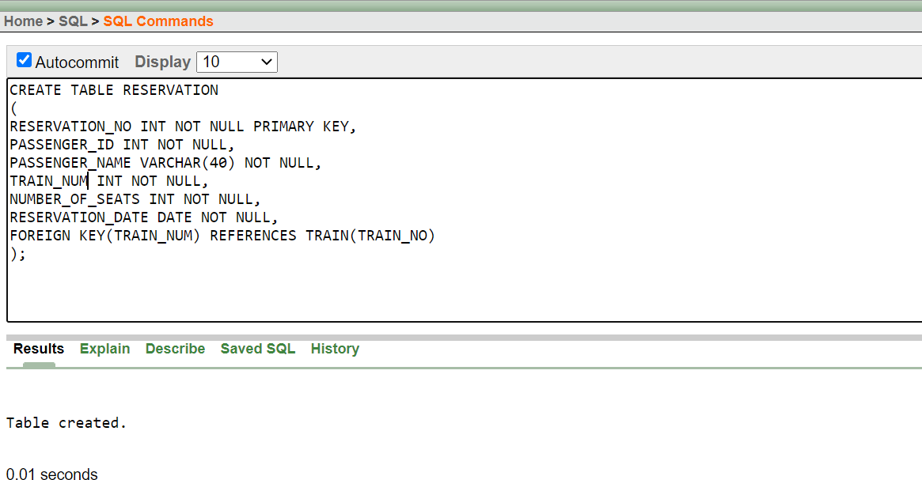

1. **TRAIN TABLE:**

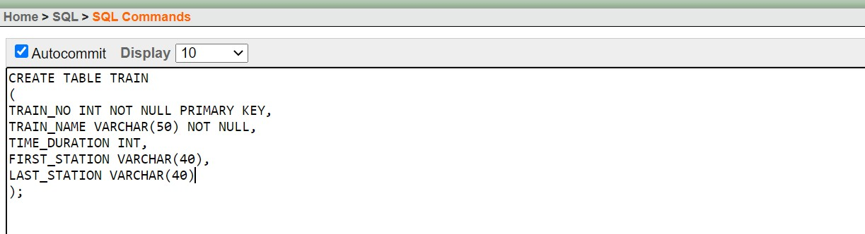

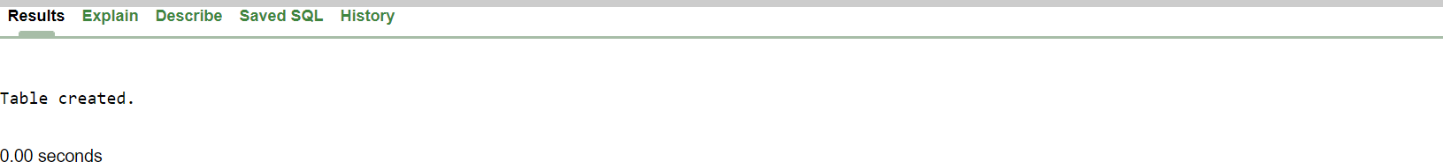

1. **TICKET TABLE:**

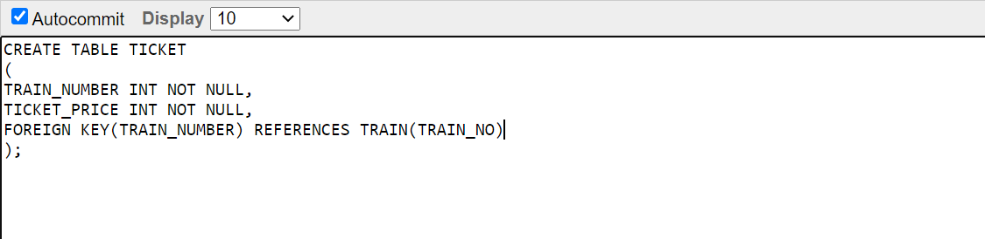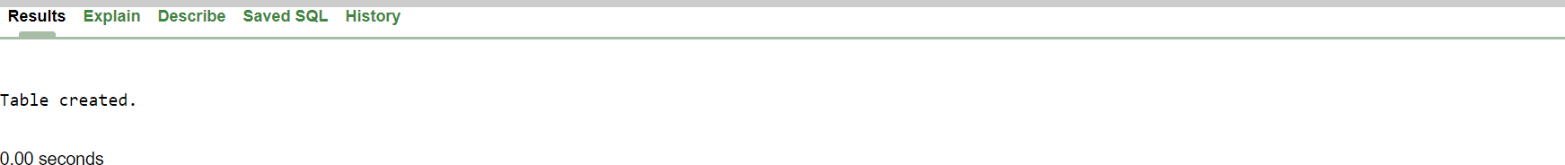

1. **PASS_ACCOUNT TABLE:**

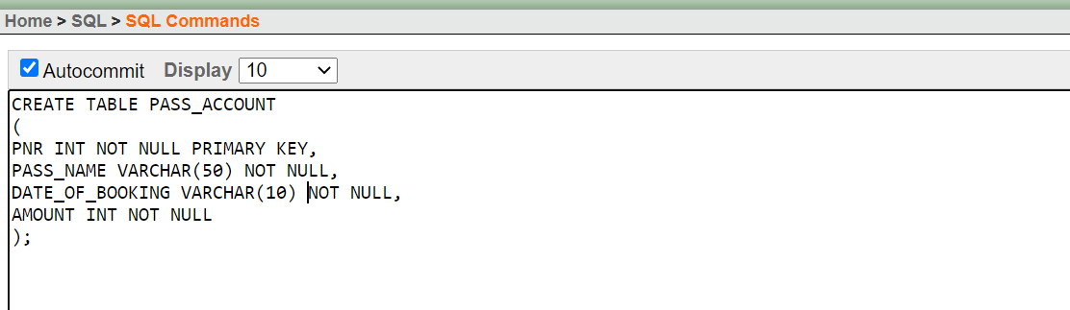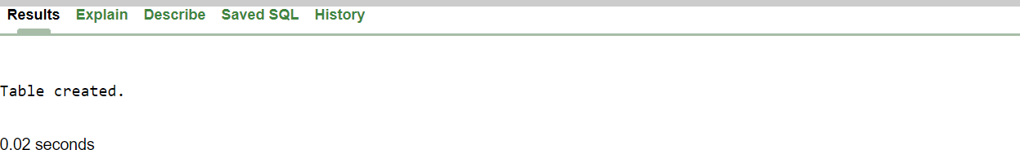

1. **CANCELLATION TABLE:**

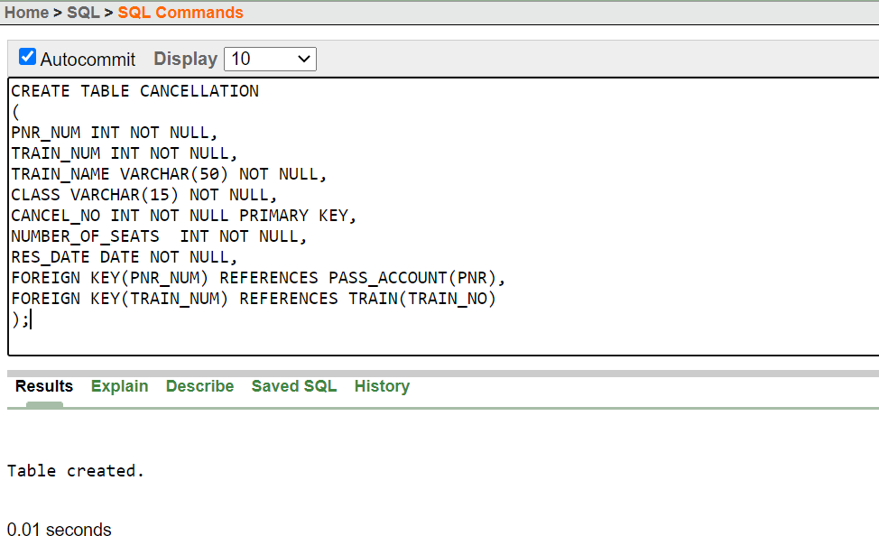

1. **SEAT_AVAILABILITY TABLE:**

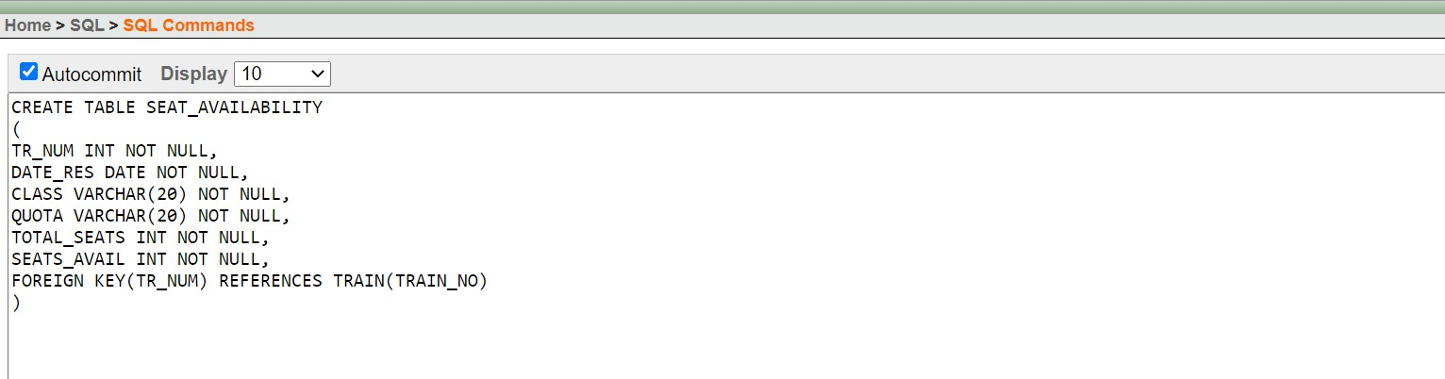



**ALTER TABLE COMMANDS:**

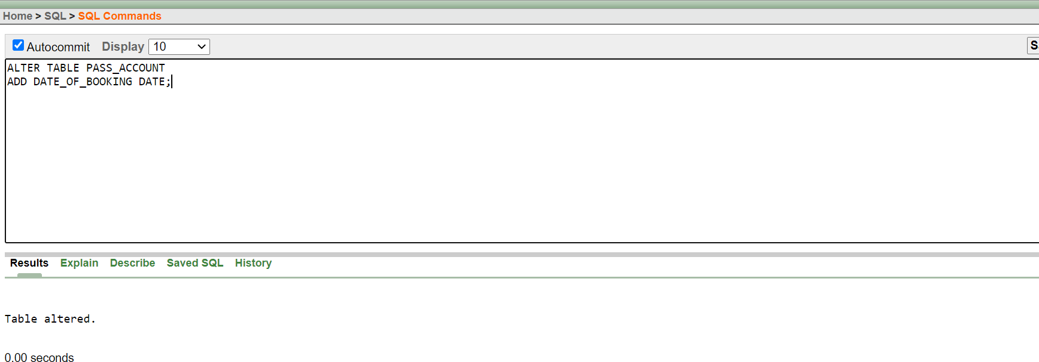

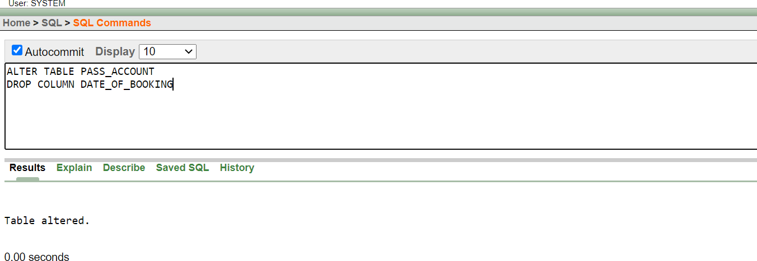

**DML Commands:**

DML stands for Data Manipulation Language. DML commands are used for insertion, deletion and modification of data in a database. The most commonly used DML commands are:

1. INSERT: This command is used to insert new records into a relation.

**Syntax:** INSERT INTO *table_name*

VALUES (*value1*, *value2*, *value3*

*,*...);

1. UPDATE: This command is used to update existing records in a relation.

**Syntax:** UPDATE *table_name*

SET *column1* = *value1*, *column2* = *value2*, ... WHERE *condition*;

1. DELETE: This command is used to delete desired records from a relation.

**Syntax:** DELETE FROM *table_name* WHERE *condition*;

1. SELECT: This command is used to retrieve data from a database.

**Syntax:** SELECT *column1*, *column2, ...* FROM *table_name*;

# Implementing DML Commands:

1. **INSERT:**

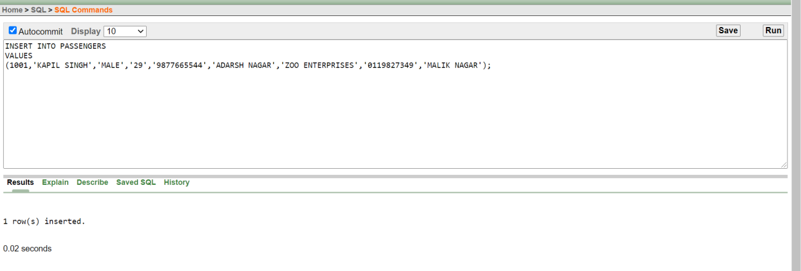

1. **UPDATE:**

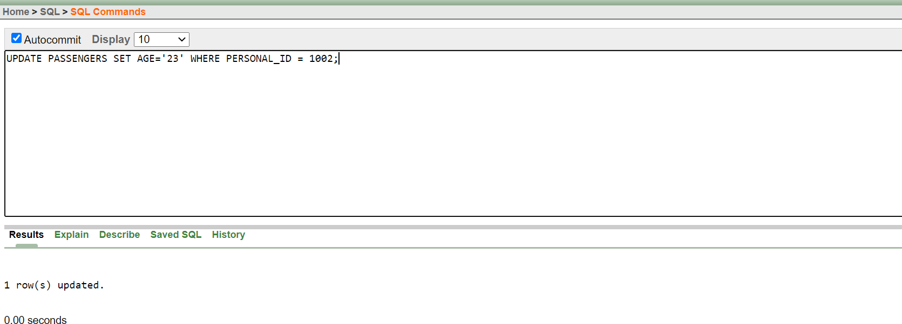

1. **DELETE:**

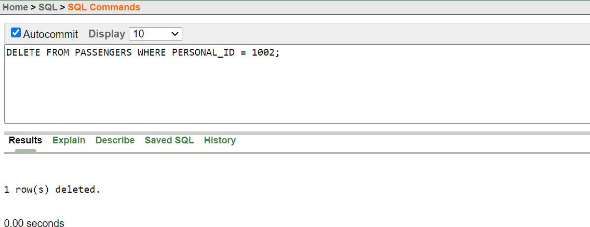

1. **SELECT:**

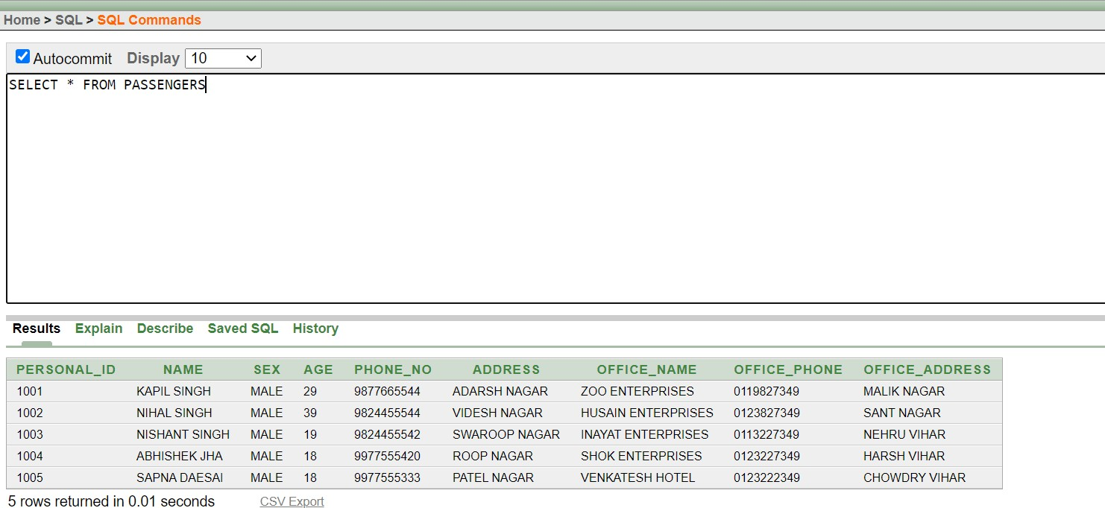

**CONCLUSION:**

At the end of this experiment, various common DDL and DML commands were successfully implemented.

# EXPERIMENT 8

**AIM:** Performing Simple Queries.

# THEORY:

**SQL Queries:**

Queries are used in SQL to manipulate and retrieve data from a database as per requirements. This is achieved with the help of some constraints. In SQL, the SELECT command is used for efficient query processing. The data retrieved is presented in the form a result table and the results are called result-sets.

# Performing Simple Queries:

1. **Retrieve all records from train table where time duration is more than 1111 minutes.**

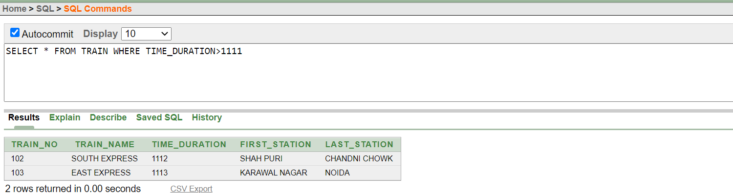

1. **Retrieve all records from passengers table whose age is greater than 20**

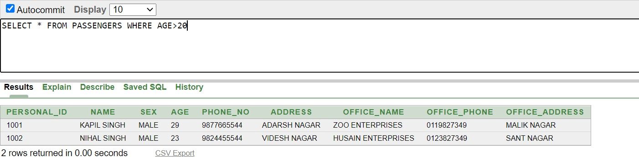

# Display the Passenger Id, Passenger Name and Number of Seats from Reservations Table where TrainNum=103

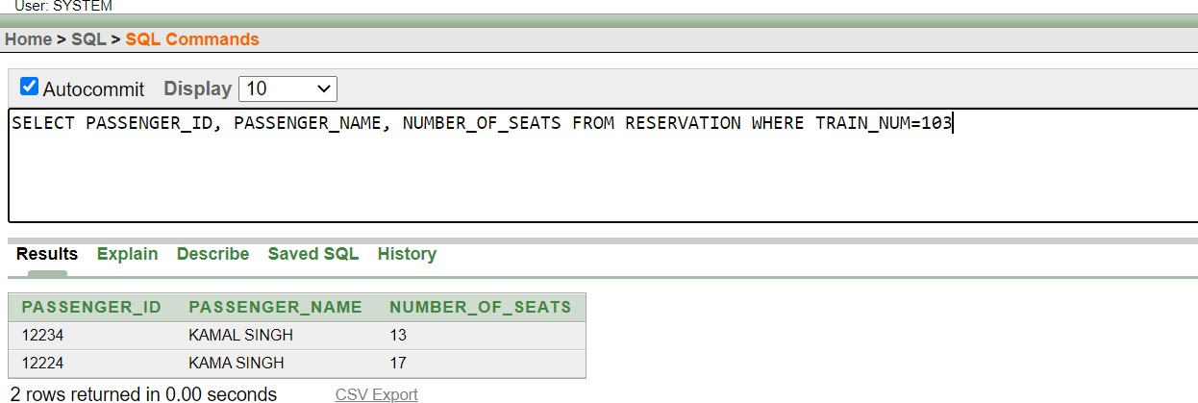

1. **Display those records from Account Table where Amount is between 3200 and 5700**

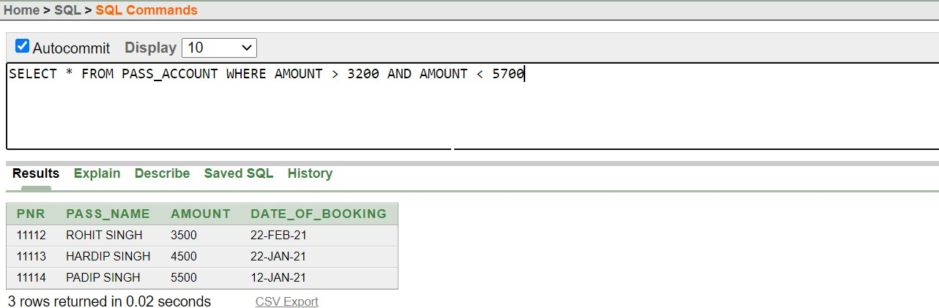

1. **Find out the number of trains in operation on the basis of their class**

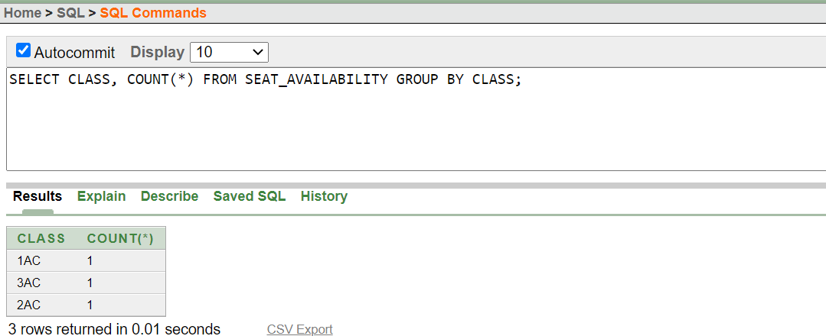

1. **Calculate the total number of seats in trains based on quota**

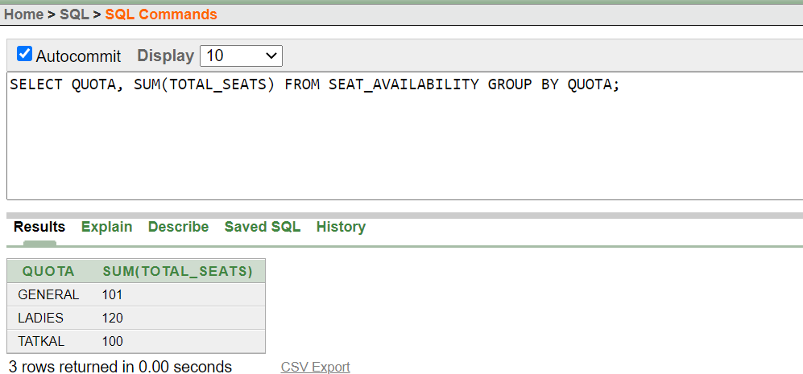

1. **Retrieve information of all bookings from Account table made between 2021- 01-15 and 2021-04-15.**

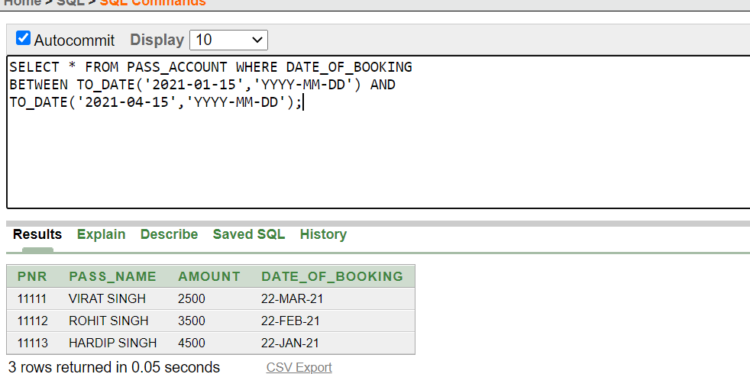

# CONCLUSION:

As observed in the experiment, we understood how to perform simple queries on a database. The significance of the SELECT command and the GROUP BY command was understood. Also, we understood how to use basic aggregate functions like COUNT, SUM AND AVERAGE in SQL.

# EXPERIMENT 9

**AIM:** Implementation of Simple Joins

# THEORY

A Join is clause in SQL that is used to combine records from two or more tables based on a related attribute between them. There are five major joins in SQL. They are listed below.

* **INNER JOIN:** This join is used to retrieve records that have matching values in both relations.
* **LEFT OUTER JOIN:** This join returns all records from the left relation and matching records from the right relation.
* **RIGHT OUTER JOIN:** This join returns all records from the right relation and matching records from the left relation.
* **FULL OUTER JOIN:** This join returns all the records along with their matches in left and right relation wherever they exist.
* **CROSS JOIN:** This join returns the Cartesian product of rows from the relations in the join.

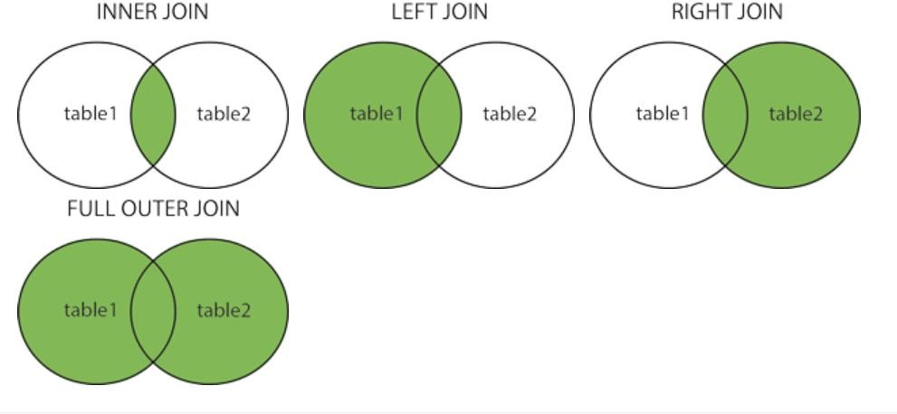

# Implementation of joins:

* Inner Join

**Syntax:** SELECT columns FROM table1 INNER JOIN table2 ON table1.clumn=table2.column WHERE Condition

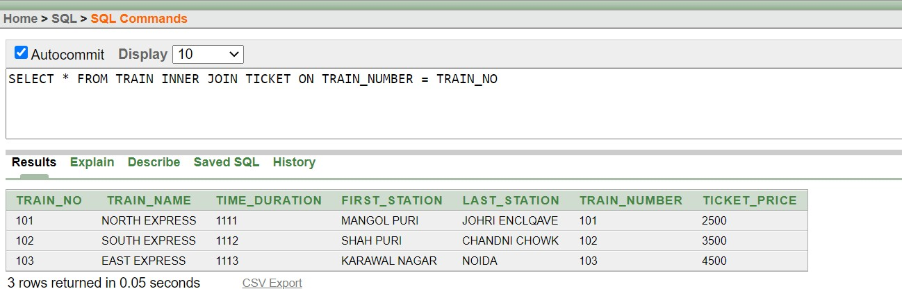

* Left Outer Join

**Syntax:** SELECT columns FROM table1 LEFT OUTER

JOIN table2 ON table1.clumn=table2.column WHERE Condition

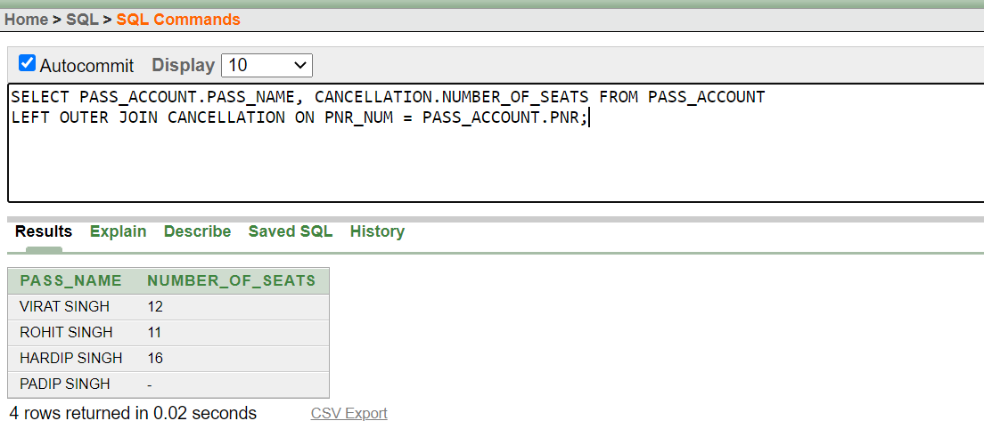

# Right Outer Join

**Syntax:** SELECT columns FROM table1 RIGHT OUTER

JOIN table2 ON table1.clumn=table2.column WHERE Condition

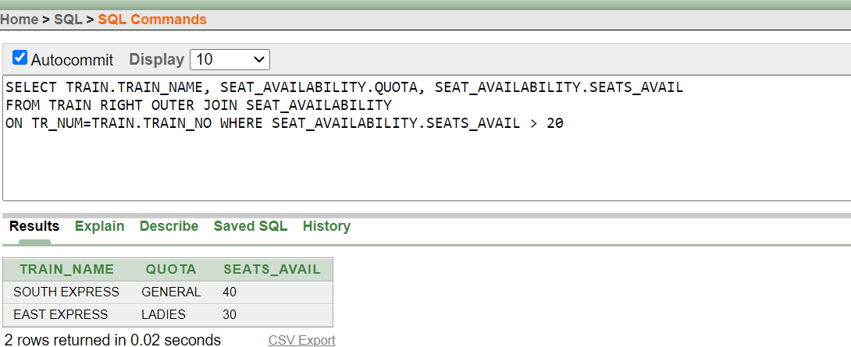

# Full Outer Join

**Syntax:** SELECT columns FROM table1 FULL OUTER JOIN table2 ON table1.clumn=table2.column

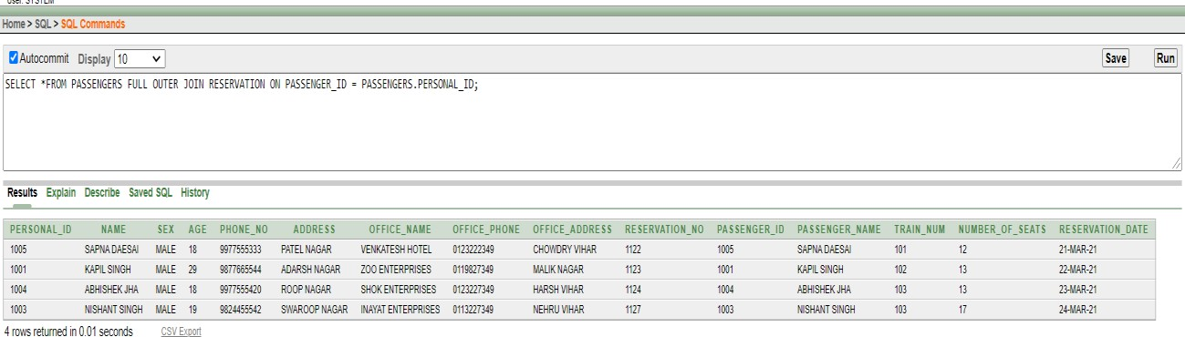

**Conclusion:** We understood how to perform various types of joins in a database and how they work.