## Table of Contents

Contents

Chapter I: Introduction 2

* 1. Introduction 2
  2. Objective 2
  3. Needs of Hotel Management System 3
  4. Methodology Development Model 3
  5. Tools and Technique 4
  6. Specification Requirement 6
     1. External Interfaces 7
     2. Software Product Features 8

Figure: Schema Diagram 12

Chapter II: Task and Activities Performed 15

* 1. Advantage 15
  2. Structure of the project 15
  3. Scope and Feasibility 16
  4. System Analysis 16
  5. System Design 17
  6. Implementation 17
  7. Test Generation 17

Screen Shot 17

## Chapter I: Introduction

# Introduction

Hotel Management System is a hotel reservation site script where site users will be able to search rooms availability with an online booking reservations system. Site users can also browse hotels, view room inventory, check availability, and book reservations in real-time.

Site users enter check in date and check out date then search for availability and rates. After choosing the right room in the wanted hotel – all booking and reservation process is done on the site and an SMS is sent to confirm the booking.

Administrator Panel Account Manager

* Administrator – Administrator can manage administrator accounts and conform the rooms.
* Room Types – Administrator can define the type of rooms in the hotels, room’s prices and upload an image for each room.
* Bookings – All booking and reservations maid on the site are displayed with all booking details: arrival date, departure date, hotel name, room type, number of passengers, price.

# Objective

The Main Objective of hotel organizations could be improved by integrating service-oriented operations service-oriented operations with project management principles. Such integration would instill innovation, proactive attitudes and regulated risk-taking needed to pursue ongoing improvement and proactive response to change. By managing each change as a project, embedded in smoothly running operations, hotels would extend their life span by continuously reinventing themselves. Due to which the customers can easily book the hotels rooms.

# Needs of Hotel Management System

This system will help administration to work easily. Because of its easy access and less time consuming administration can get the information of the Users, Rooms, Payments, etc. They do not have to search in the paper file for the log time. Members an easily handle the system.

# Methodology Development Model

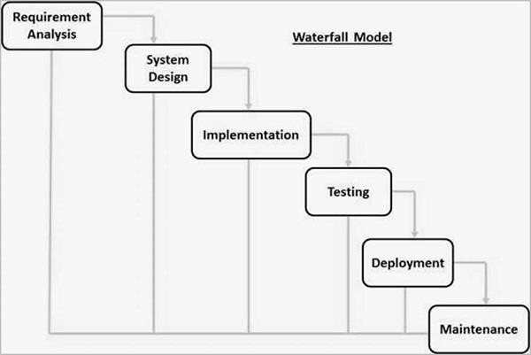

The sequential phases in Waterfall model are −

**Requirement Gathering and analysis** − All possible requirements of the system to be developed are captured in this phase and documented in a requirement specification document.

* + - **System Design** − The requirement specifications from first phase are studied in this phase and the system design is prepared. This system design helps in specifying hardware and system requirements and helps in defining the overall system architecture.
    - **Implementation** − With inputs from the system design, the system is first developed in small programs called units, which are integrated in the next phase. Each unit is developed and tested for its functionality, which is referred to as Unit Testing.
    - **Integration and Testing** − All the units developed in the implementation phase are integrated into a system after testing of each unit. Post integration the entire system is tested for any faults and failures.
    - **Deployment of system** − Once the functional and non-functional testing is done; the product is deployed in the customer environment or released into the market.
    - **Maintenance** − There are some issues which come up in the client environment. To fix those issues, patches are released. Also to enhance the product some better versions are released. Maintenance is done to deliver these changes in the customer environment.

# Tools and Technique

1. Php
2. Xampp
3. Mysql yog
4. HTML
5. Bootstrap
6. Sublime text
7. Git hub
8. Java Script
9. Css

Php

**Hypertext Preprocessor** (or simply **PHP**) is a [server-side scripting](https://en.wikipedia.org/wiki/Server-side_scripting) language designed for [Web](https://en.wikipedia.org/wiki/Web_development) [development,](https://en.wikipedia.org/wiki/Web_development) but also used as a [general-purpose programming language.](https://en.wikipedia.org/wiki/General-purpose_programming_language) It was originally created

by [Rasmus Lerdorf](https://en.wikipedia.org/wiki/Rasmus_Lerdorf) in 1994[,]](https://en.wikipedia.org/wiki/PHP#cite_note-History_of_PHP-5) the PHP [reference implementation](https://en.wikipedia.org/wiki/Reference_implementation) is now produced *by* The PHP Group. PHP originally stood for Personal *Home Page*[,]](https://en.wikipedia.org/wiki/PHP#cite_note-History_of_PHP-5) but it now stands for the [recursive acronym](https://en.wikipedia.org/wiki/Recursive_acronym) *PHP: Hypertext Preprocessor*.

PHP code may be embedded into [HTML](https://en.wikipedia.org/wiki/HTML) code, or it can be used in combination with various [web](https://en.wikipedia.org/wiki/Web_template_system) [template systems,](https://en.wikipedia.org/wiki/Web_template_system) web content management systems, and [web frameworks](https://en.wikipedia.org/wiki/Web_framework). PHP code is usually processed by a PHP [interpreter](https://en.wikipedia.org/wiki/Interpreter_(computing)) implemented as a [module](https://en.wikipedia.org/wiki/Plugin_(computing)) in the web server or as a [Common Gateway](https://en.wikipedia.org/wiki/Common_Gateway_Interface) [Interface](https://en.wikipedia.org/wiki/Common_Gateway_Interface) (CGI) executable. The web server combines the results of the interpreted and executed PHP code, which may be any type of data, including images, with the generated web page. PHP code may also be executed with a [command-line interface](https://en.wikipedia.org/wiki/Command-line_interface) (CLI) and can be used to

implement [standalone](https://en.wikipedia.org/wiki/Computer_software) [graphical applications](https://en.wikipedia.org/wiki/Graphical_user_interface).

Xampp

XAMPP is a [free and open source](https://en.wikipedia.org/wiki/Free_software) [cross-platform](https://en.wikipedia.org/wiki/Cross-platform) [web server](https://en.wikipedia.org/wiki/Web_server) [solution stack](https://en.wikipedia.org/wiki/Solution_stack) package developed by Apache Friends, consisting mainly of the [Apache HTTP Server,](https://en.wikipedia.org/wiki/Apache_HTTP_Server) [MariaDB](https://en.wikipedia.org/wiki/MariaDB) [database](https://en.wikipedia.org/wiki/Database), and [interpreters](https://en.wikipedia.org/wiki/Interpreter_(computing)) for scripts written in the [PHP](https://en.wikipedia.org/wiki/PHP) and [Perl](https://en.wikipedia.org/wiki/Perl) [programming languages](https://en.wikipedia.org/wiki/Programming_language). XAMPP stands for Cross-Platform (X), Apache (A), MariaDB (M), PHP (P) and Perl (P). It is a simple, lightweight Apache distribution that makes it extremely easy for developers to create a local web server for testing and deployment purposes. Everything needed to set up a web server – server application (Apache), database (MariaDB), and scripting language (PHP) – is included in an extractable file. XAMPP is also cross-platform, which means it works equally well on Linux, Mac and Windows. Since most actual web server deployments use the same components as XAMPP, it makes transitioning from a local test server to a live server extremely easy as well.

Mysql yog

MySQL Workbench is a unified visual tool for database architects, developers, and DBAs. MySQL Workbench provides data modeling, SQL development, and comprehensive administration tools for server configuration, user administration, backup, and much more. MySQL Workbench is available on Windows, Linux and Mac OS X.

HTML

Hypertext Markup Language (HTML) is the standard [markup language](https://en.wikipedia.org/wiki/Markup_language) for creating [web pages](https://en.wikipedia.org/wiki/Web_page) and [web](https://en.wikipedia.org/wiki/Web_application) [applications.](https://en.wikipedia.org/wiki/Web_application) With [Cascading Style Sheets](https://en.wikipedia.org/wiki/Cascading_Style_Sheets) (CSS) and [JavaScript](https://en.wikipedia.org/wiki/JavaScript), it forms a triad of cornerstone technologies for the [World Wide Web](https://en.wikipedia.org/wiki/World_Wide_Web)[.[4]](https://en.wikipedia.org/wiki/HTML#cite_note-4)

[Web browsers](https://en.wikipedia.org/wiki/Web_browser) receive HTML documents from a [web server](https://en.wikipedia.org/wiki/Web_server) or from local storage and [render](https://en.wikipedia.org/wiki/Browser_engine) the documents into multimedia web pages. HTML describes the structure of a web page [semantically](https://en.wikipedia.org/wiki/Semantic_Web) and originally included cues for the appearance of the document.

[HTML elements](https://en.wikipedia.org/wiki/HTML_element) are the building blocks of HTML pages. With HTML constructs, [images](https://en.wikipedia.org/wiki/HTML_element#Images_and_objects) and other objects such as [interactive forms](https://en.wikipedia.org/wiki/Fieldset) may be embedded into the rendered page. HTML provides a means to

create [structured documents](https://en.wikipedia.org/wiki/Structured_document) by denoting structural [semantics](https://en.wikipedia.org/wiki/Semantics) for text such as headings, paragraphs, lists, [links,](https://en.wikipedia.org/wiki/Hyperlink) quotes and other items.

Bootstrap

Bootstrap is a [free and open-source](https://en.wikipedia.org/wiki/Free_and_open-source_software) front-end framework for designing [websites](https://en.wikipedia.org/wiki/Website) and [web applications](https://en.wikipedia.org/wiki/Web_application). It contains [HTML](https://en.wikipedia.org/wiki/HTML)- and [CSS](https://en.wikipedia.org/wiki/CSS)-based design templates for [typography](https://en.wikipedia.org/wiki/Typography), forms, buttons, navigation and other

interface components, as well as optional [JavaScript](https://en.wikipedia.org/wiki/JavaScript) extensions. Unlike many web frameworks, it concerns itself with [front-end development](https://en.wikipedia.org/wiki/Front-end_web_development) only.

Java Script

JavaScript often abbreviated as JS, is a [high-level,](https://en.wikipedia.org/wiki/High-level_programming_language) [interpreted](https://en.wikipedia.org/wiki/Interpreted_language) [programming language](https://en.wikipedia.org/wiki/Programming_language). It is a language which is also characterized as [dynamic,](https://en.wikipedia.org/wiki/Dynamic_programming_language) [weakly typed,](https://en.wikipedia.org/wiki/Weak_typing) [prototype-based](https://en.wikipedia.org/wiki/Prototype-based_programming) and [multi-paradigm](https://en.wikipedia.org/wiki/Multi-paradigm_programming_language).

Alongside [HTML](https://en.wikipedia.org/wiki/HTML) and [CSS,](https://en.wikipedia.org/wiki/CSS) JavaScript is one of the three core technologies of the [World Wide](https://en.wikipedia.org/wiki/World_Wide_Web)

[Web.](https://en.wikipedia.org/wiki/World_Wide_Web) JavaScript enables interactive [web pages](https://en.wikipedia.org/wiki/Web_page) and thus is an essential part of [web applications](https://en.wikipedia.org/wiki/Web_application). The vast majority of [websites](https://en.wikipedia.org/wiki/Website) use it, and all major [web browsers](https://en.wikipedia.org/wiki/Web_browser) have a dedicated [JavaScript engine](https://en.wikipedia.org/wiki/JavaScript_engine) to execute it.

Sublime Text

Sublime Text is a [proprietary](https://en.wikipedia.org/wiki/Proprietary_software) [cross-platform](https://en.wikipedia.org/wiki/Cross-platform) [source code editor](https://en.wikipedia.org/wiki/Source_code_editor) with a [Python](https://en.wikipedia.org/wiki/Python_(programming_language)) [application programming](https://en.wikipedia.org/wiki/Application_programming_interface) [interface](https://en.wikipedia.org/wiki/Application_programming_interface) (API). It natively supports many [programming languages](https://en.wikipedia.org/wiki/Programming_languages) and [markup languages,](https://en.wikipedia.org/wiki/Markup_languages) and functions can be added by users with [plugins,](https://en.wikipedia.org/wiki/Plugins) typically community-built and maintained under [free-software](https://en.wikipedia.org/wiki/Free_software_licenses) [licenses.](https://en.wikipedia.org/wiki/Free_software_licenses)

Github

GitHub is a web-based [hosting service](https://en.wikipedia.org/wiki/Internet_hosting_service) for [version control](https://en.wikipedia.org/wiki/Version_control) using [Git.](https://en.wikipedia.org/wiki/Git) It is mostly used for [computer code.](https://en.wikipedia.org/wiki/Source_code) It offers all of the [distributed version control](https://en.wikipedia.org/wiki/Distributed_version_control) and [source code management](https://en.wikipedia.org/wiki/Source_code_management) (SCM) functionality of Git as well as adding its own features. It provides [access control](https://en.wikipedia.org/wiki/Access_control) and several collaboration features such as [bug](https://en.wikipedia.org/wiki/Bug_tracking_system)

[tracking,](https://en.wikipedia.org/wiki/Bug_tracking_system) [feature requests,](https://en.wikipedia.org/wiki/Software_feature) [task management,](https://en.wikipedia.org/wiki/Task_management) and [wikis](https://en.wikipedia.org/wiki/Wiki) for every project.

GitHub offers plans for both private repositories and free accounts which are commonly used to host [open-](https://en.wikipedia.org/wiki/Open-source) [source](https://en.wikipedia.org/wiki/Open-source) software projects.

Css

Cascading Style Sheets (CSS) is a [style sheet language](https://en.wikipedia.org/wiki/Style_sheet_language) used for describing the [presentation](https://en.wikipedia.org/wiki/Presentation_semantics) of a document written in a [markup language](https://en.wikipedia.org/wiki/Markup_language) like [HTML.](https://en.wikipedia.org/wiki/HTML) CSS is a cornerstone technology of the [World Wide](https://en.wikipedia.org/wiki/World_Wide_Web) [Web,](https://en.wikipedia.org/wiki/World_Wide_Web) alongside HTML and [JavaScript.](https://en.wikipedia.org/wiki/JavaScript)

CSS is designed to enable the separation of presentation and content, including [layout](https://en.wikipedia.org/wiki/Page_layout), [colors](https://en.wikipedia.org/wiki/Color),

and [fonts.](https://en.wikipedia.org/wiki/Typeface) This separation can improve content [accessibility,](https://en.wikipedia.org/wiki/Accessibility) provide more flexibility and control in the specification of presentation characteristics, enable multiple [web pages](https://en.wikipedia.org/wiki/Web_page) to share formatting by specifying the relevant CSS in a separate css file, and reduce complexity and repetition in the structural content.

## Specification Requirement

## External Interfaces

- This interface will be actual interface through which the user will communication with the application and perform the desired tasks.

Admin login

### D:

**Role**: Admin wishes to login to the system

**Precondition**: Username and Password

**Success end Condition**: Main option of screen display

**Failed end Condition**: User has entered incorrect Username and Password or both

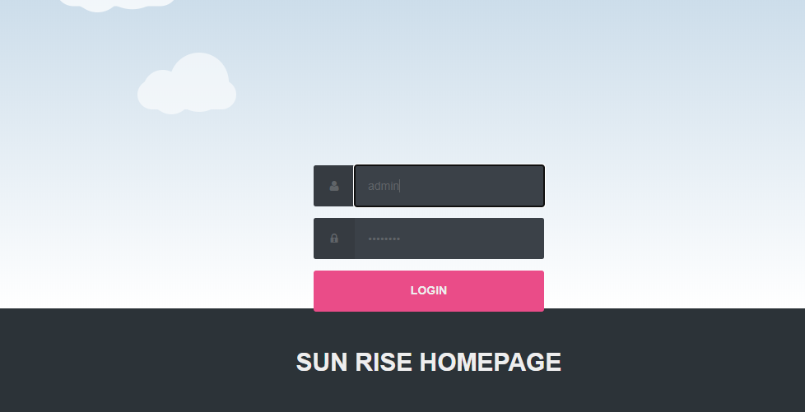

Conform

### ID:

**Precondition:** Admin has successfully navigated to the search result

**Success end Condition:** Admin has successfully made the changes

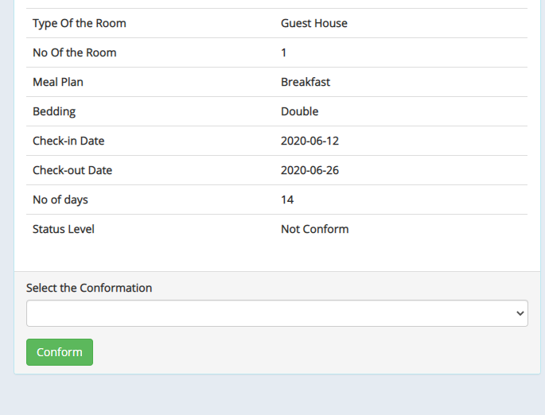

## Software Product Features

Hotel Management System

* Sequencing information

-Login information should be filled before the user allowed.

* Error Handling

-If user doesn’t filled up validate information then the system display error message for user and request to enter the validate information.

Performance required

* Security

-System should be Protected from unauthorized access Where the validate Username and Password are required so no other can access.

Logical Database

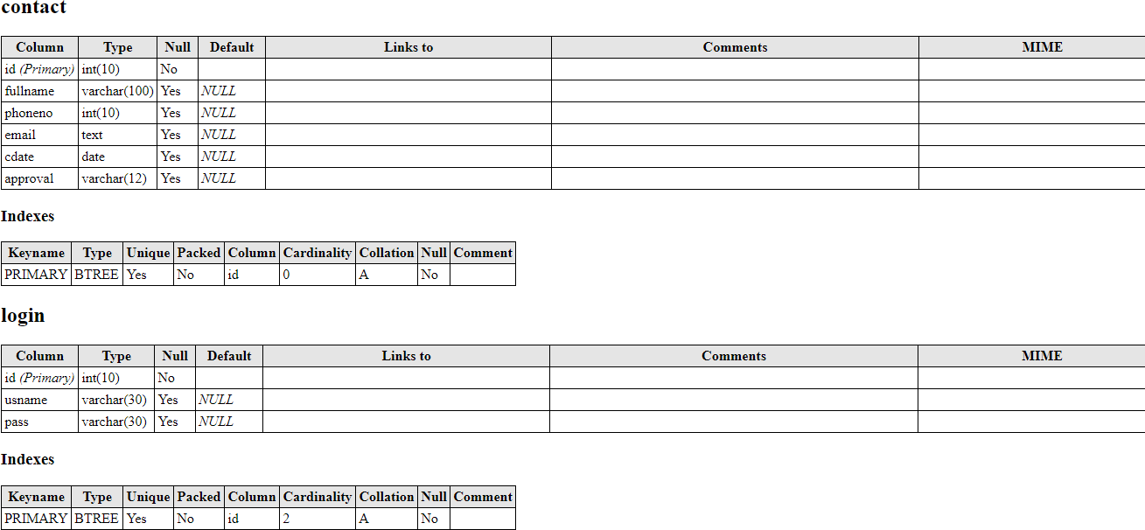

Data Design

Data Model: A database model is a type of data model that determines the logical structure of a database and fundamentally determines in which manner data can be stored, organized and manipulated.

Level

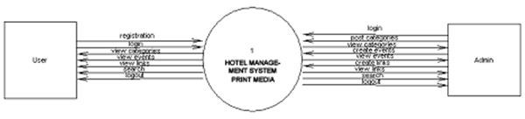

Figure: Data flow

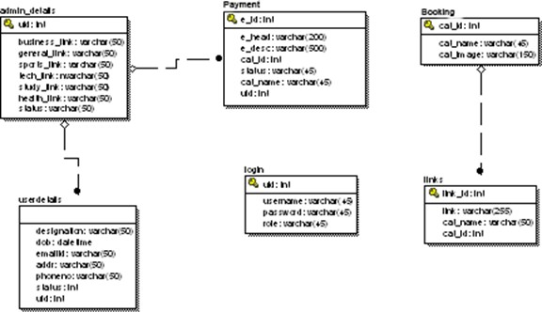

Figure: ER diagram

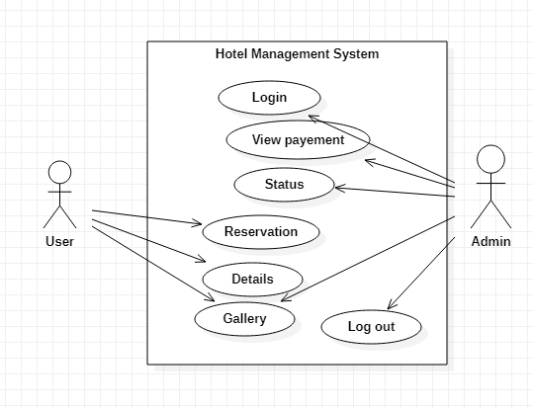

Figure: Use case Diagram

Database

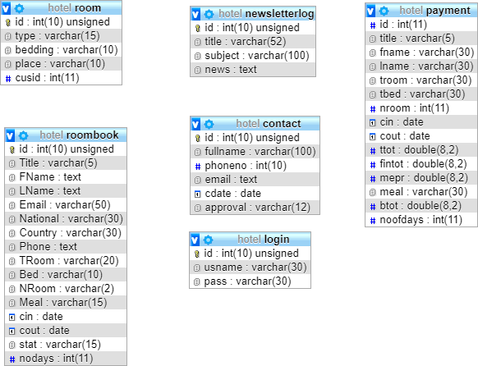

**Figure: Schema Diagram**

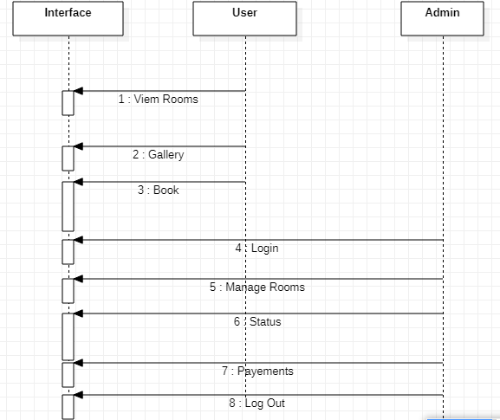

Figure: Sequence Diagram

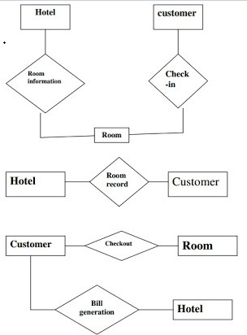

Figure: Flowchart

## Chapter II: Task and Activities Performed

# Advantage

* The advantages of *booking* a *hotel online* add up long before your arrival. Our legendary customer service extends to the web
* One advantage of booking with the hotel directly is the use of the hotel's full cancellation policy as well as not needing a deposit in most situations.
* Read reviews and compare prices for *Online Hotel Booking*.
* The most important advantage of online hotel booking is convenience, you can book your room by simply sitting in home. Internet helps you to browse through the hotels around the world and compare the facilities and rates easily.

# Structure of the project

## After Administrator Login

* + Status
  + View Booking
  + View Rooms
  + View payment’s
  + News Letter
  + Logout
* Users visit
  + View rooms
  + View Gallery
  + View services
  + Book

# Scope and Feasibility

This activity is also known as the feasibility study.

Perform and evaluate feasibility studies like cost-benefit analysis, technical feasibility, time feasibility and operational feasibility for the project. Project Scheduling should be made using chats. Feasibility study is carried out t decide whether the proposed system is feasible for the company. It begins with a request from the user for a new system. It involves the following:

## Identify the responsible user for a new system

* + - Clarify the user request
    - Identify deficiencies in the current system
    - Establish goals and objectives for the new system
    - Determine the feasibility for the new system
    - Prepare a project charter that will be used to guide the remainder of the Project

# System Analysis

It is a process of collecting and interpreting facts, identifying the problems, and decomposition of a system into its components.

System analysis is conducted for the purpose of studying a system or its parts in order to identify its objectives. It is a problem solving technique that improves the system and ensures that all the components of the system work efficiently to accomplish their purpose.

The objective of the system analysis activity is to develop structured system specification for the proposed system. The structured system specification should describe what the proposed system would do; independent of the technology, which will be used to implement these requirements. The structured system specification will be used to implement these requirements.

The essential model may itself consist of multiple models, modeling different aspect of the system. The data flow diagrams may model the data and there relationships and the state transition diagram may model time dependent behavior of the system. The essential model thus consists of the following.

* + - Context diagram
    - Leveled data flow diagrams
    - Process specification for elementary bubbles
    - Data dictionary for the flow and stores on the DFDs.

# System Design

System design involves transformation of the user implementation model into software design. The design specification of the proposed system consists of the following:

* + - Database scheme
    - Sequence Diagram
    - Flow Chart

# Implementation

This activity includes programming, testing and integration of modules into a progressively more complete system. Implementation is the process of collect all the required parts and assembles them into a major product.

# Test Generation

This activity generates a set of test data, which can be used to test the new system before accepting it. In the test generation phase all the parts are come which are to be tested to ensure that system does not produce any error. If there are some errors then we remove them and further it goes for accepting.

# Screen Shot

Login Page



Home Page

