AWS DevOps
Old Days:
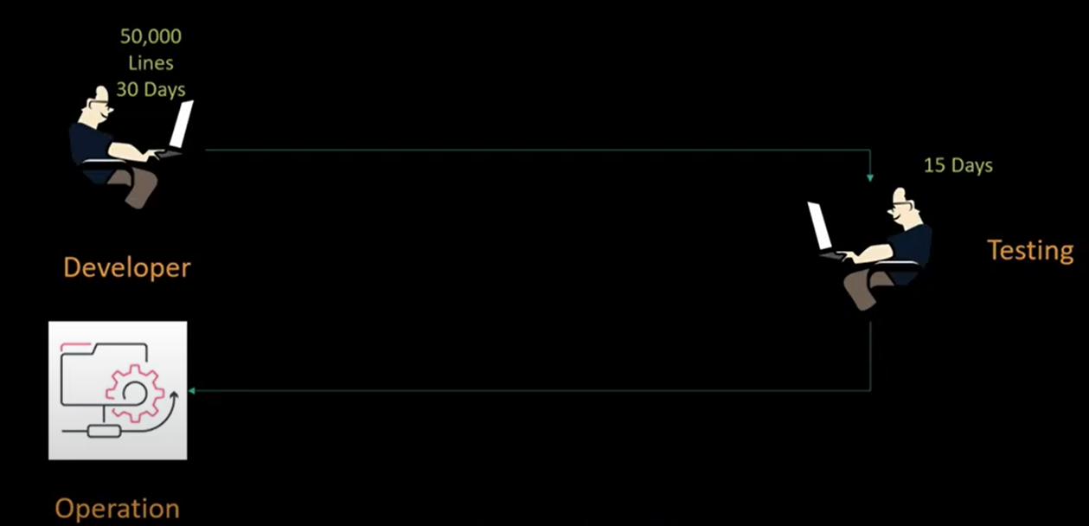
DevOps: Is a methodology but not the tools …. DevOps makes the S/W development and release very much easy and fast.
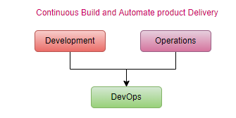
Continuous Deployment/Delivery
Starts after build generates artifacts
Continuous Integration with source code-> artifact
Continuous Deployment, application deployed on the servers and available to end-users
Continuous Delivery (CI/CD is continuous delivery to business)
UC: We have developed web application have 50 functionalities, packaged it in artifacts (.war/. ear) and expected to support 1000 concurrent users.
step1: write code
step2: build it, deploy on integration server, can support 1000 concurrent user? Are all 50 functionalities running fine?
step3: if desired behavior is ok, then deploy it on production.
step4: monitor, if there are 2000 concurrent users then behavior?
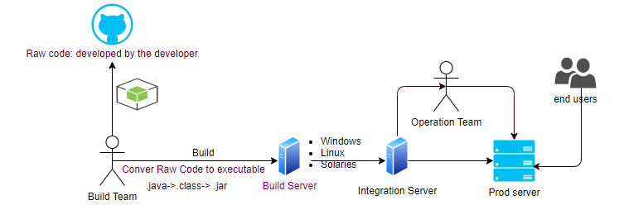
DevOps is a process to automate the all steps using proper tools.
statement: application running fine in dev machine, but not running in qa machine?
measure: is all configuration available? Is version in both environments are same?
action: package all the dependencies together and deploy, automate the process.
result: less time of deployment, less chance of failure.
UC: If instead of package, someone give us Raw Source Code?
First, we have to build the Raw Source Code.
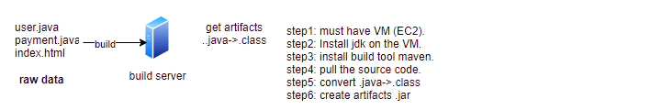
Cloud means everything is virtual.
step1: Infrastructure in the cloud.
step2: Application deployment over Cloud IT resources.
Infrastructure and Application Deployment
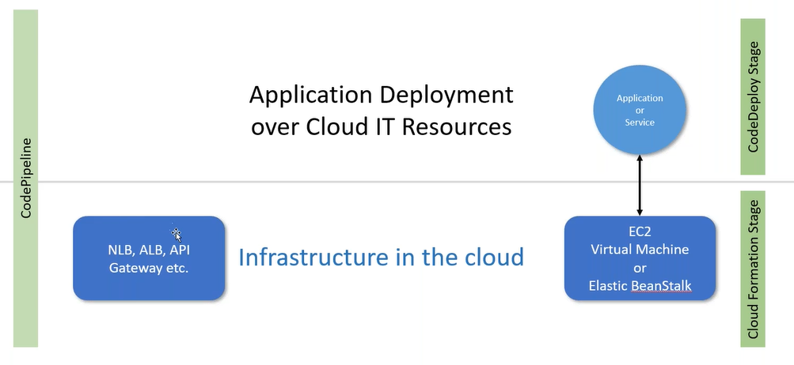
AWS Core Services
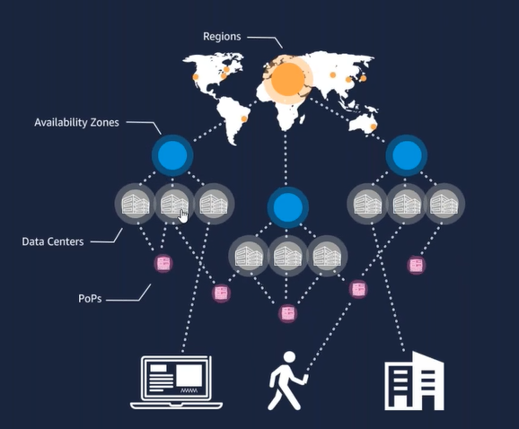
- Regions
- AZ
- Data Centers
- POP (reduce latency collaborate with third party): Using DNS and anycast (reduce latency nearest POP)
status.aws.amazon.com
#Click on personal health dashboard (global service): service used in your account (outage).
Event log # within the personal health dashboard
cloudharmony.com # different-different cloud service provider
Cloud Concept for each and every vendor almost same, just like a car manufactured by different vendors.

Rule for Palace (must be follow, you enter from any side)
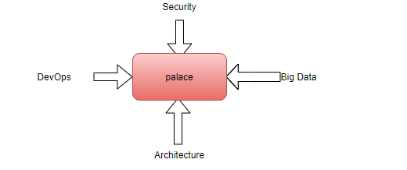
Shared Security Responsibility Model:
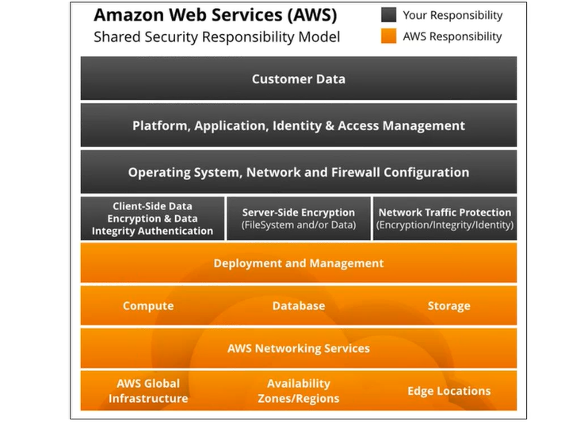
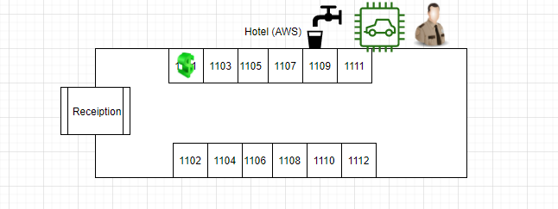
AWS Organization Account:
Define a service policy at organization level will by default applicable to all child accounts.
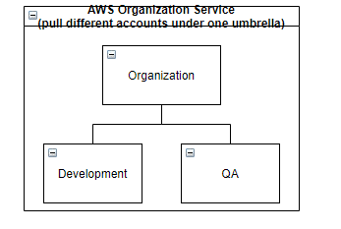
Each service comes with different layers
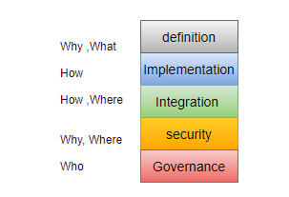
Using different-different services we automate our process; DevOps enables the same.
DevOps is about creating an environment and then deploy the application, after that making them secure and monitoring.
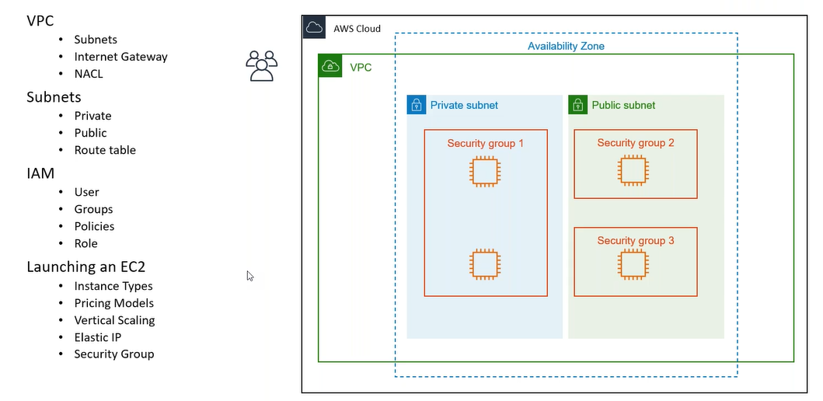
Setup:
How I Isolate my resources from other’s resources?
VPC:
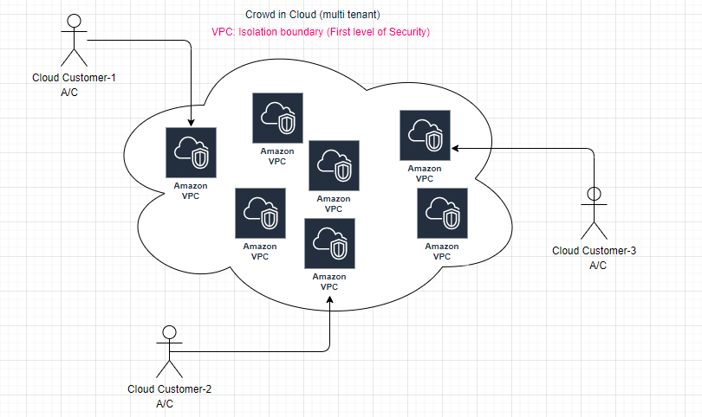
VPC- one default VPC per region
Subnet- subnet corresponding to each AZ.
public subnet: associated with IGW (entry of igw in associated route table), auto assign public ip
private subnet: not associated with IGW (NAT Gateway)
main objective of VPC is to isolate our resources , never use the pre-configured VPC (spans over all AZ with in the region).
IP address range:
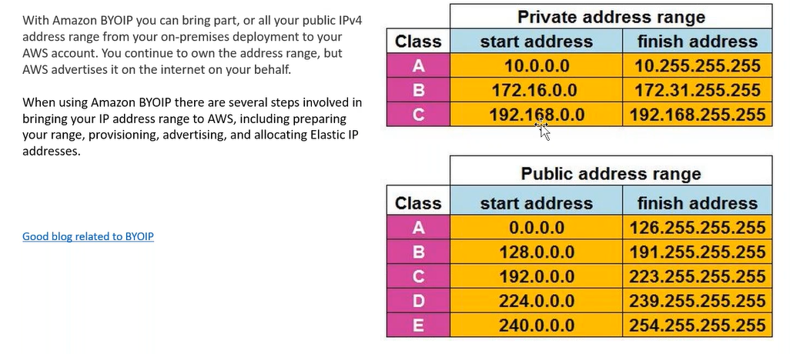
private address don’t move between different networks.
step1: create your own VPC ( LAN-default 5 vpc per account): private IP range
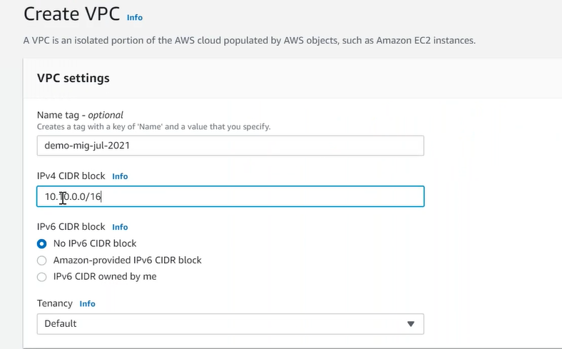
step2: By default one subnet per AZ is available, in customized vpc create own two subnets in AZ1 and AZ2, and create EC2 instances with in the subnets.
step3: As of now EC2 is not accessable to the Internet.
step4: Create your own IGW (attach with VPC).
step5: Create route table associated with subnet.
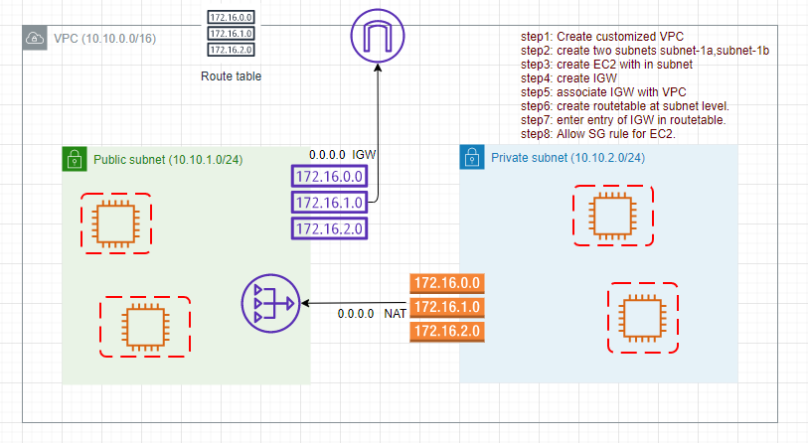
NAT Gateway: EC2 instance inside private subnet access internet through the NAT.
DHCP issues private IP for EC2 .
SG (EC2 level): Deny all traffic by default (Statefull).


NACL (subnet level): Allows all traffic by default (Sateless). Rule are evaluated sequentially.
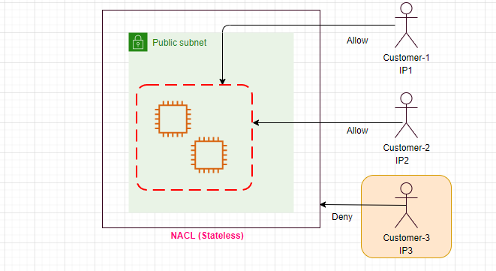
ports?
entry point, without port can’t run more than one application on the same server.
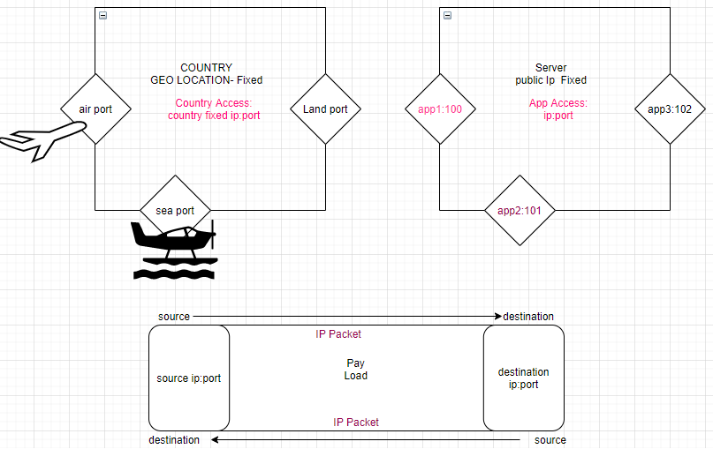
BYOIP: Bring your own IP,all public IP are paid, by default AWS assigns public ip address from its owned pool of public ip addrsses.
Elastic IP: static IP address (associate/release)
status check:
system status check: Infrastructure in which EC2 is hosting is correct
instance status check: Is that Instance reachable?
public subnet: - EC2 instances have public as well as private IP addresses.
private subnet: - EC2 instances have only private IP addresses.

