Day2
VPC (IGW, main route table), AZ, Subnet (route table) & IP Address.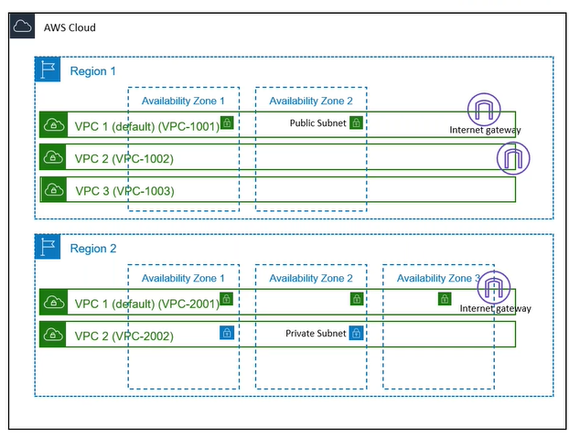
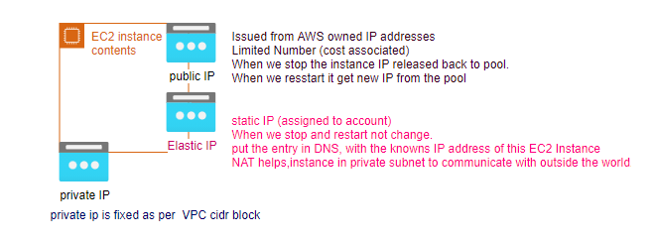

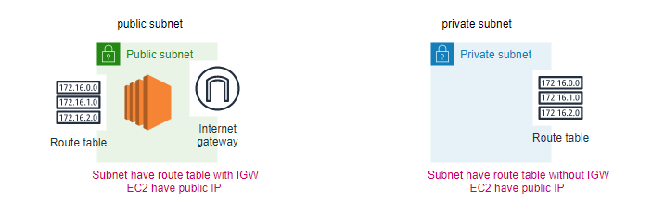

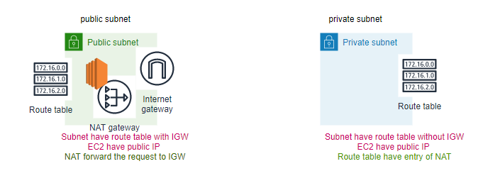
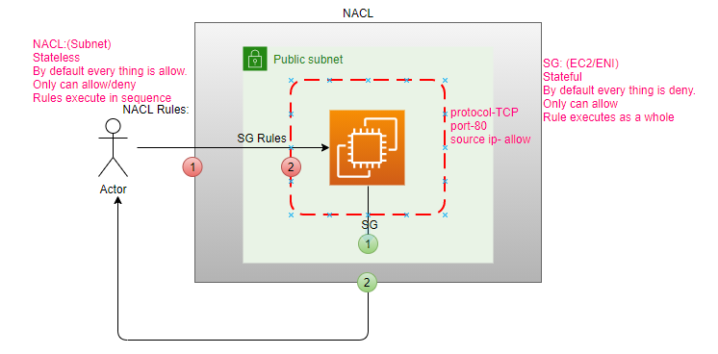

Why we need NACL?
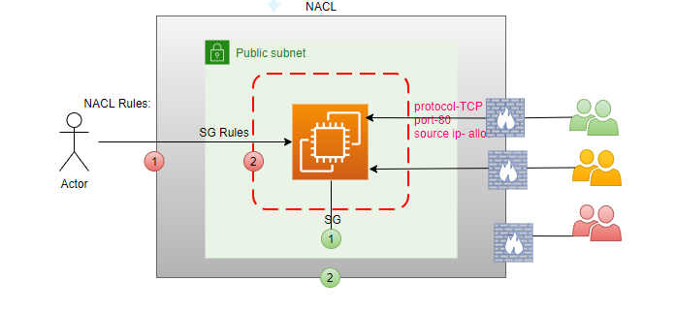

IAM: (who has access to the resources)
IAM (Authorization, Authentication, Users, Groups,Roles,Policy)
ABAC (Attribute based access control): Using tags
Context: With in the Account
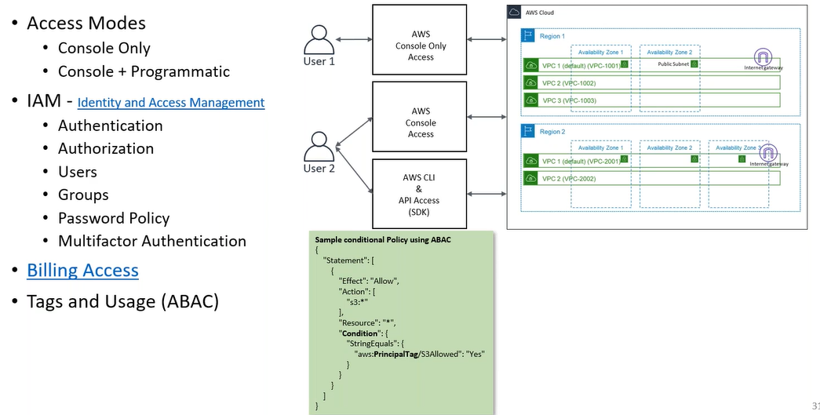

step1: IAM-> create a user
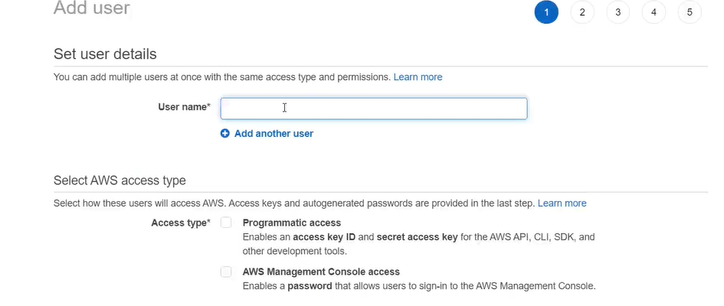

Access Modes:
- Programmatic(SDK,CLI): access key id, secret access key
- AWS Console: password
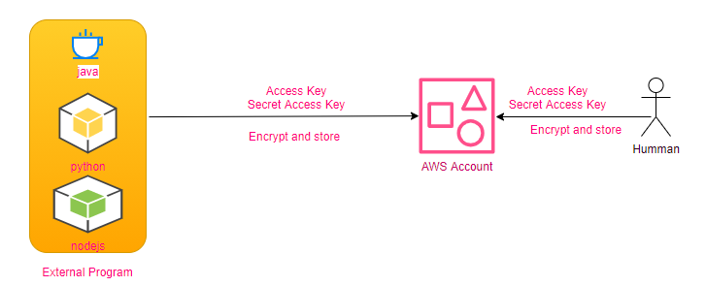
User Group: One than more Users
Policy: access permissions:
“Statements”: { “Effect”: “Allow”,
“Action”: [“s3-outposts:Get*”,” s3-outposts:List*”],
“Resource”: “*”,
“Condition”:{tag} },]
Roles: ( Initiater of the Role)
Two services (AWS resources) with in AWS must be communicate to each other through the Role. 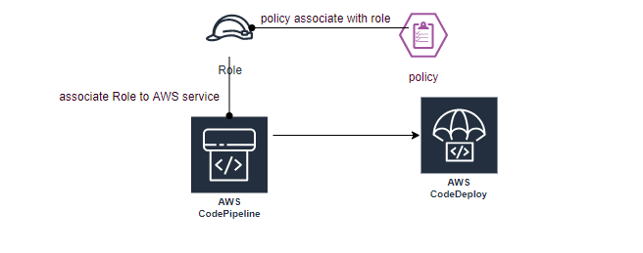
When human trying to access AWS resources using: console / Access and Secret Key, when AWS resource trying to access another AWS resource using: role,Policies can be assigned to user/user group or to Role.
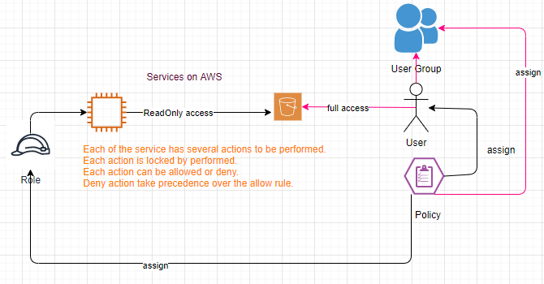
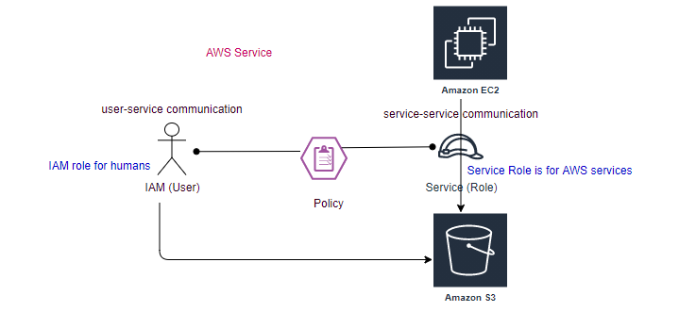
access key and secret key stored in .aws\credentials its only for CLI and SDK access. Its not for console access, its for external access.
Policies are written in JSON (Java Script Object Notation).
Each service can provide different actions using policies can allow or deny specific action.
EC2: (AMI)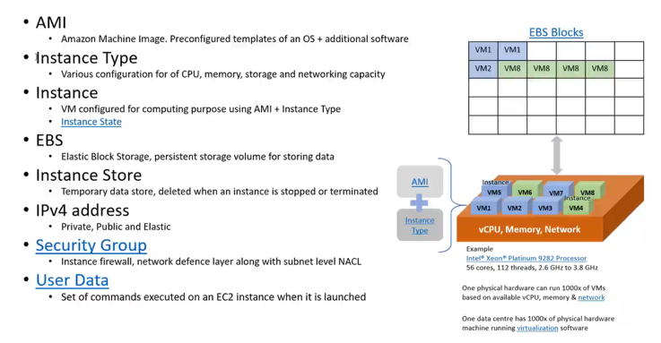
AMI: O/S + additional s/w
- Root Device Type (boot drive): ebs (persistent)/ instance store(temprary)
- Virtulization Type: hvm/paravirtual
- ENA enabled: Yes/No
Instance Type: Various configuration for CPU,memory,storage and network capacity.
Instance Store: Temprary (transitory work load)
EBS: (Elastic Block Storage): Can Only Increase the Storage, but can’t reduce, have boot drive.
Logical Unit Number (LUN)
Difference between EBS enabled (storage) Instance Store enabled devices
O/S has to load from some where, It is a temprary drive as soon as we stop the device instance type drive is revoked.
Storage Type: EBS (persistent volume to store data), EFS, S3(Object Storage)
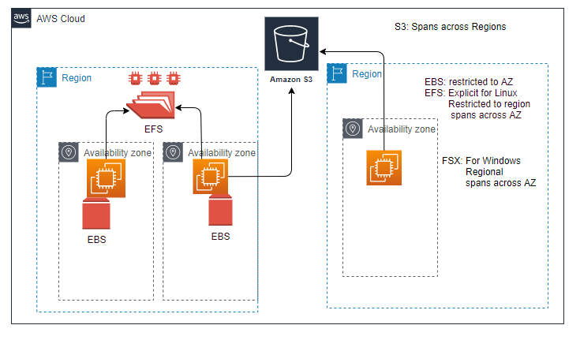
Status Checks
System Check: This check verifies that your instance is reachable. We test that we are able to get network packets to your instance. If this check fails , there may be issue with the infrastructure hosting your instance (such as AWS power, networking or software system). You may need to restart or replace the instance, wait for our system to resolve the issue, or seek technical support.This check does not validate that your operating system and applications are accepting traffic.( Underneeth configuration is available and not corrupted)
Instance Status Check: Once System check is passed, this check verifies that your instance’s O/S is accepting traffic.If this check fails you may need to reboot your instance or make modification to your operating system configuration.( Is reachable from outside the world)
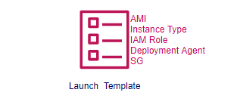
Scalling:
Vertical Saling: Stop ( update from t2.micro->t2.small) , and then restart.
Can’t vertical scale instance type at run time, first stop the instance then vertical scale the type.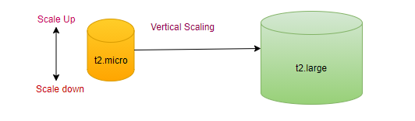
Horizontal Saling: automate with zero downtime, Increase the number of resources of same capacity.
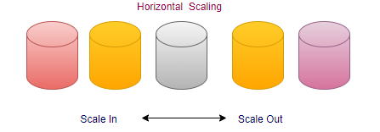
User Data:
Set of commands executed on the EC2 instance when it is launched (boot starp).
step1: choose the EC2 instance.
step1.1: right click-> Monitor and troubleshoot-> Get System log
All communication with in subnet through private IP.
HA through multi-AZ.
AWS CLI: 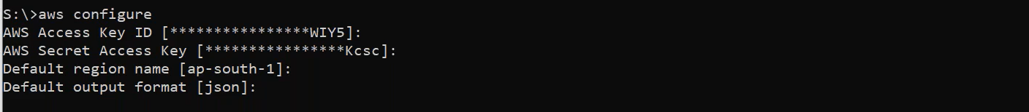
aws s3 ?
aws s3 cp ?
Automate:
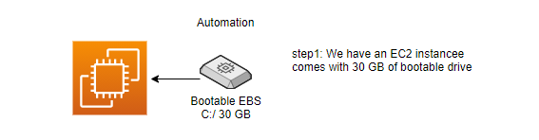
UC: Can we make it 100 GB on the fly?
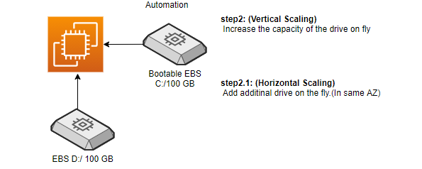
Only can Increase the size, can’t decrease. Take small resource, test and increase capacity if required.

AWS DevOps:
DevOps is a culture where developers and operation teams work together.
Code Pipeline: Caring out certain tasks in sequence(appspec.yaml).
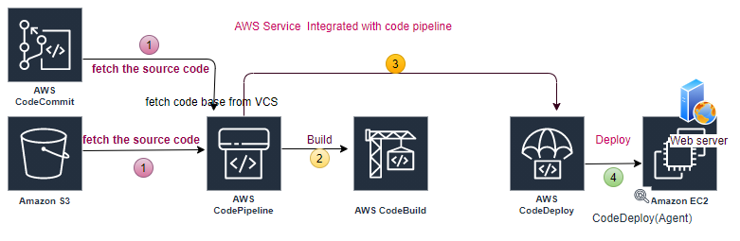
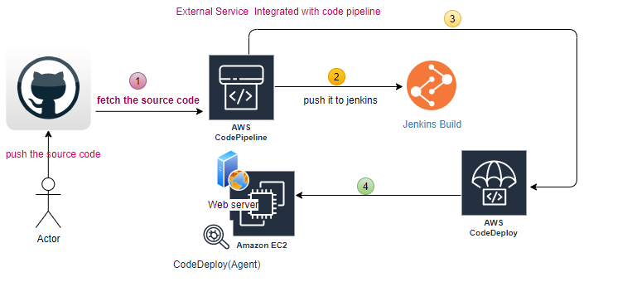
UC1: pick from s3 and deploy toward my webserver (EC2)
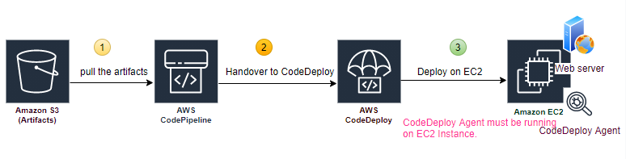
step1: Install Webserver and CodeDeploy agent on EC2 (tag).
step2: create an application in CodeDeploy.
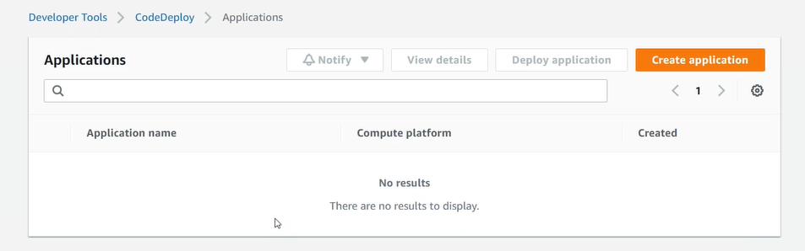
step2.1: Application Configuration.
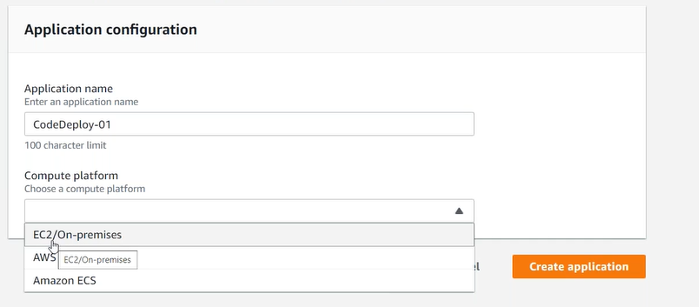
step2.2: Create Deployment Groups (Group of EC2 instances).
step2.3: Service Role (CodeDeploy access to your target Instances), CodeDeploy communicates with CodeDeployment Agent running on EC2 Instance. Then Agent follow the Instruction (script appspec.yaml).
step2.4: Agent also has to communicate back to CodeDeploy, EC2 must have role assigned to it, to communicate with CodeDeploy.
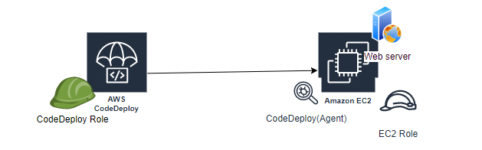

step3: Go to pipeline (ensure source code is available on S3, Instance are running and CodeDeploy agent running on it).
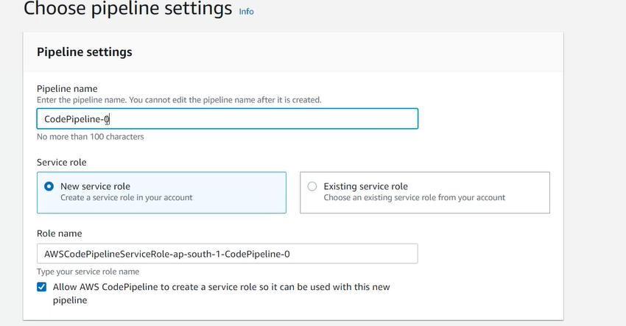
step3.1: Add source stage.
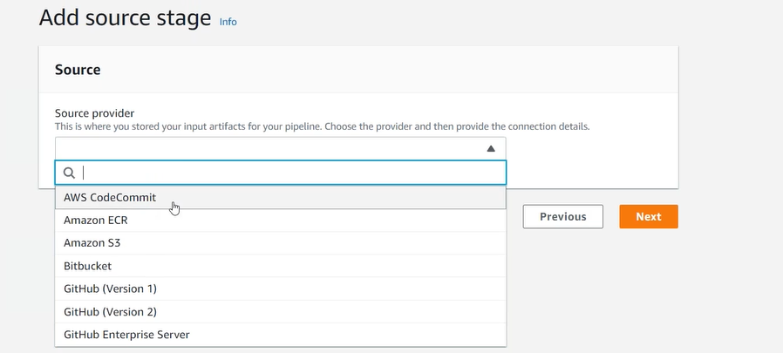
step3.2: Add build stage (optional).
step3.3: Add deploy stage
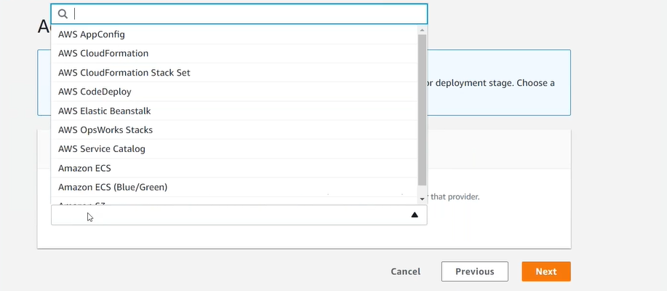
step4: Create Pipeline, our S3 bucket must be version enabled.
step4.1: pipeline view
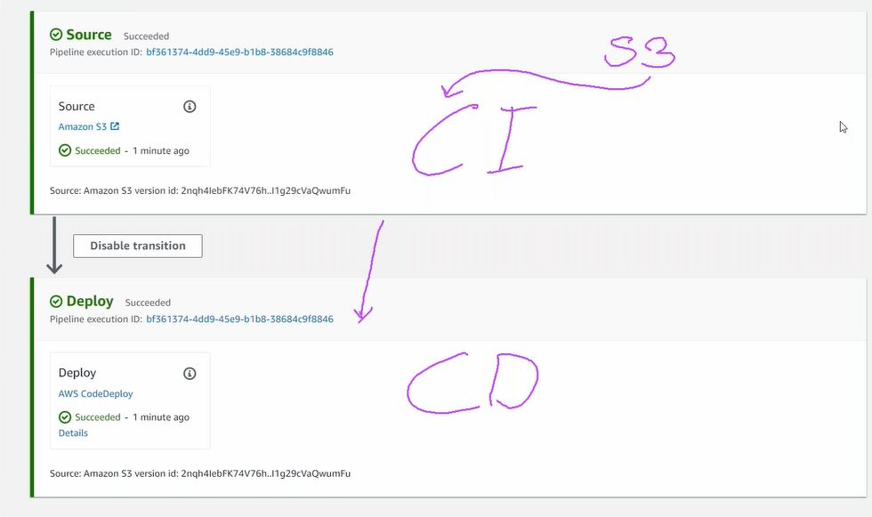
code pipeline communicates with code deploy; code deploy communicate with EC2 instance (via code deployment agent).

UC2: pick from s3, build it and deploy toward my webserver (EC2)
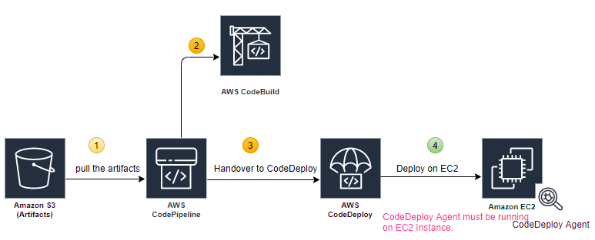
UC3: pick from CodeCommit, build it and deploy toward my webserver (EC2)
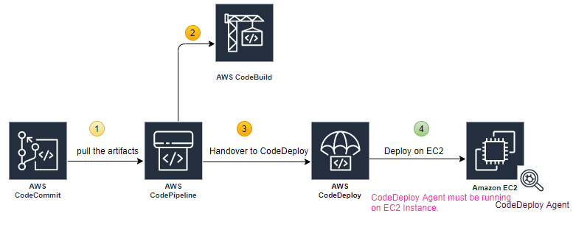
UC4: Fetch the code from Github, build in Jenkins and deploy toward my webserver (EC2)
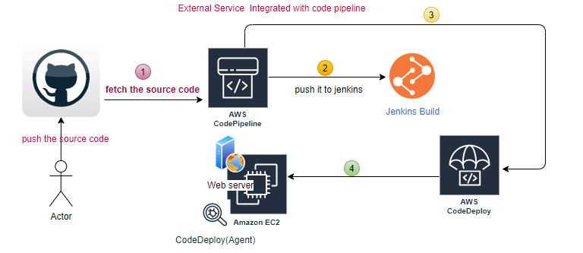
All the above run through the CodePipeline
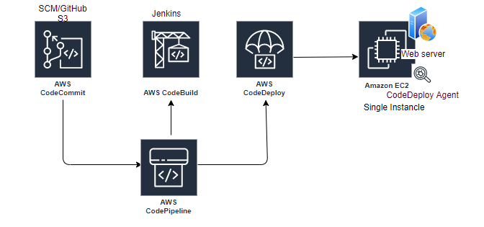
2:40 stuck

