Day3:
CodeDeploy
- Using CodeDeploy we deploy the changes in production server, It is AWS managed service to automate your deployment, result in faster deployment.
- Rollback update feature
- Blue-green deployment
Scalable…. It can be deployed to one or thousands of servers.
Deployment can be done on below
- On-premises servers
- EC2 Instances
- AWS Lambda
- Amazon ECS
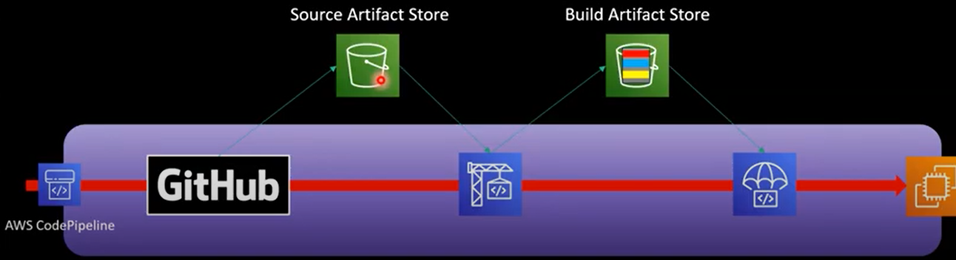
step1: As a developer handover the raw code (index.html), appspec. yaml and script folder.
version: 0.0
os: linux
files:
- source: /
destination: /home/ubuntu
hooks:
Afterinstall:
- location: after.sh
timeout: 100
Applicationstart:
- location: applicationstart.sh
timeout: 100

step2: Whenever there is a change deploy it in to the EC2 server.
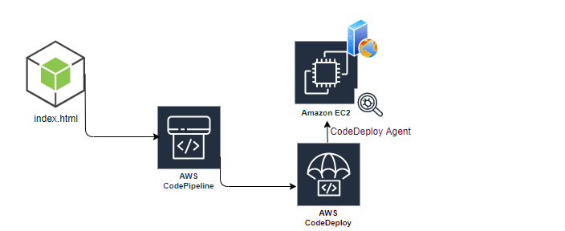
Continuous Integration happens through the CodePipeline, code deployment happens through the CodeDeploy.
Whenever there is a change in index.html, change, pipeline notified, changes picked up by CodePipeline, and request CodeDeploy service, hey! please put this file in specific folder in EC2 server.
In EC2 server, CodeDeploy agent already installed, this CodeDeploy agent gets the executable from S3 (its different default specific S3 bucket).
EC2 as a service has to communicate with S3 (EC2 must have role to interact with S3)
Policy: AWSEC2RoleforAWSCodeDeploy
Trust Relationship: ec2

- handover the piece of code to CodePipeline, CodePipeline handover to the CodeDeploy, CodeDeploy communicates with agent, and this agent communicate back to CodeDeploy Service (443).
- EC2 security group must carry TCP 443.
- There may be number of EC2, called deployment group, each of them must have (CodeDeploy agent).
What is CloudFormation?
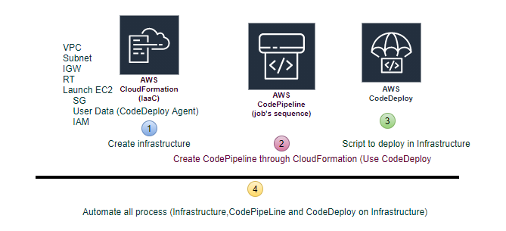
UC: CodeDeploy is input for CodePipeline, first create a CodeDeploy
step1: CodeDeploy-> deploy->application-> Create Application
step2: Create Deployment Group (fleet of EC2 instances)
Create CodePipeline
step3: Pipelines-> Create Pipeline
step4: Add Source (In case of S3 version must be enabled on S3 bucket)
step5: Build Provider (Optional in case of static contents)
step6: Deploy Provider (CodeDeploy).
step7: CodeDeploy Service communicated with the agent on the EC2 Instance.
Events (hooks): Pipeline->Deploy->Details
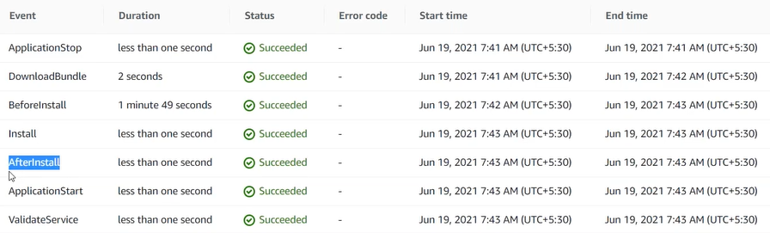
If there are some changes in S3 object, it notified to Code Pipeline. Code Pipeline immediate fetch the latest artifact and handover it to code deploys.
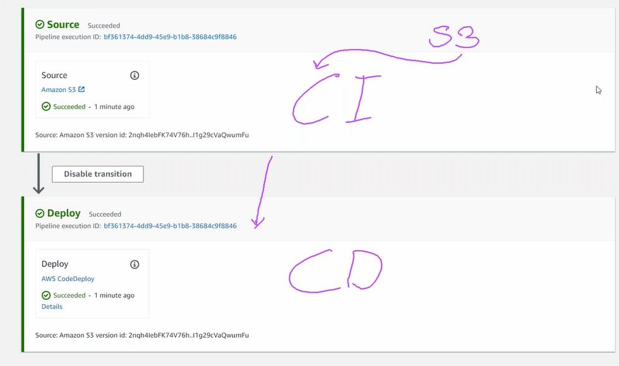
step8: How handover happens? Through S3
CodeDeploy handover the complete .zip file to CodeDeploy Agent, .zip file contains appspec.yaml: has all the necessary instructions for CodeDeploy Agent to follow and complete the deployment process. CodeDeploy service just handover the .zip to CodeDeploy Agent, Its CodeDeploy Agent actually do the deployment process.
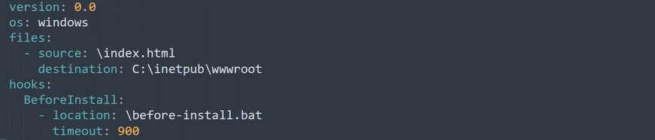
CI: source code-> CodePipeline
How S3 communicate with CodePipeline, that there is some change?
CloudWatch, has Events ->(Rule) defined, created by CodePipeline (Policy and Service Rule Created by CodePipeline).
CloudTrail, keeps eye on each and every activity that are happening in your account.
Rule says hey! CloudTrail, keep eye on S3 object, if S3 event (code change) triggered, then please trigger the event (rule). Trigger says, call the CodePipeline.
Integration is series of services connected to each other, S3 has event triggered when change the version, the event wase picked up by CloudTrail, CloudTrail notified CloudWatch, and CloudWatch trigger the Pipeline.
CodeBuild (buildspec.yaml):
version: 0.2
phases:
build:
commands:
- echo “This is built phase”
post_build:
commands:
- echo “Deploy to S3”

How to get Raw file and converts to the artifacts.
Just like maven, process of converting raw code in to executable (artifacts) e.g. .java->.class. Generates the /target
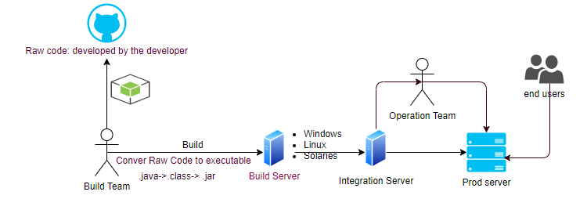

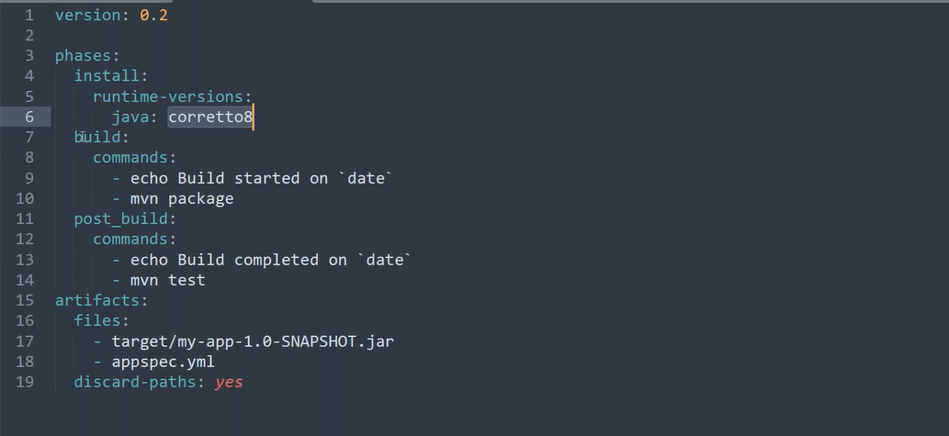
mvn package

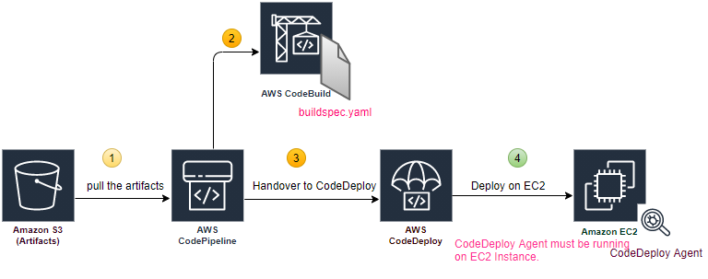

Artifacts:
CodeArtifacts (Rather than uploading in S3, upload the artifacts in CodeArtifacts).

CodeCommit (multiple users working on same artifacts):
Just like GitHub, remote repository (Underneath uses Git).
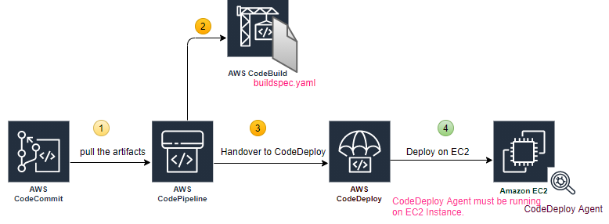
step1: CodeCommit-> Repository-> Create Repository
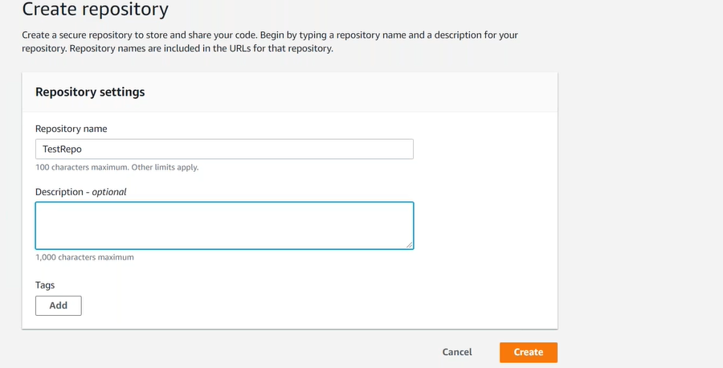
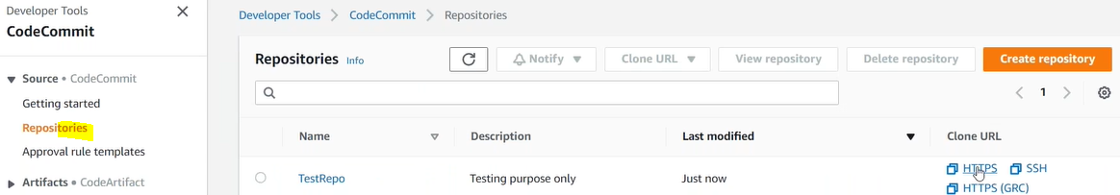

step2: In command line create folder
step2.1: git init
step2.2: git clone <url>
step3: If Using CodeCommit first time.
- IAM User-> Security Credentials-> Generate Git Credentials
- User must have Policy AWSCodeCommitPowerUser
- Have access to the Repository
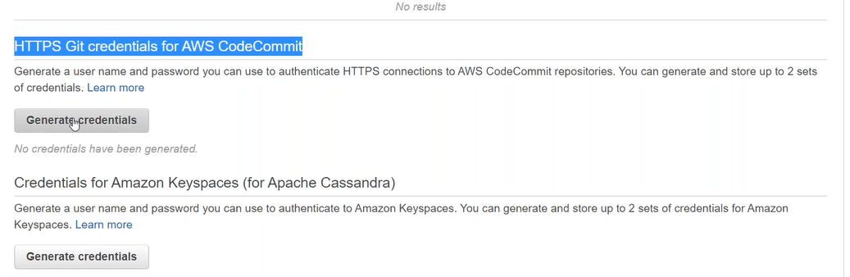
2:45 stuck

