Day4:
CodeCommit-> CodeBuild (buildspec.yaml) -> CodeDeploy-> CodePipeline
buildspec.yaml => build
appspec.yaml => deploy
Continuous Integration happens through the CodePipeline
step1: fetch the source code from version control system (s3, Github).
step2: Then build
step3: handover the build to CodeDeploy
step4: CodeDeploy will take care to deploy at EC2 Instance.
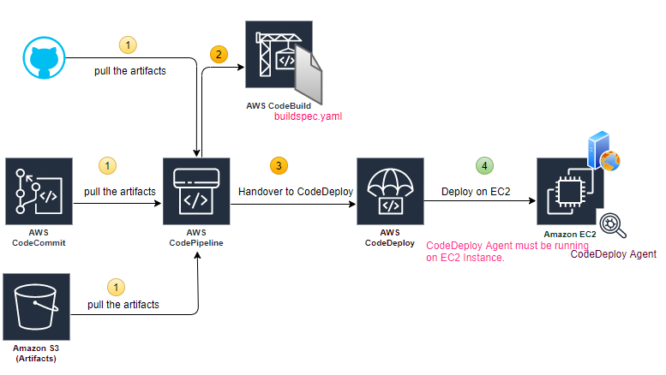
Code build
mvn package (creates a .jar file), CodeBuild do the same thing.
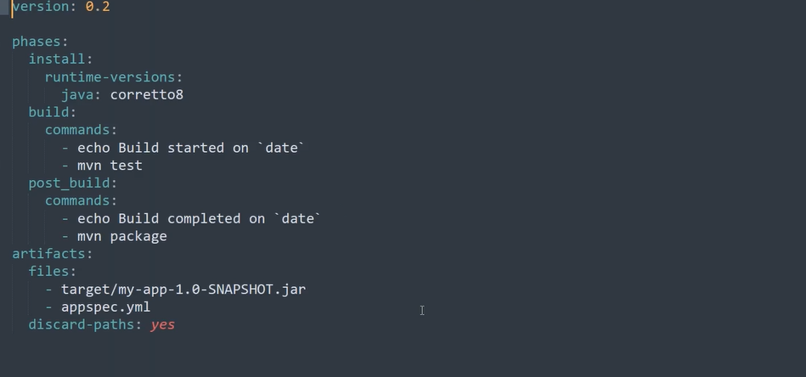
step1: CodeBuild->Build Project-> Create Build Project
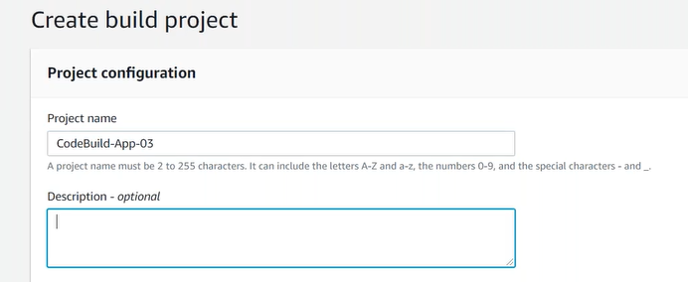
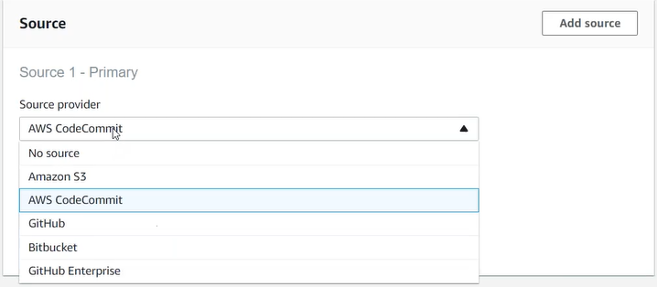
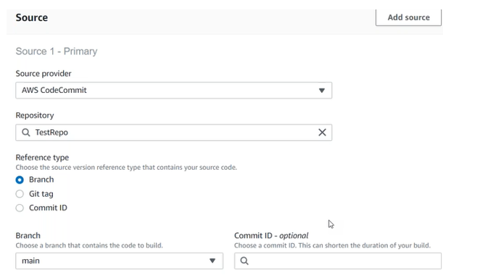
Environment: CodeBuild asking Which Machine?
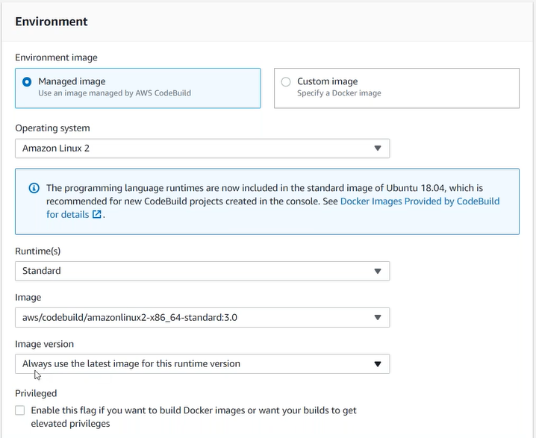

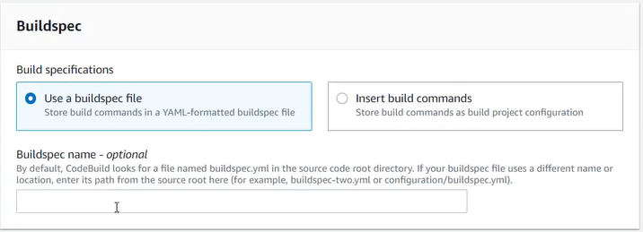
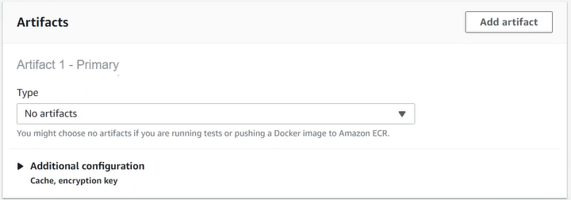
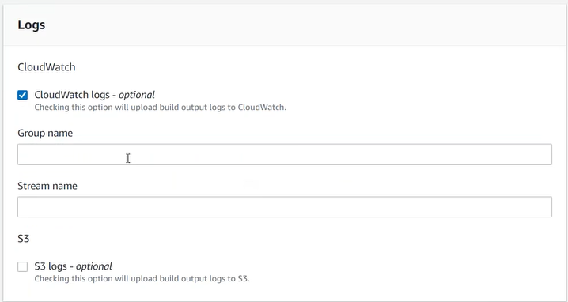
CodeBuild, instantiate a new build server provided by aws at run time and executes the instructions on buildspec.yml.

step2: Create CodePipeline for CodeBuild
step2.1: pipelines-> create pipeline
step2.2: source
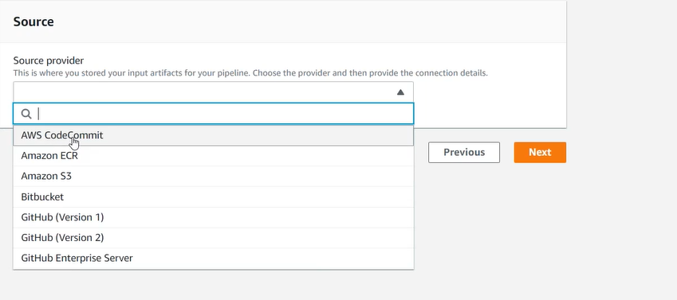
step2.3: build stage
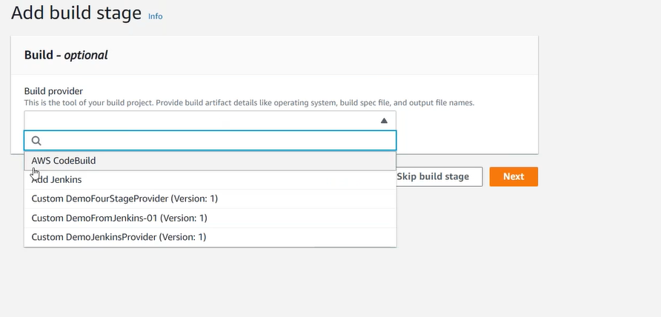
step2.4: deployment stage
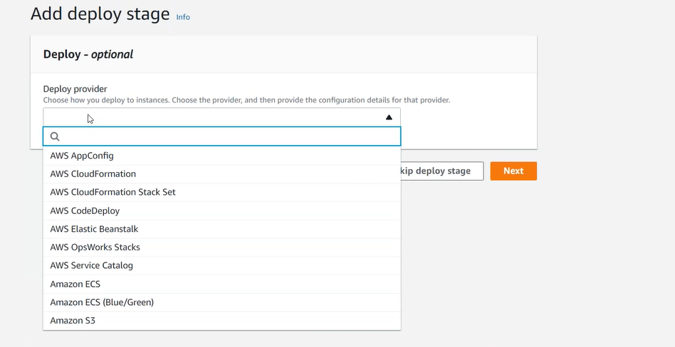
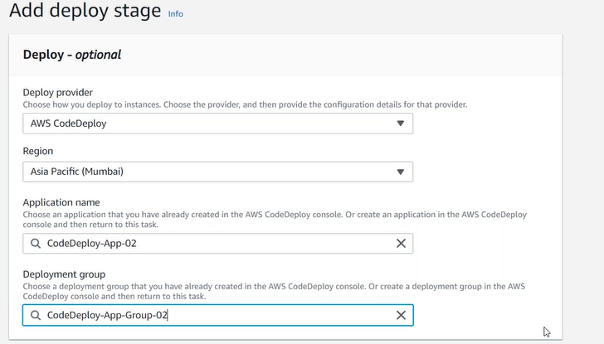
step2.5: Create a CodePipeline.
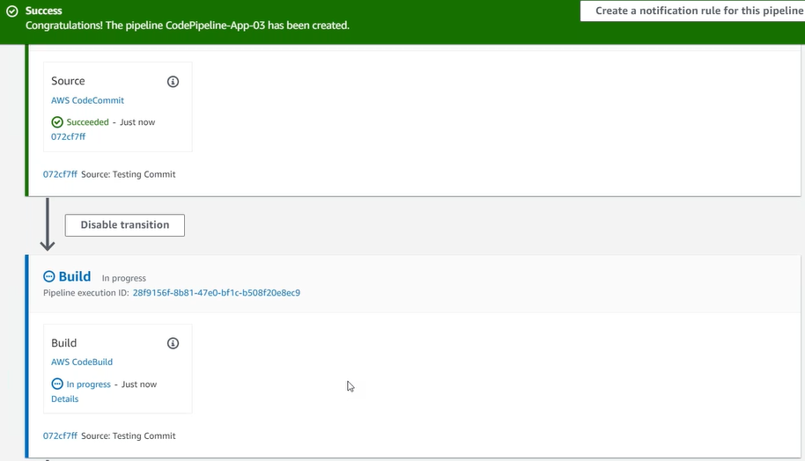
click on details of build stage
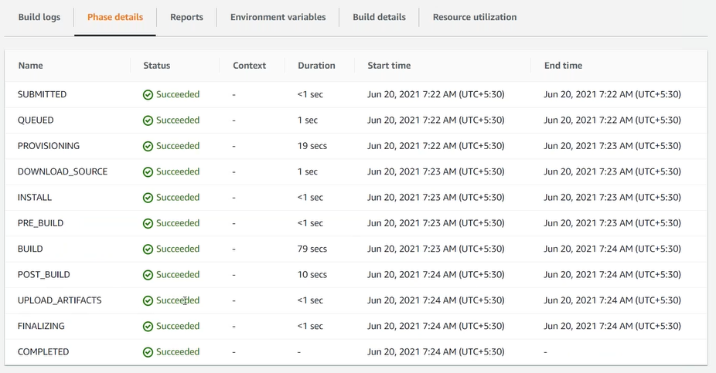
UPLOAD_ARTIFACTS: handover the artifacts to CodePipeline, CodePipeline handover it to CodeDeploy.
Click on CodeDeploy Events
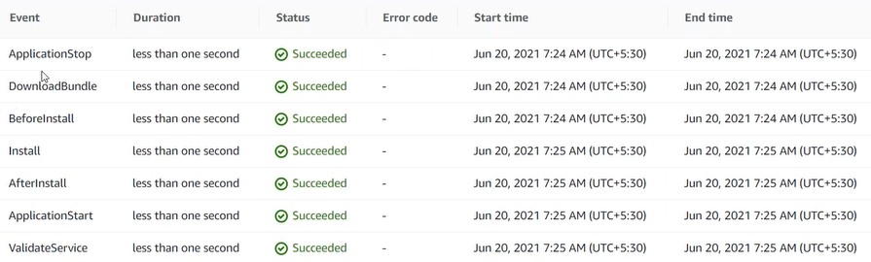
UC: Fail the build
In case of build fail, notify the user
Using the SNS => Simple Notification Service
step1: create a SNS topic.
step1.1: create a subscription.
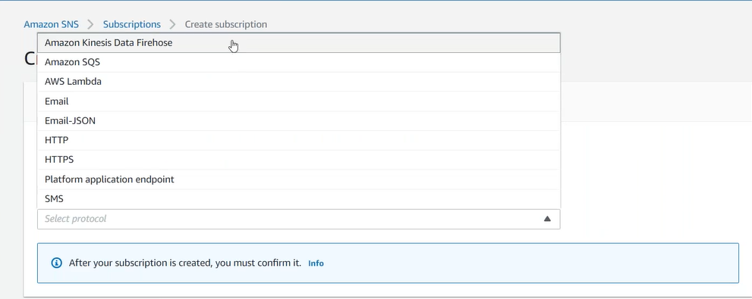
step1.2: confirm the subscription (email).
Build Server created and destroyed by AWS at run time.
step2: CodePipeline enables notification for us.

How to integrate External Version Control (GitHub), Build Service (Jenkins) in our CodePipeline?
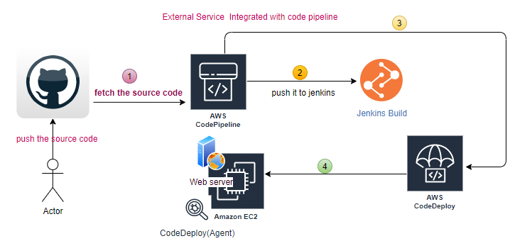
AWS pipeline pulls the source code from GitLab, handover it to Jenkins. Jenkins build the source code and handover back to CodePipeline, then CodePipeline handover the artifact to the CodeDeploy and this deploy the artifact to deployment group EC2.
How the changes in GitHub automatically updated in AWS?
CloudWatch=>Events=>Rules (informed to Pipeline there is change in CodeCommit):
created-by Pipeline automatically.
step1: source code available in GitHub.
step2: Launch Jenkins server in EC2 (SG 8080).
step2.1: EC2 is an AWS resource, requires role to interact with CodePipeline
UC: Jenkin is an external service, any external service how to communicate with AWS service?
Using Access/Secret Keys
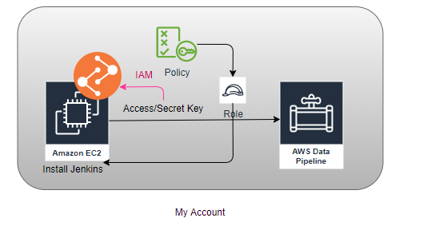External Service (Jenkins) don’t have Role, it comes with IAM User and that IAM user must carry certain policies.
Role automatically goes to EC2, to access the AWS resource, and IAM User access key and secret key must be used by external service (Jenkins) to communicate with CodePipeline, and this must be within same account.
EC2 role=> AWSCodePipelineCustomeActionAccess
Access/Secret Keys: Used by external services to access the AWS resources.
IAM User Policy-> AWSCodePipelineCustomeActionAccess
In Jenkins
AWS CodePipeline Plugin
AWS CodeDeploy Plugin, AWS CodeBuild Plugin
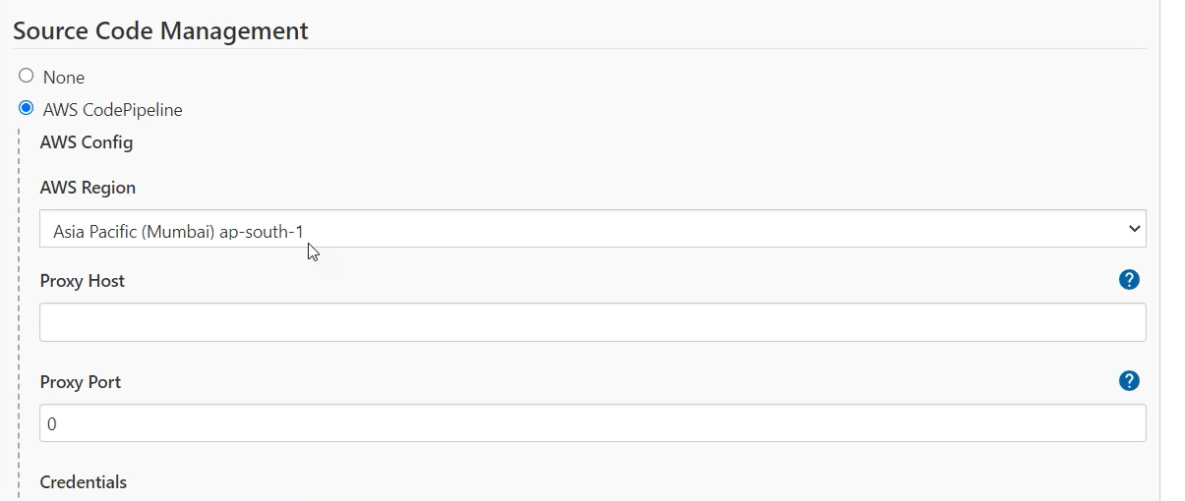
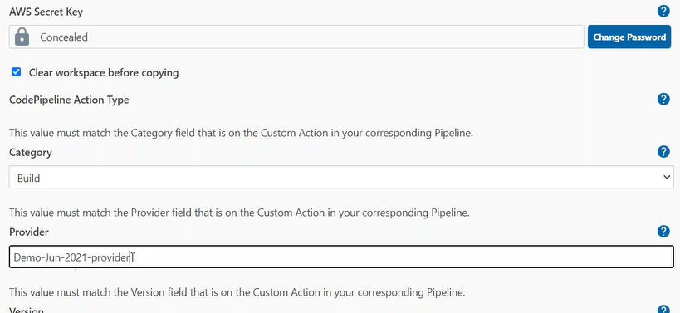
Provider=> same as mention in AWS
Create CodePipeline
step3.1: source
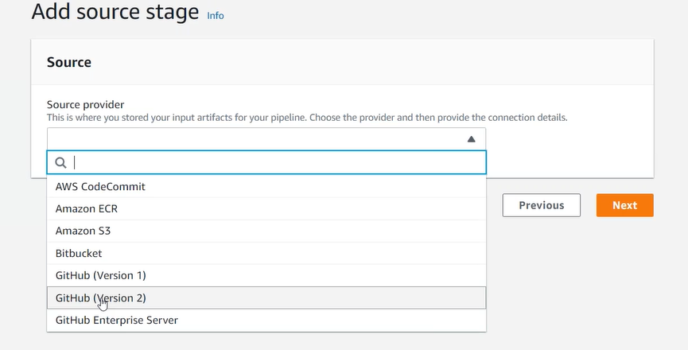
Connection: Connect to GitHub
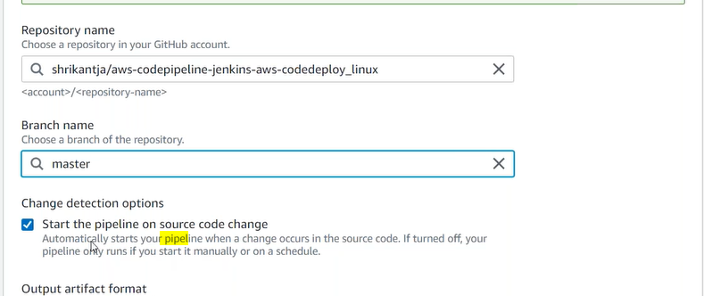
Once you select the start the pipeline option (CloudWatch is created)
Build:
step3.2: Build
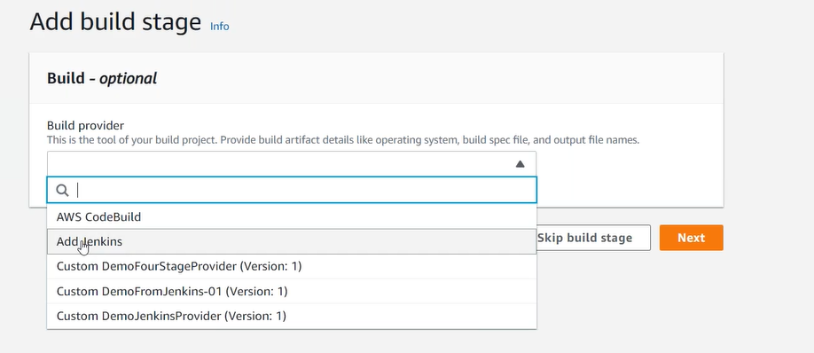
Provider: must be matched with provider name as in the Jenkins

Deploy
step3.3: Deploy
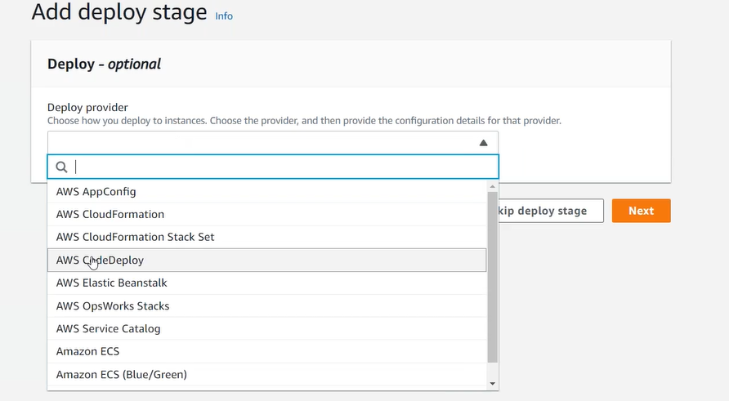

Source: GitHub, CodeCommit, S3
Build: Jenkins, CodeBuild
Deploy: CodeDeploy
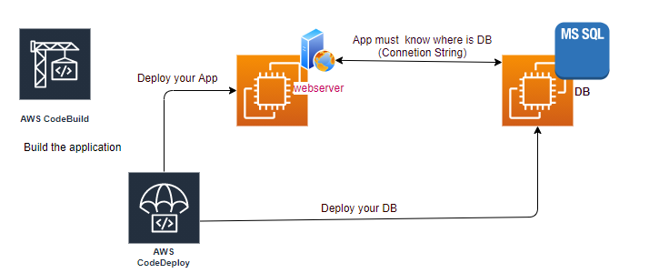

How to define Connection String, connects both Instance, Use Configuration Management tool, e.g., Ansible/puppet/Chef. It’s possible through OpsWorks.
Different Deployment Stages in CodePipeline:
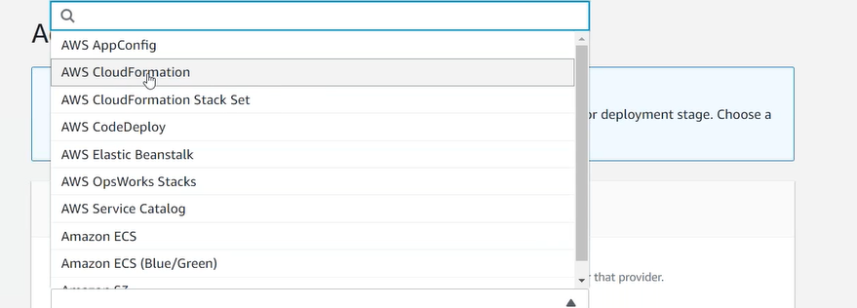
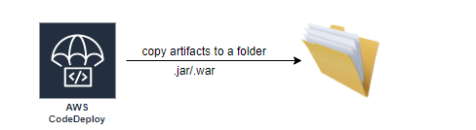
book: phoenix project (Gene Kim):
Waterfall:
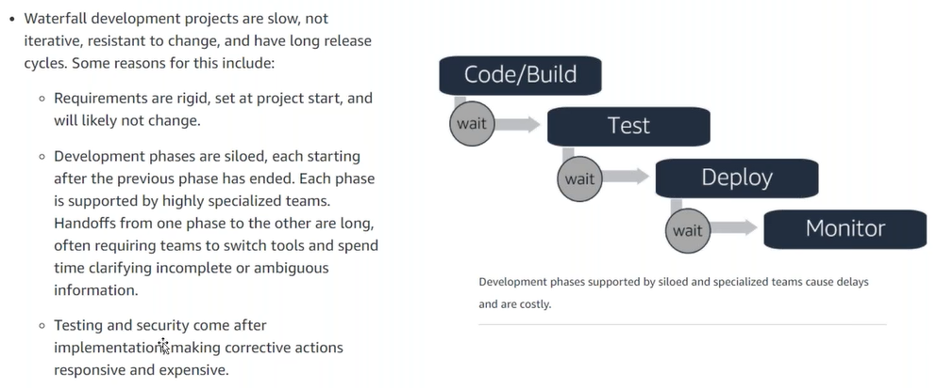

CodeBuild supports only two Operating Systems, if you want to use Window server then go for Jenkins.
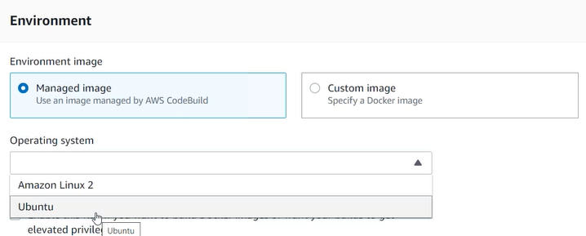
DevOps is a concept (Culture), introduced in AWS through CodePipeline.
- Agility
- Rapid Delivery
- Reliability
- Scale
- Improved Collaboration
- Security
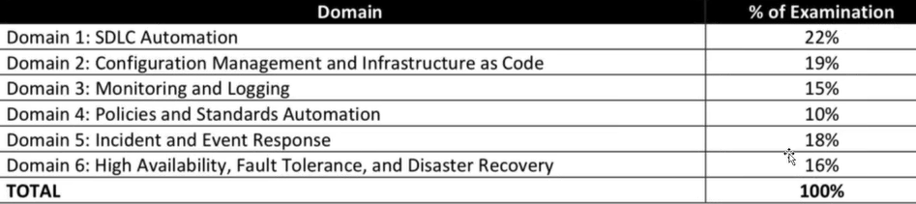

AWS Services
- List the AWS services available to implement a successful DevOps methodology.
- Identify the AWS services used to automate the CI and CD process.

