Day5:
Service Role for CodeDeploy?
Service-to-Service Communication through roles, and role carry the necessary permissions.

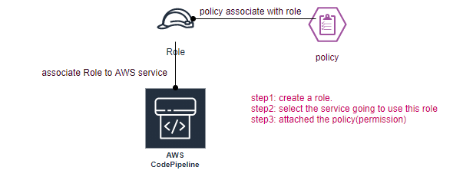
Difference between IAM role /Service role?
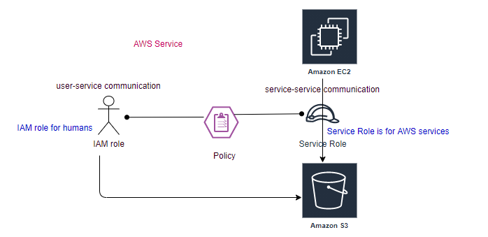

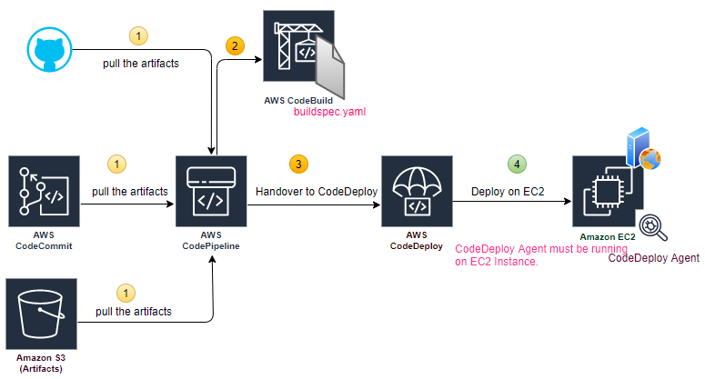
In real world there are multiple EC2 instances, Load is balanced by ELB. App is on top of EC2.
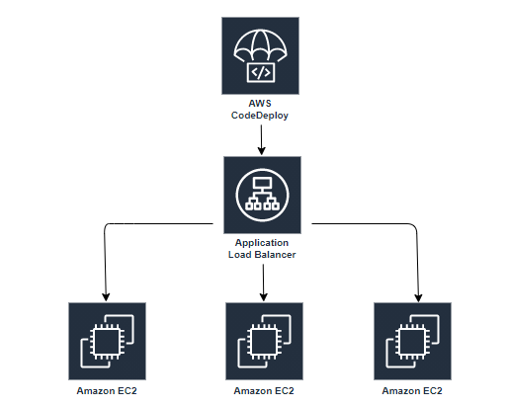

UC: LB
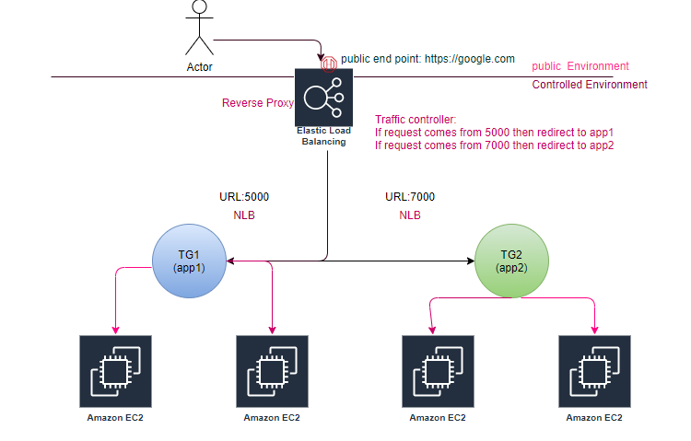
Endpoint service is just like a traffic controller (API Gateway or Reverse Proxy).
What is difference between proxy and reverse proxy (end point for external world).
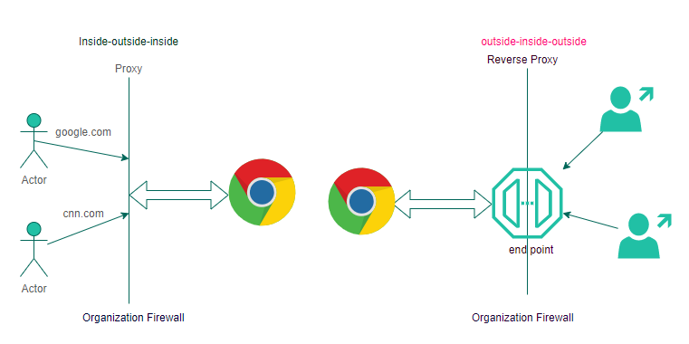
ELB (Elastic Load Balancing): NLB uses burst algo to balance the traffic.
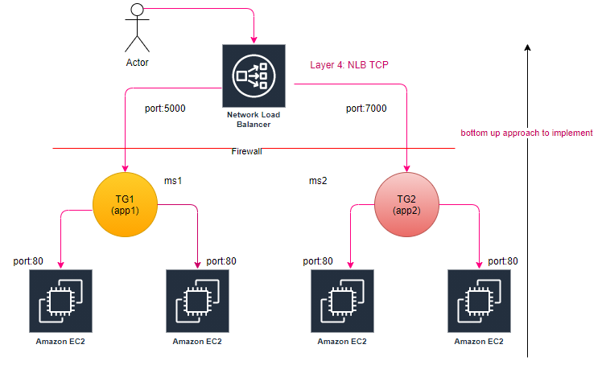
step1: Launch 2-2 instances per AZ
step2: Create TG for NLB (TCP), actual load balancing happens at TG level, health check always be HTTP
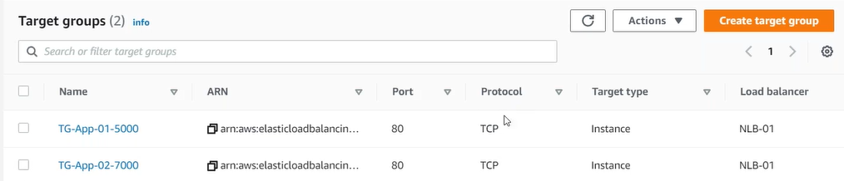
step3: Register the Instaces (targets) with TG.
step4: Configure Routing Configure Target Group
Mapping-> corresponding to each subnet(routing) a seprate NIC is created.

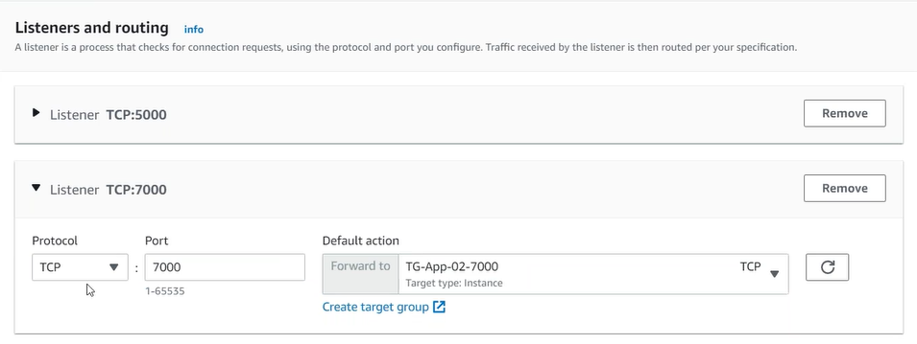
These ports are immediately dropped as traffic routed
Validate:
- Is NLB end point is active.
- Is target group’s targets are healthy
- This is also called reverse proxy?
You can host multiple applications behind single end point and redirect the traffic based on the port number.
Tab: Integrated Services
- VPC Endpoint Service (AWSPrivateLink) Layer4
  - You can create your NLB as a service, for others to consume as a VPC Endpoint Service.
- Traffic Mirroring (Layer4)
- Global Configuration (pop)
- Config (record each activity in the account)
Endpoint: DNS From consumer point of view
Endpoint Service-> publisher/provider
All applications worked at region labels.

ELB (Elastic Load Balancing): ALB, uses round robin algo to balance the traffic.
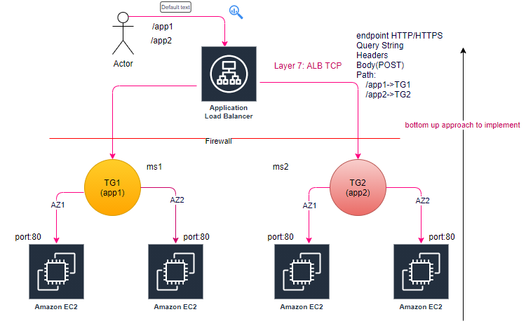
step1: Launch 2-2 instances per AZ
step2: Create TG for NLB (TCP), actual load balancing happens at TG level, health check always be HTTP
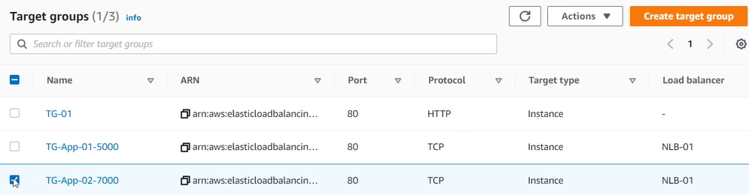
step3: Register the targets with TG.
step4: Configure Routing Configure Target Group
Mapping-> corresponding to each subnet(routing) a seprate NIC is created.
Validate:
- Is ALB end point is active.
- Is target group’s targets are healthy
- This is also called reverse proxy?
You can host multiple applications behind single end point and redirect the traffic based on the http/https, host-based routing (IP), path-based routing, http header-based, http-method based, Query String parameter-based, Source IP address CIDR based.
Tab: Integrated Services
- AWS WAF (Layer7)
- Global Configuration (pop)
- Config (record each activity in the account)

How to set Query based load balancing?
Tab: Listener
step1: Click on view/edit rule
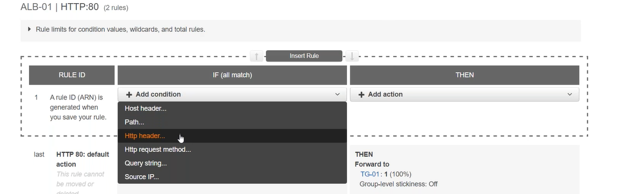
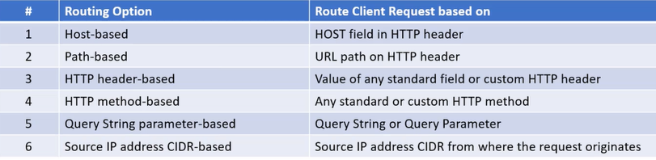
All applications worked at region labels.

Autoscaling:
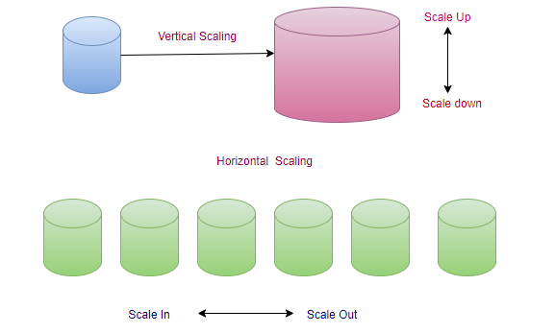
Autoscaling (HPA):
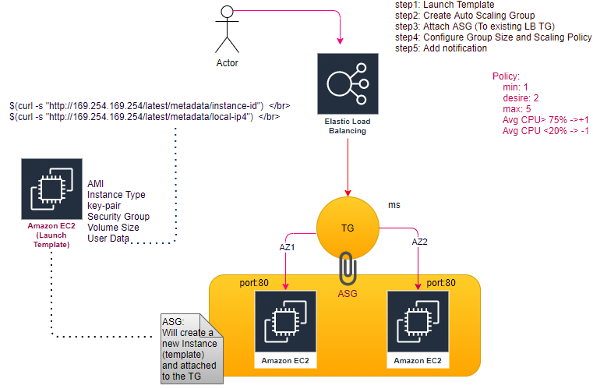
step: Just map Auto Scaling group with the target group, along with policy, will automatically create EC2 instance as per policy.
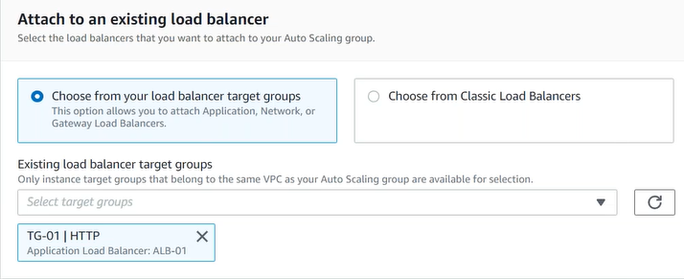
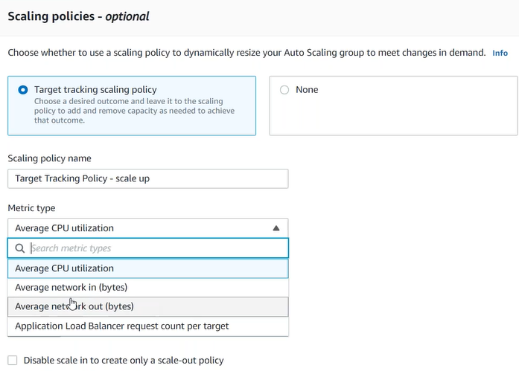
Vertical Scaling of EC2, first stop the Instance then change the Instance type.

UC: CodeDeploy (App01): more than one Instances (No LB)
step0: Artifacts available is S3 bucket.
step1: tag the both EC2 instances of app1
step2: CodeDeploy->Applications->Create Application
step3: Create Deployment Group (Group of more than 1 Instances)
step4: Environment configuration: Amazon EC2 Instances
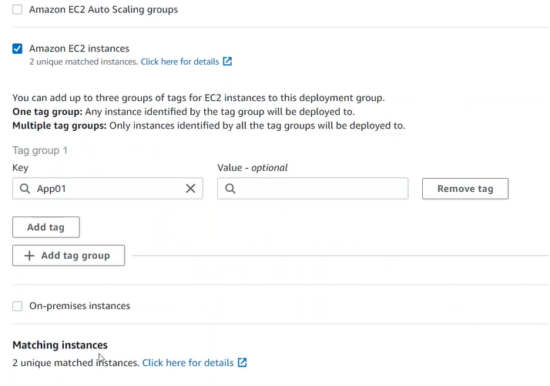
Will be failed, because CodeDeployment agent is not running on EC2 instances.
EC2 instance need also to contain IAM role to interact with the S3.
step5: CodeDeploy->Application-> Select the application->Deployment’s tab-> Create Deployment.
Artifacts are in S3, as of now we were saying CodePipeline, now CodeDeploy itself will deploy using create deployment.
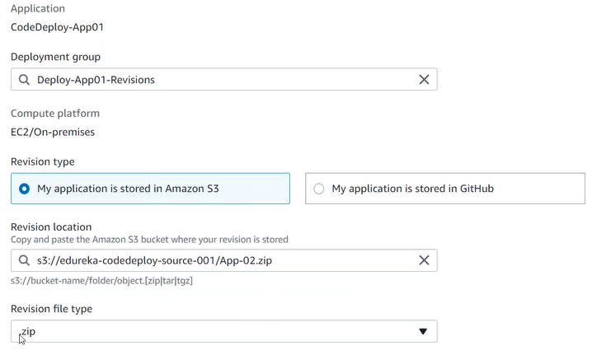
As of now we don’t have assigned role to EC2 to communicate with S3, and also don’t install CodeDeploy agent on EC2.
step6: Add the IAM role in both of the Instances (Security->Modify IAM role).
step7: Connect to the EC2 instance and install the CodeDeploy agent.
step8: Click on re-deployment
CodeDeploy and TargetGroup never talk to each other, Instances are the interface between CodeDeploy and TargetGroup. LB main objective is just traffic control.
We are just deploying new application only on 2 EC2 instances (app1).
EC2 can be connected with more than one target group.

Auto Scaling Group
Launch Template/Configuration
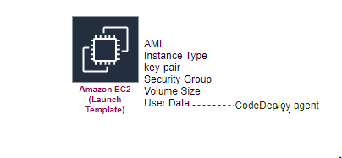
step1: Create Launch Template (IAM role CodeDeploy): Autoscaling group need to scale the instance. (Launch Configuration deprecated).
step2: Create Auto Scaling Group (min, desired, max instances)
step3: Associate Target Group with Auto Scaling Group (In case of LB association).
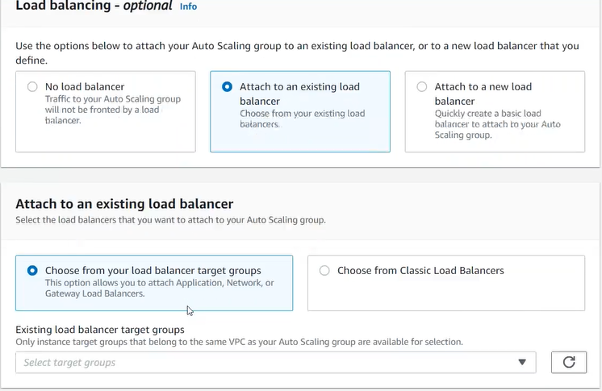

step4: Configure group size and scaling policies.
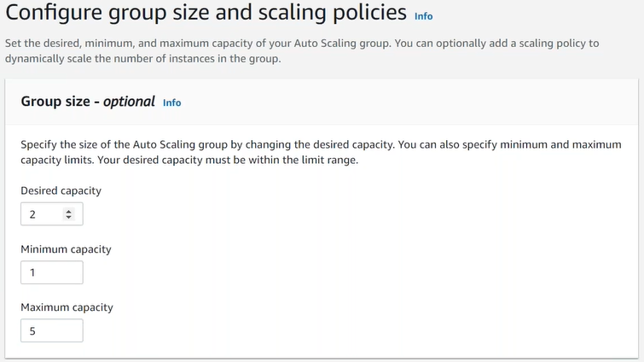
Autoscale Group Launches the EC2 automatically based on the policy defined (don’t need to create EC2 instances manually).
UC: CodeDeploy (App01): Autoscale
step5: CodeDeploy-> Create application
step5.1: Create deployment group
step5.2: Environment configuration=> Amazon EC2 Auto Scaling Group
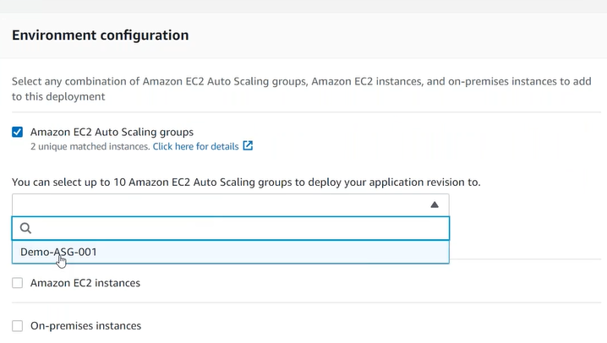
step6: Additional deployment behavior settings.
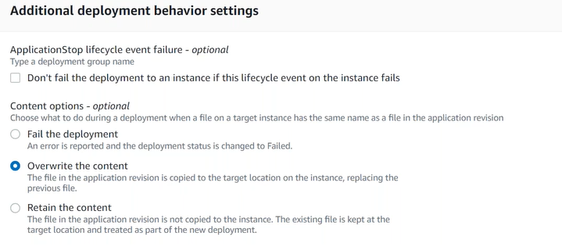

step7: CodeDeploy->Application-> Select the application->Deployment’s tab-> Create Deployment.
CodeDeploy itself will deploy using create deployment.
Autoscaling, request CodeDeploy and says hey! now we are associated to each other, i have launched a new instance, please deploy the newer version on new instance.
UC: Associate ASG with LB?
Edit the ASG:
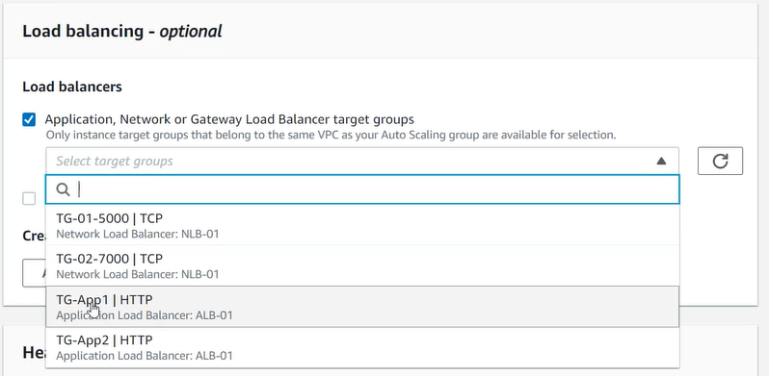
step2: Validate from TG
TG-> Targets tab
step3: Validate from LB
DNS of ALB
CodeDeploy meant for deploy artifacts on EC2 instance, not to interact with EC2 instance, just like to courier service just focus on their service.
UC: CodeDeploy, Deployment Group for LB.

Public/Private Subnet
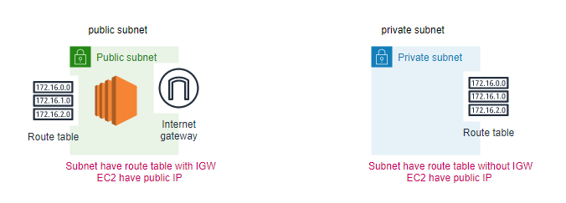
NAT (Unidirectional)
