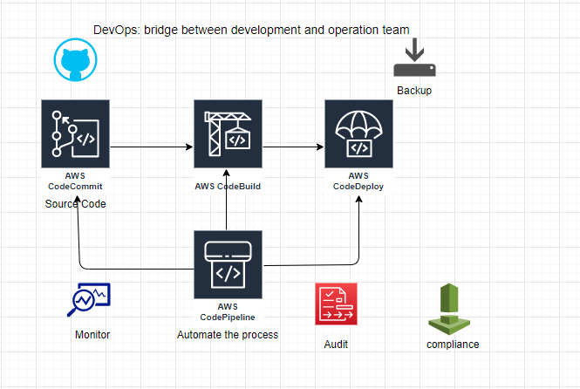
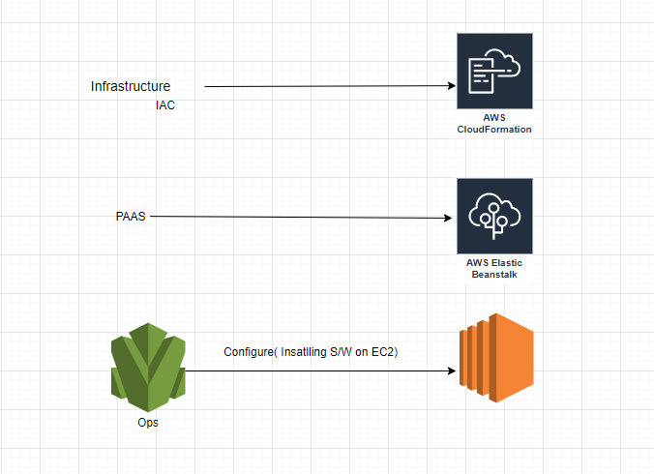

Elastic Beanstalk: (region)
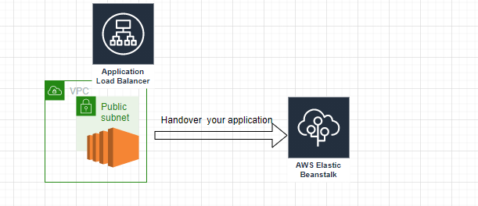
Beanstalk internally uses CloudFormation to create an environment.
VPC:
Endpoints: Service Consumer
Endpoint Service: Service Provider (Private Link)
How EC2 communicates to each other (One EC2 contains app, other contains DB)
Allow SG, actual EC2 don’t talk to each other, service running on top of it communicate to each other using the infra.
step1: Beanstalk-> Create application
step2: select platform
step3: upload your application code.
step3.1: configure more options.
step4: environment using the CloudFormation (Template).
step4.1: Infra managed by beanstalk.
DevOps in AWS, not integrate with K8s till now.
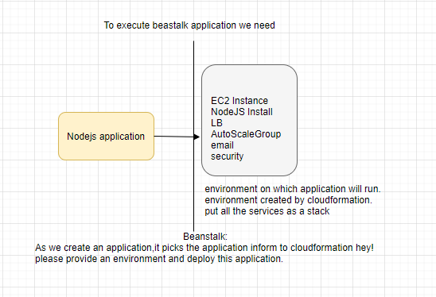
Use DNS of Beanstalk, not the public ip of EC2 to access the application.
UC: Integrate Beanstalk with AWS CodePipeline?
CodeDeploy: Handover application to Beanstalk, and ask please create infra and deploy the application.
Application-> Environment
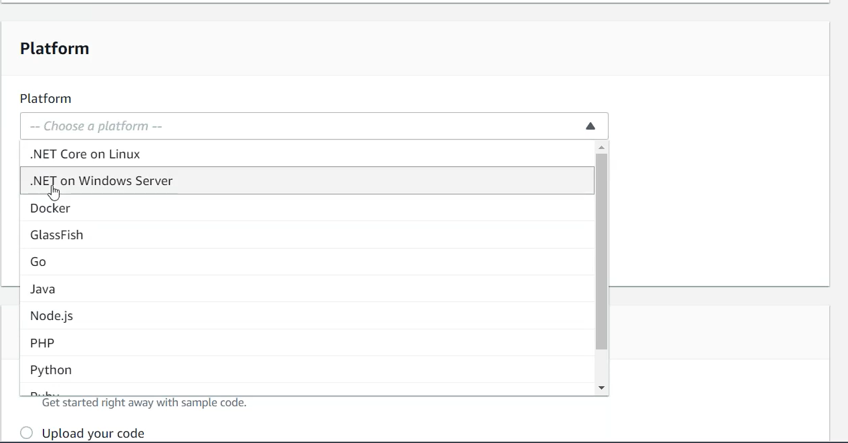

CloudFormation: (Region’s)
CloudFormation can do anything AWS has as a service (STACK). Earlier Beanstalk asks for infrastructure, using CloudFormation can customized our own infrastructure.
- “AWSTemplateFormatVersion”:
- “Description”: Stack Info
- “Resources” : What resource we need to spin up (EC2,SG)
  - “TYPE” : “AWS::EC2::Instance”
  - :{“Ref” : “SSHLocation”} # SSHLocation either from Parameter section or from Resource section.
- “Parameter”: # accepting input from user
- “Outputs”:
  - “WebsiteURL”:{
    - “Value”:{
      - “Fn::join” #Fn Intrinsic /Conditional Functions
        - {“Fn::GetAtt”:
          - [“webserver”,”publicDnsName”]
step1: create a new stack (from template: is json or yaml file)
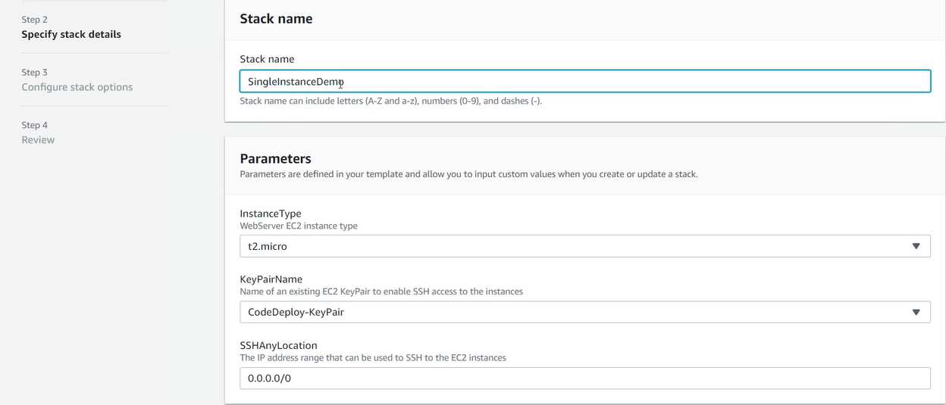
Drift:
step1: select your stack
step2: stack action-> detect drift
step2.1: stack action-> view drift

# Manually change, in the resource created through the CloudFormation template.
Drift is generally made by administrator.
step2.1: stack action-> Create change set for current stack
# Change my stack, introduce new resources/ deletion/updation of existing resources
Can make drift permanent through create change.
AWS::CloudFormation::Init
UC: Integrate CloudFormation with AWS CodePipeline?
OpsWorks:
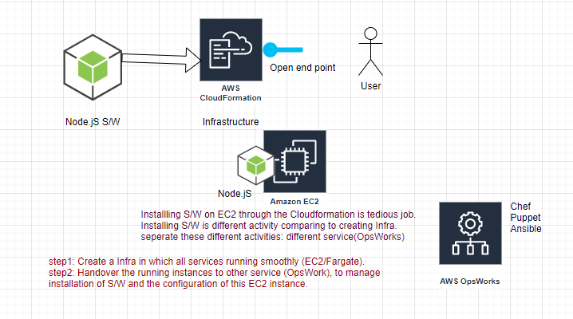
Decouple S/w related stuff from the infrastructure creation stuff.
Scaling is difficult through CloudFormation, more activities beyond the CloudFormation
OpsWorks: Installing and managing the configuration, complex configuration managed by OpsWorks.
datamation.com/cloud
compare AWS, Azure and Google Cloud Service.

How to take backup?
Code is developed by us and handover the same to the cloud vendor.
UC: Integrate OpsWorks with AWS CodePipeline?
CloudShell service of AWS- Run CLI commands.
