Day8: Peripheral Services
Security must be start from the day, team start coding (DevSecOps).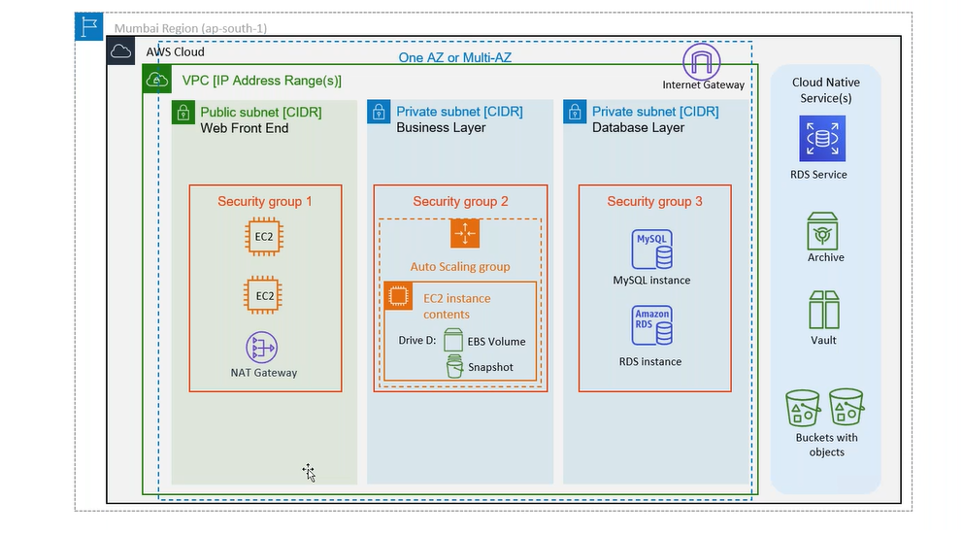
Post Migration Activities:
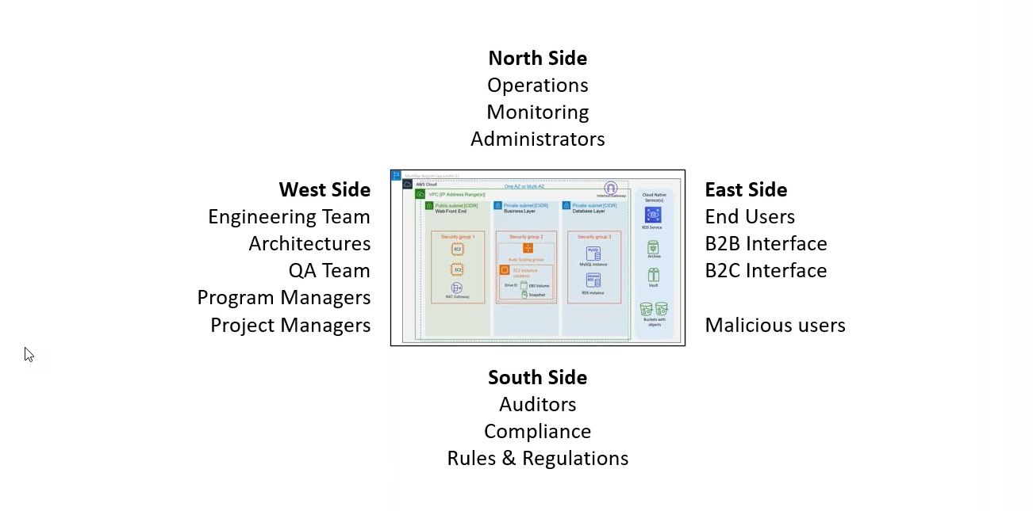
West Side: WAF/Shield
OWASP: Open Webservice application security project is a non-profit foundation that works to improve the security of software.
OFAC (Office of Foreign Asset control)
ALB->Integration Service (tab) -> AWS WAF
NLB: There is no WAF at NLB, it works on port/IP.
NLB->Integration Service (tab) -> VPC End Point Services (Private Link)
DMG Area (Outside the cloud in public area)
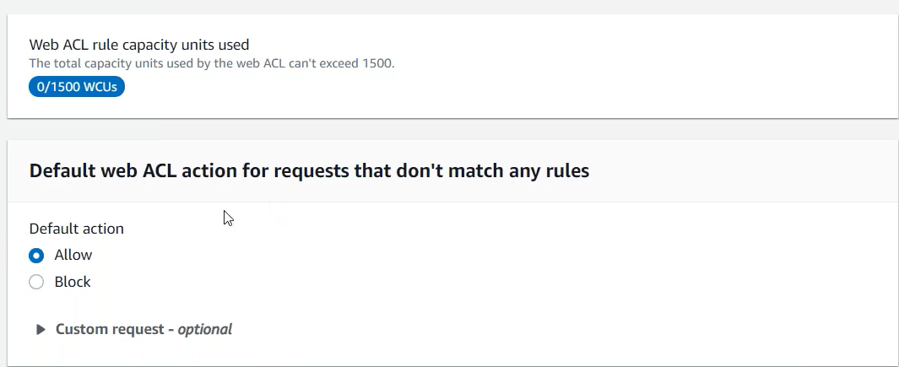
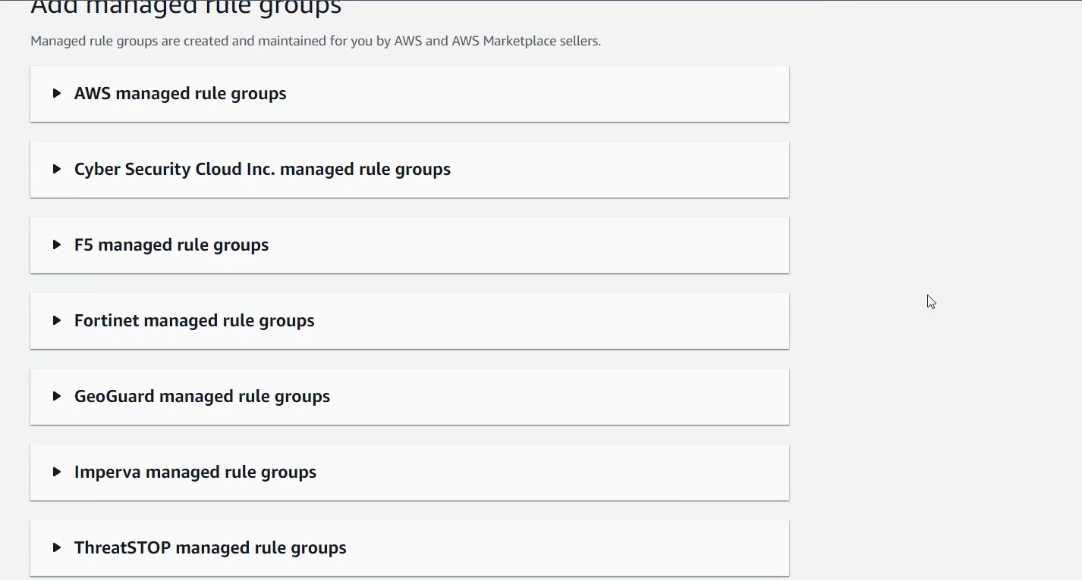
Traffic Mirroring (Mirroring the packets):
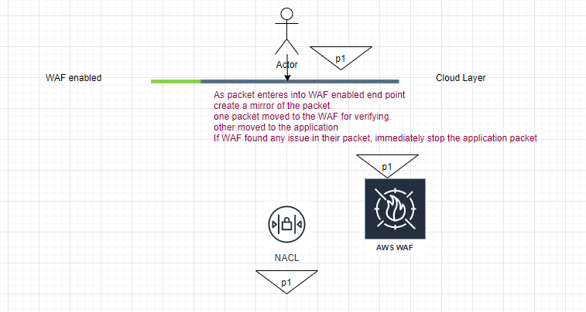
WAF
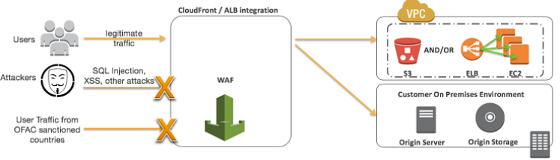
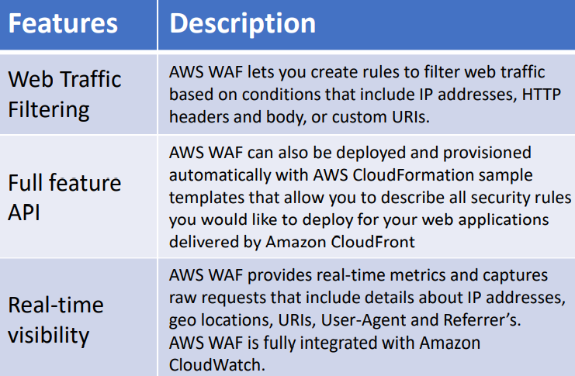
Shield: Distributed Denel of Service (DDoS attack): Attached files
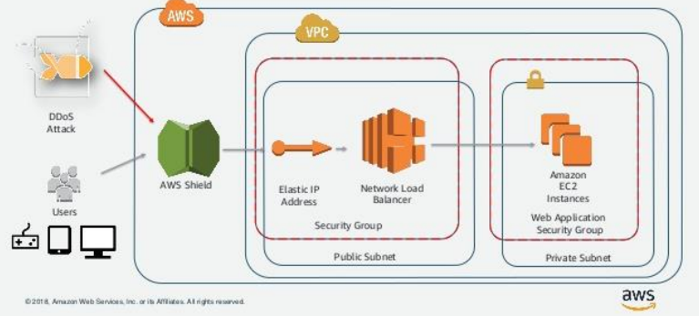
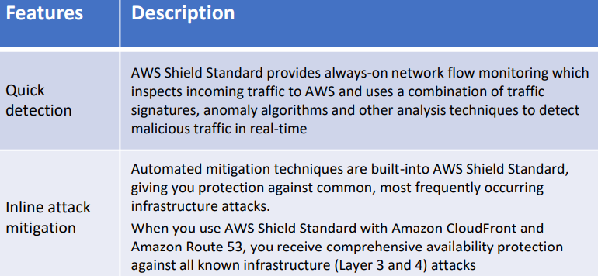
threatmap.checkpoint.com
Guard Duty
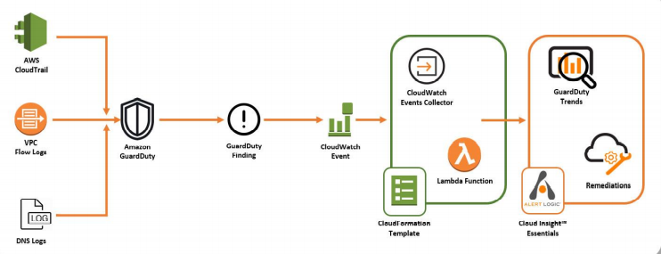
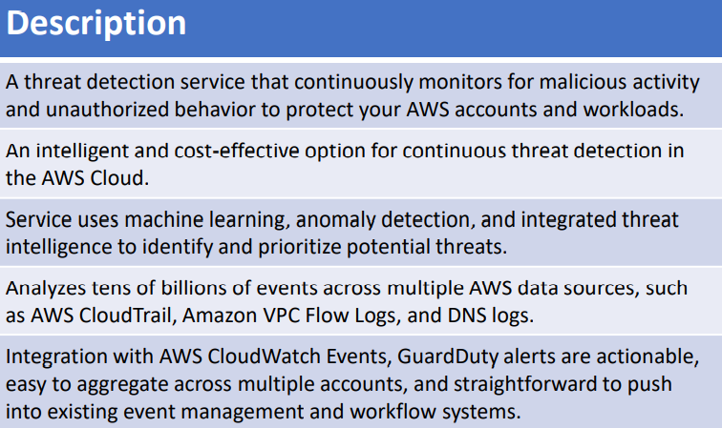
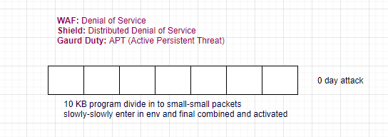
South:
Config: What AWS resources are available at given time? Track Resource Inventory and track. (Inventory Status)
UC: On 15th of Aug how many resources were available in my account, and who and when they provisioned?
Conformance packs: A conformance pack is a collection of AWS config rules and remediation actions that can be deployed and monitored as a single entity in your AWS account.
CMDB: Configure Management Database
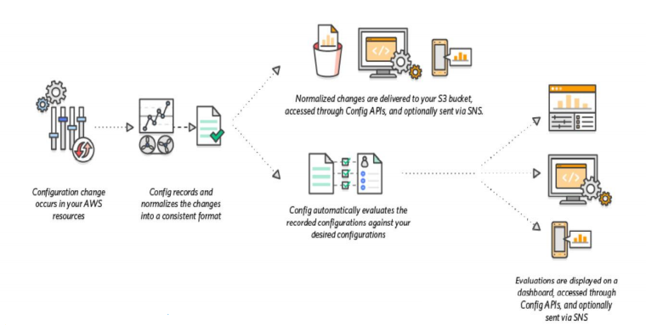
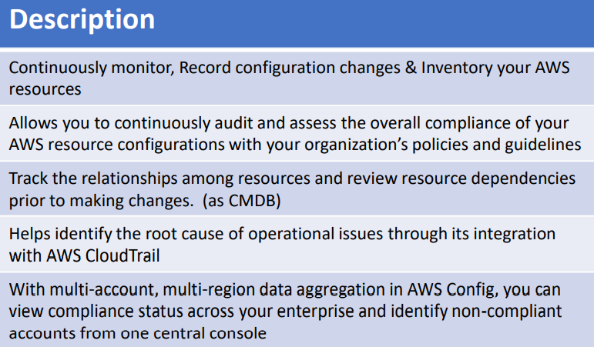
CloudTrail: (Audit) 90 days by default (detect unusual activities in your account). (Account level activities)
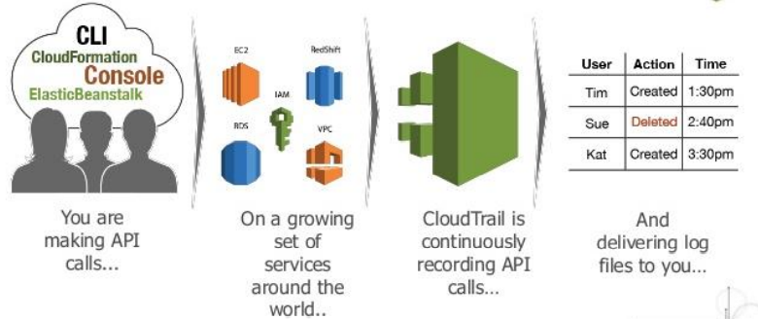
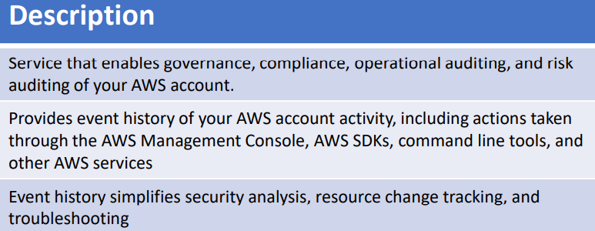
CloudWatch: (Monitoring)
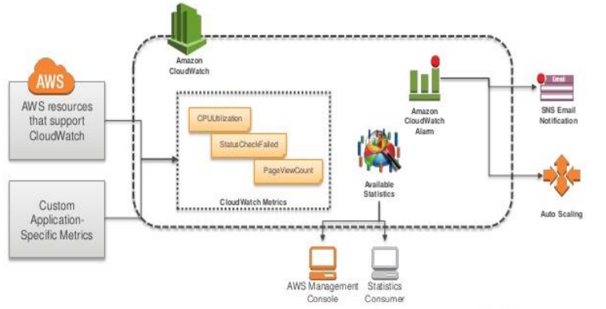
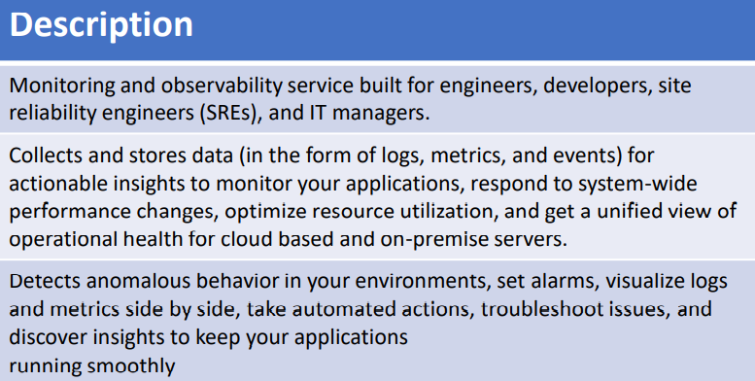
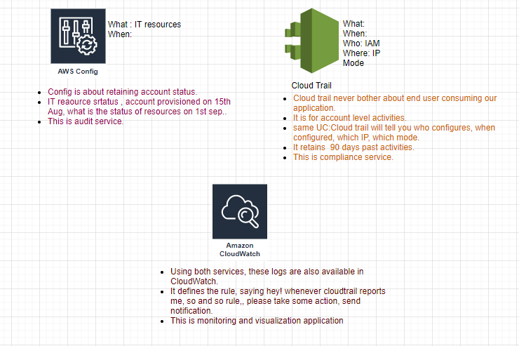
VPC Flow Log: (end user activities captured), tied with NIC
  - NIC: VPC Flow log (grouping)
  - Subnet: Flow log (grouping)
  - EC2: Flow logs
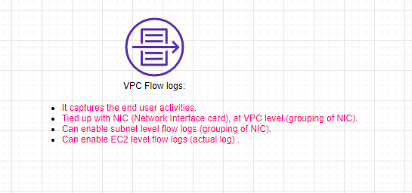
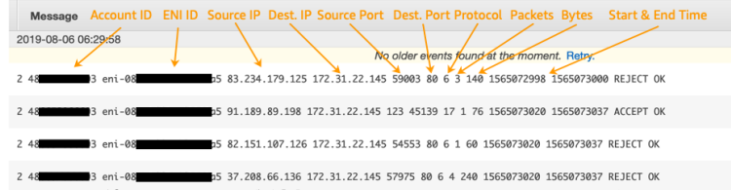
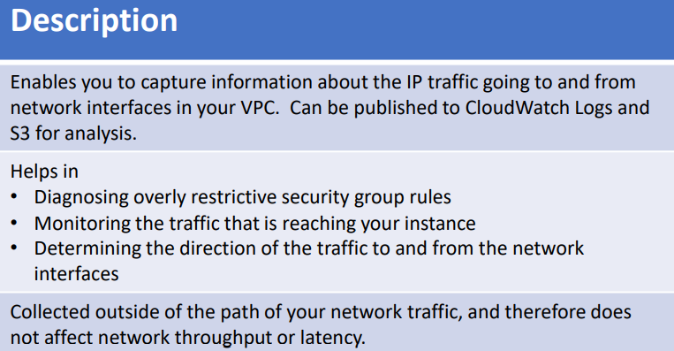
CloudFormation: (template/stack)
CloudWatch-> log groups-> event
Lambda (support max 15 min execution, alternative to execute in EC2)
API Gateway-> Rest API -> execute lambda
Whatever can execute in EC2 can be executed by lambda.
Kinesis Firehose: (bridge to store incoming stream data from IOT): helps the stream data to connect to the storage (S3).
SRE (Site Reliability Engineering)
System Management: AWS System Manager
Parameter Store and Secret Manager:
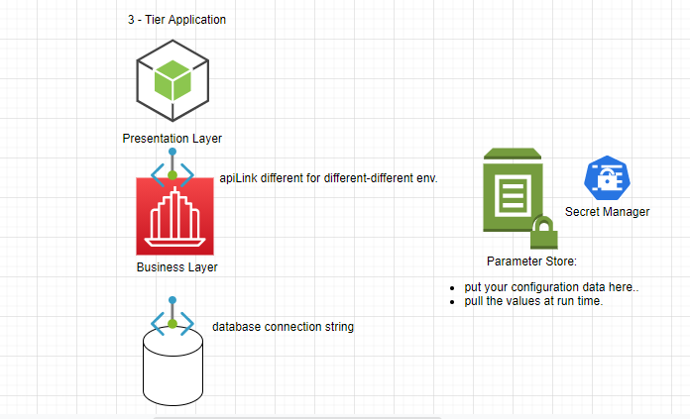
Other Monitoring tools apart from CloudWatch?
Nagios/Prometheus/Grafana/Splunk (Integrate all DB at one place)
How to manage different environments?
Using CloudFormation can create scripts for different-different environments.
ELK: Event based
CloudWatch Agent:
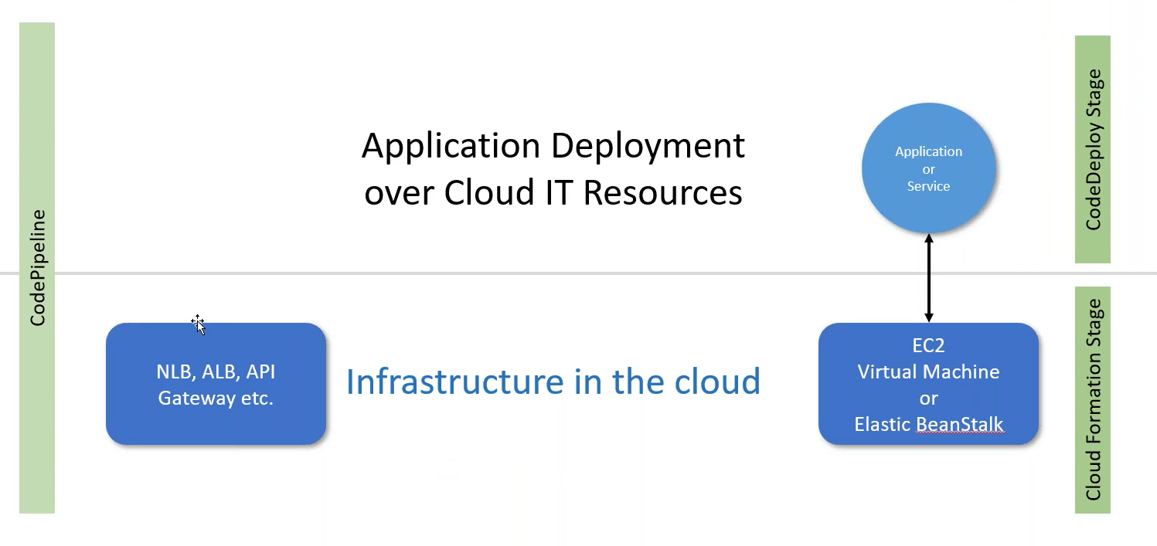
- Infrastructure in cloud managed through the CloudFormation.
- Application Deployment over Cloud IT resources CodeDeployment Stage
- Integrate the both using the CodePipeline.
Blue-Green Deployment: swap the autoscaling group behind ELB.
Route53 (blue is old version/green is new environment)
AWS Security Hub (vulnerability)
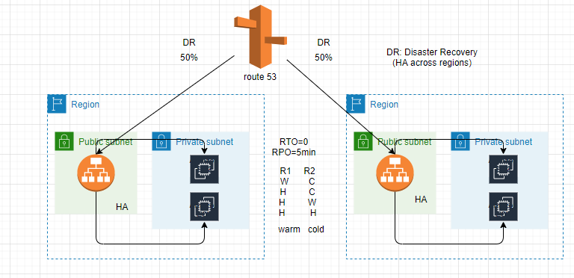
Vulnerability:
A weakness in the computational logic (e.g., code) found in software and hardware components that when exploited, results in a negative impact to confidentiality, integrity, or availability.
Certificate Project:
- IAC: CloudFormation
- Infrastructure must include multi-region architecture (HA and DR):
  - Route 53
- ECR/ECS
- CI/CD
- Application running in two different regions, pull the code without latency issue? Rather than replication pull the code.
- AWS CloudWatch and SNS

